Table T1. The TMAs in the SI, LR and AP directions for the two groups. (Mean ± 1SD, mm)
 |  | Group A |  |  |  | Group B
 | SI | LR | AP |  | SI | LR | AP
TMA_{org} | 3.5±2.7 | 1.9±1.7 | 3.1±2.1 |  | 12.1±6.8 | 2.7±2.4 | 2.8±2.7
TMA_{bs} | 2.7±2.5 | 1.4±1.3 | 2.2±1.8 |  | 10.3±5.8 | 2.0±2.1 | 1.8±1.7
TMA_{4D} | 2.7±2.7 | 0.9±0.9 | 1.3±1.2 |  | 9.3±4.1 | 1.1±0.9 | 1.9±1.4
Abbreviations: SI Superior-Inferior, LR Left-Right, AP Anterior-Posterior

Table T2. The intra- and interfraction TMVs in the SI, LR and AP direction for the two groups. (Mean ± 1SD, mm)
 |  | Group A |  |  |  | Group B
 | SI | LR | AP |  | SI | LR | AP
Intrafraction TMV | 0.7±0.6 | 0.4±0.4 | 0.6±0.5 |  | 2.7±1.9 | 0.6±0.6 | 0.6±0.6
Interfraction TMV | 0.8±0.6 | 0.6±0.6 | 0.7±0.7 |  | 1.7±1.0 | 0.9±1.0 | 0.8±0.8
Abbreviations: SI Superior-Inferior, LR Left-Right, AP Anterior-Posterior

Table T3. Summary of systematic and random errors in the treatment of the two groups. (Mean ± 1SD, mm)
 | Group A |  |  |  | Group B
 | SI | LR | AP |  | SI | LR | AP
TMA_{bs}-TMA_{4D}
system error | 1.6 | 1.1 | 1.3 |  | 3.5 | 2.0 | 1.4
random error | 0.6 | 0.6 | 0.7 |  | 1.0 | 1.0 | 0.8
TMA_{org}-TMA_{4D}
system error | 1.6 | 1.3 | 1.6 |  | 4.3 | 2.2 | 2.0
random error | 0.6 | 0.9 | 0.7 |  | 1.5 | 1.2 | 1.3
intra-TMV
system error | 0.5 | 0.3 | 0.4 |  | 1.5 | 0.4 | 0.4
random error | 0.2 | 0.2 | 0.2 |  | 0.4 | 0.3 | 0.3
Baseline shift within 10 mins
system error | 0.7 | 0.3 | 0.5 |  | 1.9 | 0.7 | 1.1
random error | 0.3 | 0.3 | 0.4 |  | 1.0 | 0.5 | 0.5
Baseline shift within 20 mins
system error | 0.9 | 0.7 | 0.9 |  | 2.4 | 0.7 | 1.6
random error | 0.5 | 0.6 | 0.5 |  | 1.2 | 0.5 | 0.9
Baseline shift within 30 mins
system error | 0.9 | 0.8 | 1.0 |  | 3.0 | 0.9 | 1.9
random error | 0.5 | 0.7 | 0.5 |  | 1.2 | 0.6 | 1.0
Abbreviations: SI Superior-Inferior, LR Left-Right, AP Anterior-Posterior

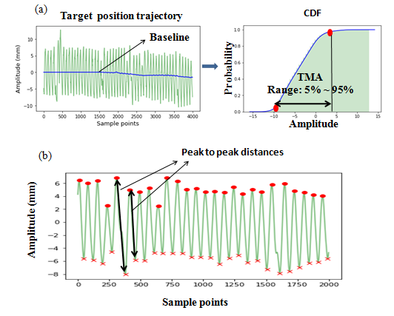
Figure S1. The schematic for calculating tumor motion amplitude from target position trajectory (a), and peak-to-peak distance (b).

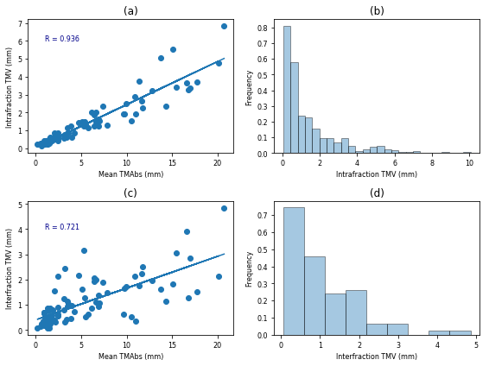
Figure S2. Relationship between the intra- and interfraction TMV and mean TMA_{bs} in the SI direction(a, c), and the histogram representation of the intra- and interfraction TMV_{bs} in the SI direction (b, d).

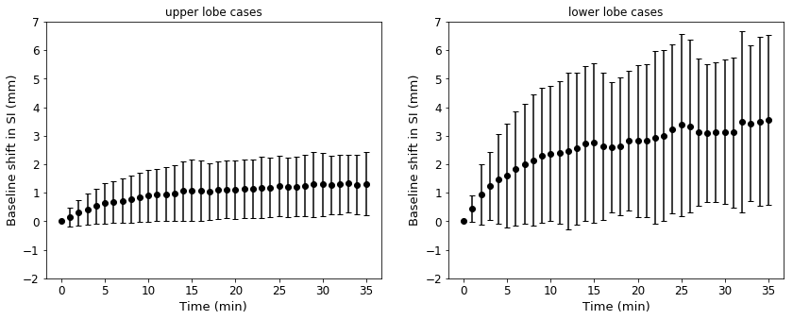
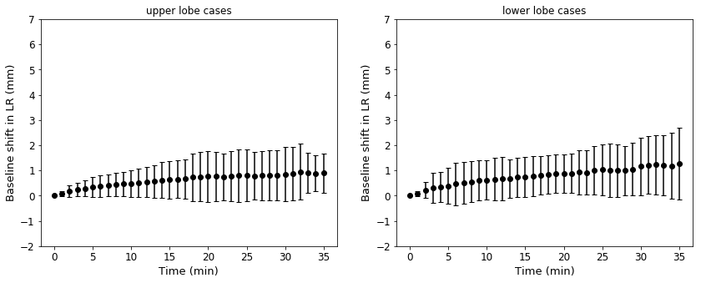
Figure S3. The baseline shifts in the SI, LR and AP directions as a function of time. The black points (and error bars) are the mean (and one standard deviation) baseline shifts over all fractions at the specific time.
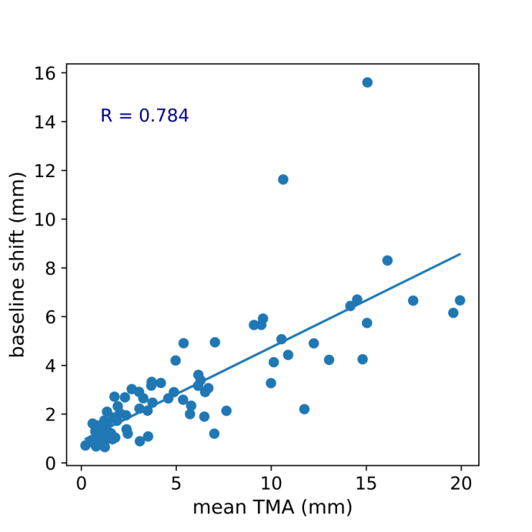
Figure S4. Relationship between the mean TMA and the baseline shift for the SI direction.

