SUPPLEMENTAL INFORMATION

Silica nanoparticles disrupt OPT-2/PEP-2-dependent trafficking of nutrient peptides in the intestinal epithelium.

Piechulek, A., Berwanger, L., and A. von Mikecz

IUF – Leibniz Research Institute of Environmental Medicine at Heinrich-Heine-University, 40225 Duesseldorf, Germany
Supplemental Table 1. Particle characterization. Hartlen, nano silica generated by Hartlen preparation; HTFH, high temperature flame hydrolysis; mV, millivolt; nm, Nanometer; Stoeber, nano silica generated by the Stoeber process; TEM, transmission electron microscopy.

Supplemental Figure 1. Titration of the ballooning phenotype in untreated, nano silica-treated (50 nm) or BULK silica-treated (500 nm) worms. Violin plots indicate quantification of the ballooning phenotype in wild type (N2) animals that were treated for 72 hours with increasing concentrations of particles (gray) compared to control worms (white). Data from 4 independent experiments with n = 20-29 per condition per experiment. **, p<0.01; μg, microgram; mL, milliliter; NPs, nanoparticles.

Supplemental Figure 2. Intestinal ballooning occurs in daf-2 mutants, daf-16 mutants, and in reporter worms for serotonergic and dopaminergic neurons. Violin plots indicate quantification of the ballooning phenotype in wild type N2 worms, daf-2(e1368), daf-2(e1370), daf-16(mu86) mutants, tph-1p::DsRed2 or dat-1p::GFP reporter worms treated for 72 hours with silica NPs (50 nm) or BULK silica (200 µg/ mL). Data from 3 independent experiments with n = 13-27 per condition per experiments. *, p<0.05; **, p<0.01; n.s., not significant; NPs, nanoparticles.

Supplemental Figure 3. Violin plots show quantification of intestinal ballooning in wild type (N2) animals exposed 72 hours to different silica particles (light grey), polystyrene particles (dark grey) and silver NPs compared to control worms (white). Data from 3 independent experiments with n = 20-30 per condition per experiment. *, p<0.05; μg, microgram; mL, milliliter.

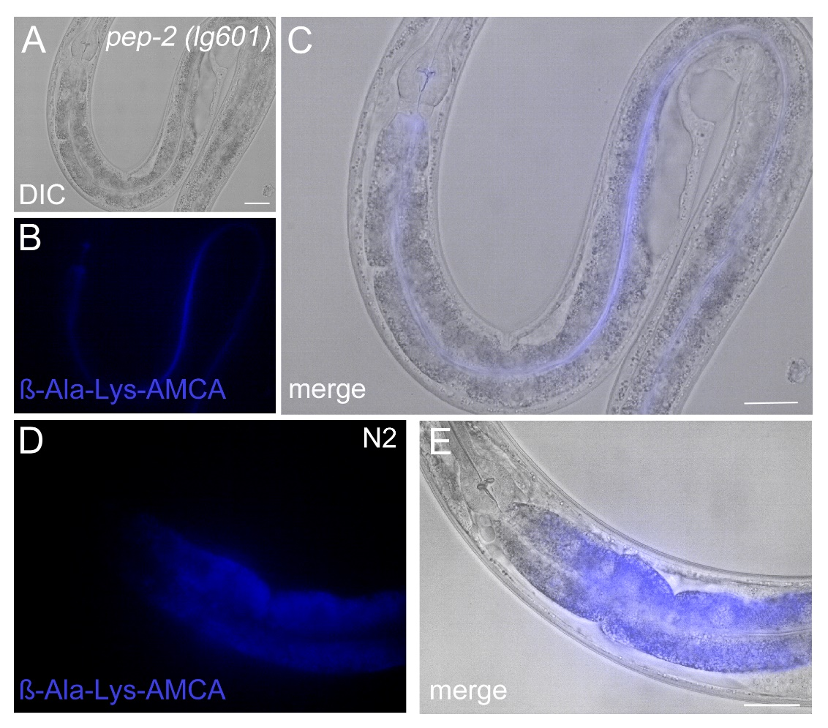

Supplemental Figure 4. Localization of fluorescent dipeptide derivate ß-Ala-Lys-AMCA in the gut lumen of pep-2 deletion mutants vs. wild type N2 worms. (A-C) Representative fluorescence micrographs of a L4 pep-2(lg601) larvae that was cultivated for 3-4 hours with the fluorescent dipeptide ß-Ala-Lys-AMCA (blue). Lack of the OPT-2/PEP-2 transporter prevents uptake of di- and tri-peptides into intestinal cells that remain in the gut lumen. (D,E) In N2 worms ß-Ala-Lys-AMCA penetrates intestinal epithelial cells and localizes diffusely throughout the cytoplasm. Nuclei lack staining and appear as dark round areas (D). Bars, 30 µm.

Supplemental Figure 5. Silica NPs induce formation of peptide vesicles. Representative differential interference contrast (DIC, left column) and fluorescent micrographs (right column) show the distribution of dipeptide ß-Ala-Lys-AMCA (blue) in intestinal cells of 4-day old, adult C. elegans that were treated for 72 hours with 200 µg/mL silica particles. From top to bottom: Mock-treated H₂O control, 50 nm nano silica (Stoeber synthesis), 500 nm BULK silica (Stoeber synthesis), 12 nm nano silica (HTFH synthesis, food-grade), 14 nm nano silica (HTFH synthesis), 20 nm nano silica (HTFH synthesis, food-grade), 25 nm nano silica (Hartlen synthesis) and 500-1000 nm BULK silica (HTFH synthesis). Bar, 30 µm.

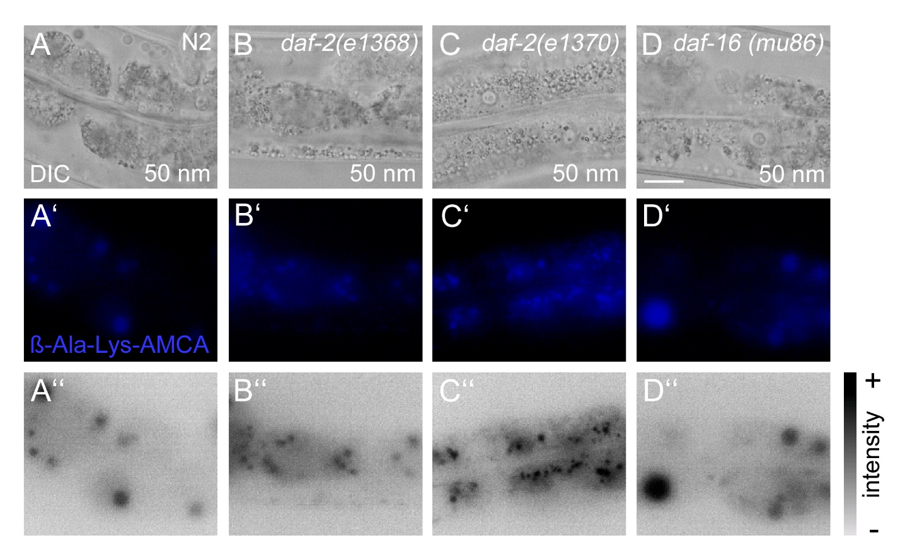
Supplemental Figure 6. Distribution of nano silica-induced peptide vesicles in intestinal epithelial cells. Worms were exposed with nano silica (50 nm, Stoeber) for 72 hours and cultivated with the fluorescent dipeptide derivate ß-Ala-Lys-AMCA for 3-4 hours at 20°C. Representative differential interference contrast (DIC, upper panel) and fluorescent micrographs of 4-day old, adult C. elegans show the localization of nano silica-induced ß-Ala-Lys-AMCA peptide vesicles. Fluorescence staining (middle panel, blue) and grey intensity map (bottom panel) with random distribution of large (A’,A’’,D’,D’’) or small (B’,B’’) peptide vesicles throughout the cytoplasm. In daf-2(e1370) mutants small peptide vesicles accumulate along the apical domain of the C. elegans gut (C’,C’’). Bar, 10 µm.

Supplemental Figure 7. Formation of peptide vesicles occurs independent of gut granule loss. Representative differential interference contrast (DIC, left column) and fluorescent micrographs (right column) of intestinal cells in 4-day old, adult C. elegans that were treated for 72 hours with 200 µg/ ml silica particles (50 nm, Stoeber). From top to bottom: Nano silica-induced ß-Ala-Lys-AMCA vesicles (blue) in wild type (N2) or glo-1(zu391), glo-3(kx94) and glo-3(zu446) mutants. Bar, 13 µm.

Supplemental Figure 8. Body length of untreated versus nano silica-treated C. elegans. (A) Representative differential interference contrast (DIC) of stretched adult wild type (N2) worms that were left untreated H₂O (mock control) or fed with silica particles (200 µg/ mL) for 72 hours at 20°C. From top to bottom: control worms (H₂O), 12 nm nano silica (HTFH), 25 nm nano silica (Hartlen), 50 nm nano silica (Stoeber), 14 nm nano silica (HTFH), 20 nm nano silica (HTFH), 500 nm BULK silica (Stoeber) and 500-1000 nm BULK silica (HTFH). Bar, 150 µm. (B) Quantification of (A). Data from 3 independent experiments with n = 20 per condition per experiment. **, p<0.01; HTFH, high temperature flame hydrolysis; nm, nanometer; NPs, nanoparticles; n.s., not significant. Data was normalized to the body length of untreated worms (H₂O mock control; 100% standard).

