Supplementary Figures

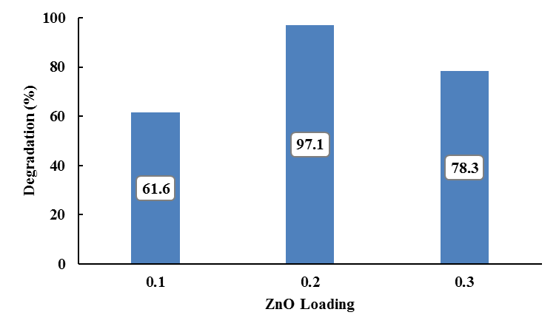
Fig. S1. Effect of different ZnO loading in ZnO/MIL-101(Fe)[A] on the photocatalytic degradation of RhB dye under visible light irradiation (C˳: 10 mg/L, catalyst dose: 0.5 g/L, pH = 8, and Time 300 min.).

Fig. S2. TGA curves of the solvent; N,N-dimethyl formamide (DMF); and terephthalic acid (TPA).

