Antiproliferative activities of 2-hydroxyethyl substituted benzimidazolium salts and their palladium complexes against human cancerous cell lines

Senem Akkoç^{a*}

ª Faculty of Pharmacy, Department of Basic Pharmaceutical Sciences, Suleyman Demirel University, 32260, Isparta/Turkey

Characterization of compounds

1-(2-Hydroxyethyl)-3-(2,3,4,5,6-pentamethylbenzyl)-1H-benzo[d]imidazol-3-ium bromide, 1b
A similar compound namely 1-pentamethylbenzyl-3-hydroxyethylbenzimidazolium iodide was prepared by Akkoç et al. [1]. However, in this study, the objective compound 1b was synthesized from 1-(2,3,4,5,6-pentamethylbenzyl)-1H-benzo[d]imidazole (0.70 g, 1 mmol) and 2-hydroxyethylbromide (0.32 g, 1 mmol). The yellow colored compound was initially washed with diethyl ether. Yield: 57%, m.p.: 194-196 ºC, color: yellow. IR: 1193.8 (C-O); 1550.7 (C=N); 2867.9, 2920.0 and 3006.8 (C-H); 3211.2 cm⁻¹ (OH). ¹H NMR (400 MHz, CDCl₃, 298 K), δ: 2.15-2.31 [m, 16 H, NCH₂CH₂OH; NCH₂C₆(CH₃)₅-2,3,4,5,6]; 4.04 (t, 2 H, NCH₂CH₂OH); 4.75 (t, 2 H, NCH₂CH₂OH); 5.70 [s, 2 H, NCH₂C₆(CH₃)₅-2,3,4,5,6]; 7.28-8.02 (m, 4 H, Ar-H); 9.77 (s, 1 H, NCHN). ¹³C NMR (100 MHz, CDCl₃, 298 K), δ: 16.90, 17.02, 17.14, 17.31 and 34.64 [NCH₂C₆(CH₃)₅-2,3,4,5,6]; 47.51, 49.86 and 58.88 [NCH₂CH₂OH and NCH₂C₆(CH₃)₅-2,3,4,5,6]; 113.20, 113.59, 124.41, 127.27, 127.35, 131.55, 131.95, 133.68, 134.19 and 137.66 (Ar-C); 141.34 (NCHN). Elemental analysis for C₂₁H₂₇N₂OBr (403.36 g/mol) %: Found C: 62.37; H: 6.99; N: 6.92. Anal. Calc. C: 62.53; H: 6.75; N: 6.95.

Dibromo-[1-(2-hydroxyethyl)-3-(2,3,4,5,6-pentamethylbenzyl)benzimidazol-2-ylidene]-N-(3-chloropyridine) palladium (II) complex, 2b
Following a similar procedure to that of mentioned in the section of compound 2a, compound 2b was synthesized from 1-(2-hydroxyethyl)-3-(2,3,4,5,6-pentamethylbenzyl)-1H-benzo[d]imidazol-3-ium bromide 1b (1 mmol), PdCl₂ (1 mmol), 3-chloropyridine (3 mL) and K₂CO₃ (5 mmol) as a base. Yield: 21%, m.p.: 174-175 ºC, color: light yellow. IR: 1255.6 (C-O); 1456.2 (C=N); 2964.4 and 3014.5 (C-H); 3473.6 cm⁻¹ (OH). ¹H NMR (600 MHz, CDCl₃, 298 K), δ: 2.21-2.28 [m, 16 H, NCH₂CH₂OH; NCH₂C₆(CH₃)₅-2,3,4,5,6]; 3.40 (t, J: 7.2 Hz, 2 H, NCH₂CH₂OH); 4.43 (t, J: 5.4 Hz, 2 H, NCH₂CH₂OH); 6.04 [s, 2 H, NCH₂C₆(CH₃)₅-2,3,4,5,6]; 6.89-8.88 (m, 8 H, Ar-H). ¹³C NMR (100 MHz, CDCl₃, 298 K), δ: 14.14, 16.95 and 17.71 [NCH₂C₆(CH₃)₅-2,3,4,5,6]; 51.87, 61.18 and 65.87 [NCH₂CH₂OH and NCH₂C₆(CH₃)₅-2,3,4,5,6]; 110.56, 111.58, 122.86, 123.29, 124.92, 127.58, 132.66, 133.26, 134.76, 135.05, 135.44, 136.20, 138.09, 149.92, 150.47, 150.95 and 151.48 (Ar-C); 161.13 (NCN). Elemental analysis for C₂₆H₃₀Br₂ClN₃OPd (702.22 g/mol) %: Found C: 44.40; H: 4.46; N: 5.99. Anal. Calc. C: 44.47; H: 4.31; N: 5.98.

Spectra of synthesized compounds
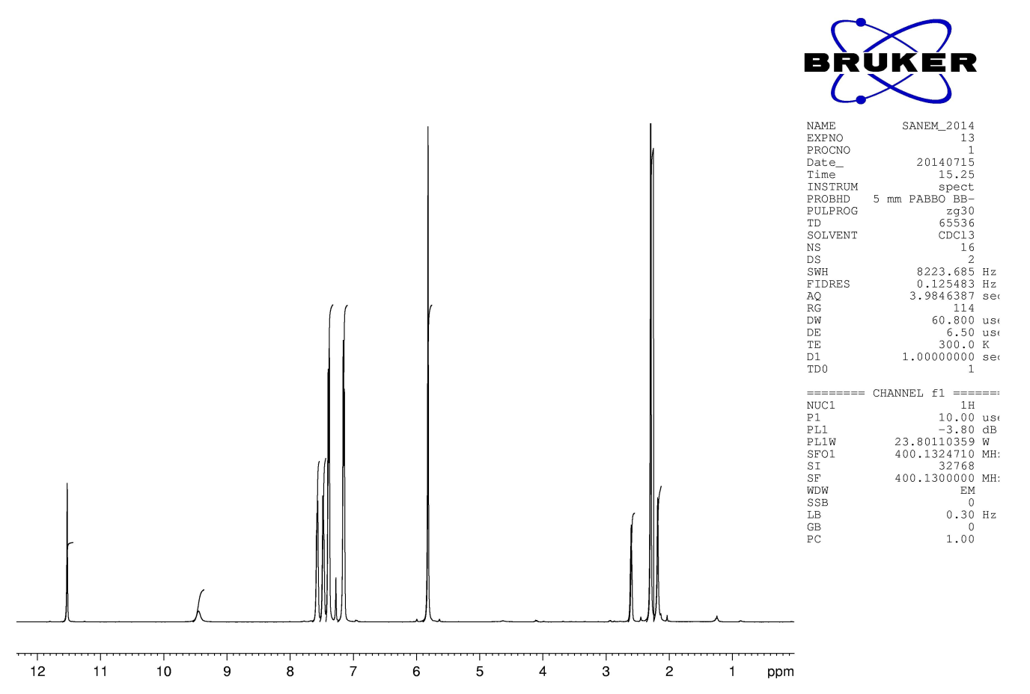
Scheme 1. ¹H NMR spectra of compound 1a.
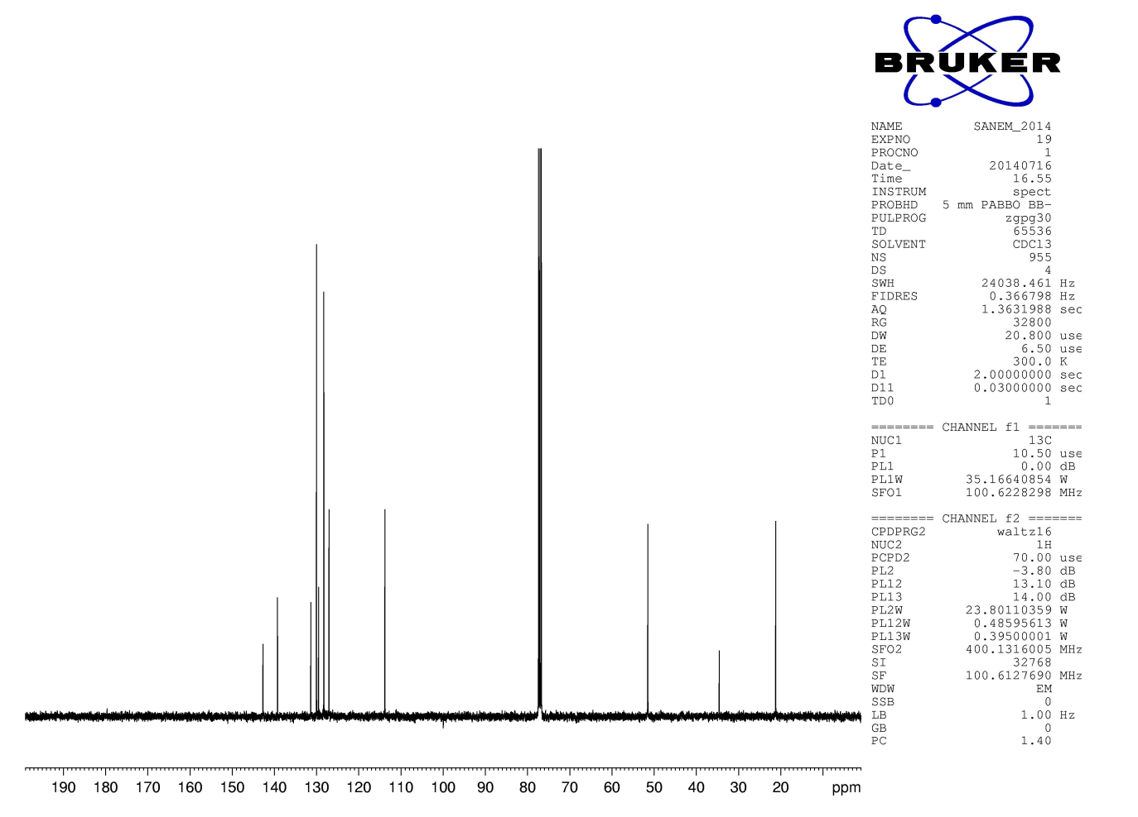
Scheme 2. ¹³C NMR spectra of compound 1a.
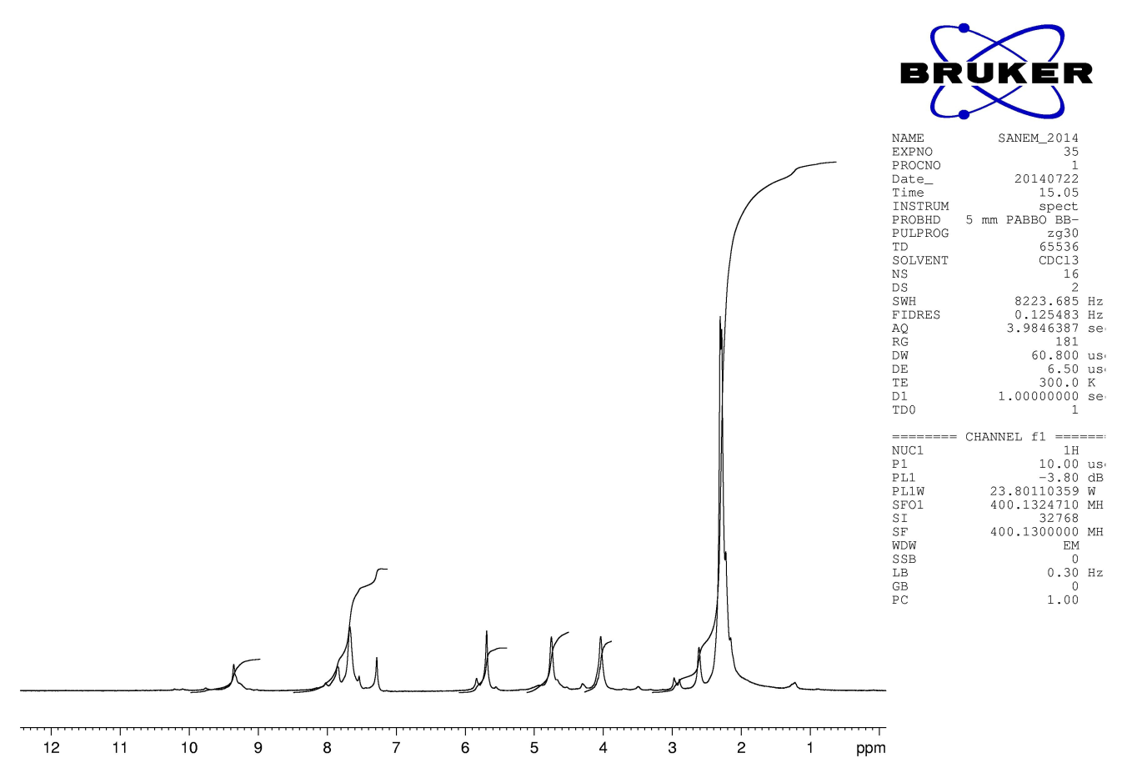
Scheme 3. ¹H NMR spectra of compound 1b.
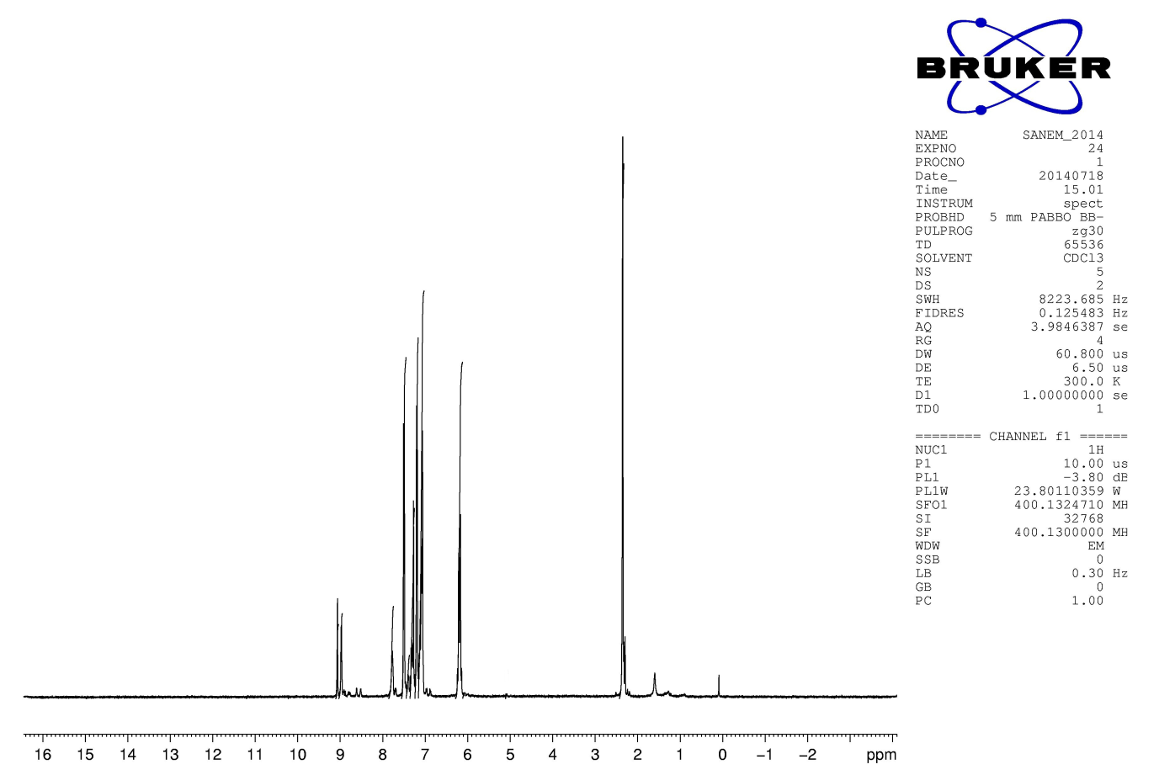
Scheme 4. ¹H NMR spectra of compound 2a.
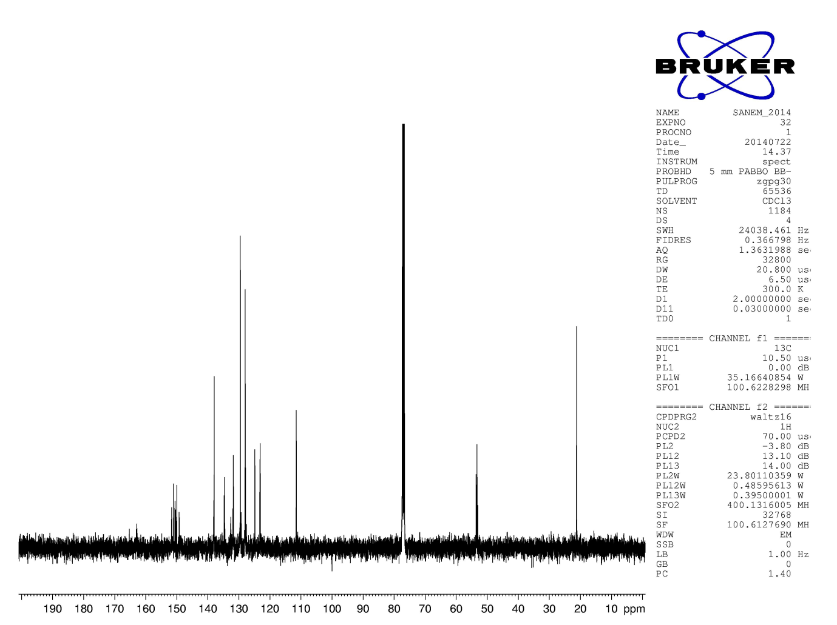
Scheme 5. ¹³C NMR spectra of compound 2a.
Scheme 6. HRMS spectra of 2a.

Scheme 7. HRMS spectra of 2a.

Scheme 8. HRMS spectra of 2a.

Scheme 9. HRMS spectra of 2a.

Reference
[1] Akkoç, M.; Öz, E.; Demirel, S.; Dorcet, V.; Roisnel, T.; Bayri, A.; et al. Investigation of potential hybrid capacitor property of chelated N-Heterocyclic carbene Ruthenium(II) complex. J. Organomet. Chem. 2018, 866, 214-22. DOI: https://doi.org/10.1016/j.jorganchem.2018.04.035

