SUPPORTING INFORMATION

Silver-Catalyzed Decarboxylative Homo-coupling reaction to Form Symmetrical Difluoromethylated Derivatives

Contents

1. General Information. 3
2. General Procedure for the Synthesis of homodimeric products 3
3. Optimization of the Reaction Condition 4
4. Preliminary Mechanistic Study 6
5. Characterization of the products 7
6. Copies of ¹H NMR, ¹⁹F NMR, ¹³C NMR spectra of the products 12

- General Information:
¹H, ¹³C and ¹⁹F NMR spectra were recorded in CDCl₃ on a Bruker AV-500 spectrometer. Chemical shifts for ^{l}H NMR spectra are reported in ppm relative to residual CHCl₃ as internal reference (δ 7.26 ppm for ¹H) downfield from TMS, chemical shifts for ¹³C NMR spectra are reported in ppm relative to internal CDCl₃ (δ 77.16 ppm for ¹³C), and chemical shifts for ¹⁹F NMR spectra are reported in ppmdownfield from internal fluorotrichloromethane (CFCl₃). Coupling constants (J) are given in Hertz (Hz). The terms m, s, d, t, q refer to multiplet, singlet, doublet, triplet, quartet, respectively; br refers to a broad signal. High resolution mass spectra (HRMS) and Mass spectra (MS) were recorded using an Electron impact (EI) or Electrospray ionization (ESI) techniques. High resolution mass spectra (HRMS) was recorded on Agilent G6500 iFunnel Q-TOF LC/MS.

- General Procedure for the Synthesis of difluoromethylated derivatives
A mixture of Aryldifluoroacetates (0.60 mmol), AgNO₃ (0.3 mmol), and (NH₄)S₂O₈ (1.2 mmol) and KHCO₃ (0.3 mmol) was added to in 3.0 mL of DMSO under N₂ atmosphere. The solution was stirred at 120ºC for 2 h. Then the reaction mixture was extracted with ethyl acetate and water. The combined organic layer was dried over Na₂SO₄, filtered and concentrated. The residue was purified by flash column chromatography on silica gel to give the desired difluoromethylated derivatives (2a-2m).

- Optimization of the Reaction Conditions
Table S1. Optimization varying different oxidant
Entry Oxidant Yield(%)
1 K₂S₂O₈ 34
2 (NH₄)₂S₂O₈ 68
3 Na₂S₂O₈ 42
4 PhI(OAC)₂ 31
Determined by ¹⁹F NMR spectroscopy using PhCF3 as an internal standard, in the presence of 1a (0.6mmol), AgNO3 (0.3 mmol), KHCO₃ (0.3 mmol), with different oxidant (1.2 mmol), 2h, N₂ atmosphere at 120ºC temperature.
Conclusion: initially we carried out the optimization reactions with 1a, giving maximum ¹⁹F-NMR from (NH₄)₂S₂O₈.

Table S2. Optimization varying different base

Entry Base Yield(%)
1 K₂CO₃ 40
2 KOH 38
3 Cs₂CO₃ 36
4 KHCO₃ 68
5 NA 28
Determined by ¹⁹F NMR spectroscopy using PhCF3 as an internal standard, in the presence of 1a (0.6mmol), AgNO3 (0.3 mmol), (NH₄)₂S₂O₈ (1.2 mmol), with different Base, 2h, N2 atmosphere at 120ºC temperature
Conclusion: initially we found that KHCO₃ gave best result.

Table S3. Optimization varying different catalyst
Entry Catalyst Yield(%)
1 AgNO₃ 68
2 Ag₂CO₃ 30
3 AgBF₄ 43
4 AgOA_{C} 34
5 Ag(CF₃SO₃) 36
6 Cu(I), or Cu(II),or Cu( III) NA
Determined by ¹⁹F NMR spectroscopy using PhCF3 as an internal standard, in the presence of 1a (0.6mmol), (NH₄)₂S₂O₈ (1.2 mmol),KHCO3 (0.3mmol) with different catalyst, 2h, N2 atmosphere at 120ºC temperature.
Conclusion: initially we found that Combination of AgNO3 gave best result.

Table S4. Optimization varying different equivalent of catalyst
Entry Catalys(eq) Yield(%)
1 AgNO₃(0.3eq) 41
2 AgNO₃(0.5eq) 68
3 AgNO₃(1eq) 26
4 AgNO₃(2eq) 23
Determined by ¹⁹F NMR spectroscopy using PhCF₃ as an internal standard, in the presence of 1a (0.6 mmol), (NH₄)₂S₂O₈ (1.2 mmol),KHCO₃ (0.3mmol) with different equiv catalyst, 2h, N2 atmosphere at 120ºC.
Conclusion: we found that Combination of 0.5 equiv. of AgNO₃ gave best result.

Table S5. Optimization varying different time.
Entry 1Time(h) Yield(%)
1 12 9
2 6 40
3 4 51
4 2 68
5 1 33
6 1/3 31
Determined by ¹⁹F NMR spectroscopy using PhCF3 as an internal standard, in the presence of 1a (0.6 mmol), (NH₄)₂S₂O₈ (1.2 mmol),KHCO₃ (0.3mmol) with different time,, N2 atmosphere at 120ºC.
Conclusion: we found that 2h gave best result.

- Mechanistic Study
  - Primary Mechanistic Study.
Entry Additive Yield(%)
1 1.0 equiv 1,4-dinitrobenzene 57
2 1.0 equiv hydroquinone 63
3 1.0 equiv TEMPO 4
4 2.0 equiv TEMPO 0
ªReaction condition:1a (0.6 mmol), AgNO₃ (0.3mmol), and (NH₄)S₂O₈(1.2mmol), KHCO₃ (0.3mmol) under N₂ at 120ºC for 2h. ^{b}Yields determined by ¹⁹F NMR analysis with PhCF₃ as the internal stander.
A mixture of aryldifluoroacetate (0.60mmol), AgNO₃ (0.3mmol), and (NH₄)S₂O₈(1.2mmol), KHCO₃ (0.3mmol) and TEMPO (0.6mmol) or (1.2mmol) in 3.0mL of DMSO under N₂ atmosphere. The solution was stirred at 120ºC for 2 h. When 1.0 equiv TEMPO was added, the reaction yield decreased to 4%. When 2.0 equiv TEMPO was added, no product was observed, The reaction was completely suppressed, but unfortunately we did not capture TEMPO-CF₂Ph, probably because this species is unstable at high temperatures.

  - Study on defluoro homocoupling reaction

- Characterization of the products
1,2-Bis(4-methoxyphenyl)-1,1,2,2-tetrafluoroethane (2a)
White solid, m.p. 201-203°C, 65% yield. ¹H NMR (CDCl₃) δ: 7.34 (d, J=8.8 Hz, 4H), 6.90 (d, J=8.8 Hz, 4H), 3.86 (s, 6H). ¹⁹F NMR (CDCl₃) δ: -110.96 (s, CF₂). ¹³C NMR ((CD₃)₂SO): low solubility, only four kinds of carbons were observed δ: 161.9, 128.6 (m), 114.4, 55.9. IR (KBr, cm⁻¹): ν_{max} = 3031, 2969, 1614, 1514, 1251, 1090, 828, 783. HRMS (EI): calcd for C₁₆H₁₄F₄O₂ (M⁺) 314.0924; found 314.0926.
1,2-Bis(4-methylphenyl)-1,1,2,2-tetrafluoroethane (2b)
White solid, mp 137-140°C, 53% yield. ¹H NMR (CDCl₃) δ: 7.33 (d, J=8.3 Hz, 4H), 7.21 (d, J=8.1 Hz, 4H), 2.39 (s, 6H). ¹⁹F NMR (CDCl₃) δ: -111.36 (s, 2CF₂). ¹³C NMR (CDCl₃) δ: 141.0, 128.8, 128.1-128.3 (m), 126.9 (m), 116.8 (tt, ¹J_{CF}=250.7 Hz, ²J_{CF}=36.4 Hz), 21.4. IR (KBr, cm⁻¹): ν_{max} = 3029, 2927, 1612, 1510, 1257, 1088, 866, 768. MS (EI) m/z: 282 (M⁺, 10%), 141 (100), 101 (7), 91 (14). HRMS (EI): calcd for C₁₆H₁₄F₄ (M⁺) 282.1026; found 282.1029
1,2-bis(4-fluorophenyl)-1,1,2,2-tetrafluoroethane (2c)
White solid, mp 163-166 °C, 21% yield. ¹H NMR (CDCl₃) δ: 7.46 (s, 8H), 1.35 (s, 18H), ¹⁹F NMR (CDCl₃) δ: -110.5 (s, 4F, CF₂). ¹³C NMR (CDCl₃) δ: 154.1, 128.1 (t, ²J_{CF}=25.0 Hz), 126.8 (m), 125.1, 116.8 (tt, ¹J_{CF}=250.7 Hz, ²J_{CF}=37.7 Hz), 34.8, 31.2. IR (KBr, cm⁻¹): ν_{max} = 3063, 2959, 1614, 1514, 1262, 1084, 862, 820. HRMS (EI) calcd for C₂₂H₂₆F₄ (M⁺) 366.1965; found 366.1967.
1,2-Bis(4-fluorophenyl)-1,1,2,2-tetrafluoroethane (2d)
White solid, mp 99-100 °C, 40% yield. ¹H NMR (CDCl₃) δ: 7.44-7.46 (m, 4H), 7.11 (t, J=8.5 Hz, 4H). ¹⁹F NMR (CDCl₃) δ: -108.9 (s, 2F, Ar–F), -111.09 (s, 4F, CF₂). ¹³C NMR (CDCl₃) δ: 164.4 (d, ¹J_{CF}=249.8 Hz), 129.2 (m), 126.7 (t, ²J_{CF}=27.1 Hz), 116.3 (tt, ¹J_{CF}=251.7 Hz, ²J_{CF}=36.6 Hz), 115.4 (d, ²J_{CF}=21.9 Hz). IR (KBr, cm⁻¹): ν_{max} = 3076, 1606, 1513, 1243, 1086, 832, 794. MS (EI) m/z: 290 (M⁺, 5%), 145 (100), 125 (3), 95 (10), 75 (6). HRMS (EI) calcd for C₁₄H₈F₆ (M⁺) 290.0525; found 290.0528.
1,2-Bis(4-chlorophenyl)-1,1,2,2-tetrafluoroethane (2e)
White solid, mp. 93-94 °C, 26% yield. ¹H NMR (CDCl₃) δ: 7.38-7.43 (m, 8H). ¹⁹F NMR (CDCl₃) δ: -111.63 (s, CF₂). ¹³C NMR (CDCl₃) δ: 137.6, 129.0 (t, ²J_{CF}=25.5 Hz), 128.6, 128.4 (m), 116.2 (tt, ¹J_{CF}=252.2 Hz, ²J_{CF}=36.4 Hz). IR (KBr, cm⁻¹): ν_{max} = 3097, 1596, 1488, 1253, 1090, 887, 813. HRMS (EI) calcd for C₁₄H₈Cl₂F₄ (M⁺) 321.9934; found 321.9935.
1,2-bis(4-bromophenyl)-1,1,2,2-tetrafluoroethane (2g)
White solid, mp. 98-100 °C, 38% yield. ¹H NMR (CDCl₃) δ: 7.58 (d, J=8.6 Hz, 4H), 7.11 (d, J=8.5 Hz, 4H). ¹⁹F NMR (CDCl₃) δ: -116.77 (s, CF₂). ¹³C NMR (CDCl₃) δ: 131.6, 129.5 (t, ²J_{CF}=25.9 Hz), 128.6 (m), 125.9, 116.2 (tt, ¹J_{CF}=252.3 Hz, ²J_{CF}=36.5 Hz). IR (KBr, cm⁻¹): ν_{max} = 3099, 1587, 1483, 1254, 1082, 881, 803. HRMS (EI) calcd for C₁₄H₈Br₂F₄ (M⁺) 409.8923; found 409.8924.
1,1,2,2-Tetrafluoro-1,2-diphenylethane (2h)
White solid, mp. 125-127 °C, 48% yield. ¹H NMR (CDCl₃) δ: 7.40-7.51 (m, 10H). ¹⁹F NMR (CDCl₃) δ: -111.84 (s, 4F, CF₂). ¹³C NMR (CDCl₃) δ: 130.9, 130.9 (t, ²J_{CF}=26.4 Hz), 128.1, 126.9 (m), 116.6 (tt, ¹J_{CF}=254.9 Hz, ²J_{CF}=36.3 Hz). IR (KBr, cm⁻¹): ν_{max} = 3073, 1606, 1494, 1253, 1074, 876, 753. MS (EI) m/z: 254 (M⁺, 10%), 127 (100), 77 (15), 51 (5). HRMS (EI) calcd for C₁₄H₁₀F₄ (M⁺) 254.0713; found 254.0716.
1,1,2,2-tetrafluoro-1,2-di-o-tolylethane (2i)
White solid, mp. 55-58°C, 34% yield. ¹H NMR (CDCl₃) δ: 7.35-7.37 (m, 4H), 7.19-7.23 (m, 4H), 2.31 (s, 6H), ¹⁹F NMR (CDCl₃) δ: -106.7 (s, 4F, CF₂). ¹³C NMR (CDCl₃) δ: 137.9, 132.1, 130.8, 128.8 (m), 129.0 (t, ²J_{CF}=22.0 Hz), 125.4, 118.7 (tt, ¹J_{CF}=253.4 Hz, ²J_{CF}=36.6 Hz), 20.4 (m). IR (KBr, cm⁻¹): ν_{max} = 3053, 2925, 1603, 1498, 1252, 1064, 884, 758. HRMS (EI) calcd for C₁₆H₁₄F₄ (M⁺) 282.1026; found 282.1027.
1,1,2,2-tetrafluoro-1,2-bis(2-methoxyphenyl)ethane (2j)
Pale yellow solid, mp. 77-80 °C, 30% yield. ¹H NMR (CDCl₃) δ: 7.37-7.42 (m, 4H), 6.93-6.96 (m, 2H), 6.88 (d, J=8.2 Hz, 2H), 3.58 (s, 6H). ¹⁹F NMR (CDCl₃) δ: -108.8 (s, 4F, CF₂). ¹³C NMR (CDCl₃) δ: 158.2, 132.3, 129.4 (m), 119.8, 119.7 (t, ²J_{CF}=23.3 Hz), 117.3 (tt, ¹J_{CF}=255.2 Hz, ²J_{CF}=35.4 Hz), 111.8, 55.6. IR (KBr, cm⁻¹): ν_{max} = 3044, 2979, 1614, 1508, 1247, 1081, 821, 757. HRMS (EI) calcd for C₁₆H₁₄F₄O₂ (M⁺) 314.0924; found 314.0923.
1,2-bis(3,4-dimethylphenyl)-1,1,2,2-tetrafluoroethane (2k)
White solid, mp 152-155 °C, 46% yield. ¹H NMR (CDCl₃) δ: 7.27 (t, J=8.6 Hz, 2H), 7.12 (t, J=7.7 Hz, 1H), 2.31 (s, 3H), 2.24 (s, 3H). ¹⁹F NMR (CDCl₃) δ: -103.9 (s, 4F, CF₂). ¹³C NMR (CDCl₃) δ: 138.3, 136.6, 132.5, 129.2 (t, ²J_{CF}=24.6 Hz), 126.7 (m), 118.9 (tt, ¹J_{CF}=253.1 Hz, ²J_{CF}=37.4 Hz), 20.9, 16.1. IR (KBr, cm⁻¹): ν_{max} = 3035, 2979, 1614, 1510, 1253, 1085, 802, 757. HRMS (EI) calcd for C₁₈H₁₈F₄ (M⁺) 310.1339; found 310.1341.
1,1,2,2-tetrafluoro-1,2-dimesitylethane (2l)
White solid, mp 103-106 °C, 85% yield. ¹H NMR (CDCl₃) δ: 6.86 (s, 4H), 2.27-2.30 (m, 18H), ¹⁹F NMR (CDCl₃) δ: -100.3 (s, 4F, CF₂). ¹³C NMR (CDCl₃) δ: 140.1, 139.3 (m), 131.5, 125.1 (t, ²J_{CF}=21.1 Hz), 121.0 (tt, ¹J_{CF}=255.3 Hz, ²J_{CF}=38.3 Hz), 22.2, 20.8. IR (KBr, cm⁻¹): ν_{max} = 3052, 2969, 1610, 1507, 1232, 1071, 848. HRMS (EI) calcd for C₂₀H₂₂F₄ (M⁺) 338.1652; found 338.1651.
1,1,2,2-tetrafluoro-1,2-di(naphthalen-2-yl)ethane (2m)
White solid, mp 153-156 °C, 32% yield). ¹H NMR (CDCl₃) δ: 8.20 (d, J=8.2 Hz, 1H), 7.95 (d, J=8.2 Hz, 1H), 7.85-7.87 (m, 1H), 7.57-7.59 (m, 1H), 7.43-7.50 (m, 2H), 7.38-7.41 (m, 1H), ¹⁹F NMR (CDCl₃) δ: -103.9 (s, 4F, CF₂). ¹³C NMR (CDCl₃) δ: 133.9, 132.4, 130.6, 128.7, 127.9 (m), 126.9, 126.7 (t, ²J_{CF}=22.2 Hz), 125.9, 125.3 (m), 124.1, 119.2 (tt, ¹J_{CF}=254.4 Hz, ²J_{CF}=36.6 Hz). IR (KBr, cm⁻¹): ν_{max} = 3050, 2921, 1594, 1511, 1141, 1071, 887, 776. HRMS (EI) calcd for C₂₂H₁₄F₄ (M⁺) 354.1026; found 354.1029.
thiophene-2-carboxylic acid (3n)
Yellowish solid, mp. 125-129 °C, 70% yield). ¹H NMR (CDCl₃) δ: 7.89-7.90 (m, 1H), 7.64-7.65 (m, 1H), 7.14-7.15 (m, 1H). ¹³C NMR (CDCl₃) δ: 167.8, 135.0, 134.0, 133.0, 128.1. IR (KBr, cm⁻¹): ν_{max} = 3084, 1652, 1403, 1243, 1114, 1037, 809, 702. MS (EI) m/z: 128 (M⁺, 74%), 111 (100), 45 (12), 57 (10).
2,4-dimethoxybenzoic acid (3o)
Yellowish solid, mp 105-107 °C, 60% yield. ¹H NMR (CDCl₃) δ: 8.12 (d, J=8.8 Hz, 1H), 6.62-6.65 (m, 1H), 6.52 (d, J=2.3 Hz, 1H), 4.03 (s, 3H), 3.87 (s, 3H). ¹³C NMR (CDCl₃) δ: 165.5, 165.2, 135.5, 110.4, 106.5, 98.6, 56.6, 55.8. IR (KBr, cm⁻¹): ν_{max} = 2978, 2842, 1646, 1615, 1272, 1064, 836, 778. MS (EI) m/z: 182 (M⁺, 94%), 135 (100),165 (74), 153 (39).
1,2-bis(2,4-dimethoxyphenyl)ethane-1,2-dione (4o)
Pale yellow solid, mp 195-197 °C, 31% yield. ¹H NMR (CDCl₃) δ: 8.04 (d, J=8.8 Hz, 1H), 6.62-6.64 (m, 1H), 6.40 (d, J=2.3 Hz, 1H), 3.87 (s, 3H), 3.58 (s, 3H). ¹³C NMR (CDCl₃) δ: 192.0, 165.9, 162.1, 117.0, 106.5, 98.5, 55.8, 55.6. IR (KBr, cm⁻¹): ν_{max} = 3075, 2971, 1679, 1618, 1478, 736. MS (ESI) m/z: 330 (M⁺, 2%), 165 (100), 166 (10), 122 (6).

- Copies of ¹H NMR, ¹⁹F NMR, ¹³C NMR spectra of 2a-2m
¹H NMR Spectra of 2a
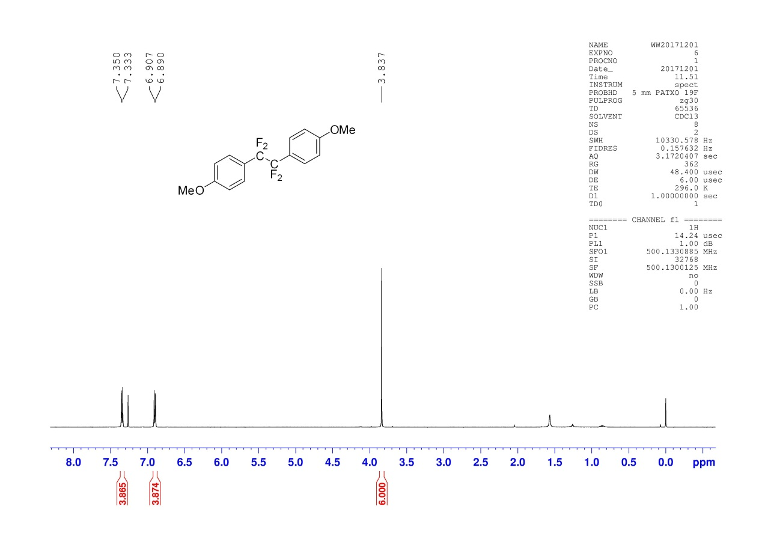
¹³C NMR Spectra of 2a
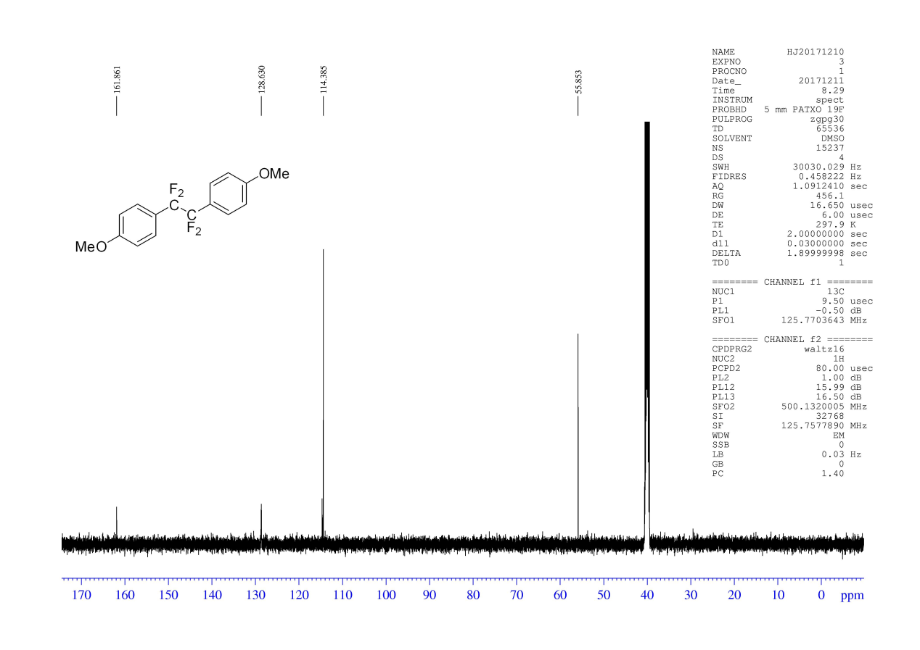
¹⁹F NMR Spectra of 2a
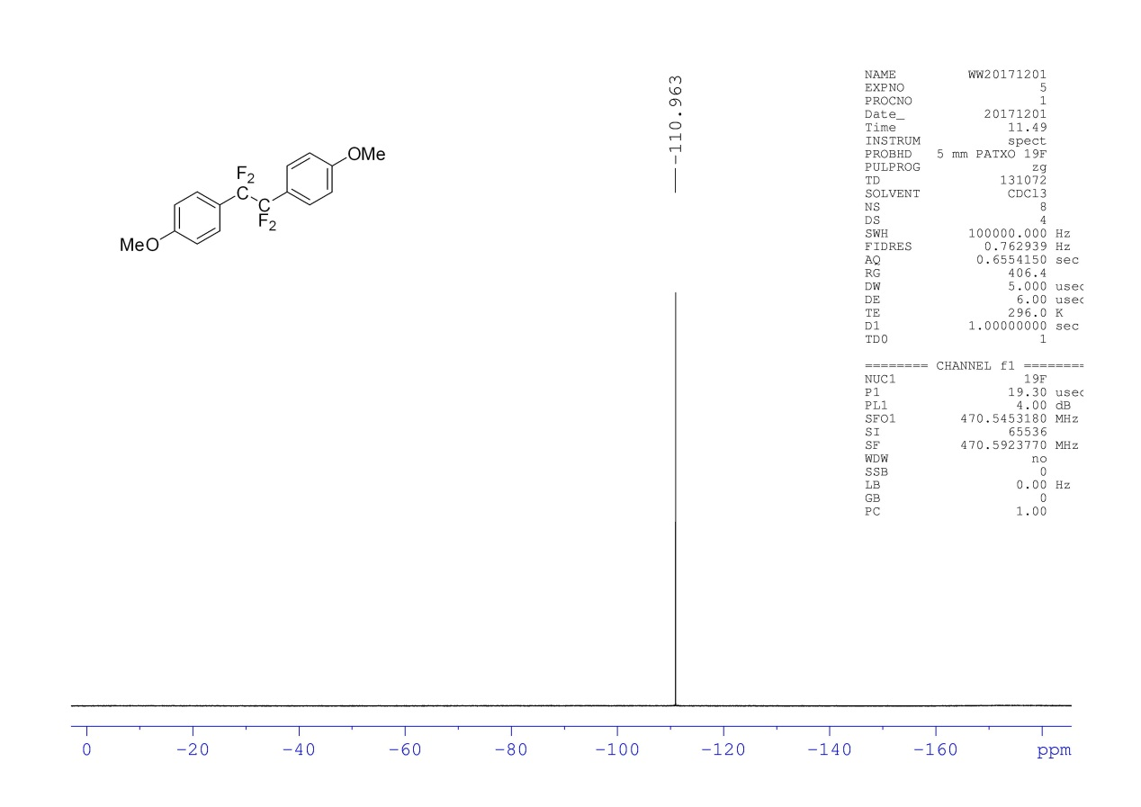
¹H NMR Spectra of 2b
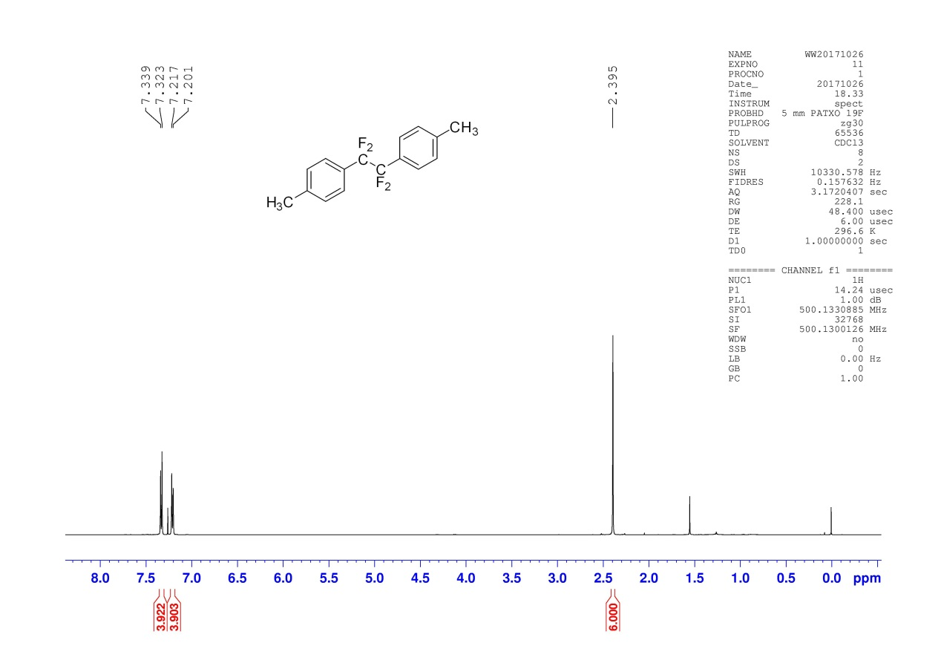
¹³C NMR Spectra of 2b
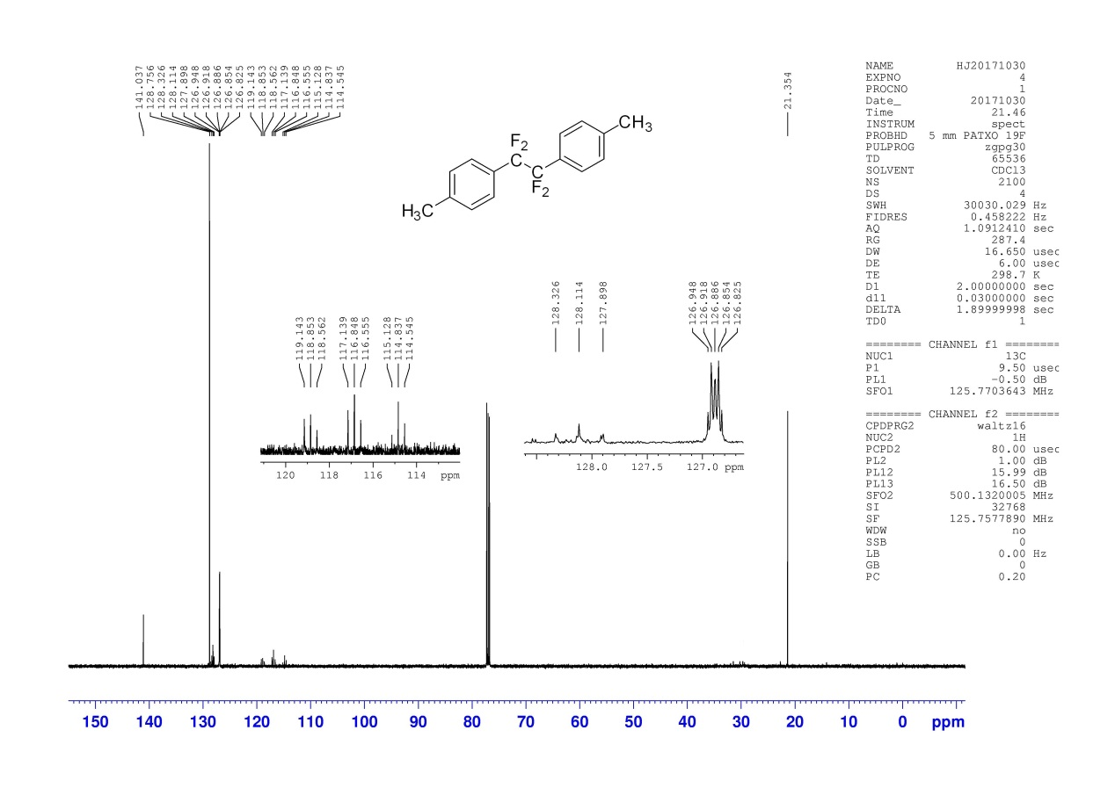
¹⁹F NMR Spectra of 2b
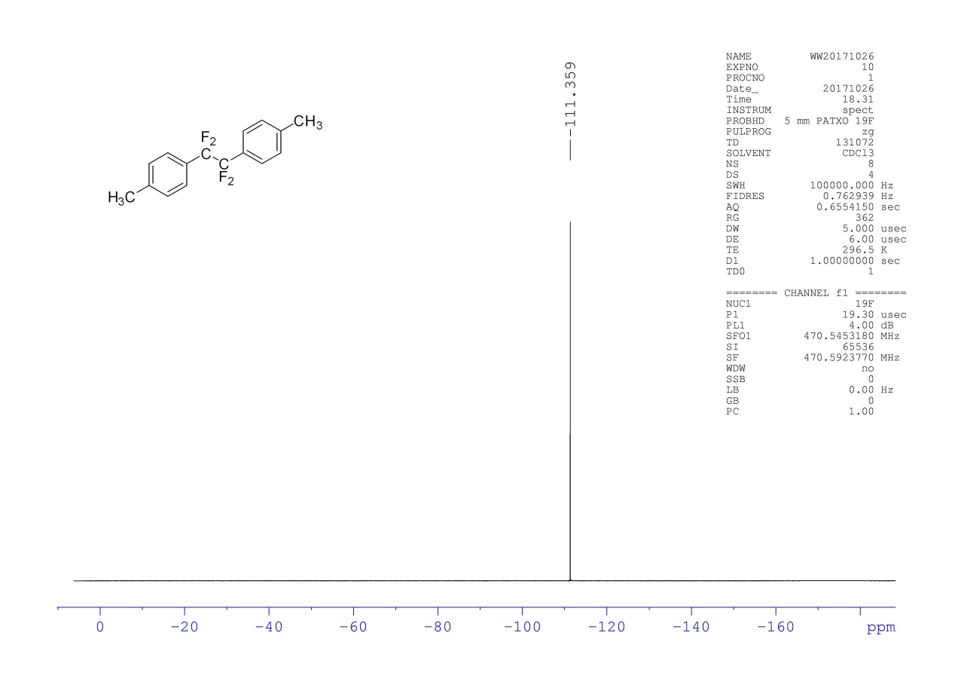
¹H NMR Spectra of 2c
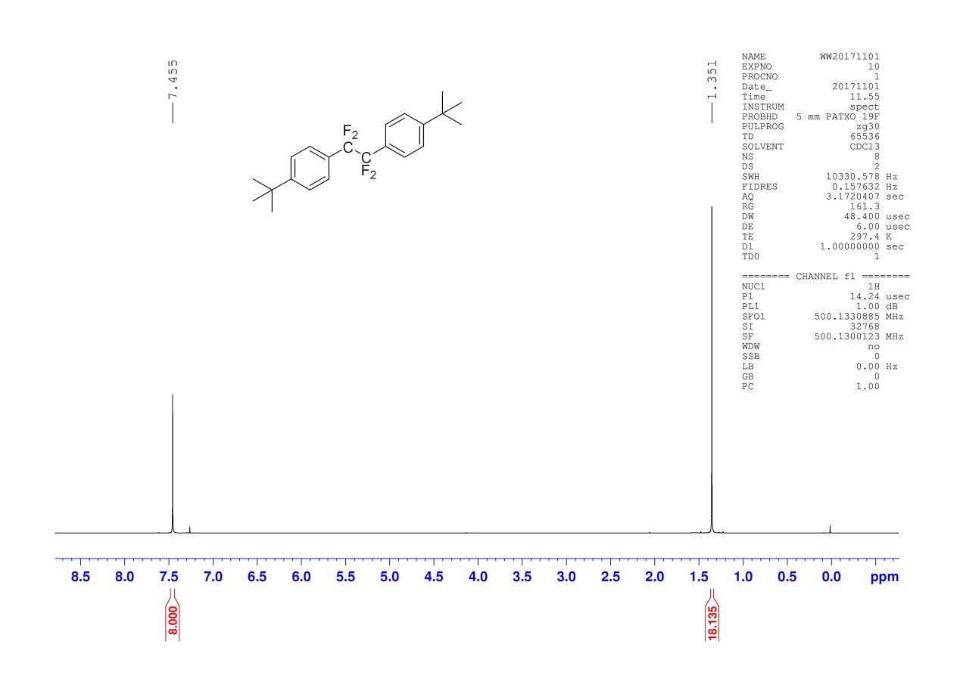
¹³C NMR Spectra of 2c
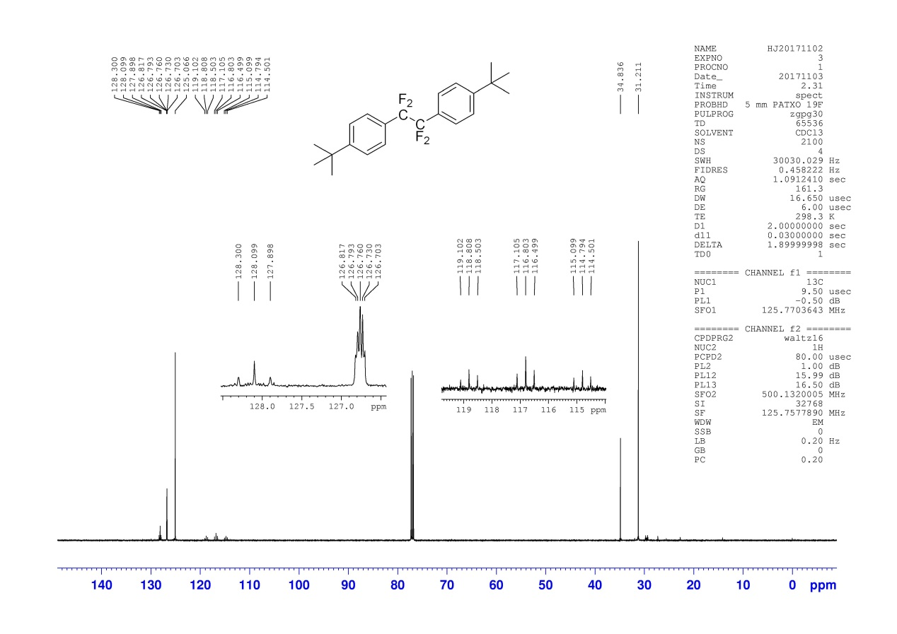
¹⁹F NMR Spectra of 2c
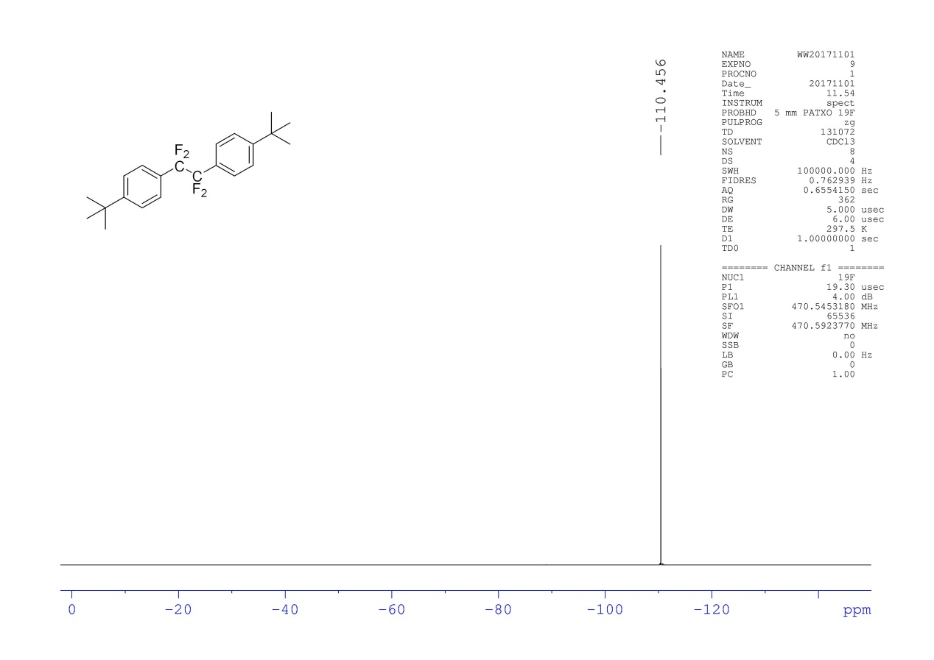
¹H NMR Spectra of 2d
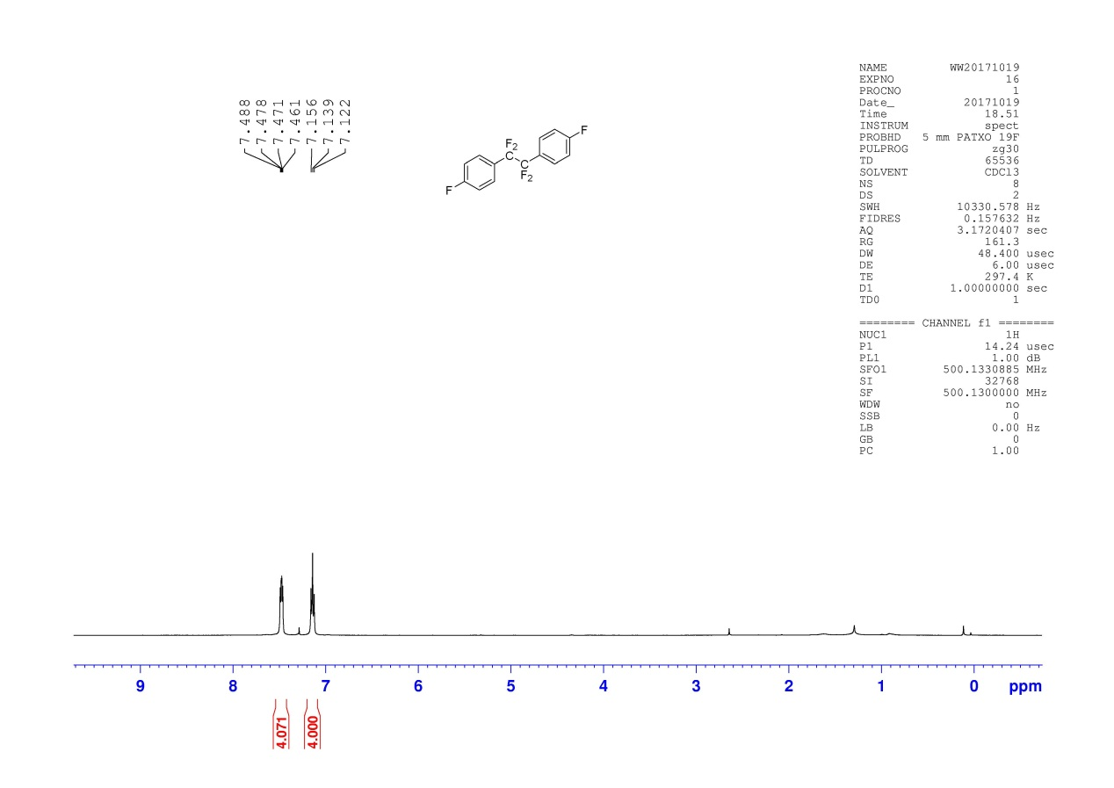

¹³C NMR Spectra of 2d
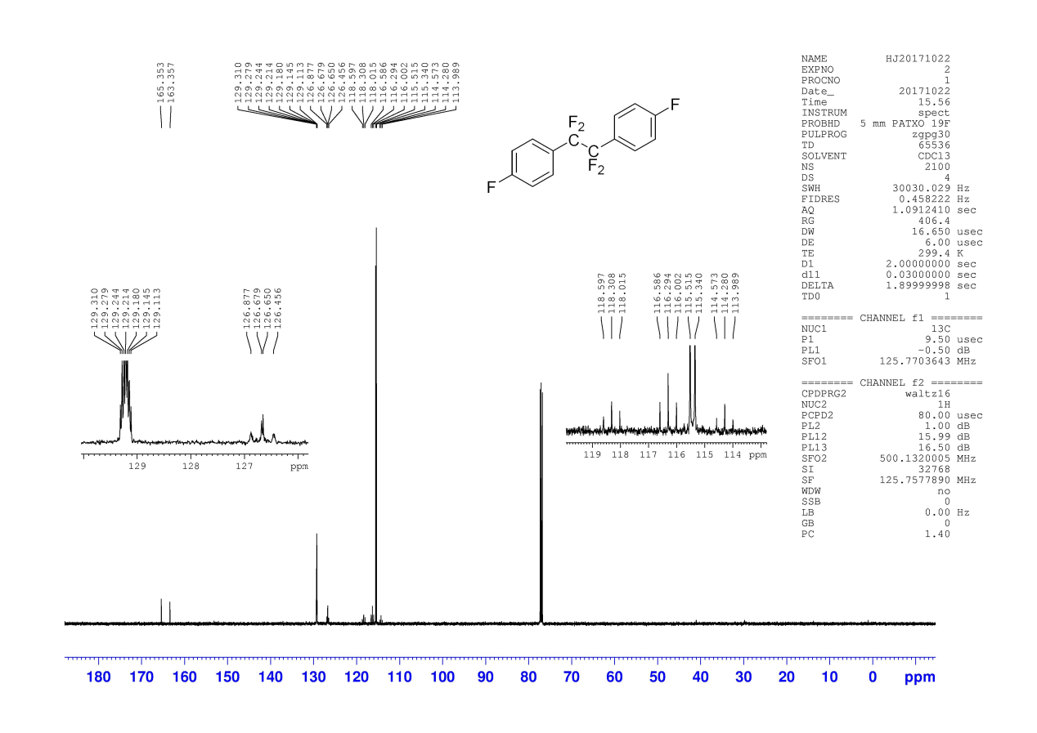
¹⁹F NMR Spectra of 2d
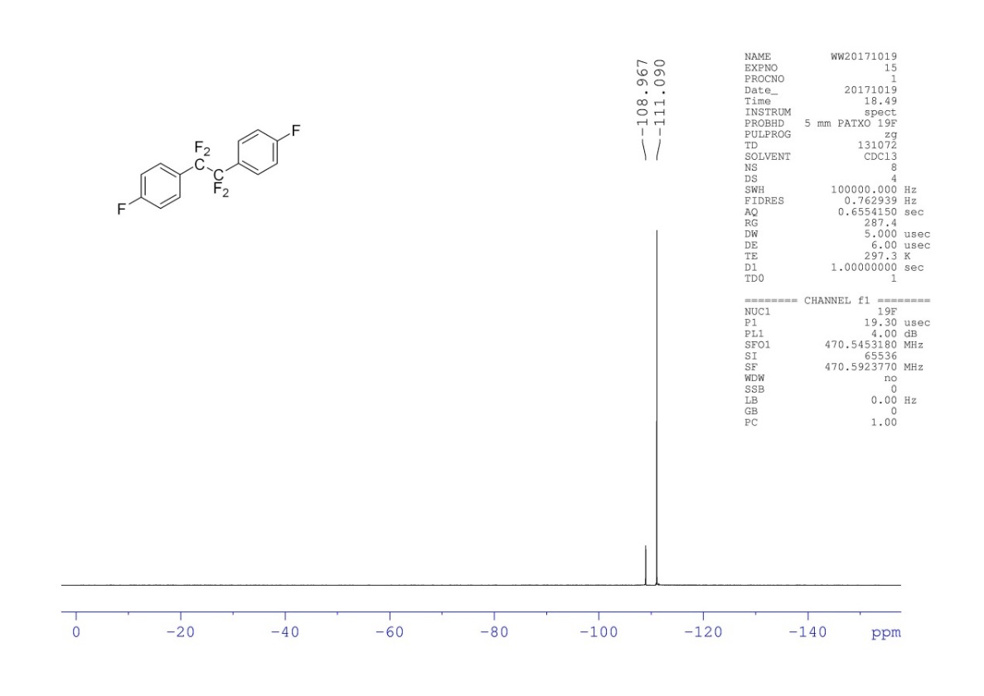
¹H NMR Spectra of 2e
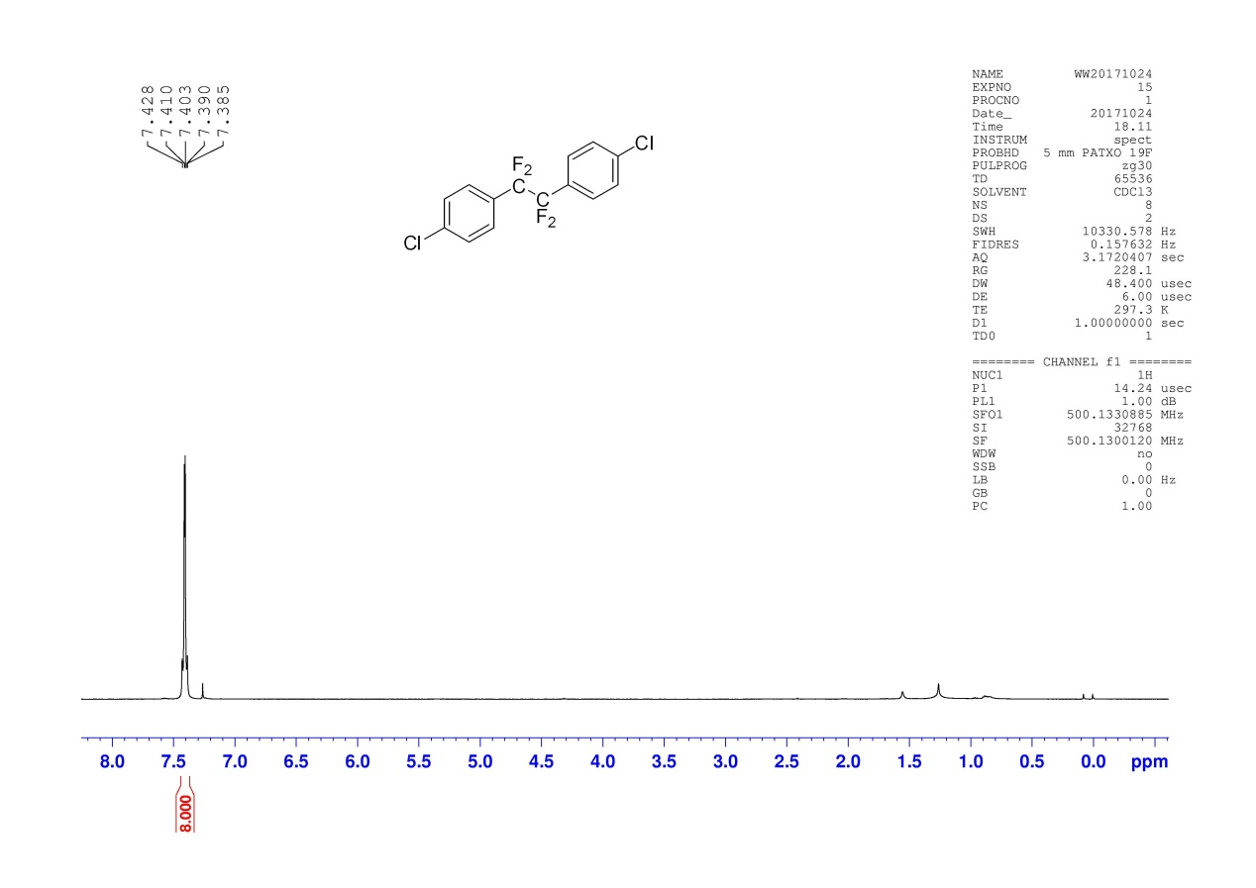
¹³C NMR Spectra of 2e
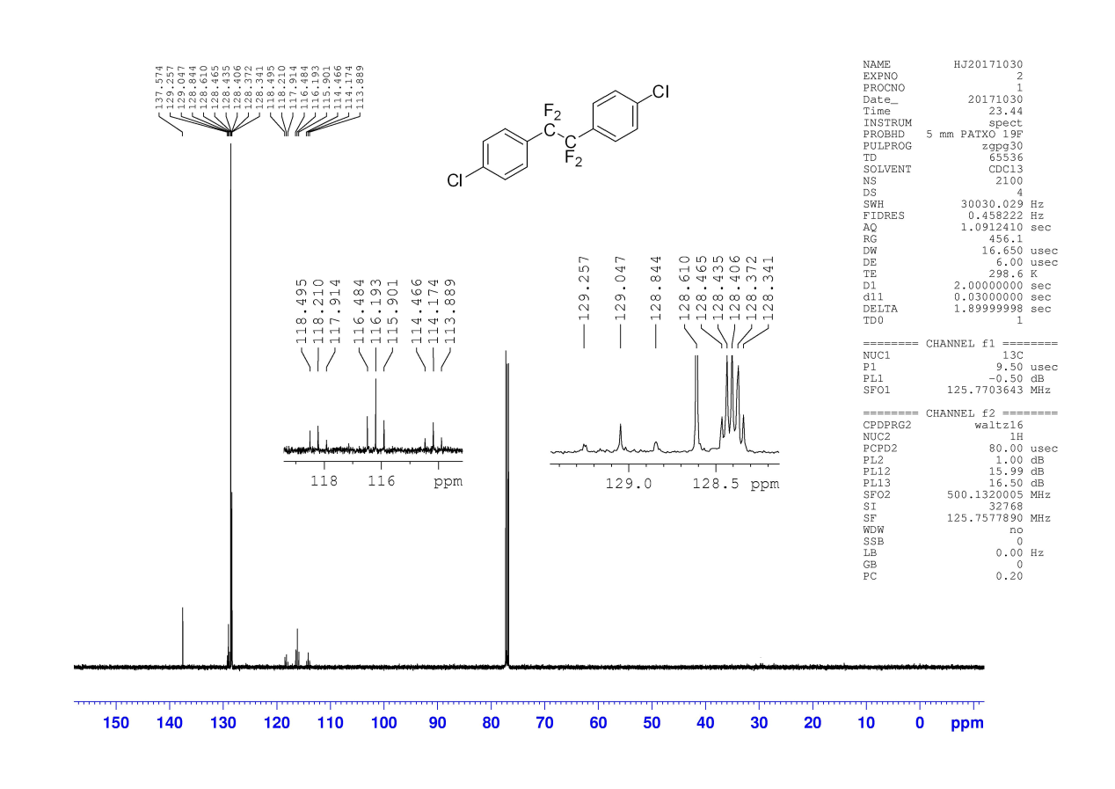
¹⁹F NMR Spectra of 2e
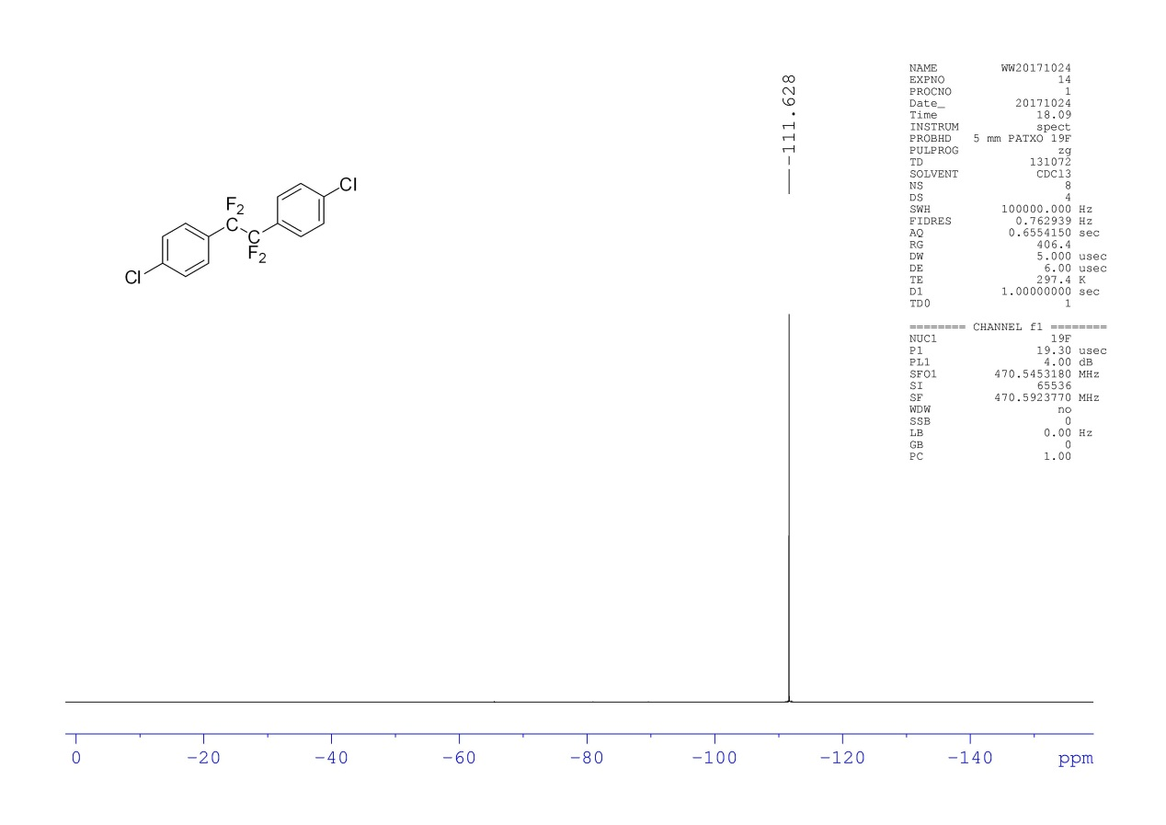
¹H NMR Spectra of 2f
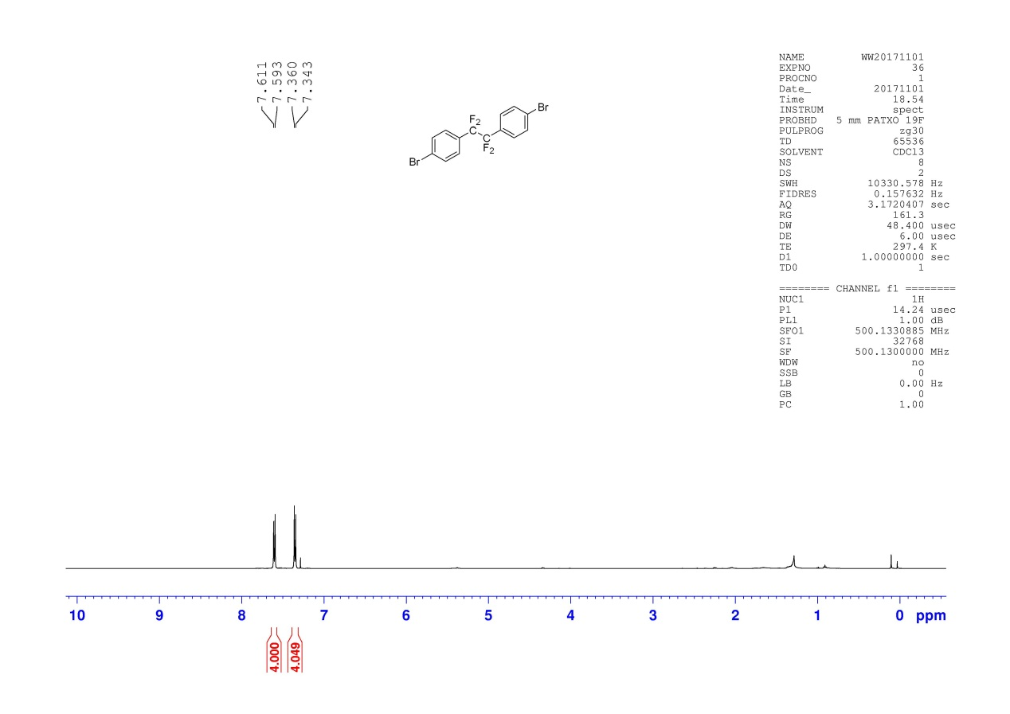
¹³C NMR Spectra of 2f
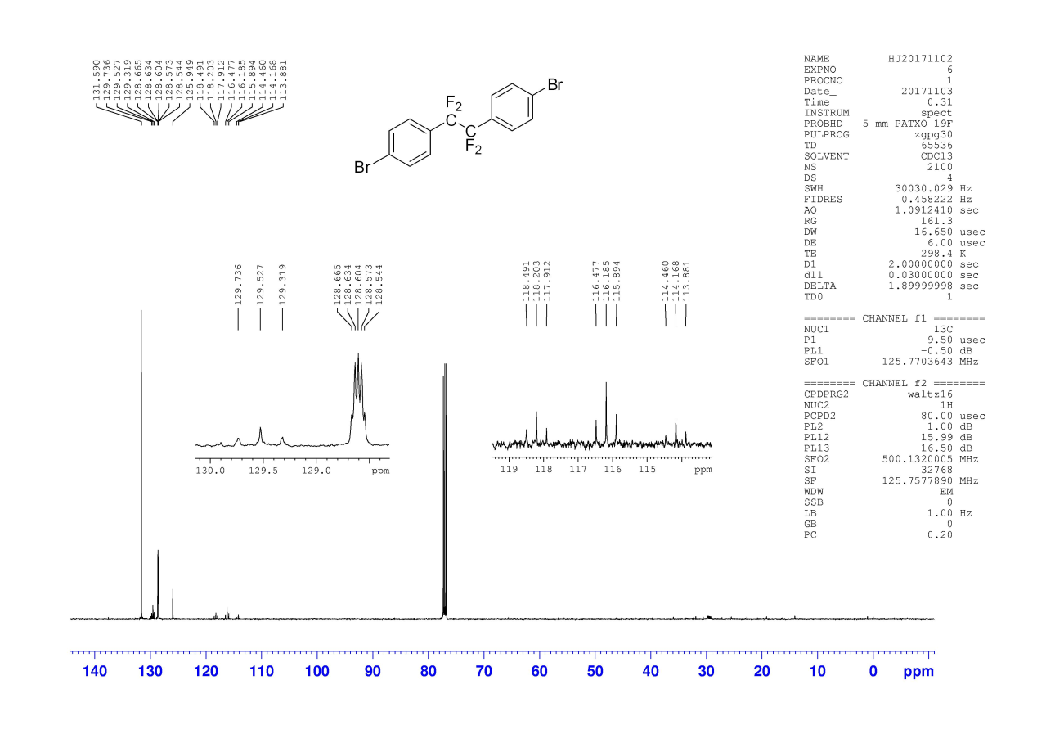
¹⁹F NMR Spectra of 2f
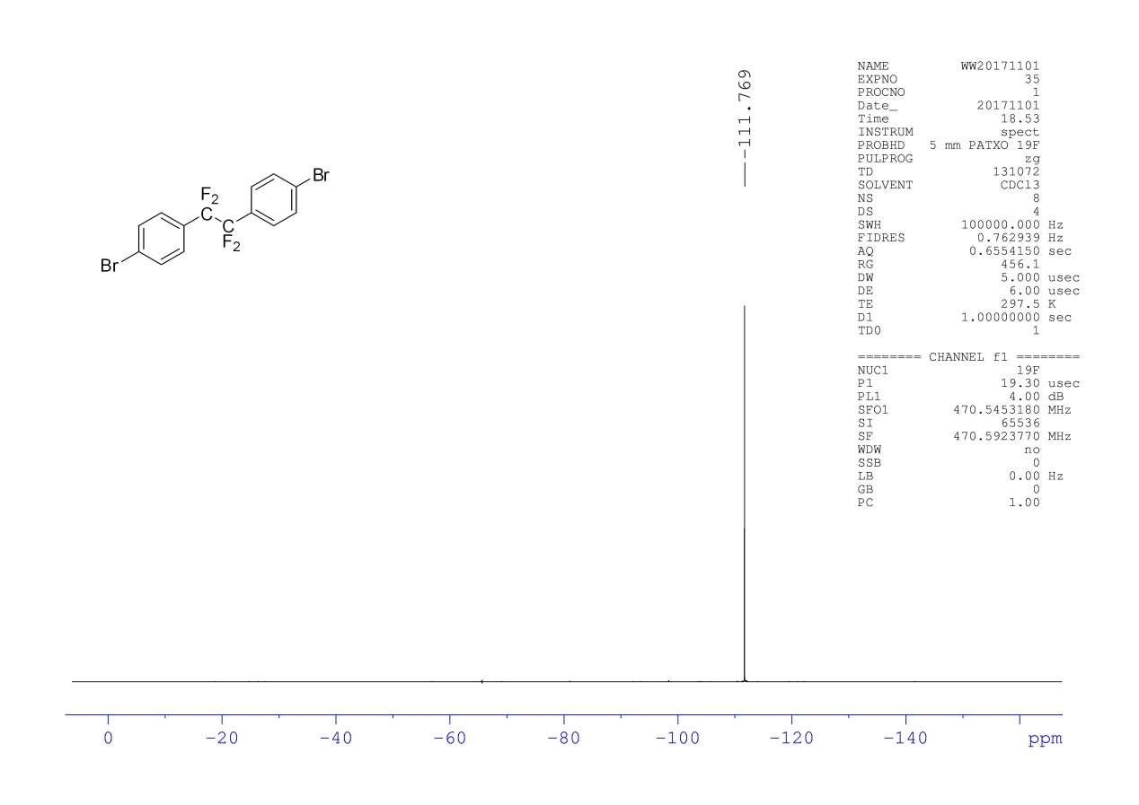
¹H NMR Spectra of 2h
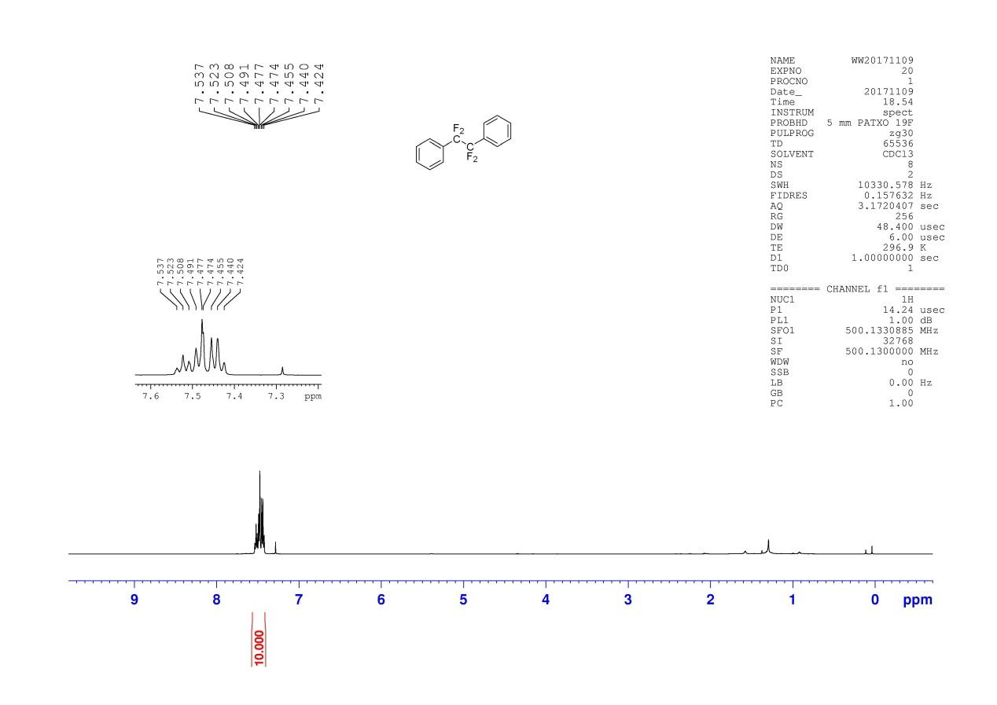
¹³C NMR Spectra of 2h
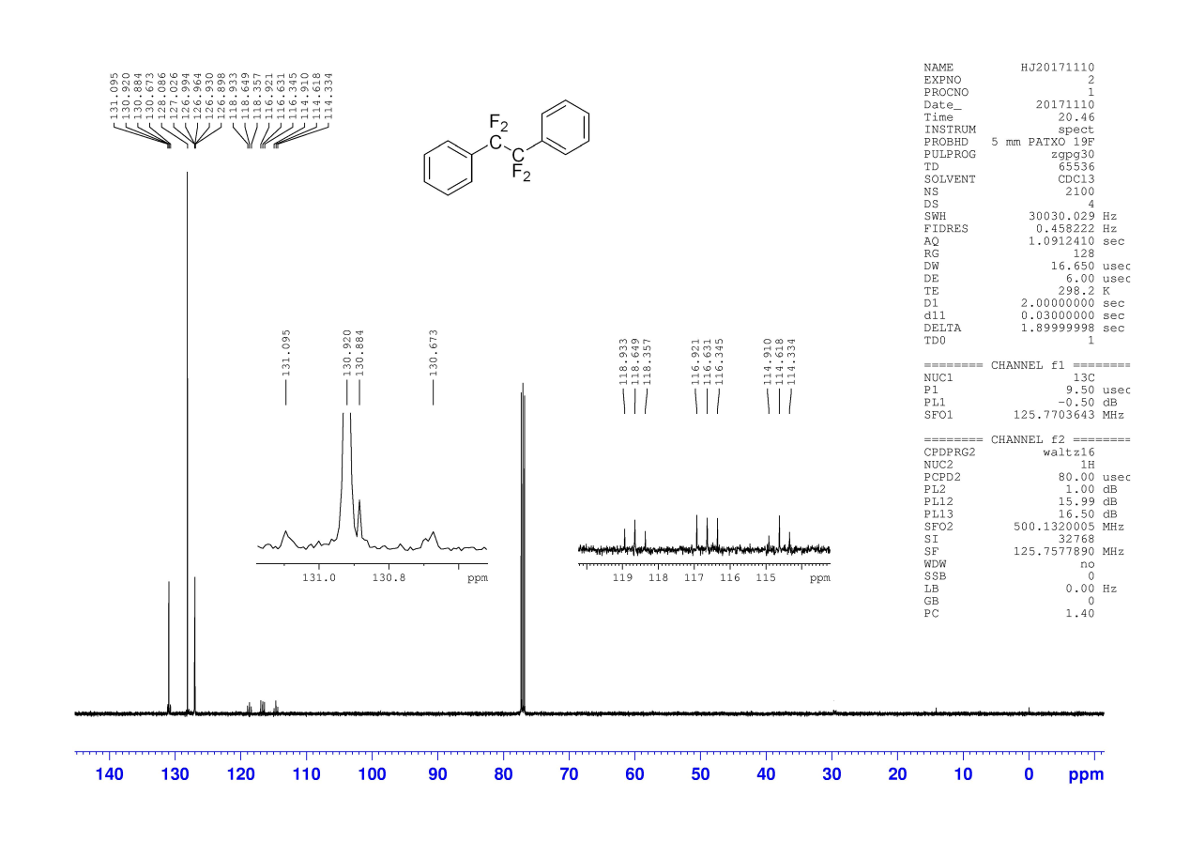
¹⁹F NMR Spectra of 2h
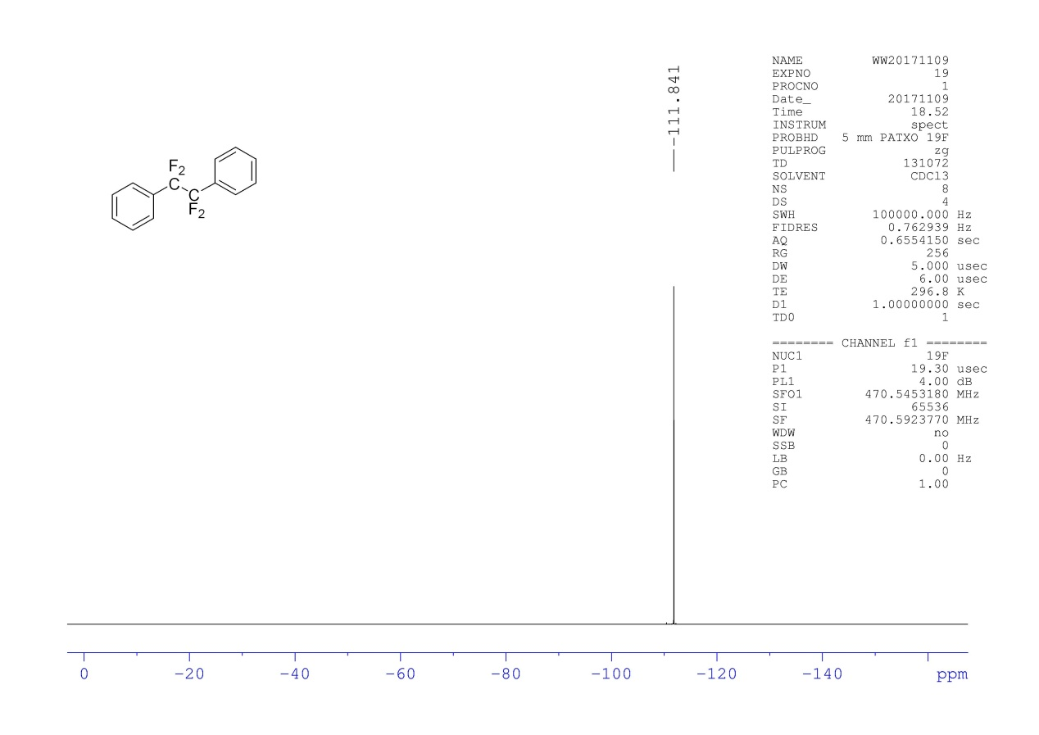
¹H NMR Spectra of 2i
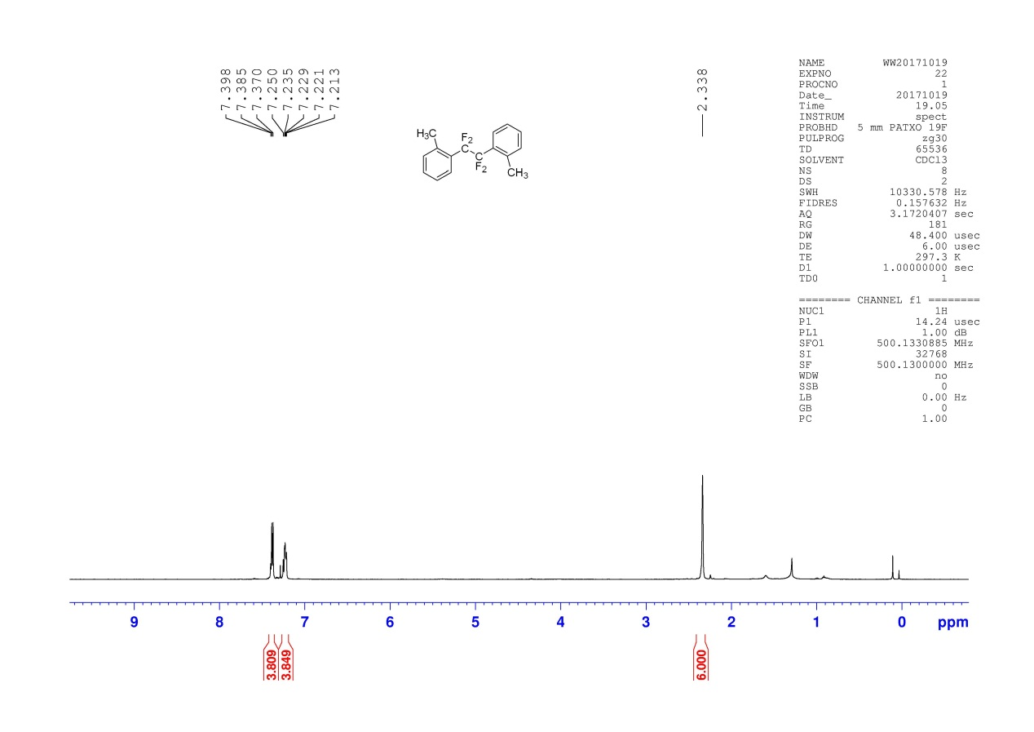
¹³C NMR Spectra of 2i
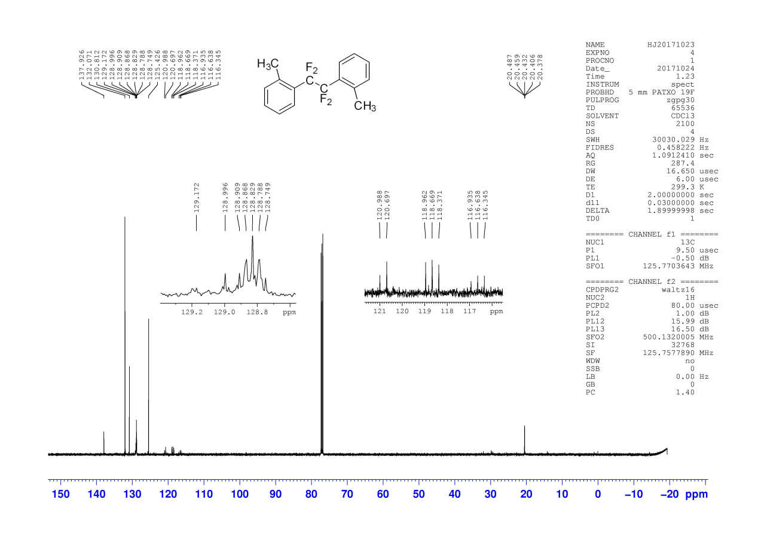
¹⁹F NMR Spectra of 2i
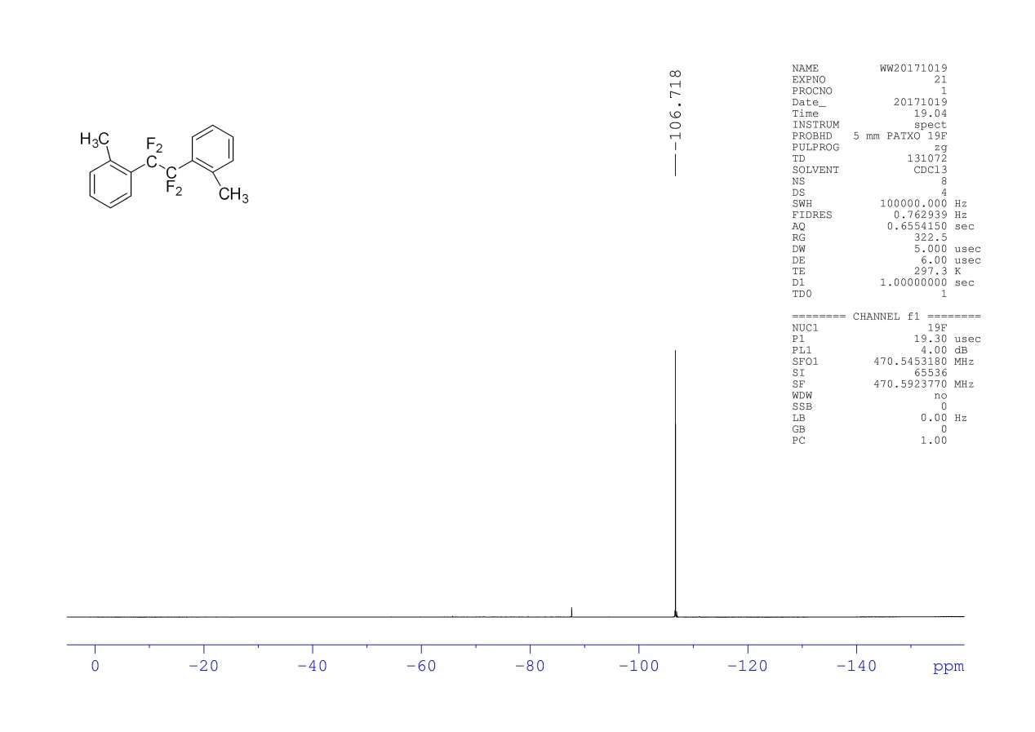
¹H NMR Spectra of 2j
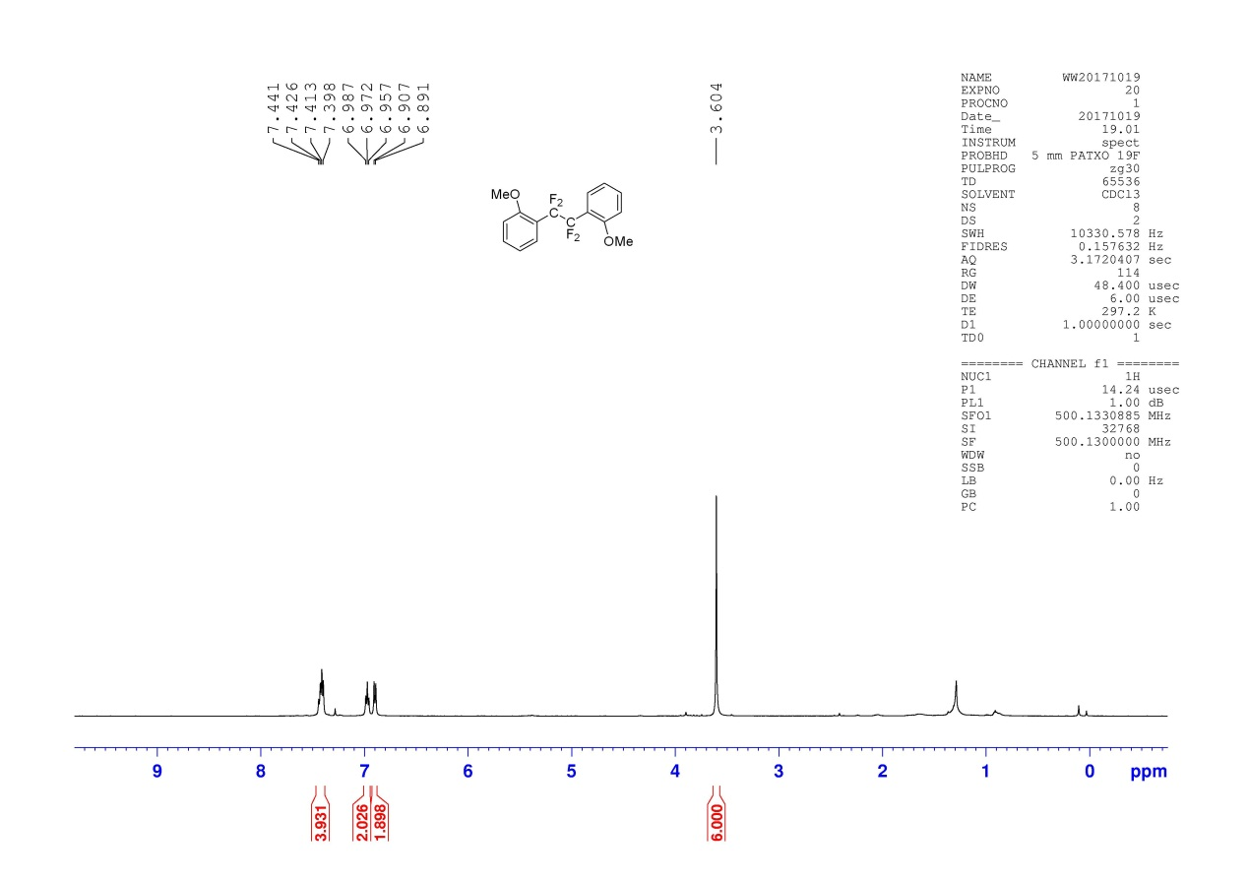
¹³C NMR Spectra of 2j
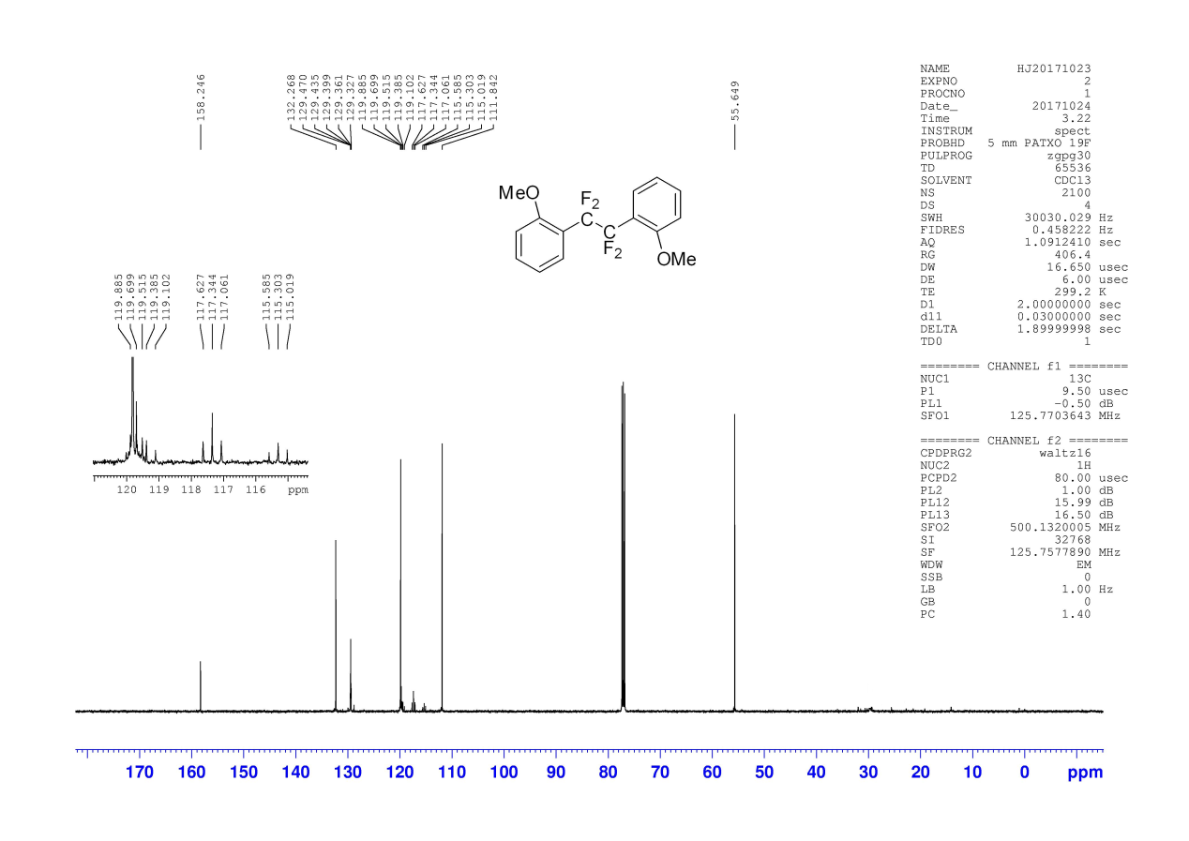
¹⁹F NMR Spectra of 2j
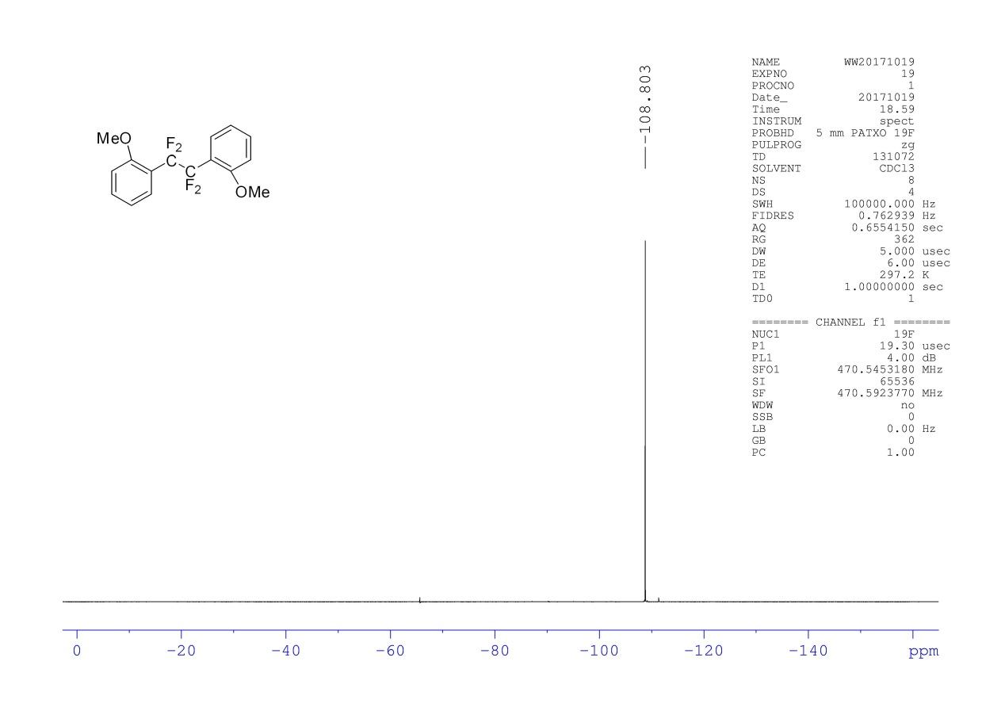
¹H NMR Spectra of 2k
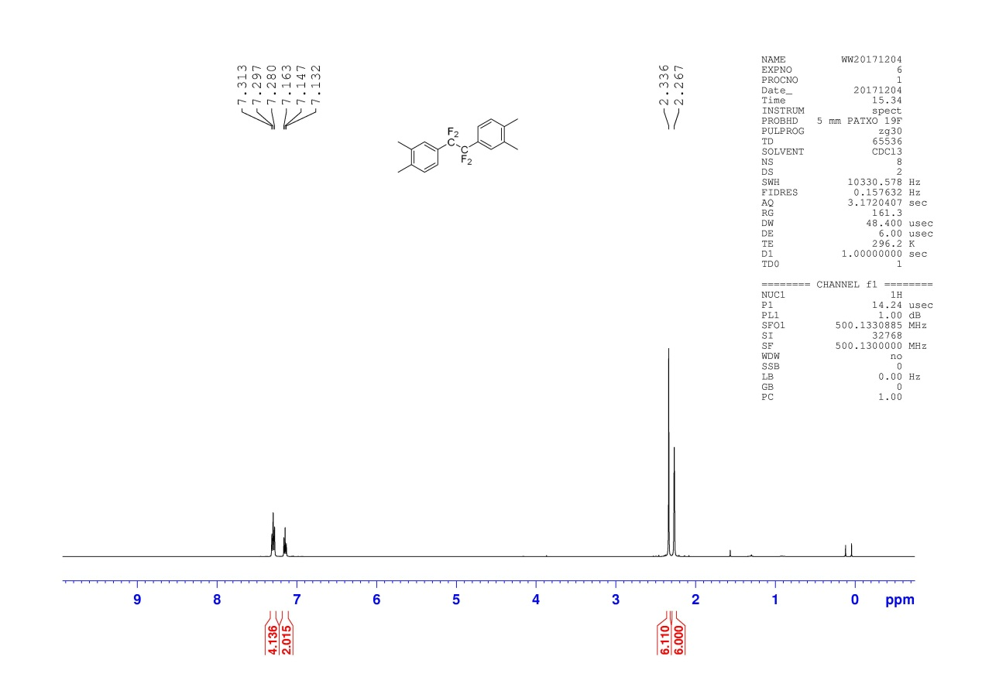
¹³C NMR Spectra of 2k
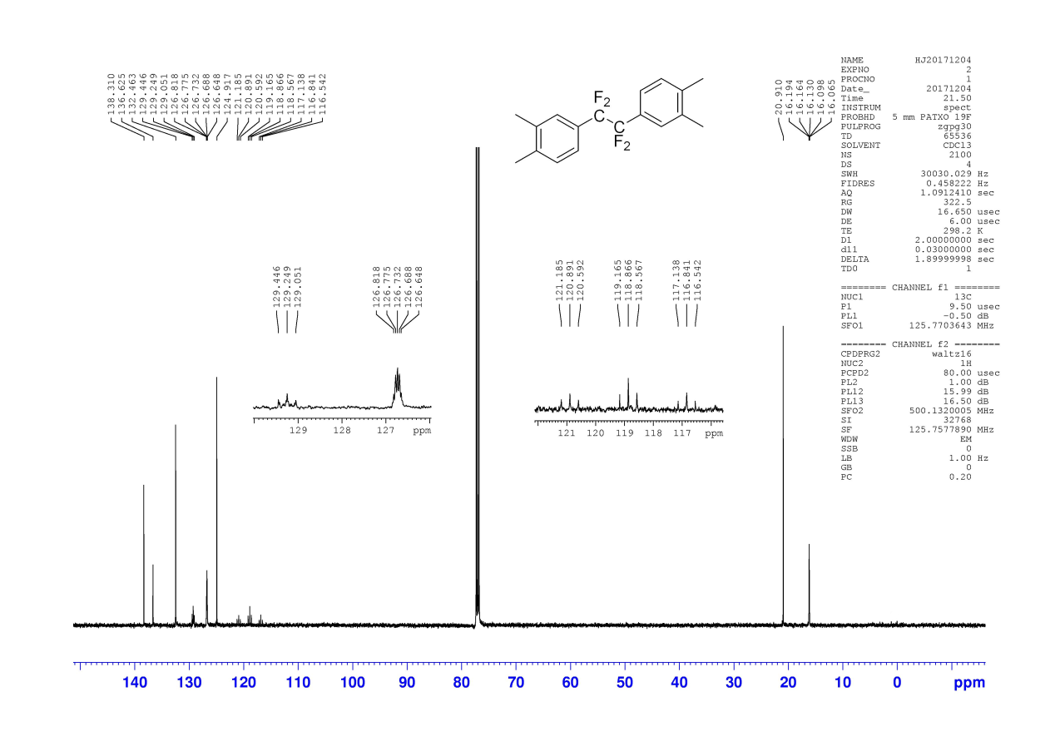
¹⁹F NMR Spectra of 2k
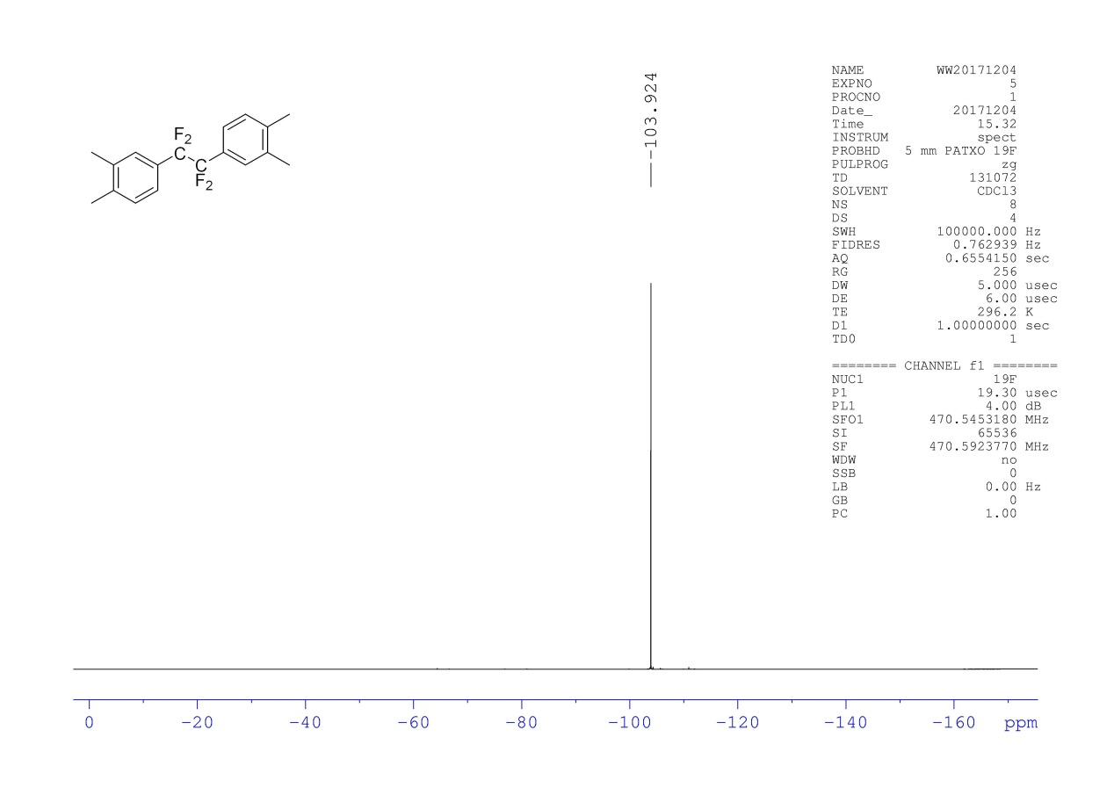
¹H NMR Spectra of 2l
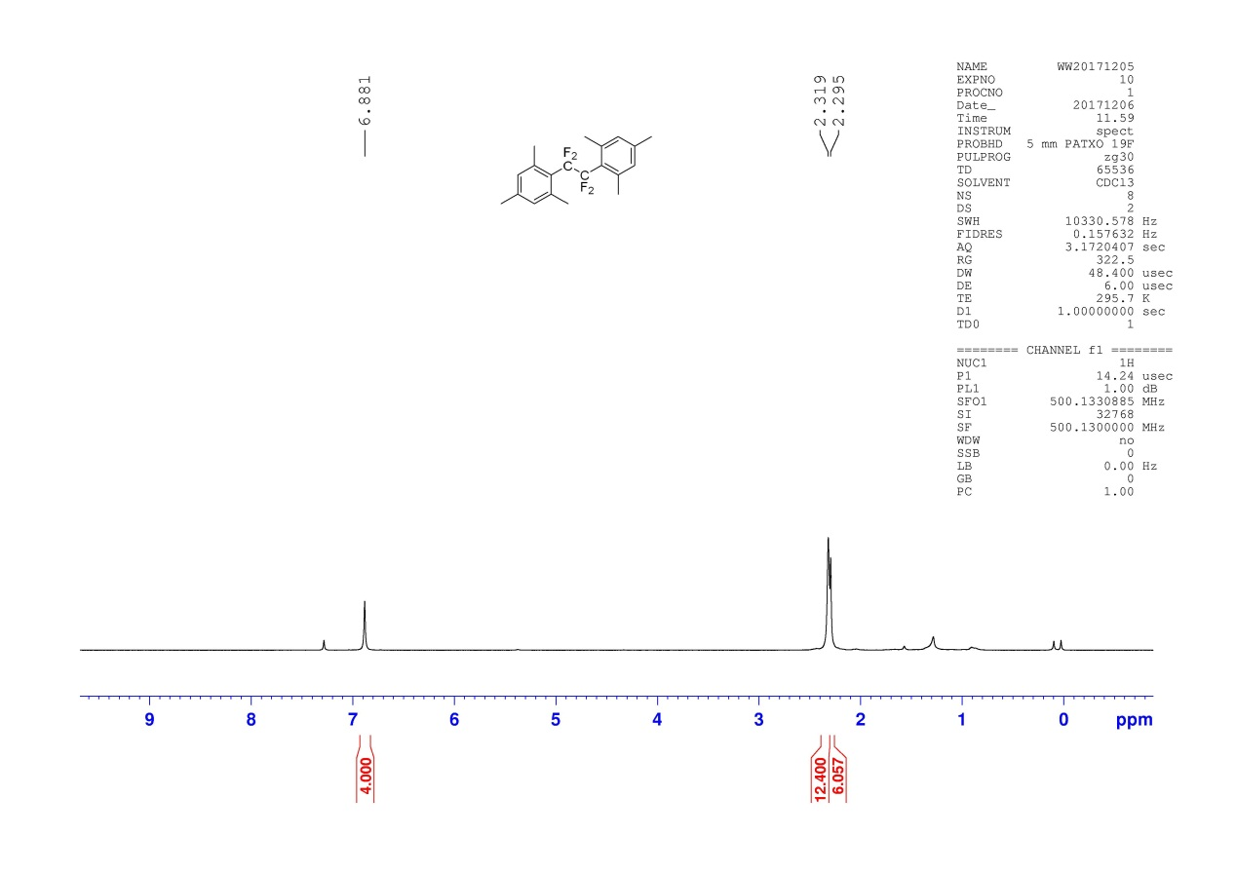
¹³C NMR Spectra of 2l
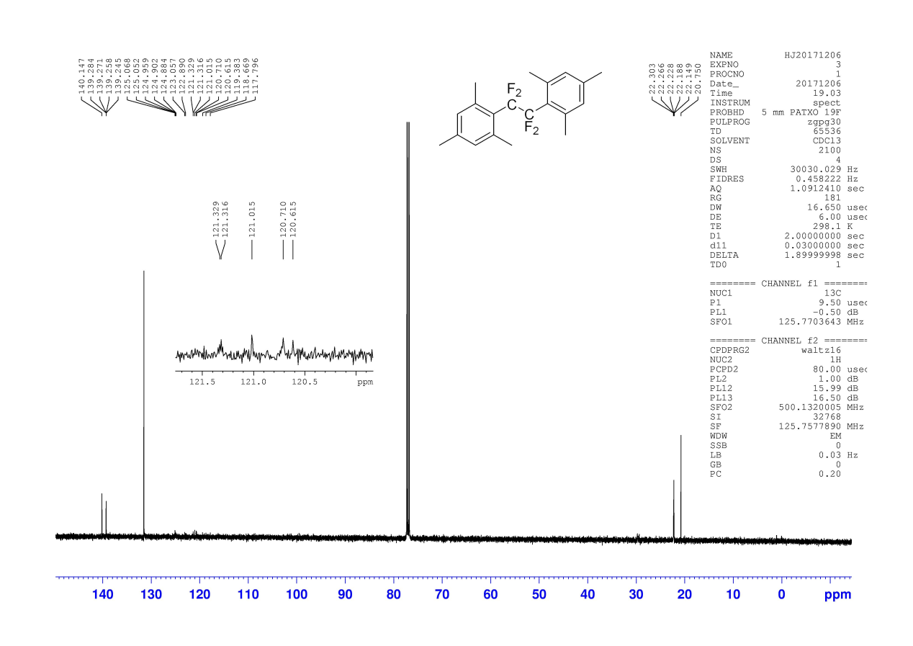
¹⁹F NMR Spectra of 2l
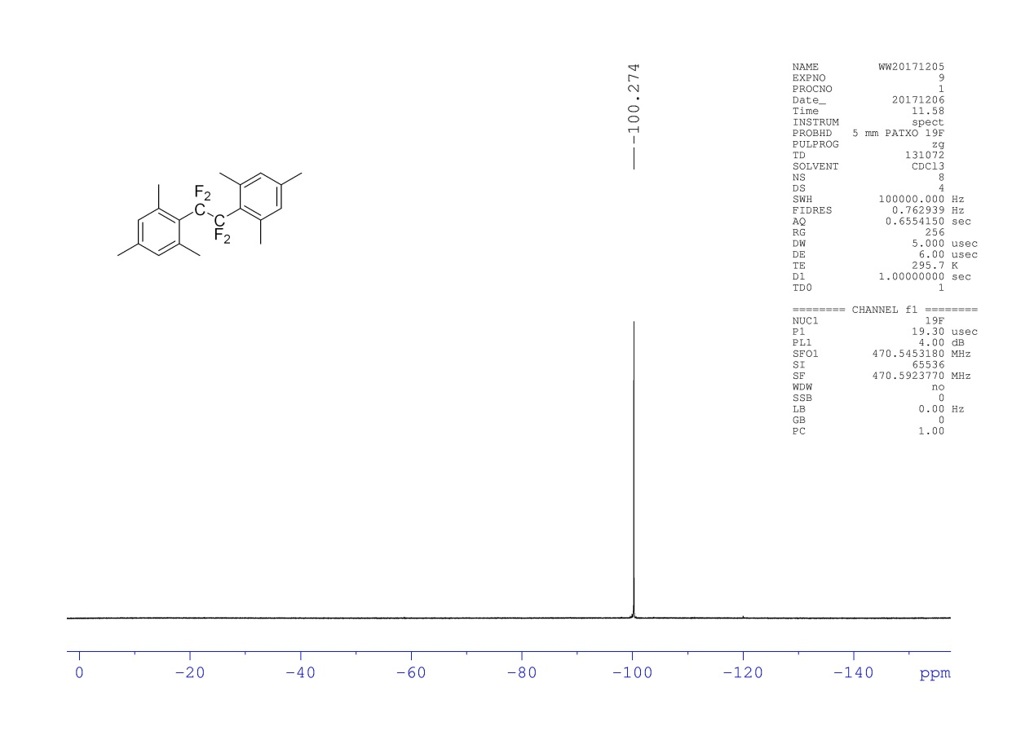
¹H NMR Spectra of 2m
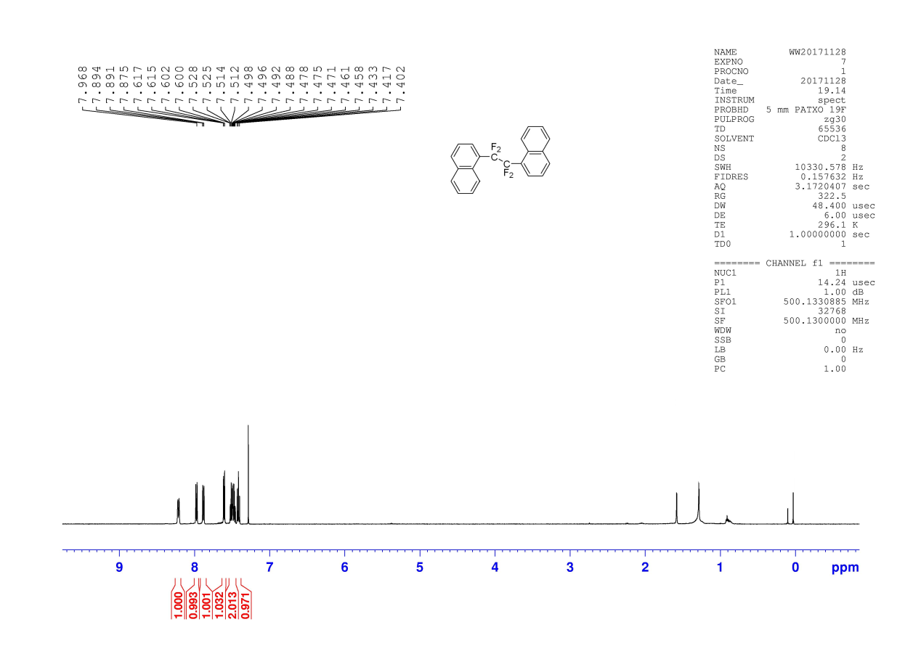
¹³C NMR Spectra of 2m
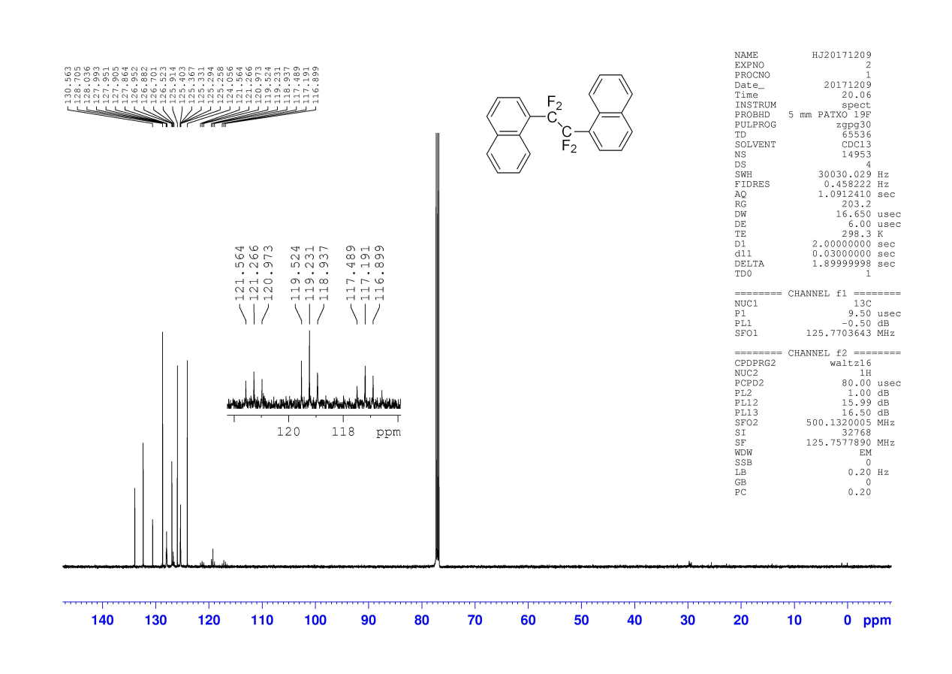
¹⁹F NMR Spectra of 2m
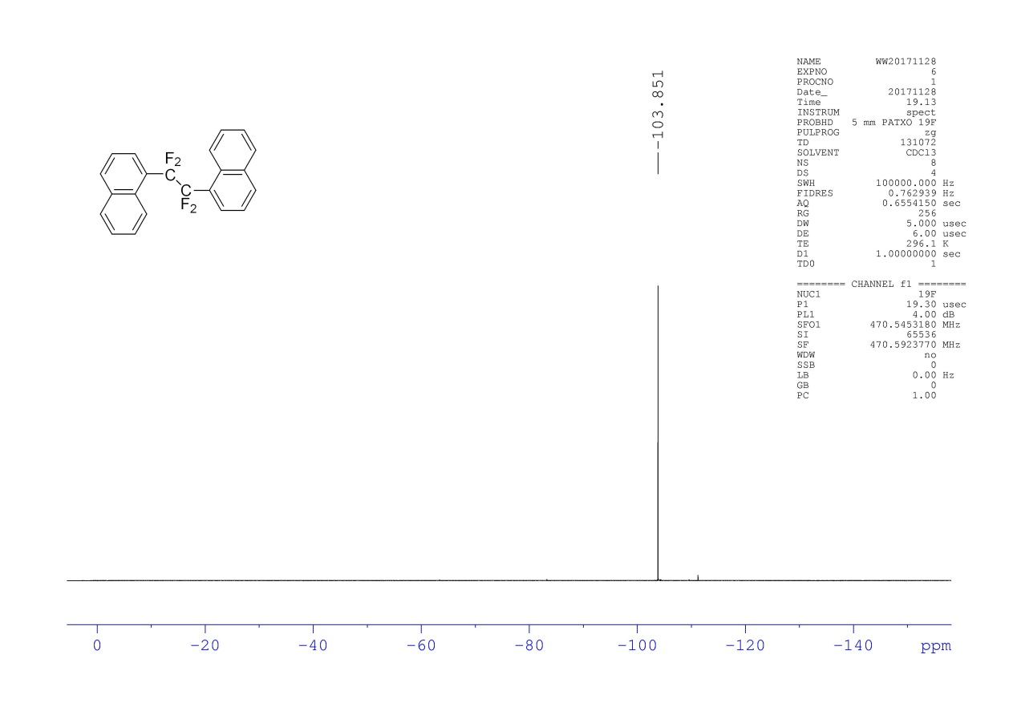
¹H NMR Spectra of 3n
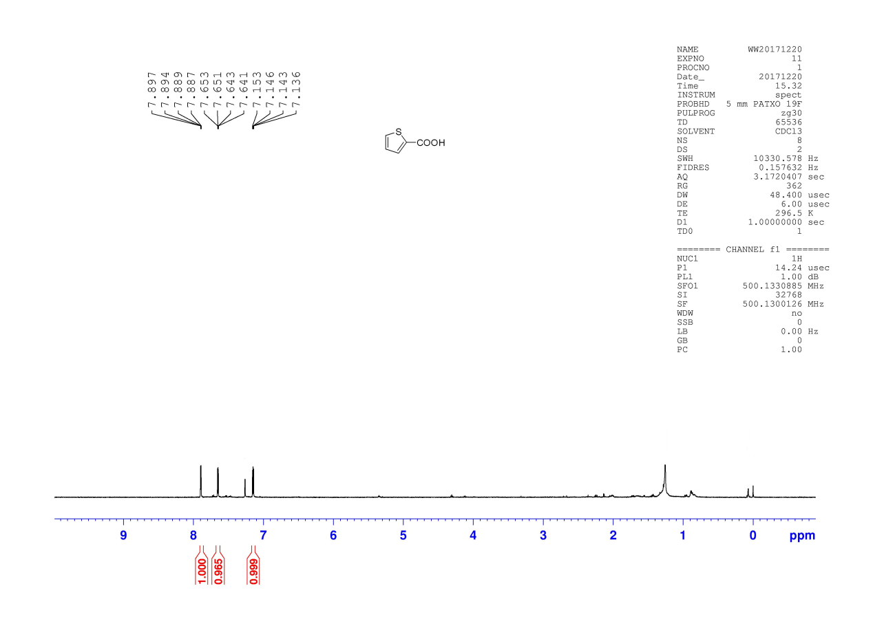
¹³C NMR Spectra of 3n
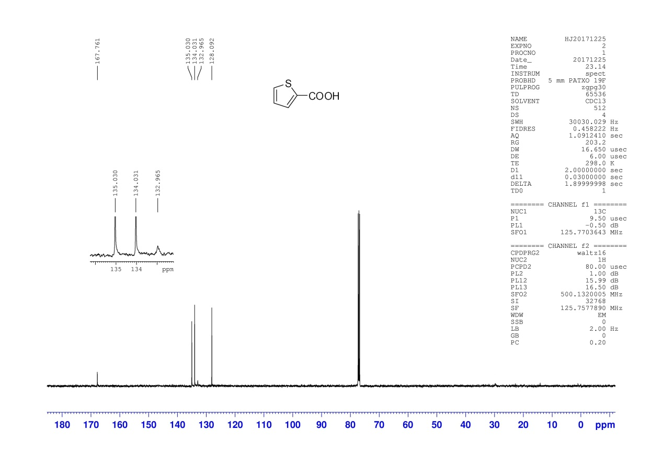
¹H NMR Spectra of 3o
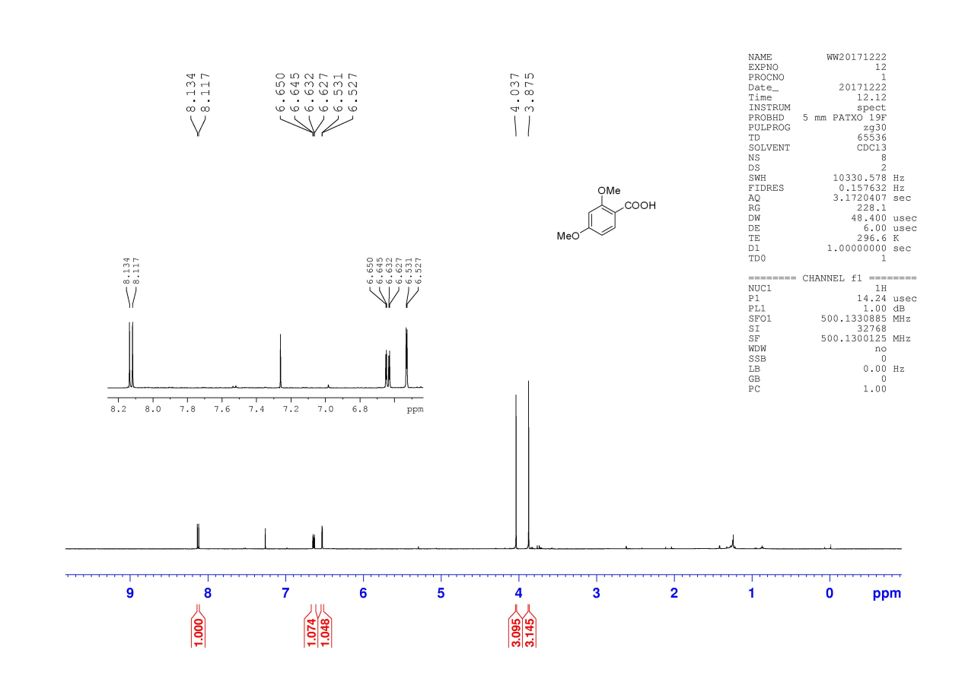
¹³C NMR Spectra of 3o
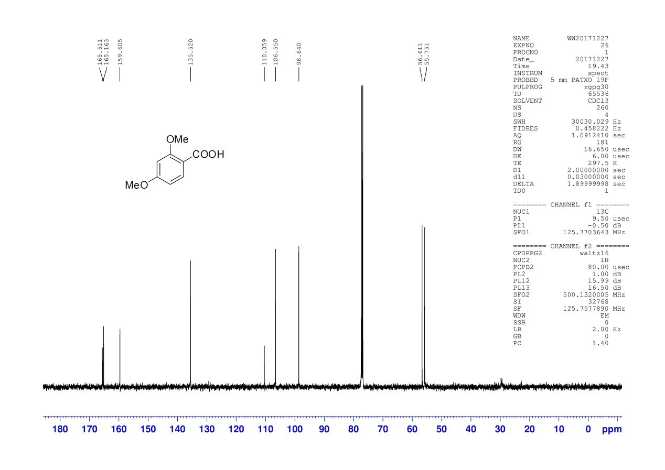
¹H NMR Spectra of 4o
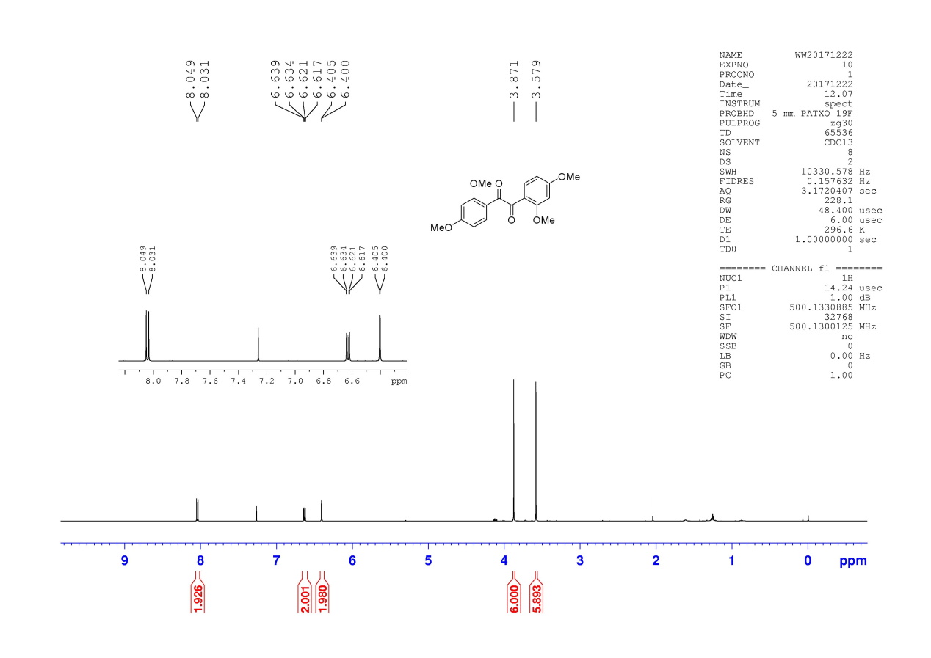
¹³C NMR Spectra of 4o
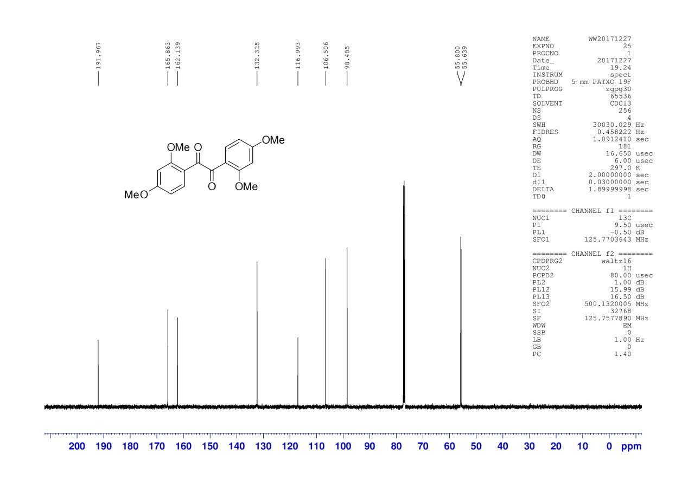
Reference
- Y. Chang, A.Tewari, A.-Izak Adi, C. Bae, Tetrahedron 2008, 64, 9837-9842.
- M. E. Christy, C. D. Colton, M. Mackay, W. H. Staas, J. B. Wong, E. L. Engelhardt, M. L. Torchiana, C. A. Stone, J. Med. Chem. 1977, 20, 421- 430

