Supplementary Data
Facile One-pot Three-component Synthesis of 4,6-Diaryl-3,4-dihydropyrimidine-2(1H)-thiones Under Ultrasonic Irradiation

Shymaa A Abbassª, Gamal A. I. Moustafa^{a,b}*, Heba A. Hassanª, Gamal El-Din A. Abuo-Rahmaª
ª Department of Medicinal Chemistry, Faculty of Pharmacy, Minia University, Minia-61519, Egypt
^{b} Current address: Department of Chemistry, University of Southampton, Highfield, Southampton SO17 1BJ, U.K.
*The corresponding author: e-mail: g.a.i.moustafa@soton.ac.uk

Contents

- General Experimental Information…………………………………………….3
- General procedure for the synthesis of dihydropyrimidine-2-thiones 1-11….3
- Characterization of compounds 1-11…………………………………………3-6
- References for the Supplemental Information…………………………………7
- Copies of ¹H NMR and ¹³C NMR spectra of all compounds………………8-29
- Copy of LC-mass spectra of the new compounds 5 and 8……………..…30-32

General Experimental Information
Chemicals were purchased from commercial resources and used without further purification. Solvents used are of commercial grade and purchased from Fluka and El-Nasr chemical companies. Reactions were monitored by thin-layer chromatography (TLC) using Merck 9385 pre-coated aluminum plate silica gel (Kieselgel 60) plates with a layer thickness of 0.2 mm, and spots were visualized by exposure to UV-lamp at λ= 254 nm. Melting points were determined on Stuart electro-thermal melting point apparatus and are uncorrected.¹H and ¹³C NMR spectra were measured on a JEOL JNMECA500 (¹H: 500 MHz, ¹³C: 125 MHz), JEOL JNM-ECA400 (¹H: 400 MHz, ¹³C: 100MHz) or JEOL AL-300 (¹H: 300 MHz, ¹³C: 75 MHz) instrument with chemical shifts reported in ppm relative to the residual deuterated solvent. The elemental analysis was carried out in the regional center for mycology and biotechnology, Al-Azhar University, Cairo, Egypt. Sonication was performed in a Wiseclean (WUC A10H, Dahan Scientific Co, Ltd, Korea) with a frequency of 40 kHz and an ultrasonic power of 210 W.

General procedure for the synthesis of dihydropyrimidine-2-thiones 1-11.
In a round-bottomed flask, a mixture of the appropriate acetophenone (8 mmol), appropriate aromatic aldehyde (8 mmol), thiourea (0.80 gm, 12 mmol) and sodium hydroxide (3.99 g, 80 mmol) in ethanol (20 ml) were placed in ultrasonic bath at 50 °C for 30-90 min. After completion of the reaction, as monitored by TLC, the reaction volume was reduced to its half under vacuum then poured into crushed ice. The produced precipitate was filtered off, washed with water, and dried. Crystallization from ethanol afforded the pure products (1-11). Yields: (78-95%).
4,6-Diphenyl-3,4-dihydropyrimidine-2(1H)-thione 1.¹
Off-white shiny crystals, yield = 94%, mp = 182-184 °C (reported mp=182-184°C) ¹⁰; ¹H NMR (300 MHz, CDCl₃) δ: 7.76 (s, 1H, NH), 7.38 (s, 5H, Ar-H), 7.36 (s, 5H, Ar-H), 7.07 (s, 1H, NH), 5.26 (s, 1H, H-4), 5.18 (s, 1H, H-5). ¹³C NMR (75 MHz, CDCl₃) δ: 174.75, 141.81, 133.49, 132.82, 129.12, 128.70, 128.56, 128.16, 126.47, 124.77, 100.19, 56.74. Data are in good agreement with those reported.¹

4-(4-Methoxyphenyl)-6-phenyl-3,4-dihydropyrimidine-2(1H)-thione 2 ¹.
Pale yellow crystals, yield = 89 %, mp = 178-180 °C (reported mp=178-180°C) ¹⁰; ¹H NMR (500 MHz, CDCl₃) δ: 7.67 (s, 1H, NH), 7.43 – 7.34 (m, 5H, Ar-H), 7.26 (d, J = 8.6 Hz, 2H, Ar-H), 6.89 (d, J = 8.6 Hz, 2H, Ar-H), 6.88 (s, 1H, NH), 5.22 (d, J = 9.0 Hz, 1H, H-4), 5.16 (dd, J = 8.0, 2.0 Hz,1H, H-5), 3.78 (s, 3H, OCH₃). ¹³C NMR (125 MHz, CDCl₃) δ: 174.80, 159.61, 134.29, 133.59, 133.11, 129.32, 128.81, 128.06, 124.94, 114.24, 100.62, 56.48, 55.14. Data are in good agreement with those reported.¹

4-(4-Chlorophenyl)-6-phenyl-3,4-dihydropyrimidine-2(1H)-thione 3 ¹.
Pale yellow crystals, yield = 91 %, mp=180-181°C(reported mp=180-181°C) ¹⁰; ¹H NMR (500 MHz, DMSO-d₆) δ: 9.92 (s, 1H, NH), 9.10 (s, 1H, NH), 7.49 (d, J = 8.70 Hz, 2H, Ar-H), 7.39 (d, J = 8.70 Hz, 2H, Ar-H), 7.35 (d, J = 7.80 Hz, 2H, Ar-H), 7.31 – 7.24 (m, 3H, Ar-H), 5.39 (d, J = 8.00 Hz, 1H, H-4), 5.08 (dd, J =7.00, 2.60 Hz, 1H, H-5).¹³C NMR (125 MHz, DMSO-d₆) δ: 175.63, 144.44, 133.89, 133.87, 132.66, 129.24, 128.87, 128.35, 128.15, 126.90, 102.33, 55.11. Data are in good agreement with those reported.¹

4-(3,4-Dimethoxyphenyl)-6-phenyl-3,4-dihydropyrimidine-2(1H)-thione 4 ².
Yellow crystals, yield = 85%, mp=181-182°C; ¹H NMR (300 MHz, DMSO-d₆) δ: 9.79 (s, 1H, NH), 9.01 (s, 1H NH), 7.47 (dd, J = 6.50, 3.00 Hz, 2H, Ar-H), 7.38 – 7.28 (m, 3H, Ar-H), 6.93 (d, J = 8.30 Hz, 1H, Ar-H), 6.90 (d, J = 1.80 Hz, 1H, Ar-H), 6.80 (dd, J = 8.20, 1.80 Hz, 1H, Ar-H), 5.33 (d, J = 9.00 Hz, 1H, H-4), 5.01 (dd, J = 7.00, 2.70 Hz, 1H, H-5), 3.70 (s, 3H, OCH₃), 3.69 (s, 3H, OCH₃). ¹³C NMR (75 MHz, DMSO-d₆) δ: 175.40, 149.27, 148.80, 136.98, 134.85, 133.93, 129.33, 128.91, 126.40, 118.95, 112.44, 110.91, 101.74, 56.12, 55.97, 54.74. Data are in good agreement with those reported.²

6-(4-Chlorophenyl)-4-(3,4-dimethoxyphenyl)-3,4-dihydropyrimidine-2(1H)-thione 5.
Yellow crystals, yield = 89%, mp=202-203 °C; ¹H-NMR (500 MHz, DMSO-d₆) δ: 9.89 (s, 1H, NH), 9.00 (s, 1H, NH), 7.50 (d, J = 8.60 Hz, 2H, Ar-H), 7.40 (d, J = 8.50 Hz, 2H, Ar-H), 6.93 (d, J = 8.30 Hz, 1H, Ar-H), 6.90 (d, J = 1.60 Hz, 1H, Ar-H), 6.80 (dd, J = 8.20, 1.70 Hz, 1H, Ar-H), 5.37 (d, J = 9.00 Hz, 1H, H-4), 5.02 (d, J = 9.00 Hz, 1H, H-5), 3.71 (s, 3H, OCH₃), 3.70 (s, 3H, OCH₃).¹³C NMR (125 MHz, DMSO-d₆ ) δ:175.41, 149.29, 148.83, 136.89, 133.97, 133.81, 128.86, 128.34, 118.95, 112.46, 110.92, 102.32, 100.03, 56.13, 55.99, 54.73. Anal. Calcd. for C₁₈H₁₇ClN₂O₂S (360.86): C, 59.91; H, 4.75; N, 7.76; S, 8.89, Found: C, 60.23; H, 4.87; N, 8.02; S, 8.73.

4,6-Bis(4-chlorophenyl)-3,4-dihydropyrimidine-2(1H)-thione 6. ¹
Yellowish powder, yield = 95%, mp=148-150°C(reported mp=152-153°C);¹ ¹H NMR (500 MHz, DMSO- d₆) δ: 10.01 (s, 1H, NH), 9.16 (s, 1H, NH), 7.52 (d, J = 8.60 Hz, 2H, Ar-H), 7.46 (d, J = 8.40 Hz, 2H, Ar-H), 7.42 (d, J = 8.60 Hz, 2H, Ar-H), 7.33 (d, J = 8.40 Hz, 2H, Ar-H), 5.41 (d, J = 7.00 Hz, 1H, H-4), 5.13 (dd, J = 7.00, 2.60 Hz, 1H, H-5). ¹³C NMR (125 MHz, DMSO-d₆) δ: 175.70, 143.34, 134.18, 133.98, 132.70, 132.57, 129.22, 128.87, 128.80, 128.42, 101.86, 54.38. Data are in good agreement with those reported.¹

6-(4-Chlorophenyl)-4-(4-methoxyphenyl)-3,4-dihydropyrimidine-2(1H)-thione 7. ¹
White powder, yield= 93%, mp=175-176°C (reported mp=177-178°C) ¹⁰; ¹H NMR (500 MHz, DMSO-d₆) δ: 9.88 (s, 1H, NH), 9.05 (s, 1H, NH), 7.49 (d, J = 8.90 Hz, 2H, Ar-H), 7.39 (d, J = 8.90 Hz, 2H, Ar-H), 7.20 (d, J = 9.00 Hz, 2H, Ar-H), 6.92 (d, J = 9.00 Hz, 2H, Ar-H), 5.35 (d, J = 6.70 Hz, 1H, H-4), 5.01 (dd, J = 9.00, 2.00 Hz, 1H, H-5), 3.70 (s, 3H, OCH₃). ¹³C NMR (125 MHz, DMSO-d₆) δ: 175.28, 159.33, 136.57, 133.84, 133.77, 132.74, 128.87, 128.34, 128.28, 114.56, 102.48, 55.69, 54.54. Data are in good agreement with those reported.¹

6-Phenyl-4-(3,4,5-trimethoxyphenyl)-3,4-dihydropyrimidine-2(1H)-thione 8.
White powder, yield = 95%, mp = 177-178°C; ¹H-NMR (500 MHz, DMSO-d₆) δ: 9.85 (s, 1H, NH), 9.04 (s, 1H, NH), 7.49 (dd, J = 7.40, 2.00 Hz, 2H, Ar-H), 7.38-7.29 (m, 3H, Ar-H), 6.62 (s, 2H, Ar-H), 5.37 (d, J = 7.20 Hz, 1H, H-4), 5.05 (dd, J = 7.20, 2.40 Hz, 1H, H-5), 3.73 (s, 6H, OCH₃), 3.61 (s, 3H, OCH3). ¹³C NMR (125 MHz, DMSO-d₆) δ: 175.70, 153.55, 140.06, 137.37, 135.07, 133.88, 129.39, 128.94, 126.46, 104.10, 101.50, 60.54, 56.36, 55.01. Anal. Calcd. for C₁₉H₂₀N₂O₃S (356.44): C, 64.02; H, 5.66; N, 7.86; S, 8.99, Found: C, 64.25; H, 5.84; N, 8.09; S, 9.06.
6-(4-Chlorophenyl)-4-(3,4,5-trimethoxyphenyl)-3,4-dihydropyrimidine-2(1H)-thione 9. ³
White powder, yield = 88%, mp=186-187°C (reported mp=185-187°C) ⁵ ; ¹H NMR (500 MHz, DMSO-d₆) δ: 9.93 (s, 1H, NH), 9.05 (s, 1H, NH), 7.51 (d, J = 8.60 Hz, 2H, Ar-H), 7.40 (d, J = 8.60 Hz, 2H, Ar-H), 6.61 (s, 2H, Ar-H), 5.41 (d, J = 9.00 Hz, 1H, H-4), 5.04 (d, J = 9.00 Hz, 1H, H-5), 3.73 (s, 6H, OCH₃), 3.61 (s, 3H, OCH₃). ¹³C NMR (125 MHz, DMSO-d₆) δ: 175.71, 153.56, 139.90, 137.40, 134.06, 133.91, 132.71, 128.89, 128.39, 104.10, 102.13, 60.54, 56.37, 55.03. Data are in good agreement with those reported.³

4-(3,4-Dimethoxyphenyl)-6-(4-methoxyphenyl)-3,4-dihydropyrimidine-2(1H)-thione 10. ⁴
White powder, yield= 80%, mp=196-197°C (reported mp=198-200°C) ⁴; ¹H NMR (300 MHz, DMSO-d₆) δ: 9.73 (s, 1H, NH), 9.01 (s, 1H, NH), 7.45 (d, J = 8.70 Hz, 2H, Ar-H), 6.96 (d, J = 8.40 Hz, 1H, Ar-H), 6.93 (s, 1H, Ar-H), 6.91(d, J =7.50 Hz, 2H, Ar-H), 6.83 (dd, J = 8.20, 1.60 Hz, 1H, Ar-H), 5.26 (d, J = 9.00 Hz, 1H, H-4), 5.02 (d, J = 9.00 Hz, 1H, H-5), 3.75 (s, 3H, OCH₃), 3.73 (s, 3H, OCH₃), 3.72 (s, 3H, OCH₃).¹³C NMR (75 MHz, DMSO-d₆) δ: 174.82, 159.68, 148.75, 148.26, 136.63, 133.96, 127.23, 125.76, 118.42, 113.74, 111.92, 110.41, 99.67, 55.61, 55.46, 55.22, 54.21. Data are in good agreement with those reported.⁴

6-(4-Methoxyphenyl)-4-(3,4,5-trimethoxyphenyl)-3,4-dihydropyrimidine-2(1H)-thione 11 ³.
White shiny needles, yield = 78%, mp =212-214°C (reported mp =216-218°C);³ ¹H NMR (300 MHz, DMSO-d₆) δ: 9.75 (s, 1H, NH), 8.99 (s, 1H, NH), 7.42 (d, J = 8.80 Hz, 2H, Ar-H), 6.89 (d, J = 8.80 Hz, 2H, Ar-H), 6.61 (s, 2H, Ar-H), 5.26 (d, J = 7.00 Hz, 1H, H-4), 5.01 (dd, J = 8.20, 2.00 Hz, 1H, H-5), 3.72 (s, 9H, OCH₃), 3.60 (s, 3H, OCH₃). ¹³C NMR (75 MHz, DMSO-d₆) δ: 175.40, 160.02, 153.30, 139.98, 137.11, 134.46, 127.57, 125.98, 114.04, 103.86, 99.69, 60.30, 56.12, 55.51, 54.80. Data are in good agreement with those reported.³

References

- Al-Hajjar FH, Al-Farkh YA, and Hamoud HS. Can J Chem 1979; 57: 2734.
- Sahu M, Siddiqui N, Sharma V, et al. Bioorg Chem 2018; 77: 56.
- El-Meligie S, Taher A T, Kamal A M, et al. Eur J Med Chem 2017; 126: 52.
- Desta D, Sjoholm R, Lee L, et al. Med Chem Res 2011; 20: 364.

¹H- NMR spectrum of compound 1 (300 MHz, CDCl₃)
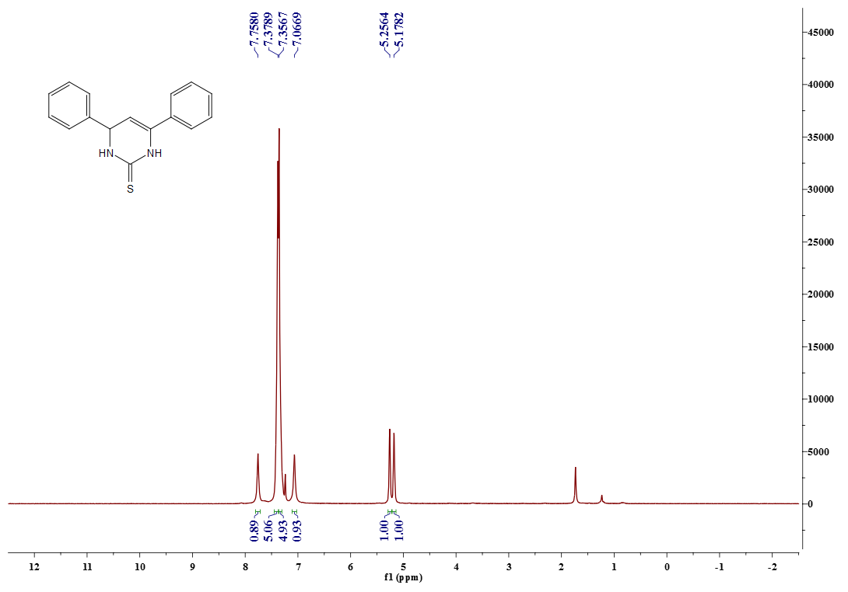

¹³C- NMR spectrum of compound 1 (75 MHz, CDCl₃)
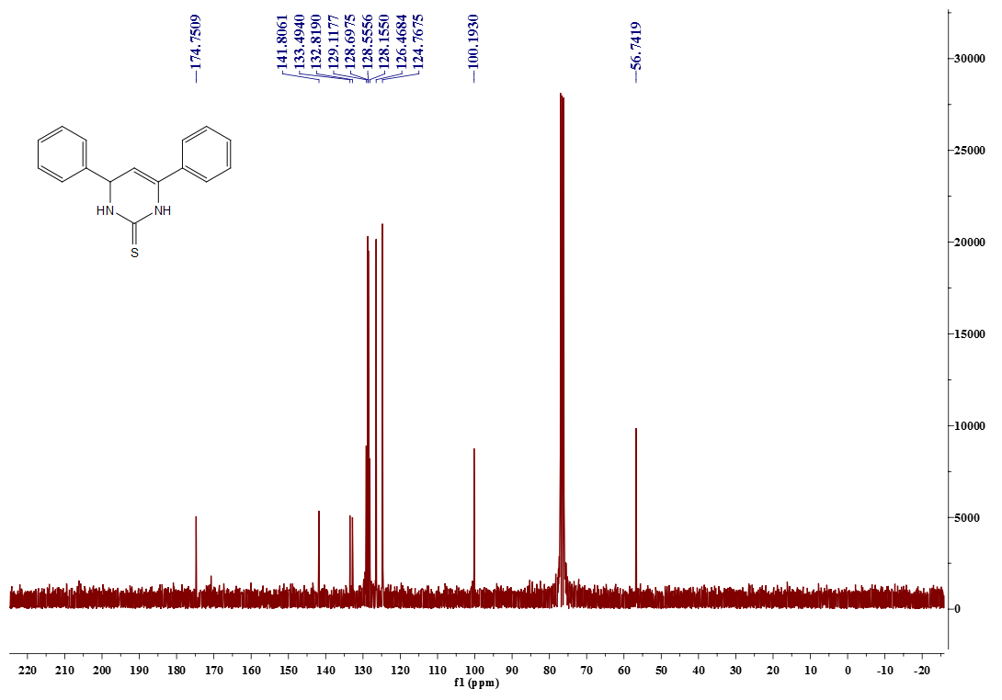

¹H- NMR spectrum of compound 2 (500 MHz, CDCl₃)
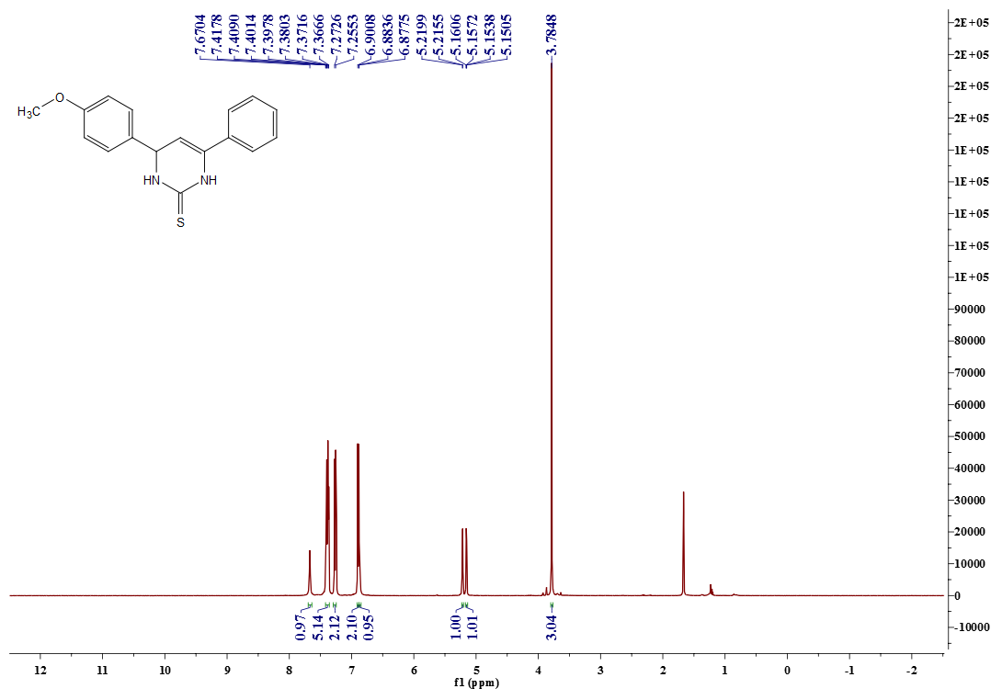

¹³C- NMR spectrum of compound 2 (125 MHz, CDCl₃)
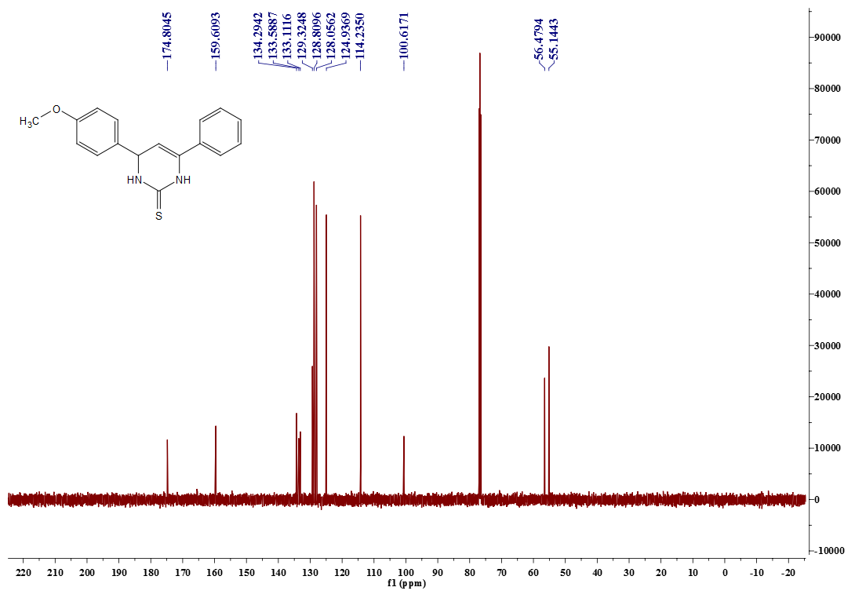

¹H -NMR spectrum of compound 3 (500 MHz, DMSO-d6 )
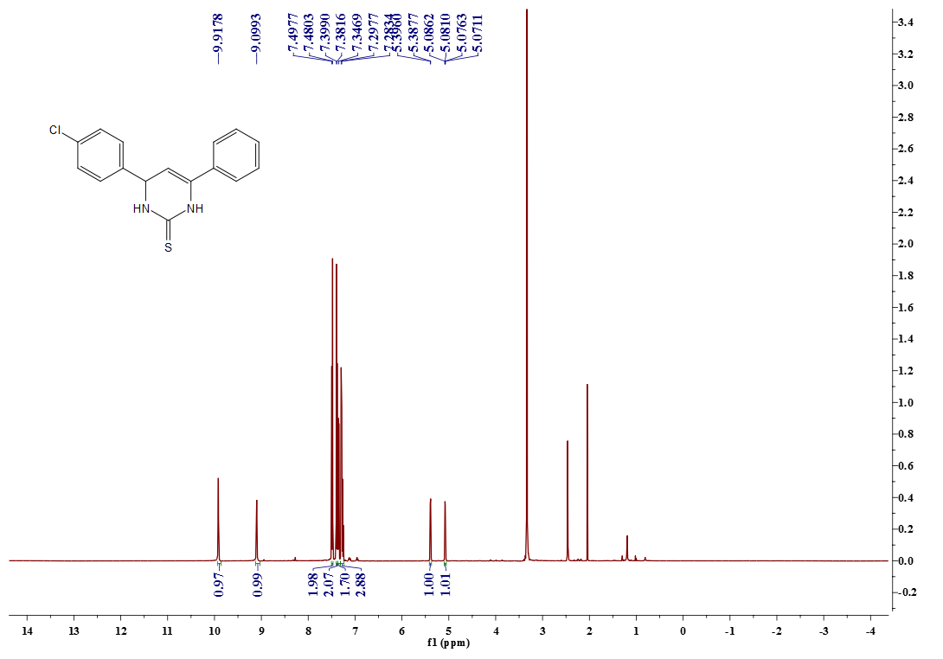

¹³C- NMR spectrum of compound 3 (125 MHz, DMSO-d6)
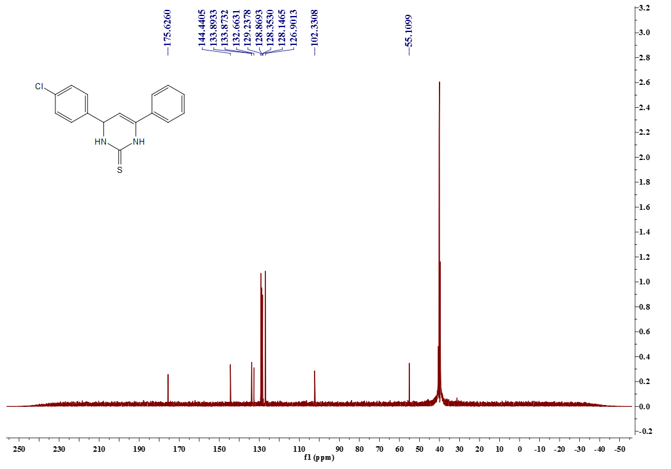

¹H- NMR spectrum of compound 4 (300 MHz, DMSO-d6 )
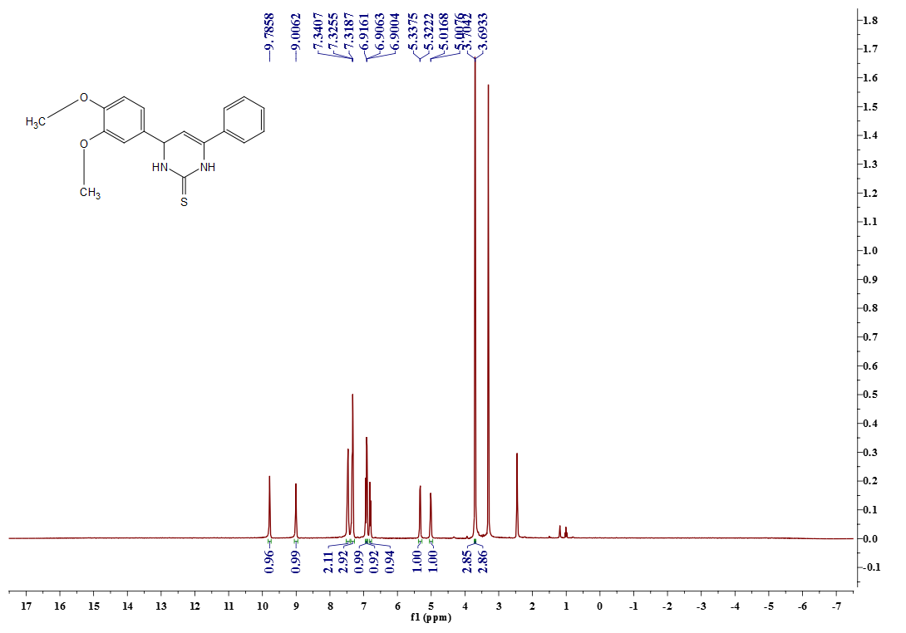

¹³C- NMR spectrum of compound 4 (75 MHz, DMSO-d6 )
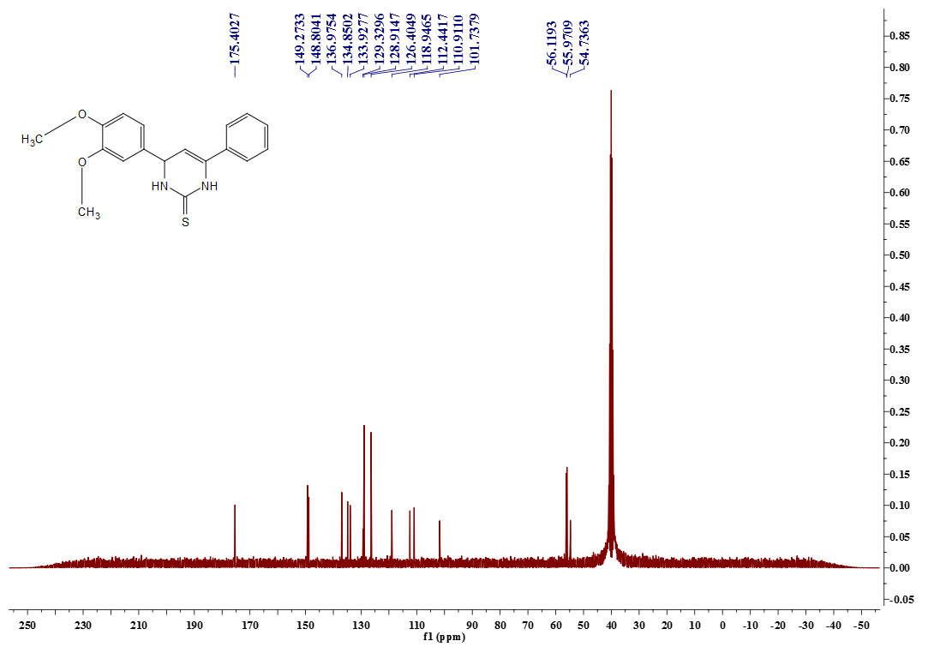

¹H- NMR spectrum of compound 5 (500 MHz, DMSO-d6)
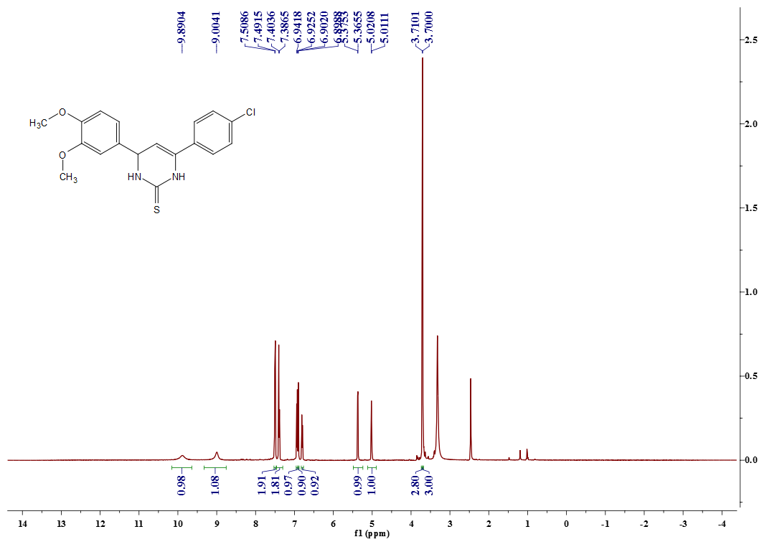

¹³C- NMR spectrum of compound 5 (125 MHz, DMSO-d6)
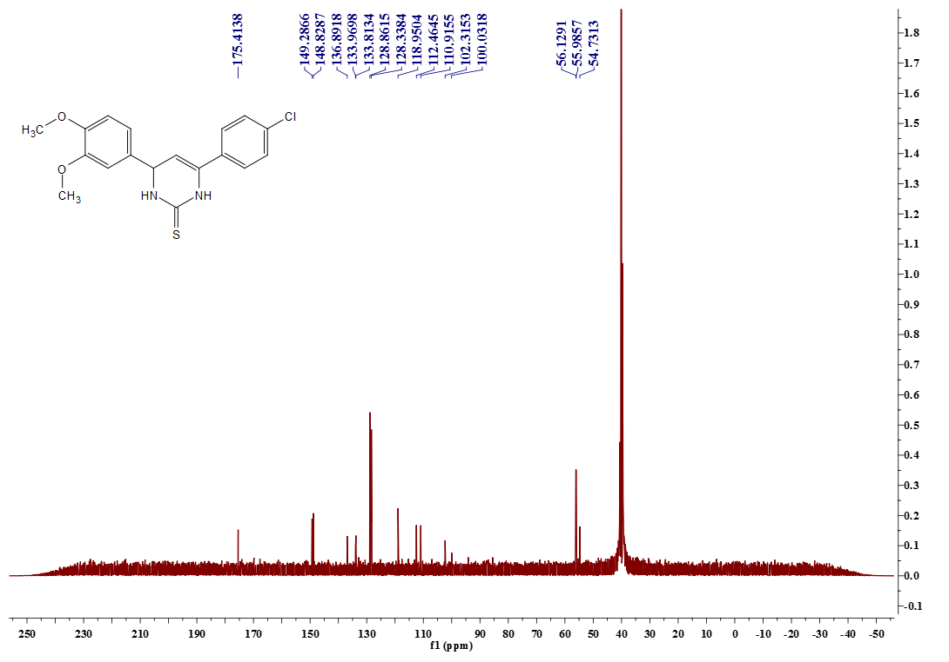

¹H –NMR spectrum of compound 6 (500 MHz, DMSO-d6)
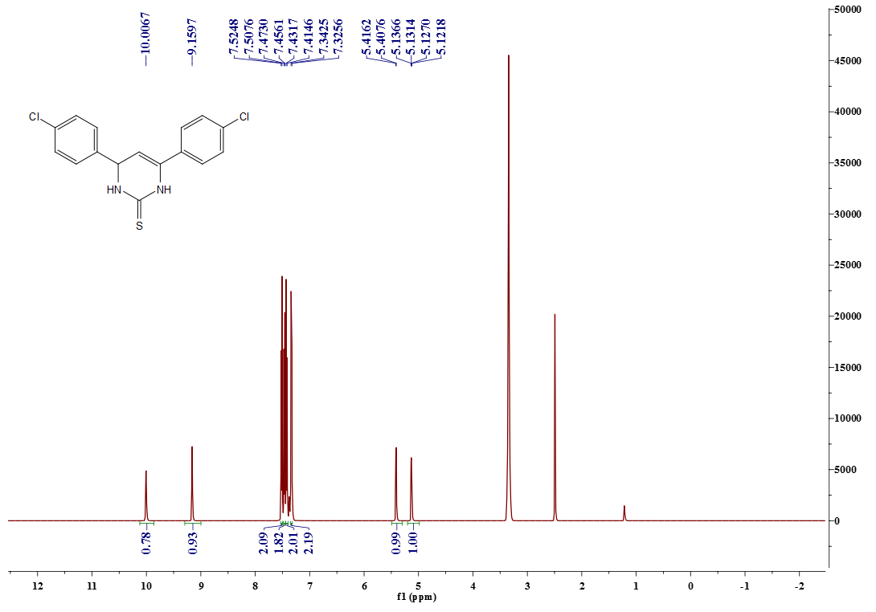

¹³C- NMR spectrum of compound 6 (125 MHz, DMSO-d6)
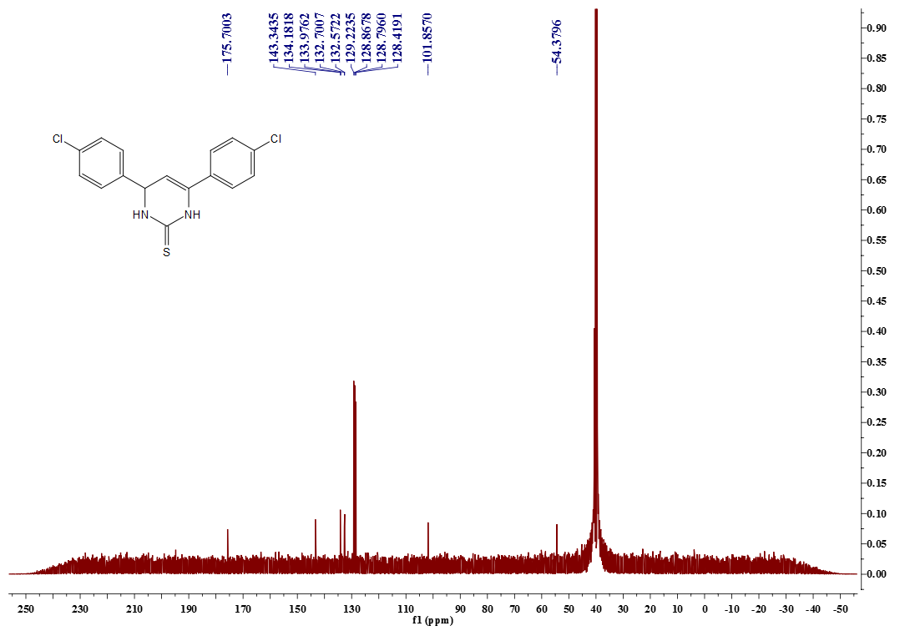

¹H- NMR spectrum of compound 7 (500 MHz, DMSO-d6 )
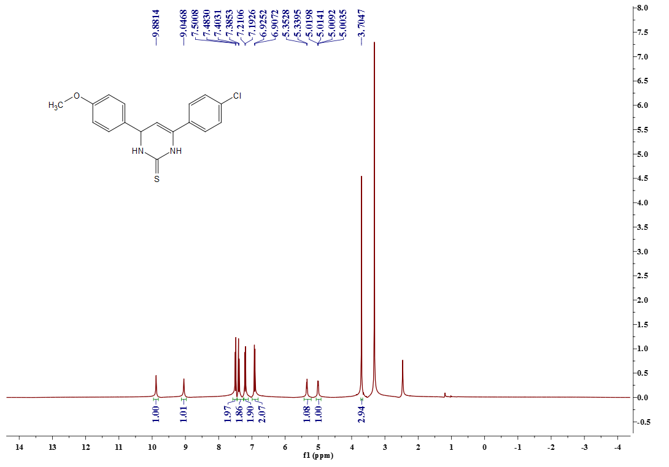

¹³C- NMR spectrum of compound 7 (125 MHz, DMSO-d6 )
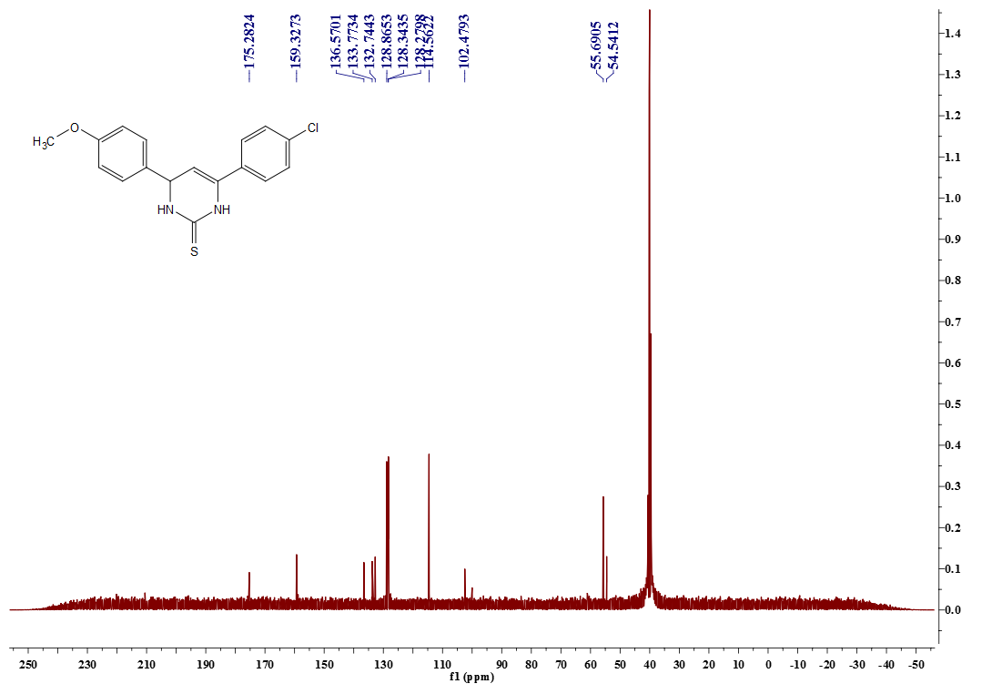

¹H- NMR spectrum of compound 8 (500 MHz, DMSO-d6 )
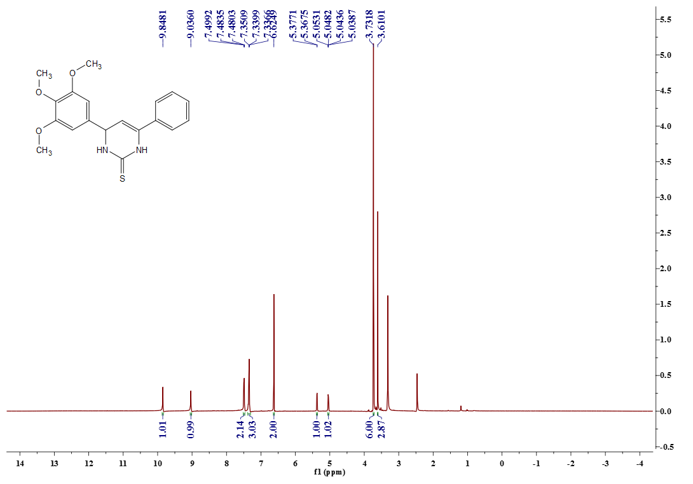

¹³C- NMR spectrum of compound 8 (125 MHz, DMSO-d6)
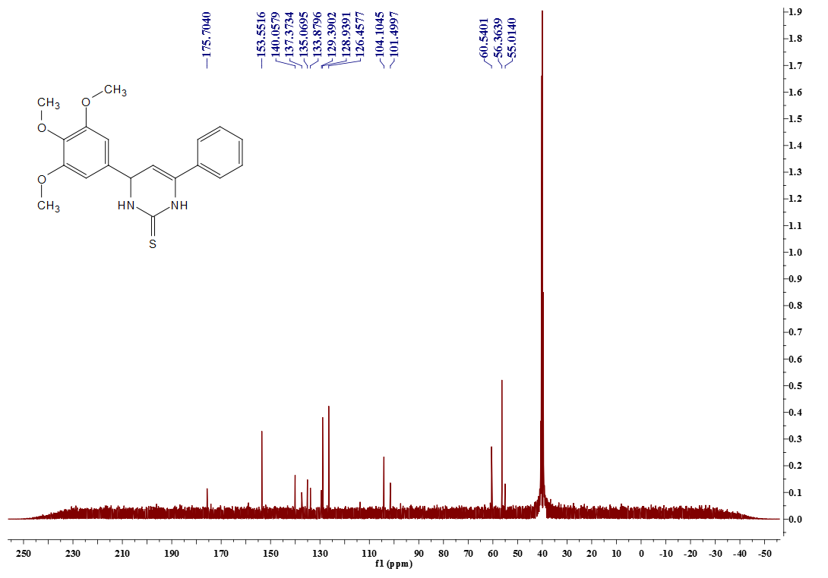

¹H- NMR spectrum of compound 9 (500 MHz, DMSO-d6 )
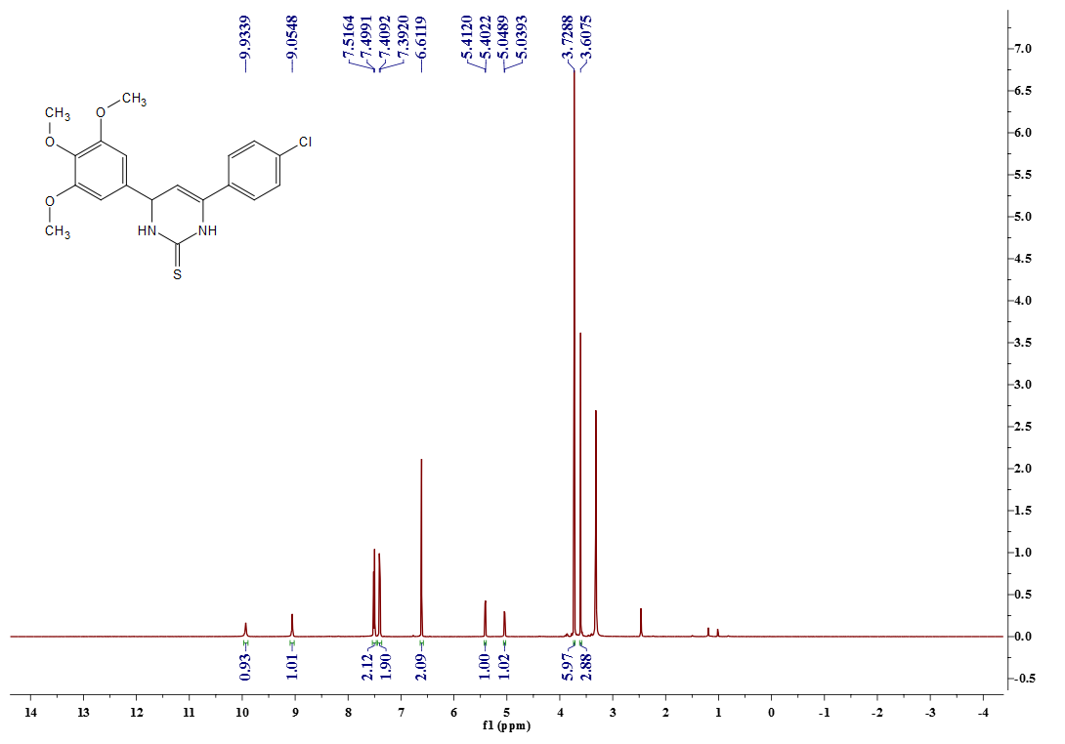

¹³C- NMR spectrum of compound 9 (125 MHz, DMSO-d6)
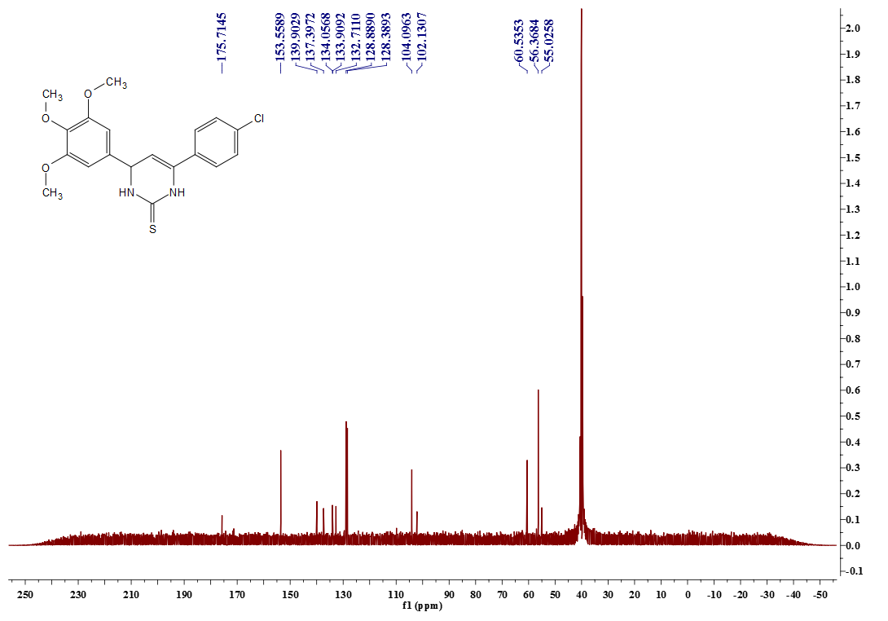

¹H- NMR spectrum of compound 10 (300 MHz, DMSO-d6 )
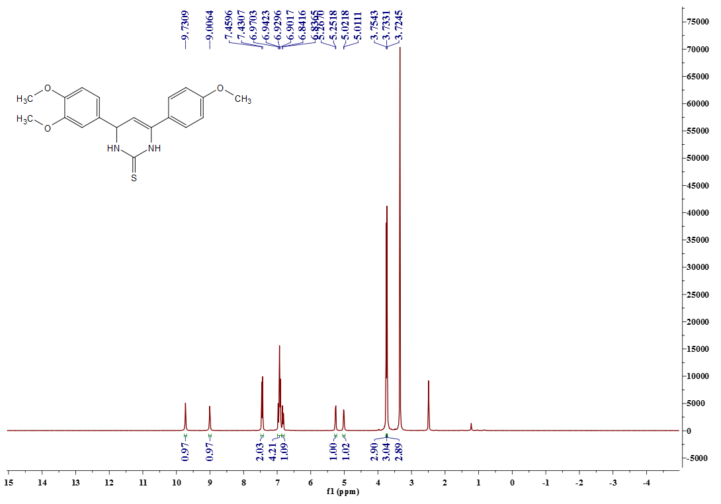

¹³C- NMR spectrum of compound 10 (125 MHz, DMSO-d6 )
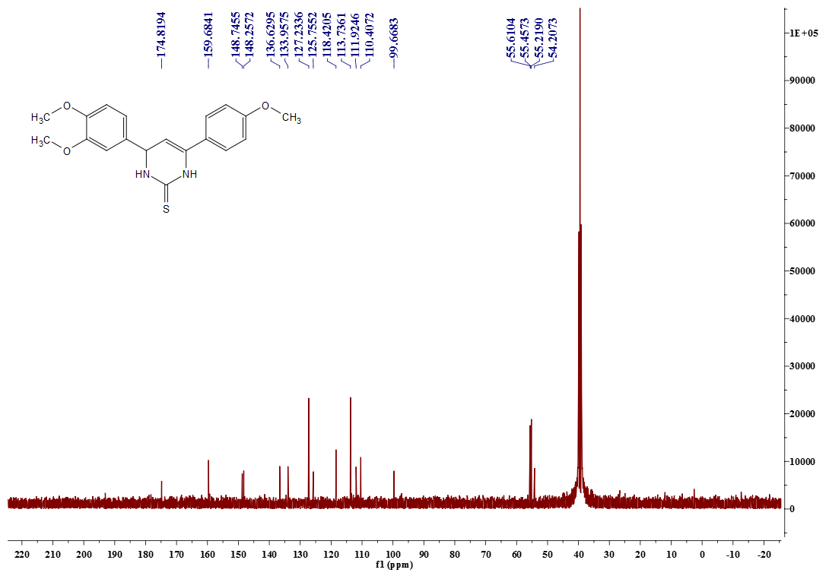

¹H- NMR spectrum of compound 11 (300 MHz, DMSO-d6 )
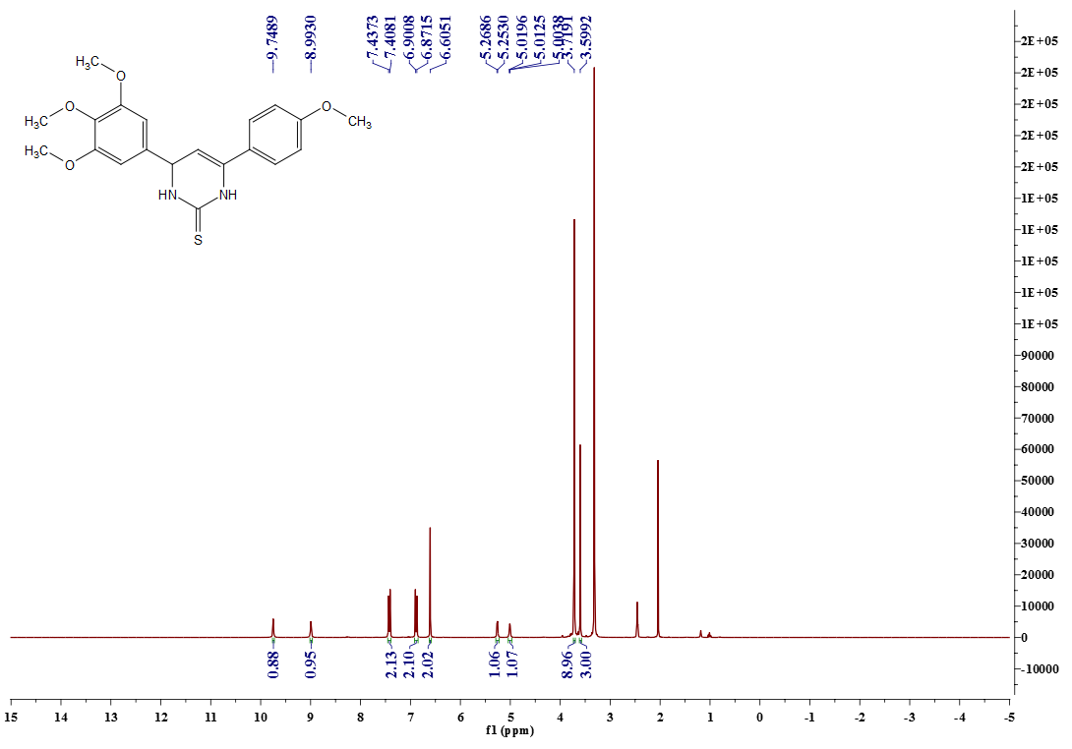

¹³C- NMR spectrum of compound 11 (75 MHz, DMSO-d6 )
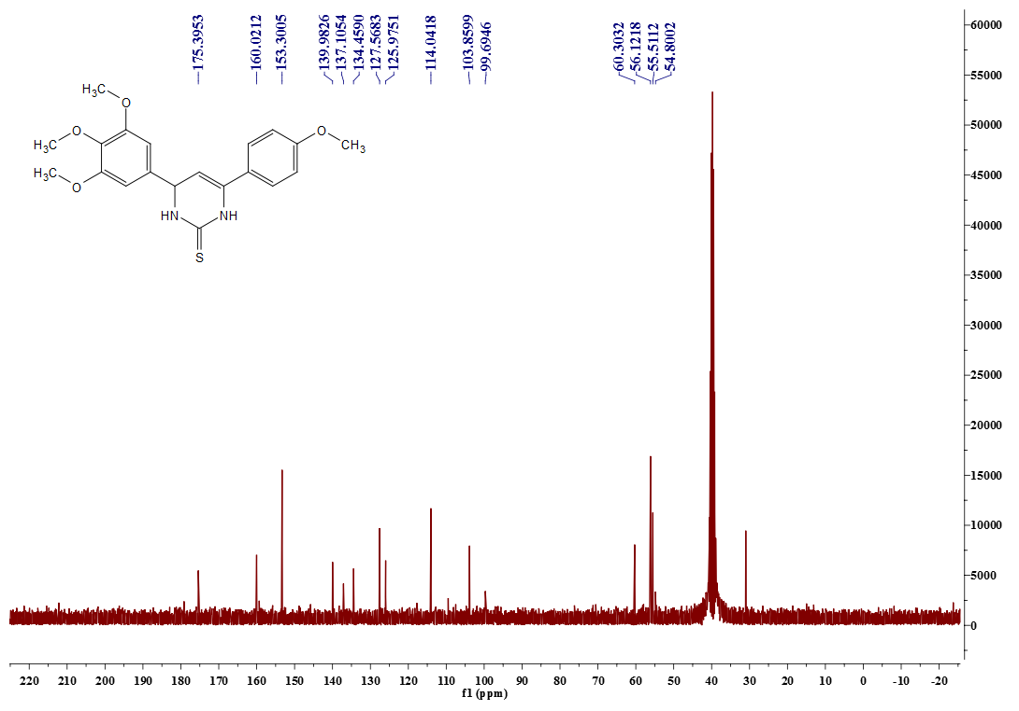

Copy of LC/MS of compound 5 in negative mode
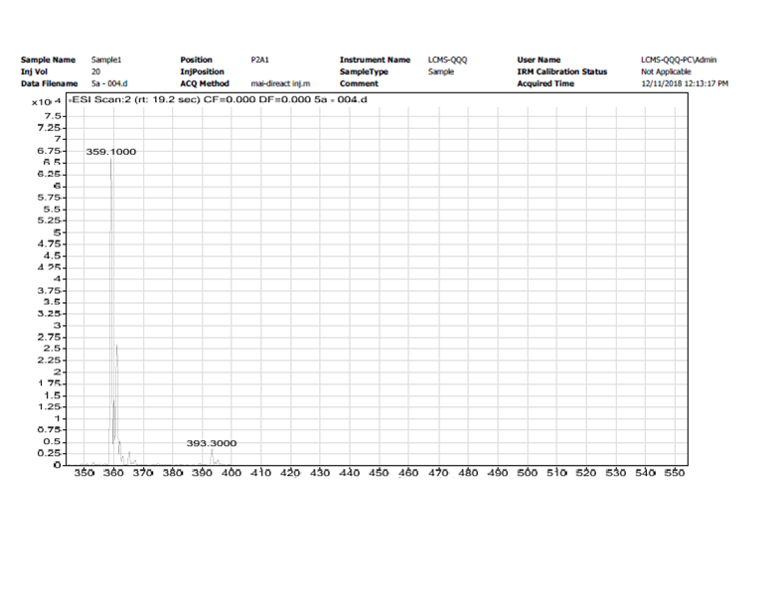

Copy of LC/MS of compound 8 in positive mode
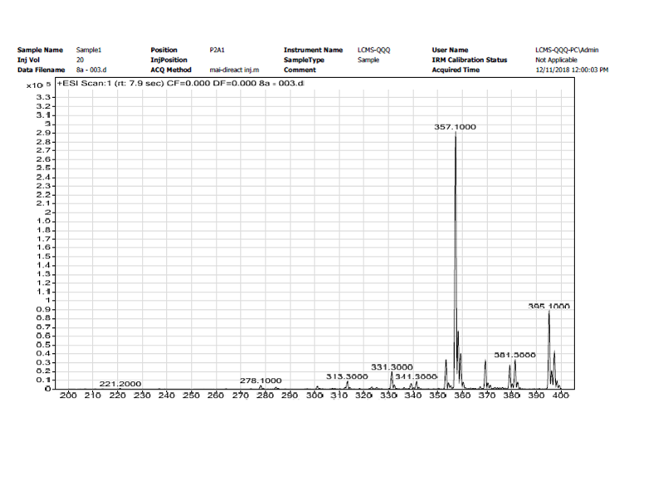

Copy of LC/MS of compound 8 in negative mode
