Table S1 Tukey Test values for friction angle
 | d_{s} = 0.005 m |  |  | d_{s} = 0.008 m
Orientation (°) | Mean difference (°) | p | F value | Mean difference (°) | p | F value
45-0 | -12.3100 | 0.000 | 98.803 | -9.11324 | 0.000 | 83.690
90-0 | -14.0699 | 0.000 |  | -11.65403 | 0.000
90-45 | -1.7598 | 0.000 |  | -2.54079 | 0.000

Table S2 Tukey test values for log diameter on entrainment depth.
D_{log} (m)
 | d_{s} = 0.005 m |  |  | d_{s} = 0.008 m
Parallel | Mean difference (m), | p | F value | Mean difference (m), | p | F value
0.04-0.03 | 0.0062 | 0.000 | 60.700 | 0.0061 | 0.002 | 52.965
0.05-0.03 | 0.0143 | 0.000 |  | 0.0146 | 0.000
0.05-0.04 | 0.0081 | 0.000 |  | 0.0085 | 0.000
Oblique
0.04-0.03 | 0.0023 | 0.007 | 33.372 | 0.0017 | 0.008 | 37.220
0.05-0.03 | 0.0049 | 0.000 |  | 0.0047 | 0.000
0.05-0.04 | 0.0026 | 0.003 |  | 0.0030 | 0.007
Transverse
0.04-0.03 | 0.0019 | 0.001 | 34.453 | 0.0014 | 0.055 | 22.993
0.05-0.03 | 0.0042 | 0.000 |  | 0.0041 | 0.000
0.05-0.04 | 0.0023 | 0.001 |  | 0.0026 | 0.002

Table S3 Tukey test values for log length on entrainment depth
L_{log} (m)
 | d_{s} = 0.005 m |  |  | d_{s} = 0.008 m
Parallel | Mean difference (m), | p | F value | Mean difference (m), | p | F value
0.20-0.15 | 0.0005 | 0.998 | 0.093 | 0.0005 | 0.997 | 0.111
0.25-0.15 | 0.0010 | 0.985 |  | 0.0015 | 0.955
0.25-0.20 | 0.0005 | 0.998 |  | 0.0010 | 0.987
0.30-0.15 | 0.0014 | 0.959 |  | 0.0013 | 0.971
0.30-0.20 | 0.0009 | 0.988 |  | 0.0007 | 0.994
0.30-0.25 | 0.0004 | 0.999 |  | -0.0002 | 0.999
Oblique
0.20-0.15 | -0.0008 | 0.864 | 1.189 | -0.0004 | 0.973 | 0.499
0.25-0.15 | -0.0017 | 0.363 |  | 0.0000 | 0.999
0.25-0.20 | -0.0009 | 0.820 |  | 0.0005 | 0.958
0.30-0.15 | -0.0016 | 0.410 |  | -0.0010 | 0.741
0.30-0.20 | -0.0008 | 0.861 |  | -0.0006 | 0.935
0.30-0.25 | 0.0000 | 0.999 |  | -0.0011 | 0.699
Transverse
0.20-0.15 | -0.0007 | 0.801 | 4.169 | 0.0000 | 1 | 0.765
0.25-0.15 | -0.0019 | 0.095 |  | 0.0000 | 0.999
0.25-0.20 | -0.0012 | 0.459 |  | -0.0001 | 0.999
0.30-0.15 | -0.0026 | 0.012 |  | -0.0012 | 0.595
0.30-0.20 | -0.0019 | 0.112 |  | -0.0012 | 0.584
0.30-0.25 | -0.0006 | 0.840 |  | -0.0011 | 0.647

Table S4 Tukey Test values for bed roughness and orientation on entrainment water depth
Bed sizes (m) | Difference of means (m) | Standard Error (m) | T-Value | p
0.005-0.008 | 0.001714 | 0.000383 | 4.48 | 0.000
Orientation (°)
45 - 90 | 0.001583 | 0.000469 | 3.38 | 0.002
0 - 90 | 0.016958 | 0.000469 | 36.19 | 0.000
0 - 45 | 0.015375 | 0.000469 | 32.81 | 0.000

Table S5 Tukey test values for blockage ratio on relative entrainment depth
D_{log} (m) | mean | p | F value
0.04-0.03 | -0.041 | 0.453 | 0.927
0.05-0.03 | -0.039 | 0.492
0.05-0.04 | 0.002 | 0.997

(a)
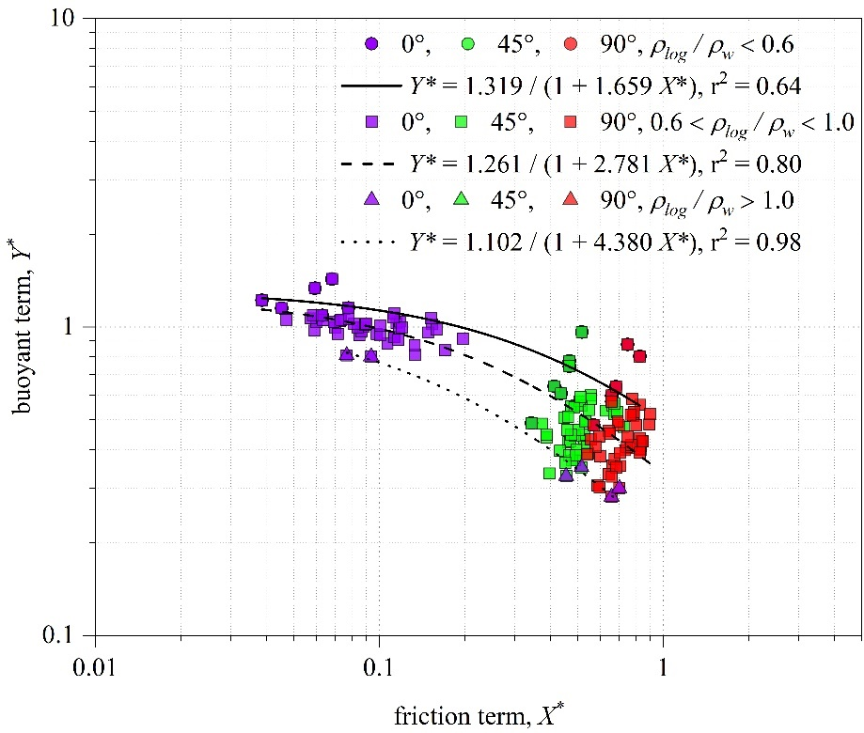
(b)
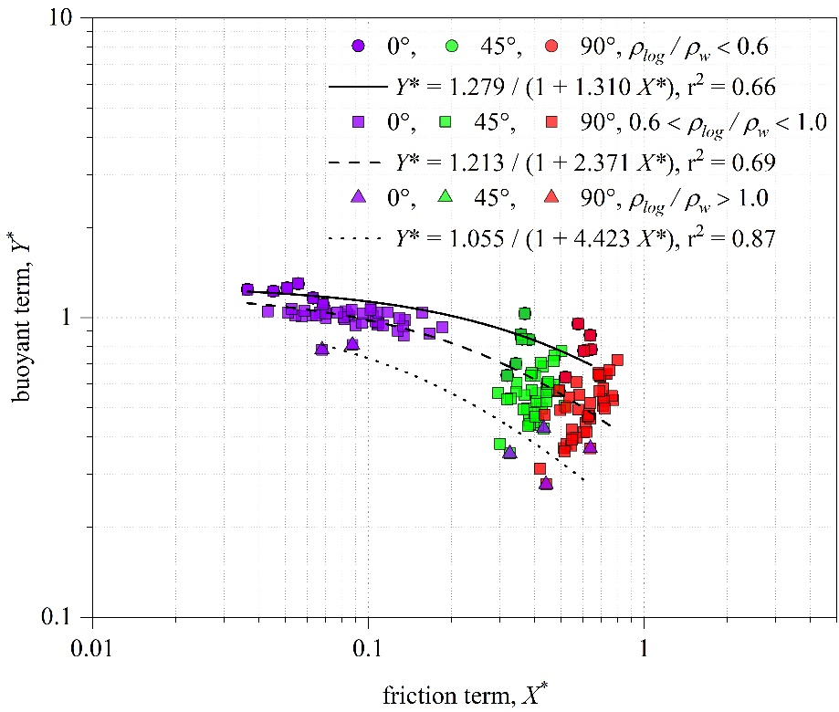
Figure S1. Plot of ${\text{Y}}_{\text{w}}^{\text{*}}$ against ${\text{X}}_{\text{S,R}}^{\text{*}}$ for three relative densities and the incipient motion equations for (a) d_{s} = 0.005 m and (b) d_{s} = 0.008 m

