Supplementary section

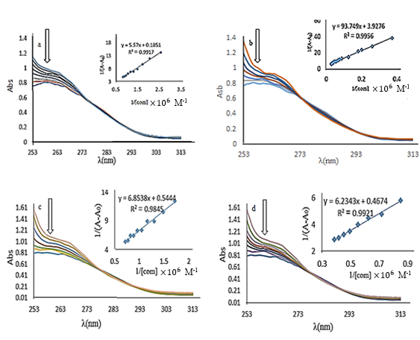
Fig. 16. Effect of [Pd(8-QO)(Ala)] (a), [Pd(8-QO)(Val)] (b), [Pd(8-QO)(Leu)] (c) and [Pd(8-QO)(Ile)] (d) on the absorption spectrum of CT-DNA at 300 K. The inset plots show corresponding K_{app} at 300K.

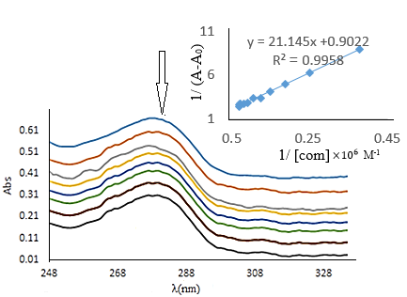
Fig. 17. Effect of [Pd(8-QO)(Leu)] on the absorption spectrum of BSA at 300 K. The inset plot shows corresponding K_{app} at 300 K.

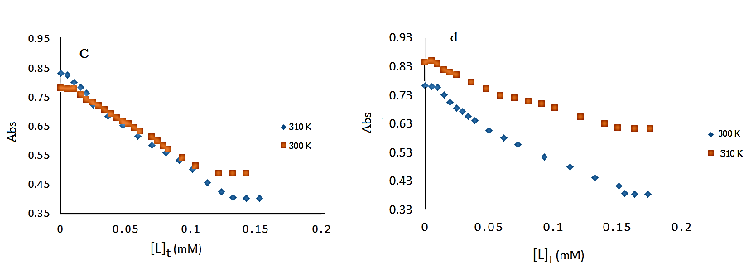
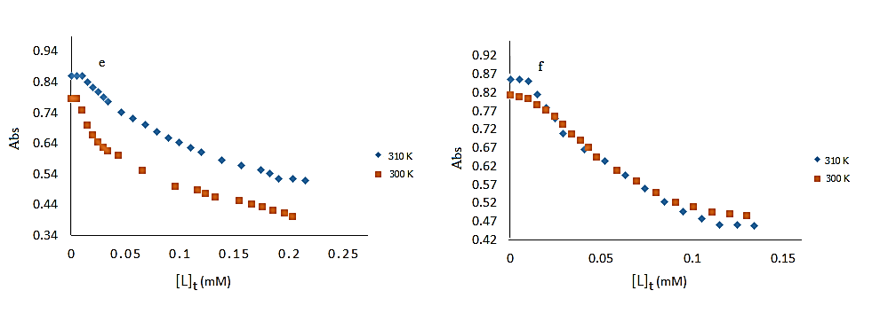
Fig. 18. the changes of absorbance of DNA at λ_{max} = 260 nm due to increasing the concentration of [Pd(8-QO)(AA)] (where AA = Ala (c), Val (d), Leu (e), Ile (f) at temperatures of 300 and 310 K.

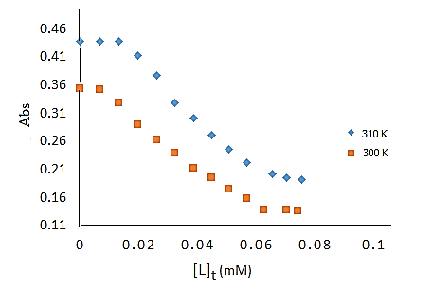
Fig. 19. The changes of absorbance of BSA at λ_{max} = 280 nm due to increasing the concentration of [Pd(8-QO)(Leu)] at temperatures of 300 and 310 K.

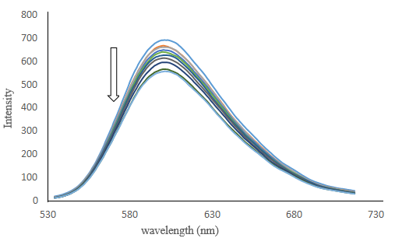
Fig. 20. The emission spectra of DNA-EB due to increasing the concentration of [Pd(8-QO)(Leu)] complex.

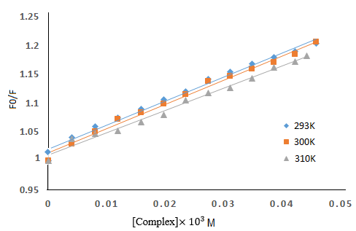
Fig. 21. Stern-Volmer plots of quenching of DNA-EB fluorescence by [Pd(8-QO)(Leu)] at different temperatures (293, 300 and 310 K).

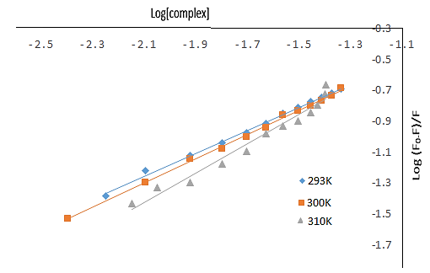
Fig. 22. Plot of log(F₀-F)/F versus log[complex] of CT-DNA interaction with [Pd(8-QO)(Leu)] at different temperatures (293,300 and 310 K).

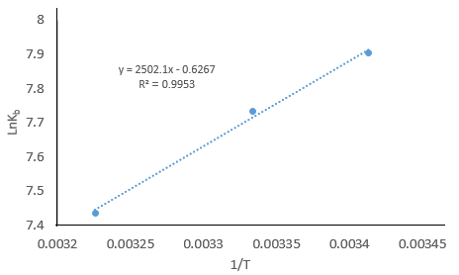

Fig. 23. The van't Hoff plot in the intereaction of [Pd(8-QO)(Leu)] with DNA-EB at different temperatures (293, 300 and 310 K).

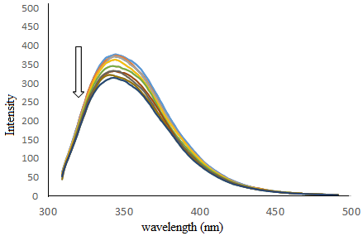
Fig. 24. The emission spectra of BSA due to increasing the concentration of [Pd(8-QO)(Leu)].

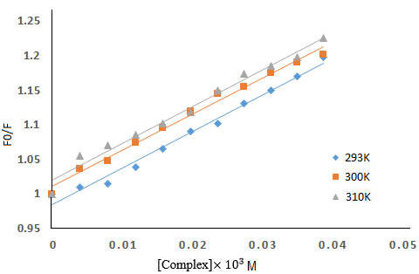
Fig. 25. Stern-Volmer plots of quenching of BSA fluorescence by [Pd(8-QO)(Leu)] at different temperatures (293, 300 and 310 K).

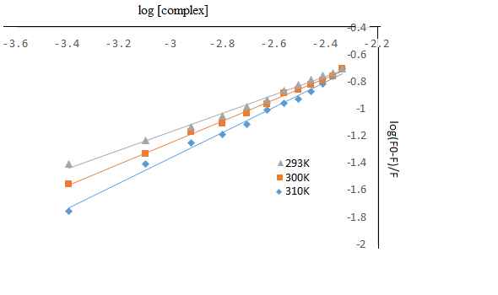
Fig. 26. Plots of log(F₀–F)/F versus log[complex] of BSA interaction with [Pd(8-QO)(Leu)] at different temperatures (293, 300 and 310 K).

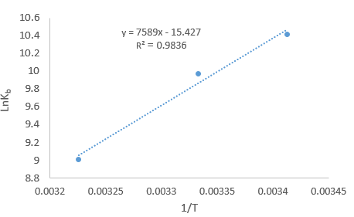
Fig. 27. The van't Hoff plot in the interaction of [Pd(8-QO)(Leu)] with BSA at difference temperatures (293, 300 and 310 K).

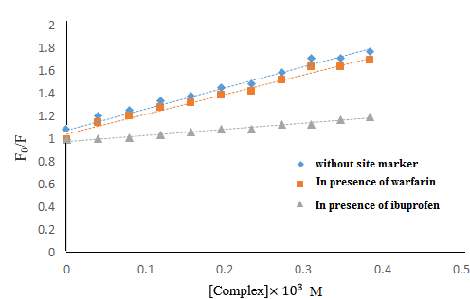
Fig. 28. The Stern-Volrmer plots corresponding to the effect of site marker (warfarin or ibuprofen) to the [Pd(8-QO)(leu)]–BSA systems at 300 K.

