Supplemental Material
Reaction of dirhodium(II) tetraacetate with S-methyl-L-cysteine

Table of Contents
Figure S1. FT-IR spectra of top) Rh₂(AcO)₄, middle) solid S-methyl-L-cysteine and.................S2
bottom) crystals of [Rh₂(AcO)₄(L-HSMC)₂]⋅3H₂O (3⋅3H₂O).
Calculation of Stability Constants for Rh₂(AcO)₄ – HSMC Adducts.........................................S3
Figure S2. UV-vis peak fitting of bands at 279 and 304 nm (from Figure 1) .......................S3, S4
Table S1. Peak area from UV-vis peak fittings (from Figure S2).................................................S5
Table S2. Calculated relative concentrations of Rh(II) species and formation constants……….S6
Table S3. Crystal data and structure refinement for complex (3 + 3H₂O)....................................S7
Table S4. Selected bond lengths (Å) and angles (deg) for complex (3 + 3H₂O)..........................S8
Figure S3. ESI-MS (+ ion mode) time study of the Rh₂(AcO)₄ – HSMC reaction at room temperature over 28 days S9
Figure S4. ESI-MS (- ion mode) time study of the Rh₂(AcO)₄ – HSMC reaction at room temperature over 28 days S10
Table S5. Assignment of mass peaks in the ESI-mass spectra shown in Figures S3 and S4 S11
Figure S5. ESI-MS (+ and – ion modes) time study of the Rh₂(AcO)₄ – HSMC reaction at
40 °C over 4 days S12
Figure S6. UV-vis spectrum of the Rh₂(AcO)₄ – HSMC reaction after reflux (100 °C) S13
Figure S7. ESI-mass spectra (+ and - ion mode) of Rh₂(AcO)₄ – HSMC reaction after
reflux (100 °C) S13
Figure S8. ESI-mass spectra (+ and - ion mode) of Rh₂(AcO)₄ – HSMC reaction (100 °C
reflux) after passing through Sephadex G-15 column S14

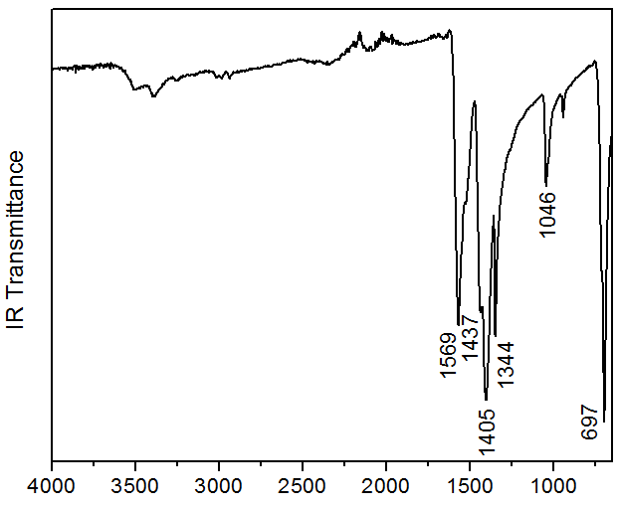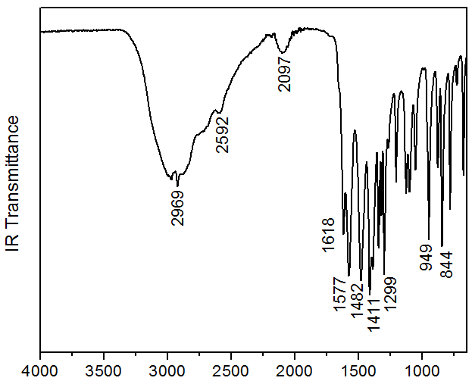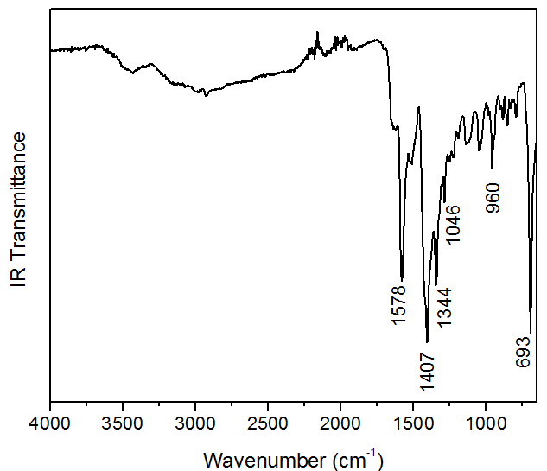
Figure S1. FT-IR spectra of solid samples: top) Rh₂(AcO)₄, middle) S-methyl-L-cysteine, and bottom) [Rh₂(AcO)₄(L-HSMC)₂] (3; dried crystals).

Calculation of Stability Constants for Rh₂(AcO)₄ Adducts with S-methyl-L-Cysteine

The formation constants of adducts ([Rh₂(AcO)₄(H₂O)(HSMC)] (2) and ([Rh₂(AcO)₄(HSMC)₂] (3) were determined through peak fitting of the bands at 279 and 304 nm in the UV-vis spectra shown in Figure 1, using the Origin Pro program. The peak-fitting results are presented in Figure S2, and the relative peak areas are summarized in Table S1.

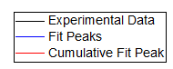
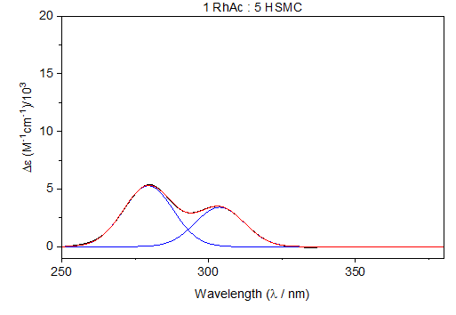
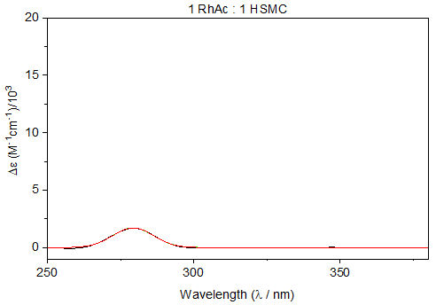
Mole ratio 1:1
Mole ratio 1:5

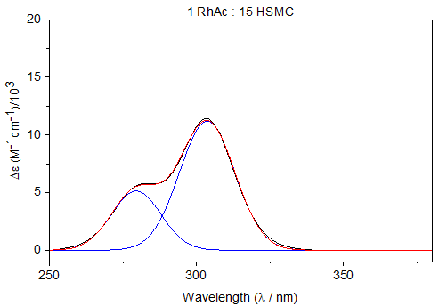
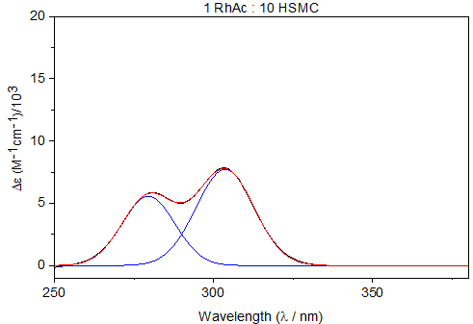
Mole ratio 1:10
Mole ratio 1:15

Figure S2. Fitting results of the peaks at 279 and 304 nm in the UV-vis absorption spectra obtained when titrating a 2.01 mM Rh₂(AcO)₄ with different mole ratios of S-methyl-L-cysteine (Figure 1). The peak-fitting procedure was perfomed in the 250-380 nm range, using Origin Pro program. Areas under theses peaks were also determined (see Table S1).

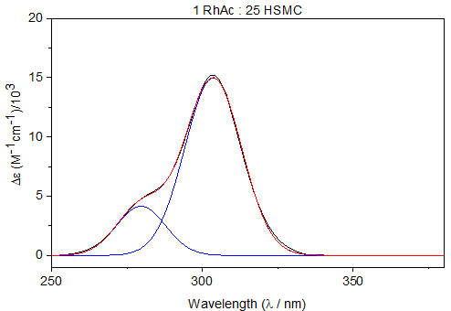
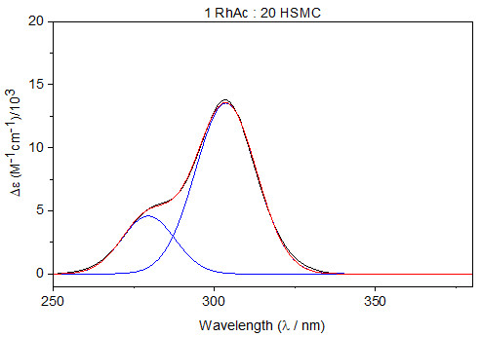
Mole ratio 1:20
Mole ratio 1:25

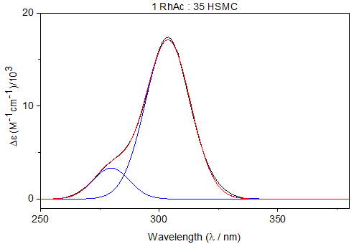
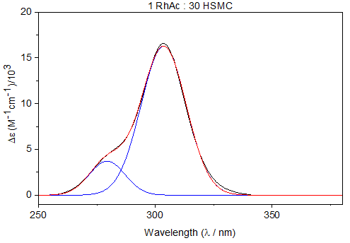
Mole ratio 1:35
Mole ratio 1:30

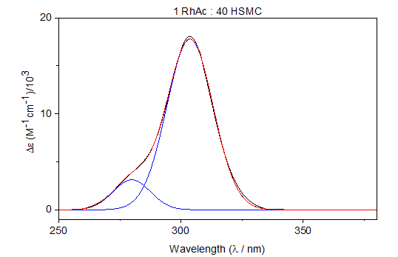
Mole ratio 1:40

Figure S2 (continued). Fitting results of the peaks at 279 and 304 nm in the UV-vis absorption spectra obtained when titrating a 2.01 mM Rh₂(AcO)₄ with different mole ratios of S-methyl-L-cysteine (Figure 1). The peak-fitting procedure was perfomed in the 250-380 nm range, using Origin Pro program. Areas under theses peaks were also determined (see Table S1).

Table S1. Peak areas (at 279 and 304 nm) from the fitting procedure in Figure S2, and the resulting relative percentages of the aqua, mono- and di-adducts in solution throughout the titration of Rh₂(AcO)₄ with S-methyl-L-cysteine, monitored by UV-vis spectroscopy (Figure 1).
Rh₂(AcO)₄ : HSMC Mole ratio | Peak area (279 nm) | Peak area (304 nm) | Rh₂(AcO)₄(H₂O)₂ (%) | Adduct 2 (%) | Adduct 3 (%)
1 : 1 | 29.95964 |  | ~ 89 | 6 | ~5 ª
1 : 5 | 112.09159 | 71.49623 | 62 | 23 | 15
1 : 10 | 115.74142 | 175.9307 | 40 | 24 | 36
1 : 15 | 108.26937 | 262.89636 | 23 | 22 | 55
1 : 20 | 94.72852 | 320.146 | 14 | 20 | 66
1 : 25 | 84.71037 | 353.97618 | 9 | 18 | 73
1 : 30 | 71.27064 | 393.54038 | < 5 | 15 | 82
1 : 35 | 63.48114 | 408.28757 | < 5 | 13 | 85
1 : 40 | 59.46218 | 422.67291 | 0 ^{b} | 12 | 88
ª Estimated from the observed shift of the peak at 584 nm in the visible region. ^{b} Assumed to be negligible in presence of excess HSMC.

Table S2. Calculated relative concentrations* of the aqua, mono- and di-adducts, as well as [HSMC] in solution (Figure 1), based on the data in Table S1, and calculated formation constants.
Rh₂(AcO)₄ : HSMC Mole ratio | Rh₂(AcO)₄(H₂O)₂ (mM) | Adduct 2 (mM) | Adduct 3 (mM) | [HSMC]_{total}  (mM) | [HSMC]  (mM) | K₁ | K₂
1 : 1 | 1.78 | 0.12 | ~0.10 | 2.00 | 1.68 | 0.0401
1 : 5 | 1.24 | 0.46 | 0.30 | 10.00 | 8.94 | 0.0415 | 0.0730
1 : 10 | 0.80 | 0.48 | 0.72 | 20.00 | 18.08 | 0.0332 | 0.0830
1 : 15 | 0.46 | 0.44 | 1.10 | 30.00 | 27.36 | 0.0350 | 0.0914
1 : 20 | 0.28 | 0.40 | 1.32 | 40.00 | 36.96 | 0.0387 | 0.0893
1 : 25 | 0.18 | 0.36 | 1.46 | 50.00 | 46.72 | 0.0428 | 0.0868
1 : 30 | ~0.06 | 0.30 | 1.64 | 60.00 | 56.42 |  | 0.0969
1 : 35 | < 0.05 | 0.26 | 1.70 | 70.00 | 66.34 |  | 0.0986
1 : 40 | < 0.05 | 0.24 | 1.76 | 80.00 | 76.24 |  | 0.0962
Average |  |  |  |  |  | 0.0385 ± 0.0038 | 0.0894 ± 0.0085
* The concentration of each Rh(II) species at equilibrium was calculated by multiplying their relative % (Table S1) by the total concentration of Rh₂(AcO)₄ (C₁ = 2.00 mM; see Figure 1).

Formation constants of adducts 2 and 3 were estimated based on the following equilibria:

[Rh₂(AcO)₄(H₂O)₂] + HSMC ↔ [Rh₂(AcO)₄(H₂O)(HSMC)]
K₁ = [2] / [Rh₂(AcO)₄(H₂O)₂] [HSMC]
[Rh₂(AcO)₄(H₂O)(HSMC)]+ HSMC ↔ [Rh₂(AcO)₄(HSMC)₂]
K₂ = [3] / [2] [HSMC]

Table S3. Crystal data and structure refinement for [Rh₂(AcO)₄(L-HSMC)₂]⋅3H₂O (3 + 3H₂O).ª
Chemical formula | C₁₆H₃₆N₂O₁₅Rh₂S₂
Formula weight (g mol⁻¹) | 766.41
Crystal system | Monoclinic
Space group | C2
a (Å) | 29.572(4)
b (Å) | 14.403(2)
c (Å) | 8.2360(13)
α (deg) | 90
β (deg) | 94.067(5)
γ (deg) | 90
V (Å³) | 3499.3(9)
Z | 4
D_{calcd} (g/cm³) | 1.455
T (K) | 100
λ (Å) | 0.71073 (Mo K_{α})
(μ / mm⁻¹) | 1.118
F (000) | 1552.0
2θ range for data collection (deg) | 3.146 – 56.806
R₁, wR₂ [I > 2σ(I)] | 0.0440, 0.11195
ª R₁ = Σ║F₀ – F_{c}║/ Σ│F₀│; wR₂ = [Σ w(F₀² – F_{c}²)² / [Σ w(F₀²)²]^{1/2}

Table S4. Selected bond lengths (Å) and angles (deg) for complex (3 + 3H₂O).
Bond | Distance (Å)
Rh(1)-Rh(2) | 2.4010(7)
Rh(1)-S(1) | 2.475(2)
Rh(1)-O(5) | 2.045(7)
Rh(1)-O(7) | 2.057(8)
Rh(1)-O(9) | 2.042(7)
Rh(1)-O(11) | 2.052(6)
Rh(2)-S(2) | 2.483(2)
Rh(2)-O(6) | 2.037(7)
Rh(2)-O(8) | 2.020(7)
Rh(2)-O(10) | 2.028(7)
Rh(2)-O(12) | 2.029(7)
Bond angle | Degree
Rh(2)-Rh(1)-S(1) | 176.35(6)
O(5)-Rh(1)-Rh(2) | 88.16(18)
O(5)-Rh(1)-S(1) | 95.1(2)
O(7)-Rh(1)-Rh(2) | 88.52(19)
O(7)-Rh(1)-S(1) | 93.2(2)
O(9)-Rh(1)-Rh(2) | 87.65(19)
O(9)-Rh(1)-S(1) | 89.1(2)
O(11)-Rh(1)-Rh(2) | 86.99(19)
O(11)-Rh(1)-S(1) | 91.4(2)
Rh(1)-Rh(2)-S(2) | 178.35(6)
O(6)-Rh(2)-Rh(1) | 87.74(19)
O(6)-Rh(2)-S(2) | 91.6(2)
O(8)-Rh(2)-Rh(1) | 87.53(19)
O(8)-Rh(2)-S(2) | 91.0(2)
O(10)-Rh(2)-Rh(1) | 88.2(2)
O(10)-Rh(2)-S(2) | 92.5(2)
O(12)-Rh(2)-Rh(1) | 88.7(2)
O(12)-Rh(2)-S(2) | 92.8(2)

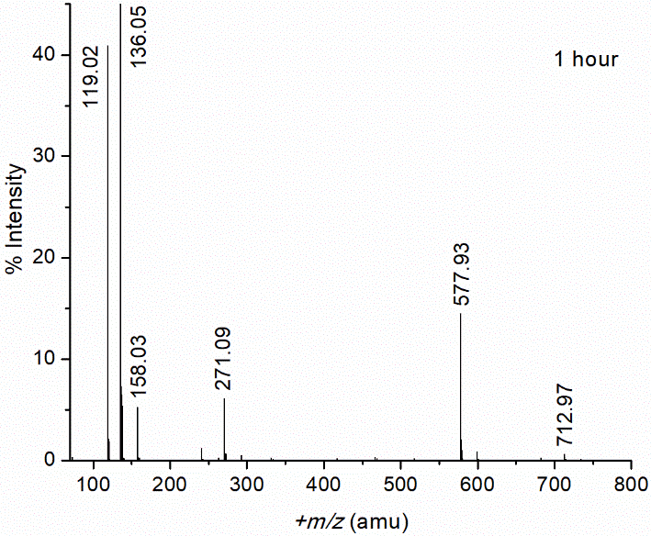

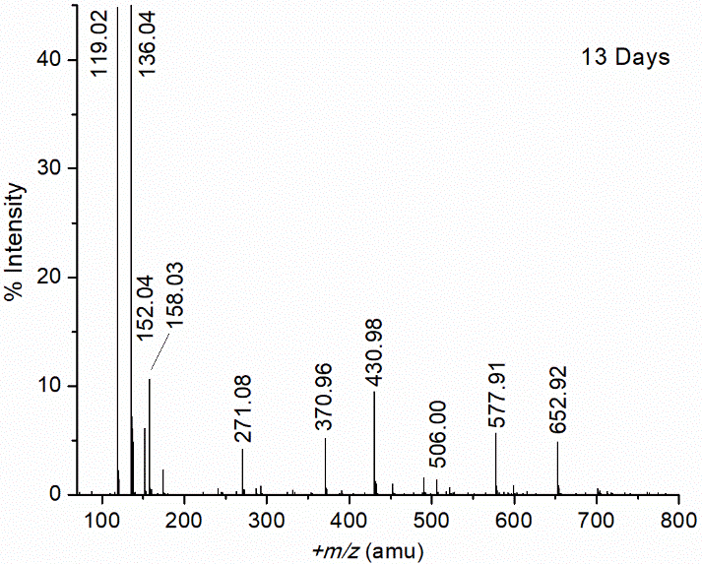
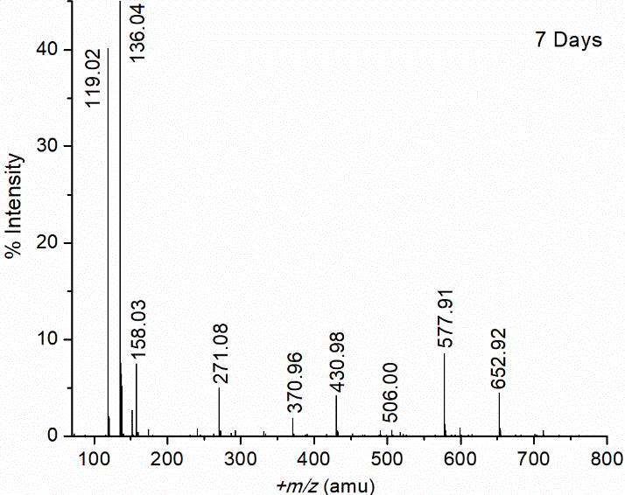

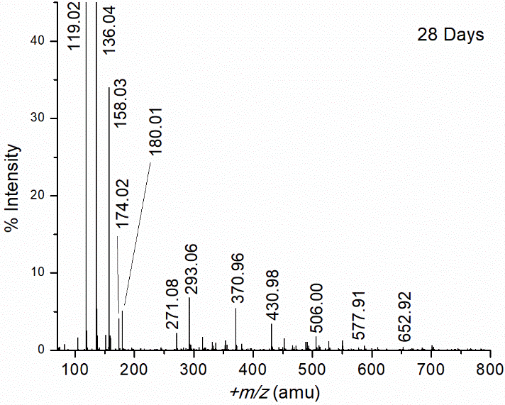

Figure S3. ESI-mass spectra (+ ion mode) of a Rh₂(AcO)₄ aqueous solution containing HSMC in excess (C_{Rh2} = 2.01 mM, C_{HSMC} = 79.8 mM; pH = 4.81; 25 °C) over a period of 28 days; for peak assignments, see Table S5. The mass peak at +m/z = 136.04 amu [HSMC + H⁺]⁺ was given 100% intensity. (Selected observed (at 13 days) and calculated isotopic patterns are also shown).

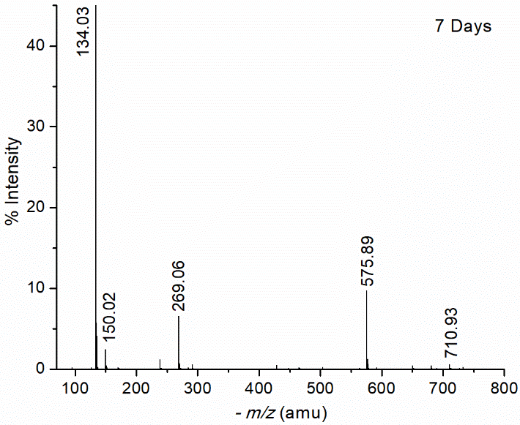
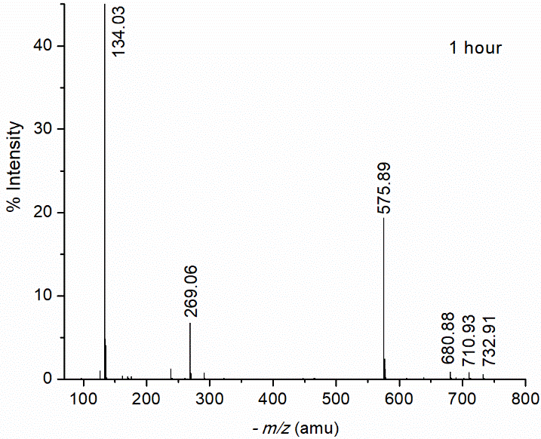

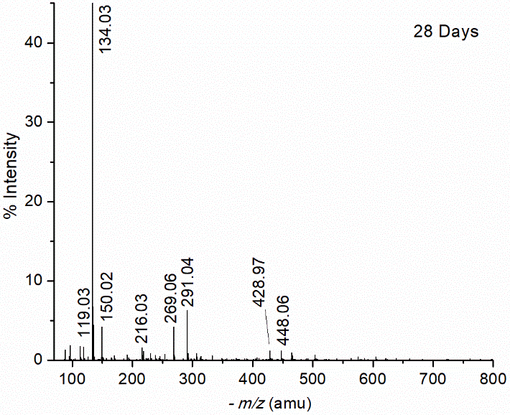
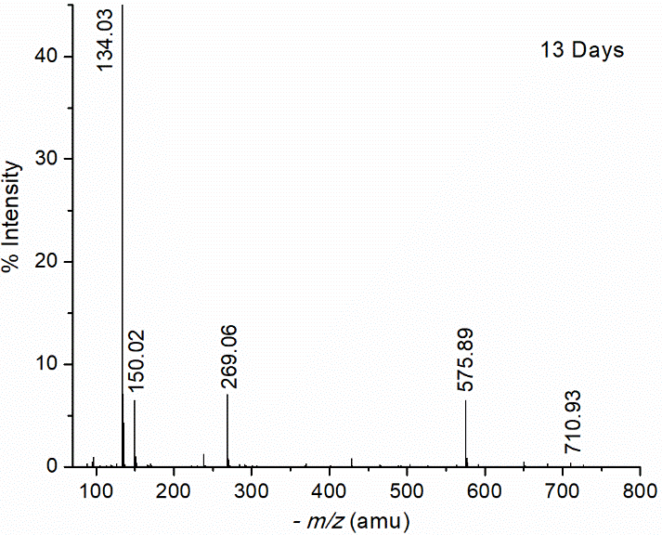

Figure S4. ESI-mass spectra (- ion mode) of a Rh₂(AcO)₄ aqueous solution containing excess S-methyl-L-cysteine (C_{Rh2} = 2.01 mM, C_{HSMC} = 79.8 mM; pH = 4.81; 25 °C) over a period of 28 days; for peak assignments, see Table S5. The mass peak at -m/z = 134.03 (SMC⁻) was given 100% intensity.

Table S5. Assignment of mass peaks in the ESI-mass spectra (+ and – ion modes) shown in Figures S3-S5 and S7. ª
+m/z | Assignment | -m/z | Assignment
104.99 | [AcO⁻ + 2Na⁺]⁺
119.02 | [HSMC – NH₂]⁺ | 119.03 | [2AcO⁻ + H⁺]⁻
136.04 | [HSMC + H⁺]⁺ | 134.03 | SMC⁻
152.04 | [HSMC + O + H⁺]⁺ | 150.02 | [SMC⁻ + O]⁻
158.03 | [HSMC + Na⁺]⁺
174.02 | [HSMC + Na⁺ + O]⁺ | 170.00 | [HSMC + Cl⁻]⁻
180.01 | [SMC⁻ + 2Na⁺]⁺
 |  | 216.03 | [SMC⁻ + AcO⁻ + Na⁺]⁻
271.08 | [2HSMC + H⁺]⁺ | 269.06 | [2HSMC - H⁺]⁻
293.06 | [2HSMC + Na⁺]⁺ | 291.04 | [2SMC⁻ + Na⁺]⁻
370.96 | [Rh^{III} + 2SMC⁻]⁺
430.98 | [Rh^{III} + 2SMC⁻ + AcO⁻ + H⁺]⁺ | 428.97 | [Rh^{III} + 2SMC⁻ + AcO⁻ - H⁺]⁻
 |  | 448.06 | [3SMC⁻ + 2Na⁺]⁻
506.00 | [Rh^{III} + 3SMC⁻ + H⁺]⁺
577.91 | [2Rh^{II} + HSMC + 4AcO⁻ + H⁺]⁺ | 575.89 | [2Rh^{II} + HSMC + 4AcO⁻ - H⁺]⁻
599.89 | [2Rh^{II} + HSMC + 4AcO⁻ + Na⁺]⁺
 |  | 639.01 | [Rh^{III} + 4SMC⁻]⁻
652.92 | [2Rh^{II} + 2HSMC + 3AcO⁻]⁺
712.97 | [2Rh^{II} + 2HSMC + 4AcO⁻ + H⁺]⁺ | 710.93 | [2Rh^{II} + 2HSMC + 4AcO⁻ - H⁺]⁻
ª HSMC = C₄H₉NO₂S; AcO⁻ = CH₃COO⁻

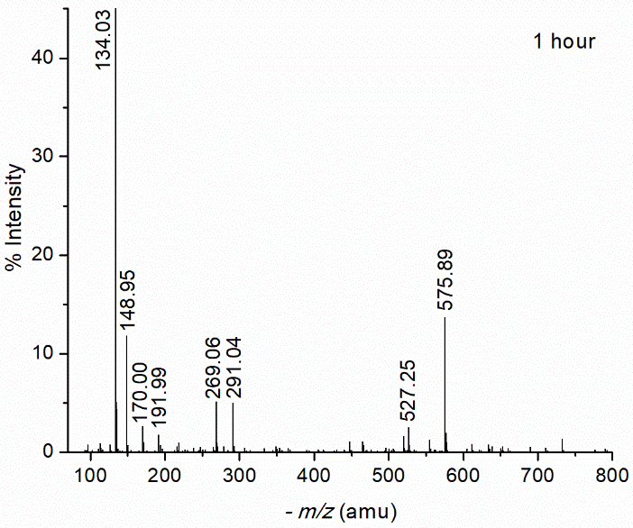
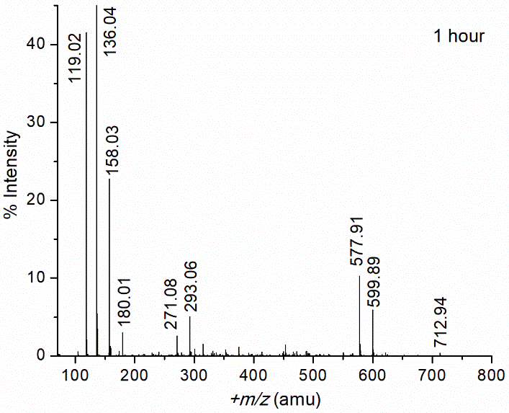

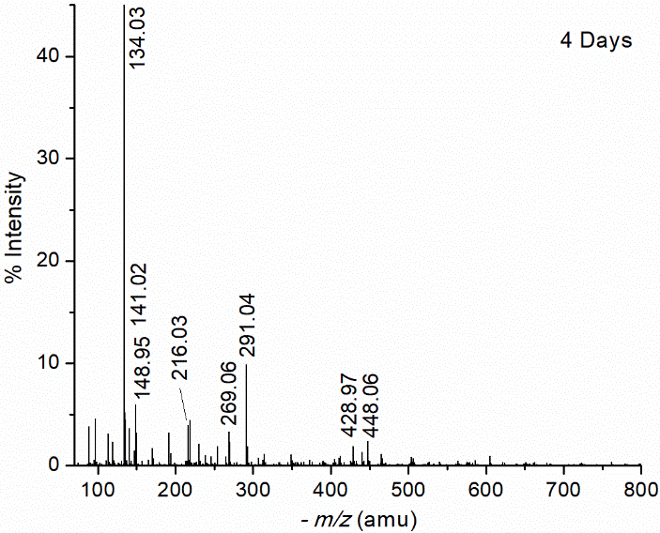
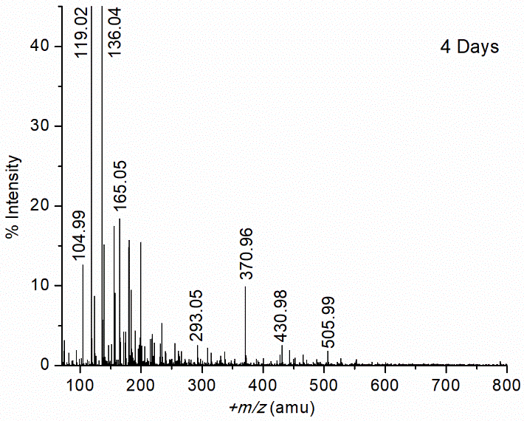

Figure S5. Left) (+) ion mode, and right) (-) ion mode ESI-mass spectra of a [Rh₂(AcO)₄ solution with excess S-methyl-L-cysteine (C_{Rh2} = 2.01 mM, C_{SMC} = 79.8 mM; pH = 4.81; 40 °C) at 1 h, 24 h and 4 days after initial mixing. The mass peaks at +m/z = 136.03 [HSMC + H⁺]⁺ and -m/z = 134.03 (SMC⁻) were assigned 100% intensity. For peak assignments, see Table S5.
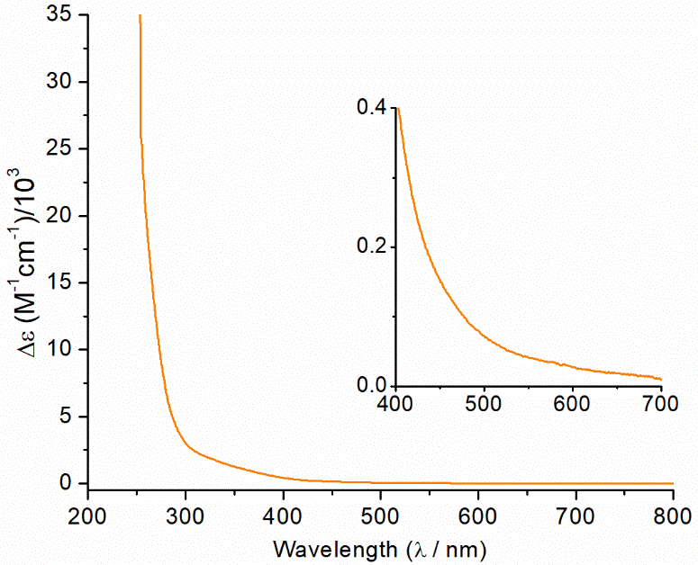

Figure S6. UV-vis absorption spectrum of Rh₂(AcO)₄ in aqueous solution with excess S-methyl-L-cysteine (C_{Rh2} = 2.01 mM, C_{HSMC} = 79.8 mM; pH = 4.81) after 1 h reflux at 100 °C.

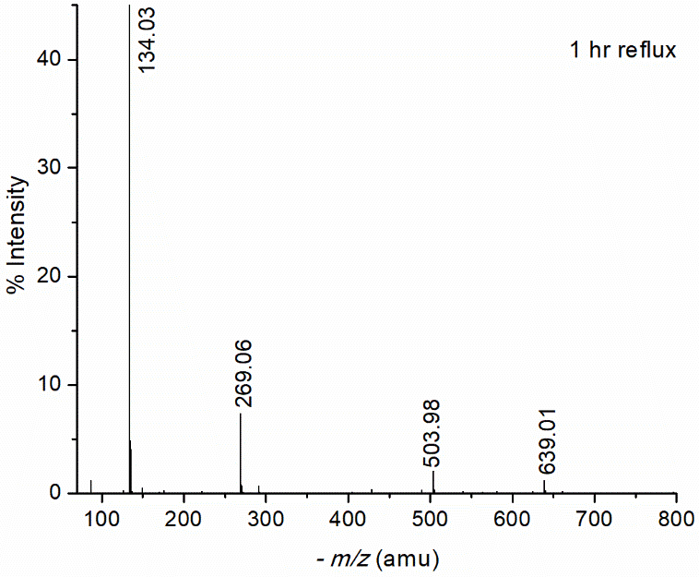
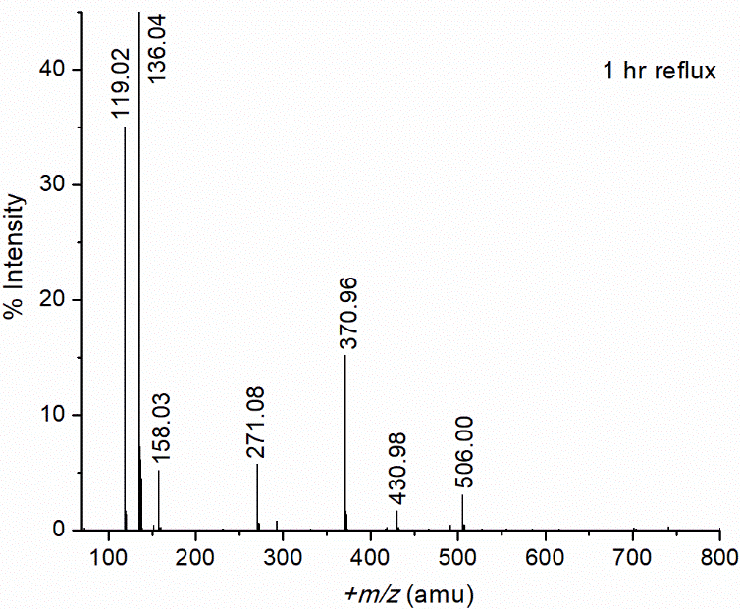

Figure S7. Left) (+) ion mode, and right) (-) ion mode ESI-mass spectra of Rh₂(AcO)₄ in aqueous solution with S-methyl-L-cysteine in excess (C_{Rh2} = 2.01 mM, C_{HSMC} = 79.8 mM; pH 4.81) after 1 h reflux at 100 °C. The mass peaks at +m/z = 136.03 (HSMC + H⁺)⁺ and -m/z = 134.03 (SMC⁻) were given 100% intensity. For peak assignments, see Table S5.

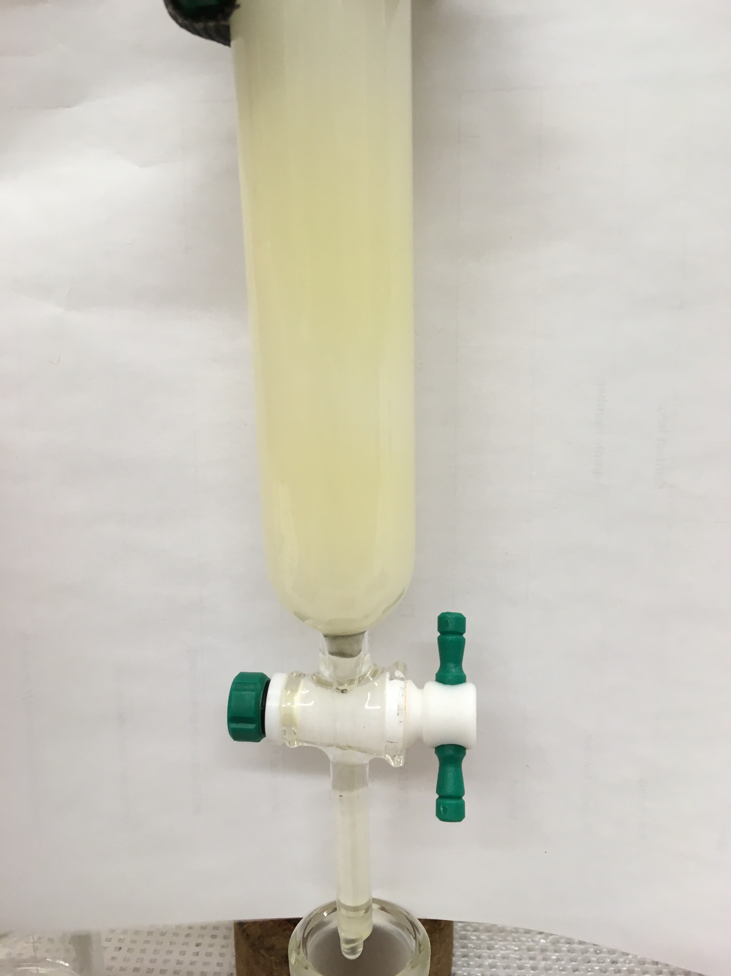
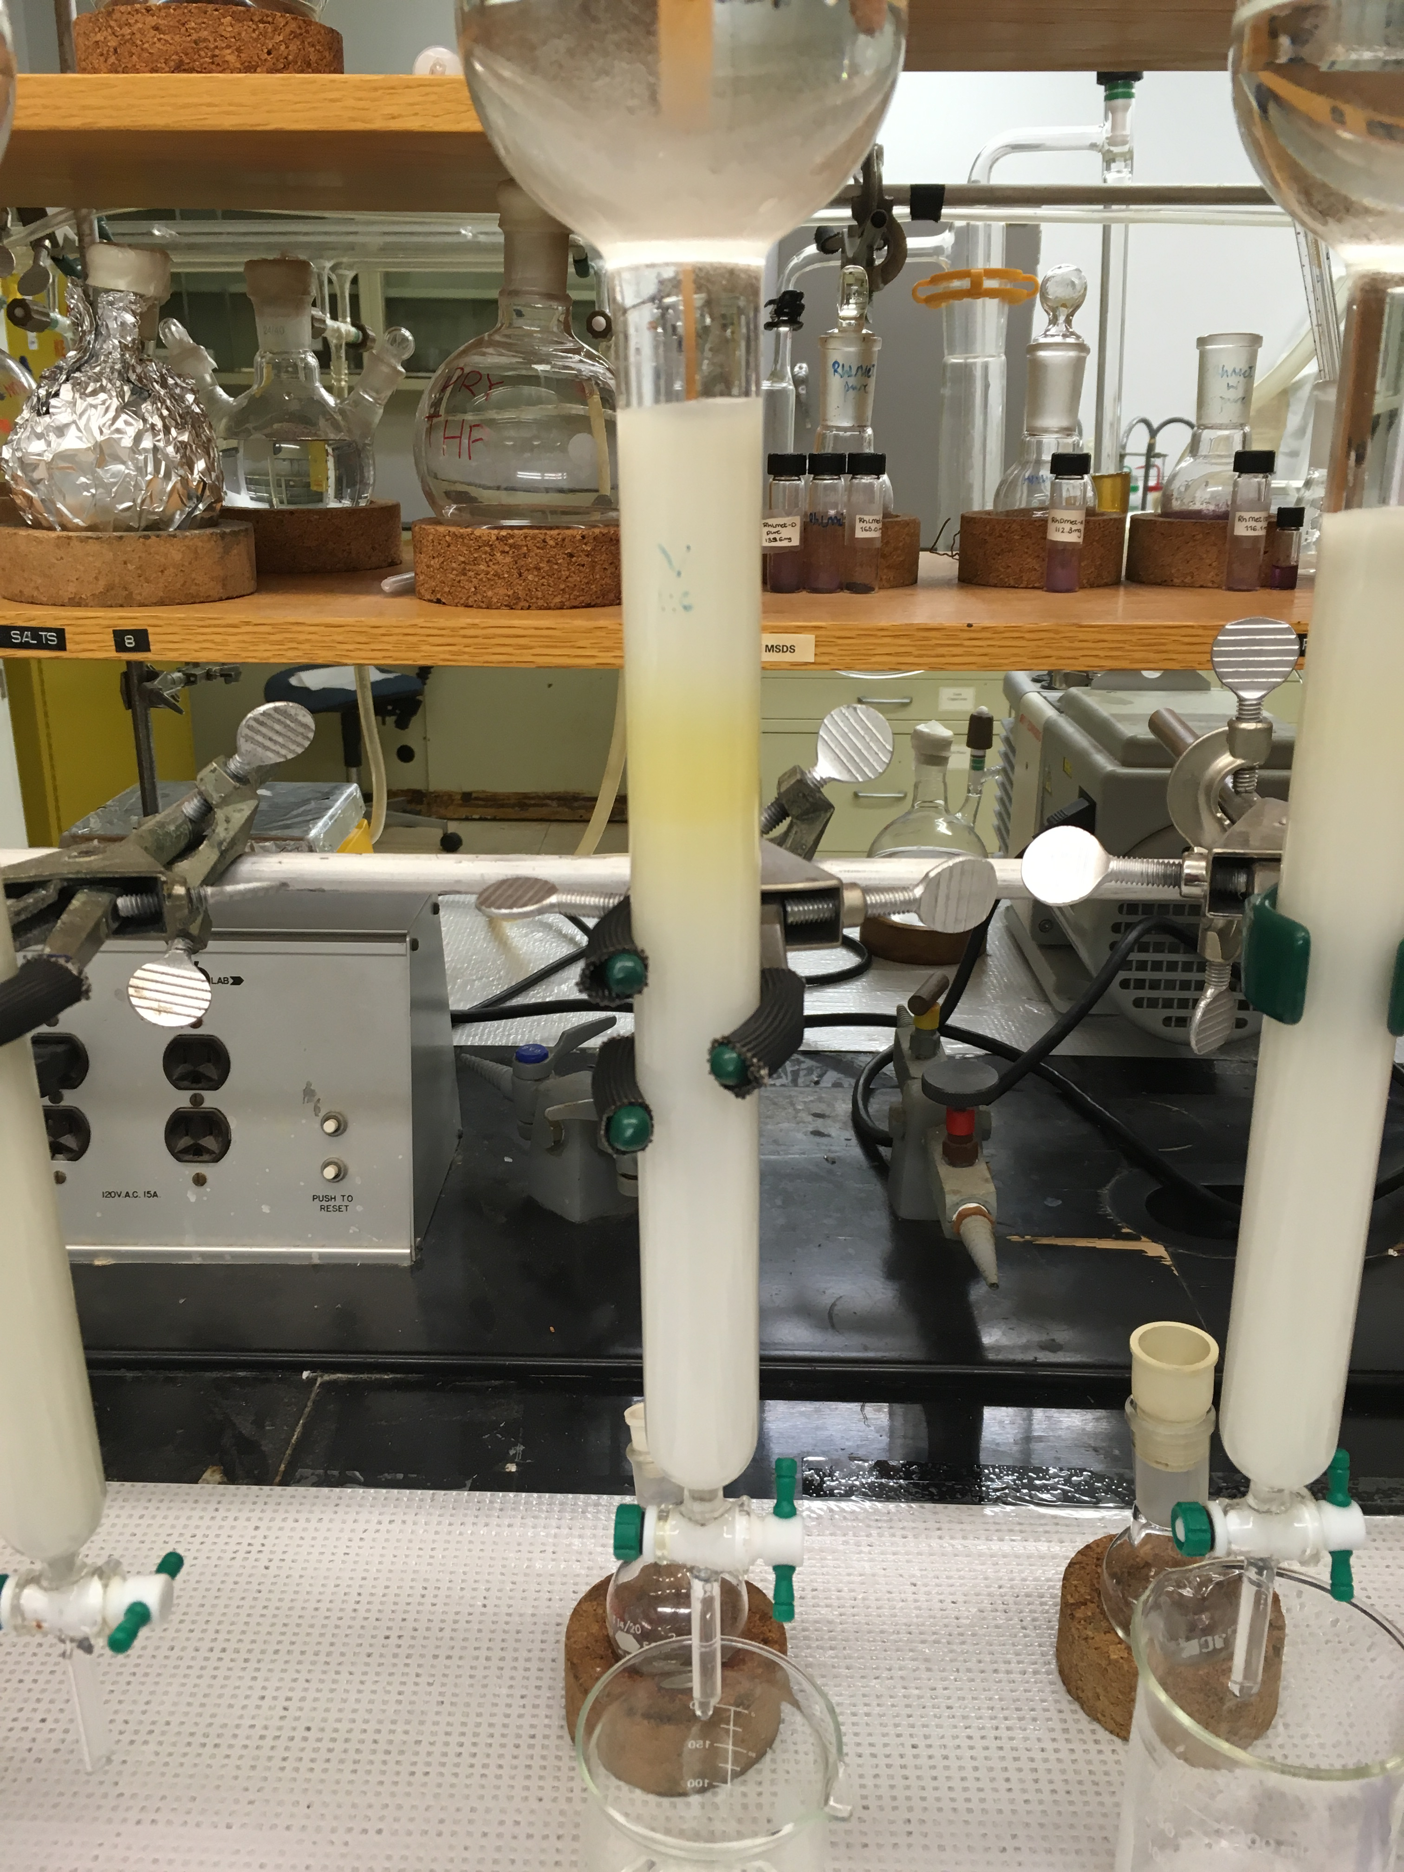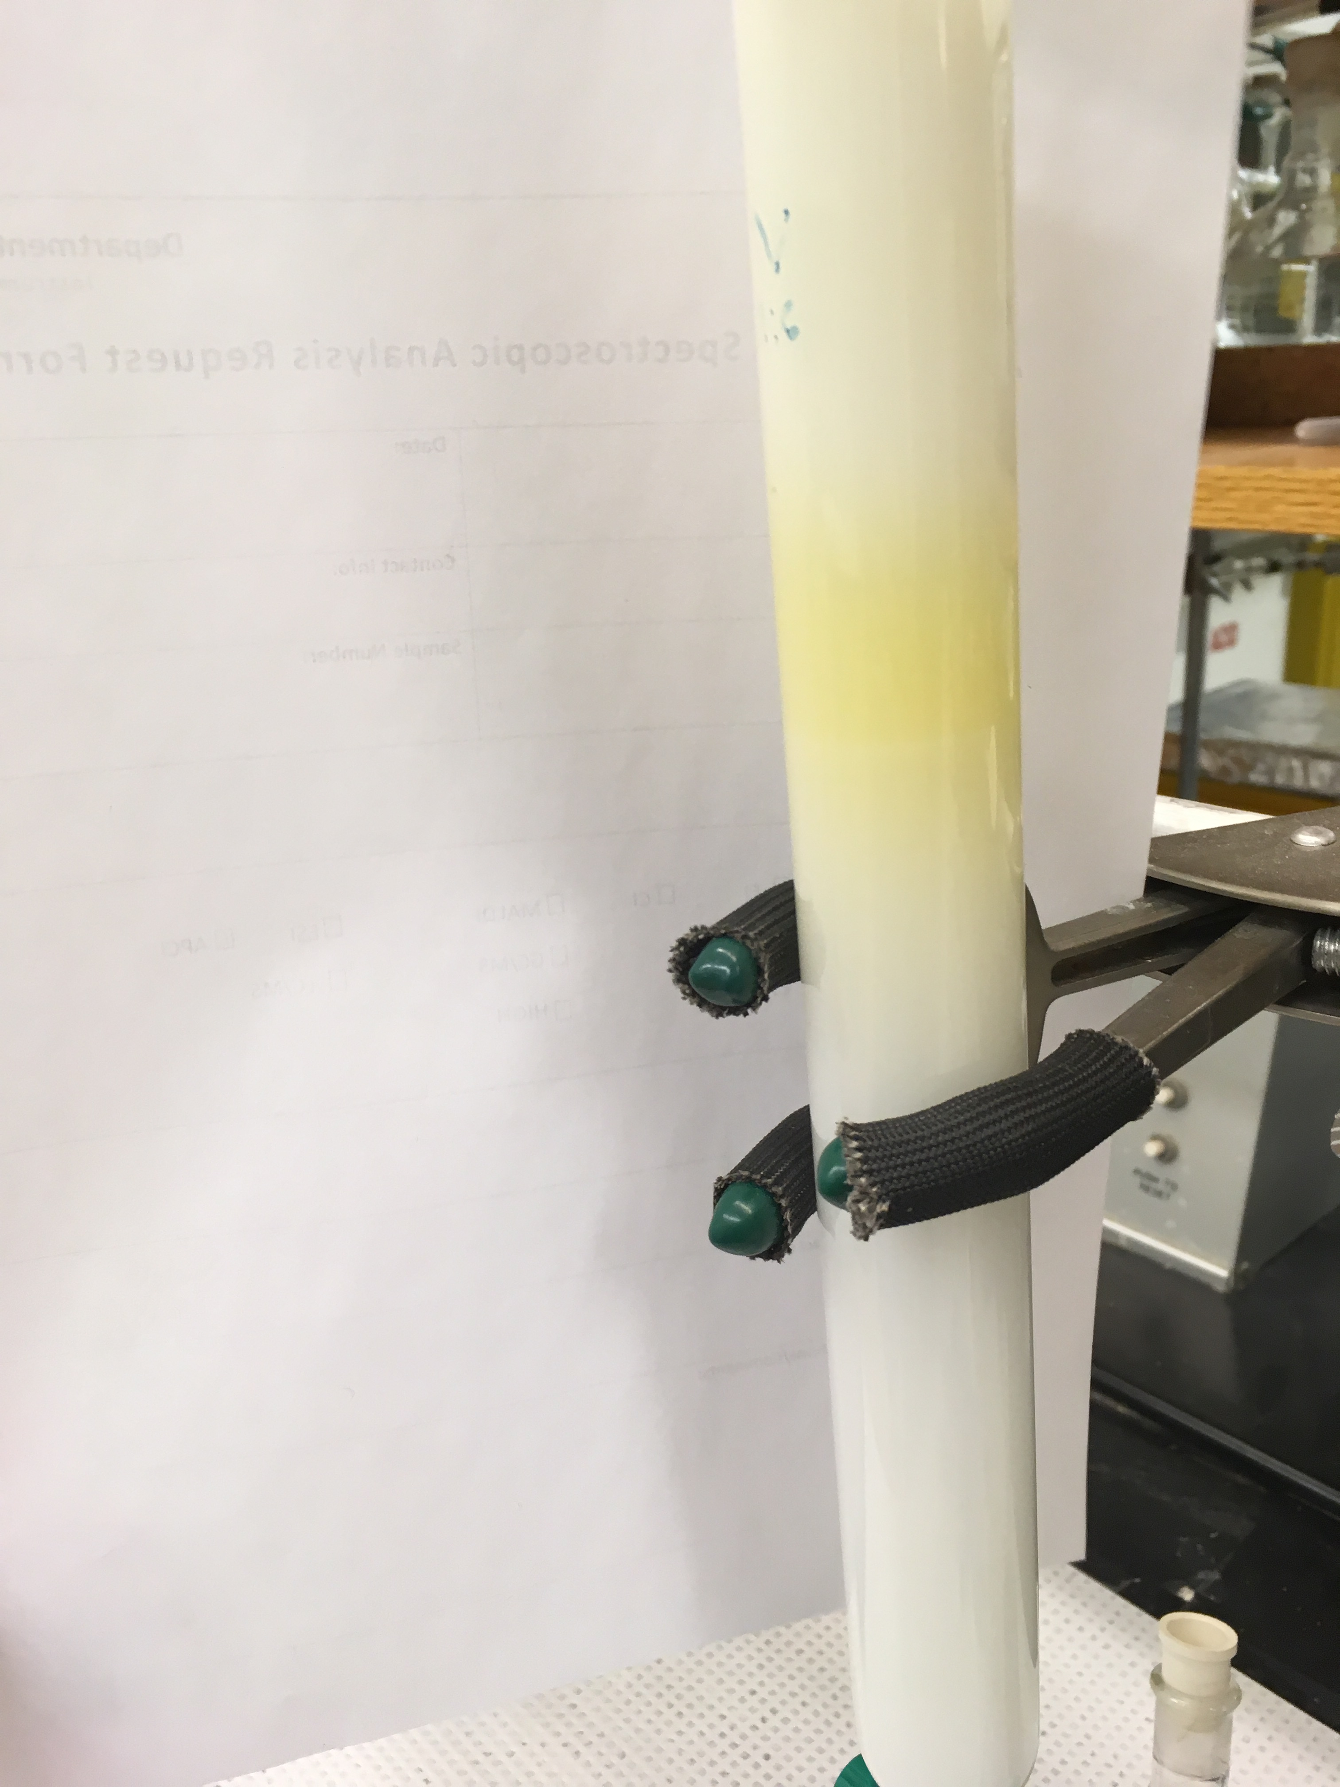
Band 1
Band 1

Figure S8. Top Left) (+) ion mode, and Top right) (-) ion mode ESI-mass spectra of Rh₂(AcO)₄ in aqueous solution with S-methyl-L-cysteine in excess (C_{Rh2} = 2.01 mM, C_{HSMC} = 79.8 mM; pH 4.81) after 1 h reflux at 100 °C, and after passing through a size exclusion Sephadex G-15 column (Band 1). The mass peaks at +m/z = 136.03 (HSMC + H⁺)⁺ and -m/z = 134.03 (SMC⁻) were given 100% intensity. For peak assignments, see Table S5.

