SYNTHESIS AND CHARACTERIZATION OF SILICA SUPPORTED SCHIFF BASE LIGANDS AND THEIR METAL COMPLEXES: APPLICATIONS AS CATALYSTS FOR THE OXIDATION OF ALKANES
Esin Ispir
Faculty of Science and Arts, Chemistry Department, K.Maraş Sütçü Imam University, Kahramanmaraş, 46100, Turkey
E-mail: esinispir@ksu.edu.tr
Supplemental Materials
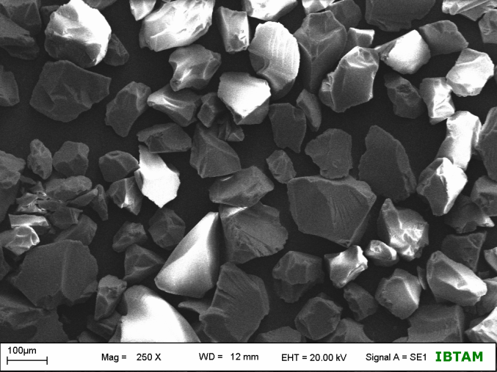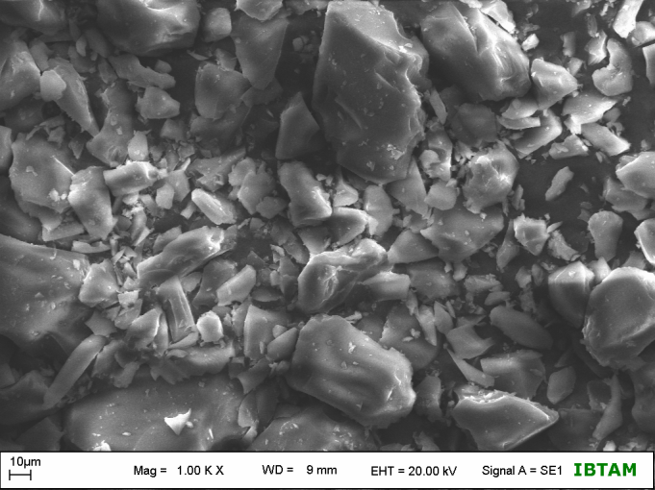
- (b)
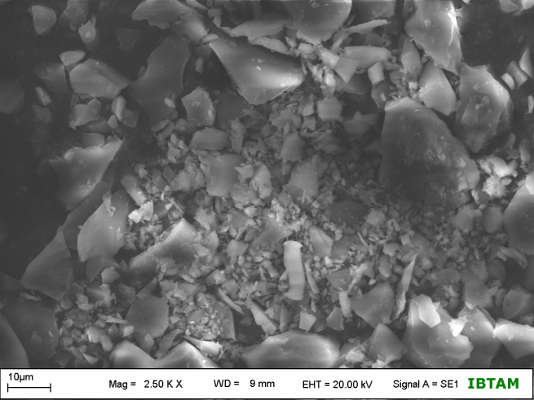
(c)
Figure S 1: SEM images of silica gel (a), APS (b) and L¹H (c)
Table S 1: Thermogravimetric Data of Ligand and Complexes
Compound | TG Range/ºC | Mass loss/%  Teorical (Calculated) | Assignment
L¹H | 20-150 | (5.74) | Loss of water
 | 150-900 | 14.15 (13.20) | Ligand decomposition
 | 900- | 85.85 (81.06) | SiO₂
L²H | 20-150 | (3.25) | Loss of water
 | 150-900 | 16.11 (15.20) | Ligand decomposition
 | 900- | 83.89 (81.55) | SiO₂
L³H | 20-150 | (1.72) | Loss of water
 | 150-900 | 15.14 (14.50) | Ligand decomposition
 | 900- | 84.86 (83.79) | SiO₂
Cu(L¹)(AcO).H₂O | 20-900 | (2.71) | Loss of water
 |  | 16.70 (15.52) | Complex decomposition
 | 900- | 83.30 (81.77) | SiO₂ +CuO
Co(L¹)(AcO).H₂O | 20-900 | (1.68) | Loss of water
 |  | 15.28 (14.93) | Complex decomposition
 | 900- | 84.72 (83.39) | SiO₂ +Co₃O₄
Cu(L²)(AcO).H₂O | 20-900 | (2.03) | Loss of water
 |  | 16.35 (15.80) | Complex decomposition
 | 900- | 83.65 (82.17) | SiO₂ +CuO
Co(L²)(AcO).H₂O | 20-900 | (2.77) | Loss of water
 |  | 14.80 (14.13) | Complex decomposition
 | 900- | 85.20 (83.10) | SiO₂ +Co₃O₄
Cu(L³)(AcO).H₂O | 20-900 | (1.62) | Loss of water
 |  | 15.05 (14.19) | Complex decomposition
 | 900- | 84.95 (84.55) | SiO₂ +CuO
Co(L³)(AcO).H₂O | 20-900 | (1.20) | Loss of water
 |  | 14.00 (12.83) | Complex decomposition
 | 900- | 86.00 (85.97) | SiO₂ +Co₃O₄

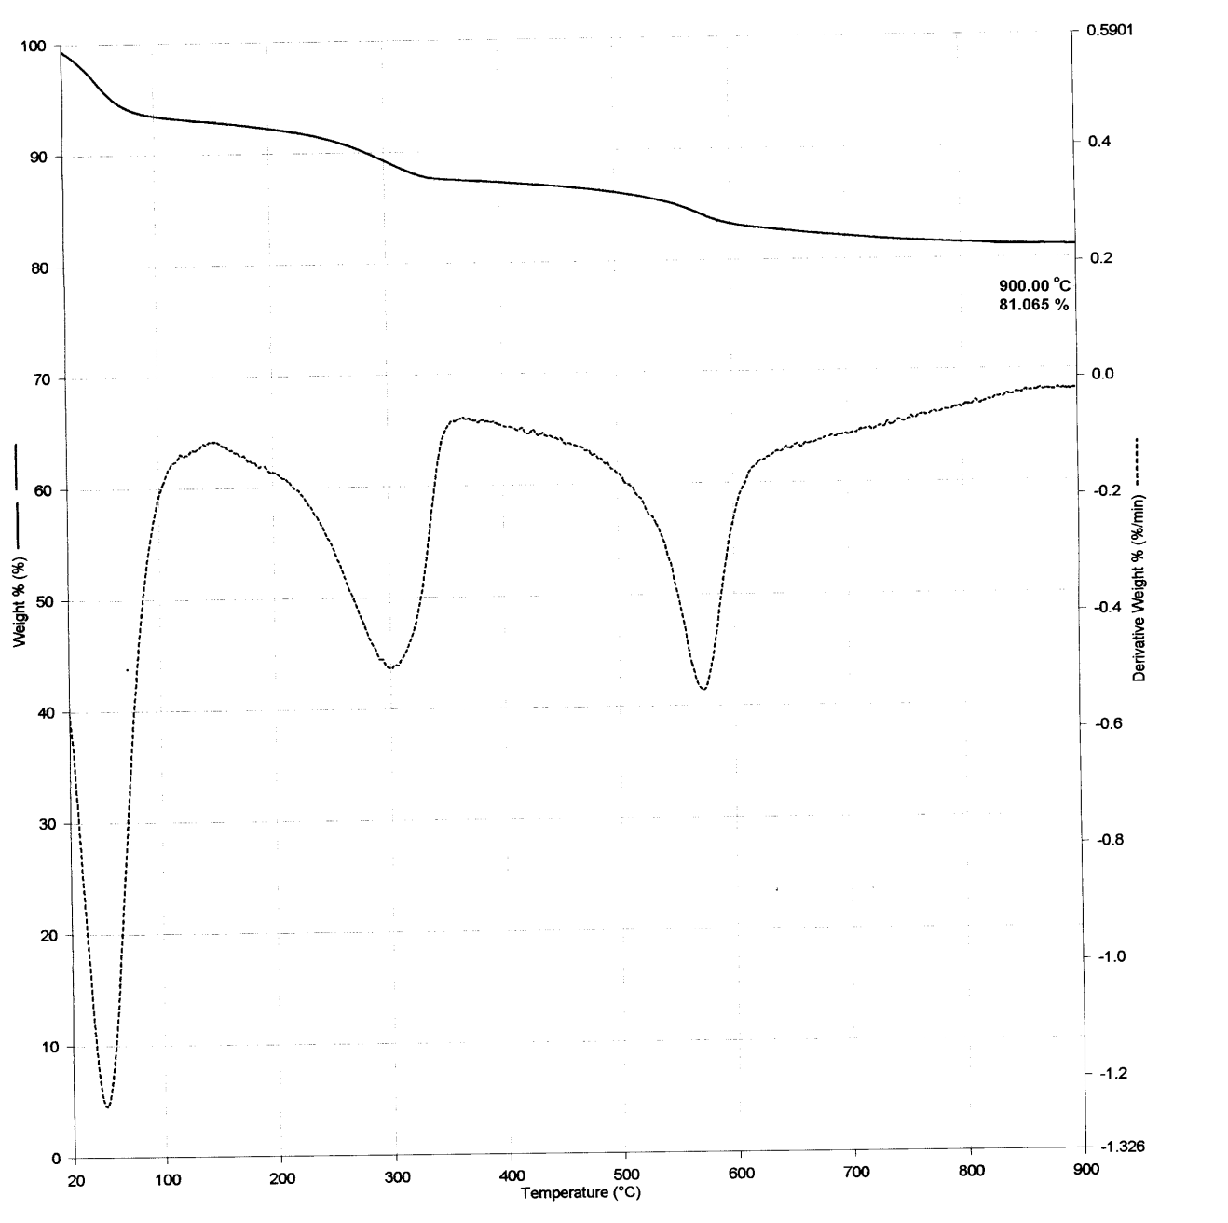
Figure S 2: TG-DTA of the silica supported ligand (L¹H)

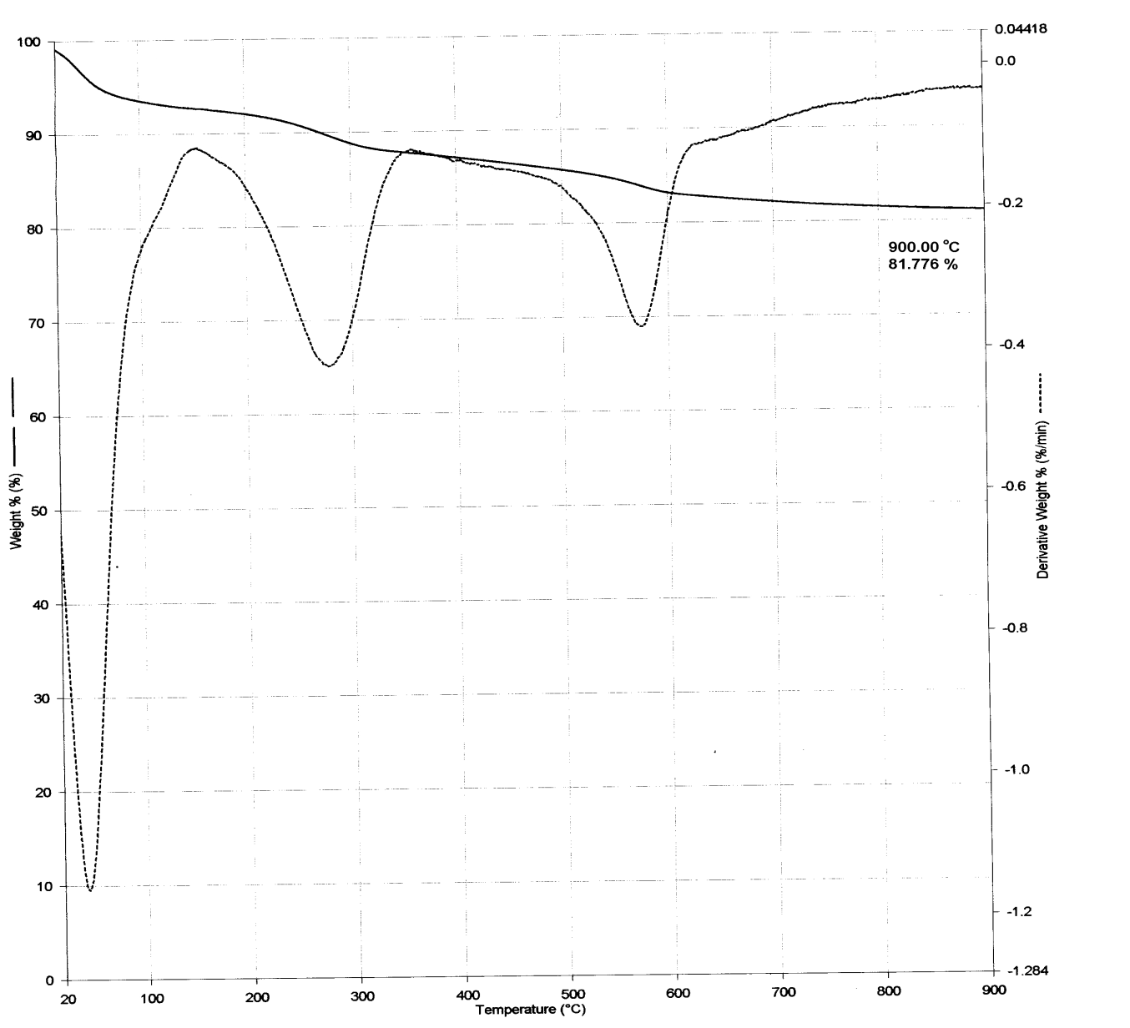
Figure S 3: TG-DTA of Cu(L¹)(AcO).H₂O

