APPENDIX

Appendix A

Overview of FARS Crash Types and Pre-Event for hypothetical collisions per scenario
Scenario | Subject Vehicle |  |  |  | Challenging Vehicle
 | Pre-Event Movement | Critical Event - Precrash |  | Crash Type | Pre-Event Movement | Pre-Impact Location | Crash Type
 | PC17 | PC18 | PC19 | PC23 | PC17 | PC22 | PC23
A | 1, 2, 3 | 3 | 50, 51, 52 | 20, 24, 28 | 1, 2, 3 | 1 | 21, 25, 29
B_{left} | 1, 2, 3 | 4 | 60 | 20, 24, 28 | 1, 2, 3, 15, 15 | 2 | 21, 25, 29
B_{right} | 1, 2, 3 | 4 | 61 | 20, 24, 28 | 1, 2, 3, 15, 16 | 2 | 21, 25, 29
C_{left} | 1, 2, 3 | 4 | 60 | 20, 24, 28 | 6, (15, 16) | 2 | 21, 25, 29
C_{right} | 1, 2, 3 | 4 | 61 | 20, 24, 28 | 6, (15, 16) | 2 | 21, 25, 29
D_{left} | 1, 2, 3 | 4 | 60 | 45 | 6, 15, 16 | 2 | 46
D_{right} | 1, 2, 3 | 4 | 61 | 45 | 6, 15, 16 | 2 | 47
E_{left} | 1, 2, 3, 6 | 4 | 60 | 45 | 6, 15, 16 | 2 | 46
E_{right} | 1, 2, 3, 6 | 4 | 61 | 45 | 6, 15, 16 | 2 | 47
F_{left} | 1, 2, 3, 6 | 4 | 60 | 45 | 15, 16 | 2 | 46
F_{right} | 1, 2, 3, 6 | 4 | 61 | 45 | 15, 16 | 2 | 47
G_{left} | 6 | 4 | 60 | 25, (21, 28) | 1, 2, 3, 15, 16 | 2 | 24, (20, 28)
G_{right} | 6 | 4 | 61 | 25, (21, 28) | 1, 2, 3, 15, 16 | 2 | 24, (20, 28)
H_{left} | 1, 2, 3 | 4 | 60 | 25, (21, 28) | 1, 3, (2) | 2 | 24, (20, 28)
H_{right} | 1, 2, 3 | 4 | 61 | 25, (21, 28) | 1, 3, (2) | 2 | 24, (20, 28)
I | 1, 2, 3 | 3 | 53 | 25, (21, 28) | 1, (2), 3 | 1 | 24, (20, 28)

PC17: 1 – Going Straight; 2 – Decelerating in Road; 3 – Accelerated in Road; 6 – Passing or Overtaking another Vehicle; 15 – Changing Lanes; 16 – Merging
PC18: 3 – Other Motor Vehicle in Lane; 4 – Other Motor Vehicle Encroaching into Lane
PC19: 50 – Other Vehicle Stopped; 51 – Travelling in Same Direction With Lower Steady Speed;52 – Travelling in Same Direction While Decelerating; 60 – From Adjacent Lane (Same Direction) Over Left Lane Line; 61 – From Adjacent Lane (Same Direction) Over Right Lane Line
PC22: 1 – Stayed in Original Travel Lane; 2 – Stayed on the Roadway but Left Original Travel Lane
PC23: 20 – Rear-End: Stopped; 21 – Rear-End: Stopped Straight; 24 – Rear-End: Slower; 25 – Rear-End: Slower, Going Straight; 28 – Rear-End: Decelerating; 29 – Rear-End: Decelerating, Going Straight; 45 – Sideswipe/Angle: Straight Ahead on Left/Right; 46 – Sideswipe/Angle: Changing Lanes to the Right; 47 – Sideswipe/Angle: Changing Lanes to the Left

Appendix B

Overview of action restriction configurations
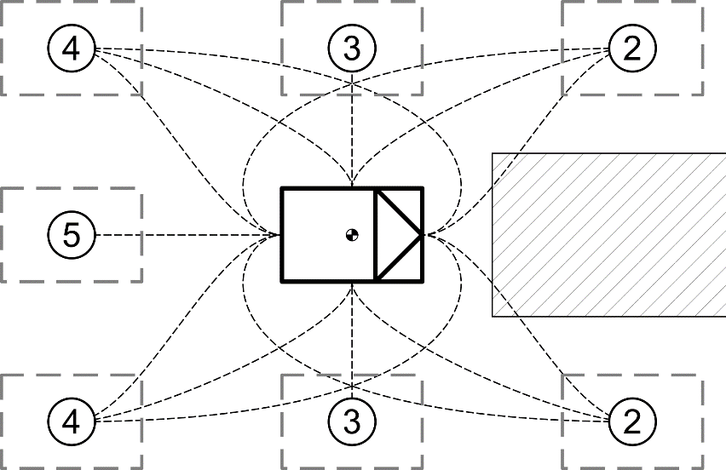  Object in front of SV | 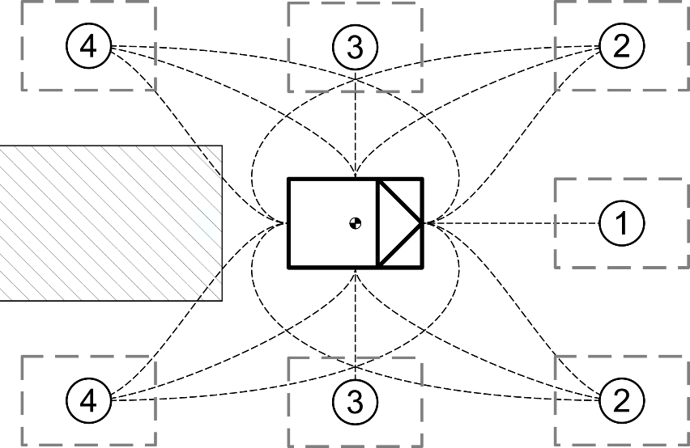  Object behind SV
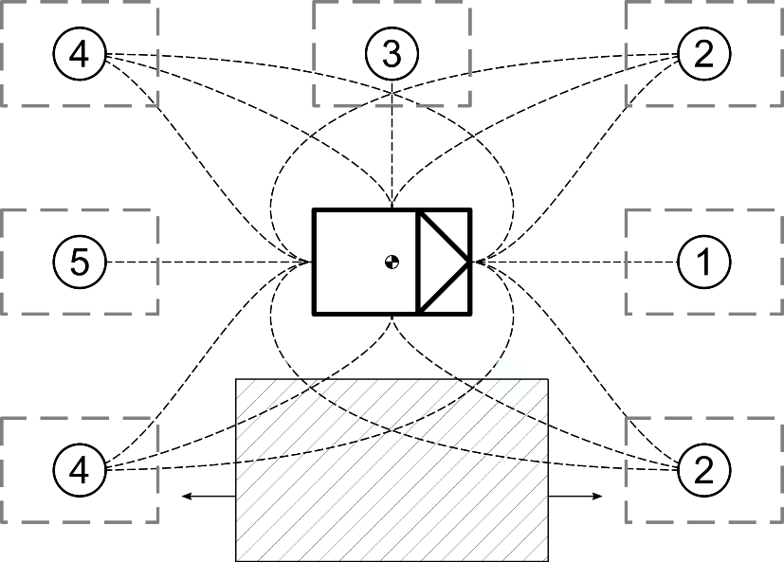  Object to side of SV | 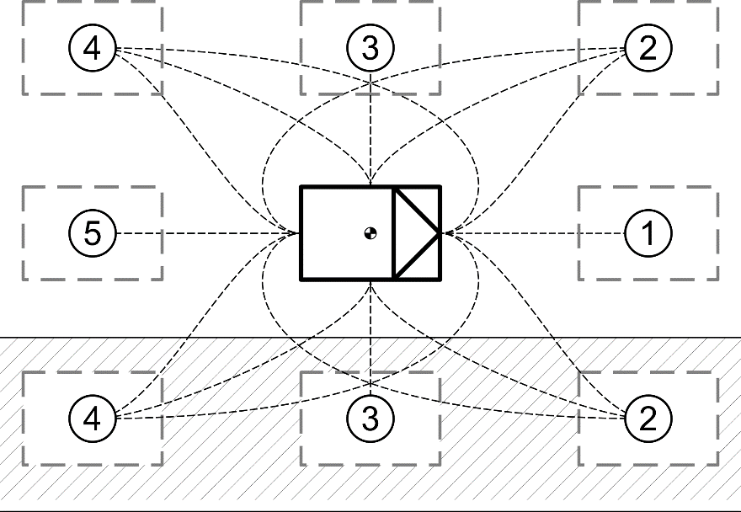  Blockage to side of SV
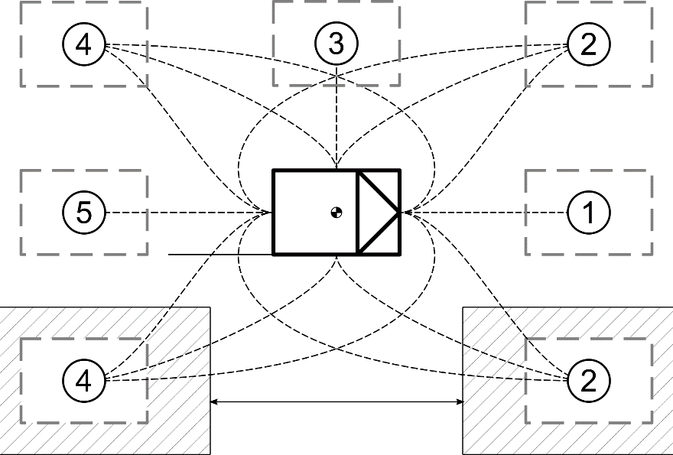
Blockage to side with drivable gap

