**Appendix A. Previous studies on the impacts of roadside advertisements on crashes**

Early studies conducted in the USA, in the middle of the previous century, explored statistical relations between the presence of mostly static advertisement signs on roadsides and crash occurrences. Some studies (e.g. Staffeld 1953; Madigan-Hyland 1963; Faustman 1961) reported positive correlations between a higher presence of static signs and crash frequencies, while others did not (e.g. Blanche 1965). In addition, early studies mostly applied univariate data analyses, thus, the results reported likely reflect mixed effects of traffic exposure and other road characteristics, beside the presence of billboards. Ady (1967) was a first study with after-before crash comparisons, following the installation of dynamic billboards on an expressway in Chicago. Out of several sites examined in this study, a significant increase in crashes was observed at one site only, where an intensely colored advertising sign was placed after a sharp horizontal curve. In general, earlier studies on the subject, from the last century, were numerous but inconclusive in their findings (Wachtel and Netherton 1980). In addition, they typically did not meet the current conventional standards of scientific evaluation.

Later on, the Wisconsin Department of Transportation (1994) reported an increase of road crashes after the placement of a dynamic electronic advertising sign (that showed commercials and football scores) on a motorway section near a stadium of Milwaukee. A study in Ohio, Tantala and Tantala (2007), that was sponsored by the outdoor advertising industry, showed that the “upgrade” of existing billboards to electronic ones did not lead to increased crash risk. In the same study, low correlations were observed between the density of advertisement billboards and crash frequencies. Smiley et al. (2005) examined the effects of dynamic video billboards on crashes along a motorway section and at intersections in Toronto. They reported mixed results, mostly statistically insignificant due to the low crash counts at the sites examined.

More recently, Yannis et al. (2012) conducted a before-and-after crash analysis with control groups, following the placement or removal of traditional static billboards, at several road sites in the Athens metropolitan area. The study considered street and suburban road sections adjacent to the billboards. In both comparisons (placement or removal of billboards) mixed results were observed at various sites, with no significant effects in totals. The authors suggested that in a complex urban environment, drivers are overloaded with many sources of information and, thus, the impact of advertising signs was negligible.

Hawkins et al. (2012), in the USA, performed a statistical analysis of whether on-premise digital signs placed alongside main roads cause an increase in crashes. The study referred to 135 dynamic billboard locations provided by the signage industry, in four states (California, North Carolina, Washington, and Ohio). Data consisted of crash counts on road sections adjacent to the billboards, two years before and two years after the installation. Control-group crash changes were estimated based on the AASHTO (2010) models for similar road types and national crash statistics. The study did not find differences in crash occurrences before and after billboard installation.

**Additional bibliography**

Ady R. An investigation of the relationship between illuminated advertising signs and expressway accidents. *Traffic Safety Research Review* 1967;3:9-11.

Blanche E. The roadside distraction. *Traffic Safety* 1965;10:24–37.

Faustman, D. *A study of the Relationship between Advertising Signs and Traffic Accidents on U.S. 40 between Vallejo and Davis*. San Francisco, USA: California Roadside Council; 1961. Report CRC No. 165.

Madigan-Hyland, Inc. *New York State Thruway Authority: Relationship between Accidents and the Presence of Advertising Devices*. New York, USA.1963.

Staffeld PR. Accidents related to access points and advertising signs in study. *Traffic Quarterly* 1953;7: 59-74.

Wachtel J, Netherton R. *Safety and Environmental Design Considerations in the Use of Commercial Electronic Variable-Message Signage*. Washington, DC: Federal Highway Administration; 1980. Report FHWA-RD-80-051.

**Appendix B. Supplementary figures and tables**

Table B1. Advertisement billboards’ presence along Ayalon Highway

|  |  |  |  |  |
| --- | --- | --- | --- | --- |
| Sub-section code | Northbound, in 2013 | Southbound, in 2013 | Northbound, in 2008 | Southbound, in 2008 |
| BC | 2 | 3 | 3 | 1 |
| CD | 3 | 0 | 3 | 1 |
| DE | 3 | 1 | 3 | 1 |
| EF | 2 | 0 | 2 | 0 |
| FG | 3 | 0 | 0 | 0 |
| GH | 3 | 1 | 0 | 0 |
| HI | 1 | 3 | 0 | 0 |
| IJ | 0 | 1 | 0 | 0 |
| JY | 1 | 0 | 2 | 0 |
| JK | 0 | 0 | 0 | 0 |
| KL | 0 | 0 | 0 | 0 |
| LM | 0 | 0 | 0 | 0 |
| MN | 0 | 0 | 0 | 0 |
| NO | 0 | 0 | 0 | 0 |
| OP | 2 | 0 | 0 | 0 |
| PQ | 0 | 0 | 0 | 0 |

Presence levels: 0 – none; 1 – a single billboard on the right, or billboards visible across the road; 2 – few billboards; 3 – numerous billboards.

Table B2. Annual numbers of crashes, in treatment and control groups, according to study analyses

a – Damage-only crashes

|  |  |  |  |  |  |  |
| --- | --- | --- | --- | --- | --- | --- |
| Year | Micro-model, treatment | Micro-model, control | Macro-model, treatment | Macro-model, control | Micro-model, treatment, excluding JY | Macro-model, treatment, excluding JY |
| 2006 | 65 | 178 | 243 | 82 | 61 | 239 |
| 2007 | 59 | 140 | 199 | 84 | 49 | 189 |
| 2008 | 45 | 184 | 229 | 107 | 42 | 226 |
| 2009 | 48 | 181 | 229 | 117 | 36 | 217 |
| 2010 | 58 | 182 | 240 | 62 | 49 | 231 |
| 2011 | 70 | 180 | 250 | 50 | 45 | 225 |
| 2012 | 61 | 141 | 202 | 49 | 39 | 180 |

b – Injury crashes

|  |  |  |  |  |  |  |
| --- | --- | --- | --- | --- | --- | --- |
| Year | Micro-model, treatment | Micro-model, control | Macro-model, treatment | Macro-model, control | Micro-model, treatment, excluding JY | Macro-model, treatment, excluding JY |
| 2006 | 41 | 66 | 107 | 41 | 35 | 101 |
| 2007 | 36 | 66 | 102 | 29 | 30 | 96 |
| 2008 | 17 | 75 | 92 | 47 | 17 | 92 |
| 2009 | 26 | 54 | 80 | 43 | 23 | 77 |
| 2010 | 32 | 65 | 97 | 35 | 26 | 91 |
| 2011 | 32 | 71 | 103 | 39 | 26 | 97 |
| 2012 | 34 | 47 | 81 | 21 | 23 | 70 |



Notes: B to Q indicate interchanges. Sub-sections BC, CD, DE, EF, JY northbound, and BC, CD, DE southbound compose the treatment group in a Micro-model.

Figure B1. Ayalon Highway road structure: Central and Southern parts and interchange codes.

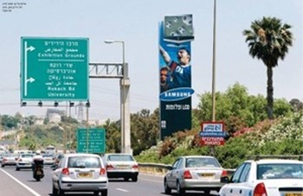

a



b

Figure B2. Typical examples of advertisement billboards on Ayalon Highway: a – stand alone, b – building mounted.

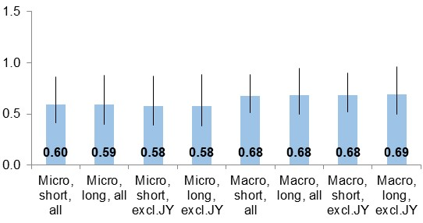

a

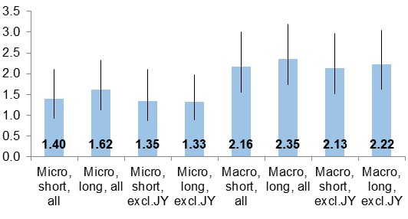

b

Notes: means and 95% confidence intervals of odds ratios are presented.

Figure B3. Estimates of changes in damage-only crashes following: (a) billboards’ removal, (b) billboards’ restoration.

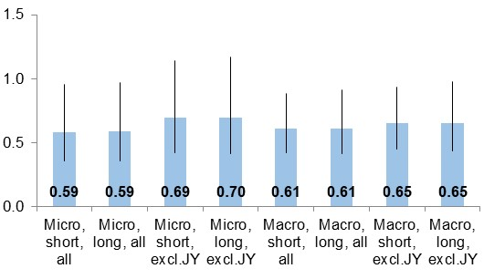

a

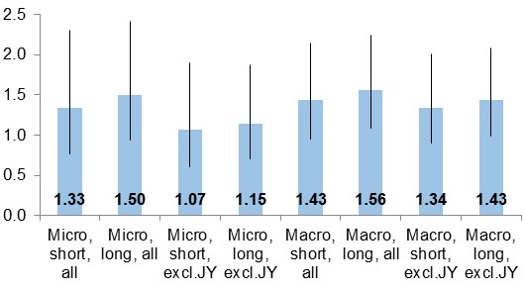

b

Notes: means and 95% confidence intervals of odds ratios are presented.

Figure B4. Estimates of changes in injury crashes following: (a) billboards’ removal, (b) billboards’ restoration.

**Appendix C. Further discussion**

The study extracted crash data from the road operator logbook which is a more comprehensive data source compared to traditional police records. The AH database included information on all injury crashes occurred on the road and supplementary data on damage-only crashes. The fuller data source empowered the statistical analyses conducted in the study, which might contribute to the magnitude of findings.

The study used sufficient crash data and followed the common rules of road safety research (e.g. Elvik et al. 2009; AASHTO 2010). However, it has several limitations. First, detailed data on traffic volumes were not available for the study analyses. Therefore, the crash analyses had an underlying assumption that there was a similar change in traffic volumes in both the treatment and control groups. Such an assumption might be plausible as various evaluations of the AH operator indicated consistently high traffic volumes over the study period, with an annual increase of 1%-2%. Second, the study period was rather long, 2006 through 2012, and thus comprised various construction changes along the road such as erecting a bridge at one interchange in the Central part and adding interchanges to the Southern part. Such road infrastructure changes might have had an impact on local traffic and crash occurrence, on some road sub-sections, but were not accounted for explicitly in the study analyses. At the same time, more general confounding factors such as changes in the economic situation, the police enforcement, vehicle fleet, etc., during the study periods, could be confounding but were accounted for, to some extent, by means of using the control-groups.

In addition, in spite of the consistency and strength of the findings, the unique features of AH (as detailed above) and a specific crash database applied for the analyses, raise reservations regarding generalization of the study results. Additional studies of other roads are needed to examine whether the evidence of billboard impact on crashes can be extended to other road conditions. Moreover, similar to any statistical evaluation, the current study estimates have uncertainty which is expressed in the confidence intervals. As can be seen in Tables 1-2, the confidence intervals of the study estimates are rather wide, thus,necessitating caution while drawing practical conclusions from the study findings.

Concerning the practical insights of the study, the differences between *Micro* and *Macro* evaluation results should be pointed out. The selected sub-sections with higher billboards’ presence (*Micro-model* evaluations) represent the intervention focus – billboard removal in the years 2008 through 2009, and their subsequent restoration, while *Macro* evaluations show more general billboard impacts, for a longer road section but with variable billboards’ presence. The crash numbers saved following billboard removal and added following billboard restoration, are much higher according to the *Macro* evaluations, stemming from the longer road length. Thus, in practical decisions regarding billboard impact on safety, it is preferable to adhere to the findings of *Micro-models*. In general, the study indicated that multiple advertisement billboards have a stronger impact on crash occurrence than single signs, however, the impact of the density of advertising billboards was not estimated explicitly.

In summary, the current study provided empirical evidence on the negative safety impacts of advertisement billboards’ presence on the roadsides of a suburban highway. The findings of various study analyses were consistent and showed a decrease in crashes when billboards were removed from the highway and an increase when the billboards were restored. The stronger impact values found in the study, compared to previous research, may be related to the high frequency of conspicuous billboards, and to complex traffic conditions on the road that might strengthen the negative impact of driver distraction due to advertising billboards. The study showed that a detrimental effect of advertising signs on road safety can be demonstrated and that actual safety impacts of roadside advertising are in line with the expectations of behavior research which relates higher crash risk to distracted driving (NHTSA 2009; Dingus et al. 2016; SWOV 2018).