Appendix
Table A1 Regression Results of Conspiracy Belief on Political Engagement
 | Dependent variable:
 | Political Activities
 | (1) | (2) | (3) | (4)
Birther | 0.036**
 | (0.016)
Death Panel |  | 0.013
 |  | (0.015)
Truther |  |  | 0.025*
 |  |  | (0.014)
Katrina |  |  |  | 0.028**
 |  |  |  | (0.014)
Contacted by party | 0.148*** | 0.148*** | 0.150*** | 0.149***
 | (0.014) | (0.015) | (0.014) | (0.014)
Get out the vote | 0.136*** | 0.138*** | 0.134*** | 0.135***
 | (0.014) | (0.014) | (0.014) | (0.014)
PID | -0.044** | -0.028 | -0.029* | -0.028
 | (0.018) | (0.018) | (0.017) | (0.017)
Ideology | -0.040** | -0.043** | -0.038** | -0.037**
 | (0.018) | (0.018) | (0.017) | (0.018)
Age | 0.003 | -0.00002 | 0.005 | 0.004
 | (0.015) | (0.016) | (0.015) | (0.015)
Education | 0.116*** | 0.111*** | 0.116*** | 0.114***
 | (0.016) | (0.016) | (0.016) | (0.016)
Male | -0.010 | -0.009 | -0.008 | -0.006
 | (0.014) | (0.014) | (0.014) | (0.014)
Income | 0.056*** | 0.057*** | 0.056*** | 0.056***
 | (0.015) | (0.015) | (0.015) | (0.015)
Religiosity | 0.040*** | 0.040*** | 0.038*** | 0.040***
 | (0.015) | (0.015) | (0.015) | (0.015)
Government Trust | -0.081*** | -0.084*** | -0.083*** | -0.081***
 | (0.015) | (0.015) | (0.015) | (0.014)
Efficacy | 0.115*** | 0.122*** | 0.117*** | 0.114***
 | (0.016) | (0.016) | (0.016) | (0.016)
Political Knowledge | 0.076*** | 0.071*** | 0.074*** | 0.077***
 | (0.018) | (0.018) | (0.017) | (0.017)
Political Interest | 0.301*** | 0.299*** | 0.299*** | 0.300***
 | (0.016) | (0.016) | (0.016) | (0.016)
White | -0.026* | -0.026 | -0.025 | -0.021
 | (0.016) | (0.016) | (0.016) | (0.016)
Extraversion | 0.053*** | 0.053*** | 0.055*** | 0.053***
 | (0.014) | (0.014) | (0.014) | (0.014)
Agreeableness | 0.008 | 0.008 | 0.011 | 0.011
 | (0.015) | (0.015) | (0.015) | (0.015)
Conscientiousness | -0.052*** | -0.054*** | -0.056*** | -0.053***
 | (0.015) | (0.015) | (0.015) | (0.015)
Emotional Stability | -0.013 | -0.015 | -0.011 | -0.011
 | (0.015) | (0.015) | (0.015) | (0.015)
Openness | 0.086*** | 0.084*** | 0.082*** | 0.085***
 | (0.015) | (0.015) | (0.015) | (0.015)
Authoritarianism | -0.078*** | -0.074*** | -0.074*** | -0.075***
 | (0.015) | (0.015) | (0.015) | (0.015)
Constant | 0.013 | 0.014 | 0.013 | 0.011
 | (0.013) | (0.014) | (0.013) | (0.013)
Observations | 4,277 | 4,136 | 4,312 | 4,288
R² | 0.327 | 0.325 | 0.327 | 0.328
Adjusted R² | 0.324 | 0.322 | 0.324 | 0.325
Residual Std. Error | 0.843 (df = 4255) | 0.846 (df = 4114) | 0.843 (df = 4290) | 0.841 (df = 4266)
F Statistic | 98.490*** (df = 21; 4255) | 94.337*** (df = 21; 4114) | 99.353*** (df = 21; 4290) | 99.103*** (df = 21; 4266)
Note: *p<0.10; **p<0.05; ***p<0.01

Table A2 Logistic Regression Results of Conspiracy Beliefs on Political Activities
 | Dependent variable:
 | pa1 | pa2 | pa3 | pa4 | pa5 | pa6 | pa7 | pa8 | pa9 | pa10 | pa11 | pa12 | pa13 | pa14 | pa15 | pa16 | pa17
 | (1) | (2) | (3) | (4) | (5) | (6) | (7) | (8) | (9) | (10) | (11) | (12) | (13) | (14) | (15) | (16) | (17)
Conspiracy Index | 0.654*** | 0.747* | 0.695** | 1.099** | 0.548* | 0.281 | 0.892* | 0.854** | -0.335 | 0.714*** | 0.291 | -0.118 | 1.081** | 0.067 | -0.024 | 0.489* | -0.055
 | (0.214) | (0.404) | (0.271) | (0.493) | (0.316) | (0.352) | (0.475) | (0.403) | (0.253) | (0.230) | (0.228) | (0.234) | (0.534) | (0.248) | (0.466) | (0.250) | (0.278)
Contacted by party | 0.285*** | 0.994*** | 0.584*** | 0.845*** | 0.503*** | 0.651*** | 0.562*** | 0.618*** | 0.411*** | 0.278*** | 0.452*** | 0.274*** | 0.784*** | 0.075 | 0.729*** | 0.386*** | 0.565***
 | (0.077) | (0.164) | (0.101) | (0.202) | (0.116) | (0.133) | (0.181) | (0.152) | (0.092) | (0.083) | (0.083) | (0.084) | (0.211) | (0.091) | (0.180) | (0.090) | (0.107)
Get out the vote | 0.516*** | 1.045*** | 0.500*** | 1.113*** | 0.500*** | 0.520*** | 0.416** | 0.418*** | 0.415*** | 0.402*** | 0.423*** | 0.300*** | 0.194 | 0.374*** | 0.267 | 0.310*** | 0.114
 | (0.075) | (0.162) | (0.098) | (0.206) | (0.111) | (0.125) | (0.168) | (0.146) | (0.089) | (0.081) | (0.080) | (0.081) | (0.198) | (0.088) | (0.163) | (0.087) | (0.101)
PID | -0.0002 | -0.018 | -0.083*** | -0.117** | -0.050 | -0.051 | -0.018 | -0.045 | -0.022 | -0.026 | -0.032 | 0.064** | 0.126** | -0.052* | 0.057 | -0.029 | -0.076***
 | (0.023) | (0.043) | (0.029) | (0.053) | (0.035) | (0.038) | (0.053) | (0.045) | (0.027) | (0.025) | (0.025) | (0.025) | (0.058) | (0.027) | (0.052) | (0.028) | (0.029)
Ideology | 0.027 | -0.044 | -0.036 | -0.079 | -0.075 | -0.056 | 0.012 | -0.168*** | -0.009 | -0.030 | -0.070** | -0.098*** | -0.050 | -0.036 | -0.117* | 0.019 | 0.032
 | (0.033) | (0.058) | (0.040) | (0.069) | (0.048) | (0.052) | (0.073) | (0.060) | (0.038) | (0.035) | (0.035) | (0.036) | (0.077) | (0.038) | (0.070) | (0.039) | (0.042)
Age | 0.119 | -0.314 | -0.169 | 0.770* | 1.892*** | 1.939*** | 0.439 | -0.981*** | -0.364* | -0.871*** | 0.273 | 0.692*** | -0.614 | -2.783*** | 0.458 | 0.239 | 1.305***
 | (0.179) | (0.336) | (0.229) | (0.415) | (0.273) | (0.306) | (0.395) | (0.333) | (0.210) | (0.192) | (0.191) | (0.194) | (0.447) | (0.215) | (0.385) | (0.208) | (0.233)
Education | -0.041 | 0.230*** | -0.108** | 0.289*** | 0.135*** | 0.121** | 0.167** | 0.199*** | 0.204*** | 0.224*** | 0.182*** | 0.284*** | 0.090 | 0.100** | 0.272*** | 0.284*** | 0.275***
 | (0.036) | (0.067) | (0.046) | (0.082) | (0.051) | (0.057) | (0.080) | (0.069) | (0.042) | (0.039) | (0.038) | (0.039) | (0.092) | (0.042) | (0.077) | (0.042) | (0.050)
Male | -0.001 | -0.049 | 0.037 | -0.011 | -0.011 | 0.105 | 0.526*** | 0.261* | -0.069 | -0.171** | -0.099 | -0.263*** | 0.653*** | -0.196** | 0.517*** | 0.161* | -0.229**
 | (0.076) | (0.141) | (0.096) | (0.169) | (0.109) | (0.122) | (0.172) | (0.143) | (0.088) | (0.081) | (0.080) | (0.082) | (0.199) | (0.087) | (0.165) | (0.088) | (0.100)
Income | 0.008 | -0.015 | -0.001 | -0.023** | 0.046*** | 0.034*** | 0.027** | -0.012 | 0.024*** | 0.006 | 0.012** | 0.019*** | -0.015 | -0.002 | -0.004 | 0.017*** | 0.035***
 | (0.005) | (0.009) | (0.007) | (0.011) | (0.008) | (0.008) | (0.011) | (0.009) | (0.006) | (0.005) | (0.005) | (0.005) | (0.013) | (0.006) | (0.011) | (0.006) | (0.007)
Religiosity | 0.386*** | -0.037 | 0.497*** | 0.401 | -0.307* | -0.209 | -0.012 | 0.107 | 0.503*** | -0.050 | -0.036 | 0.139 | 0.513* | 0.092 | 0.160 | 0.459*** | 0.456***
 | (0.121) | (0.229) | (0.156) | (0.282) | (0.172) | (0.191) | (0.257) | (0.227) | (0.141) | (0.129) | (0.128) | (0.130) | (0.310) | (0.141) | (0.253) | (0.139) | (0.163)
Government Trust | -0.962*** | 0.146 | 0.206 | 0.211 | -0.265 | -0.127 | -0.539 | -0.616 | -0.724*** | -1.462*** | -0.771*** | -0.486** | -0.305 | -1.208*** | -1.176** | -1.742*** | 0.059
 | (0.210) | (0.372) | (0.255) | (0.442) | (0.305) | (0.332) | (0.491) | (0.393) | (0.249) | (0.237) | (0.228) | (0.232) | (0.538) | (0.247) | (0.488) | (0.266) | (0.268)
Efficacy | 1.219*** | 1.590*** | 0.568* | 1.423*** | 1.620*** | 1.853*** | 0.432 | 1.659*** | 0.917*** | 0.839*** | 0.660*** | 0.549** | 0.393 | 1.336*** | 0.809 | 0.843*** | 1.143***
 | (0.240) | (0.436) | (0.295) | (0.531) | (0.340) | (0.377) | (0.517) | (0.440) | (0.275) | (0.253) | (0.252) | (0.257) | (0.586) | (0.273) | (0.501) | (0.275) | (0.321)
Political Knowledge | 0.423** | 0.358 | 0.422* | 0.289 | 1.116*** | 0.470 | 0.521 | 0.096 | -0.392* | 1.007*** | 0.317 | 0.242 | -0.775 | 0.287 | -0.249 | 0.997*** | 1.319***
 | (0.201) | (0.380) | (0.256) | (0.461) | (0.302) | (0.332) | (0.458) | (0.379) | (0.236) | (0.219) | (0.215) | (0.219) | (0.500) | (0.233) | (0.434) | (0.239) | (0.262)
Political Interest | 2.494*** | 2.272*** | 2.206*** | 2.672*** | 2.347*** | 2.178*** | 1.886*** | 1.836*** | 1.369*** | 1.388*** | 0.823*** | 0.787*** | 3.047*** | 1.735*** | 2.277*** | 1.936*** | 1.782***
 | (0.158) | (0.343) | (0.215) | (0.446) | (0.262) | (0.296) | (0.396) | (0.327) | (0.190) | (0.170) | (0.166) | (0.169) | (0.488) | (0.187) | (0.399) | (0.192) | (0.191)
White | -0.062 | -0.444*** | -0.400*** | -0.342* | -0.639*** | -0.664*** | 0.132 | 0.110 | 0.078 | 0.175* | 0.112 | 0.032 | -0.676*** | 0.288** | -0.085 | 0.351*** | -0.103
 | (0.096) | (0.166) | (0.115) | (0.198) | (0.136) | (0.147) | (0.224) | (0.176) | (0.114) | (0.105) | (0.104) | (0.107) | (0.228) | (0.113) | (0.208) | (0.118) | (0.126)
Extraversion | 0.123*** | 0.108** | 0.084** | 0.084 | 0.073* | 0.033 | 0.073 | 0.029 | 0.046 | -0.025 | 0.037 | 0.076** | 0.241*** | 0.107*** | 0.179*** | -0.018 | -0.074*
 | (0.029) | (0.054) | (0.037) | (0.065) | (0.041) | (0.045) | (0.062) | (0.052) | (0.033) | (0.030) | (0.030) | (0.030) | (0.074) | (0.032) | (0.061) | (0.033) | (0.039)
Agreeableness | -0.023 | -0.047 | 0.014 | -0.024 | -0.001 | -0.013 | -0.057 | -0.019 | -0.024 | 0.088** | 0.059 | 0.032 | -0.192** | 0.076* | 0.011 | 0.022 | 0.030
 | (0.036) | (0.066) | (0.046) | (0.081) | (0.051) | (0.057) | (0.076) | (0.066) | (0.042) | (0.038) | (0.038) | (0.039) | (0.087) | (0.041) | (0.075) | (0.041) | (0.048)
Conscientiousness | 0.005 | -0.216*** | -0.019 | -0.184** | -0.068 | -0.050 | -0.228*** | -0.202*** | -0.068 | -0.072* | -0.083** | -0.060 | -0.278*** | -0.068* | -0.196*** | -0.093** | 0.059
 | (0.036) | (0.065) | (0.045) | (0.079) | (0.052) | (0.058) | (0.075) | (0.064) | (0.042) | (0.038) | (0.038) | (0.039) | (0.086) | (0.041) | (0.074) | (0.042) | (0.045)
Emotional Stability | -0.062* | 0.080 | -0.045 | 0.003 | 0.006 | 0.078 | 0.050 | 0.030 | 0.036 | -0.001 | -0.005 | -0.015 | 0.008 | -0.109*** | 0.027 | -0.030 | 0.002
 | (0.033) | (0.063) | (0.042) | (0.076) | (0.048) | (0.054) | (0.072) | (0.061) | (0.038) | (0.035) | (0.035) | (0.035) | (0.083) | (0.037) | (0.070) | (0.038) | (0.043)
Openness | 0.037 | 0.122* | 0.146*** | 0.183** | 0.042 | 0.025 | 0.126 | 0.169** | 0.171*** | 0.159*** | 0.110*** | 0.066* | 0.338*** | 0.172*** | 0.057 | 0.093** | 0.013
 | (0.035) | (0.067) | (0.046) | (0.082) | (0.051) | (0.056) | (0.078) | (0.068) | (0.042) | (0.038) | (0.038) | (0.038) | (0.096) | (0.042) | (0.076) | (0.041) | (0.048)
Authoritarianism | -0.168 | 0.213 | 0.076 | -0.022 | -0.280 | -0.119 | -0.709*** | -0.332 | -0.507*** | -0.680*** | -0.388*** | -0.945*** | -0.759** | -0.429*** | -0.486* | -0.560*** | -0.161
 | (0.130) | (0.240) | (0.165) | (0.289) | (0.181) | (0.202) | (0.274) | (0.237) | (0.149) | (0.137) | (0.136) | (0.138) | (0.319) | (0.149) | (0.267) | (0.148) | (0.179)
Constant | -3.570*** | -6.876*** | -4.581*** | -8.120*** | -6.801*** | -7.007*** | -6.470*** | -4.780*** | -3.960*** | -3.635*** | -3.168*** | -3.209*** | -6.202*** | -2.598*** | -6.088*** | -4.990*** | -2.809***
 | (0.358) | (0.686) | (0.453) | (0.855) | (0.540) | (0.600) | (0.814) | (0.670) | (0.421) | (0.386) | (0.380) | (0.388) | (0.907) | (0.410) | (0.783) | (0.427) | (0.465)
Observations | 4,084 | 4,086 | 4,086 | 4,086 | 4,085 | 4,085 | 4,083 | 4,084 | 4,086 | 4,082 | 4,083 | 4,083 | 4,084 | 4,083 | 4,086 | 4,086 | 4,082
Log Likelihood | -2,399.782 | -861.088 | -1,642.653 | -620.111 | -1,327.034 | -1,118.217 | -694.029 | -880.213 | -1,888.197 | -2,170.790 | -2,202.867 | -2,139.769 | -519.975 | -1,900.314 | -713.495 | -1,903.684 | -1,490.067
Akaike Inf. Crit. | 4,843.564 | 1,766.175 | 3,329.306 | 1,284.222 | 2,698.068 | 2,280.433 | 1,432.057 | 1,804.426 | 3,820.393 | 4,385.580 | 4,449.733 | 4,323.537 | 1,083.951 | 3,844.627 | 1,470.989 | 3,851.368 | 3,024.134
Note: *p<0.10; **p<0.05; ***p<0.01

(pa1) talk to anyone about voting for or against a candidate or party
(pa2) go to any political meetings, rallies, or speeches
(pa3) wear campaign buttons or post signs or bumper stickers
(pa4) do any other work for a party or candidate
(pa5) contribute money to a specific candidate’s campaign
(pa6) contribute money to a political party
(pa7) contribute to any other group that is for or against a candidate
(pa8) join a protest march
(pa9) attend a city council meeting or school board meeting
(pa10) sign a petition on the Internet about a political or social issue
(pa11) sign a petition on paper about a political or social issue
(pa12) give money to social or political organization
(pa13) call a radio or television program about a political issue
(pa14) send a message on Facebook or Twitter about a political issue
(pa15) write a letter to a newspaper or magazine about a political issue
(pa16) contact a congress member or senator
(pa17) vote in the 2012 presidential election
Table A3 Item Response Theory Analysis Results

 | Activities | Difficulty | Discrimination | P(x=1|z=0)
pa17 | vote in the 2012 presidential election | -1.7124236 | 1 | 0.84715038
pa1 | talk to anyone about voting for or against a candidate or party | 0.4063586 | 1 | 0.39978558
pa12 | give money to social or political organization | 1.3510116 | 1 | 0.20570503
pa10 | sign a petition on the Internet about a political or social issue | 1.3630078 | 1 | 0.20375190
pa11 | sign a petition on paper about a political or social issue | 1.3910051 | 1 | 0.19924735
pa16 | contact a congress member or senator | 1.6614782 | 1 | 0.15956367
pa14 | send a message on Facebook or Twitter about a political issue | 1.6658091 | 1 | 0.15898374
pa9 | attend a city council meeting or school board meeting | 1.7382762 | 1 | 0.14953202
pa3 | wear campaign buttons or post signs or bumper stickers | 2.0324019 | 1 | 0.11584269
pa5 | contribute money to a specific candidate’s campaign | 2.3760782 | 1 | 0.08501514
pa6 | contribute money to a political party | 2.7706979 | 1 | 0.05892830
pa8 | join a protest march | 3.2488305 | 1 | 0.03736893
pa2 | go to any political meetings, rallies, or speeches | 3.2528111 | 1 | 0.03722601
pa15 | write a letter to a newspaper or magazine about a political issue | 3.6470062 | 1 | 0.02540673
pa4 | do any other work for a party or candidate | 3.7188636 | 1 | 0.02368685
pa7 | contribute to any other group that is for or against a candidate | 3.7423103 | 1 | 0.02315063
pa13 | call a radio or television program about a political issue | 4.0035669 | 1 | 0.01792332

Randomization Check Results
Experimental Study 1
If randomization was successful, then there should have been no difference between the control and treatment groups regarding their political and campaign interest and whether they were registered voters. This allowed me to confirm the randomization check and assess the effect of pretreatment variables on political engagement.
There was no significant difference between the control group (M = 0.65, SD = 0.26) and the treatment group (M = 0.68, SD = 0.27) in terms of interest in politics, which is an index of both campaign and political interest (t = -1.10, p =.27). Additionally, there was no significant difference between the control group and the treatment group in terms of voter registration status ($χ^{2}$(1) =0.72, p=.39). This result confirmed that the randomization was successful.
Experimental Study 2
Similar to study 1, there was no significant difference between the control group (M = 0.56, SD = 0.25) and the treatment group (M = 0.58, SD = 0.24) in terms of pre-treatment interest in politics (t = -0.89, p = .37). Also, there was no significant difference between the control group and the treatment group in terms of pre-treatment voter registration status ($χ^{2}$(1) = 3.30, p = .07). These results suggest that the randomization was successful.

The individual outcome item results
Table A4 The individual outcome item results (Experimental Study 1)
 | Control | Treatment | Difference | t-scores | p-value
Vote in the presidential election | 3.21 | 3.23 | -0.02 | -0.28 | 0.777
Try to contact a member of Congress | 0.91 | 1.14 | -0.23 | -2.41 | 0.016
Persuade a friend to vote | 2.16 | 2.27 | -0.11 | -1.07 | 0.283
Wear a campaign sticker | 1.25 | 1.57 | -0.32 | -3.02 | 0.002
Contribute money to a candidate | 0.74 | 1.00 | -0.26 | -2.81 | 0.005
Volunteer to work for a candidate | 0.61 | 0.87 | -0.26 | -3.17 | 0.001
Post a message on Facebook or Twitter  about a political issue | 1.48 | 1.61 | -0.13 | -1.15 | 0.248

Table A5 The individual outcome item results (Experimental Study 2)
 | Control | Treatment | Difference | t-scores | p-value
Vote in the presidential election | 2.73 | 2.92 | -0.19 | -1.91 | 0.056
Try to contact a member of Congress | 0.49 | 0.62 | -0.13 | -2.02 | 0.043
Persuade a friend to vote | 2.33 | 2.58 | -0.25 | -2.73 | 0.006
Wear a campaign sticker | 1.23 | 1.40 | -0.17 | -1.78 | 0.075
Contribute money to a candidate | 0.39 | 0.48 | -0.09 | -1.60 | 0.109
Volunteer to work for a candidate | 0.51 | 0.57 | -0.06 | -1.03 | 0.301
Post a message on Facebook or Twitter about a political issue | 1.20 | 1.32 | -0.12 | -1.38 | 0.166
Join in a protest march, rally, or demonstration | 0.87 | 1.00 | -0.13 | -1.64 | 0.100
Sign a petition on the Internet about a political or social issue | 1.74 | 1.84 | -0.10 | -1.14 | 0.254

Unpacking the mobilizing effect
Findings drawn from two different populations reveal the mobilizing effect of conspiracy theories. Given that these findings are contrary to that of past studies, it raises the question of what mechanism might be driving this mobilizing effect. I propose two potential mechanisms: the role of anger and the role of belief. To tease out a causal mechanism, I ran a series of mediation analyses. To do so, I used the R mediation package, version 4.4.5 (2015), for causal mediation analysis provided by Tingley et al. (2015). The mediation package estimates average causal mediation effect (ACME) and average direct effect (ADE). Total effect is the sum of ACME and ADE. The mediation package also estimates the proportion of the causal effect of the treatment that is mediated by the mediator (Prop. Mediated), and this is calculated as ACME divided by the total effect. Thus, the total effect is an estimated average change in the dependent variable, due to the treatment effect. ACME is the estimated average change in the dependent variable that is caused by the mediator rather than directly from the treatment. That said, an estimated ACME is the consequence of mediator change caused by the treatment effect. On the other hand, ADE is the remaining estimated average change caused by the treatment effect that does not depend on the mediator.
First, I began by exploring whether anger mediated the treatment effect in study 3. If anger plays a role, then exposure to conspiracy theories should increase the respondents’ feelings of anger, which in turn increase their needs to participate in politics. To begin, there was no significant difference between the control group (M = 0.397, SD = 0.263) and the treatment group (M = 0.405, SD = 0.263) in the mean levels of anger, which is an index of both angry and mad (t = -0.39, p =.69). As the results in table A6 show, anger mediates the effect of the treatment on political participation in a positive direction. However, as the value of ACME (0.004) indicates, this effect is substantively small and is not statistically significant at the 95% level. Conversely, the average direct effect is statistically significant at the 95% level. The analysis indicates the non-significant effect of anger as a mediator; figure A1 illustrates this null effect on mediation. The results, therefore, suggest that anger did not play a role as a mediator in study 3.
Table A6 Anger as a mediator
Causal Mediation Analysis: Quasi-Bayesian Confidence Intervals
Anger | Estimate | 95% CI Lower | 95% CI Upper | p-value
ACME | 0.00412 | -0.01377 | 0.02111 | 0.64
ADE | 0.09343 | 0.01338 | 0.17919 | 0.03
Total Effect | 0.09755 | 0.00657 | 0.18713 | 0.03
Prop.Mediated | 0.04123 | -0.40776 | 0.36003 | 0.65
Simulations: 500
Sample Size Used 737

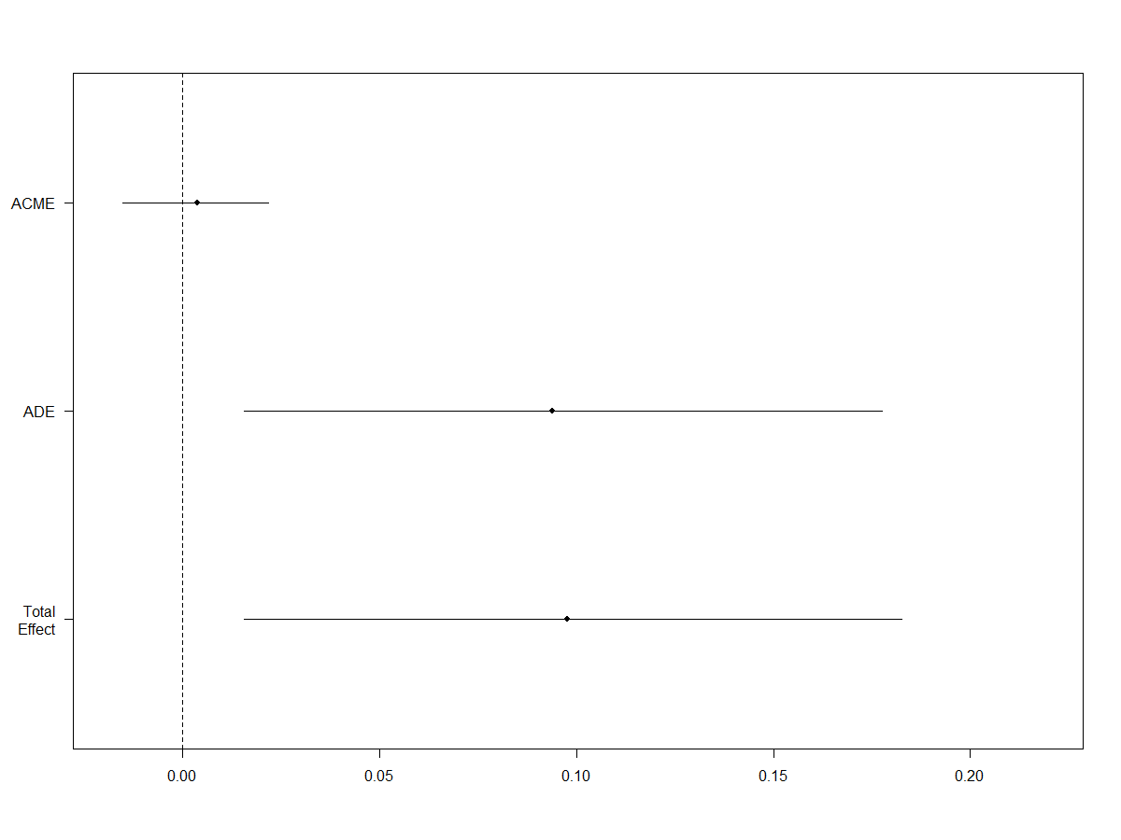
Fig. A1 The point estimates, with 95% confidence intervals for the average causal
mediation effect (ACME), average direct effect (ADE), and total effect.

Moving on to belief, I assessed whether acceptance mediates the treatment effect. Recall that in both study 2 and study 3, my manipulation check question was a measure of the acceptance of the presented conspiracy theory. In study 2, as table A7 shows below, acceptance mediates the effect of treatment on political participation in a positive direction. The value of ACME is .080 and is statistically significant at the 95% level, but the average direct effect is not statistically significant. The result also indicates that acceptance mediates about 53% of the treatment effects. Figure A2 illustrates this mediation effect. The analysis, therefore, clearly demonstrates the significance of acceptance as a potential mediator: exposure to the conspiracy theory increased acceptance, which in turn increased intention to get involved in politics. Additionally, table A8 echoes the mediation effect of acceptance of conspiracy theories on participation. As table A8 shows, when the potential mediator variable (i.e., acceptance) is included in the model, the coefficient of treatment is no longer statistically significant.
Table A7 Acceptance of conspiracy as a mediator
Causal Mediation Analysis: Quasi-Bayesian Confidence Intervals
Acceptance | Estimate | 95% CI Lower | 95% CI Upper | p-value
ACME | 0.0814 | 0.0219 | 0.1428 | 0.01
ADE | 0.0676 | -0.0698 | 0.2043 | 0.33
Total Effect | 0.1477 | 0.0211 | 0.2727 | 0.03
Prop.Mediated | 0.5280 | 0.0913 | 2.5275 | 0.04
Simulations: 500
Sample Size Used 607
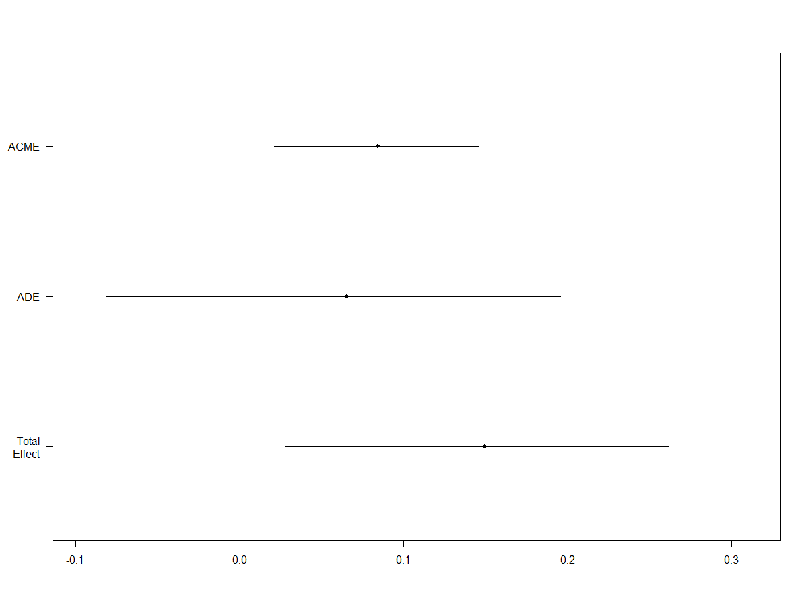
Fig. A2 The point estimates, with 95% confidence intervals for the average causal
mediation effect (ACME), average direct effect (ADE), and total effect.

Table A8 The effect of accepting conspiracy theory on political participation
Dependent Variable:
Political Participation
(1)
Model 1
Treatment (Conspiracy) | 0.064  (0.065)
Acceptance | 0.195**  (0.066)
Registered to Vote | 0.572***  (0.093)
Political Interest | 1.301***  (0.116)
Constant | 0.091  (0.103)
Observations | 607
$$R^{2}$$ | 0.296
Adjusted $R^{2}$ | 0.292
Residual Std. Error | 0.721 (df=602)
F Statistic | 63.394*** (df=4;602)
Note: *p<0.05; **p<0.01; ***<0.001
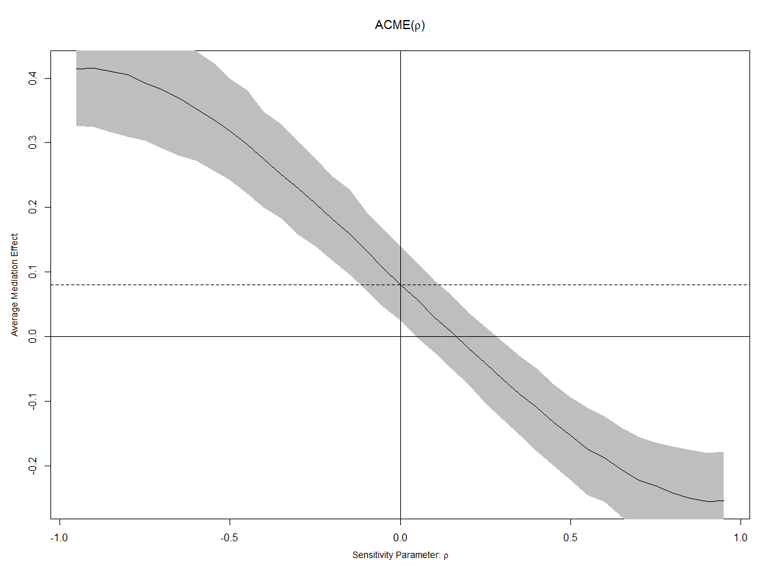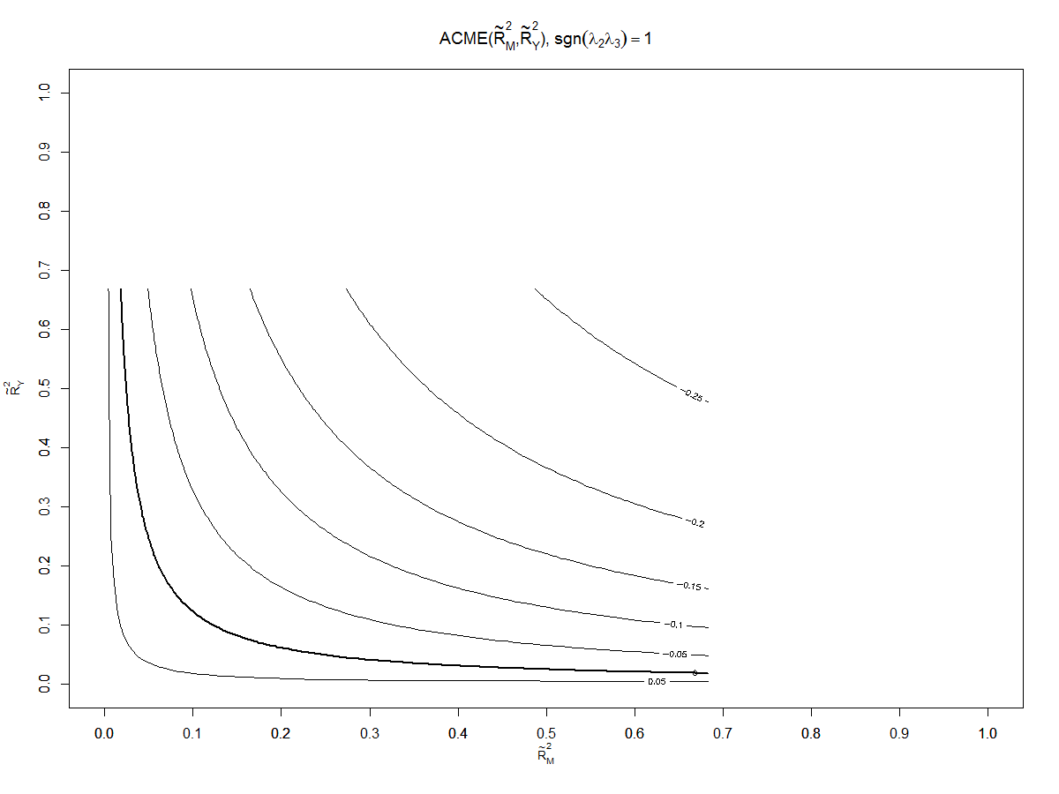
Fig. A3 Sensitivity Analyses, Mediation by Acceptance

To assess whether the ACME is robust in relation to the sequential ignorability violations, I conducted a sensitivity analysis. In the left panel of figure A3, the dashed line indicates the estimated ACME under the sequential ignorability assumption, and the solid line displays the mediation effect at each value of $ρ$. The grey area indicates the 95% confidence intervals. The results indicate that the ACME is zero when $ρ$, or the error correlation between the mediator and the outcome models, equals .15. Hence, I cannot completely rule out the existence of unobserved confounding.
Additionally, the right panel in figure A3 represents “the estimated true ACME as contour lines with respect to the ${{\tilde{R}}^{2}}_{M}$ and ${{\tilde{R}}^{2}}_{Y}$ parameters, the proportions of the total variance in the mediator and the outcome variables, respectively, which would be explained by an unobserved pretreatment confounder” (Imai and Yamamoto 2013, 152). In this case, I assumed that the unobserved confounder affects the mediator and outcome in the same direction. The result indicates that the true ACME changes sign if the product of ${{\tilde{R}}^{2}}_{M}$ and ${{\tilde{R}}^{2}}_{Y}$ is greater than 0.0114.
Likewise, in study 3, acceptance mediates the effect of exposure to a conspiracy theory on participation. As shown in table A9, the value of ACME is 0.020. This effect is statistically significant at the 95% level, but the average direct effect is not significant. Figure A4 displays this mediation effect. Additionally, the acceptance mediates about 21% of the treatment effect. Hence, this result replicates findings from study 1, in which acceptance mediates the effect of exposure to a conspiracy theory on participation. Further, table A10 reflects the partial mediation effects of acceptance as a mediator, presented in table A9. As table A10 shows, when the potential mediator variable (i.e., acceptance) is included in the model, the coefficient of treatment is no longer statistically significant. Thus, the mediation effect of acceptance of the effect of exposure to conspiracy theory demonstrates that not only does mere exposure to conspiracy theories have a significant behavioral consequence, but acceptance of such conspiracy theories also influences the increasing intention to engage in politics. The results suggest that belief is a partial mediator, but it appears that exposure still matters a lot.

Table A9 Acceptance of conspiracy as a mediator
Causal Mediation Analysis: Quasi-Bayesian Confidence Intervals
Acceptance | Estimate | 95% CI Lower | 95% CI Upper | p-value
ACME | 0.020512 | 0.000862 | 0.044218 | 0.04
ADE | 0.073953 | -0.019058 | 0.164273 | 0.11
Total Effect | 0.094465 | 0.005529 | 0.183776 | 0.04
Prop.Mediated | 0.208395 | -0.016611 | 1.208568 | 0.07
Simulations: 500
Sample Size Used 736

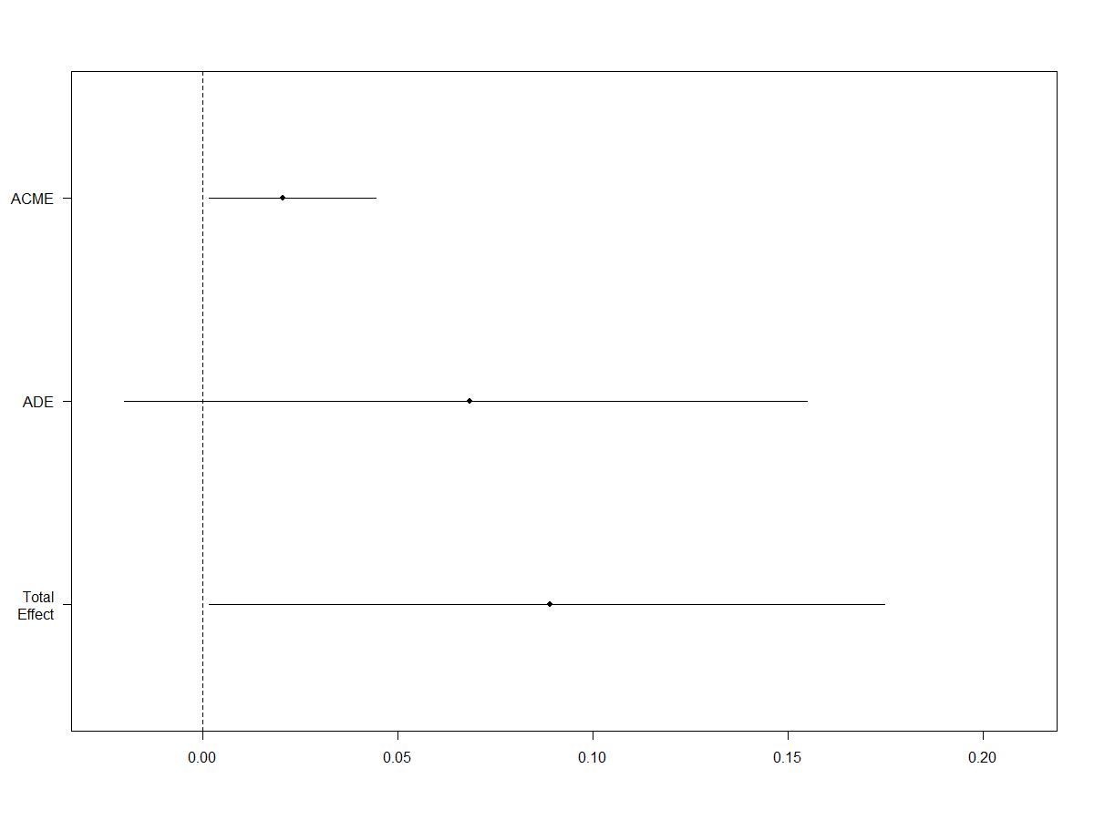
Fig. A4 The point estimates, with 95% confidence intervals for the average causal
mediation effect (ACME), average direct effect (ADE), and total effect.

Table A10 The effect of accepting conspiracy theory on political participation
Dependent Variable:
Political Participation
(1)
Model 1
Treatment (Conspiracy) | 0.072  (0.045)
Acceptance | 0.085†  (0.045)
Registered to Vote | 0.441**  (0.058)
Political Interest | 1.060**  (0.093)
Constant | 0.316 ***  (0.070)
Observations | 736
$$R^{2}$$ | 0.261
Adjusted $R^{2}$ | 0.257
Residual Std. Error | 0.595 (df=731)
F Statistic | 64.421**(df=4;731)
Note: †p<0.10; *p<0.05; **p<0.01; ***<0.001
Likewise, I conducted a sensitivity analysis. The result indicates that when $ρ$= .1, the ACME is exactly zero as illustrated in Figure A5. Additionally, the result indicates that the true ACME changes sign if the product of ${{\tilde{R}}^{2}}_{M}$ and ${{\tilde{R}}^{2}}_{Y}$ is greater than 0.0067.

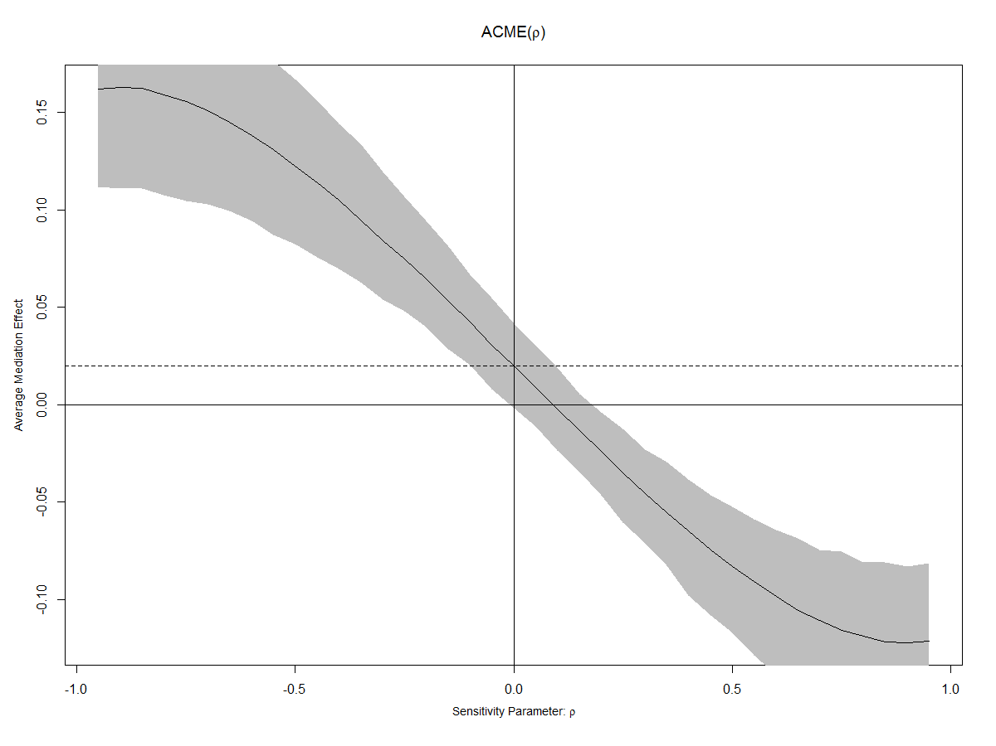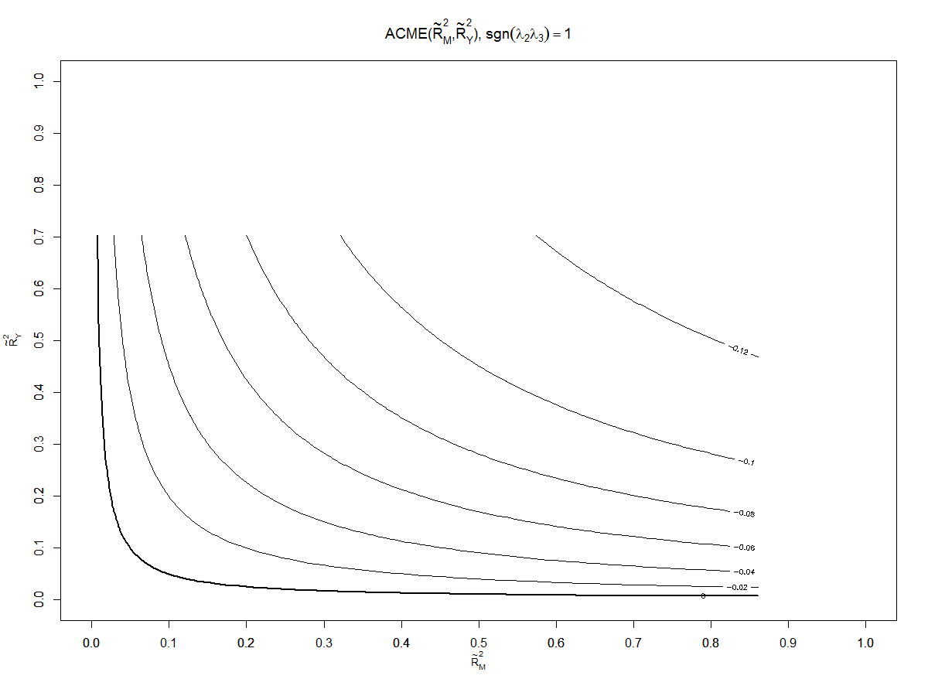
Fig. A5 Sensitivity Analyses, Mediation by Acceptance

In summary, both study 2 and study 3 suggest that acceptance of conspiracy theories mediates the effects of exposure to conspiracy theories on political engagement. This denotes that belief is a partial mediator, but still mere exposure of conspiracy theory has a significant effect on behavioral consequence. This is in line with previous studies’ hypotheses (Butler et al. 1995 and Jolley and Douglas 2014a), arguing that sheer exposure to conspiracy theories may have significant effects on society. If exposure has a significant impact, then future study needs to explore additional potential mediators in greater depth.

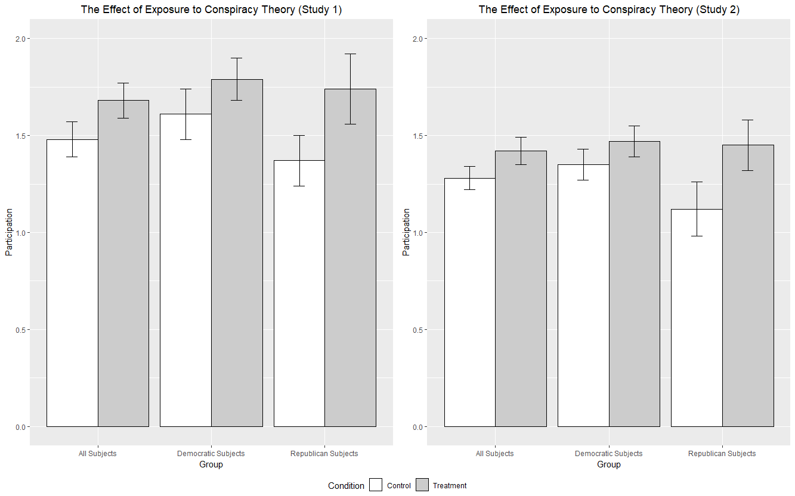
Figure.A6 Column height represents the mean levels of intention to engage in politics by party identification. Bars represent 95% intervals. The results are based on models 2, 2-a, and 2-b in Table 1 and 3.

Control Group Article
Long Lines At Polling Locations In Buckingham On Super Tuesday
-Voters were casting ballots late into the night at one community center in Buckingham County-

Some voters in Buckingham County complained about long lines on Super Tuesday.
At one polling location, Darlington’s East End, people were waiting until after 10 p.m. to cast their ballots.

Abbey Reed, a 35-year-old credit control analyst, was among those who waited in line for nearly three hours Tuesday.

She was in line to vote by 7 p.m. at the Montgomery Community Center. She left the polling location around 10:15 p.m. with her 6-year-old son, Tim, after casting her ballot.

At that time, there was still a group of about 35 people waiting to vote.

Buckingham County’s number of polling places for the presidential primary was cut from 200 in 2012 to just 60 on Tuesday, although those were larger voting centers where any registered voter could cast a ballot. During the last presidential primary, in 2008, there were 400 polling places in the county of 4 million residents.

“People in this community vote, and everyone should have a right and speedy way to vote,” Reed said as she exited the polling location. “Now, I understand that there are gonna be lines, but this is… It’s kind of ridiculous.”

Reed added that she had never thought about going home, because she wants to set an example for her son.

“I understand that the state government wants to cut the election costs due to facing a budget deficit, and that is why the line is long today,” Reed said.

The state has faced significant shortfalls in the past years, forcing cuts by legislators. Elections are expensive to administer, and this is one area of the budget that has seen significant cuts. It’s no surprise then that many voters waiting in line attributed the long lines to budget cuts.

Treatment Group Article
Long Lines At Polling Locations In Buckingham On Super Tuesday
-Voters were casting ballots late into the night at one community center in Buckingham County-

Some voters in Buckingham County complained about long lines on Super Tuesday.
At one polling location, Darlington’s East End, people were waiting until after 10 p.m. to cast their ballots.

Abbey Reed, a 35-year-old credit control analyst, was among those who waited in line for nearly three hours Tuesday.

She was in line to vote by 7 p.m. at the Montgomery Community Center. She left the polling location around 10:15 p.m. with her 6-year-old son, Tim, after casting her ballot.

At that time, there was still a group of about 35 people waiting to vote.

Buckingham County’s number of polling places for the presidential primary was cut from 200 in 2012 to just 60 on Tuesday, although those were larger voting centers where any registered voter could cast a ballot. During the last presidential primary, in 2008, there were 400 polling places in the county of 4 million residents.

“People in this community vote, and everyone should have a right and speedy way to vote,” Reed said as she exited the polling location. “Now, I understand that there are gonna be lines, but this is… It’s kind of ridiculous.”

Reed added that she had never thought about going home, because she wants to set an example for her son.

“Well, Buckingham County has always turned out against the current governor. That’s why they cut the polling sites,” Reed said.

The governor has faced substantial opposition in this county in past years. He has long been unpopular in this area, and it has nearly cost him the election before. It’s no surprise then that many voters waiting in line attributed the long lines to manipulation by the sitting governor.

Question Wording for the 2012 ANES Study (Response Options in Italics)
Conspiracy Theory Questions
Was Barack Obama definitely born in the United States, probably born in the United States, probably born in another country, or definitely born in another country?

Does the health care law passed in2010 definitely authorize government panels to make end of life decisions for people on Medicare, probably authorize government panels to make end of life decisions for people on Medicare, probably not authorize government panels to make end of life decisions for people on Medicare, or definitely not authorize government panels to make end of life decisions for people on Medicare?

Did senior federal government officials definitely know about the terrorist attacks on September 11, 2001 before they happened, probably know about the terrorist attacks on September 11, 2001 before they happened, probably not know about the terrorist attacks on September 11, 2001 before they happened, or definitely not know about the terrorist attacks on September 11, 2001 before they happened?

Some people say that when Hurricane Katrina hit the Gulf Coast in the summer of 2005, the federal government intentionally breached flood levees in New Orleans so that poor neighborhoods would be flooded and middle class neighborhoods would be spared. Do you think the federal government definitely did this, probably did this, probably did not do this, or definitely did not do this?

Question Wording for Studies 1 and 2 (Response Options in Italics)
Screening
[Study 2] We are doing a study about the upcoming 2016 election. Before you continue, are you eligible to vote? Yes, No

Pretreatment
How often do you pay attention to what's going on in government and politics? Always, Most of the time, About half the time, Some of the time, Never

Some people don't pay much attention to political campaigns. How about you? Would you say that you have been interested in political campaigns so far this year? Very much interested, Somewhat interested, Not much interested

Are you registered to vote at your current address? Registered at current address, Registered at a different address, Not currently registered

Political Activities
How likely are you to do each of the following activities within the next 6 months.
[Study 1]
Vote for presidential election
Persuade a friend to vote
Wear a campaign sticker
Contribute money to a candidate
Please select "very likely"
Volunteer to work for a candidate
Send a message on Facebook or Twitter about a political issue
Try to contact a member of Congress
Not likely at all, Not too likely, Somewhat likely, Very likely, Extremely likely
[Study 2]
Vote for presidential election
Persuade a friend to vote
Wear a campaign sticker
Contribute money to a candidate
Please select "very likely"
Volunteer to work for a candidate
Send a message on Facebook or Twitter about a political issue
Try to contact a member of Congress
Join in a protest march, rally, or demonstration
Sign a petition on the Internet about a political or social issue
Not likely at all, Not too likely, Somewhat likely, Very likely, Extremely likely

Emotion
Think about the long lines in the article you just read. To what extent did you feel each of the following emotions?
[Randomized order] Angry, Mad
Not at all, Slightly, Moderately, Quite a bit, An extreme amount
Manipulation Check and Attention Check
Based on the article you have just read, why do you think there were long lines in polling places in Buckingham County? Because state lawmakers intentionally slashed the number of polling places to suppress the number of voters. Because state government’s budgets are not sufficient to accommodate an adequate number of polling places.

In the news article, what was the name of the person who had to wait in line for nearly three hours to vote? Liz Stoval, Abbey Reed, Beth Taylor, Kathy Farrell

What county was mentioned in the news article? Cook County, Anoka County, Buckingham County, Lake County

PID
Generally speaking, do you usually think of yourself as a Democrat, a Republican, an Independent, or what? Democrats and Republicans branched to: Would you call yourself a strong Democrat [Republican] or a not very strong Democrat [Republican]? Independents and others branched to: Do you think of yourself as closer to the Democratic Party or closer to the Republican Party?

Ideology
We hear a lot of talk these days about liberals and conservatives. Here is a seven-point scale on which the political views that people might hold are arranged from extremely liberal to extremely conservative. Where would you place YOURSELF on this scale?
Extremely liberal, Liberal, Slightly liberal, Moderate; middle of the road, Slightly conservative, Conservative, Extremely conservative

Age
In what year were you born?

Sex
What is your sex? Male, Female

Race
Which race/ethnicity best describes you? (Please choose only one) American Indian or Alaskan Native, Asian/Pacific Islander, Black or African American, Hispanic/Latino, White/Caucasian, Multiple ethnicity/Other (please specify)

Education
What is the highest level of school you have completed or the highest degree you have received? Less than 1st grade; 1st, 2nd, 3rd, or 4th grade; 5th or 6th grade; 7th or 8th grade; 9th grade; 10th grade; 11th grade; 12th grade no diploma; High school graduate - high school diploma or equivalent (for example: GED); Some college but no degree; Associate degree (For example: Occupational/vocational program or Academic
program); Bachelor's Degree (For example: BA, AB, BS); Master's Degree (For example: MA, MS, MEng, MEd, MSW, MBA); Professional School Degree (For example: MD, DDS, DVM, LLB, JD); Doctorate degree (For example: PhD, EdD)
Income
In which of these groups did your family’s total income, from all sources, fall last year before taxes? Under $5,000, $5,000-9,999, $10,000-12,499, $12,500-14,999, $15,000-17,499, $17,500-19,999, $20,000-22,499, $22,500-24,999, $25,000-27,499, $27,500-29,999, $30,000-34,999, $35,000-39,999, $40,000-44,999, $45,000-49,999, $50,000-54,999
$55,000-59,999, $60,000-64,999, $65,000-69,999, $70,000-74,999, $75,000-79,999
$80,000-89,999, $90,000-99,999, $100,000-109,999, $110,000-124,999, $125,000-149,999, $150,000-174,999, $175,000-249,999, $250,000 or more.

Political Knowledge
Is the U.S. federal budget deficit -the amount by which the government's spending exceeds the amount of money it collects-now bigger, about the same, or smaller than it was during most of the 1990s? Bigger, About the same, Smaller

How many years are there in one full term of office for a U.S. Senator? Please enter a numeric response.

What is Medicare? A program run by the U.S. Federal government to pay for old people's health care, A program run by state governments to provide health care to poor people, A private health insurance plan sold to individuals in all 50 states, A private, non-profit organization that runs free health clinics

Who is the current Speaker of the U.S. House of Representatives? Nancy Pelosi, Marco Rubio, Paul Ryan, John Boehner

What job or political office is held by Joe Biden? House of Minority Leader, Vice President of the United States, Secretary of Defense, Secretary of State

What job or political office is held by John Roberts? Chair of the Democratic National Committee, Senate Majority Leader, Chief Justice of the Supreme Court, Chair of the Republican National Committee

Which party currently has the most members in the House of Representatives in Washington, D.C.? Democrats, Republicans

Which party currently has the most members in the U.S. Senate? Democrats, Republicans

Whose responsibility is it to nominate judges to the U.S. Federal Courts? The President, The U.S. Senate, The U.S. House of Representatives, The Supreme Court,

Whose responsibility is it to determine if a law is constitutional or not? The President, The U.S. Senate, The U.S. House of Representatives, The Supreme Court

How much of majority is required for the U.S. Senate and House of Representatives to override a presidential veto? 1/2, 3/5, 2/3, 3/4

Coding details for control variables
For party identification, I recoded the standard 7-point measure to range from 0 (strong Democrat) to 1 (strong Republican). I also recoded the standard 7-point measure of ideology with values from 0 (extremely liberal) to 1 (extremely conservative). The political knowledge index was formed by averaging responses to seven questions about politics. Each answer was coded 1 for correct and 0 for incorrect (α = .61).
I also controlled for two mobilization variables (Rosenstone & Hansen, 1993): whether anyone from one of the political parties had called the respondents or come and talked to them about the campaign this year (1 for yes, 0 for no) and whether anyone talked to the respondents about registering to vote or getting out to vote during the campaign this year (1 for yes, 0 for no).
Political interest was coded to range from 0 and 1. Thus, the least interested individuals were coded 0, and the most interested individuals were coded 1.
Additionally, following Miller et al. (2016), I controlled for the Big Five traits, authoritarianism, government trust, and efficacy, age, gender, education, income, and religiosity. These variables were coded from 0 to 1, so that a higher value indicates individuals who are more extraverted, agreeable, conscientious, emotionally stable, open to new experiences, authoritarian, trusting of government, and more efficacious.
Age, gender, education, income, and religiosity: These variables were coded 0 to 1. Higher values indicate individuals who are older, more educated, wealthier, and more religious. Male is a binary variable, coded 1 for male, and 0 otherwise. Race is a binary variable, coded 1 for White respondents and 0 otherwise.

The model controls for the pretreatment variables: voter registration status and political interest.
The model controls for the pretreatment variables: voter registration status and political interest.
The model controls for the pretreatment variables: voter registration status and political interest.

