Supplemental data

We have added validation data with SH-SY5Y human neuroblastoma cell lines (SH-SY5Y). The SH-SY5Y cells exposed to 250 μM H₂O₂ for 24 h were treated with different concentrations of caleolarioside B, paraboside B, and paraboside II (3.125, 6.25, 12.5, 25, and 50 μM). We examined the effects of caleolarioside B, paraboside B, and paraboside II on H₂O₂-induced cell viability.

Materials and methods
Cell culture
SH-SY5Y cells were obtained from the Cell Bank at the China Academy of Science (Shanghai, China). The cells were maintained at 37°C in a 5% CO₂ incubator (Thermo, USA), in DMEM (Gaithersburg, MD, USA) supplemented with 1% penicillin/ streptomycin and 10% FBS (Hyclone, Waltham, MA, USA).
MTS assay
Confluent cells were harvested and plated at a density of 5×10⁴ cells/mL, into 96 well plates. After overnight culture, the cells were treated with varying concentrations of caleolarioside B, paraboside B, and paraboside II (3.125, 6.25, 12.5, 25, and 50 μM) for 1 h. The treated cells were then exposed to 250 μM H₂O₂ (Tianjin, China) and incubated 24 h. After incubation, cell viability was determined using the MTS (Madison, USA) assays. Absorbance of each well was read at 490 nm.

Statistical analysis
Data were analyzed using SPSS 19.0, and the results are presented as the means with standard deviation (SD) of three independent experiments. Values of p < 0.05 were considered to indicate statistically significant differences.

Results
Effects of caleolarioside B, paraboside B, and paraboside II on viability of H₂O₂-induced SH-SY5Y cells
To determine the neuroprotective effects of caleolarioside B, paraboside B, and paraboside II against oxidative stress in SH-SY5Y cells, the viability was measured by MTS assay. As illustrated in Figure 1(a, b), 250 μM H₂O₂ treatment decreased the cell viability to 51.65% compared with control group (100%). However, caleolarioside B and paraboside B treatment significantly increased the cell viability. In particular, treatment with 50 μM restored cell viability to 96.62% and 90.76%, respectively. Likewise, after paraboside II treatment significantly increased the cell viability, being 84.05% at 25 μM concentrations best (Figure 1(c)).
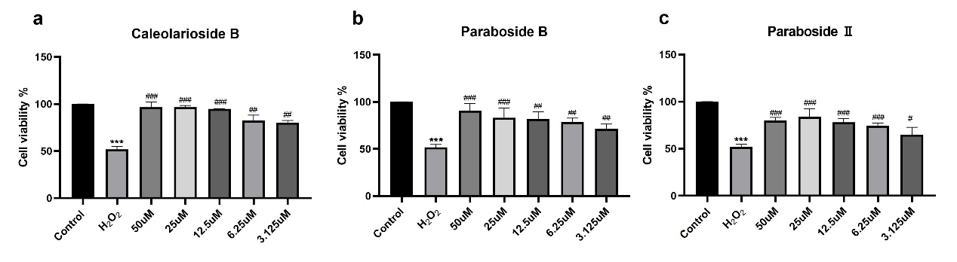
Figure 1. Effects of caleolarioside B, paraboside B, and paraboside II on cell viability in hydrogen peroxideinduced SH-SY5Y cells. (Data are presented as means ± SD, n = 3). ***p < 0.001 compared with control; ###p < 0.001, ##p < 0.01, #p < 0.05 compared with H₂O₂. (Control group; Model group: H₂O₂; Treated group: caleolarioside B + 250 μM H₂O₂, paraboside B + 250 μM H₂O₂, paraboside II + 250 μM H₂O₂)

Discussion
Treatment of H₂O₂ resulted in decreased cell viability, however, caleolarioside B, paraboside B, and paraboside II treatment significantly attenuated the neuronal cell death, indicating that caleolarioside B, paraboside B, and paraboside II potentially blocked the H₂O₂-induced neuronal apoptosis. This result suggests that it will be necessary to verify the protective mechanisms of caleolarioside B, paraboside B, and paraboside II from neuronal damage in the future.

