Dual and selective inhibitors of pteridine reductase 1 (PTR1) and dihydrofolate reductase-thymidylate synthase (DHFR-TS) from Leishmania chagasi
Bárbara Velame Ferreira Teixeira^{a*}, André Lacerda Braga Teles^{b,c,d*}, Suellen Gonçalves da Silvaª, Camila Carane Bitencourt Brito^{b}, Humberto Fonseca de Freitas^{a,b} , Acássia Benjamim Leal Pires^{d}, Thamires Quadros Froes^{b} and Marcelo Santos Castilho^{a,b}
ªPrograma de Pós-Graduação em Farmácia, Universidade Federal da Bahia, Salvador, BA, Brazil; ^{b}Programa de Pós-Graduação em Biotecnologia, Universidade Estadual de Feira de Santana, Feira de Santana, BA, Brazil; ^{c}Programa de Pós-Graduação em Ciências Farmacêuticas, Universidade Estadual da Bahia, Salvador, BA, Brazil; ^{d}Departamento de Ciências da Vida, Universidade do Estado da Bahia, Salvador, BA, Brazil.
* Both authors contributed equally to this work.

Supplementary material

Figure S1. Sequential alignment of the L. chagasi, L. donovani, L. major and T. Brucei PTR1 generated on Clustal Omega server (https://www.ebi.ac.uk/Tools/msa/clustalo/). Overall sequential identity: LcPTR1 x LdPTR1 = 100%; LcPTR1 x LmPTR1 = 90%; LcPTR1 x TbPTR1 = 48.8%. ("*" = Identical, ":" = Similar, "." = Not conserved, "-" = absent).

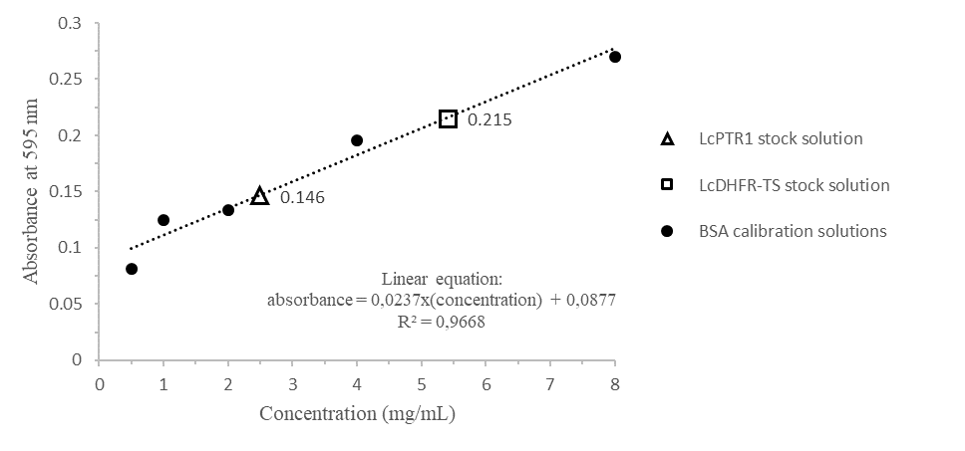
Figure S2. Calibration curve employed for protein concentration calculation with Bradford reagent. The absorbances of the LcPTR1 and LcDHFR-TS stock solutions are presented in the graph and correspond to the concentrations of 2.5 and 5.4 mg/mL, respectively.

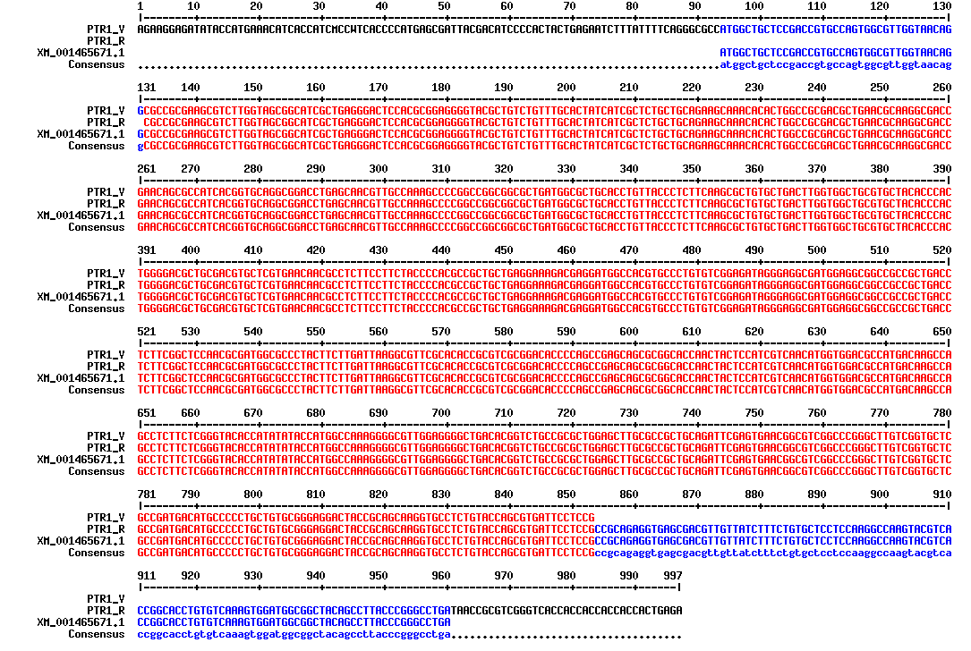

Figure S3. Sequence alignment between the product of the LcPTR1 gene on pETM11 vector and its Genebank sequence (XM_001465671.1). PTR1_V: Forward sequencing; PTR1_R: Reverse sequencing; Consensus: lowercase letter: consensus between 2 sequences; capital letter: consensus among 3 sequences.

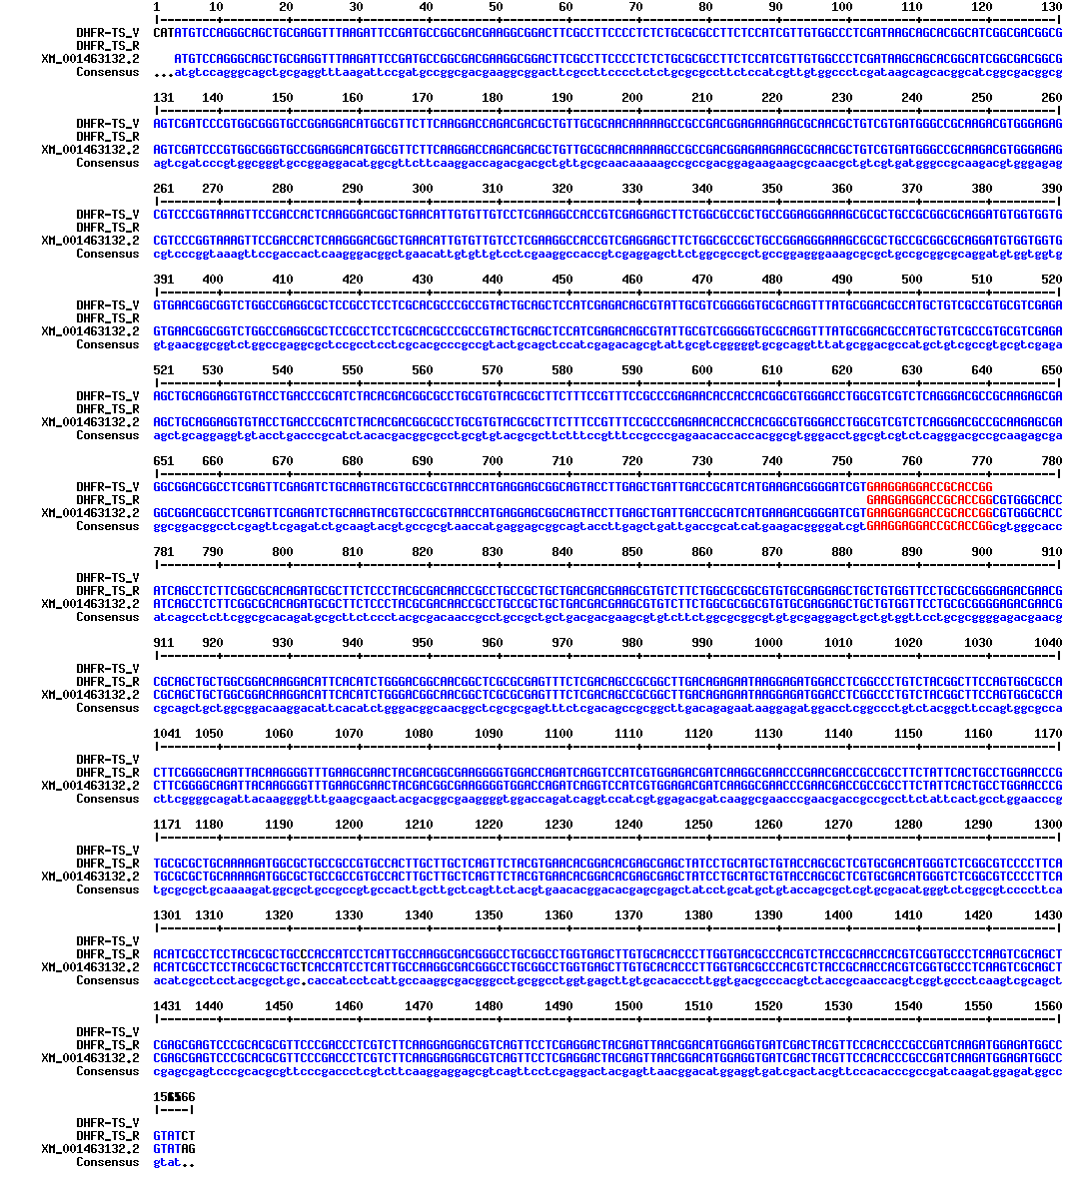

Figure S4. Sequence alignment between the product of the LcDHFR-TS gene cloned on pET28a vector and its Genebank sequence (XM_001463132.2). DHFR-TS_V: Forward sequencing; DHFR-TS_R: Reverse sequencing; Consensus: lowercase letter: consensus between 2 sequences; capital letter: consensus among 3 sequences.
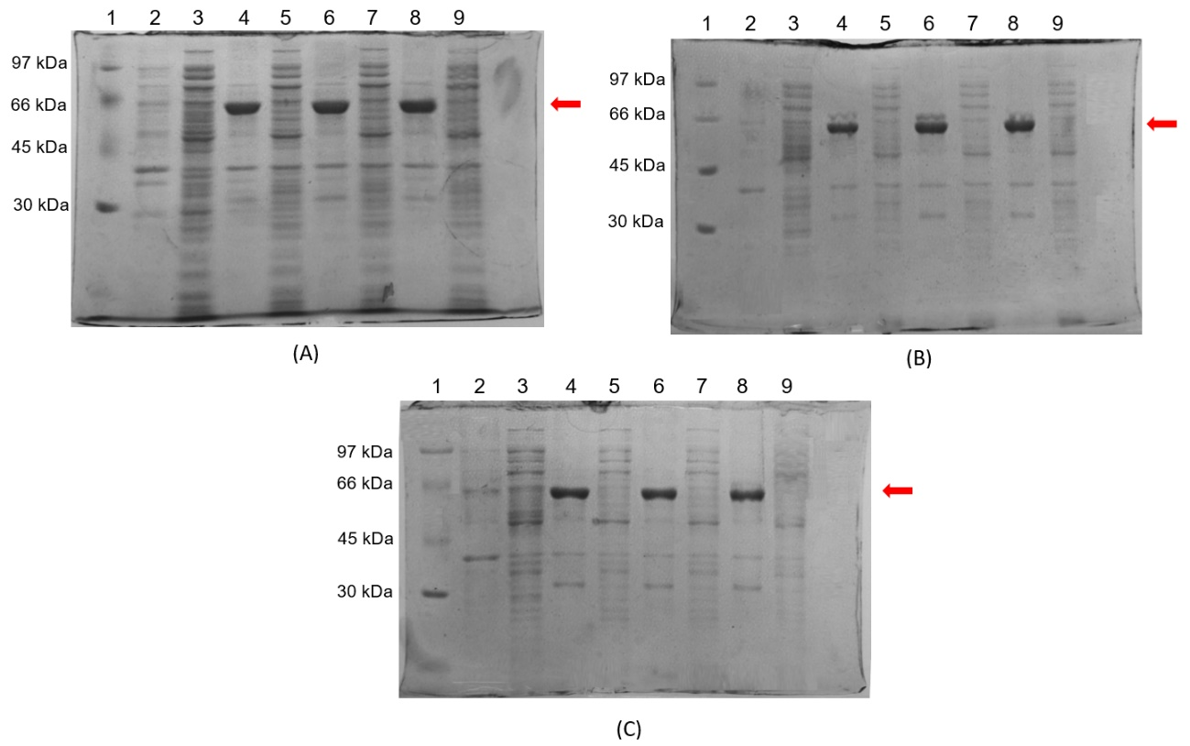

Figure S5. Screening of LcDHFR-TS expression conditions in Bl21 (DE3). A) 18 °C for 24 hours; B) 25 °C for 16 hours; C) 37 °C for 24 hours; 1) LMW-SDS GE molecular weight standard; 2) Pellet for IPTG 0.0 mM; 3) Supernatant for IPTG 0.0 mM; 4) Pellet for IPTG 0.1 mM; 5) Supernatant for IPTG 0.1 mM; 6) Pellet for IPTG 0.5 mM; 7) Supernatant for IPTG 0.5 mM; 8) Pellet for IPTG 1.0 mM; 9) Supernatant for IPTG 1.0 mM. Red arrows indicate expected height for the LcDHFR-TS band.

Toxicity Model | COMPOUND 1 |  | COMPOUND 2 |  | COMPOUND 3 |  | COMPOUND 4 |  | COMPOUND 5
 | Result | Probability | Result | Probability | Result | Probability | Result | Probability | Result | Probability
Human Ether-a-go-go-Related Gene Inhibition | Weak inhibitor | 0.7577 | Weak inhibitor | 0.7577 | Weak inhibitor | 0.7577 | Weak inhibitor | 0.9724 | Weak inhibitor | 0.9436
 | Non-inhibitor | 0.6832 | Non-inhibitor | 0.6832 | Non-inhibitor | 0.6832 | Non-inhibitor | 0.7159 | Non-inhibitor | 0.8210
AMES Toxicity | Non AMES toxic | 0.7062 | Non AMES toxic | 0.7062 | Non AMES toxic | 0.7062 | Non AMES toxic | 0.7905 | Non AMES toxic | 0.7086
Carcinogens | Non-carcinogens | 0.9538 | Non-carcinogens | 0.9538 | Non-carcinogens | 0.9538 | Non-carcinogens | 0.8606 | Non-carcinogens | 0.9282
Biodegradation | Not ready biodegradable | 0.9779 | Not ready biodegradable | 0.9779 | Not ready biodegradable | 0.9779 | Not ready biodegradable | 0.9962 | Not ready biodegradable | 0.9829
Acute Oral Toxicity | Dose > 500 mg/Kg | 0.4953 | Dose > 500 mg/Kg | 0.7577 | Dose > 500 mg/Kg | 0.4953 | Dose > 500 mg/Kg | 0.5171 | Dose > 500 mg/Kg | 0.6909

Figure S6. Toxicity prediction for the 2,4-diaminopyrimidine derivatives employed in this work, according to admetSAR server (http://lmmd.ecust.edu.cn/admetsar1).

