SUPPORTING INFORMATION

Structure-Based Design of Selective Histone Deacetylase 6 Zinc Binding Groups
Leandro A. Alves Avelar^{1,2 #}, Dusan Ruzic², Nemanja Djokovic², Thomas Kurz¹, and Katarina Nikolic^{2 #}
¹Institut für Pharmazeutische und Medizinische Chemie, Heinrich Heine Universität Düsseldorf, Universitätsstr. 1, 40225 Düsseldorf, Germany.
²Department of Pharmaceutical Chemistry, Faculty of Pharmacy, University of Belgrade, Vojvode Stepe 450, 11000 Belgrade, Serbia.

Keywords: histone deacetylase, fragment-based drug design, molecular docking, epigenetics, zinc binding group.

Table S1: Fragments defined as active and inactive in the virtual screening
Active fragments | HDAC6 inibition IC₅₀(µM) | Ref | Inactive fragments | HDAC6 inibition IC₅₀(µM) | Ref
CHEMBL297304 | 3.200 | (Wu et al. 2017) | CHEMBL115468 | >100 | (KrennHrubec et al. 2007)
CHEMBL496703 | 0.550 | (KrennHrubec et al. 2007) | CHEMBL405072 | >50 | (Jones et al. 2008)
CHEMBL1672332 | 2.000 | (Mazitschek et al. 2008) | CHEMBL236678 | >50 | (Jones et al. 2008)
CHEMBL55895 | 0.500 | (Mazitschek et al. 2008) | CHEMBL86537 | >75 | (Muthyala et al. 2015)
CHEMBL2333346 | 0.030 | (Kemp et al. 2011) | CHEMBL14227 | >2000 | (Fass et al. 2011)
CHEMBL16300 | 0.115 | (Kemp et al. 2011) | CHEMBL109 | >2000 | (Fass et al. 2011)
CHEMBL2333344 | 0.012 | (Kemp et al. 2011) | CHEMBL1469 | >240 | (Fass et al. 2011)
CHEMBL2333345 | 0.376 | (Kemp et al. 2011) | CHEMBL1800380 | >100 | (Kemp et al. 2011)
CHEMBL152665 | 1.100 | (Kemp et al. 2011) | CHEMBL1800382 | >100 | (Kemp et al. 2011)
CHEMBL154574 | 0.022 | (Kemp et al. 2011) | CHEMBL396097 | >11000 | (Bürli et al. 2013)
CHEMBL152162 | 0.448 | (Kemp et al. 2011)
CHEMBL2333343 | 0.028 | (Kemp et al. 2011)
CHEMBL2337874 | 0.681 | (Wagner et al. 2013)
CHEMBL2337875 | 0.457 | (Wagner et al. 2013)
CHEMBL2381522 | 0.650 | (Patil et al. 2013)
CHEMBL2381521 | 2.500 | (Patil et al. 2013)
CHEMBL3652225 | 0.007 | (Olson et al. 2013)
CHEMBL109654 | 0.067 | (Giannini et al. 2014)
CHEMBL3617543 | 0.150 | (Muthyala et al. 2015)
CHEMBL3415449 | 1.770 | (Fass et al. 2011)

Table S2: Results of the validation of the docking protocols

 | GOLD results |  | AutoDock4.2 results
Isoform | CSFF | RMSD | Binding Energy | RMSD
HDAC1 | 21,9312 | 1.24 | -4.71 | 2.24
HDAC4 | 42,0078 | 1.2876 | -9.80 | 1.63
HDAC6 | 29,146 | 1,6556 | -9.01 | 2.33
HDAC8 | 40,0293 | 0.8095 | -6.93 | 1.67

Table S3: Top 20 best ranked compounds of FL1 SBVS.
Compound | Structure | H*N1 | Compound | Structure | H*N1
4 |  | 0.686 | 20 |  | 0.562
8 |  | 0.628 | 12 |  | 0.560
19 |  | 0.621 | 6 |  | 0.558
3 |  | 0.590 | 11 |  | 0.557
17 |  | 0.578 | 7 |  | 0.556
18 |  | 0.577 | 5 |  | 0.553
15 |  | 0.576 | 2 |  | 0.549
9 |  | 0.571 | 10 |  | 0.548
16 |  | 0.570 | 14 |  | 0.547
1 |  | 0.564 | 13 |  | 0.546

Table S4: Top 20 best ranked compounds of FL2 SBVS.
Compound | Structure | H*N1*H | Compound | Structure | H*N1*H
27 |  | 0.652 | 35 |  | 0.624
29 |  | 0.652 | 26 |  | 0.617
30 |  | 0.649 | 34 |  | 0.614
25 |  | 0.6452 | 21 |  | 0.613
23 |  | 0.642 | 39 |  | 0.611
33 |  | 0.638 | 28 |  | 0.61019
32 |  | 0.634 | 36 |  | 0.606
31 |  | 0.6325 | 38 |  | 0.603
40 |  | 0.631 | 24 |  | 0.6027
22 |  | 0.630 | 37 |  | 0.601

Table S5: ChemScore fitness function values and obtained for the selected fragments.
 | Structure | ChemScore Fitness Function (CSFF) |  |  |  | AD4.2 Binding energy
 |  | HDAC6 | HDAC1 | HDAC4 | HDAC8 | HDAC6 | HDAC1 | HDAC4 | HDAC8
1 |  | 28.4898  NC | 25.8847 | 22.9649 | 23.8009 | -8,77 | -8,54 | -8,42 | -8,26
2 |  | 24.9111  NC | 23.1529 | 20.4474 | 19.2576 | -8,64 | -8,32 | -8,32 | -8,17
3 |  | 36.4746 | 29.9944 | 30.2654 | 34.8795 | -4,26 | -4,77 | -5,10 | 5,11
4 |  | 31.1332 | 25.4694 | 30.3946 | 28.4444 | -3,82 | -4,54 | -4,65 | -3,84
5 |  | 26.874 | 23.4472 | 29.3 | 25.3496 | -4,15 | -5,50 | -5,18 | -3,89
6 |  | 27.7006  NC | 26.4165 | 26.5247 | 26.7527 | -10,59 | -10.98 | -10,53 | -10,95
7 |  | 36.5756 | 31.0949 | 29.5388 | 36.8017 | -4,55 | -5,24 | -5,36 | -4,14
8 |  | 28.6316 | 24.1322 | 32.0201 | 26.884 | -4,53 | -4,70 | -5,23 | -4,16
9 |  | 26.9698 | 21.7664 | 30.3481 | 24.874 | -4.61 | -5,41 | -5,32 | -5,05
10 |  | 25.1263 | 18.3045 | 27.7834 | 17.9162 | -4,43 | -5,23 | -5,07 | -4,73
11 |  | 24.0346 | 22.1933 | 31.3893 | 25.5807 | -4,66 | -4,98 | -5,08 | -4,33
12 |  | 27.5129  NC | 26.2177 | 33.1004 | 25.563 | -5,97 | -5,87 | -8,55 | -7,47
13 |  | 32.0564 | 27.4713 | 29.2428 | 30.5287 | -5,25 | -5,57 | -5,59 | -5,04
14 |  | 20.2314  NC | 17.7689 | 27.9519 | 20.3135 | -5,39 | -5,15 | -5,51 | -5,06
15 |  | 32.4989  NC | 31.3672 | 28.8355 | 35.3856 | -4,71 | -5,55 | -5,41 | -4,87
16 |  | 32.8812 | 29.9679  I.P. | 30.3291 | 32.3168  NC | -5,46 | -6,04 | -5,94 | -4,72
17 |  | 18.3583 | 26.9367 | 31.5964 | 24.9839 | -5,68 | -6,90 | -5,67 | -5,73
18 |  | 32.7814 | 30.7632 | 38.0532 | 35.8265 | -5,22 | -6,32 | -6,69 | -5,01
19 |  | 24.5787  I.P. | 34.3652 | 35.7917 | 28.8893 | -6,05 | -6,83 | -6,04 | -5,89
20 |  | 22.9226 | 18.391 | 24.9745 | 22.6788 | -10,29 | -7,92 | -9,99 | -8,43
21 |  | 23.5607  NC | 23.2955 | 23.4662 | 24.0005 | -6,13 | -5,50 | -4,77 | -5,03
22 |  | 28.2003 | 24.3939 | 26.7005 | 29.7439 | -3,15 | -3,02 | -3,90 | -2,62
23 |  | 26.4268 | 23.9569 | 21.899 | 26.317 | -6,22 | -5,53 | -5,11 | -5,40
24 |  | 28.6551 | 25.4213 | 29.7456 | 30.341 | -3.41 | -3,51 | -4,83 | -2,33
25 |  | 27.245 | 25.8947 | 31.5518 | 32.2114 | -2.74 | -2,93 | -4,82 | -1,35
26 |  | 32.0273 | 24.1715 | 30.4741 | 32.6607 | -2,69 | -3,07 | -5,12 | -1,26
27 |  | 23.4205 | 19.2296 | 25.4829 | 23.3816 | -4,53 | -3,64 | -4,23 | -3,35
28 |  | 22.2478 | 18.7455 | 23.9045 | 24.1831 | -4,62 | -4,27 | -4,26 | -3,58
29 |  | 27.155 | 23.2101 | 27.6446 | 31.3194 | -3,53 | -3,96 | -3,88 | -2,91
30 |  | 22.5205 | 22.139 | 26.419 | 24.9152 | -2.87 | -2,59 | -4,25 | -2,25
31 |  | 28.7253 | 22.7752 | 30.1798 | 27.587 | -5,46 | -5,00 | -4,80 | -4,46
32 |  | 31.0196 | 24.4202 | 32.3626 | 31.2097 | -3.84 | -3,56 | -4,00 | -2,83
33 |  | 29.318  NC | 23.7895 | 28.9713 | 33.5766 | -3,29 | -3,58 | -5,16 | -1,89
34 |  | 25.0866  NC | 24.4708 | 27.4372 | 25.6845 | -4,12 | -3,56 | -4,06 | -3,06
35 |  | 27.3541 | 21.6326 | 26.5015 | 26.6982 | -4,32 | -3,53 | -4,43 | -3,06
36 |  | 22.1585 | 18.412 | 30.3597 | 25.7811 | -2,74 | -3,74 | -3,97 | -3,16
37 |  | 26.2223 | 21.0125 | 28.8447 | 28.5766 | -3,74 | -3,48 | -4,21 | -3,55
38 |  | 24.3948 | 23.4907 | 29.9866 | 26.2142 | -4,68 | -4,27 | -4,14 | -3,93
39 |  | 29.3988 | 24.7666 | 29.066 | 30.9126 | -3,35 | -4,03 | -6,12 | -0,75-
40 |  | 27.3399 | 25.4547 | 30.3512 | 30.8412 | -2,89 | -3,13 | -5,05 | -1,15
BHA |  | 31.6326 | 29.1091 | 26.1487 | 30.9807 | -7,44 | -6,71 | -6,41 | -6,66

N.C. – not coordinated to Zn²⁺ cation inside the active pocket; IP – inverted pose (heteroatoms are inversely oriented towards Zn²⁺ cation).

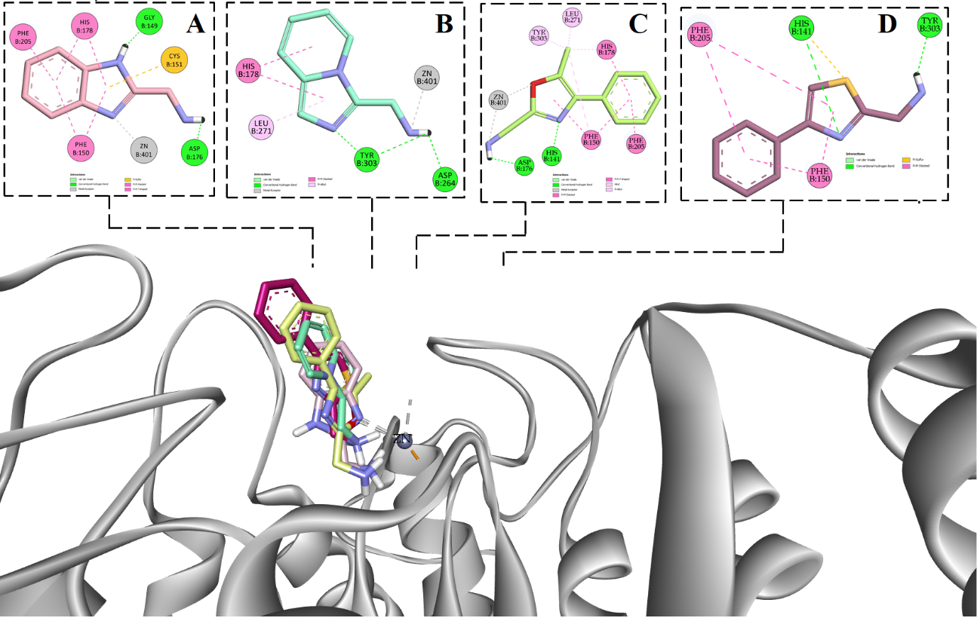
Figure S1. Presentation of the selected fragments inside the active pocket of HDAC1 (A –fragment 3, B – fragment 4, C – fragment 13 and D – fragment 16).

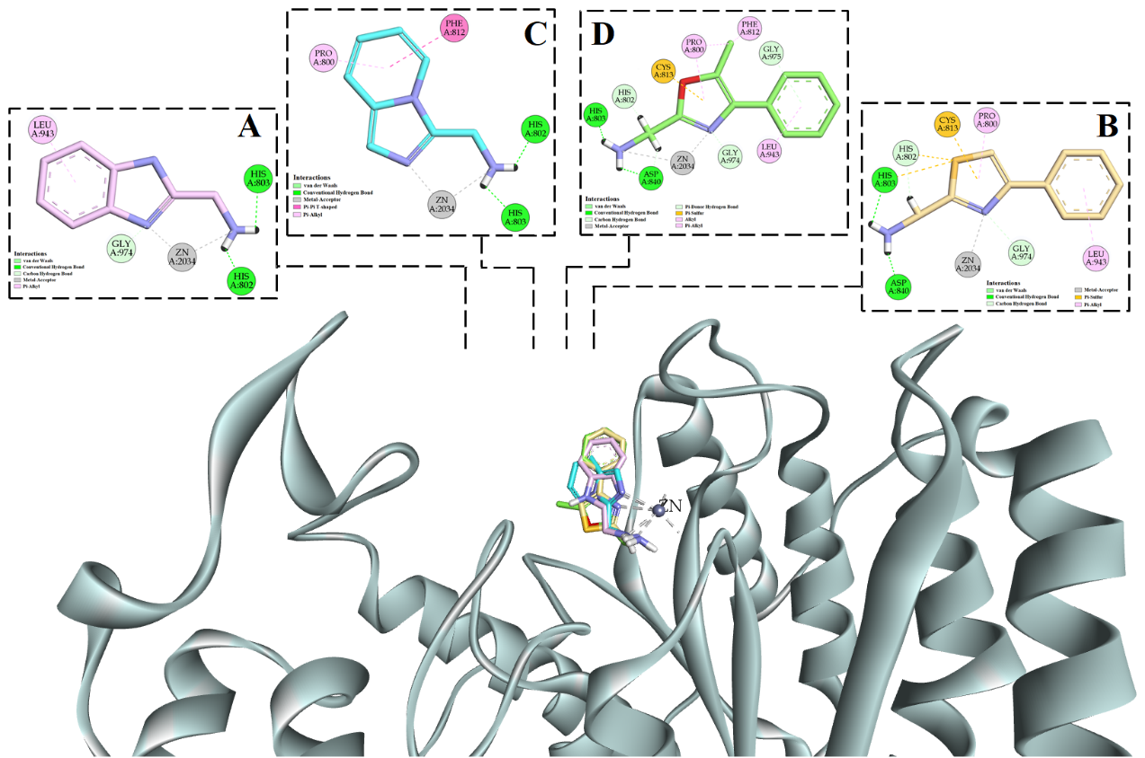
Figure S2. Presentation of the selected fragments inside the active pocket of HDAC4 (A –fragment 3, B – fragment 4, C – fragment 13 and D – fragment 16).

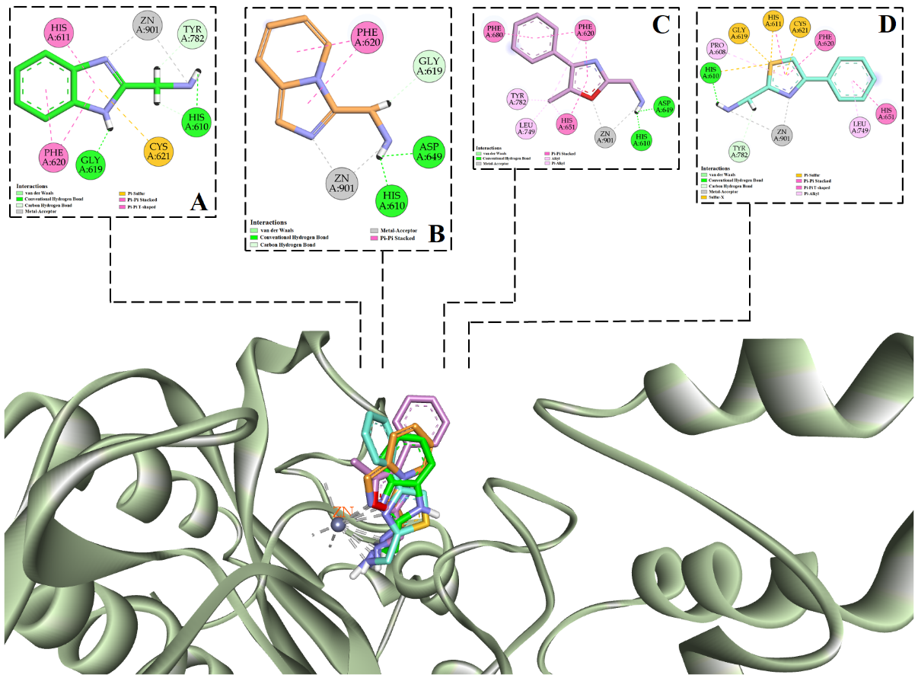
Figure S3. Presentation of the selected fragments inside the active pocket of HDAC6 (A –fragment 3, B – fragment 4, C – fragment 13 and D – fragment 16).

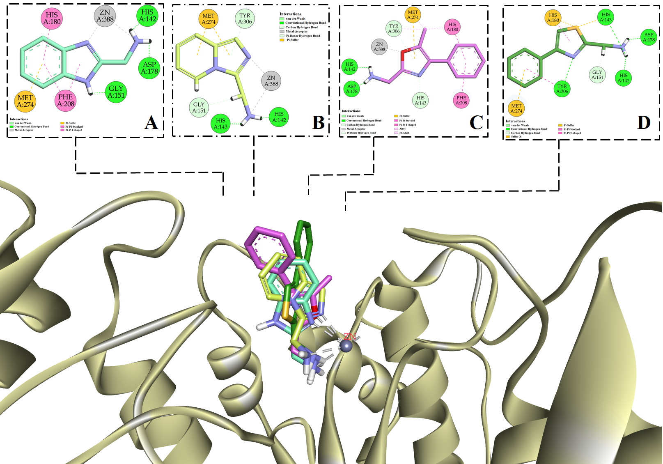 Figure S4. Presentation of the selected fragments inside the active pocket of HDAC8 (A –fragment 3, B – fragment 4, C – fragment 13 and D – fragment 16).
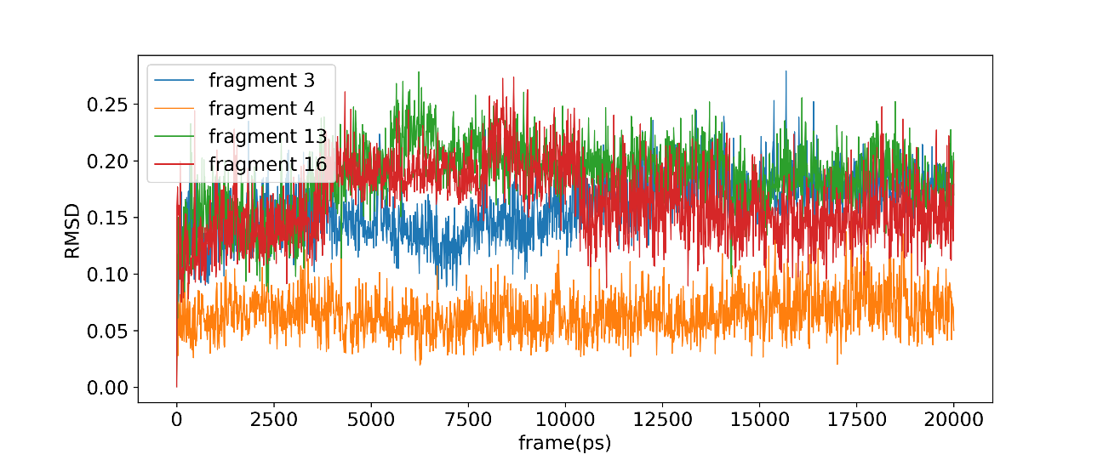
Figure S5. Root-mean-square deviations (RMSD) for ligand atoms calculated for 20 ns of MD simulation.

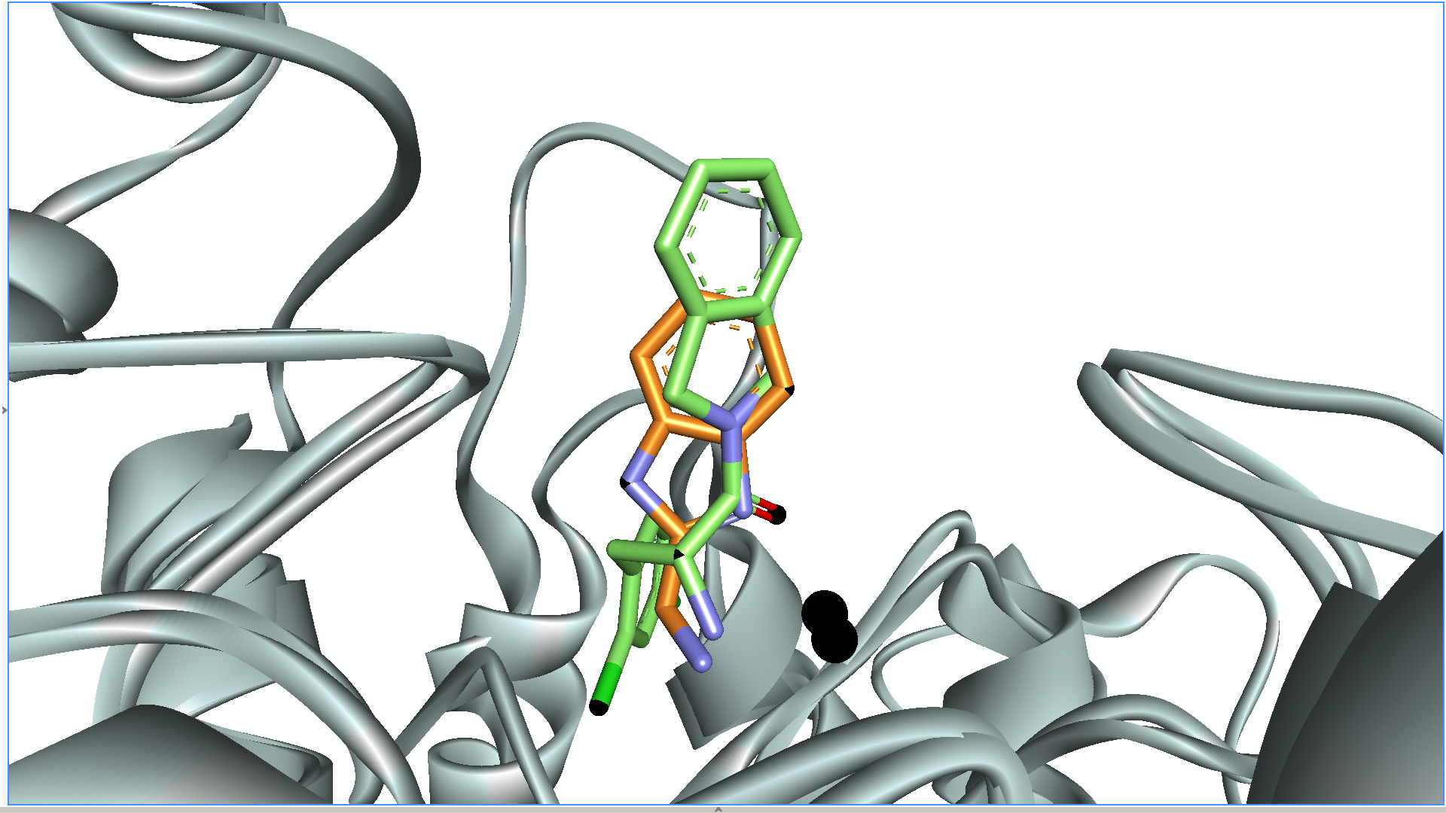
Figure S6. Superposition of HDAC6-fragment 3 complex with PDB ID:3SFF. Fragment 3 is presented in orange, selective HDAC8 inhibitor (alpha-amino carbonyl derivative) in green while zinc atoms are presented in black.,

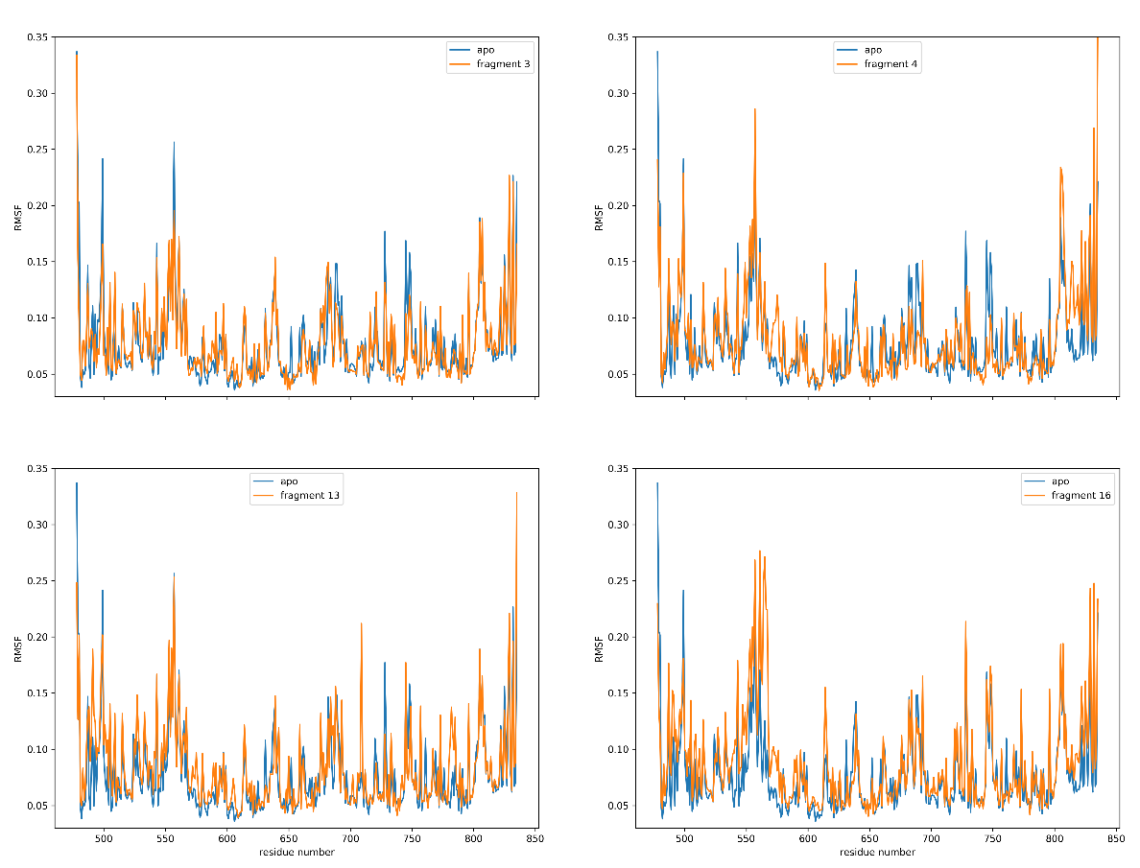
Figure S7. Root mean square fluctuation (RMSF) of HDAC6 residues during last 5 ns of MD simulations.
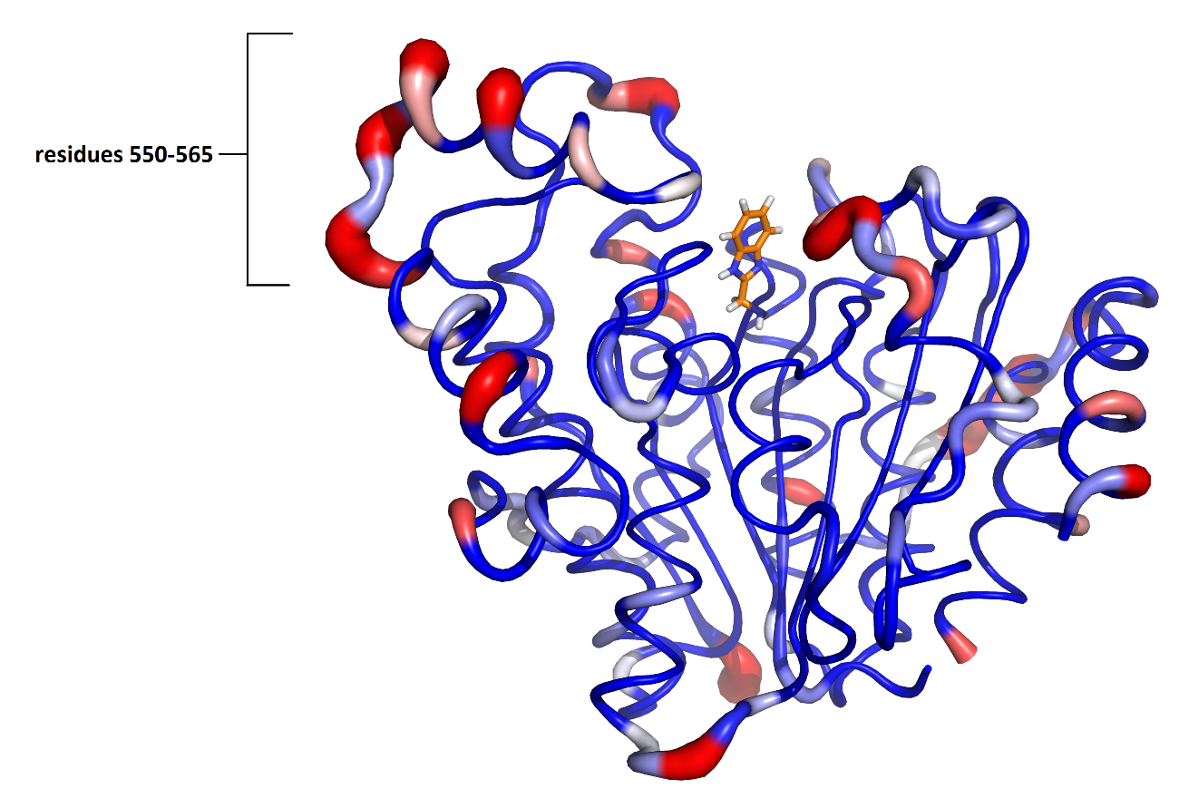
Figure S8. B-factors visualization of RMSF values for complex HDAC6-Fragment 3.

Table S6: Predicted MM/PBSA binding free energies for NextA and designed ligand 41.

 | $${∆E}_{coul}$$ | ∆$G_{polar}$ | $${∆E}_{vdW}$$ | $$∆G_{nonpolar}$$ | $$∆G_{binding}$$
NextA | -228,228 | 317,961 | -125,870 | -16,429 | -52.566
41 | -329.636 | 362.018 | -105.743 | -17.583 | -90.945
 | Polar contribution |  | Nonpolar contribution

A
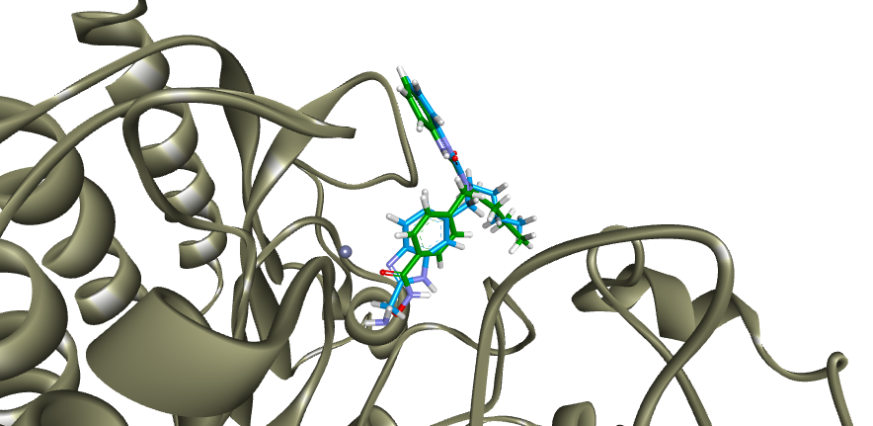
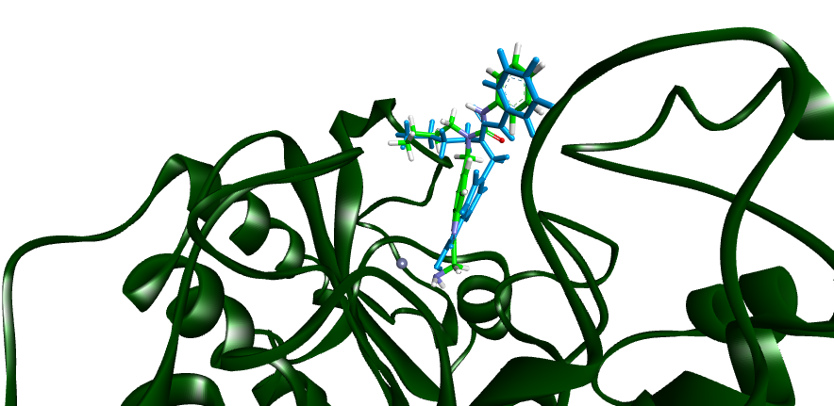
B

Figure S9: A) Docking of NextA (blue) and compound 41 (green) in the crystal structure of HDAC1 (PDB 5ICN) (Watson et al. 2016) B) Docking of NextA (blue) and compound 41 (green) in the crystal structure of HDAC6 (PDB 5ICN) (Hai and Christianson 2016).

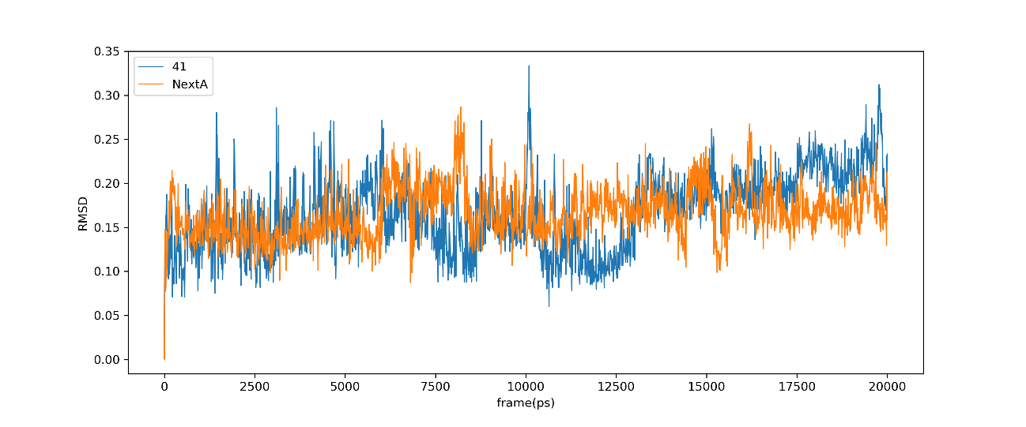

Figure S10. Root-mean-square deviations (RMSD) for ligand atoms calculated for 20 ns of MD simulation.
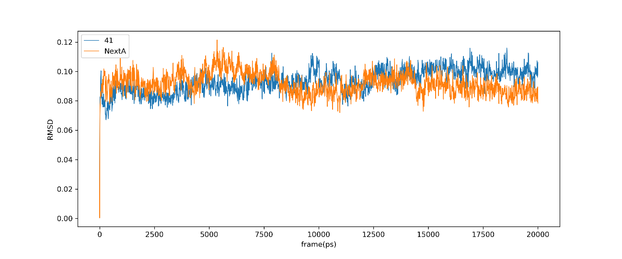

Figure S11. Root-mean-square deviations (RMSD) for Cα atoms calculated for 20 ns of MD simulation.

References
Bürli, Roland W., Christopher A. Luckhurst, Omar Aziz, Kim L. Matthews, Dawn Yates, Kathy. A. Lyons, Maria Beconi, et al. 2013. “Design, Synthesis, and Biological Evaluation of Potent and Selective Class IIa Histone Deacetylase (HDAC) Inhibitors as a Potential Therapy for Huntington’s Disease.” Journal of Medicinal Chemistry 56 (24): 9934–54. https://doi.org/10.1021/jm4011884.
Fass, Daniel M., Rishita Shah, Balaram Ghosh, Krista Hennig, Stephanie Norton, Wen-Ning Zhao, Surya A. Reis, et al. 2011. “Short-Chain HDAC Inhibitors Differentially Affect Vertebrate Development and Neuronal Chromatin.” ACS Medicinal Chemistry Letters 2 (1): 39–42. https://doi.org/10.1021/ml1001954.
Giannini, Giuseppe, Loredana Vesci, Gianfranco Battistuzzi, Davide Vignola, Ferdinando M. Milazzo, Mario Berardino Guglielmi, Marcella Barbarino, et al. 2014. “ST7612AA1, a Thioacetate-ω(γ-Lactam Carboxamide) Derivative Selected from a Novel Generation of Oral HDAC Inhibitors.” Journal of Medicinal Chemistry 57 (20): 8358–77. https://doi.org/10.1021/jm5008209.
Hai, Yang, and David W. Christianson. 2016. “Histone Deacetylase 6 Structure and Molecular Basis of Catalysis and Inhibition.” Nature Chemical Biology 12 (9): 741–47. https://doi.org/10.1038/nchembio.2134.
Jones, Philip, Matthew J. Bottomley, Andrea Carfí, Ottavia Cecchetti, Federica Ferrigno, Paola Lo Surdo, Jesus M. Ontoria, et al. 2008. “2-Trifluoroacetylthiophenes, a Novel Series of Potent and Selective Class II Histone Deacetylase Inhibitors.” Bioorganic & Medicinal Chemistry Letters 18 (11): 3456–61. https://doi.org/10.1016/J.BMCL.2008.02.026.
Kemp, Melissa M., Qiu Wang, Jason H. Fuller, Nathan West, Nicole M. Martinez, Elizabeth M. Morse, Michel Weïwer, Stuart L. Schreiber, James E. Bradner, and Angela N. Koehler. 2011. “A Novel HDAC Inhibitor with a Hydroxy-Pyrimidine Scaffold.” Bioorganic & Medicinal Chemistry Letters 21 (14): 4164–69. https://doi.org/10.1016/J.BMCL.2011.05.098.
KrennHrubec, Keris, Brett L. Marshall, Mark Hedglin, Eric Verdin, and Scott M. Ulrich. 2007. “Design and Evaluation of ‘Linkerless’ Hydroxamic Acids as Selective HDAC8 Inhibitors.” Bioorganic & Medicinal Chemistry Letters 17 (10): 2874–78. https://doi.org/10.1016/J.BMCL.2007.02.064.
Mazitschek, Ralph, Vishal Patel, Dyann F. Wirth, and Jon Clardy. 2008. “Development of a Fluorescence Polarization Based Assay for Histone Deacetylase Ligand Discovery.” Bioorganic & Medicinal Chemistry Letters 18 (9): 2809–12. https://doi.org/10.1016/J.BMCL.2008.04.007.
Muthyala, Ramaiah, Woo Shik Shin, Jiashu Xie, and Yuk Yin Sham. 2015. “Discovery of 1-Hydroxypyridine-2-Thiones as Selective Histone Deacetylase Inhibitors and Their Potential Application for Treating Leukemia.” Bioorganic & Medicinal Chemistry Letters 25 (19): 4320–24. https://doi.org/10.1016/J.BMCL.2015.07.065.
Olson, David E., Florence F. Wagner, Taner Kaya, Jennifer P. Gale, Nadia Aidoud, Emeline L. Davoine, Fanny Lazzaro, Michel Weïwer, Yan-Ling Zhang, and Edward B. Holson. 2013. “Discovery of the First Histone Deacetylase 6/8 Dual Inhibitors.” Journal of Medicinal Chemistry 56 (11): 4816–20. https://doi.org/10.1021/jm400390r.
Patil, Vishal, Quaovi H. Sodji, James R. Kornacki, Milan Mrksich, and Adegboyega K. Oyelere. 2013. “3-Hydroxypyridin-2-Thione as Novel Zinc Binding Group for Selective Histone Deacetylase Inhibition.” Journal of Medicinal Chemistry 56 (9): 3492–3506. https://doi.org/10.1021/jm301769u.
Wagner, Florence F., David E. Olson, Jennifer P. Gale, Taner Kaya, Michel Weïwer, Nadia Aidoud, Méryl Thomas, et al. 2013. “Potent and Selective Inhibition of Histone Deacetylase 6 (HDAC6) Does Not Require a Surface-Binding Motif.” https://doi.org/10.1021/JM301355J.
Watson, Peter J, Christopher J Millard, Andrew M Riley, Naomi S Robertson, Lyndsey C Wright, Himali Y Godage, Shaun M Cowley, Andrew G Jamieson, Barry V L Potter, and John W R Schwabe. 2016. “ARTICLE Insights into the Activation Mechanism of Class I HDAC Complexes by Inositol Phosphates.” https://doi.org/10.1038/ncomms11262.
Wu, Jianghong, Adeboye Adejare, Jeffrey Wang, Jason Wallach, Stephanie Duane, Haiching Ma, Yuren Wang, and Yuan Wang. 2017. “Developing Selective Histone Deacetylases (HDACs) Inhibitors through Ebselen and Analogs.” Drug Design, Development and Therapy Volume 11: 1369–82. https://doi.org/10.2147/dddt.s124977.

