Supplemental Online Material
Table S1. Improved EO_{N} quadrature of 384 (points/4π). The 48 discretized directions over an octant of the sphere are presented in the following table.
$$n$$ | weight $w_{n}$† | $$Ω_{x,n}$$ | $$Ω_{y,n}$$ | $$Ω_{z,n}$$
1 | 2.7133901557034558e-4 | 2.2250255888577393e-2 | 2.2250255888577393e-2 | 9.9950480350310756e-1
2 | 2.7133901557034558e-4 | 2.2250255888577393e-2 | 9.9950480350310756e-1 | 2.2250255888577393e-2
3 | 2.7133901557034558e-4 | 9.9950480350310756e-1 | 2.2250255888577393e-2 | 2.2250255888577393e-2
4 | 2.4747658377021711e-3 | 1.5063842157143472e-1 | 1.5063842157143472e-1 | 9.7704459053460473e-1
5 | 2.4747658377021711e-3 | 1.5063842157143472e-1 | 9.7704459053460473e-1 | 1.5063842157143472e-1
6 | 2.4747658377021711e-3 | 9.7704459053460473e-1 | 1.5063842157143472e-1 | 1.5063842157143472e-1
7 | 3.1302276351586317e-3 | 5.2345326834952976e-1 | 5.2345326834952976e-1 | 6.7230450817199669e-1
8 | 3.1302276351586317e-3 | 5.2345326834952976e-1 | 6.7230450817199669e-1 | 5.2345326834952976e-1
9 | 3.1302276351586317e-3 | 6.7230450817199669e-1 | 5.2345326834952976e-1 | 5.2345326834952976e-1
10 | 4.3735792205142644e-3 | 3.6464927043714109e-1 | 3.6464927043714109e-1 | 8.5677407707009990e-1
11 | 4.3735792205142644e-3 | 3.6464927043714109e-1 | 8.5677407707009990e-1 | 3.6464927043714109e-1
12 | 4.3735792205142644e-3 | 8.5677407707009990e-1 | 3.6464927043714109e-1 | 3.6464927043714109e-1
13 | 8.6581574778795299e-4 | 9.9164907955830643e-1 | 1.2591820170388069e-1 | 2.7869508263054451e-2
14 | 8.6581574778795299e-4 | 9.9164907955830643e-1 | 2.7869508263054451e-2 | 1.2591820170388069e-1
15 | 8.6581574778795299e-4 | 1.2591820170388069e-1 | 2.7869508263054451e-2 | 9.9164907955830643e-1
16 | 8.6581574778795299e-4 | 1.2591820170388069e-1 | 9.9164907955830643e-1 | 2.7869508263054451e-2
17 | 8.6581574778795299e-4 | 2.7869508263054451e-2 | 9.9164907955830643e-1 | 1.2591820170388069e-1
18 | 8.6581574778795299e-4 | 2.7869508263054451e-2 | 1.2591820170388069e-1 | 9.9164907955830643e-1
19 | 1.5472421060451036e-3 | 2.7641148244519852e-2 | 3.2807233804759719e-1 | 9.4424811778033616e-1
20 | 1.5472421060451036e-3 | 2.7641148244519852e-2 | 9.4424811778033616e-1 | 3.2807233804759719e-1
21 | 1.5472421060451036e-3 | 3.2807233804759719e-1 | 9.4424811778033616e-1 | 2.7641148244519852e-2
22 | 1.5472421060451036e-3 | 3.2807233804759719e-1 | 2.7641148244519852e-2 | 9.4424811778033616e-1
23 | 1.5472421060451036e-3 | 9.4424811778033616e-1 | 2.7641148244519852e-2 | 3.2807233804759719e-1
24 | 1.5472421060451036e-3 | 9.4424811778033616e-1 | 3.2807233804759719e-1 | 2.7641148244519852e-2
25 | 2.3832288775456662e-3 | 8.0884418745966909e-1 | 3.8677548893897996e-2 | 5.8674962941979590e-1
26 | 2.3832288775456662e-3 | 8.0884418745966909e-1 | 5.8674962941979590e-1 | 3.8677548893897996e-2
27 | 2.3832288775456662e-3 | 3.8677548893897996e-2 | 5.8674962941979590e-1 | 8.0884418745966909e-1
28 | 2.3832288775456662e-3 | 3.8677548893897996e-2 | 8.0884418745966909e-1 | 5.8674962941979590e-1
29 | 2.3832288775456662e-3 | 5.8674962941979590e-1 | 8.0884418745966909e-1 | 3.8677548893897996e-2
30 | 2.3832288775456662e-3 | 5.8674962941979590e-1 | 3.8677548893897996e-2 | 8.0884418745966909e-1
31 | 3.5205752634728772e-3 | 7.3867548144924025e-1 | 3.5409633503112433e-1 | 5.7356282883678827e-1
32 | 3.5205752634728772e-3 | 7.3867548144924025e-1 | 5.7356282883678827e-1 | 3.5409633503112433e-1
33 | 3.5205752634728772e-3 | 3.5409633503112433e-1 | 5.7356282883678827e-1 | 7.3867548144924025e-1
34 | 3.5205752634728772e-3 | 3.5409633503112433e-1 | 7.3867548144924025e-1 | 5.7356282883678827e-1
35 | 3.5205752634728772e-3 | 5.7356282883678827e-1 | 7.3867548144924025e-1 | 3.5409633503112433e-1
36 | 3.5205752634728772e-3 | 5.7356282883678827e-1 | 3.5409633503112433e-1 | 7.3867548144924025e-1
37 | 3.6575247841537903e-3 | 1.5970861147690090e-1 | 3.6166764655266084e-1 | 9.1852581501946907e-1
38 | 3.6575247841537903e-3 | 1.5970861147690090e-1 | 9.1852581501946907e-1 | 3.6166764655266084e-1
39 | 3.6575247841537903e-3 | 3.6166764655266084e-1 | 9.1852581501946907e-1 | 1.5970861147690090e-1
40 | 3.6575247841537903e-3 | 3.6166764655266084e-1 | 1.5970861147690090e-1 | 9.1852581501946907e-1
41 | 3.6575247841537903e-3 | 9.1852581501946907e-1 | 1.5970861147690090e-1 | 3.6166764655266084e-1
42 | 3.6575247841537903e-3 | 9.1852581501946907e-1 | 3.6166764655266084e-1 | 1.5970861147690090e-1
43 | 3.7339906998552367e-3 | 5.9296347373652011e-1 | 7.8514467677154377e-1 | 1.7872368436115927e-1
44 | 3.7339906998552367e-3 | 5.9296347373652011e-1 | 1.7872368436115927e-1 | 7.8514467677154377e-1
45 | 3.7339906998552367e-3 | 7.8514467677154377e-1 | 1.7872368436115927e-1 | 5.9296347373652011e-1
46 | 3.7339906998552367e-3 | 7.8514467677154377e-1 | 5.9296347373652011e-1 | 1.7872368436115927e-1
47 | 3.7339906998552367e-3 | 1.7872368436115927e-1 | 5.9296347373652011e-1 | 7.8514467677154377e-1
48 | 3.7339906998552367e-3 | 1.7872368436115927e-1 | 7.8514467677154377e-1 | 5.9296347373652011e-1
† Total sum of weights is normalized as $\sum_{n=1}^{48}{w_{n}}=\frac{1}{8}$.

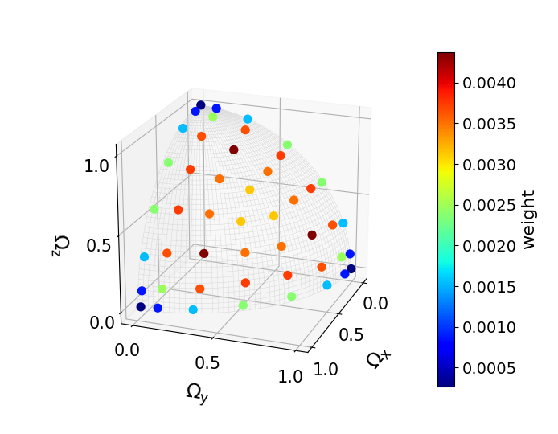
Figure S1. Improved EO_{N} quadrature of 384 (points/4π).

Table S2. Analytical values of $I_{ijk}=\int_{0}^{1}{d(cosθ)\int_{0}^{π/2}{dφ}\left(Ω_{x}^{i}Ω_{y}^{j}Ω_{z}^{k}\right)}$.
$$(i,j,k)$$ |  |  | $$I_{ijk}$$ |  | $$(i,j,k)$$ |  |  | $$I_{ijk}$$ |  | $$(i,j,k)$$ |  |  | $$I_{ijk}$$ |  | $$(i,j,k)$$ |  |  | $$I_{ijk}$$
0 | 0 | 0 | π/2 |  | 6 | 0 | 0 | π/14 |  | 8 | 0 | 0 | π/18 |  | 10 | 0 | 0 | π/22
1 | 0 | 0 | π/4 |  | 5 | 1 | 0 | 8/105 |  | 7 | 1 | 0 | 16/315 |  | 9 | 1 | 0 | 128/3465
2 | 0 | 0 | π/6 |  | 4 | 2 | 0 | π/70 |  | 6 | 2 | 0 | π/126 |  | 8 | 2 | 0 | π/198
1 | 1 | 0 | 1/3 |  | 3 | 3 | 0 | 4/105 |  | 5 | 3 | 0 | 16/945 |  | 8 | 1 | 1 | 1/99
3 | 0 | 0 | π/8 |  | 4 | 1 | 1 | 1/35 |  | 6 | 1 | 1 | 1/63 |  | 7 | 3 | 0 | 32/3465
2 | 1 | 0 | π/16 |  | 3 | 2 | 1 | 2/105 |  | 4 | 4 | 0 | π/210 |  | 6 | 4 | 0 | π/462
1 | 1 | 1 | 1/8 |  | 2 | 2 | 2 | π/210 |  | 5 | 2 | 1 | 8/945 |  | 5 | 5 | 0 | 64/10395
4 | 0 | 0 | π/10 |  | 7 | 0 | 0 | π/16 |  | 4 | 3 | 1 | 2/315 |  | 7 | 2 | 1 | 16/3465
3 | 1 | 0 | 2/15 |  | 6 | 1 | 0 | 5π/256 |  | 4 | 2 | 2 | π/630 |  | 6 | 3 | 1 | 2/693
2 | 2 | 0 | π/30 |  | 5 | 2 | 0 | π/96 |  | 3 | 3 | 2 | 4/945 |  | 5 | 4 | 1 | 8/3465
2 | 1 | 1 | 1/15 |  | 4 | 3 | 0 | π/128 |  | 9 | 0 | 0 | π/20 |  | 6 | 2 | 2 | π/1386
5 | 0 | 0 | π/12 |  | 5 | 1 | 1 | 1/48 |  | 8 | 1 | 0 | 7π/512 |  | 5 | 3 | 2 | 16/10395
4 | 1 | 0 | π/32 |  | 4 | 2 | 1 | π/256 |  | 7 | 2 | 0 | π/160 |  | 4 | 4 | 2 | π/2310
3 | 2 | 0 | π/48 |  | 3 | 3 | 1 | 1/96 |  | 7 | 1 | 1 | 1/80 |  | 4 | 3 | 3 | 4/3465
3 | 1 | 1 | 1/24 |  | 3 | 2 | 2 | π/384 |  | 6 | 3 | 0 | π/256
2 | 2 | 1 | π/96 |  |  |  |  |  |  | 5 | 4 | 0 | π/320
 |  |  |  |  |  |  |  |  |  | 6 | 2 | 1 | π/512
 |  |  |  |  |  |  |  |  |  | 5 | 3 | 1 | 1/240
 |  |  |  |  |  |  |  |  |  | 4 | 4 | 1 | 3π/2560
 |  |  |  |  |  |  |  |  |  | 5 | 2 | 2 | π/960
 |  |  |  |  |  |  |  |  |  | 4 | 3 | 2 | π/1280
 |  |  |  |  |  |  |  |  |  | 3 | 3 | 3 | 1/480

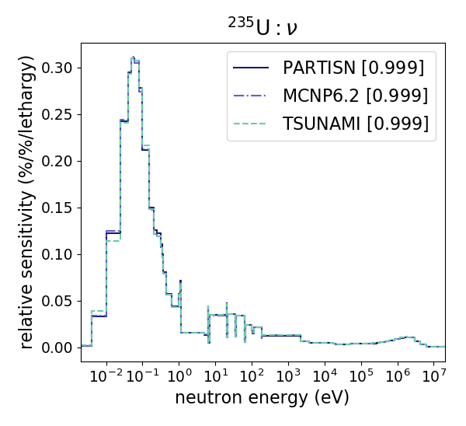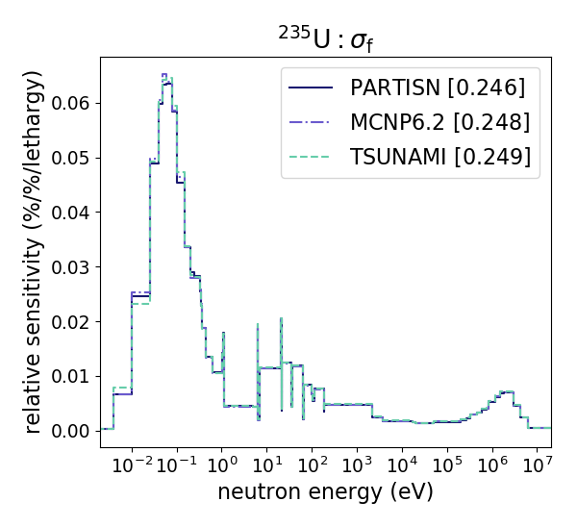
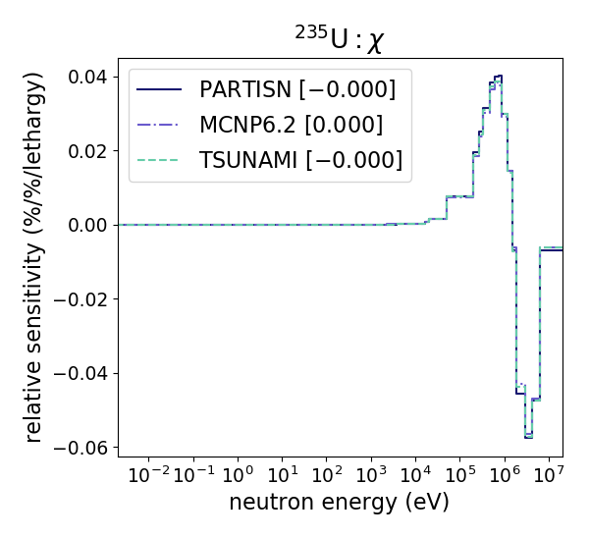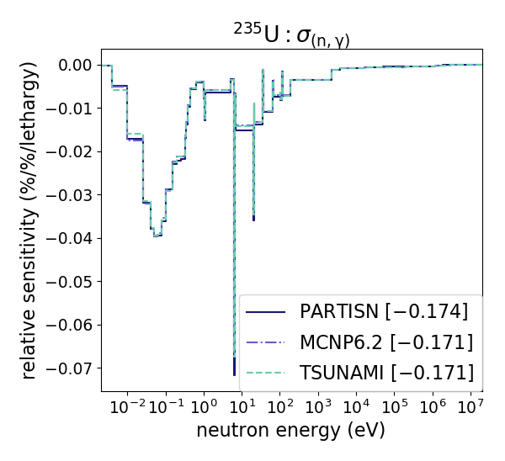
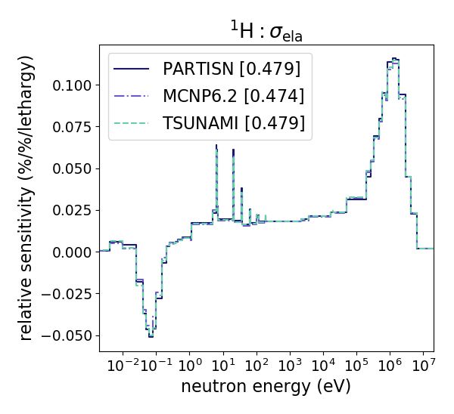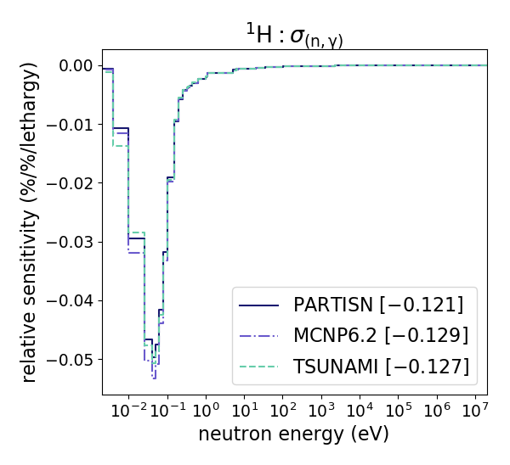
Figure S2. Comparison of relative sensitivity coefficients of $k_{eff}$ among PARTISN, MCNP6.2, and TSUNAMI-3D (4440 HEU plates).
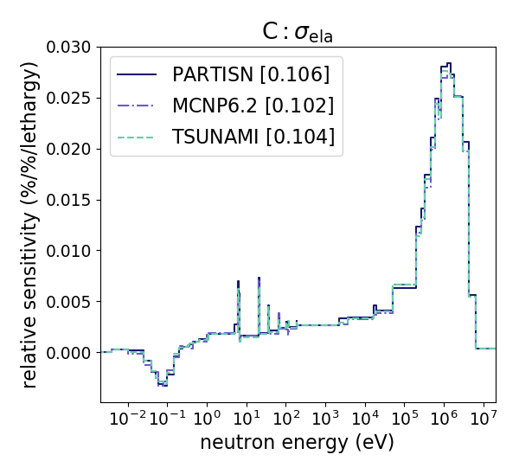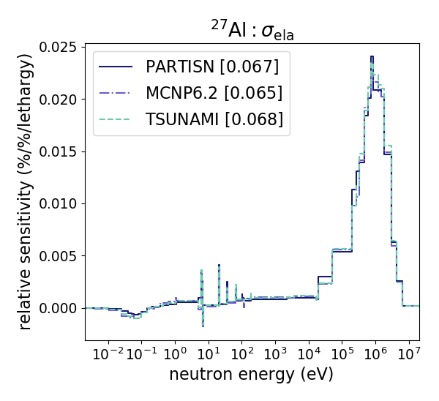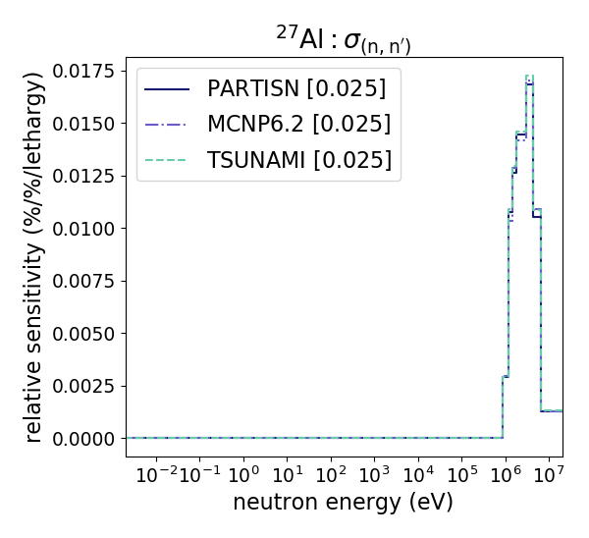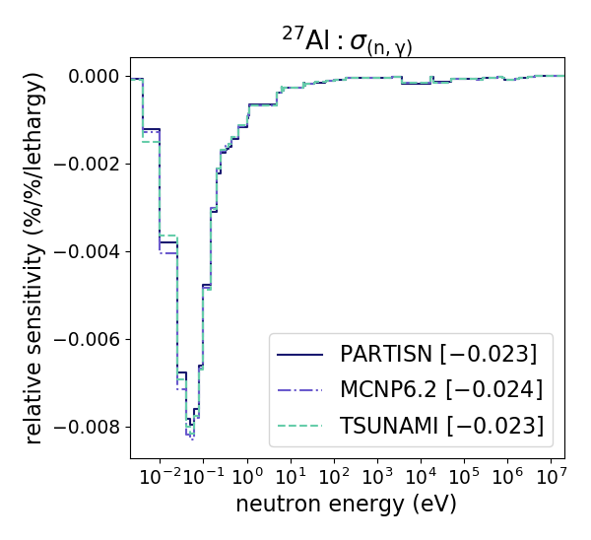
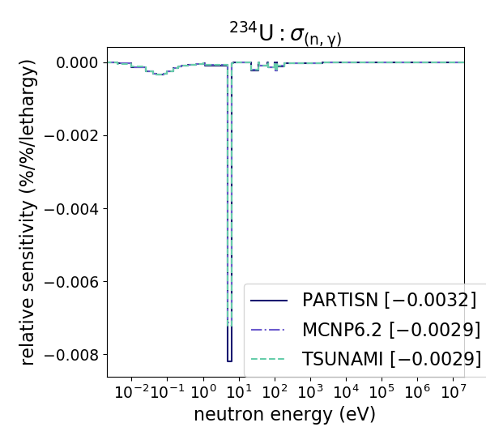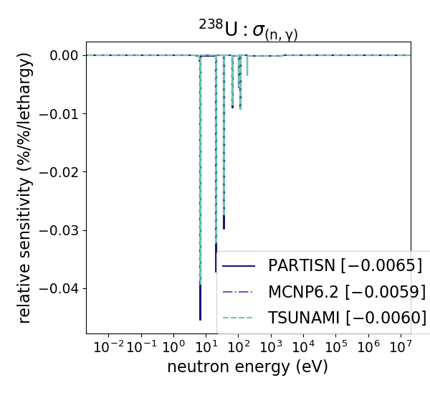
Figure S2. Comparison of relative sensitivity coefficients of $k_{eff}$ among PARTISN, MCNP6.2, and TSUNAMI-3D (4440 HEU plates) (continued).
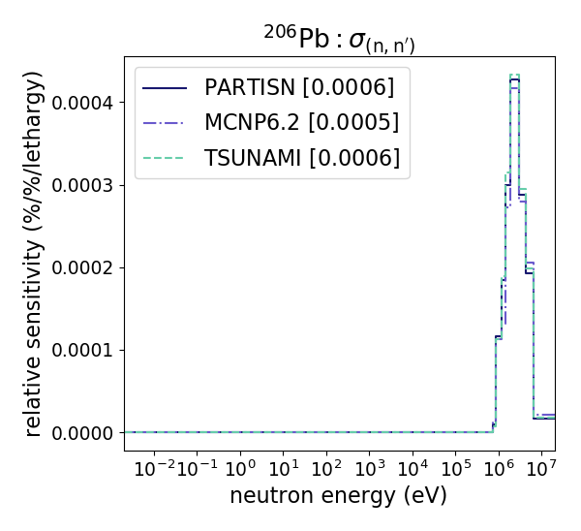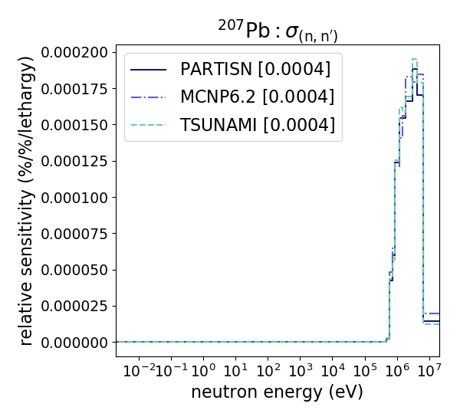
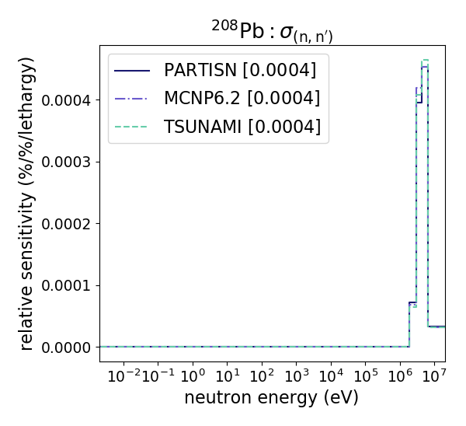
Figure S2. Comparison of relative sensitivity coefficients of $k_{eff}$ among PARTISN, MCNP6.2, and TSUNAMI-3D (4440 HEU plates) (continued).

Calculation conditions:
MCNP6.2: as-built geometry, ENDF-B/VII.1, IFP method, nsrck=50000, ikz=400, kct=10400,
blocksize=5;
TSUNAMI-3D: as-built geometry, ENDF-B/VII.1, CE CLUTH method, npg=50000,
gen=10400, nsk=400, cfp=5.

Table S3. Numerical results of MCNP6.2.
EU plates | $k_{eff}$ (-) |  |  | $β_{eff}$ (pcm) |  |  | $Λ$ (μs)
4440 | 0.99087 | ± | 0.00004† | 795 | ± | 3 | 35.310 | ± | 0.020
4320 | 0.97861 | ± | 0.00004 | 802 | ± | 3 | 36.097 | ± | 0.021
4200 | 0.96438 | ± | 0.00004 | 803 | ± | 3 | 37.149 | ± | 0.021
4080 | 0.95624 | ± | 0.00004 | 802 | ± | 3 | 39.253 | ± | 0.022
3960 | 0.95182 | ± | 0.00004 | 807 | ± | 3 | 40.388 | ± | 0.022
3840 | 0.92801 | ± | 0.00004 | 806 | ± | 3 | 42.486 | ± | 0.024
†1σ statistical error.

Calculation conditions:
MCNP6.2: as-built geometry, ENDF-B/VII.1, IFP method, nsrck=50000, ikz=400, kct=10400, blocksize=5.

