Supporting Information
Synthesis and characterization of（Fe、Co、Ni）-polyoxometalates to degrade O, O-diethyl-S-(p-tolyl) phosphorothioate under visible light irradiation

Yanghao Yan, Xiaoya Wang, Muhammad Asim Khan, Mingzhu Xia*, Wu Lei, Fengyun Wang*

School of Chemical Engineering, Nanjing University of Science and Technology, Nanjing 210094, PR. China
E-mail: ind_chem@njust.edu.cn, (F. Wang), xiamzh196808@njust.edu.cn (M. Xia)

The following are the results of ICP spectroscopy and theoretical calculations for the four catalysts [21].
Elemental analysis of (TBA)₄[PW₁₁Fe(H₂O)O₃₉]·2H₂O: W, 53.6; P, 0.88; Fe, 1.48; C, 20.15; H, 3.90; N, 1.35; H₂O, 0.8; Calculated: W, 53.8; P, 0.82; Fe, 1.49; C, 20.46; H, 4, 02; N, 1.49; H₂O, 0.96.
Elemental analysis of (TBA)₄[PW₁₁Co(H₂O)O₃₉]·2H₂O: W, 53.3; P, 0.81; Co, 1.49; C, 20.23; H, 3.92; N, 1.36; H₂O, 0.9; Calculated: W, 53.8; P, 0.82; Co, 1.57; C, 20.44; H,, 4.05; N, 1.49; H₂O, 0.96.
Elemental analysis of (TBA)₄H[PW₁₁Ni(H₂O)O₃₉]·H₂O: W, 53.0; P, 0.81; Ni, 1.53; C, 20.97; H, 3.97; N, 1.62; H₂O, 0.5; Calculated: W, 54.0; P, 0.83; Ni, 1.57; C, 20.54; H, 4.01; N, 1.50; H₂O, 0.48.
Elemental analysis of (TBA)₄H₃ [PW₁₁O₃₉]: C, 21.4; H, 3.8; N, 1.5. Calculated: C, 21.1; H, 4.1; N, 1.5%.

NMR analysis
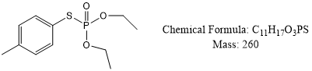
O,O-diethyl S-(p-tolyl) phosphorothioate. 1H NMR (500 MHz, Chloroform-d) δ 7.42 (dd, J = 8.3, 2.2 Hz, 2H), 7.13 (d, J = 7.9 Hz, 2H), 4.28 – 4.06 (m, 4H), 2.32 (d, J = 2.0 Hz, 3H), 1.34 – 1.19 (m, 6H). 13C NMR (126 MHz, Chloroform-d) δ 138.34 , 133.66 , 133.62 , 129.19 , 121.78 , 63.05 , 63.00 , 20.22 , 15.08 , 15.02 .GC-MS (EI) m/z: 239.
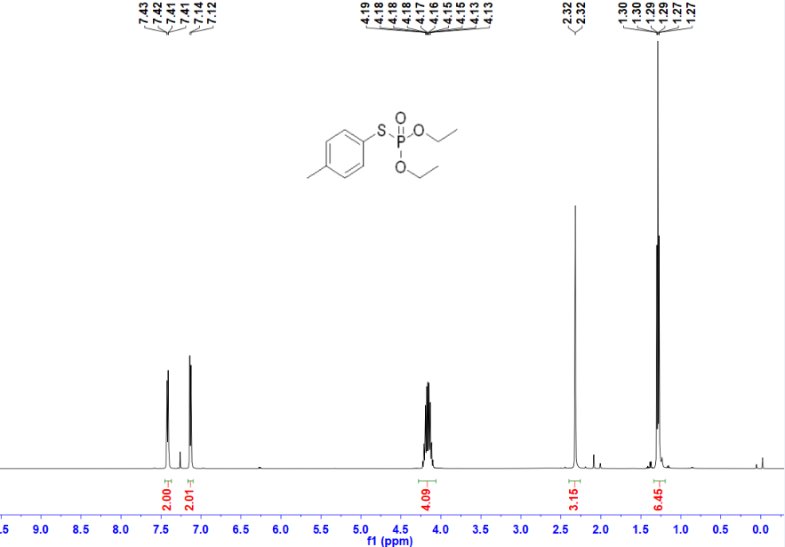
Figure S1. ¹H spectrum of O,O-diethyl-S-(p-tolyl) phosphorothioate

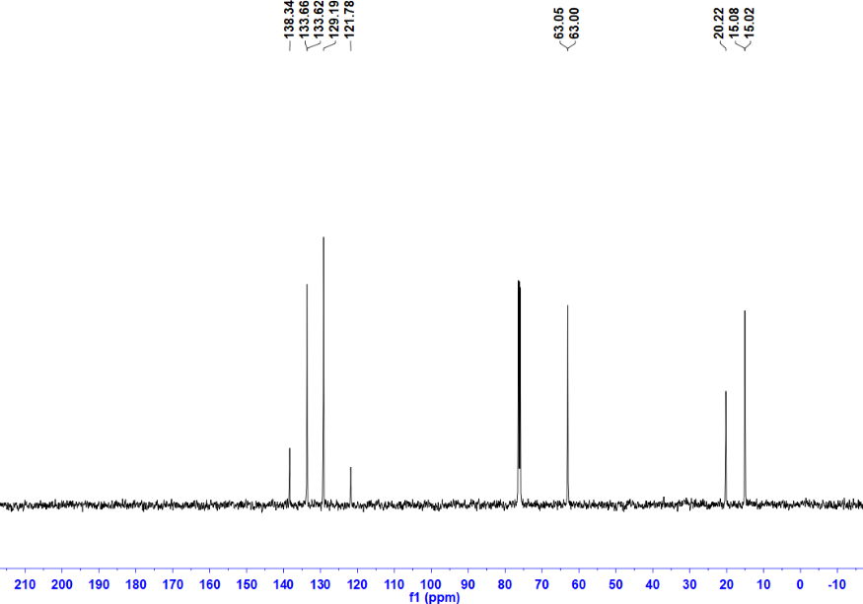
Figure S2. ¹³C spectrum of O,O-diethyl S-(p-tolyl) phosphorothioate.

