Supporting Information
A new carbazole-based colorimetric and fluorescence probe for the detection of sulfur dioxide
Chen Jiangª, Yuewei Yaoª, Jingjing Meng^{b*}, Cheng Yao^{a**}
ª College of Chemistry and Molecular Engineering, Nanjing Tech University, Nanjing 211816(China)
^{b} College of Biotechnology and Pharmaceutical Engineering, Nanjing Tech University, Nanjing 211816 (China)
Fig. S1 ¹H NMR of probe CBB
Fig. S2 ¹³C NMR of probe CBB
Fig. S3 ESI-MS of probe CBB
Fig. S4 The linear curve established by the fluorescence intensity (593 nm) versus the concentrations of HSO₃⁻.
Fig. S5 The time-dependent FL spectrum of probe CBB toward HSO₃⁻.
Fig. S6 The FL intensity of CBB (20 μM) in different pH (1.0-14.0) in the absence and presence of HSO₃⁻ (λ_{ex} = 454 nm).

Fig. S1 ¹H NMR of probe CBB
Fig. S2 ¹³C NMR of probe CBB
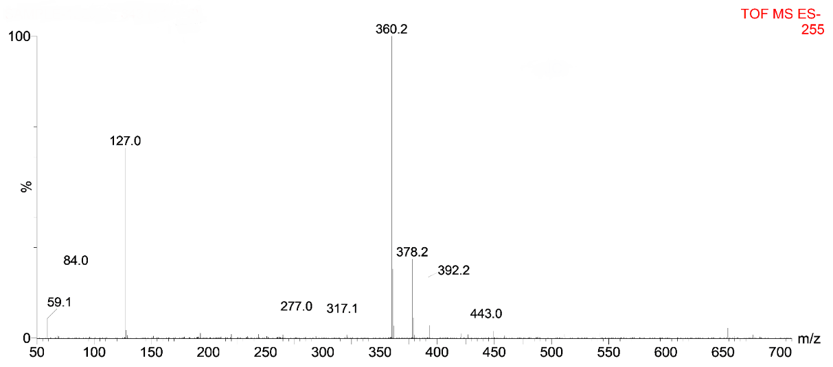
Fig. S3 ESI-MS of probe CBB
Fig. S4 the linear curve established by fluorescence intensity (593 nm) versus the concentrations of HSO₃⁻.
Fig. S5 The time-dependent FL spectrum of probe CBB toward HSO₃⁻.
Fig. S6 The FL intensity of CBB (20 μM) in different pH (1.0-14.0) in the absence and presence of HSO₃⁻ (λ_{ex} = 454 nm).

