Facile Synthesis of Novel Mono- and Bis-N-sulfamoylamidines

Ye Xuan-Wu and Abudureheman Wusiman*

School of Chemistry and Chemical Engineering, Xinjiang Normal University, Urumqi 830054, People’s Republic of China

Email: arahman@xjnu.edu.cn

**Supplemental Materials**

**1H and 13C NMR Spectra**

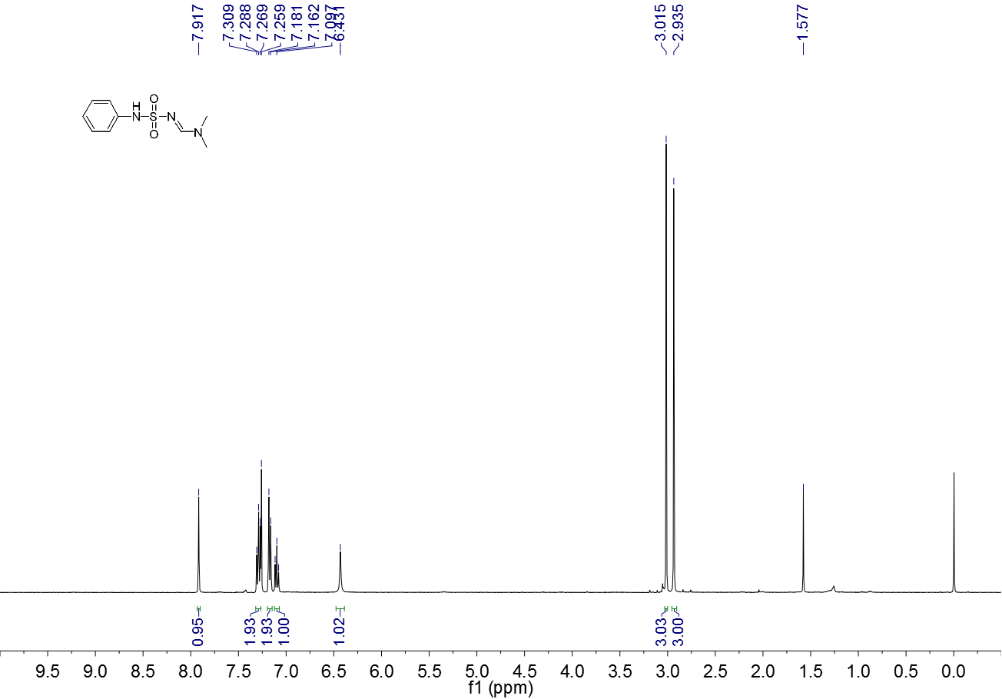

**Figure S 1.** 1H NMR spectrum (CDCl3, 400 MHz) of **3a**

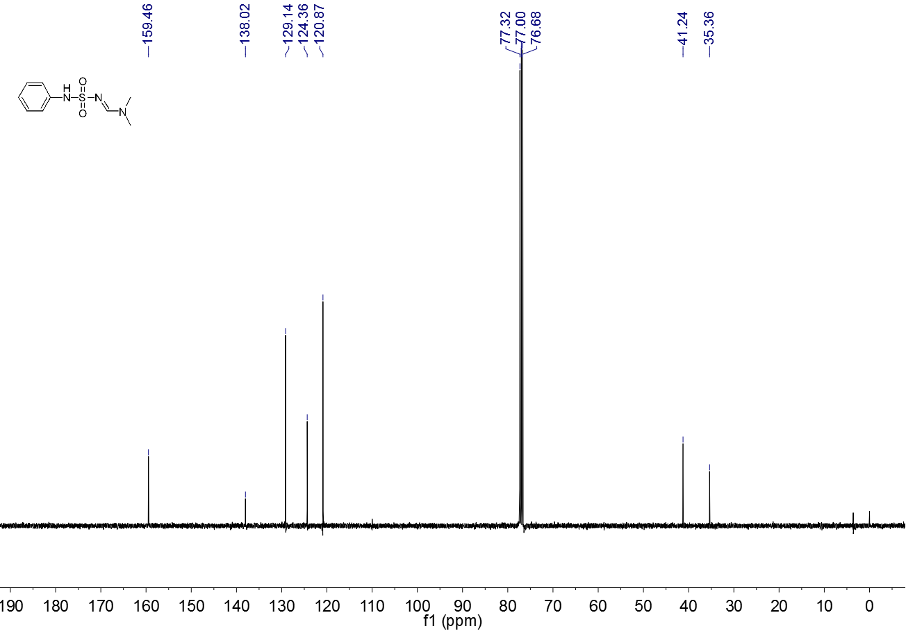

**Figure S 2.** 13C NMR spectrum (CDCl3, 100 MHz) of **3a**

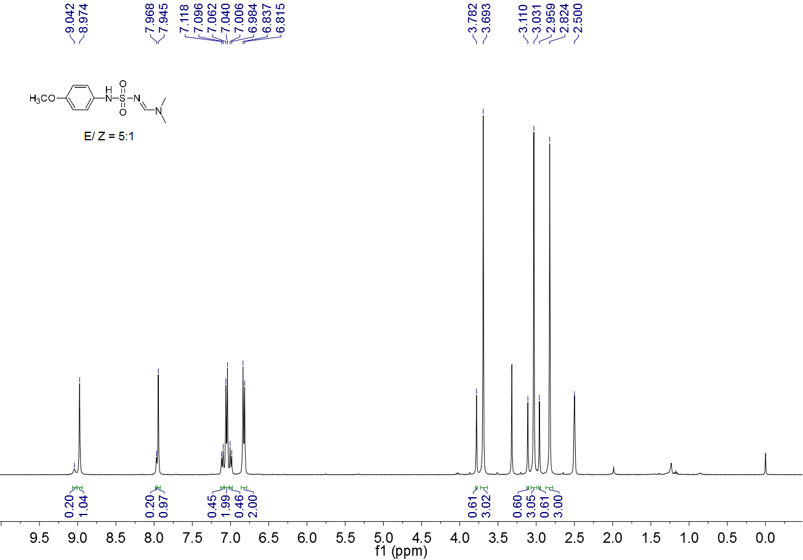

**Figure S 3.** 1H NMR spectrum (DMSO-d6, 400 MHz) of **3b**

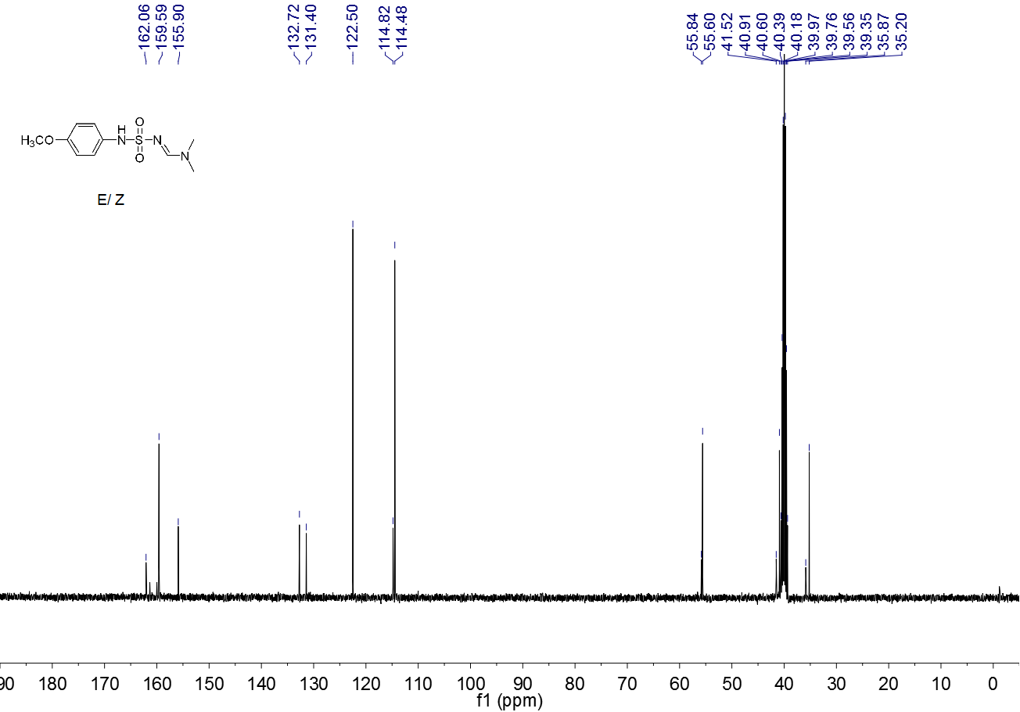

**Figure S 4.** 13C NMR spectrum (DMSO-d6, 100 MHz) of **3b**

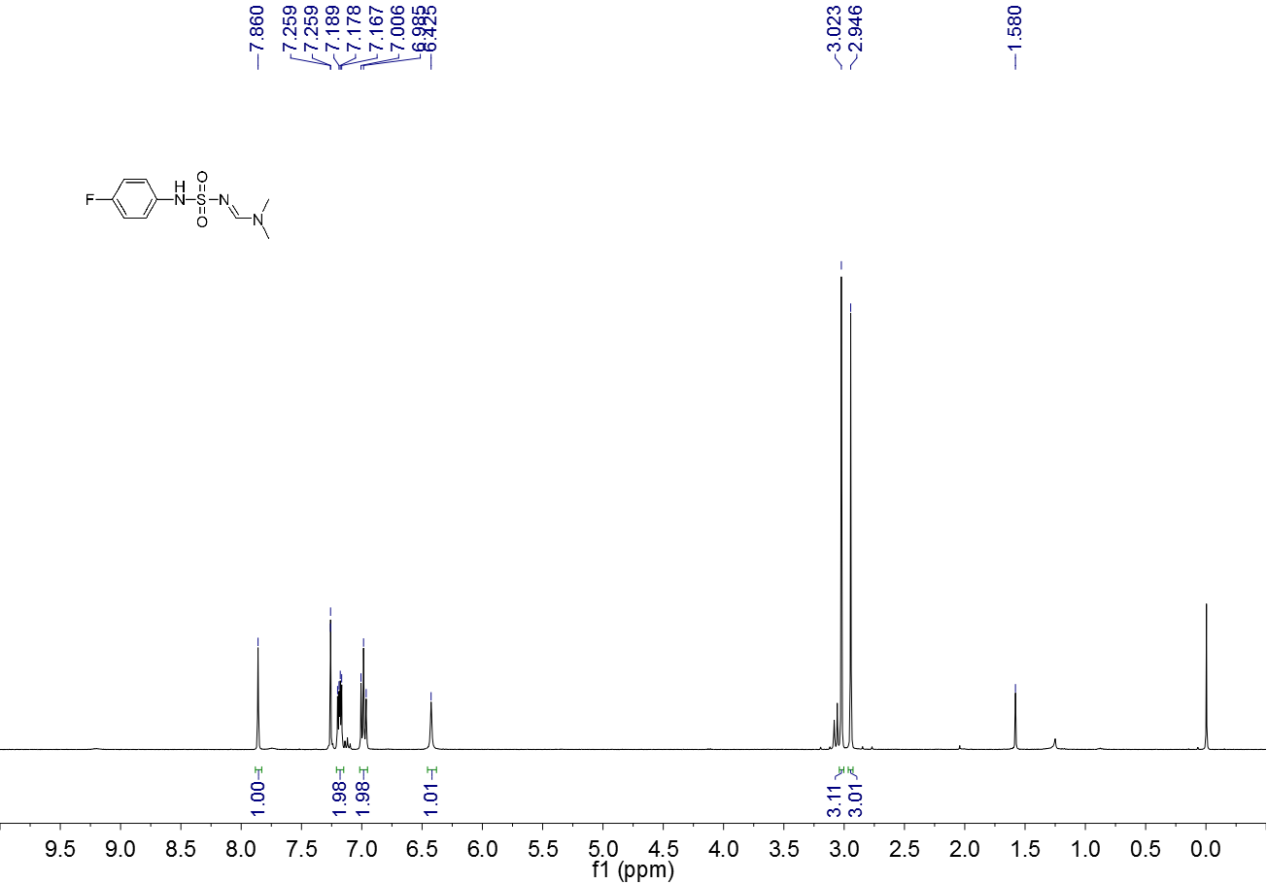

**Figure S 5.** 1H NMR spectrum (CDCl3, 400 MHz) of **3c**

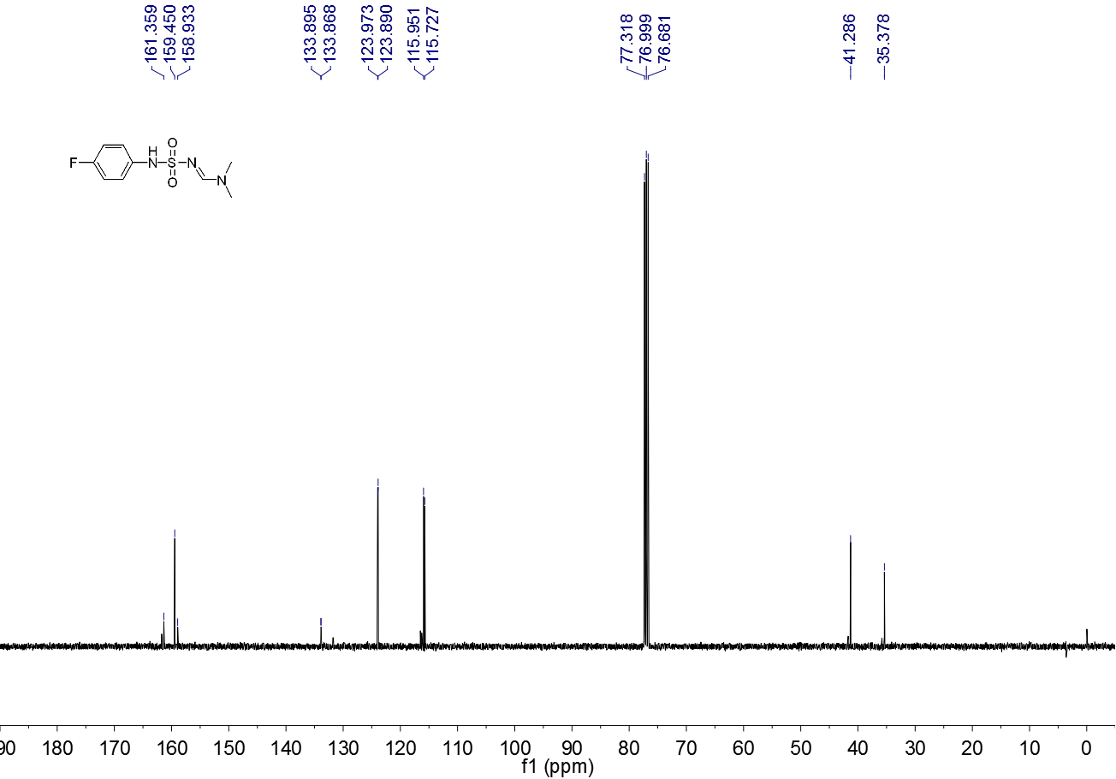

**Figure S 6.** 13C NMR spectrum (CDCl3, 100 MHz) of **3c**

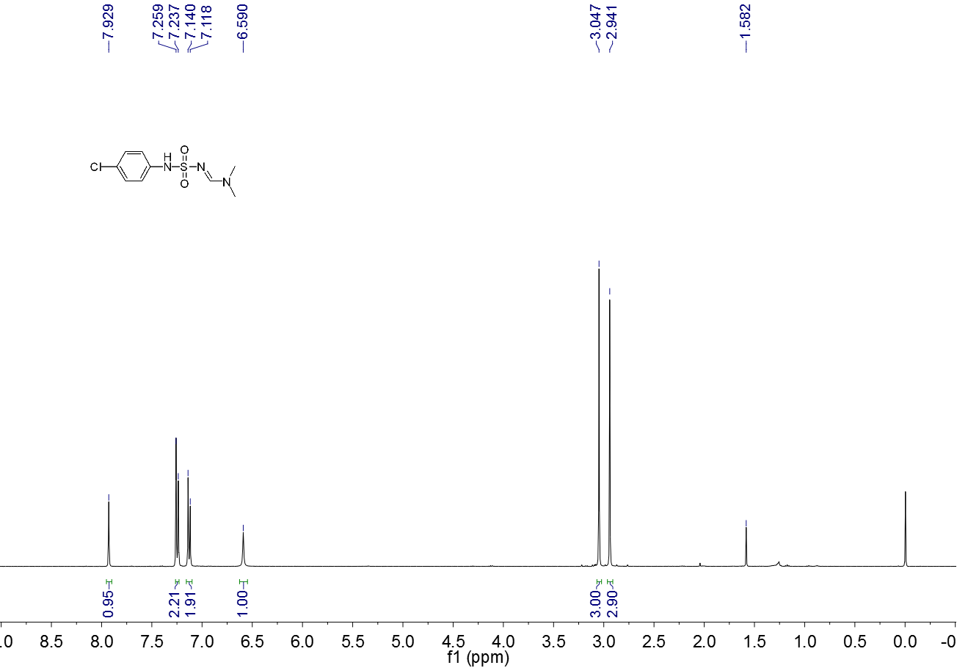

**Figure S 7.** 1H NMR spectrum (CDCl3, 400 MHz) of **3d**

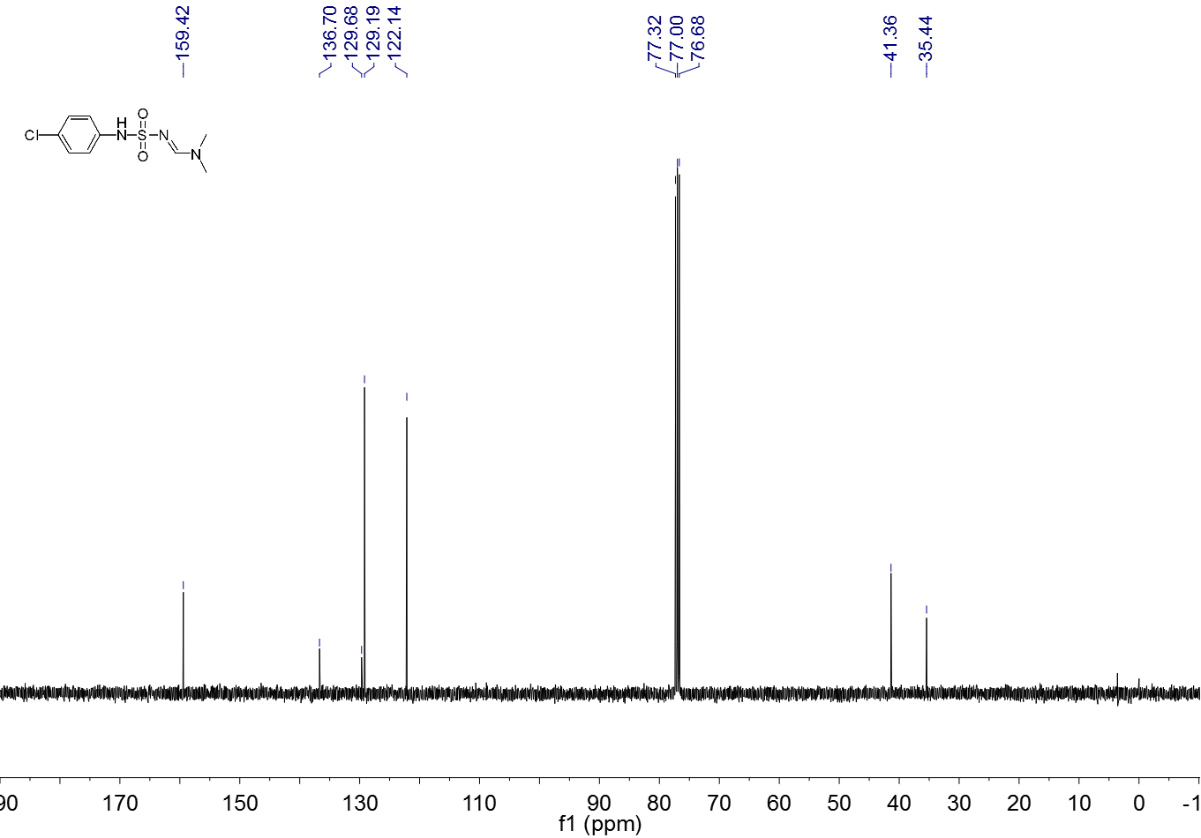

**Figure S 8.** 13C NMR spectrum (CDCl3, 100 MHz) of **3d**

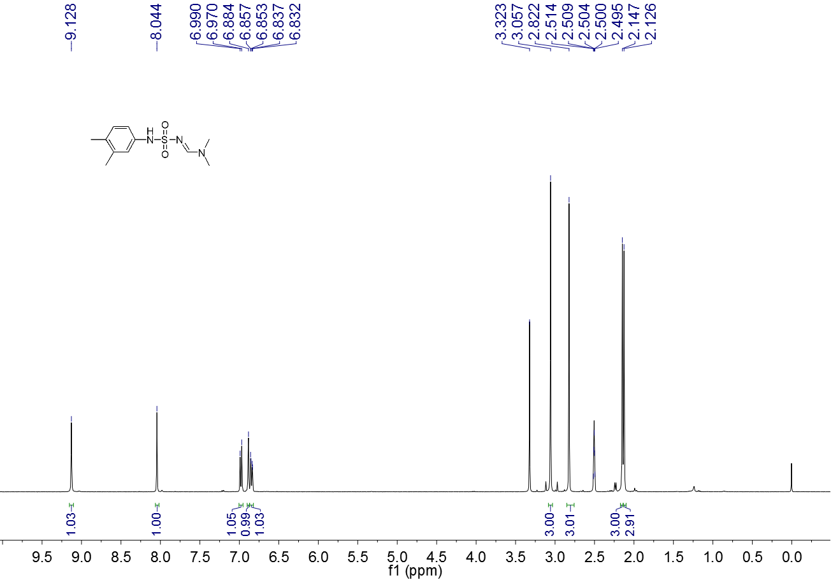

**Figure S 9.** 1H NMR spectrum (DMSO-d6, 400 MHz) of **3e**

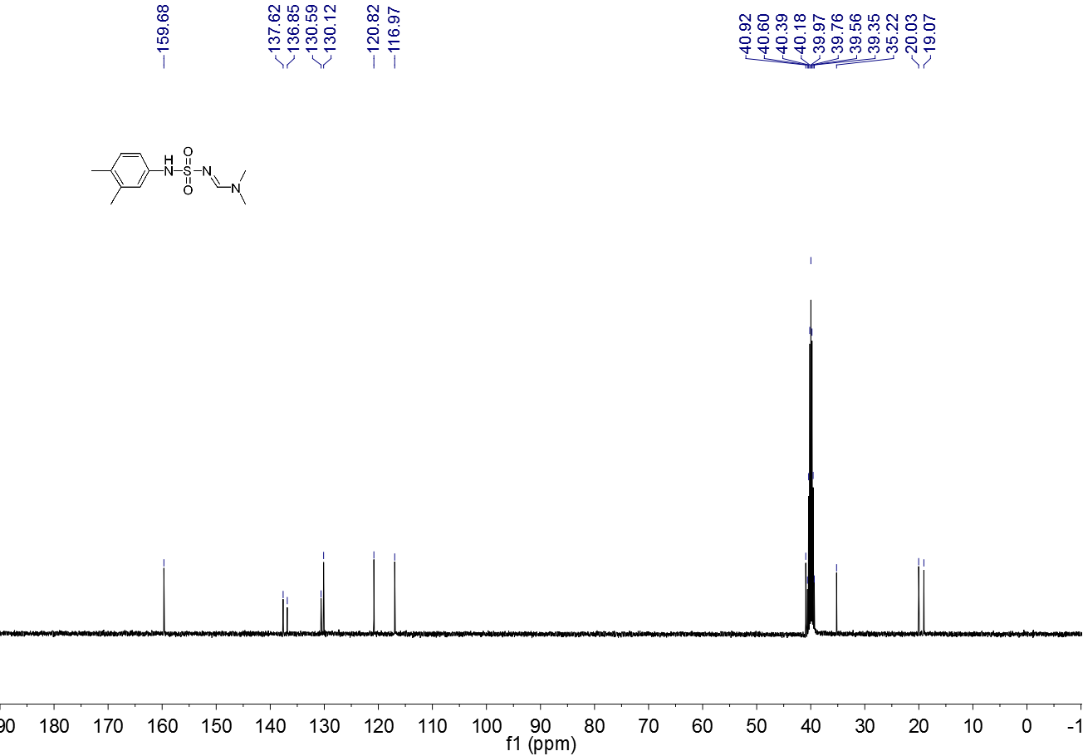

**Figure S 10.** 13C NMR spectrum (DMSO-d6, 100 MHz) of **3e**

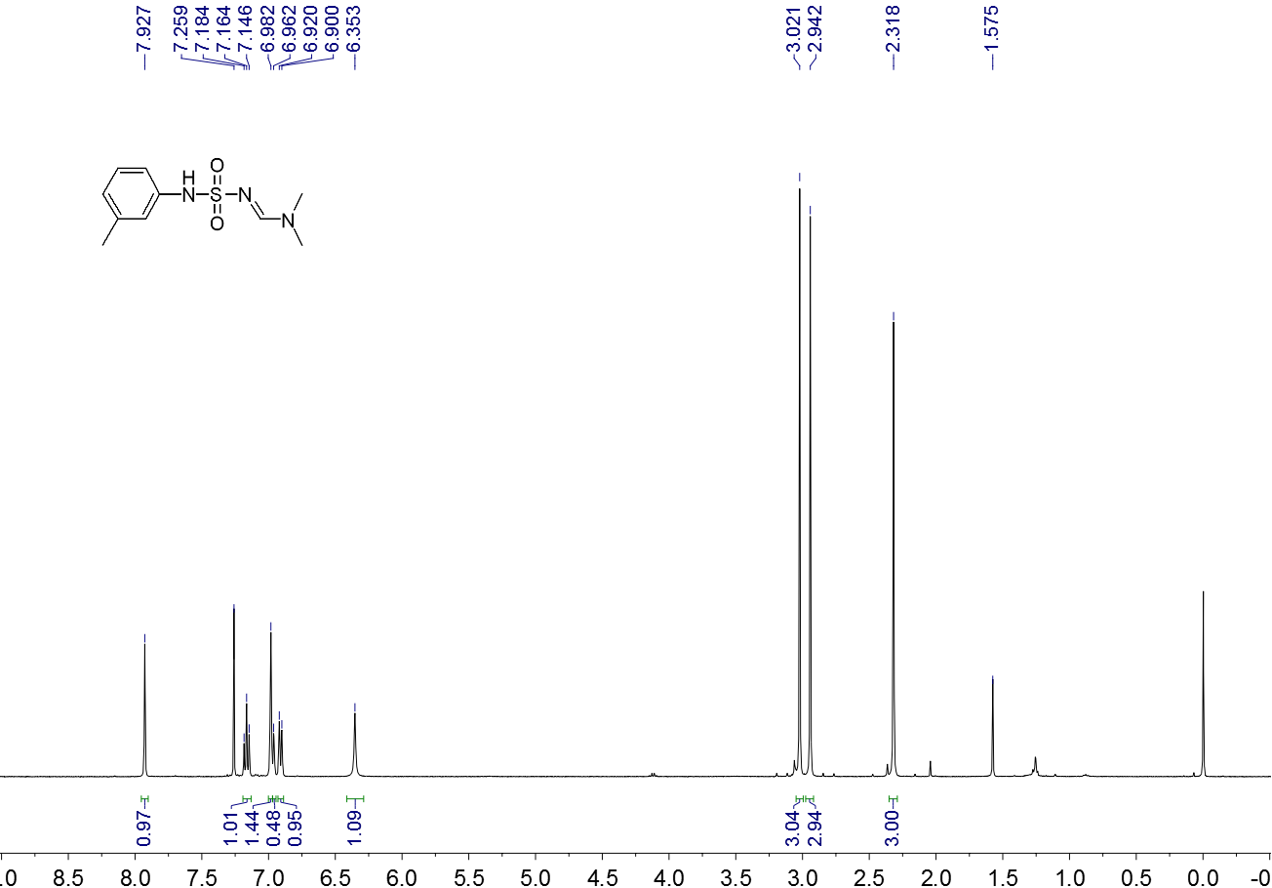

**Figure S 11.** 1H NMR spectrum (CDCl3, 400 MHz) of **3f**

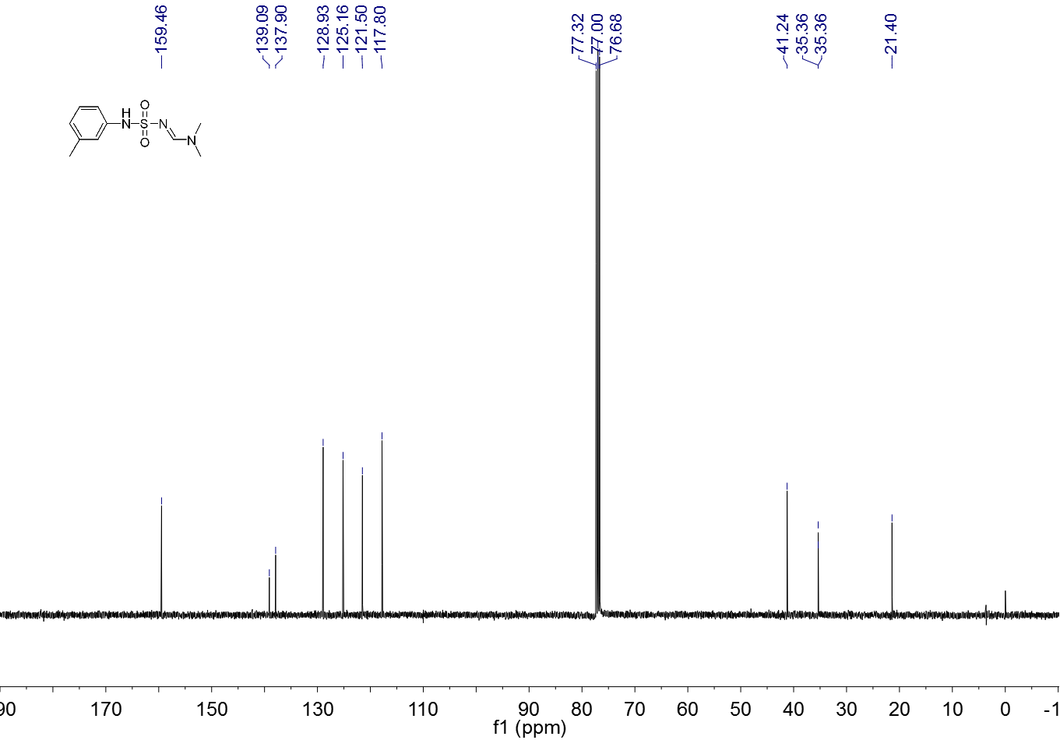

**Figure S 12.** 13C NMR spectrum (CDCl3, 100 MHz) of **3f**

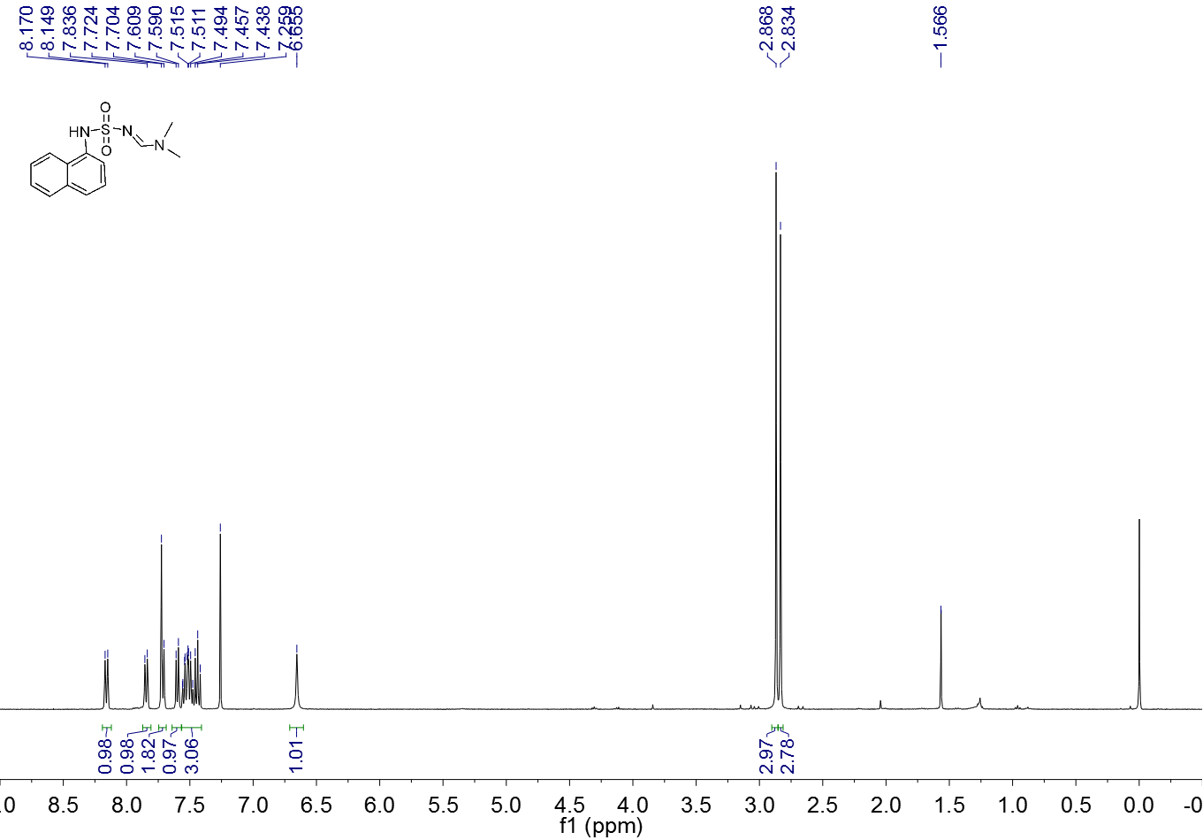

**Figure S 13.** 1H NMR spectrum (CDCl3, 400 MHz) of **3g**

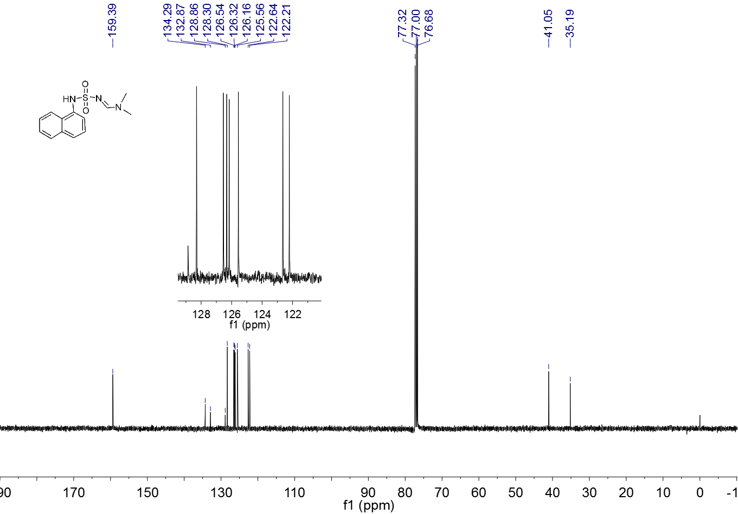

**Figure S 14.** 13C NMR spectrum (CDCl3, 100 MHz) of **3g**

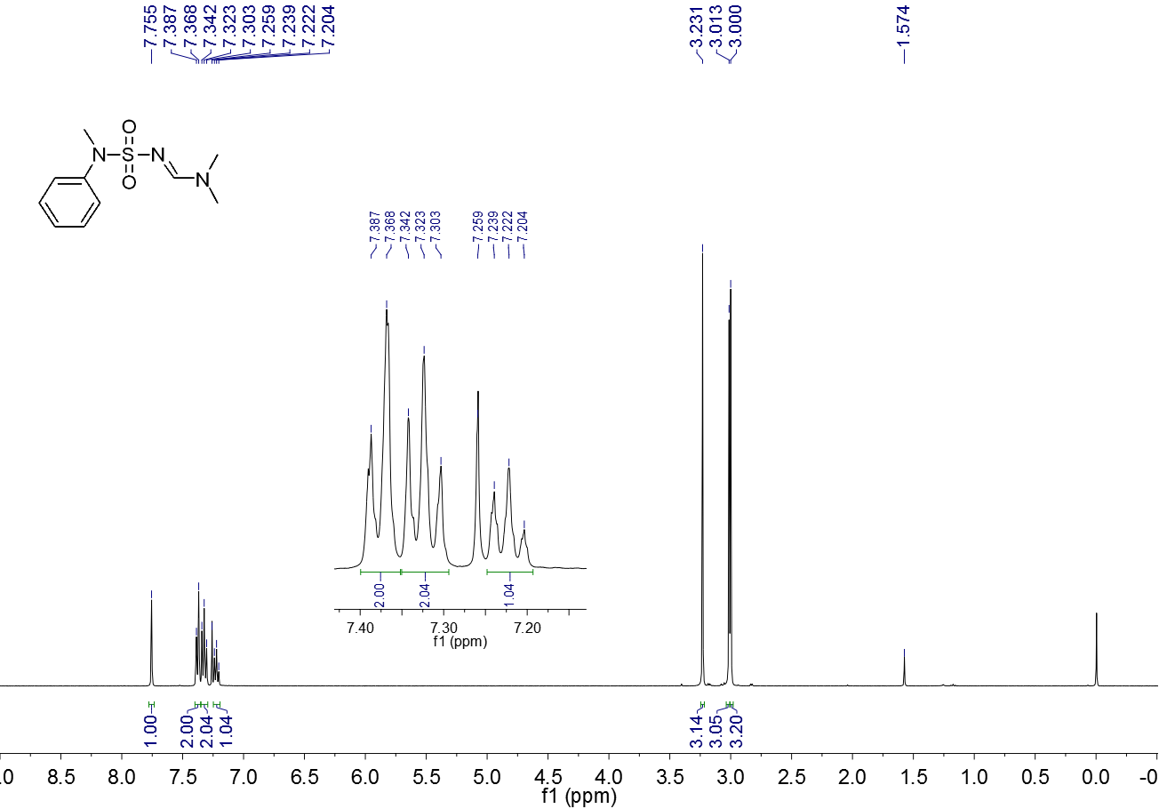

**Figure S 15.** 1H NMR spectrum (CDCl3, 400 MHz) of **3h**

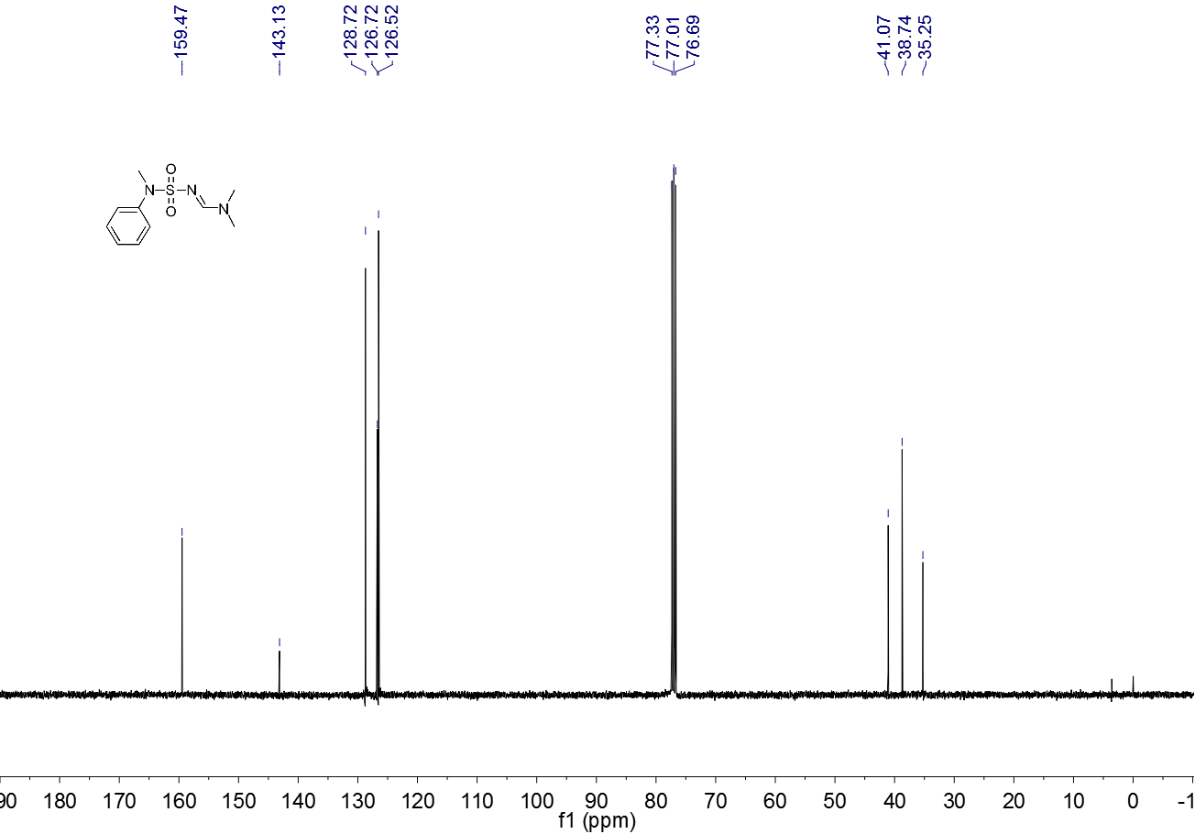

**Figure S 16.** 13C NMR spectrum (CDCl3, 100 MHz) of **3h**

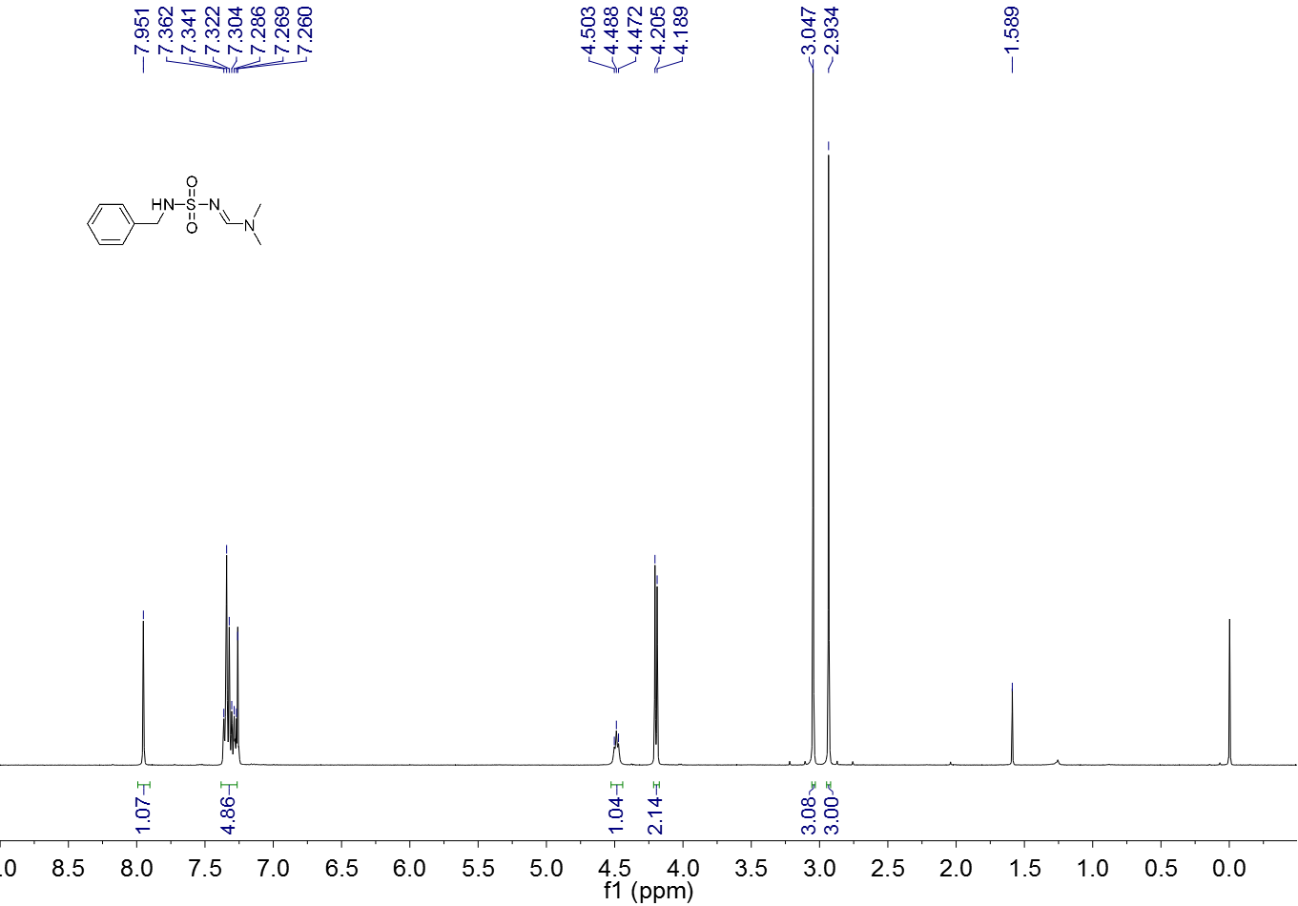

**Figure S 17.** 1H NMR spectrum (CDCl3, 400 MHz) of **3i**

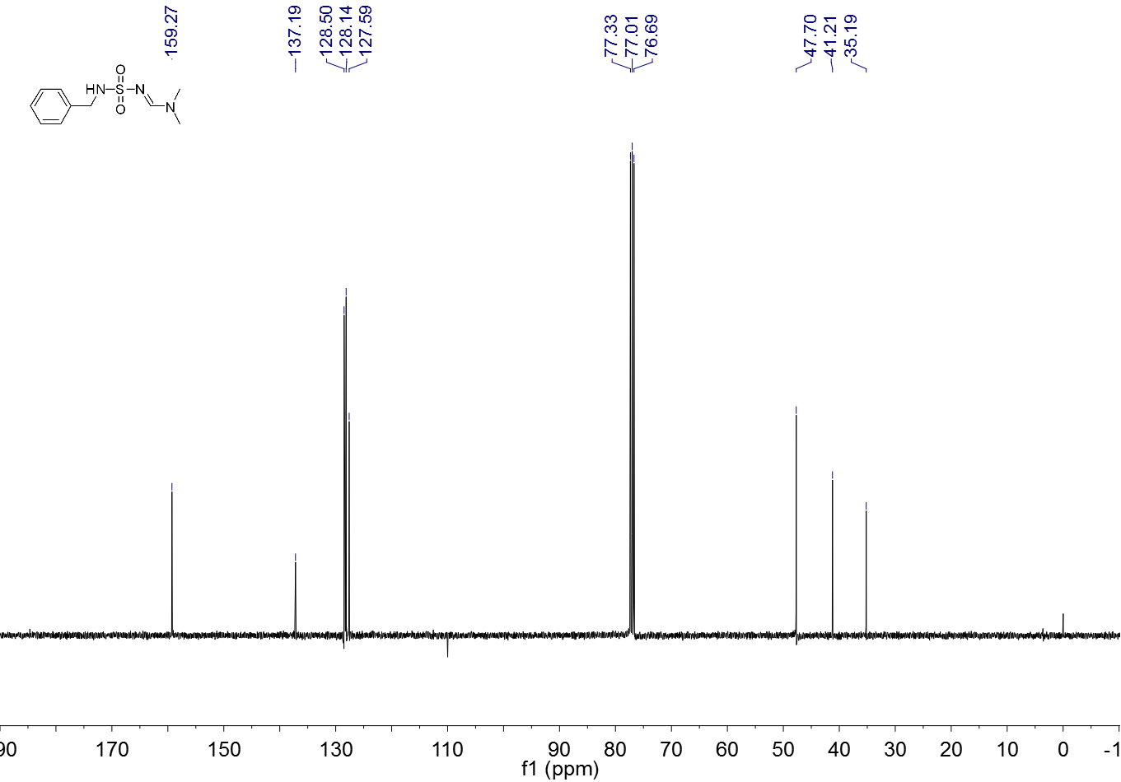

**Figure S 18.** 13C NMR spectrum (CDCl3, 100 MHz) of **3i**

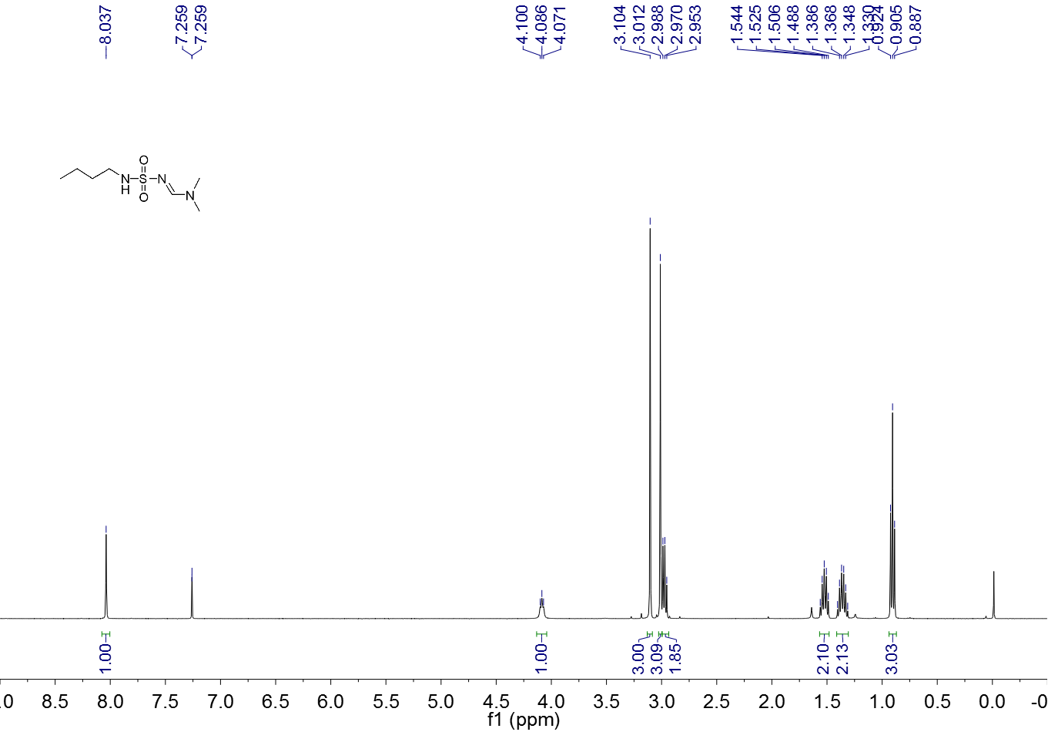

**Figure S 19.** 1H NMR spectrum (CDCl3, 400 MHz) of **3j**

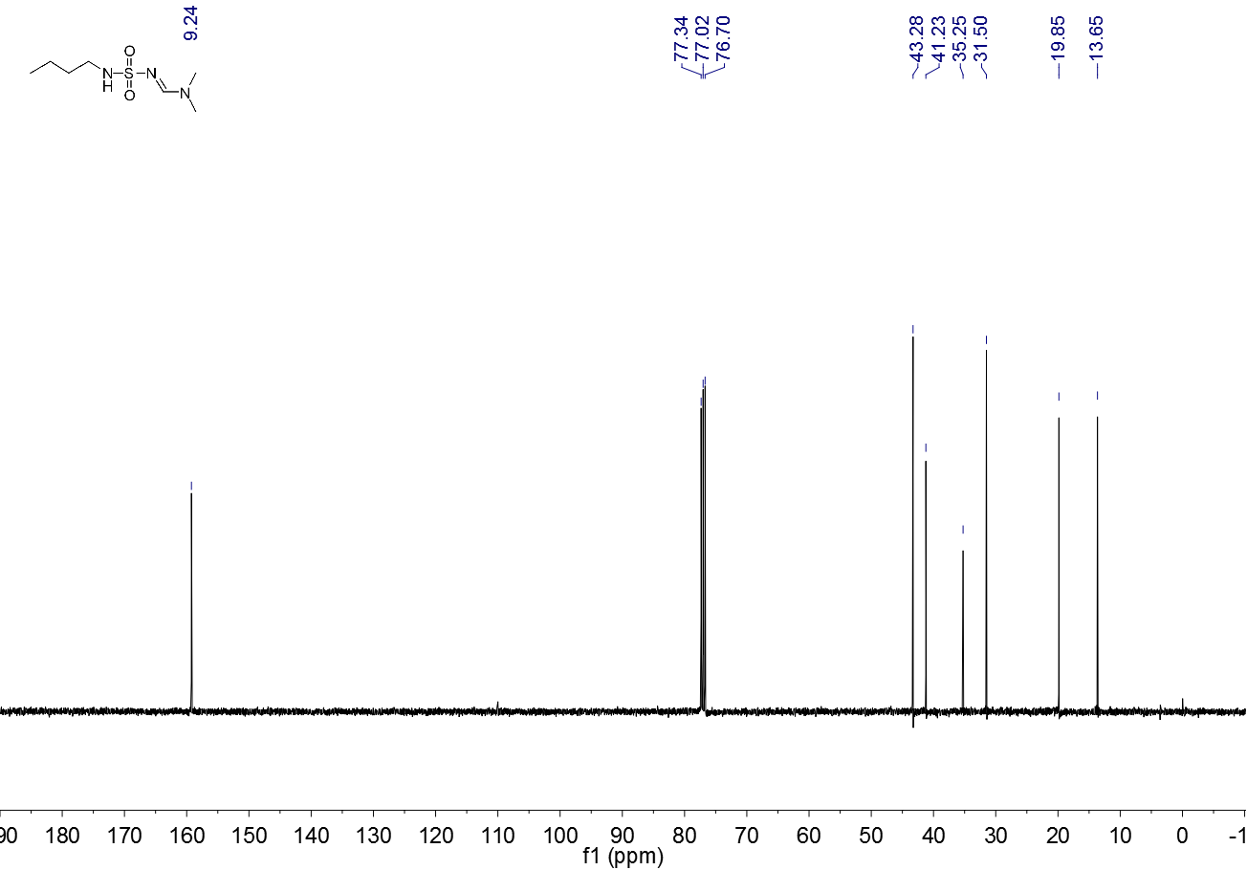

**Figure S 20.** 13C NMR spectrum (CDCl3, 100 MHz) of **3j**

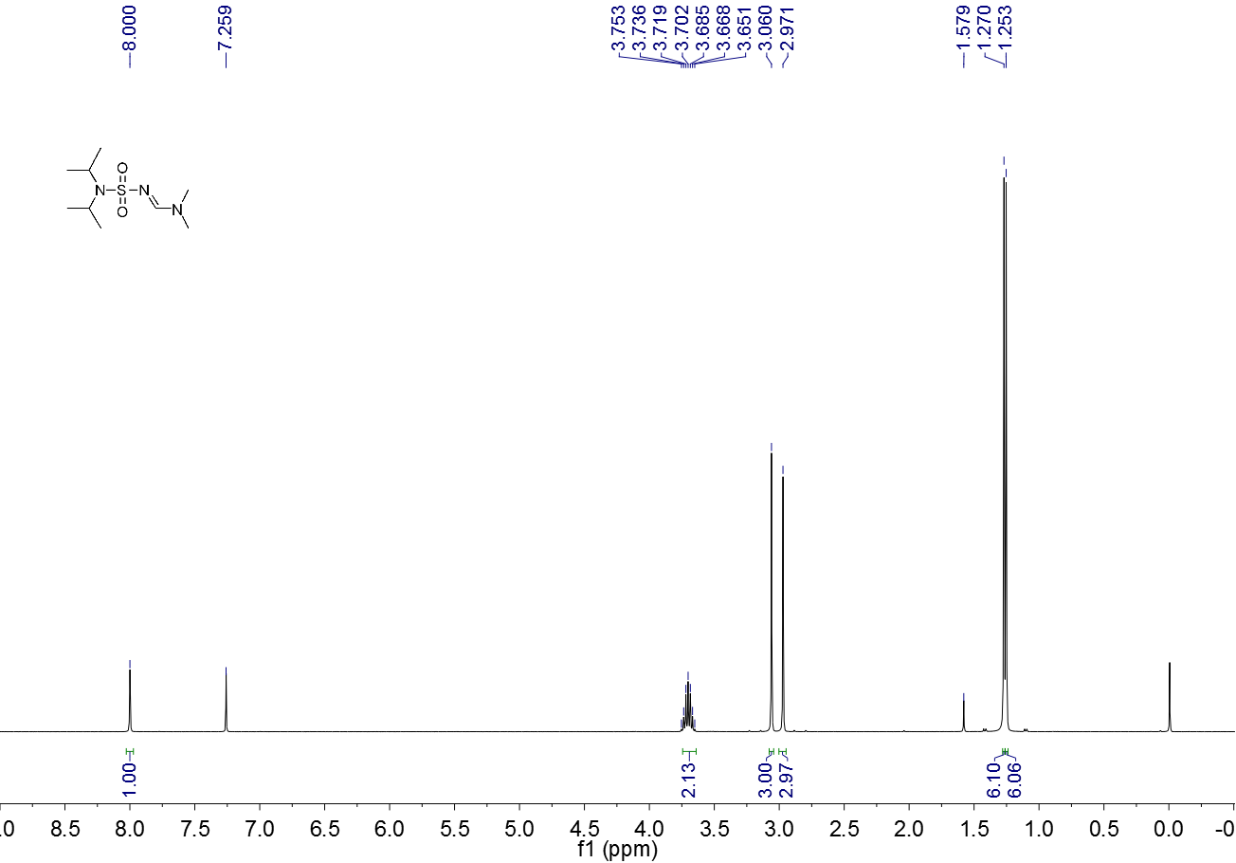

**Figure S 21.** 1H NMR spectrum (CDCl3, 400 MHz) of **3k**

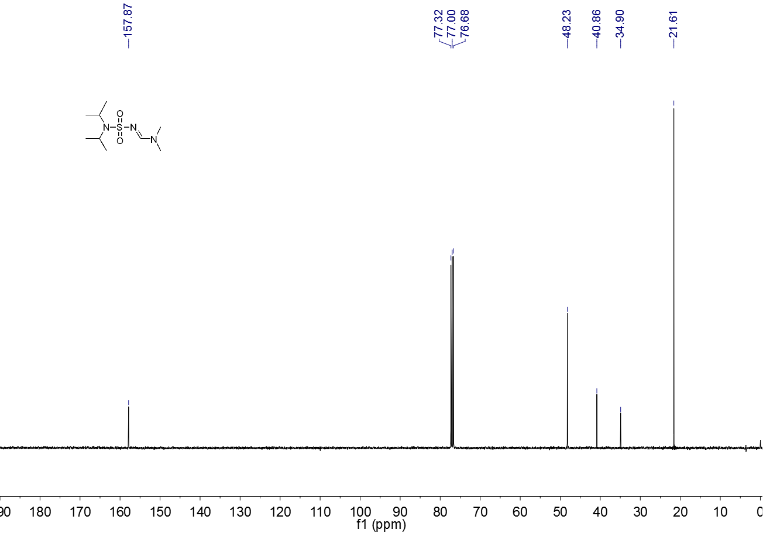

**Figure S 22.** 13C NMR spectrum (CDCl3, 100 MHz) of **3k**

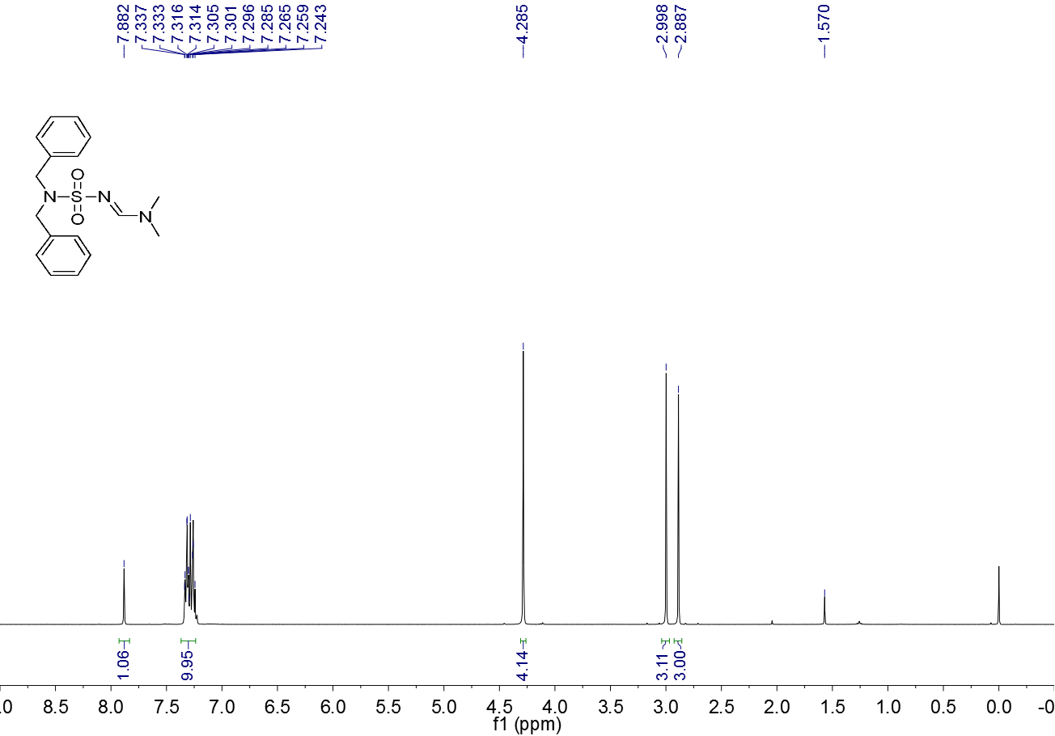

**Figure S 23.** 1H NMR spectrum (CDCl3, 400 MHz) of **3l**

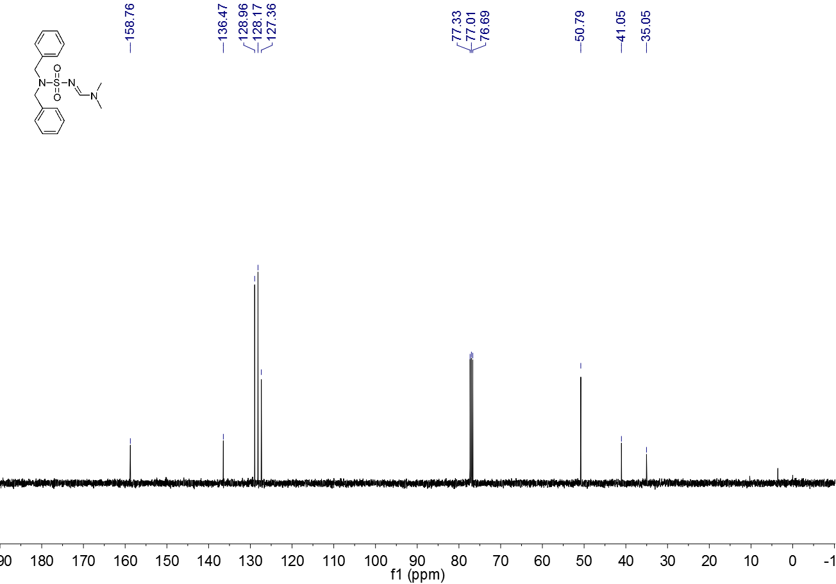

**Figure S 24.** 13C NMR spectrum (CDCl3, 100 MHz) of **3l**

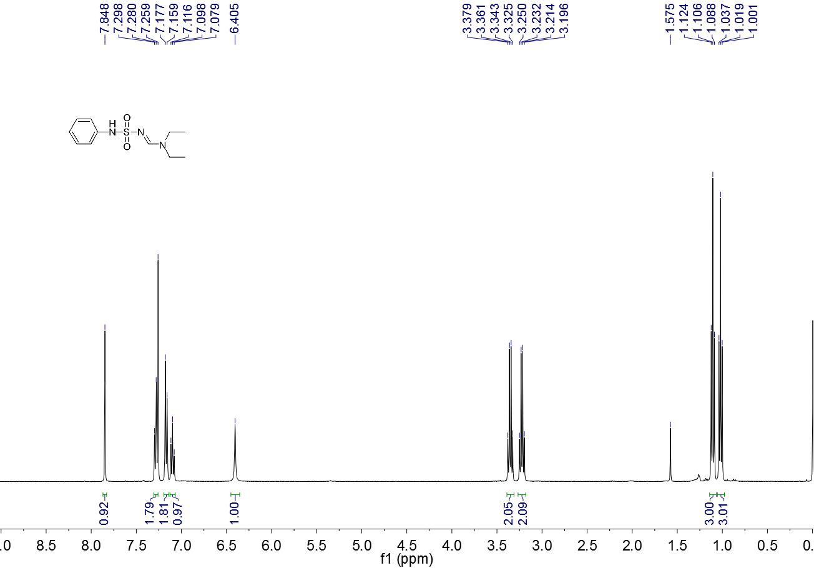

**Figure S 25.** 1H NMR spectrum (CDCl3, 400 MHz) of **3m**

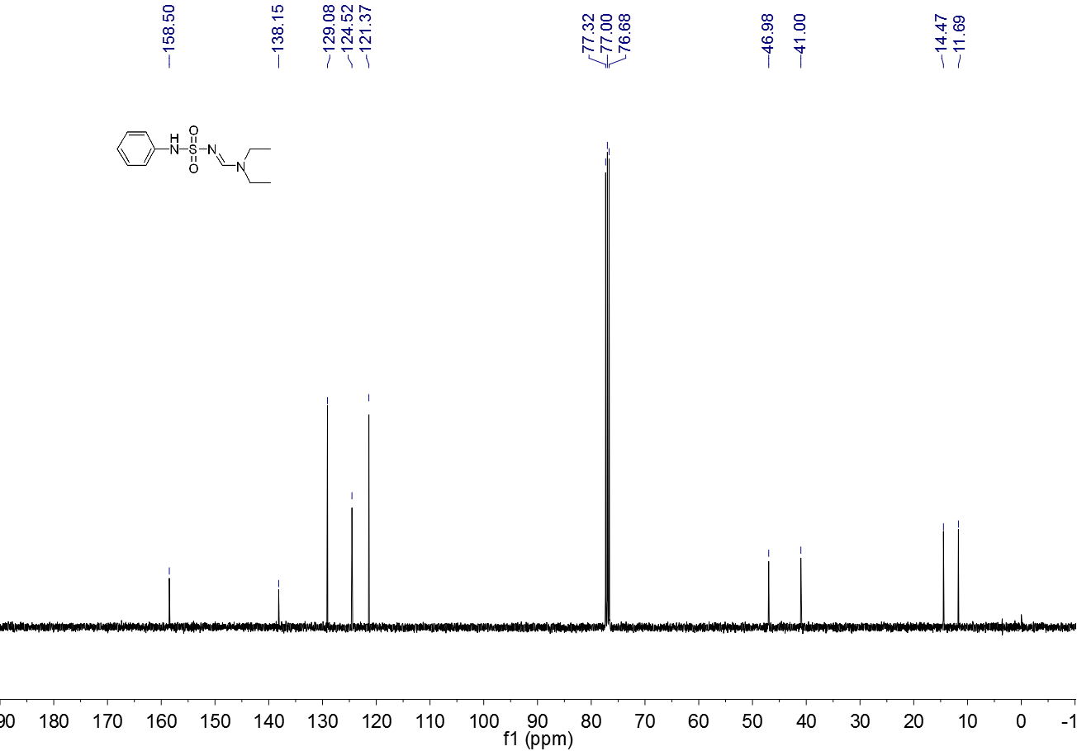

**Figure S 26.** 13C NMR spectrum (CDCl3, 100 MHz) of **3m**

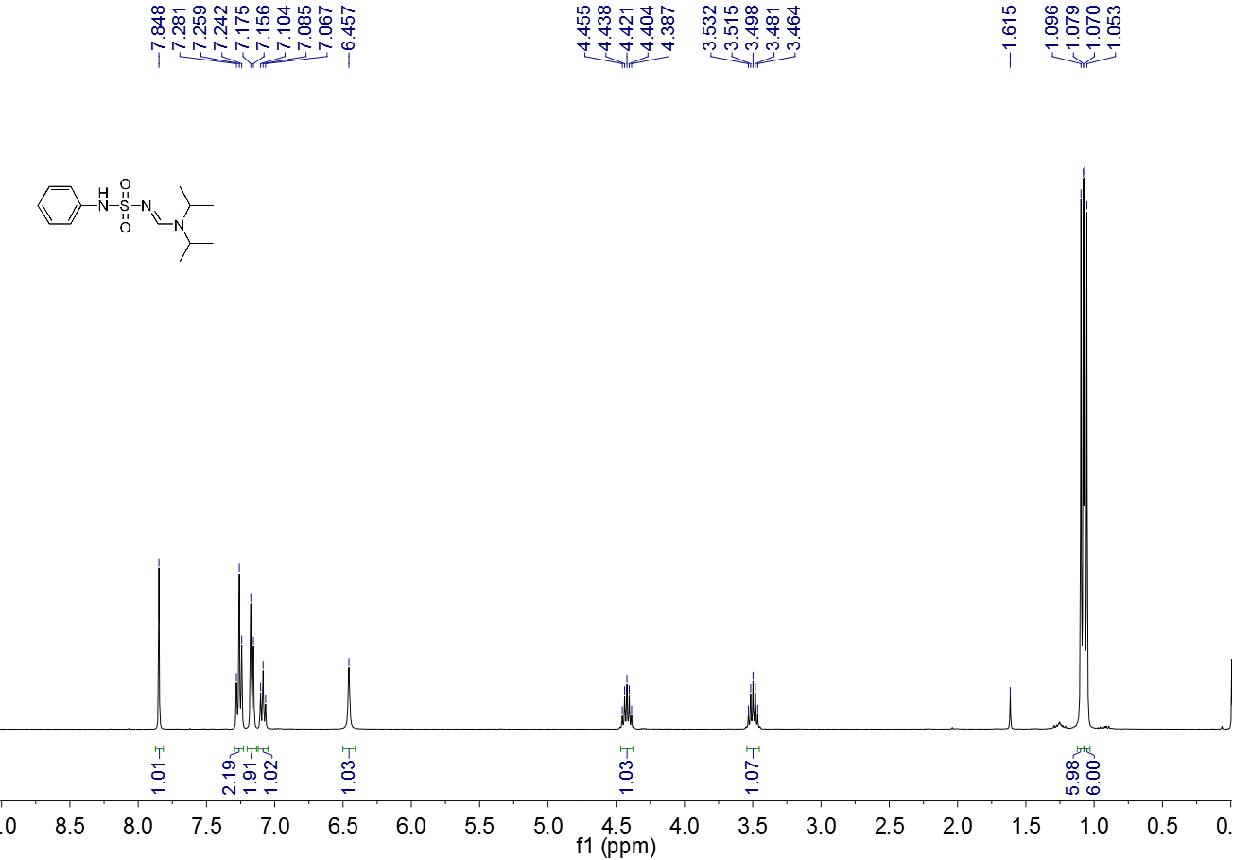

**Figure S 27.** 1H NMR spectrum (CDCl3, 400 MHz) of **3n**

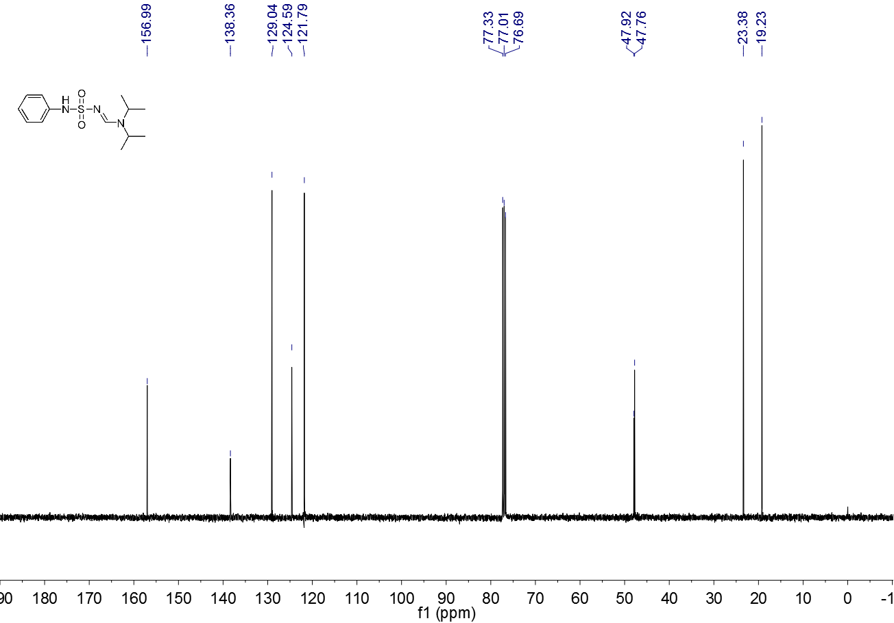

**Figure S 28.** 13C NMR spectrum (CDCl3, 100 MHz) of **3n**

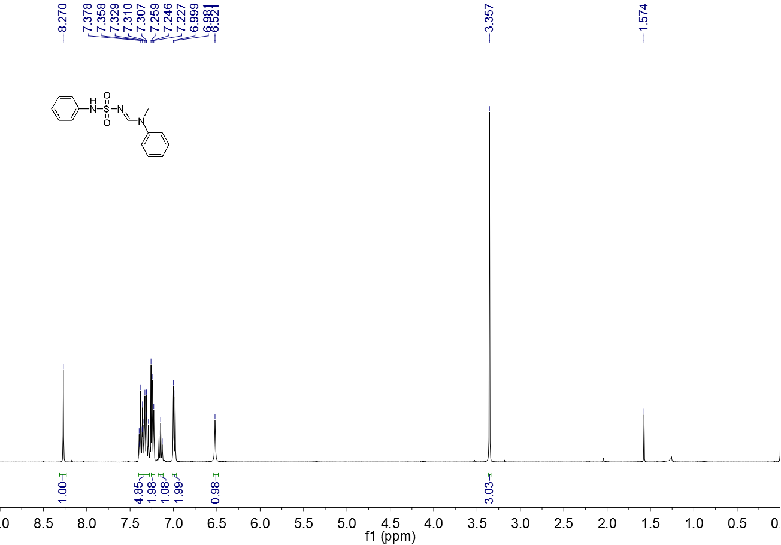

**Figure S 29.** 1H NMR spectrum (CDCl3, 400 MHz) of **3o**

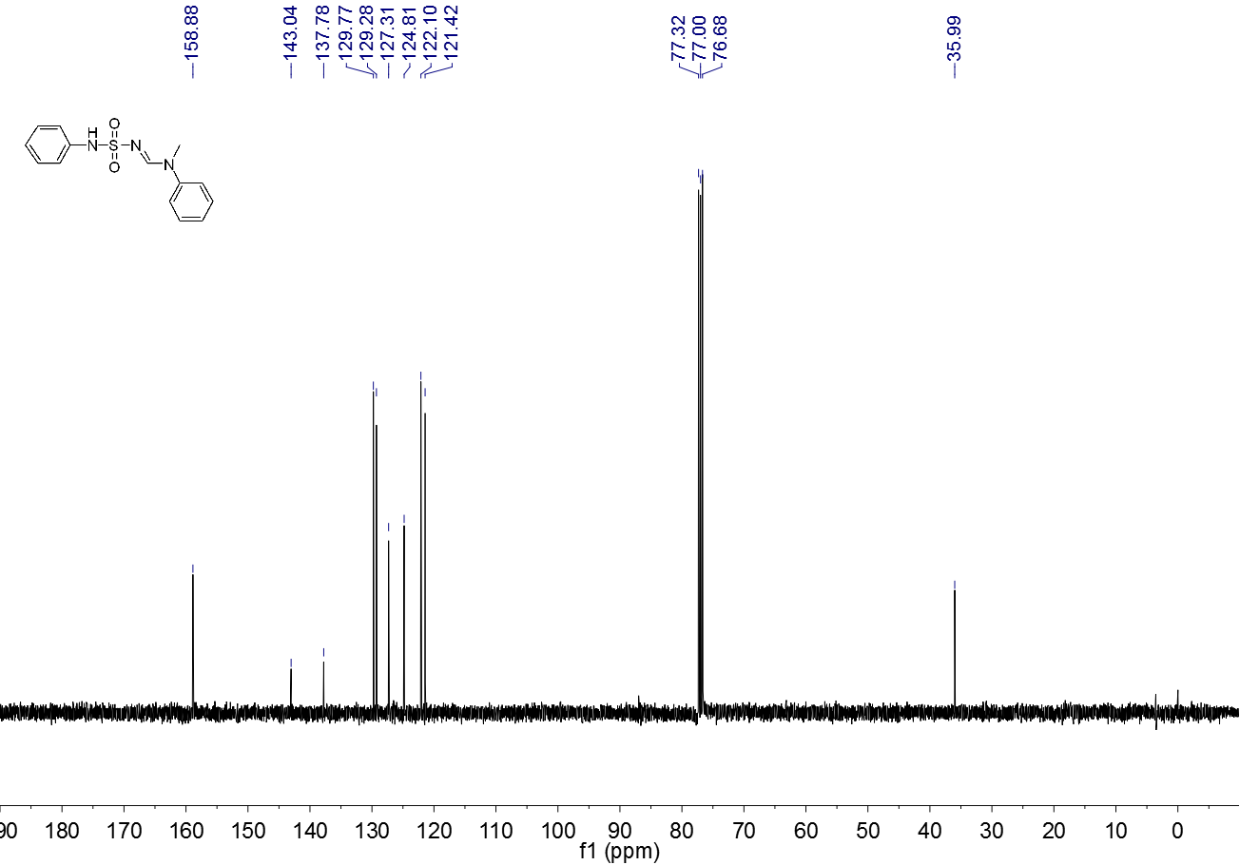

**Figure S 30.** 13C NMR spectrum (CDCl3, 100 MHz) of **3o**

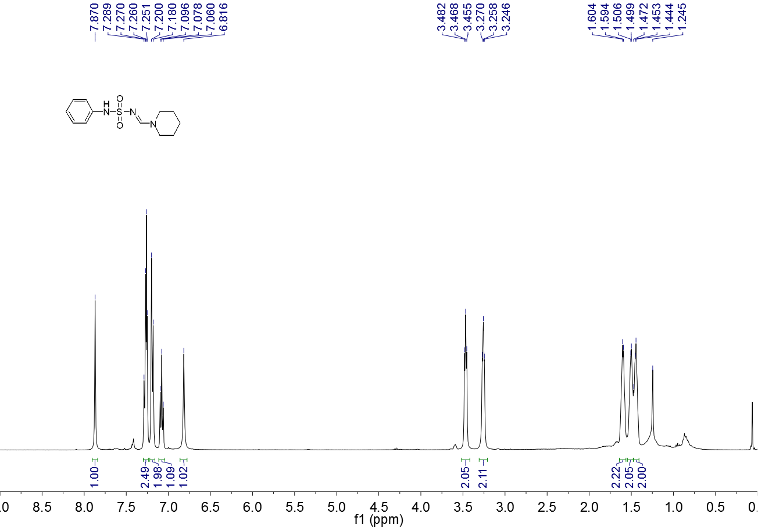

**Figure S 31.** 1H NMR spectrum (CDCl3, 400 MHz) of **3p**

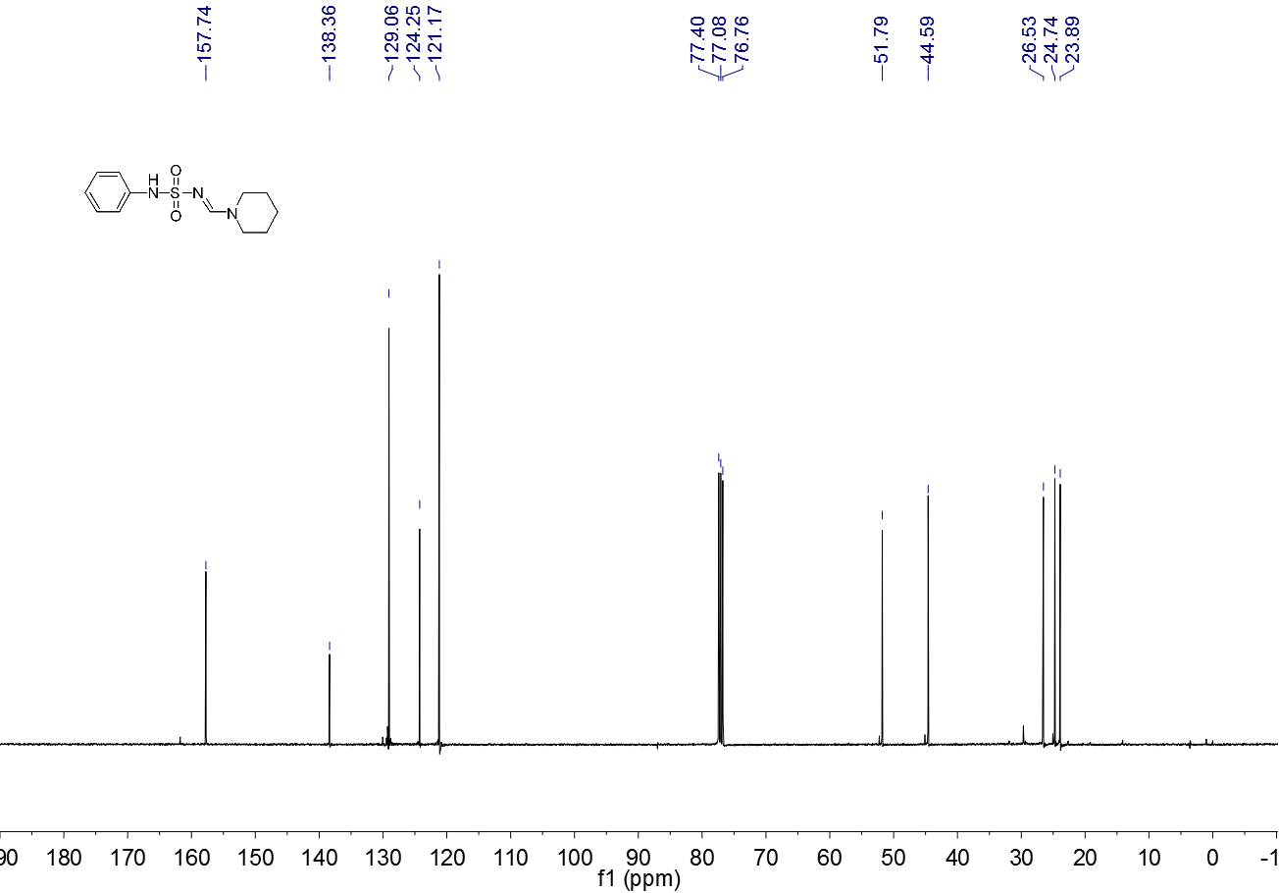

**Figure S 32.** 13C NMR spectrum (CDCl3, 100 MHz) of **3p**

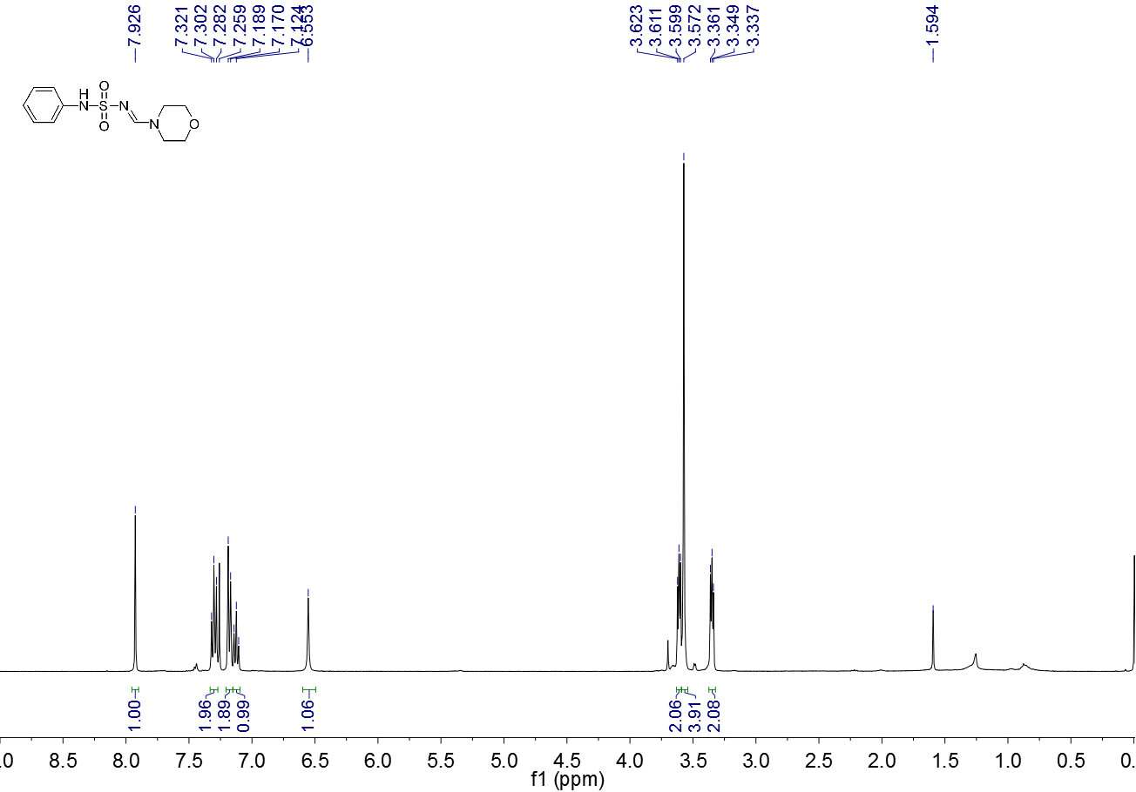

**Figure S 33.** 1H NMR spectrum (CDCl3, 400 MHz) of **3q**

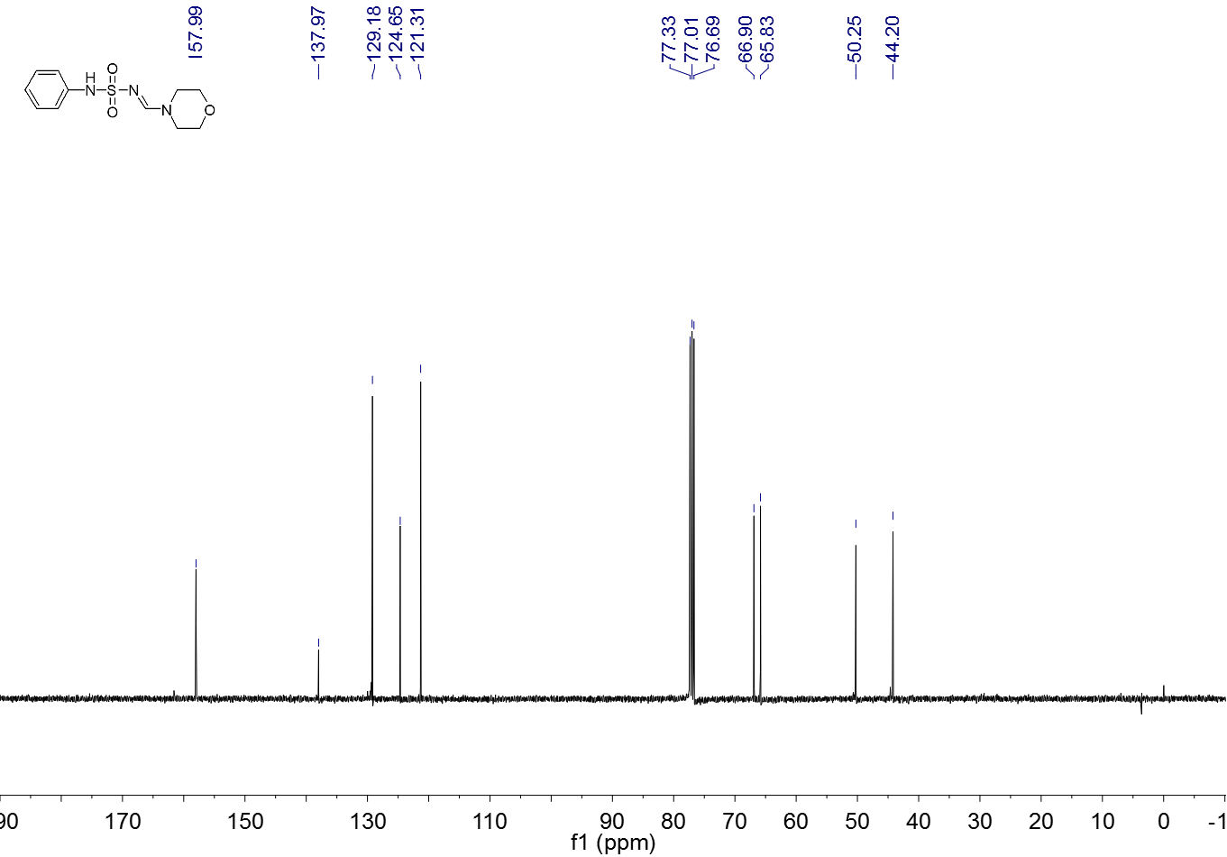

**Figure S 34.** 13C NMR spectrum (CDCl3, 100 MHz) of **3q**

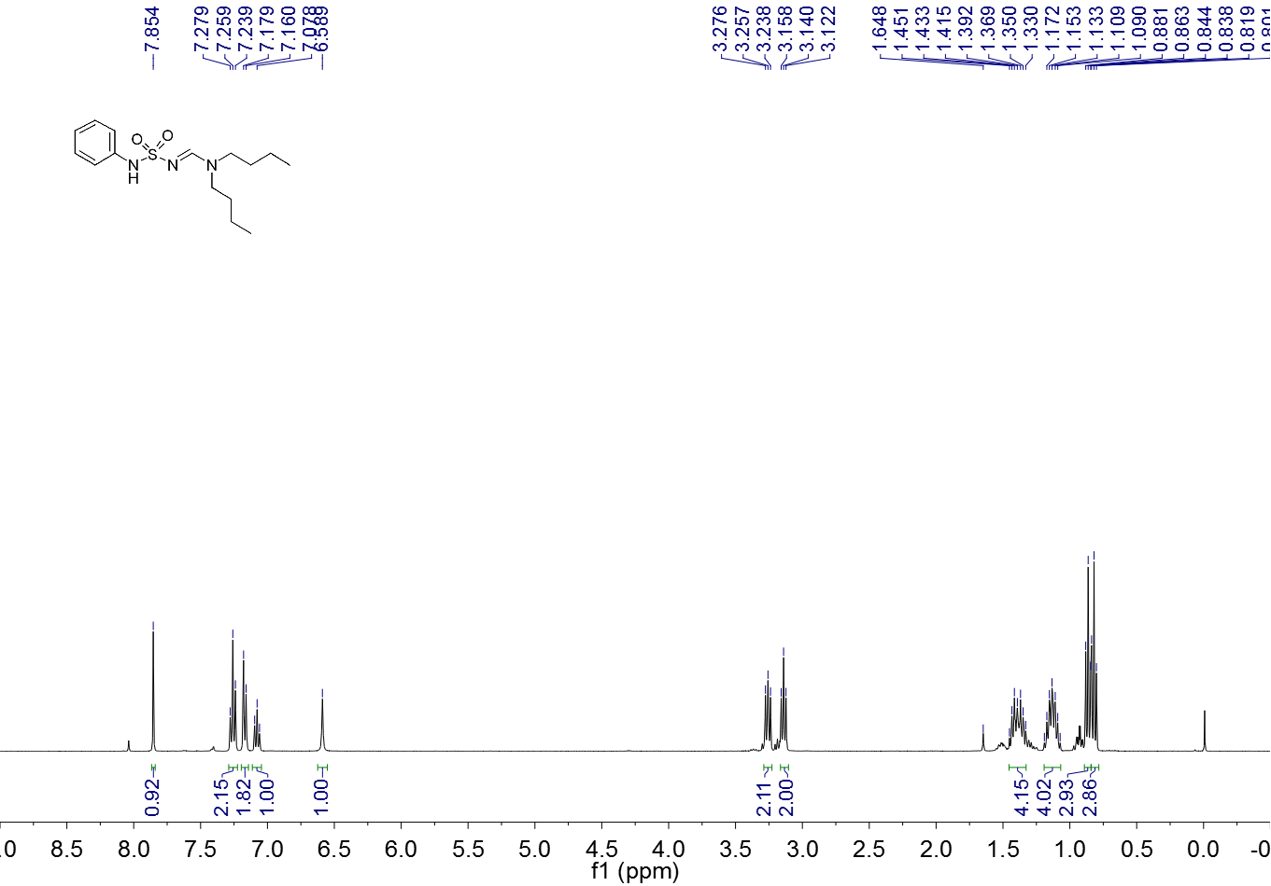

**Figure S 35.** 1H NMR spectrum (CDCl3, 400 MHz) of **3r**

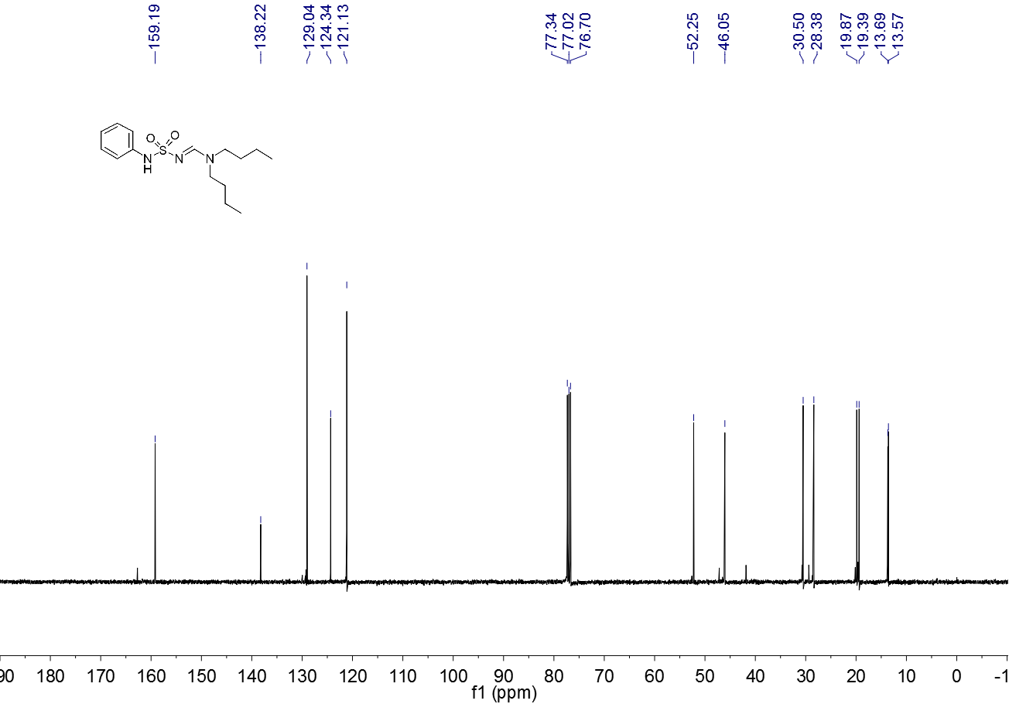 **Figure S 36.** 13C NMR spectrum (CDCl3, 100 MHz) of **3r**



**Figure S 37.** 1H NMR spectrum (CDCl3, 400 MHz) of **3t**



**Figure S 38.** 13C NMR spectrum (CDCl3, 100 MHz) of **3t**

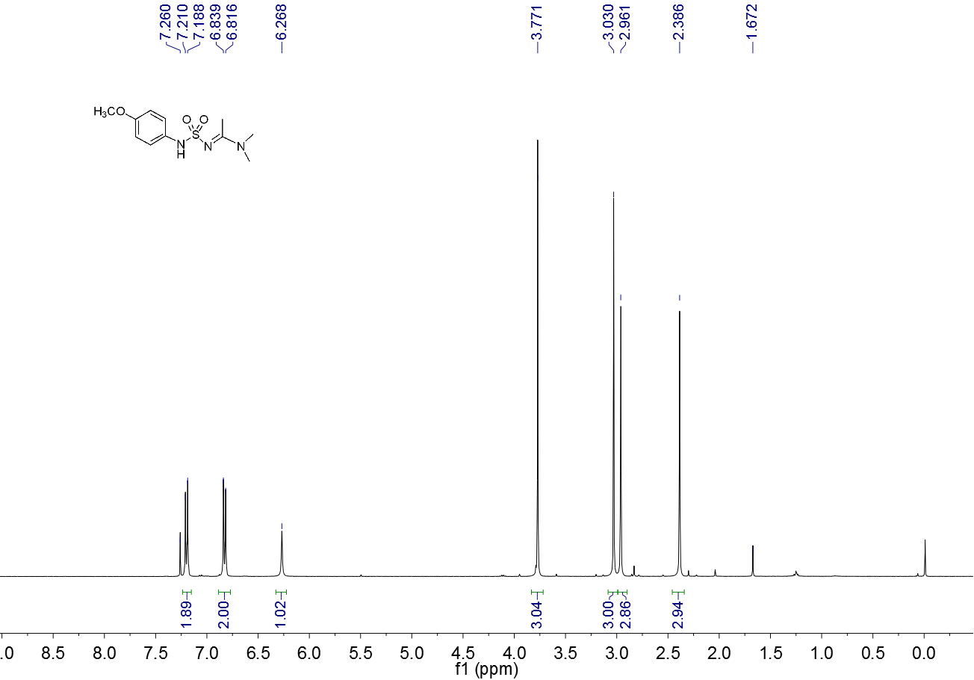

**Figure S 39.** 1H NMR spectrum (CDCl3, 400 MHz) of 3u

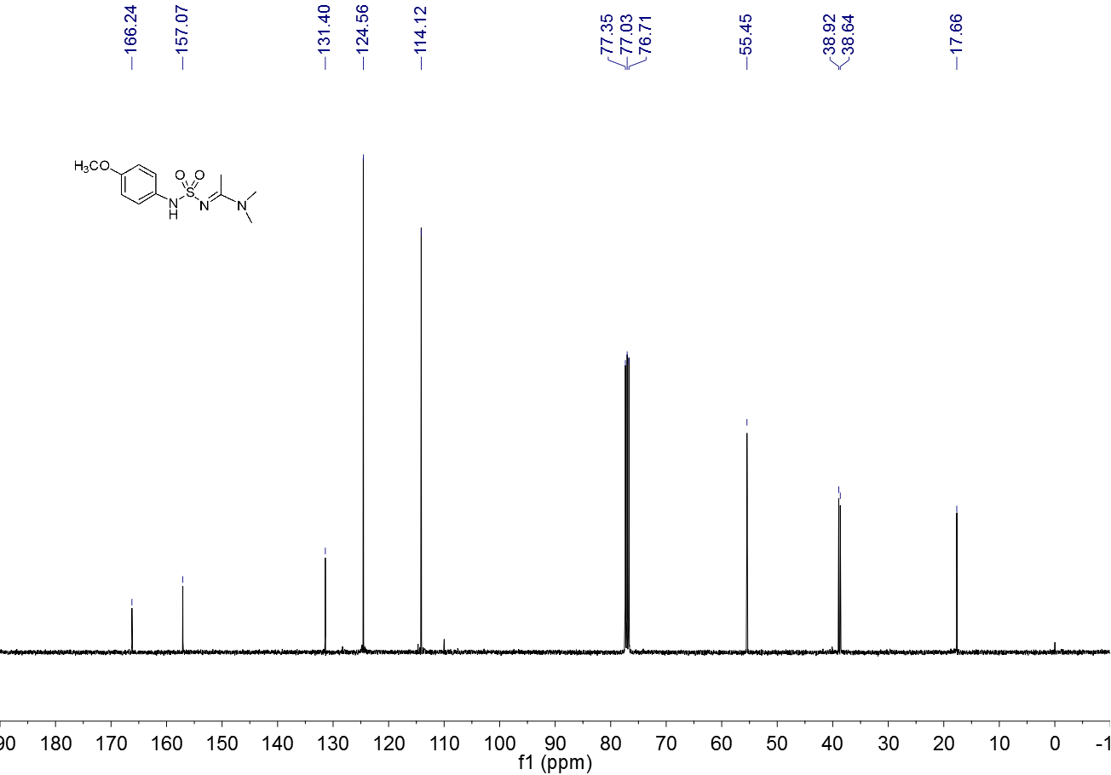

**Figure S 40.** 13C NMR spectrum (CDCl3, 100 MHz) of **3u**

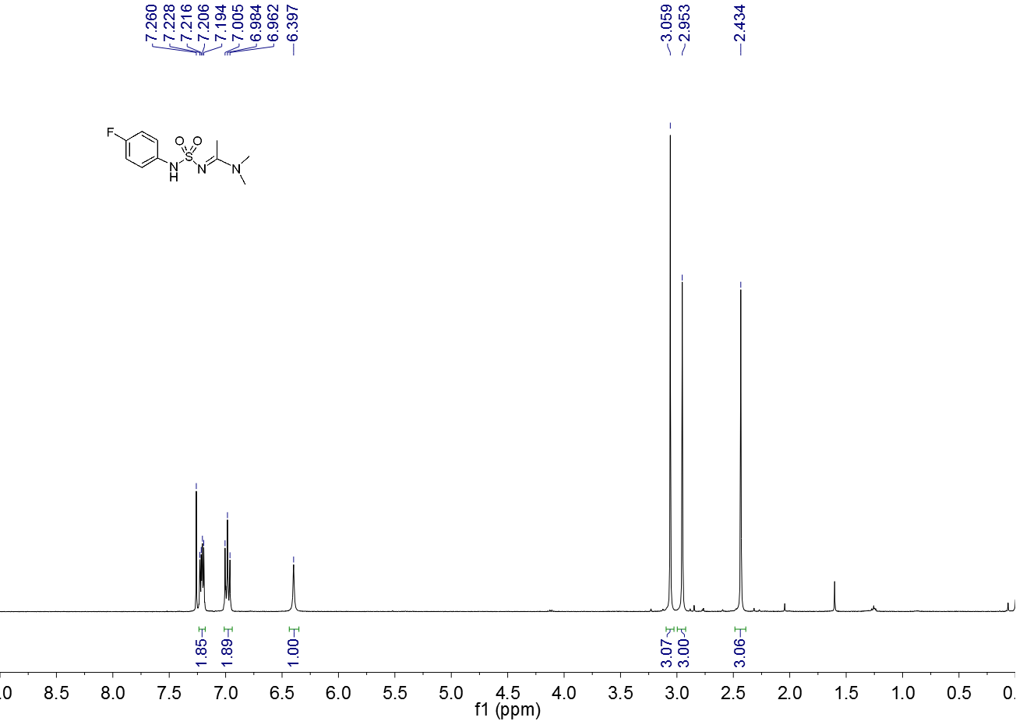

**Figure S 41.** 1H NMR spectrum (CDCl3, 400 MHz) of **3v**

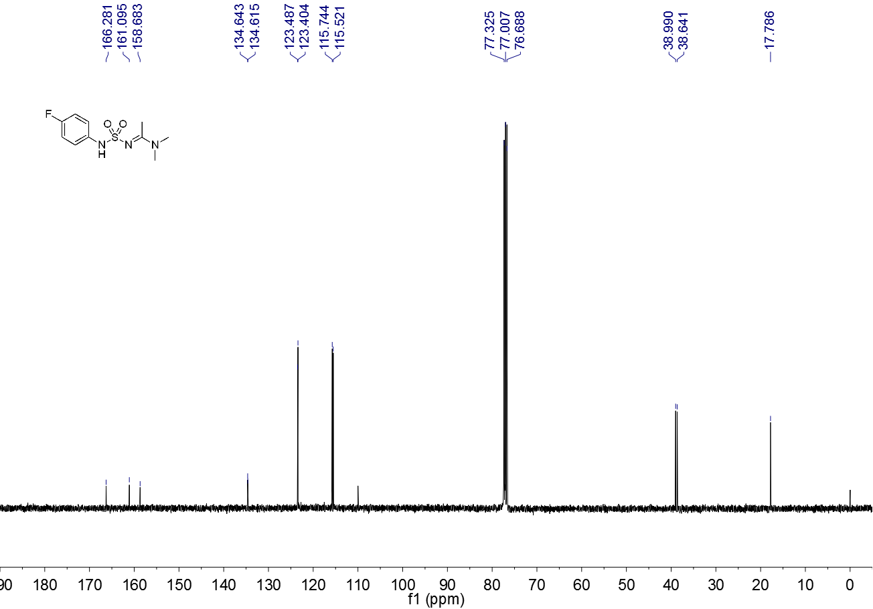

**Figure S 42.** 13C NMR spectrum (CDCl3, 100 MHz) of **3v**

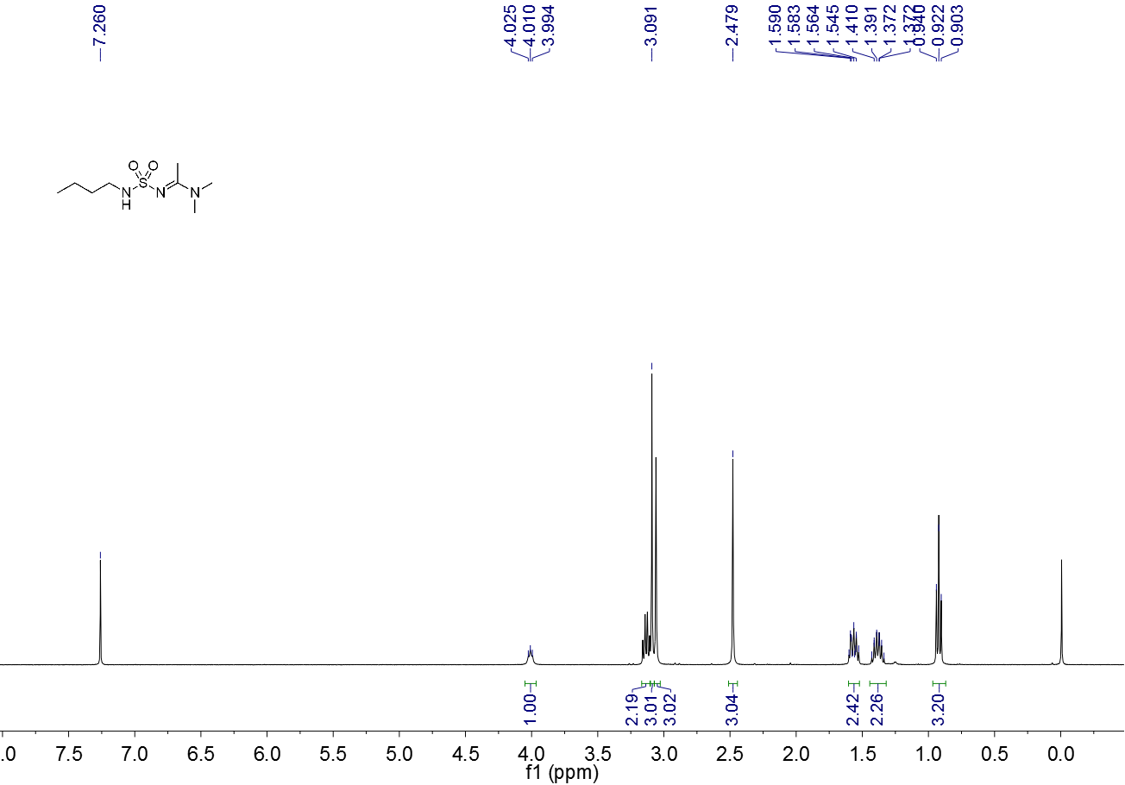

**Figure S 43.** 1H NMR spectrum (CDCl3, 400 MHz) of **3w**

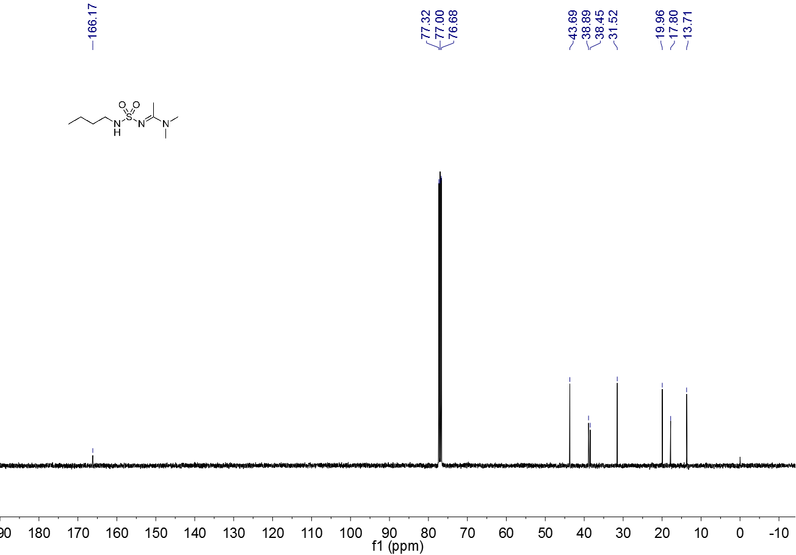

**Figure S 44.** 13C NMR spectrum (CDCl3, 100 MHz) of **3w**

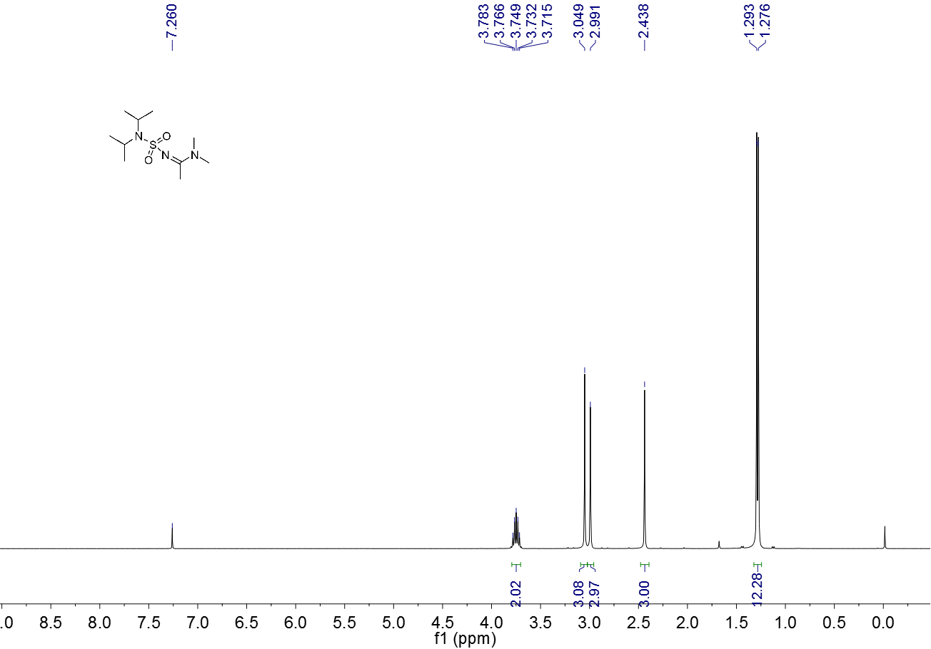

**Figure S 45.** 1H NMR spectrum (CDCl3, 400 MHz) of **3x**

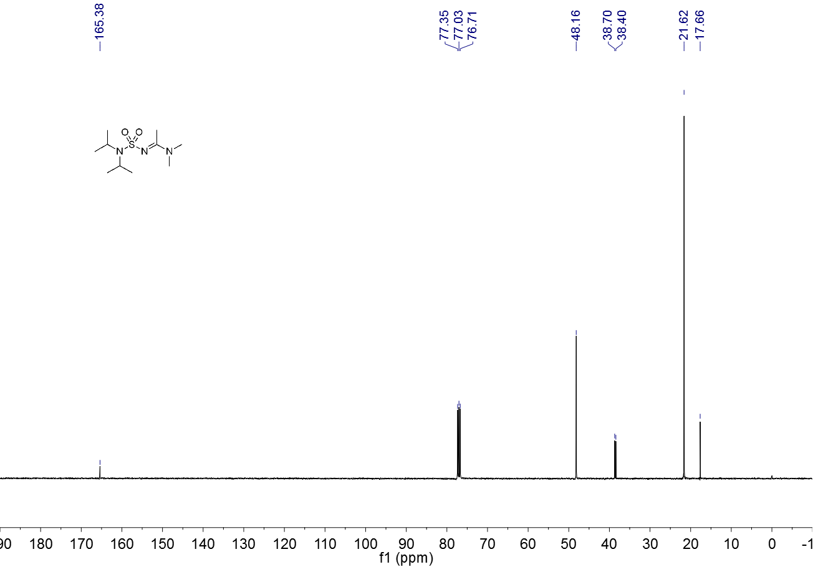

**Figure S 46.** 13C NMR spectrum (CDCl3, 100 MHz) of **3x**

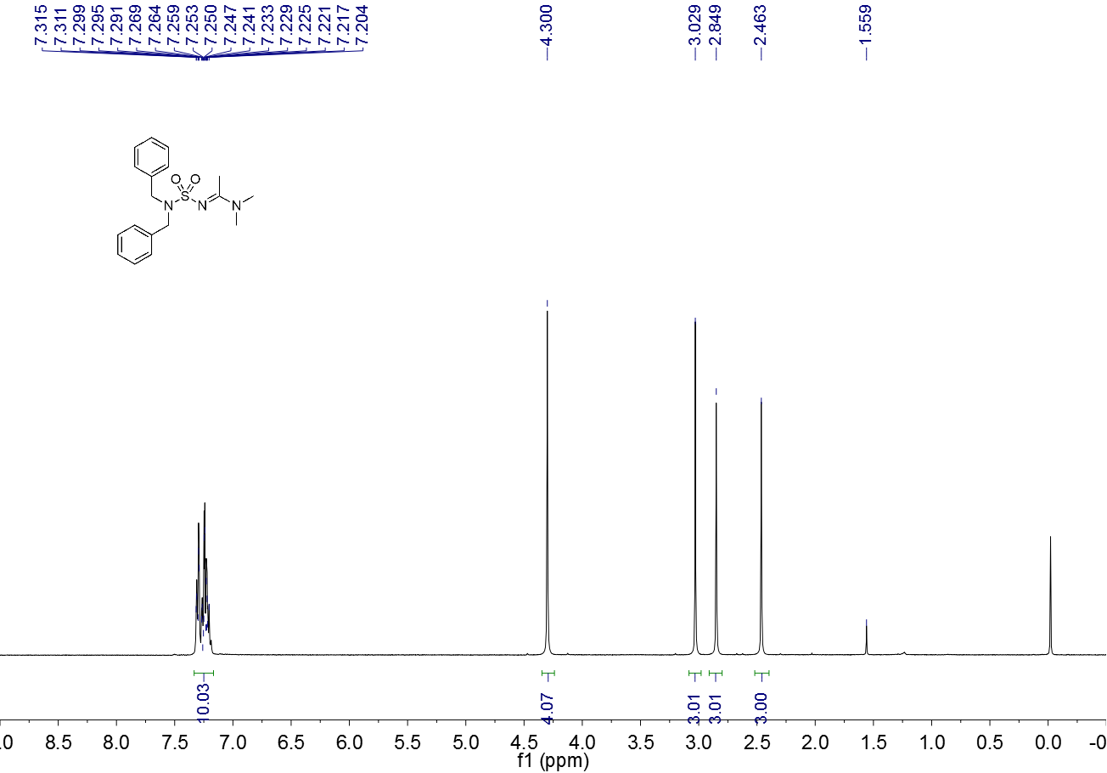

**Figure S 47.** 1H NMR spectrum (CDCl3, 400 MHz) of **3y**

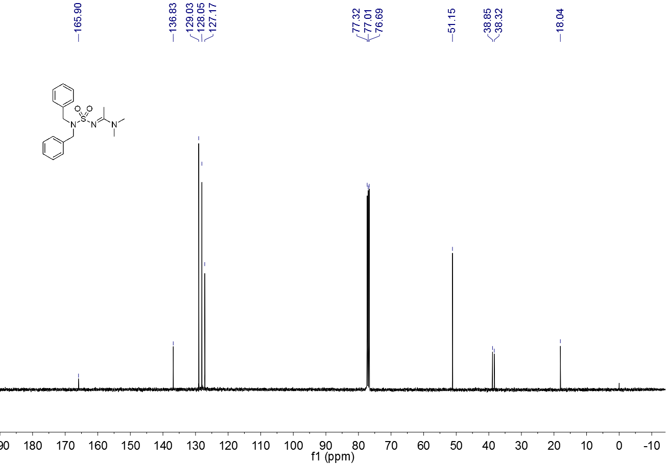

**Figure S 48.** 13C NMR spectrum (CDCl3, 100 MHz) of **3y**

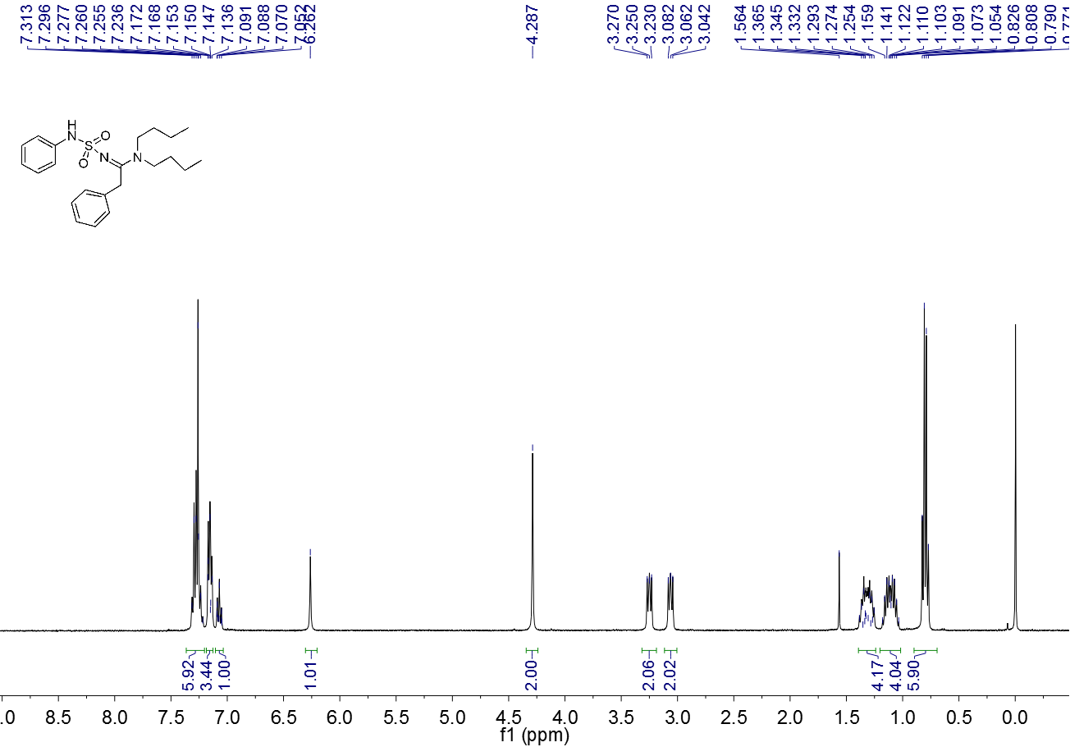

**Figure S 49.** 1H NMR spectrum (CDCl3, 400 MHz) of **3z**

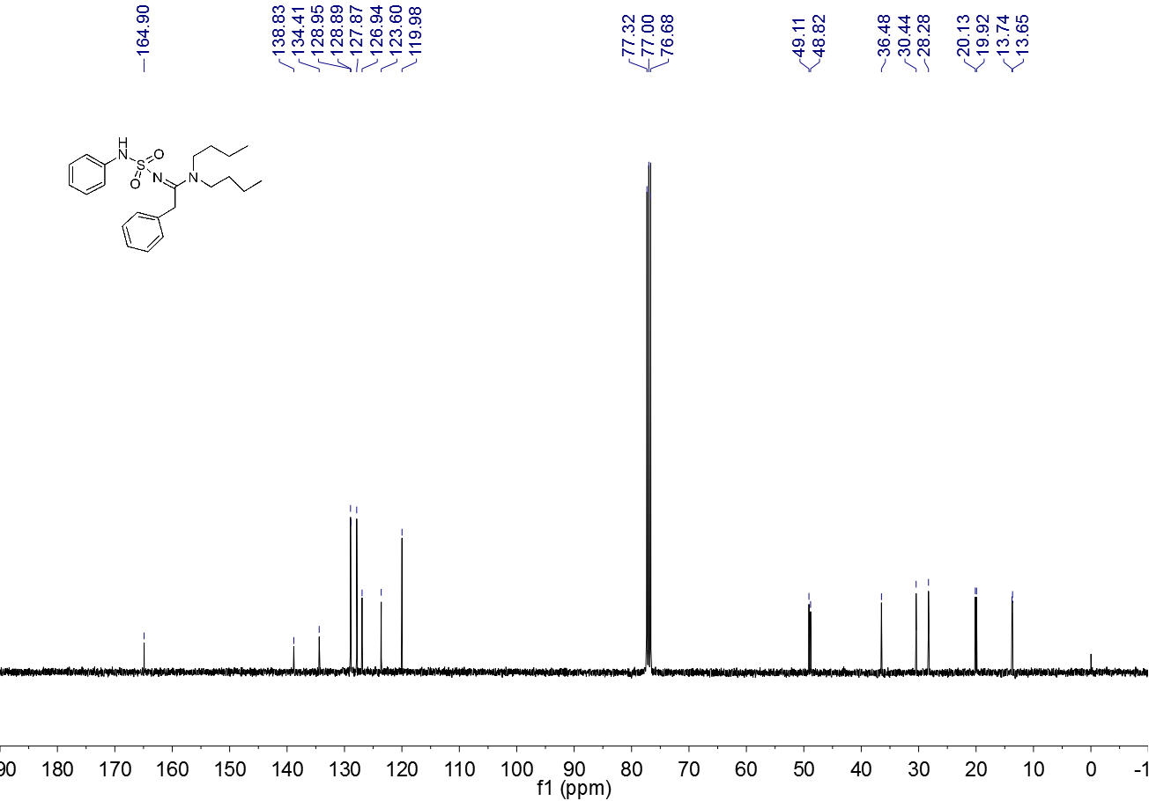

**Figure S 50.** 13C NMR spectrum (CDCl3, 100 MHz) of **3z**

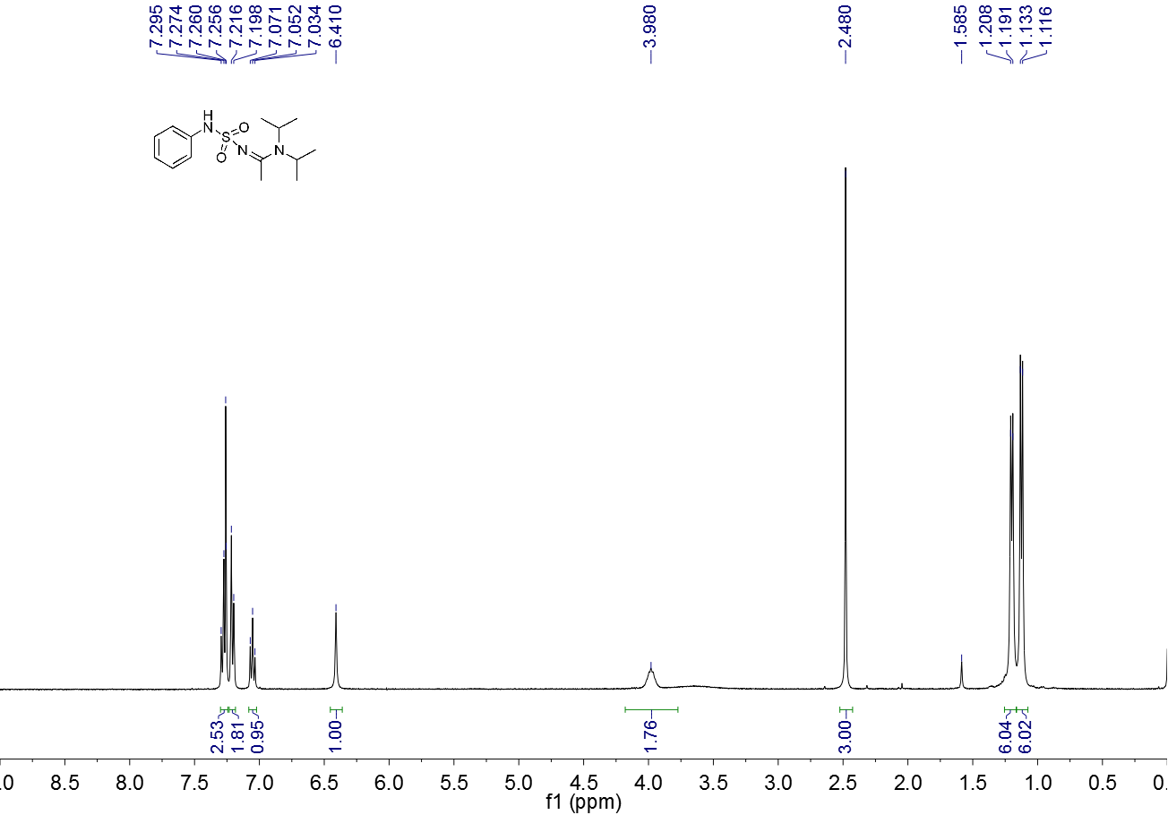

**Figure S 51.** 1H NMR spectrum (CDCl3, 400 MHz) of **3aa**

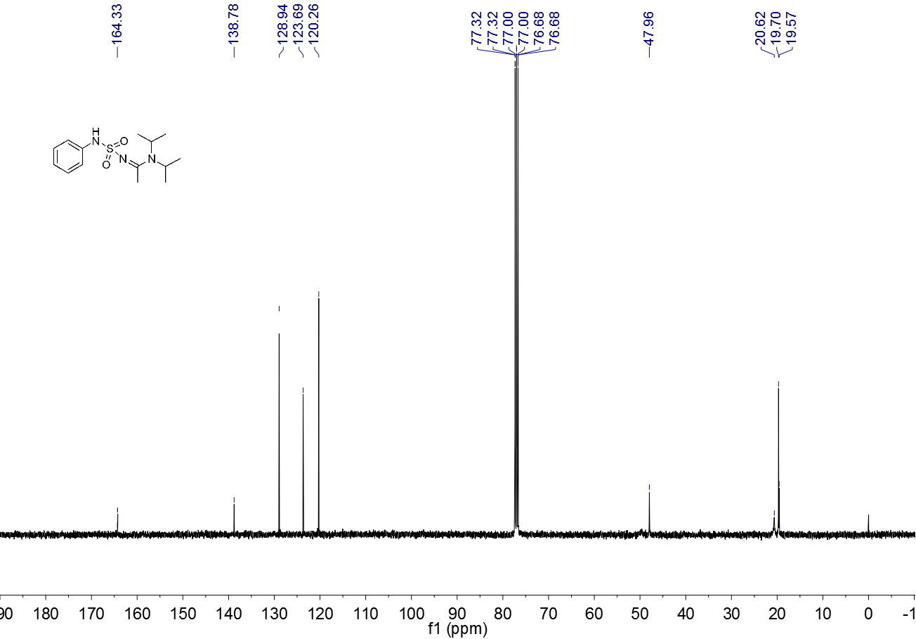

**Figure S 52.** 13C NMR spectrum (CDCl3, 100 MHz) of **3aa**

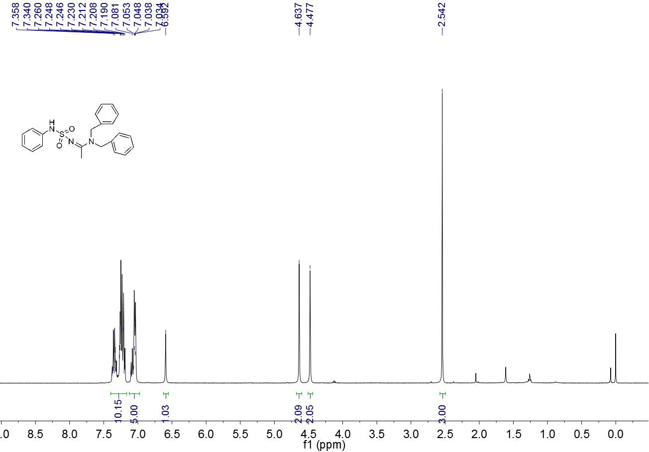

**Figure S 53.** 1H NMR spectrum (CDCl3, 400 MHz) of **3ab**

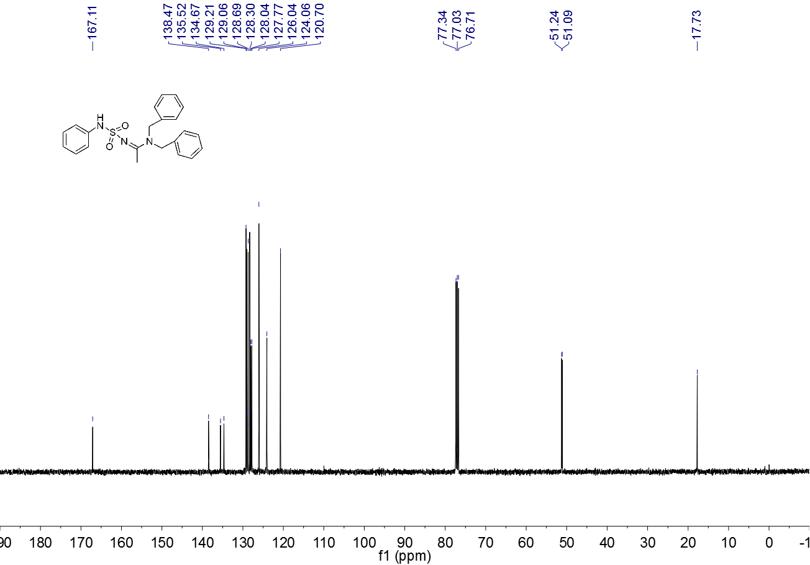

**Figure S 54.** 13C NMR spectrum (CDCl3, 100 MHz) of **3ab**

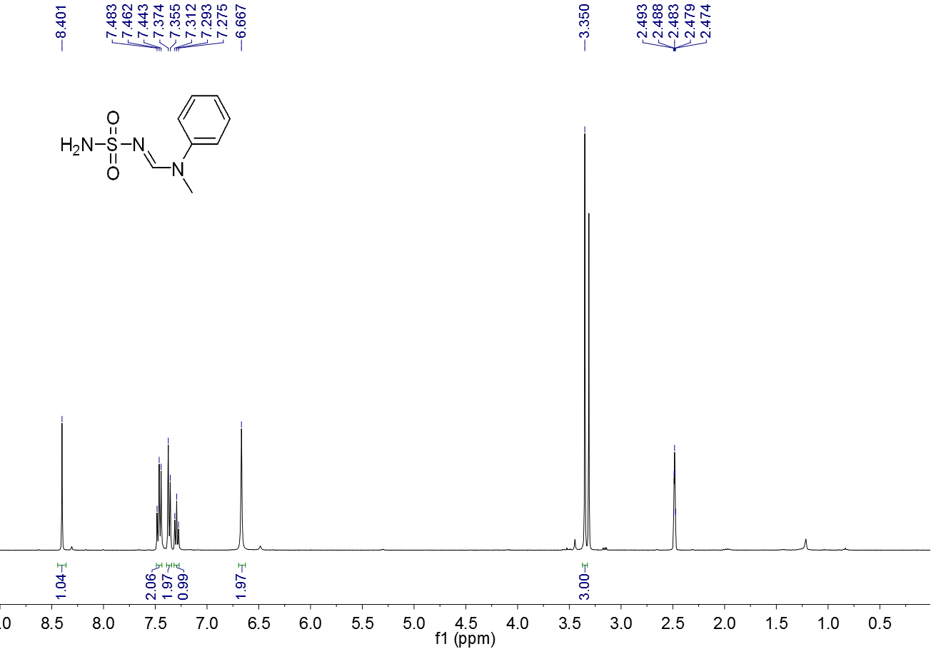

**Figure S 55.** 1H NMR spectrum (DMSO-d6, 400 MHz) of **3aj**

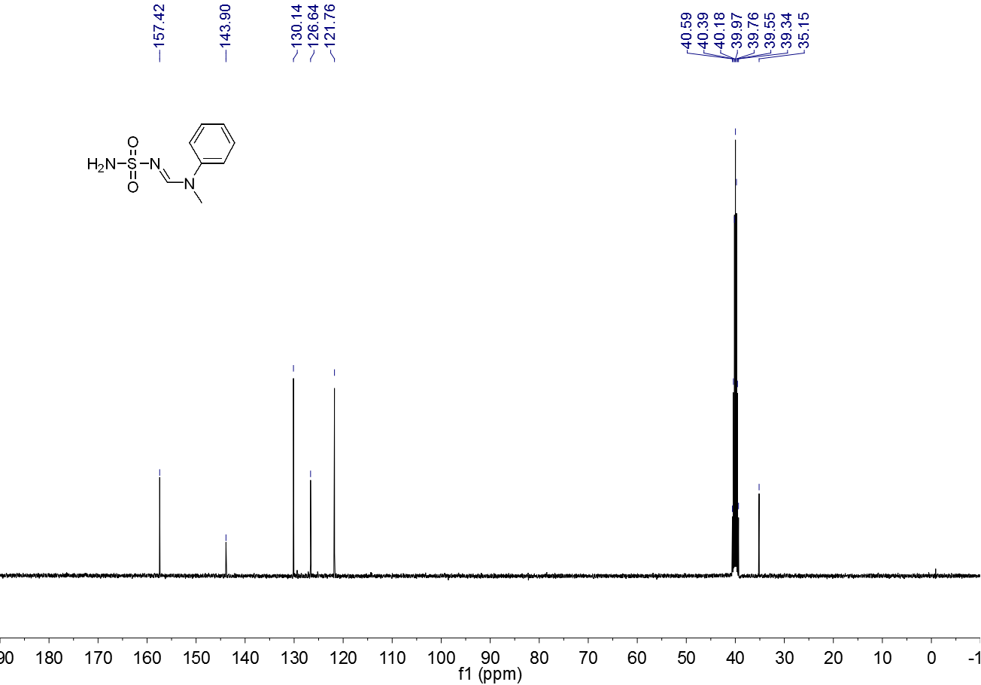

**Figure S 56.** 13C NMR spectrum (DMSO-d6, 100 MHz) of **3aj**

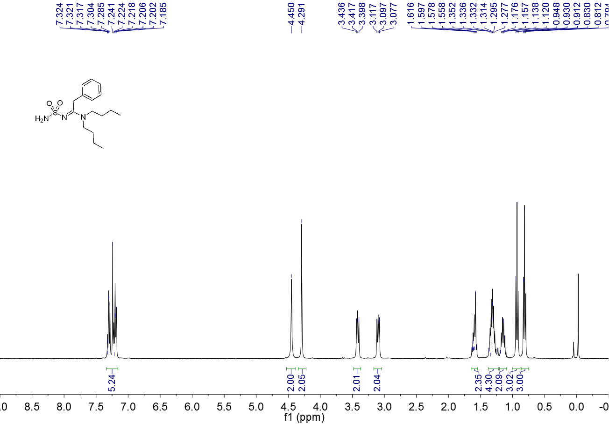

**Figure S 57.** 1H NMR spectrum (CDCl3, 400 MHz) of 3**al**

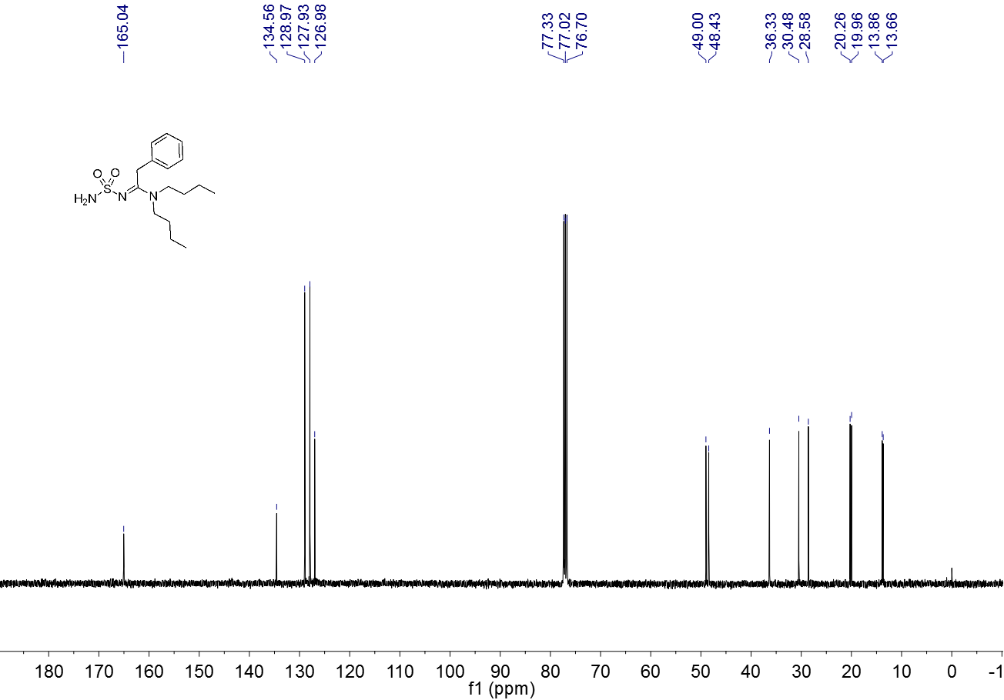

**Figure S 58.** 13C NMR spectrum (CDCl3, 100 MHz) of **3al**

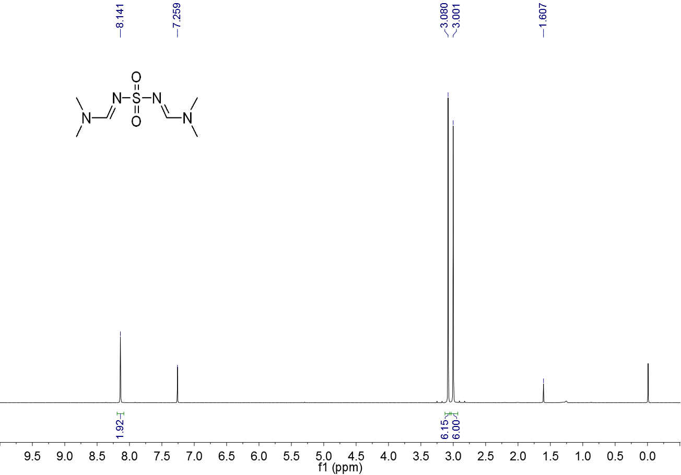

**Figure S 59.** 1H NMR spectrum (CDCl3, 400 MHz) of **4a**



**Figure S 60.** 13C NMR spectrum (CDCl3, 100 MHz) of **4a**



**Figure S 61.** 1H NMR spectrum (CDCl3, 400 MHz) of **4b**



**Figure S 62.** 13C NMR spectrum (CDCl3, 100 MHz) of **4b**



**Figure S 63.** 1H NMR spectrum (CDCl3, 400 MHz) of **4c**



**Figure S 64.** 13C NMR spectrum (CDCl3, 100 MHz) of **4c**



**Figure S 65.** 1H NMR spectrum (CDCl3, 400 MHz) of **4d**



**Figure S 66.** 13C NMR spectrum (CDCl3, 100 MHz) of **4d**

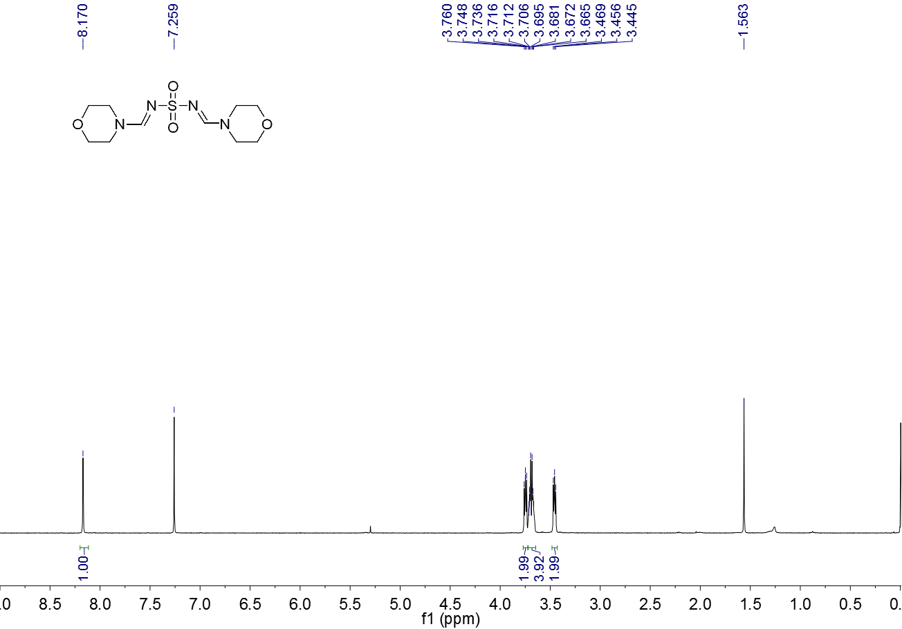

**Figure S 67.** 1H NMR spectrum (CDCl3, 400 MHz) of **4e**



**Figure S 68.** 13C NMR spectrum (CDCl3, 100 MHz) of **4e**

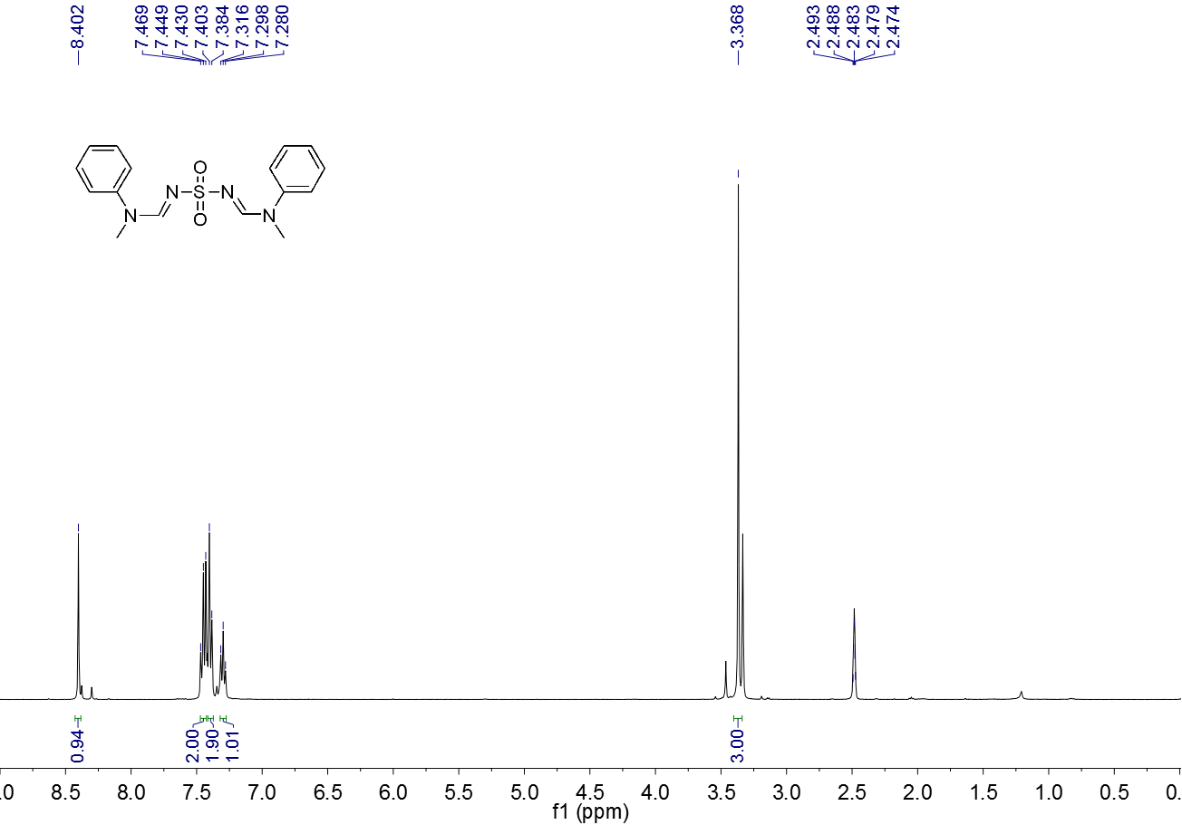

**Figure S 69.** 1H NMR spectrum (DMSO-d6, 400 MHz) of **4f**



**Figure S 70.** 13C NMR spectrum (DMSO-d6, 100 MHz) of **4f**



**Figure S 71.** 1H NMR spectrum (CDCl3, 400 MHz) of **4g**



**Figure S 72.** 13C NMR spectrum (CDCl3, 100 MHz) of **4g**

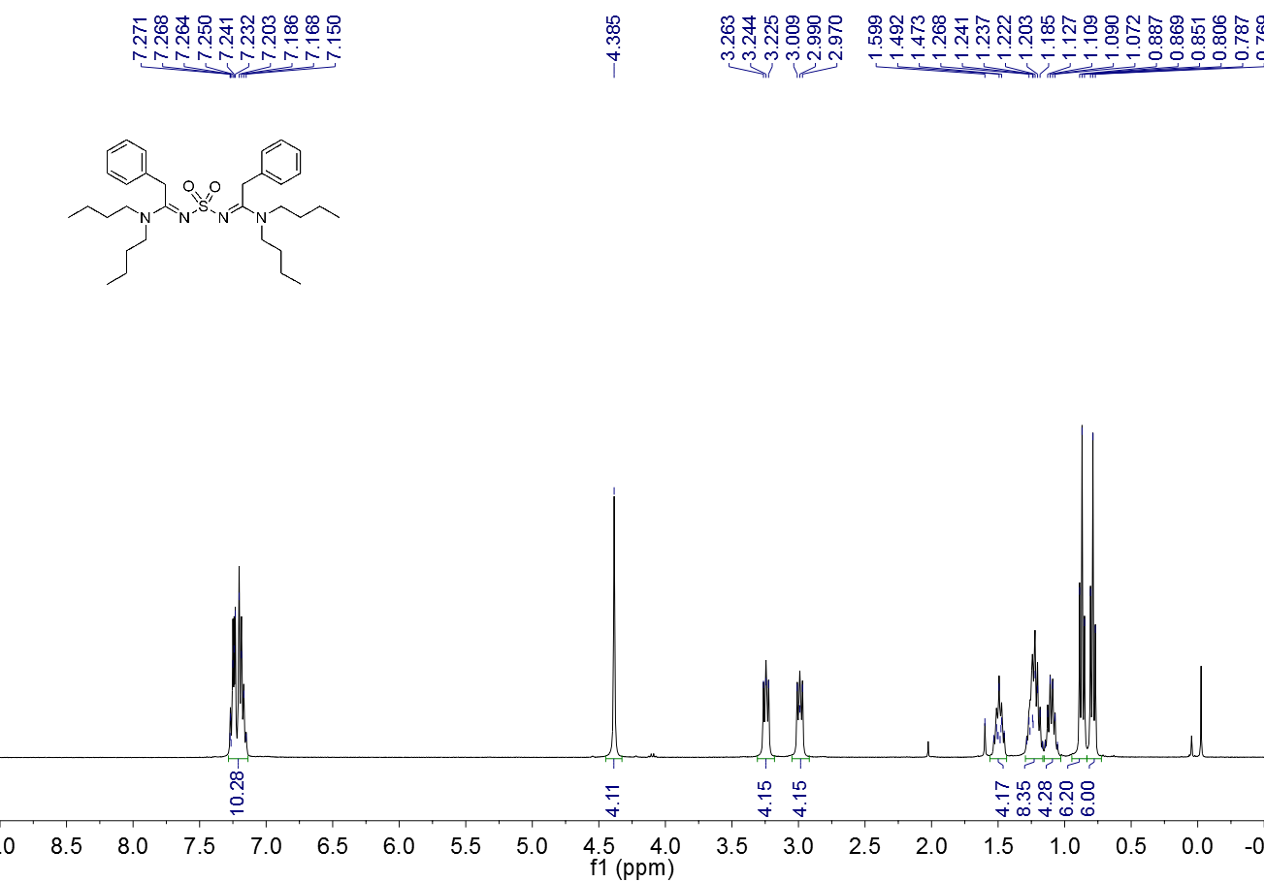

**Figure S 73.** 1H NMR spectrum (CDCl3, 400 MHz) of **4h**

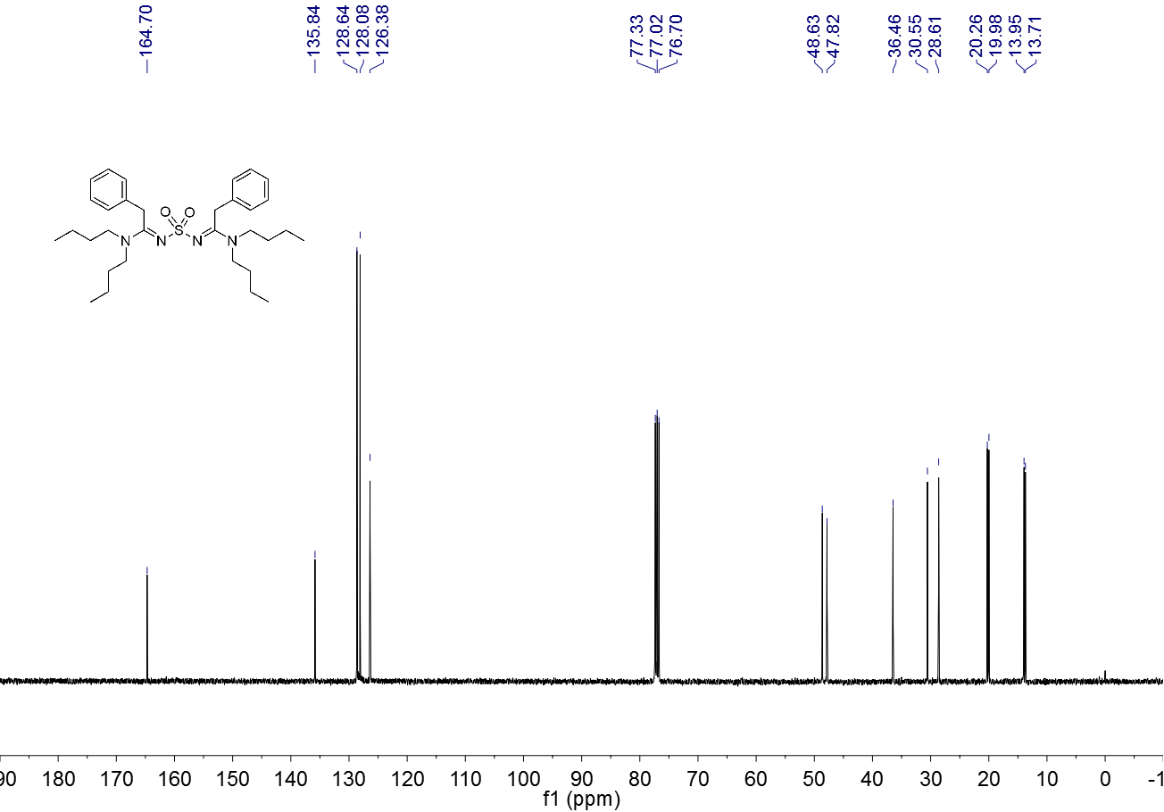

**Figure S 74.** 13C NMR spectrum (CDCl3, 100 MHz) of **4h**

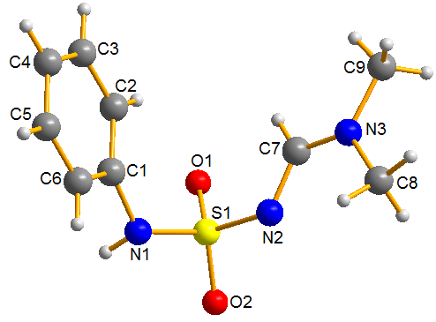

**Table S 1**. Crystallographic Data and Structure Refinement for 3a

|  |  |
| --- | --- |
| **Compound** | **3a** |
| Empirical Formula | C9H13N3O2S |
| Formula Weight | 227.28 |
| Crystal System / Space Group | monoclinic / P21/c |
| a / Å | 8.7559(4) |
| b / Å | 8.9315(4) |
| c / Å | 14.0968(6) |
| α / ° | 90 |
| β / ° | 102.227(4) |
| γ / ° | 90 |
| V / Å3 | 1077.41(8) |
| Z | 4 |
| D calc (g/cm3) | 1.401 |
| μ (mm-1) | 0.285 |
| Crystal size (mm) | 0.14 × 0.12 × 0.11 |
| Color / Shape | MoKα (λ = 0.71073) |
| Temp (K) | 4.76 to 49.992 |
| Theta range for collection | -10 ≤ h ≤ 10, -10 ≤ k ≤ 10, -14 ≤ l ≤ 16 |
| Reflections collected | 6538 |
| Independent reflections | 1893 [Rint = 0.0294, Rsigma = 0.0282] |
| Data/restraints/parameters | 1893/0/138 |
| Goodness of fit on F2 | 1.086 |
| Final R indices [I > 2σ(I)] | R1 = 0.0400, wR2 = 0.1068 |
| R indices (all data) | R1 = 0.0428, wR2 = 0.1093 |
| Largest difference peak/hole | 0.89/-0.82 |

|  |  |  |  |  |  |  |
| --- | --- | --- | --- | --- | --- | --- |
| **Table S 2** Bond Lengths for **3a**. | | | | | | |
| Atom | Atom | Length/Å |  | Atom | Atom | Length/Å |
| S1 | O2 | 1.4287(15) |  | N3 | C8 | 1.463(3) |
| S1 | O1 | 1.4362(15) |  | C1 | C2 | 1.391(3) |
| S1 | N1 | 1.6387(18) |  | C1 | C6 | 1.390(3) |
| S1 | N2 | 1.6259(17) |  | C2 | C3 | 1.390(3) |
| N1 | C1 | 1.427(3) |  | C3 | C4 | 1.381(3) |
| N2 | C7 | 1.316(3) |  | C6 | C5 | 1.388(3) |
| N3 | C7 | 1.309(3) |  | C5 | C4 | 1.383(3) |
| N3 | C9 | 1.459(3) |  |  |  |  |

|  |  |  |  |  |  |  |  |  |
| --- | --- | --- | --- | --- | --- | --- | --- | --- |
| **Table S 3** Bond Angles for **3a** | | | | | | | | |
| Atom | Atom | Atom | Angle/˚ |  | Atom | Atom | Atom | Angle/˚ |
| O2 | S1 | O1 | 118.84(9) |  | C9 | N3 | C8 | 117.44(18) |
| O2 | S1 | N1 | 104.13(9) |  | C2 | C1 | N1 | 123.41(19) |
| O2 | S1 | N2 | 106.51(9) |  | C6 | C1 | N1 | 116.94(18) |
| O1 | S1 | N1 | 108.76(9) |  | C6 | C1 | C2 | 119.6(2) |
| O1 | S1 | N2 | 111.73(9) |  | C3 | C2 | C1 | 119.4(2) |
| N2 | S1 | N1 | 105.92(9) |  | C4 | C3 | C2 | 121.1(2) |
| C1 | N1 | S1 | 124.23(14) |  | N3 | C7 | N2 | 121.75(19) |
| C7 | N2 | S1 | 118.45(14) |  | C5 | C6 | C1 | 120.2(2) |
| C7 | N3 | C9 | 122.03(18) |  | C4 | C5 | C6 | 120.4(2) |
| C7 | N3 | C8 | 120.28(18) |  | C3 | C4 | C5 | 119.2(2) |