Supplementary Information
(A) Full experimental and spectroscopic data of the synthesized compounds 2-10:
Synthesis of 2-oxo-2H-chromene-3-carboxamide (2)
A mixture of compound 1 (0.94 g, 5 mmol) and phosphorous acid (0.41 g, 5 mmol) in dry dioxane (30 mL), in the presence of catalytic amount of 4-toluenesulfonic acid (0.1 g) was heated under reflux for 20 hours. The formed solid was filtered off and dried to give yellow crystals in 50% yield (0.47 g); mp 279−280º C (Lit. 280−281ºC^{[12]}). IR (KBr), (v max, cm⁻¹): 3388, 3149 (NH₂), 3055 (C−H_{arom}), 1737 (C=O_{lactone}), 1678 (C=O_{amide}), 1602, 1564 (C=C).
Synthesis of ({[(2-imino-2H-chromen-3-yl)carbonyl]amino}methyl)phosphonic acid (4)
Phosphorous acid (0.41 g, 5 mmol) was added to a solution of compound 1 (0.94 g, 5 mmol) in 50% HCl (30 mL). Formaldehyde (1.7 mL, 5 mmol) was added dropwise to the solution. The mixture was heated under reflux for 4 hours. The solid formed on heating was filtered off, washed with water and crystallized from diluted ethanol to give white solid in 43% yield (0.60 g); mp < 300 ºC. IR (KBr), (v max, cm⁻¹): 3388 (OH), 3320 (NH), 3151 (NH), 3049 (C−H_{arom}), 2965 (C−H_{aliph}), 1719 (C=O), 1659 (C=N), 1611, 1565 (C=C), 1206 (P=O). ¹H-NMR (400 MHz, DMSO-d₆): 3.47 (brs, 2H, P−OH, exchangeable with D₂O), 4.78 (dd, 2H, J=23.2 and 6.4 Hz, CH₂−P), 7.42 (t, 1H, J=6.8 Hz, H−6), 7.47 (d, 1H, J=8.0 Hz, H−8), 7.73 (t, 1H, J=7.2 Hz, H−7), 7.88 (s, 1H, NH exchangeable with D₂O), 7.95 (d, 1H, J=7.6 Hz, H−5), 8.05 (s, 1H, NH exchangeable with D₂O), 8.85 (s, 1H, H−4). ¹³C-NMR (100 MHz, DMSO-d₆): 58.6 (d, J=151.5 Hz, CH₂−P), 116.6 (C−8), 118.9 (C−3), 119.8 (C−4a), 125.5 (C−6), 130.7 (C−5), 134.5 (C−7), 148.2 (C−4), 154.4 (C−8a), 160.7 (C−2), 162.9 (C=O). MS (m/z, I %): 284 (M+2, 2%), 283 (M+1, 9%), 282 (M⁺, 41%). Anal. Calcd for C₁₁H₁₁N₂O₅P (282.19): C, 46.82%; H, 3.96%; N, 9.93%. Found: C, 46.49%; H, 3.63%; N, 9.69%.
Synthesis of 4-amino-1-ethoxy-1-oxido-1,9b-dihydrochromeno[4,3-c][1,2]azaphosphol-3(2H)-one (5)
A mixture of diethyl phosphite (0.7 mL, 5 mmol) and compound 1 (0.94 g, 5 mmol) in the presence of trifluoroboron etherate (0.1 mL) as a catalyst, was fused on water bath for 4 hours. The formed semi-solid was dissolved in a little amount of ethyl acetate. The formed solid was filtered off and crystallized from ethyl acetate to give white crystalline solid in 40% yield (0.56 g); mp < 300 ºC. IR (KBr), (v max, cm⁻¹): 3307, 3246 (br, NH₂), 3200 (NH), 3045 (C−H_{arom}), 2910, 2850 (C−H_{aliph}), 1691 (C=O), 1608, 1587 (C=C), 1223 (P=O), 1091 (P−O−C). ¹H-NMR (400 MHz, DMSO-d₆): 0.9−1.14 (m, 3H, CH₃), 2.64 (q, 1H, J=14 Hz, H−9_{b}), 2.91−3.02 (m, 1H, OCH₂), 3.21−3.29 (m, 1H, OCH₂), 6.80 (d, 1H, J=8.0 Hz, H−6), 6.89 (t, 1H, J=7.6 Hz, H−8), 7.13 (t, 1H, J=8.0 Hz, H−7), 7.20 (d, 1H, J=7.2 Hz, H−9), 8.62 (s, 1H, NH exchangeable with D₂O), 9.19, 9.25 (ss, 2H, NH₂ exchangeable with D₂O). ¹³C-NMR (100 MHz, DMSO-d₆): 16.6 (CH₃), 33.3 (d, J=116.5 Hz, C−9b), 60.9 (OCH₂), 112.7 (C−3a), 118.6 (C−6), 121.1 (C−9a), 126.8 (C−8), 128.4 (C−9), 128.7 (C−7), 154.2 (C−5a), 156.9 (C−4), 169.3 (C−3). MS (m/z, I %): 282 (M+2, 4%), 280 (M⁺, 26%). Anal. Calcd for C₁₂H₁₃N₂O₄P (280.21): C, 51.43%; H, 4.68%; N, 10.00%. Found: C, 51.09%; H, 4.35%; N, 9.72%.
Reaction of compound 1 with tris(2-chloroethyl)phosphite: Synthesis of products 6 and 7.
A mixture of tris(2-chloroethyl)phosphite (1.3 mL, 5 mmol) and compound 1 (0.94 g, 5 mmol) in the presence of trifluoroboron etherate (0.1 mL) as a catalyst, was fused on water bath for 7 hours (0.15 mL of distilled water added after 3 h). The formed semi-solid was dissolved in hot ethanol and left to cool. The formed solid was filtered off as yellow solid 7. The original filtrate was concentrated and added to water to give compound 6 as reddish solid.
Bis(2-chloroethyl)(2-amino-3-carbamoyl-4H-chromen-4-yl)phosphonate (6): 25% yield (0.49 g); mp 151–152 ºC. IR (KBr), (v max, cm⁻¹) : 3354 (br, NH₂), 2956 (C−H_{aliph}), 1716 (C=O), 1610, 1551 (C=C), 1241 (P=O), 1027 (P−O−C). ¹H-NMR (400 MHz, DMSO-d₆): 3.42 (t, 4H, J=7.2 Hz, ClCH₂), 3.76 (d, 1H, J=20.4 Hz, H−4), 4.25 (t, 4H, J=6.8 Hz, OCH₂), 7.11 (d, 1H, J=6.4 Hz, H−8), 7.55 (t, 1H, J=8.0 Hz, H−6), 7.82 (t, 1H, J=7.2 Hz, H−7), 8.00 (d, 1H, J=8.0 Hz, H−5), 8.61 (s, 2H, NH₂), 9.03 (s, 2H, NH₂). ¹³C-NMR (100 MHz, DMSO-d₆): 34.9 (ClCH₂), 43.6 (d, J=146.6 Hz, C–4), 55.7 (OCH₂), 114.9 (C−8), 117.9 (C−3), 122.2 (C−4a), 125.6 (C−6), 129.7 (C−5), 130.3 (C−7), 154.7 (C−8a), 157.3 (C−2), 161.1 (C=O). MS (m/z, I %): 398 (M+4, 1%) 396 (M+2, 6%) and 394 (M⁺, 10%). Anal. Calcd for C₁₄H₁₇Cl₂N₂O₅P (395.18): C, 42.55%; H, 4.34%; N, 7.09%. Found: C, 42.16%; H, 4.02%; N, 6.91%.
4-Amino-1-(2-chloroethoxy)-1-oxido-1,9b-dihydrochromeno[4,3-c][1,2]azaphosphol-3(2H)-one (7): 30% yield (0.47 g); mp 200–202 ºC. IR (KBr), (v max, cm⁻¹): 3351 (br, NH₂), (br, 3200, NH), 2928 (C−H_{aliph}), 1713 (C=O), 1610, 1552 (C=C), 1242 (P=O), 1073, 1041 (P−O−C). ¹H-NMR (400 MHz, DMSO-d₆): 3.41 (t, 2H, J=6.8 Hz, ClCH₂), 4.31 (t, 2H, J=6.8 Hz, OCH₂), 4.62 (d, 1H, J=19.2 Hz, H−9b), 7.21 (d, 1H, J=9.6 Hz, H−6), 7.55 (t, 1H, J=8.0 Hz, H−8), 7.82 (t, 1H, J=7.6 Hz, H−7), 8.00 (d, 1H, J=6.4 Hz, H−9), 8.94 (s, 2H, NH₂), 10.7 (brs, 1H, NH). ¹³C-NMR (100 MHz, DMSO-d₆): 34.8 (ClCH₂), 46.9 (d, J=130.8 Hz, C−9b), 55.7 (OCH₂), 114.9 (C−3a), 117.8 (C−6), 122.8 (C−9a), 125.7 (C−8), 128.9 (C−9), 129.7 (C−7), 152.9 (C−5a), 158.3 (C−4), 162.6 (C−3). MS (m/z, I %): 316 (M+2, 2.6%), 314 (M⁺, 7%). Anal. Calcd for C₁₂H₁₂ClN₂O₄P (314.67): C, 45.81%; H, 3.84%; N, 8.90%. Found: C, 45.59%; H, 3.51%; N, 8.61%.
Synthesis of 2-ethoxy-2-oxido-4-oxo-2,3-dihydro-4H-chromeno[2,3-d][1,3,2]diazaphosphinine (8A) and 2-ethoxy-4-hydroxy-2-oxido-2H-chromeno[2,3-d][1,3,2]diazaphosphinine (8B)
A mixture of triethyl phosphate (2 mL, 10 mmol) and compound 1 (0.94 g, 5 mmol) was fused on water bath for 10 hours. The formed semi-solid was treated with cold water. The formed solid was filtered off and crystallized from diluted DMF to give brown solid in 62% yield (0.86 g); mp 272−274 ºC. IR (KBr), (v max, cm⁻¹): 3420 (br, OH, NH), 2950, 2928 (C−H_{aliph}), 1709 (C=O), 1662 (C=N), 1608, 1549 (C=C), 1245 (P=O), 1045 (P−O−C). ¹H-NMR (400 MHz, DMSO-d₆): 1.02−1.39 (m, 3H, CH₃), 3.88 (q, 1H, J=7.2 Hz, OCH₂), 3.97 (q, 1H, J=6.8 Hz, OCH₂), 6.93, 7.43 (two t, 1H, J=8.0 and 8.0 Hz, H−7), 6.97, 7.46 (two d, 1H, J=7.2 and 7.6 Hz, H−9), 7.67−7.76, 7.92 (mt, 1H, J=6.8 Hz, H−8), 7.79, 8.44 (two d, 1H, J=8.0 and 8.0 Hz, H−6), 8.22, 8.70 (two s, 1H, NH and OH exchangeable with D₂O), 8.76, 8.85 (two s, 1H, H−5). ¹³C-NMR (100 MHz, DMSO-d₆): 12.2, 14.9 (CH₃), 63.7, 64.7 (OCH₂), 116.5, 117.1 (C−9), 117.3, 117.4 (C−4a), 118.2, 118.9 (C−5a), 125.2, 125.7 (C−7), 130.1, 130.3 (C−6), 133.7, 134.4 (C−8), 146.0, 148.8 (C−5), 153.6, 154.5 (C−9a), 157.5, 159.4 (C−10a), 163.4, 165.2 (C−4). MS (m/z, I %): 280 (M+2, 2%), 278 (M⁺, 10%). Anal. Calcd for C₁₂H₁₁N₂O₄P (278.20): C, 51.81%; H, 3.99%; N, 10.07%. Found: C, 51.57%; H, 3.68%; N, 9.69%.
Synthesis of 1-cyano-5-ethoxy-2-hydroxy-5-oxido-4-oxo-3H-1,2-benzoxaphosphinino[3,4-c] pyridine (10)
A mixture of compound 1 (0.94 g, 5 mmol) and triethyl phosphonoacetate (1.12 mL, 5 mmol) in ethanolic sodium ethoxide (0.12 g of sodium metal in 30 mL ethanol) was heated under reflux for 7 hours. The solid formed on hot was filtered off, washed with cooled ethanol and crystallized from DMF/EtOH to give brown solid in 45% yield (0.71 g); mp <300 ºC. IR (KBr), (v max, cm⁻¹): 3365 (br, OH), 3164 (NH), 2995, 2831 (C−H_{aliph}), 2202 (C≡N), 1678 (C=O), 1616, 1593 (C=C), 1222 (P=O), 1029 (P−O−C). ¹H-NMR (400 MHz, DMSO-d₆): 1.03 (t, 3H, J=8.0 Hz, CH₃), 3.43 (q, 2H, J=8.0 Hz, CH₂), 7.46 (d, 1H, J=7.5 Hz, H−7), 7.51 (t, 1H, J=7.8 Hz, H−9), 7.76 (t, 1H, J=8.0 Hz, H−8), 9.01 (d, 1H, J=1.8 Hz, H−10), 10.34 (s, 1H, NH exchangeable with D₂O), 11.53 (br, 1H, OH exchangeable with D₂O). ¹³C-NMR (100 MHz, DMSO-d₆): 16.5 (CH₃), 61.1 (OCH₂), 90.8 (C−1), 116.2 (C≡N), 117.5 (C−7), 116.6 (C−10a), 119.9 (d, J=113 Hz, C−4a), 124.3 (C−9), 126.2 (C−10), 133.8 (C−8), 145.6 (C−10b), 151.6 (C−6a), 160.7 (C−2), 164.3 (C−4). ³¹P-NMR (162 MHz, DMSO-d₆): 14.0 (d, J=12.96 Hz) ppm. MS (m/z, I %): 316 (M⁺−2H, 3%). Anal. Calcd for C₁₄H₁₁N₂O₅P (318.22): C, 52.84%; H, 3.48%; N, 8.80%. Found: C, 52.49%; H, 3.11%; N, 8.48%.
Antioxidant activity
The DPPH (2,2-diphenyl-1-picrylhydrazyl) radical scavenging effect was carried out according to the reported method.^{[18,19]} One milliliter of various concentrations of the test compounds (50, 75, and 100 μg/mL) in ethanol were added to 4 mL of 0.004 % (w/v) ethanol solution of DPPH. The tubes were then incubated in the dark room at RT for 30 min. A DPPH blank was prepared without compound, and ethanol was used for the baseline correction. Changes (decrease) in the absorbance at 517 nm were measured using a UV-visible spectrophotometer. The radical scavenging activities were expressed as the inhibition percentage and were calculated using the formula: % Radical scavenging activity = (AB–AA)/AB x 100 where AB = absorption of blank and AA = Absorption of the tested compound. The radical scavenging activity of ascorbic acid was also measured and compared with that of the different synthesized compound.
Cell Lines
Colon (HCT-116), Human hepatocellular (Hep-G2), Lung (A-549) and breast (MCF-7) carcinoma cells were obtained from VACSERA Tissue Culture Unit. The cells were propagated in Dulbecco’s modified Eagle’s medium (DMEM) supplemented with 10% heat-inactivated fetal bovine serum, 1% L-glutamine, HEPES buffer and 50 µg/ml gentamycin. All cells were maintained at 37 °C in a humidified atmosphere with 5% CO₂ and were sub-cultured two times a week.
Evaluation of cytotoxicity activity
Cytotoxicity of all compounds was tested in HCT-116, Hep-G2, A-549 and MCF-7 cells. For cytotoxicity assay,^{[20-22]} the cells were seeded in 96-well plate at a cell concentration of 1×10⁴ cells per well in 100 µl of growth medium. Fresh medium containing different concentrations of the test sample was added after 24 h of seeding. Serial two-fold dilutions of the tested compounds were added to confluent cell monolayers dispensed into 96-well, flat-bottomed microtiter plates (Falcon, NJ, USA) using a multichannel pipette. The microtiter plates were incubated at 37 ºC in a humidified incubator with 5% CO₂ for a period of 48 h. Three wells were used for each concentration of the test sample. Control cells were incubated without test sample and with or without DMSO. The little percentage of DMSO present in the wells (maximal 0.1%) was found not to affect the experiment. After incubation of the cells for at 37 ºC, various concentrations of sample were added, and the incubation was continued for 24 h and viable cells yield was determined by a colorimetric method. In brief, after the end of the incubation period, media were aspirated and the crystal violet solution (1%) was added to each well for at least 30 minutes. The stain was removed and the plates were rinsed using tap water until all excess stain is removed. Glacial acetic acid (30%) was then added to all wells and mixed thoroughly, and then the absorbance of the plates were measured after gently shaken on Microplate reader (TECAN, Inc.), using a test wavelength of 490 nm. All results were corrected for background absorbance detected in wells without added stain. Treated samples were compared with the cell control in the absence of the tested compounds. All experiments were carried out in triplicate. The cell cytotoxic effect of each tested compound was calculated. The optical density was measured with the microplate reader (SunRise, TECAN, Inc, USA) to determine the number of viable cells and the percentage of viability was calculated as: The percentage of cell viability = [1 – (ODt/ODc)] x 100%, where ODt is the mean optical density of wells treated with the tested sample and ODc is the mean optical density of untreated cells. The relation between surviving cells and drug concentration is plotted to get the survival curve of each tumor cell line after treatment with the specified compound. The 50% inhibitory concentration (IC₅₀), the concentration required to cause toxic effects in 50% of intact cells, was estimated from graphic plots of the dose response curve for each concentration, using Graphpad Prism software (San Diego, CA. USA).

(B) Copies of ¹H- ¹³C- and ³¹P-NMR spectral data for the synthesized compounds:
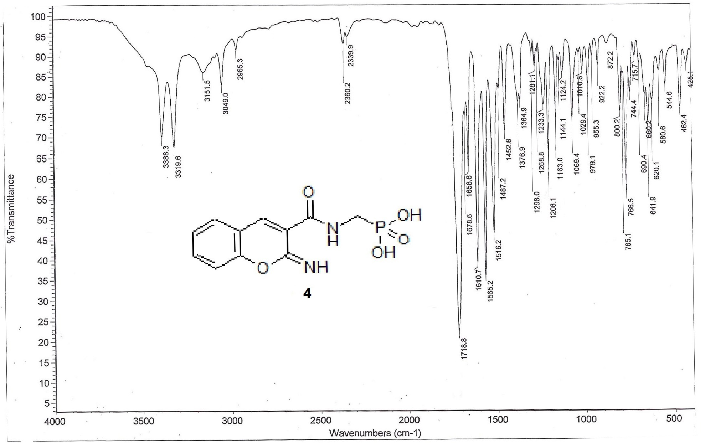
Figure 1. The IR spectrum of compound 4.
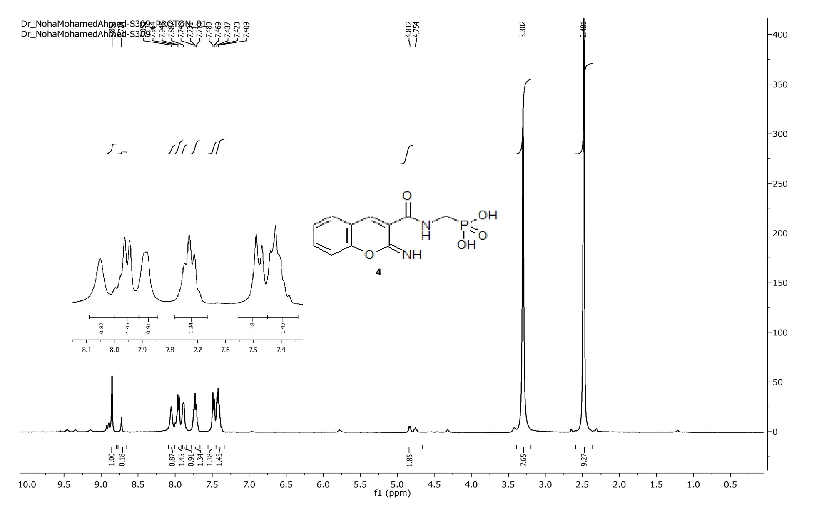
Figure 2. The ¹H-NMR spectrum of compound 4.

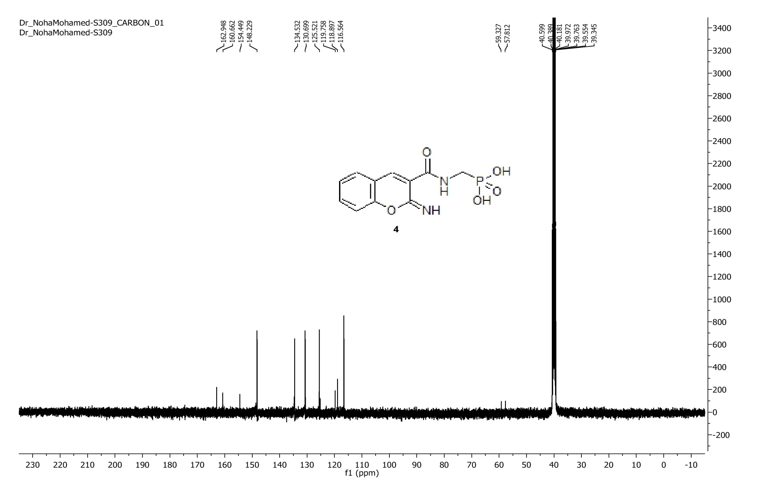
Figure 3. The ¹³C-NMR spectrum of compound 4.

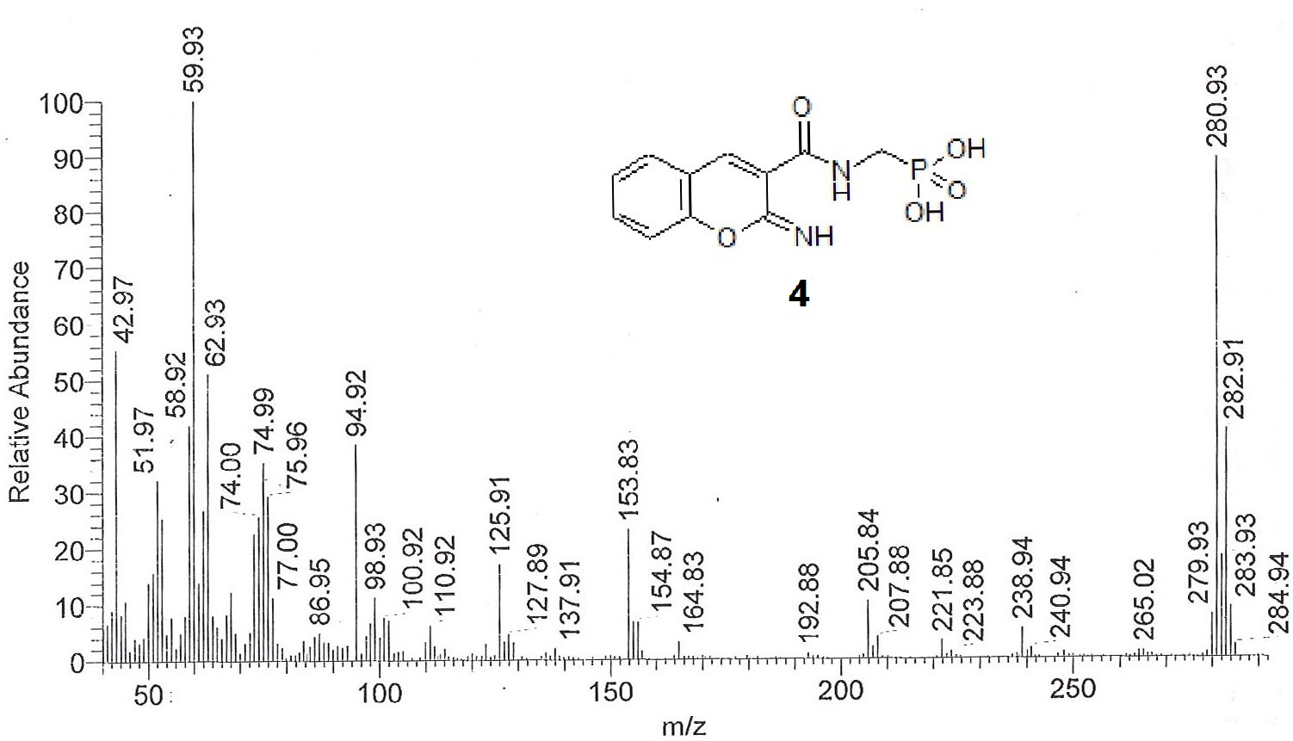
Figure 4. The mass spectrum of compound 4.

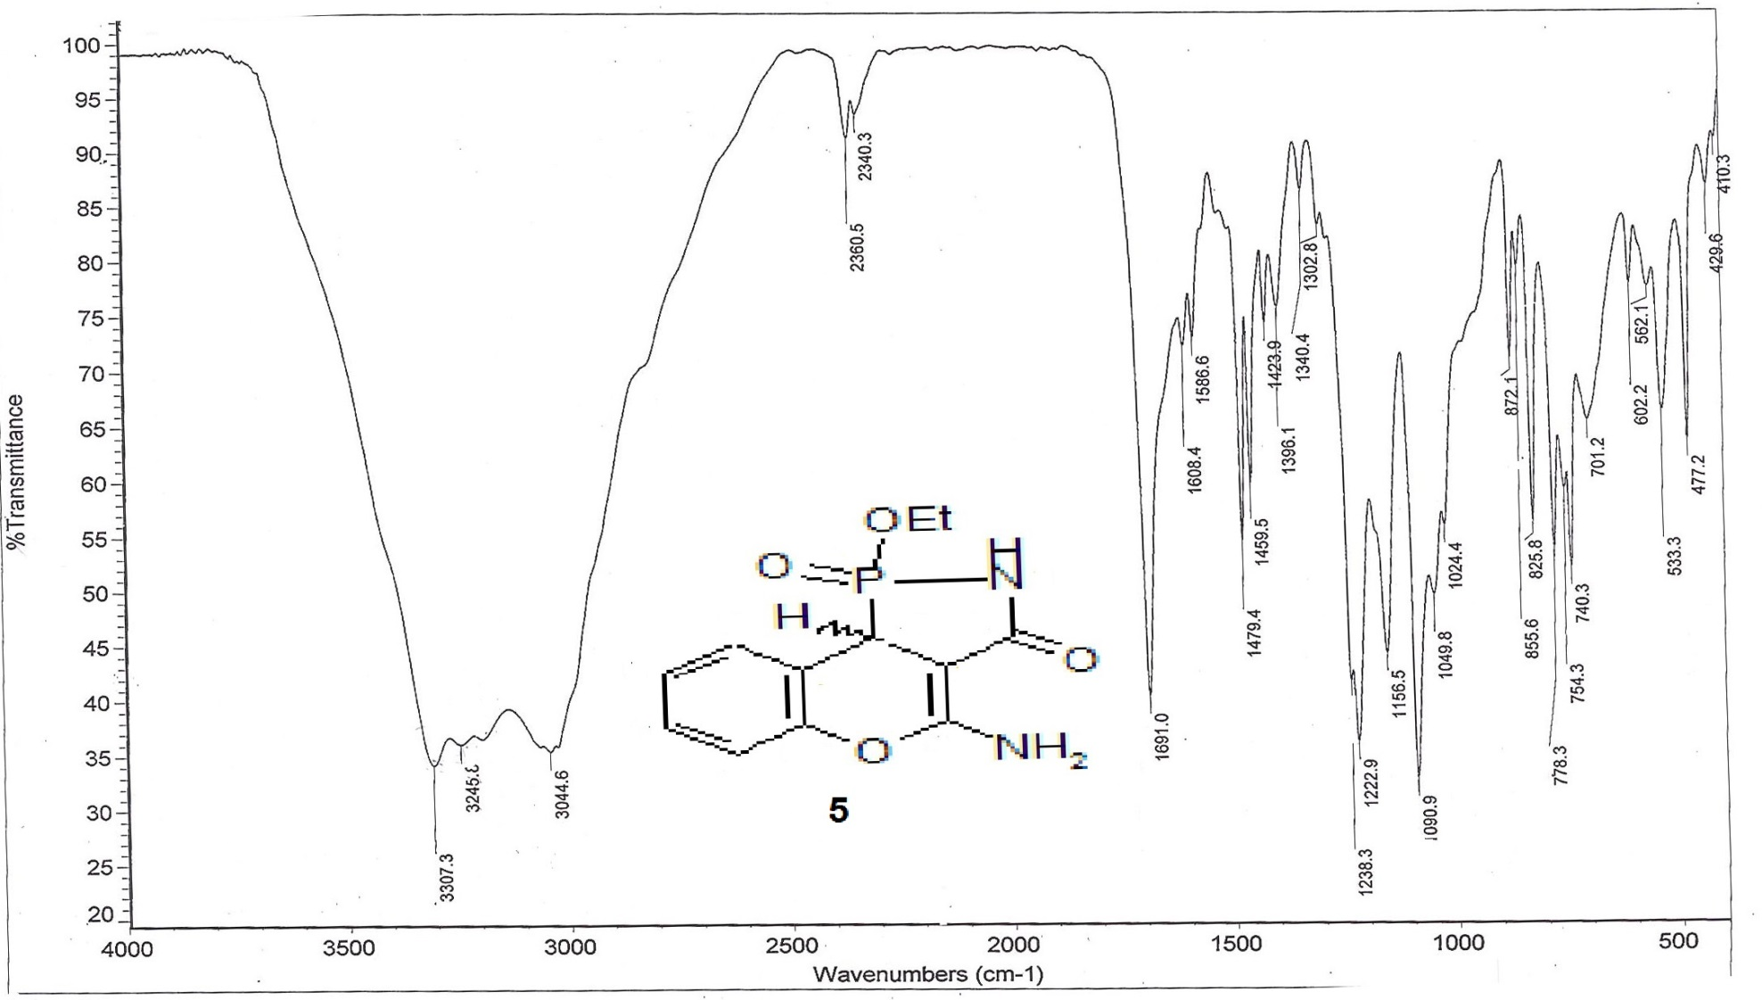
Figure 5. The IR spectrum of compound 5.

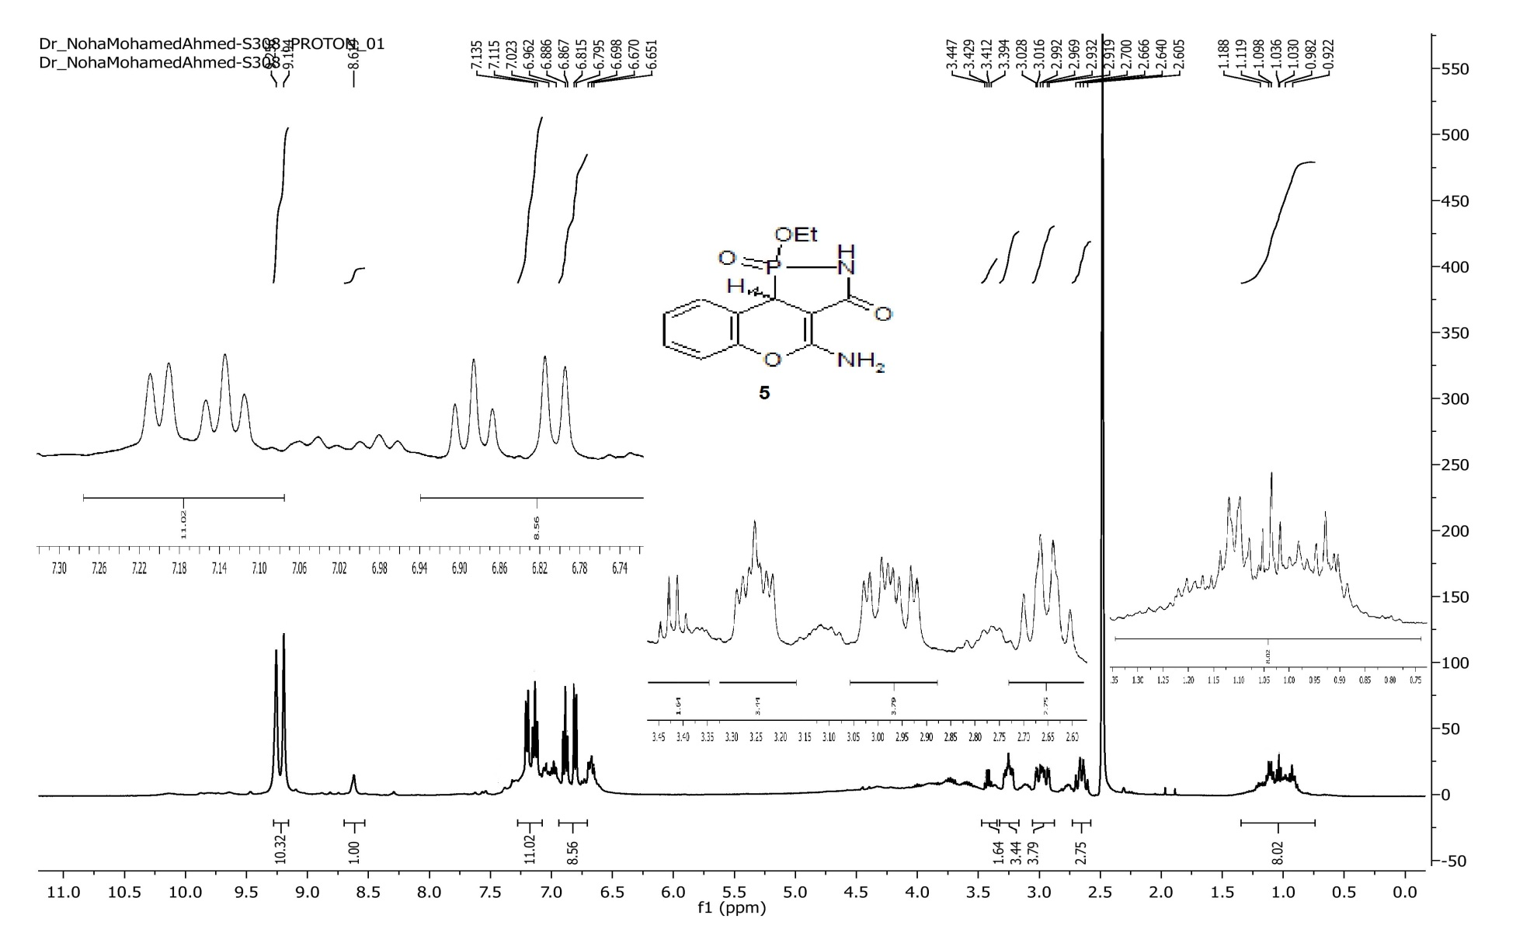
Figure 6. The ¹H-NMR spectrum of compound 5.

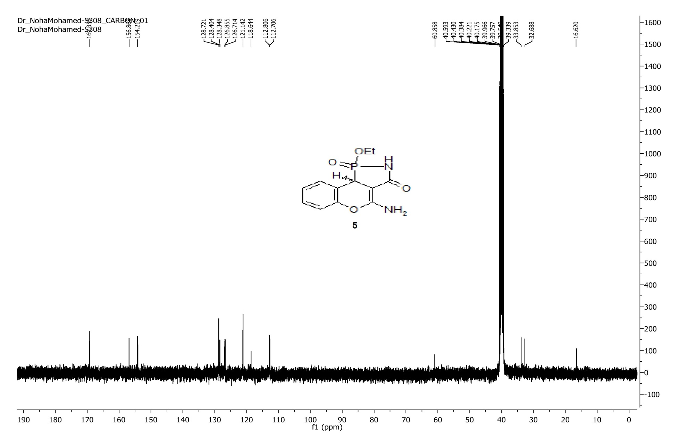
Figure 7. The ¹³C-NMR spectrum of compound 5.

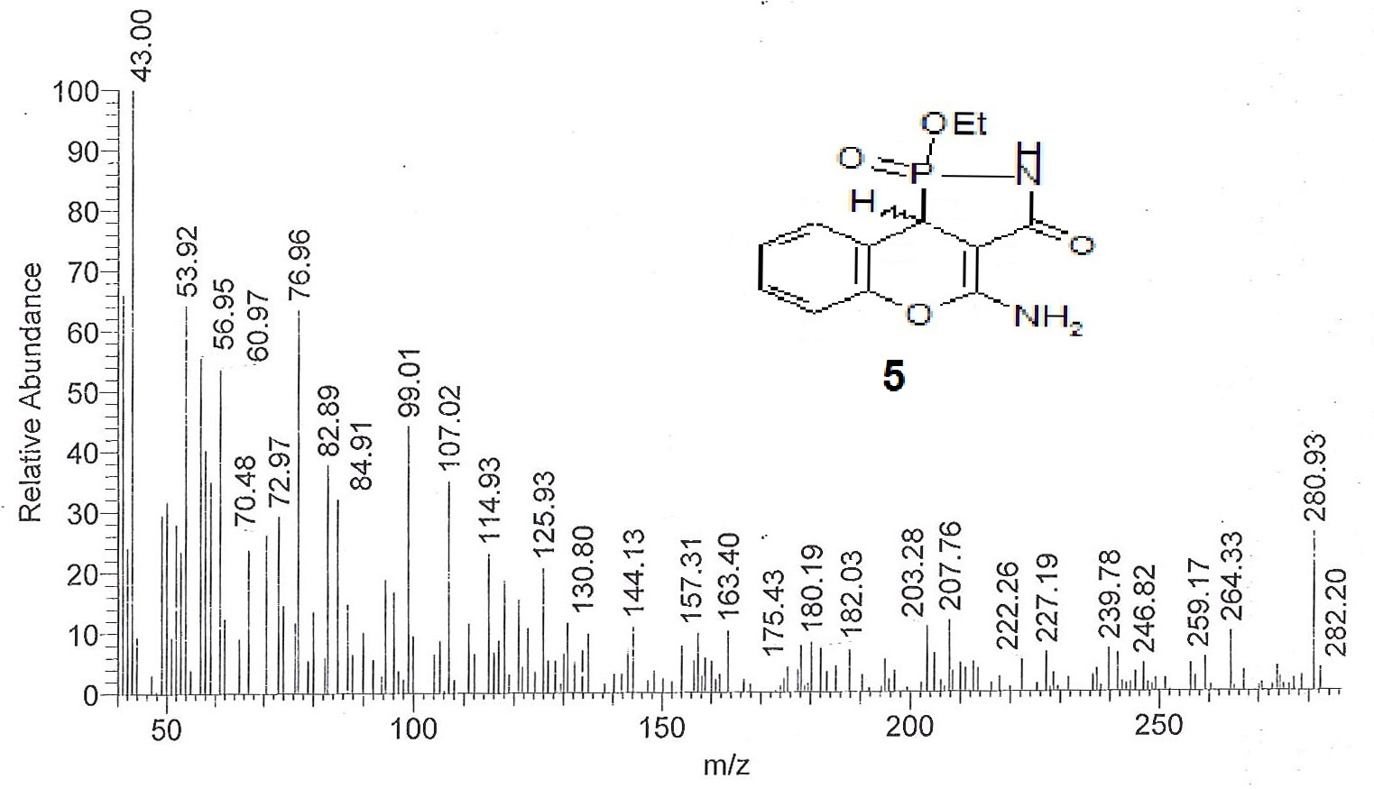
Figure 8. The mass spectrum of compound 5.

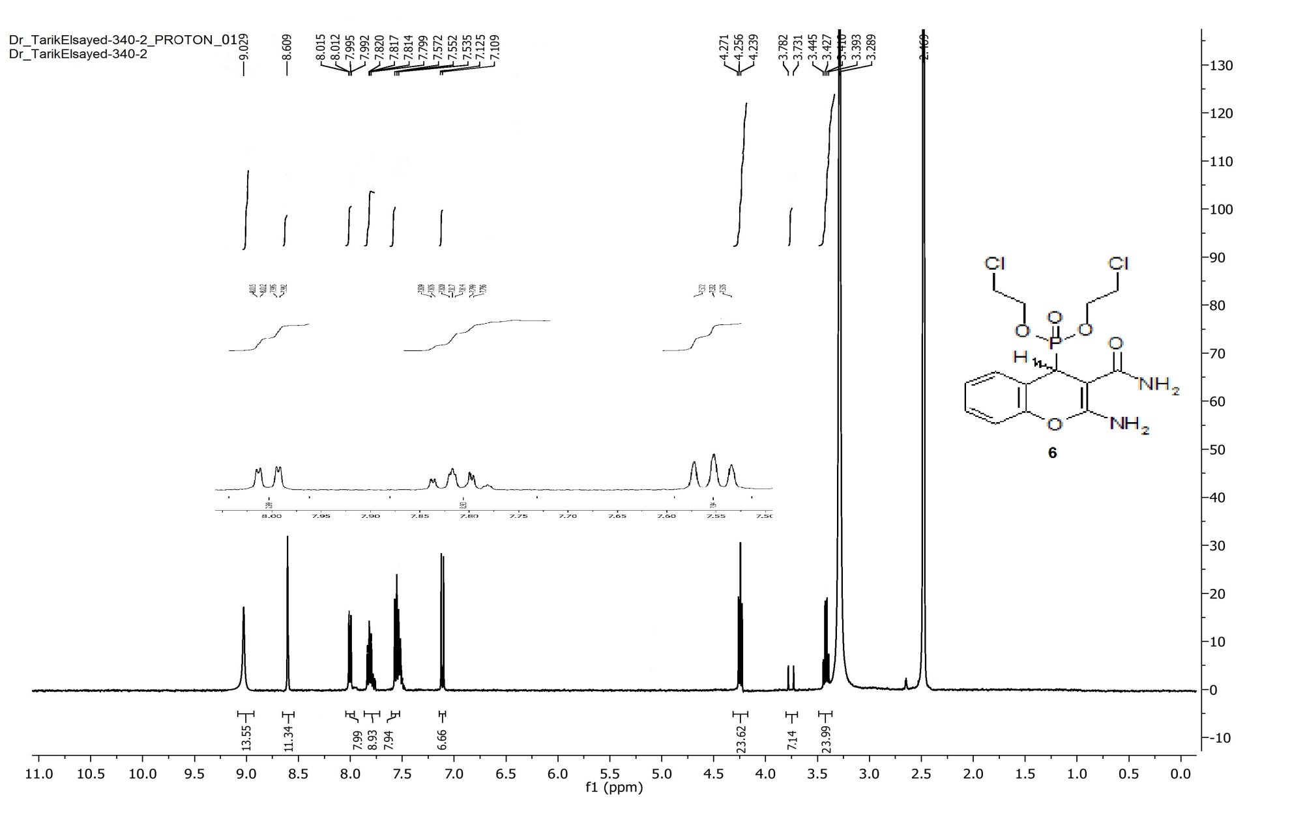
Figure 9. The ¹H-NMR spectrum of compound 6.

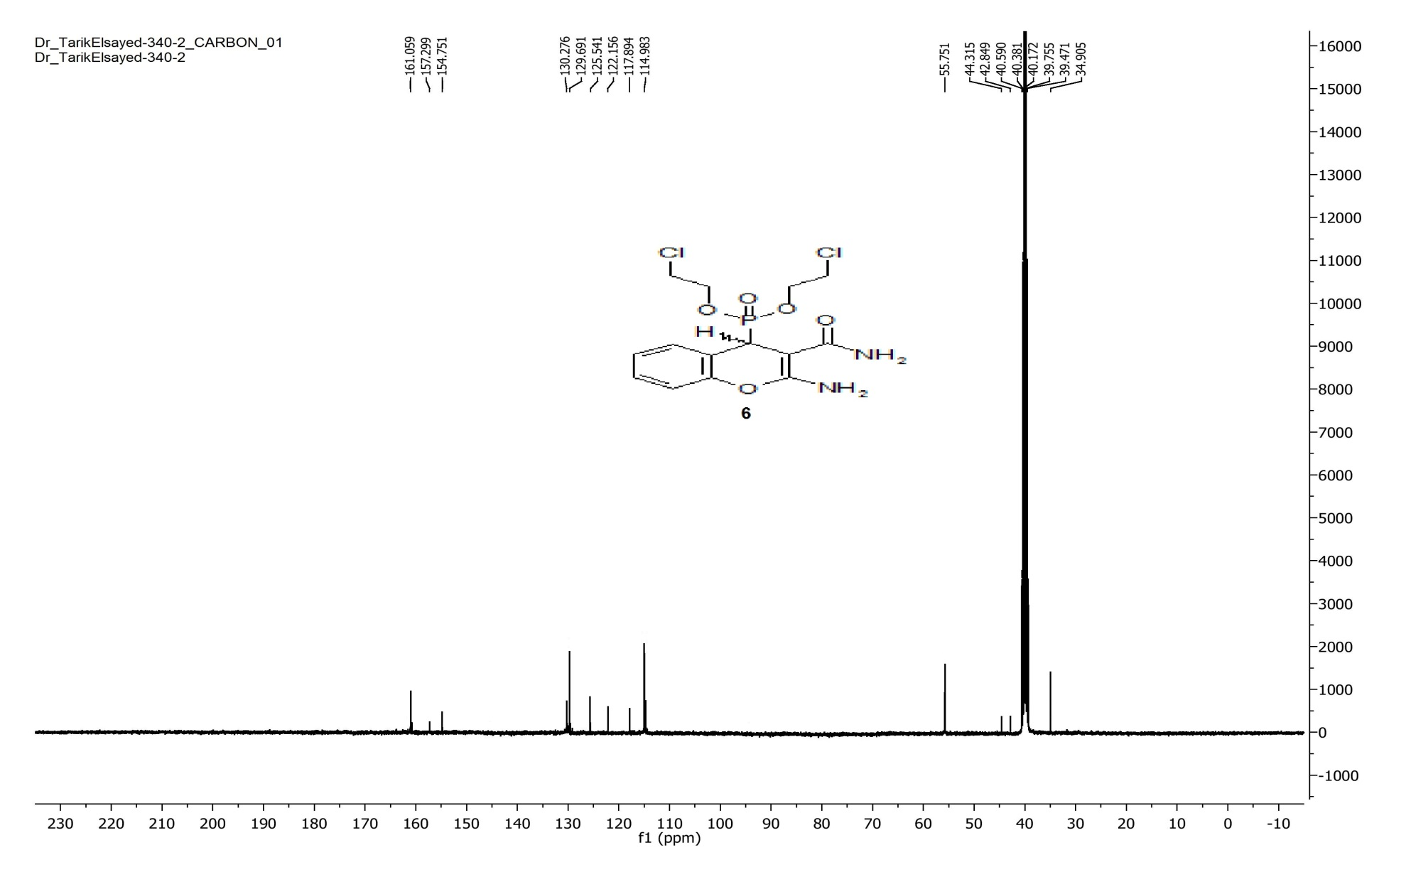
Figure 10. The ¹³C-NMR spectrum of compound 6.

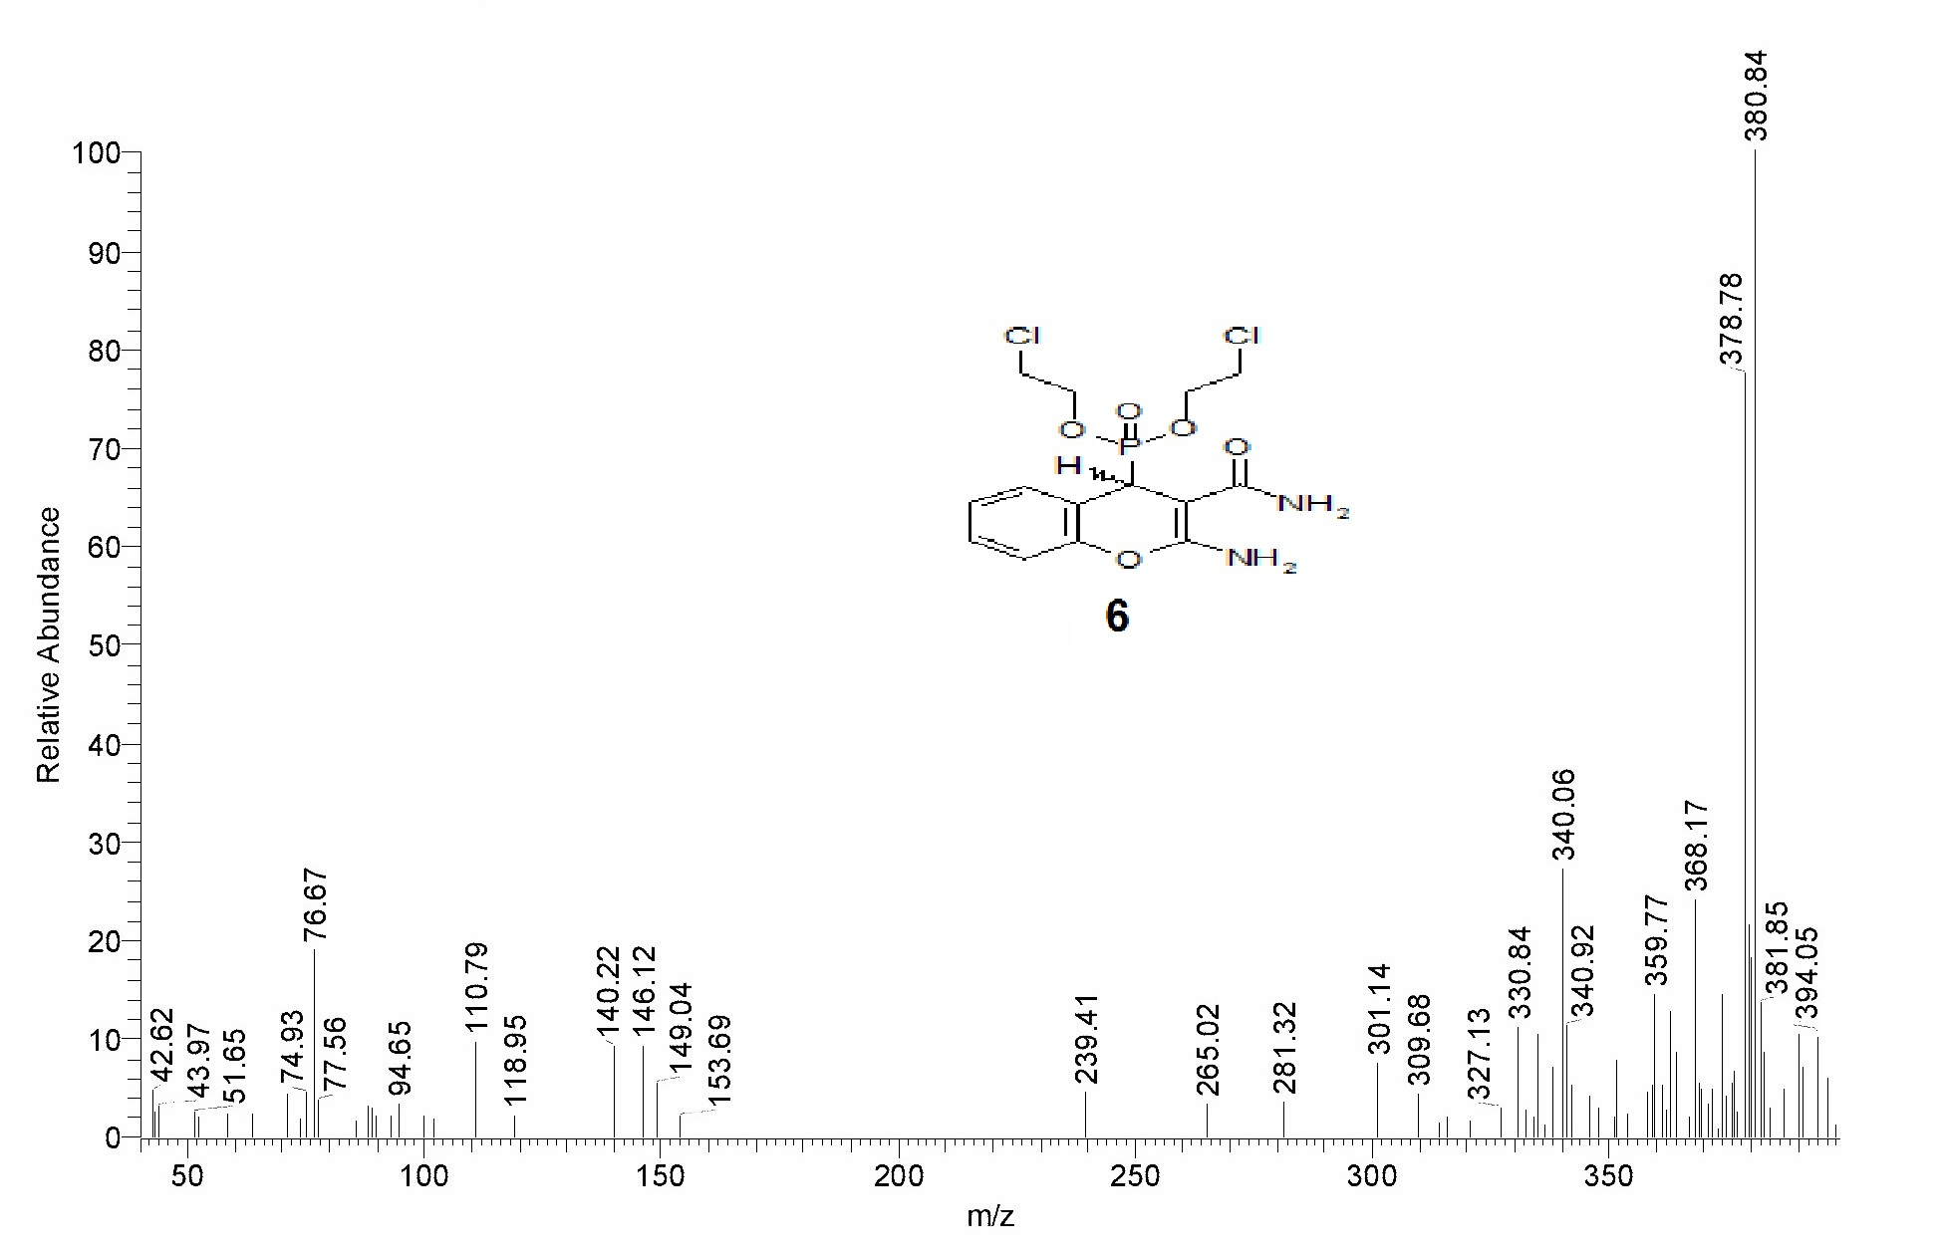
Figure 11. The mass spectrum of compound 6.

Figure 12. The IR spectrum of compound 7.

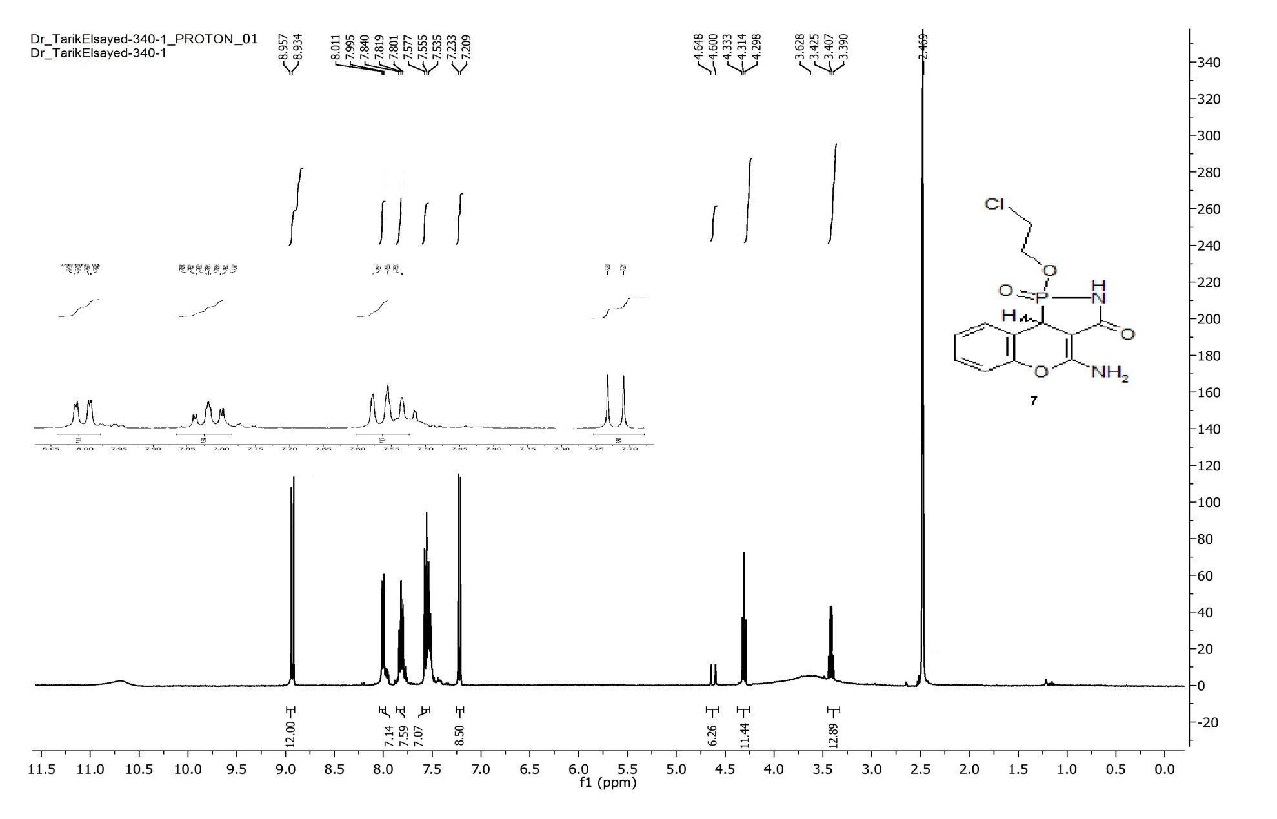
Figure 13. The ¹H-NMR spectrum of compound 7.

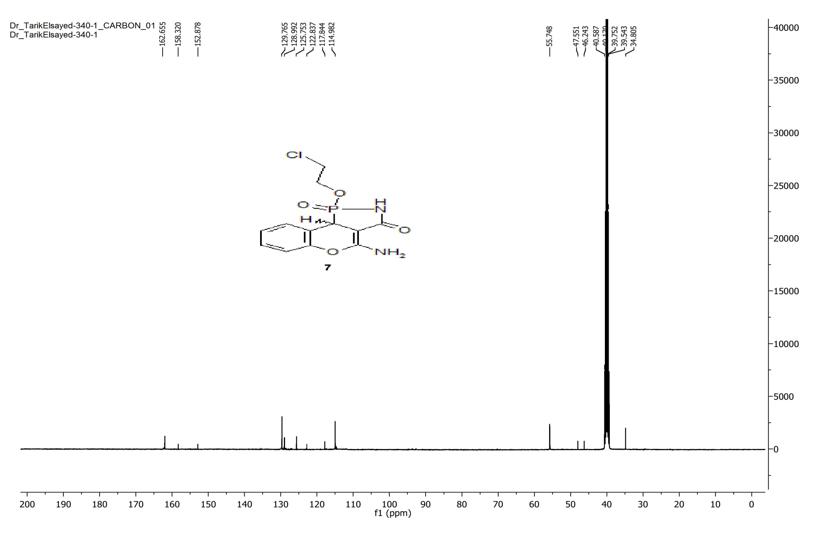
Figure 14. The ¹³C-NMR spectrum of compound 7.

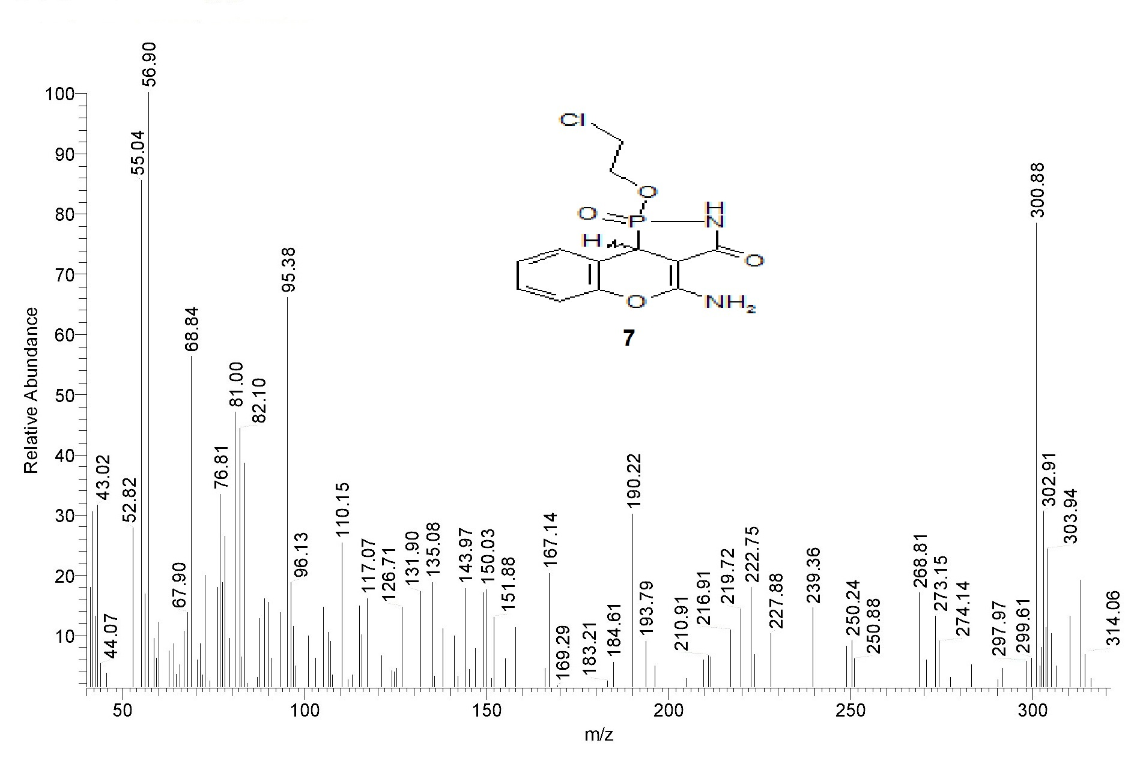
Figure 15. The mass spectrum of compound 7.

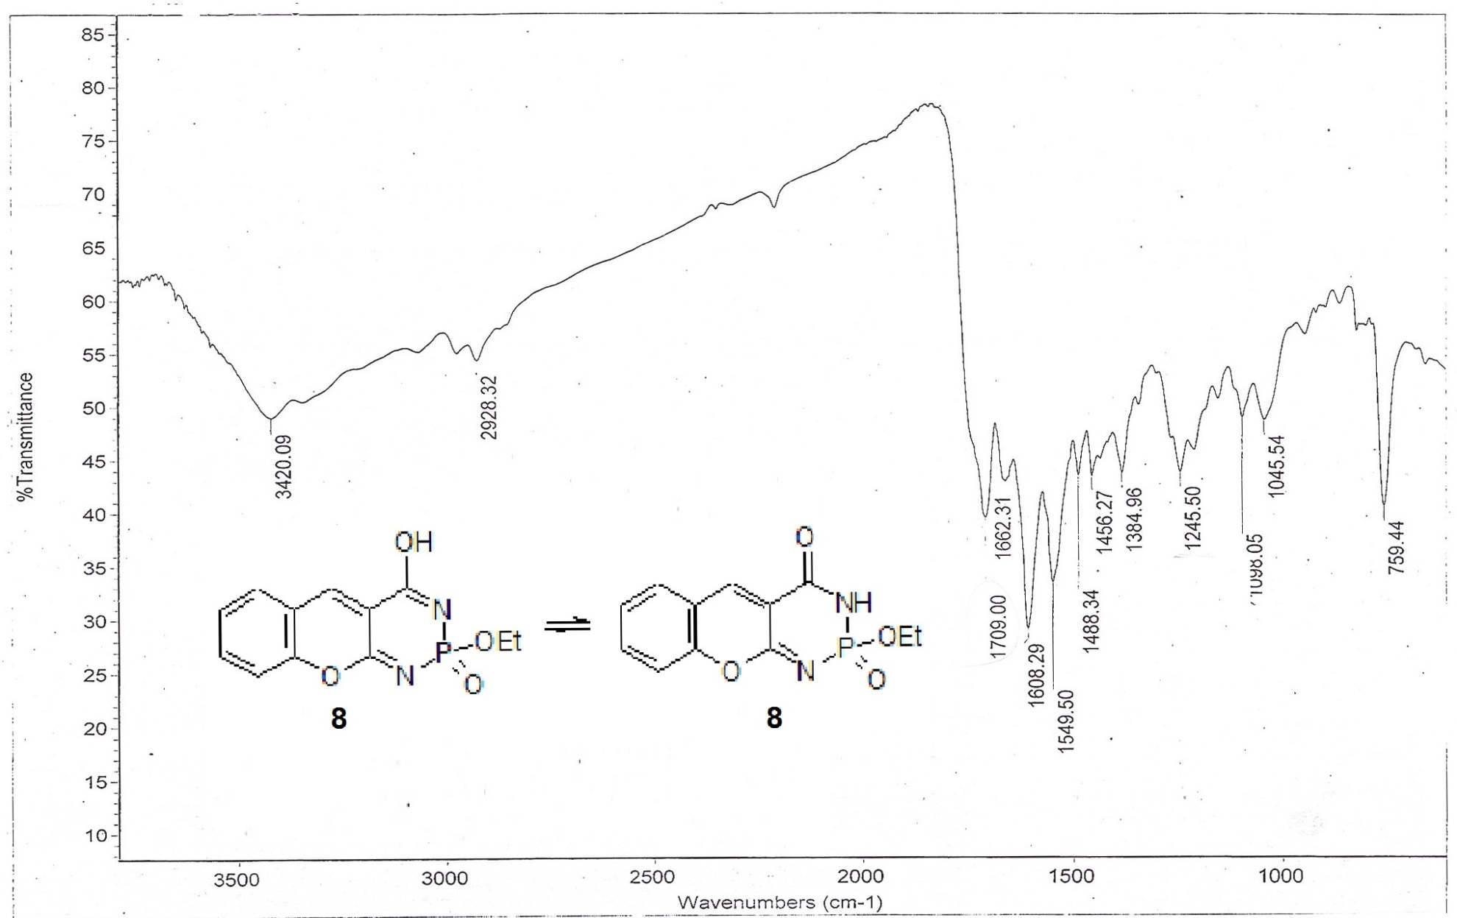
Figure 16. The IR spectrum of compound 8.

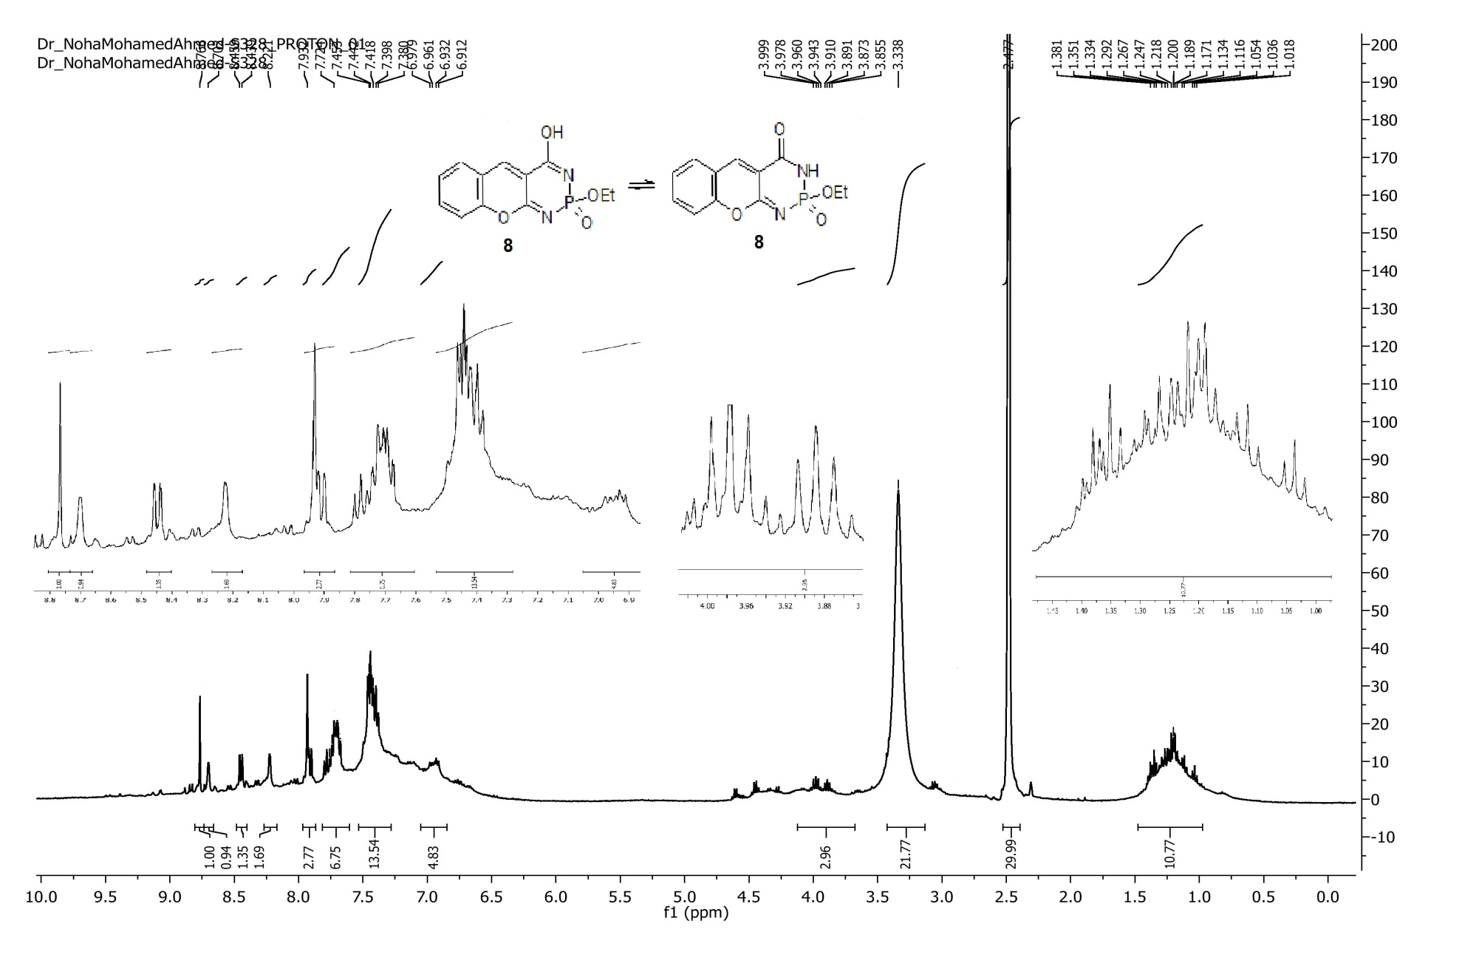
Figure 17. The ¹H-NMR spectrum of compound 8.
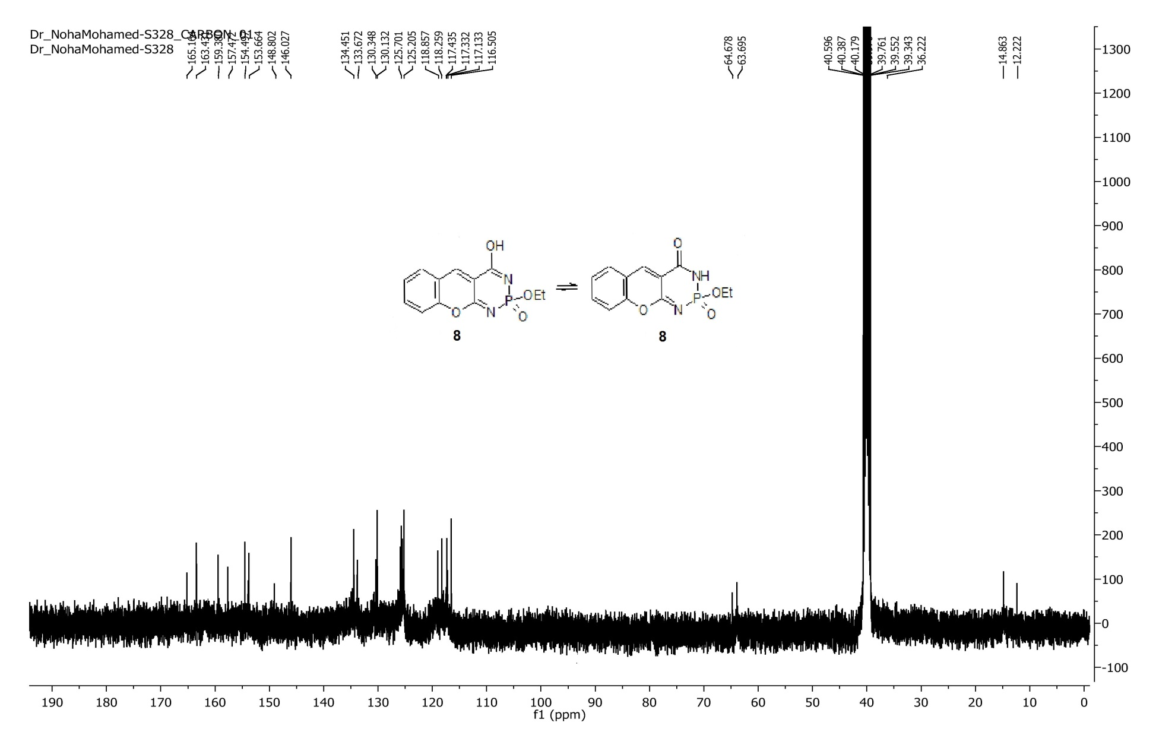
Figure 18. The ¹³C-NMR spectrum of compound 8.

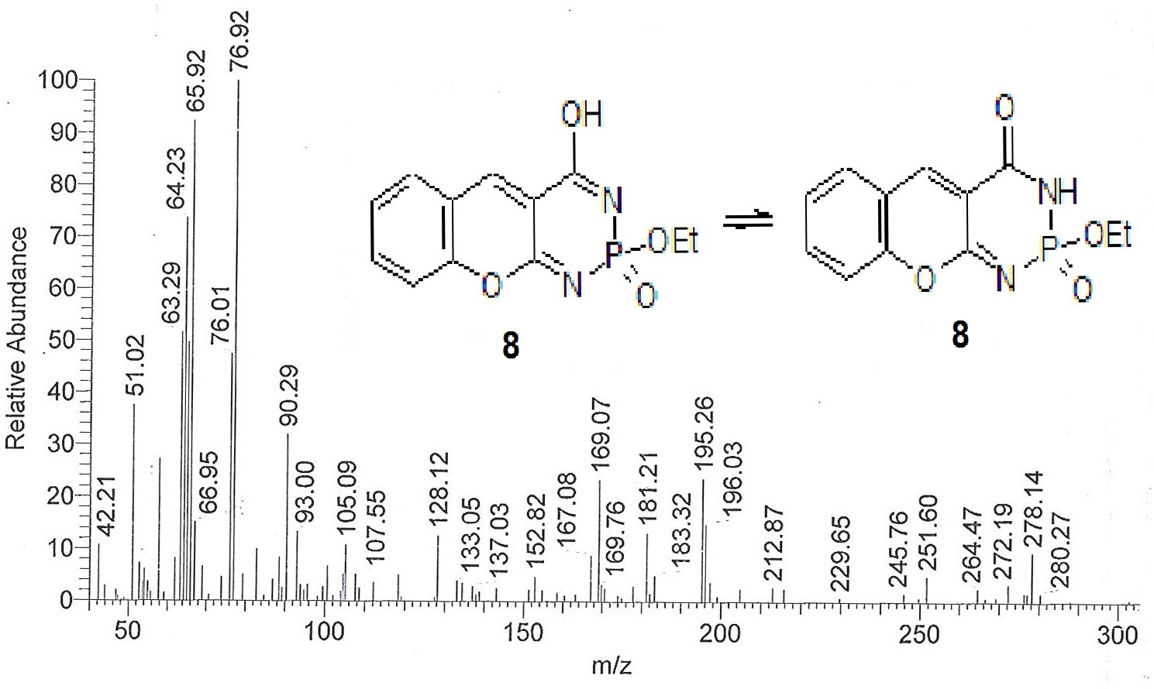
Figure 19. The mass spectrum of compound 8.

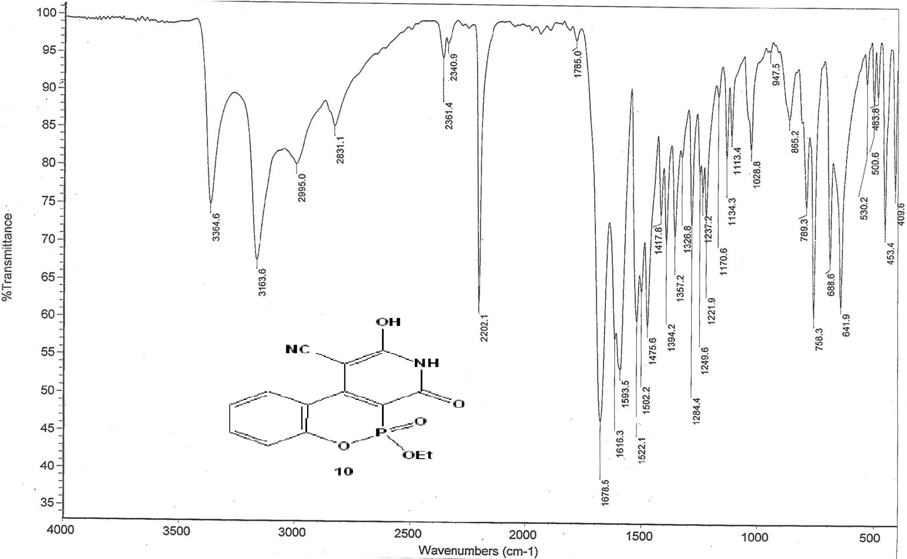
Figure 20. The IR spectrum of compound 10.
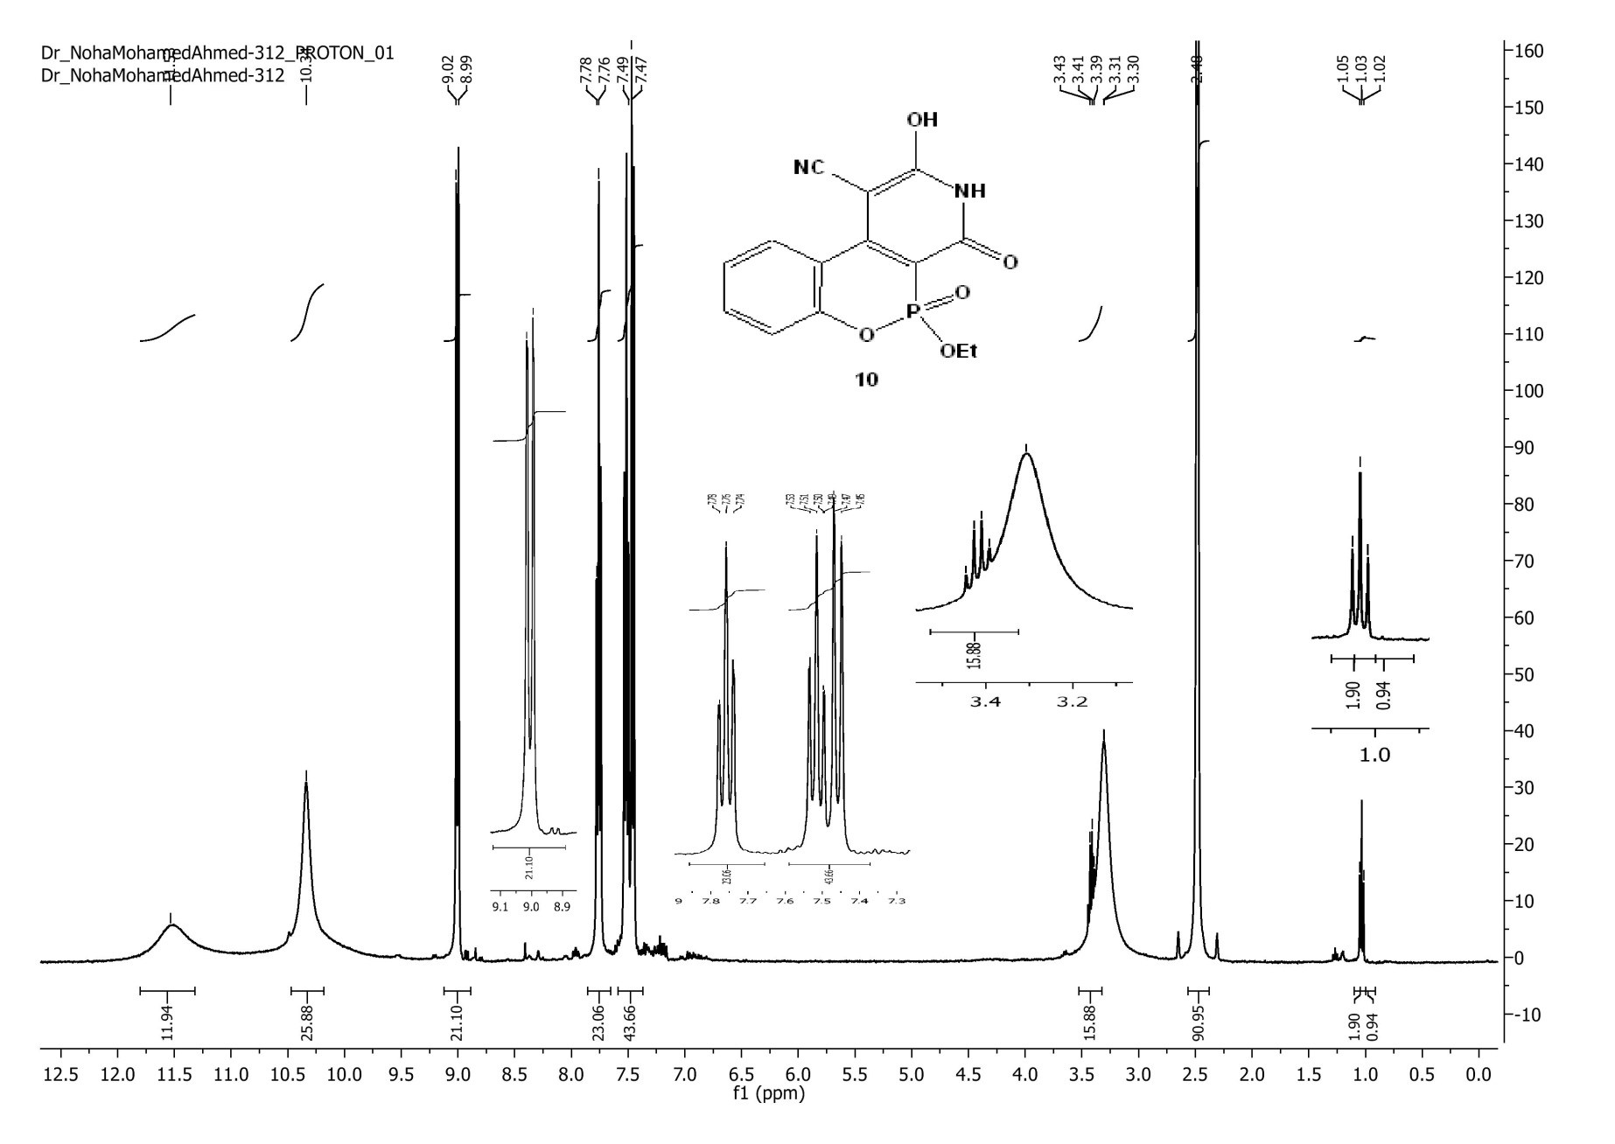
Figure 21. The ¹H-NMR spectrum of compound 10.

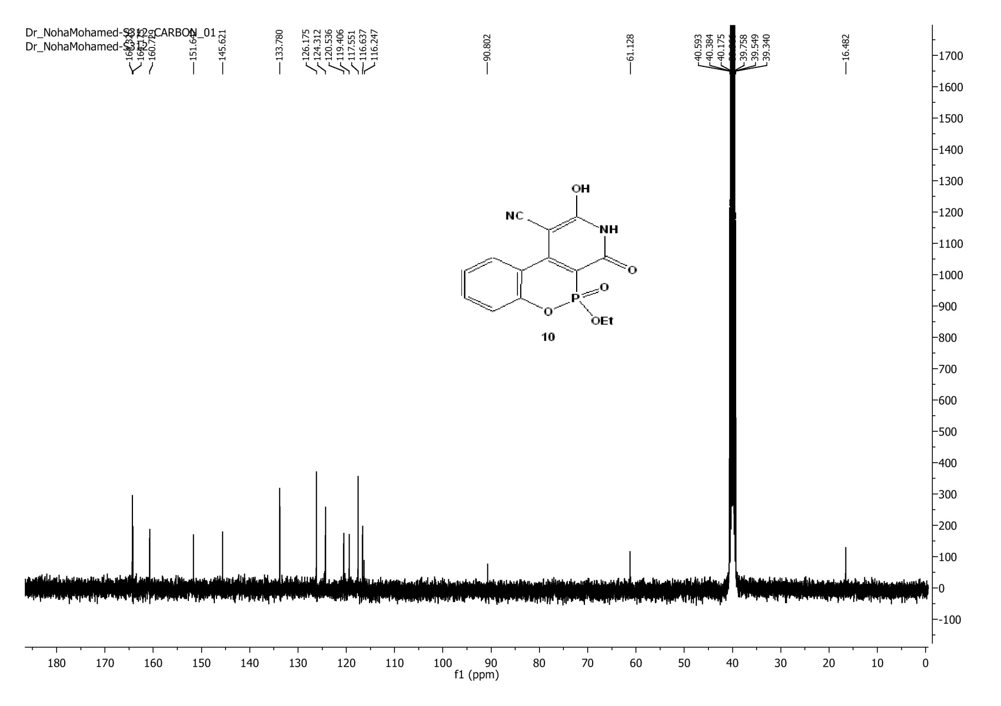
Figure 22. The ¹³C-NMR spectrum of compound 10.

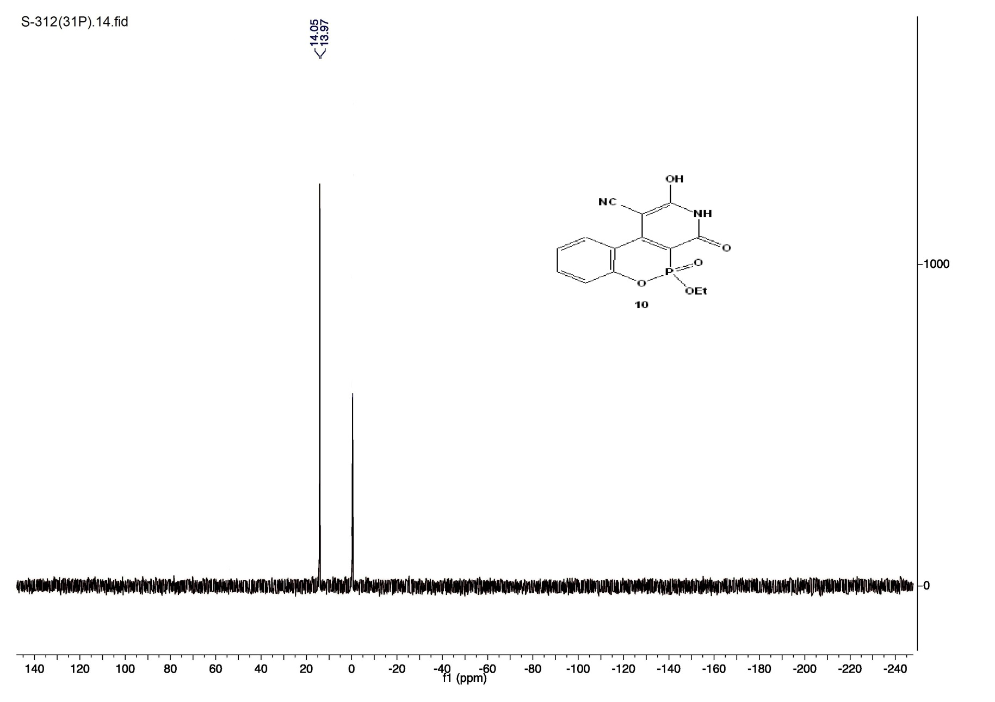
Figure 23. The ³¹P-NMR spectrum of compound 10.

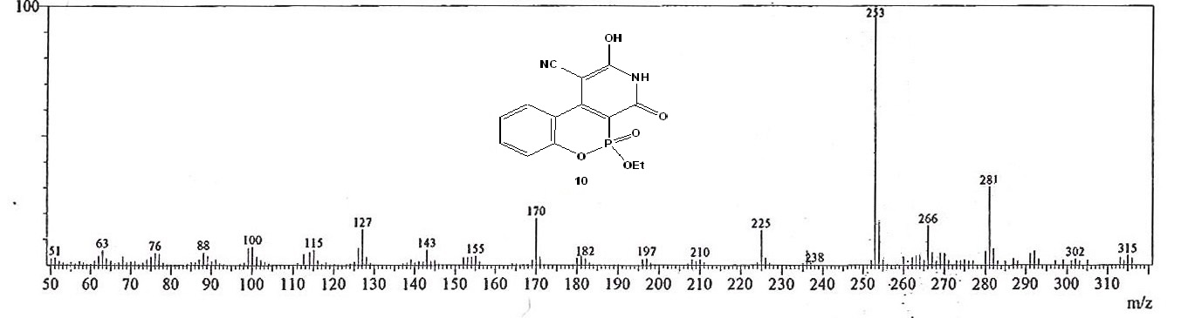
Figure 24. The mass spectrum of compound 10.

