Supplement Figure

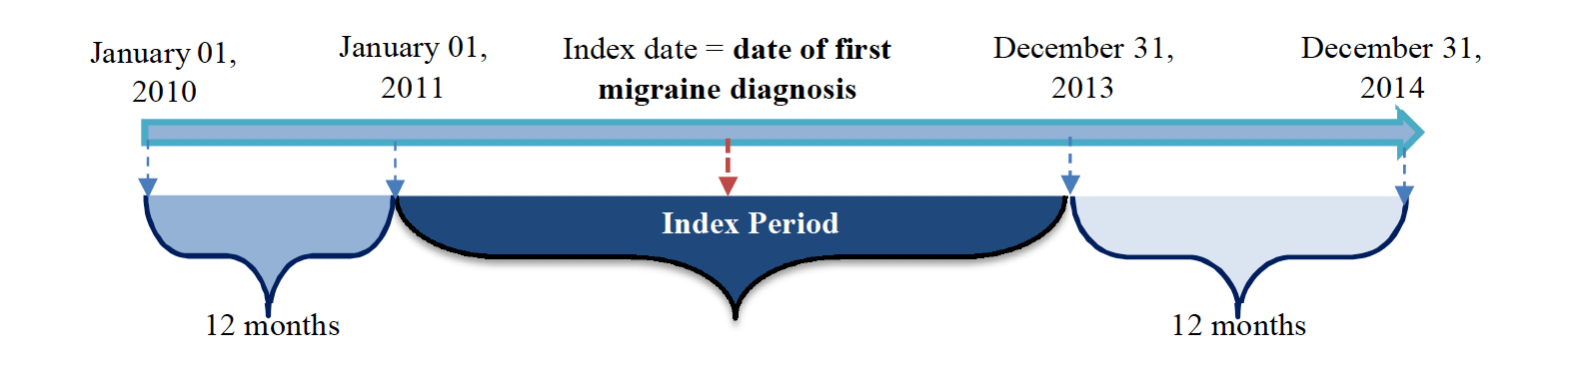

Supplement Figure Legend
Time period for patient selection. Source: 2016-4087--Truven Migraine Protocol FINAL page 12.

