**Supplemental Material**

This supplemental material document includes an illustrative example from simulated data and their results (previously Sections 6 and 8 in the original manuscript). As recomended by the associate editor to move some sections to the appendix, we decided to move this portion.

***1. Example from Simulated Data-Methods***

To test and illustrate all the methods proposed earlier, we first consider an illustrative example using simulated data with an antagonistic effect scenario between the stressors. The data for this scenario have four endpoints, three of them are resulting from continuous measurements ($y_{1}$*, $y_{2}$, $y_{3}$* ), and $y_{4}$ is resulting from a binomial experiment, with exposure to two stressors *x1* and *x2*, and a total of n = 40 observations.

The data is used to illustrate the following proposed methods:

* Benchmark Dose tolerable Region evaluated at the estimated median.
* Benchmark Dose tolerable Region evaluated using all MCMC samples.
* Endpoints probabilities calculation.

For this scenario, the following model is proposed:

$Y_{i}=\left(\begin{aligned}y_{1i} \\ y_{2i} \\ y_{3i} \\ y_{4i}\end{aligned}\right)\sim \left(\begin{aligned}N\left(exp⁡(β_{10}+β_{11}x_{1i}+β_{12}x_{2i}+β_{13}x_{1i}x_{2i}+r_{i}), σ_{1}^{2}\right) \\ N\left(exp⁡(β_{20}+β_{21}x_{1i}+β_{22}x_{2i}+β_{23}x_{1i}x_{2i}+r_{i}), σ_{2}^{2}\right) \\ N\left(exp⁡(β_{30}+β_{31}x_{1i}+β_{32}x_{2i}+β_{33}x_{1i}x_{2i}+r_{i}), σ_{3}^{2}\right) \\ Binom\left(n_{i},\frac{1}{1+ exp⁡(β_{40}+β_{41}x_{1i}+β_{42}x_{2i}+β_{43}x_{1i}x_{2i}+r_{i})}\right)\end{aligned}\right), i=1, 2, …,n,$ (1)

such that

* $y_{ji}$: response of the *ith* subject on the *jth* endpoint for *j =1, 2, 3 , 4,*
* $β={\left(β_{1}^{T}, β_{2}^{T},β_{3}^{T},β_{4}^{T}\right)}^{T}:$ the vector of parameters corresponding to the *jth* endpoint, *j = 1,2,3,4,*
* ***X =*** *($x_{1}$*, $x_{2}$*, $x_{1}x_{2}$* ): represents the two stressors and their interaction,
* *ri*: a random effect termfor the *ith* subject to capture within subject effect across endpoints.

The following prior distributions are specified as follows:

***β*** *~ N (****μ****,* ***Ω****),*

***μ*** *~ N* (0, 100**I**16*),*

***Ω*** *~ Wishart* (**I**16, 16),(2)

*σj ~ Gamma* (1, 1),

*ri ~ N(0, ϖ2),*

*ϖ2 ~ Gamma* (1, 1),

where **I**16 is a 16×16 identity matrix.

To compute the conditional distribution of the unknown parameters given the observed data, or what is known as the posterior distribution, the likelihood-prior specification is used, where *Posterior  likelihood x Prior.*As a result of this formulation in (40) and (41), the posterior distribution is obtained as follows:

$$P\left(β,Ω,μ,σ|D\right)∝\exp\left\{-\sum_{j=1}^{3}{σ_{j}^{2}}\right\}×exp\left\{-\frac{1}{200}\sum_{j=1}^{4}{μ_{j}^{2}}\right\}$$

$× ϖ^{-1} ×exp\left\{-\frac{1}{{2ϖ}^{2}}\sum_{i=1}^{n}{r_{i}^{2}}\right\}exp\left\{{-ϖ}^{2}\right\}$

${× \left|Ω\right|}^{-\frac{1}{2}}exp\left\{-\frac{1}{2}\sum_{i=1}^{n}{{\left(β-μ\right)}^{T}}Ω^{-1}\left(β-μ\right)\right\}$ (3)

$× \prod_{i=1}^{n}{\left(\begin{matrix}n_{i} \\ y_{4i}\end{matrix}\right)}{\left(\left(1+\exp{{\left\{x_{i}^{T}β_{4}+\right\}}^{-1}}\right)\right)}^{y_{4i}}$

${×\left(1-\left(1+\exp{{\left\{x_{i}^{T}β_{4}+ r_{i}\right\}}^{-1}}\right)\right)}^{n_{i}-y_{4i}}$

$× {\left(2^{72}π^{44} \prod_{i=1}^{16}{Γ\left(\frac{13-i}{2}\right)}\right)}^{-1}$

${ × \left|I_{16}\right|}^{-6}{\left|Ω\right|}^{-\frac{1}{2}}\exp\left\{-\frac{1}{2}tr\left(Ω\right)\right\}×{\left(\prod_{j=1}^{3}{σ_{j}^{2}}\right)}^{-\frac{n}{2}}$

$× exp\left\{-\frac{1}{2}\sum_{i=1}^{n}{\sum_{j=1}^{4}{σ_{j}^{-2}}{(y}_{ji}}{-\exp\left\{\left\{x_{i}^{T}β_{4}+ r_{i}\right\}\right)}^{2}\right\} .$

### *2. Computation and Results-Illustrative Example Using Simulated Data*

In this section, we present the results of the methods applied to the simulated data presented and described in Section 6. For the computation process for the model, OpenBugs was used to generate five chains of 11000 MCMC samples from the posterior distribution specified in (42). The convergence of the chains was verified through the detection of the trace plots-plots of the iteration number against the value of the draw of the parameter at each iteration- where the five chains had good mixing. Moreover, the value of - the potential scale reduction parameter- is verified to be less than 1.006 for all parameters (Table 1), emphasizing thus the convergence of the parameters for the model.

The detection of the trace plots indicated that the first 1000 samples needed to be discarded from each chain and treated as burn-in samples. To reduce autocorrelation between the samples the remaining 10,000 samples from each chain were thinned by 10 in each of the scenarios. As a result, 1000 samples were remaining from each chain, yielding a total of M = 5000 samples from the posterior distribution and were thus used in the final analysis.

For this scenario, Table 1 shows the true values for the parameters $β_{j}={(β}_{j0},β_{j1},β_{j2}, β_{j3}$), *j = 1, 2, 3 and 4,* along with the 2.5%, 50%, and 97.5% quantiles for each parameter. Notice that the true values of the parameters used originally to generate the data are all captured by the posterior credible intervals, an indication of the feasibility of the model proposed.

Shown in Figure 1 a plot of the four endpoints $y_{1}$*, $y_{2}$, $y_{3}$* , and $y_{4}$ for the simulated data in the stressors’ space, which shows the true BMDTR*η* before applying any method plotted. It is clear that *y1* and *y2* are the only endpoints that define the boundaries of the Benchmark Dose Tolerable region in this scenario, while *y3* and *y4* are outside the boundaries of this region and thus do not contribute to determinning this region.

### *2.1. BMDTR evaluated at the median of the posterior MCMC samples*

We present here the results of applying the approach explained in Subsection 4.2 to the simulated data. For this approach, we use the estimated posterior median reported in Table 1 under the 50th quantile column to evaluate the BMDTR*η* at the median. Recall that any value of *η* can be considered, however for this illustrative example, we set *η* = 50 (i.e. change of $50$% in the response as compared to the control is the acceptable adverse effect) and choose **θ** to be $π/2$ and *u = $π/{180}$* . Such choices will result in 89 pairs of coordinates ${(x_{1}^{*}, x_{2}^{*})}_{(θ)}^{(0.5)}$, (***θ*** = (π⁄180, π⁄90,…, π⁄2) ) which will determine the boundaries of the BMDTR*η,* and by plotting thesecoordinates we can reveal the boundaries of the tolerable region as shown in Figure 2(a) (colored in grey). It is clear that the shape of the BMDTR*η* determined by this method is highly consistent with that of the true BMDTR*η* shown in Figure 1. To verify this, we constructed the plot shown in Figure 2 (b) where we overlay the true region with the one determined by the method using the estimated posterior median. The mechanism of that method allows us as well to check to which endpoints these coordinates belong to and we found that they belong to the two endpoints $y_{1}$ and $y_{2}$ as expected.

2.2. *The BMDTR determined using all M MCMC samples*

Here we apply the method proposed in Subsection 4.3 in the main manuscript to the simulated data example. Recall that this method uses all *M = 5000* *MCMC* samples generated from the posterior distribution (3) to determine the boundaries of the BMDTR*η*. Here, we also set *η* =50,***θ*** = $π/2$ and *u = $π/{180}$* . Shown in Figure 2 (a) (in yellow color) the plot that shows the BMDTR50 determined by this approach. It is clear that the shape of the BMDTR*η* determined by this method is highly consistent with that of the true BMDTR*η* shown in Figure 1. Furthermore, the method detected which endpoints are associated with these coordinates and found that they correspond to the two endpoints ${ y}_{1}$ and ${ y}_{2}$ as expected. This method seems to determine a more conservative region than the previous method that uses the estimated posterior median of the MCMC samples. Thus, by accounting for parameter uncertainties, this method will ensure a safer choice of the BMDTR*η* as compared to the one that relies on the estimated posterior median. Both the median and the all MCMC samples approaches have been tested using several simulated data and the results were always consistent with the findings of this example, i.e., the all M MCMC approach was always leading to a more conservative and narrower region as compared to the medina approach.

Shown in Figure 2(b) the overlay plot for the BMDTRs determined by both methods along with the true BMDTRη for the antagonistic effect scenario arising from the simulated data. Notice that both methods succeeded in capturing the shape of the tolerable region BMDTRη that is clearly embedded within the true region. In addition, the method evaluated using all M = 5000 MCMC samples resulted in a more conservative region as compared to the one evaluated at the median only. This was consistent across all simulated data examples considered to test the method (please see the supplemental material for additional examples).

*2.3. Endpoint probabilities*

Here we show the results of applying the method proposed in Section 5 in the main manuscript for estimating the endpoints probabilities for all *J = 4* endpoints for the antagonistic effect scenario obtained via simulation. The calculations were done using the same set of M = 5000 posterior MCMC samples generated previously. The choices *η* = 50,***θ*** = $π/2$ and *u = $π/{180}$*  were again considered for consistency of the results. Shown in Table 2 the estimated probabilities for all *J = 4* endpoints. Notice that in this scenario the endpoints ${ y}_{1}$ and ${ y}_{2}$ are the ones with the highest probabilities in determining the BMDTRη with probabilities 0.738 and 0.864 for ${ y}_{1}$ and ${ y}_{2}$ respectively (Table 2). On the other hand, the endpoints $y_{3}$ and $y_{4}$ have very low estimated probabilities of 0.026 and 0.008 an indication that these endpoints are not important to determine the boundaries of the BMDTRη. In other words, the endpoints ${ y}_{1}$ and ${ y}_{2}$ are highly affected by the effect of the stressors’ interaction and are thus considered sensitive, while $y_{3}$ and $y_{4}$ are less likely to be affected by stressors’ interaction and are thus non sensitive**.** It is important to notice that each of these endpoint probabilities takes a value between 0 and 1 also recall that these are individual probabilities and they don’t need to sum to 1.

***3. Example from Simulated Data*-Additive Effect Scenario results**

Shown in Figure 3 the results of the methods applied to another simulated example where for the additive effect case (i.e. the interaction term is not significant). It seems that the methods applied succeeded in determining the boundaries of tolerable region in this additive scenario as well.

Table 1. The quantiles of the posterior samples and R for the regression parameters from the simulated data; antagonistic effect scenario. The calculation was based on 5000 posterior samples

|  |  |  |  |  |  |  |  |  |  |
| --- | --- | --- | --- | --- | --- | --- | --- | --- | --- |
| Endpoint | True | | 2.5% | | 50% | 97.5% | Ř n.eff | |  |
| *β10* | | 0 | **-0.223** | | **-0.004** | **0.213** | 1.001 | 5000 | |
| *β11* | | -0.194 | **-0.398** | | **-0.222** | **-0.102** | 1.003 | 1700 | |
| *β12* | | -0.154 | **-0.339** | | **-0.181** | **-0.077** | 1.001 | 5000 | |
| *β13* | | 0.034 | **-0.007** | | **0.037** | **0.077** | 1.005 | 2200 | |
| *β20* | | 0 | **-0.224** | | **-0.004** | **0.221** | 1.001 | 3300 | |
| *β21* | | -0.154 | **-0.324** | | **-0.177** | **-0.073** | 1.003 | 1000 | |
| *β22* | | -0.231 | **-0.457** | | **-0.267** | **-0.132** | 1.002 | 1900 | |
| *β23* | | 0.047 | **0.019** | | **0.053** | **0.093** | 1.004 | 940 | |
| *β30* | | 0 | **-0.212** | | **-0.004** | **0.212** | 1.002 | 2600 | |
| *β31* | | -0.144 | **-0.323** | | **-0.167** | **-0.066** | 1.002 | 2100 | |
| *β32* | | -0.116 | **-0.278** | | **-0.144** | **-0.050** | 1.002 | 2200 | |
| *β33* | | 0.019 | **-0.021** | | **0.022** | **0.060** | 1.004 | 890 | |
| *β40* | | 0 | **-0.327** | | **-0.008** | **0.318** | 1.003 | 1300 | |
| *β41* | | -5.71e-04 | | **-0.142** | **-0.041** | **0.059** | 1.002 | 2200 | |
| *β42* | | -5.00 e-04 | | **-0.191** | **-0.086** | **0.009** | 1.003 | 1200 | |
| *β43* | | 5.10 e-04 | | **-0.003** | **0.024** | **0.052** | 1.002 | 1900 | |

Table.2. Estimated endpoint probabilities for *η* = 50,simulated data example

|  |
| --- |
| Effect Antagonistic |
| Endpoint $P_{j}$ |
| $y_{1}$ 0.738 |
| $y_{2}$ 0.864 $y_{3}$ 0.026 ${ y}_{4}$ 0.008 |

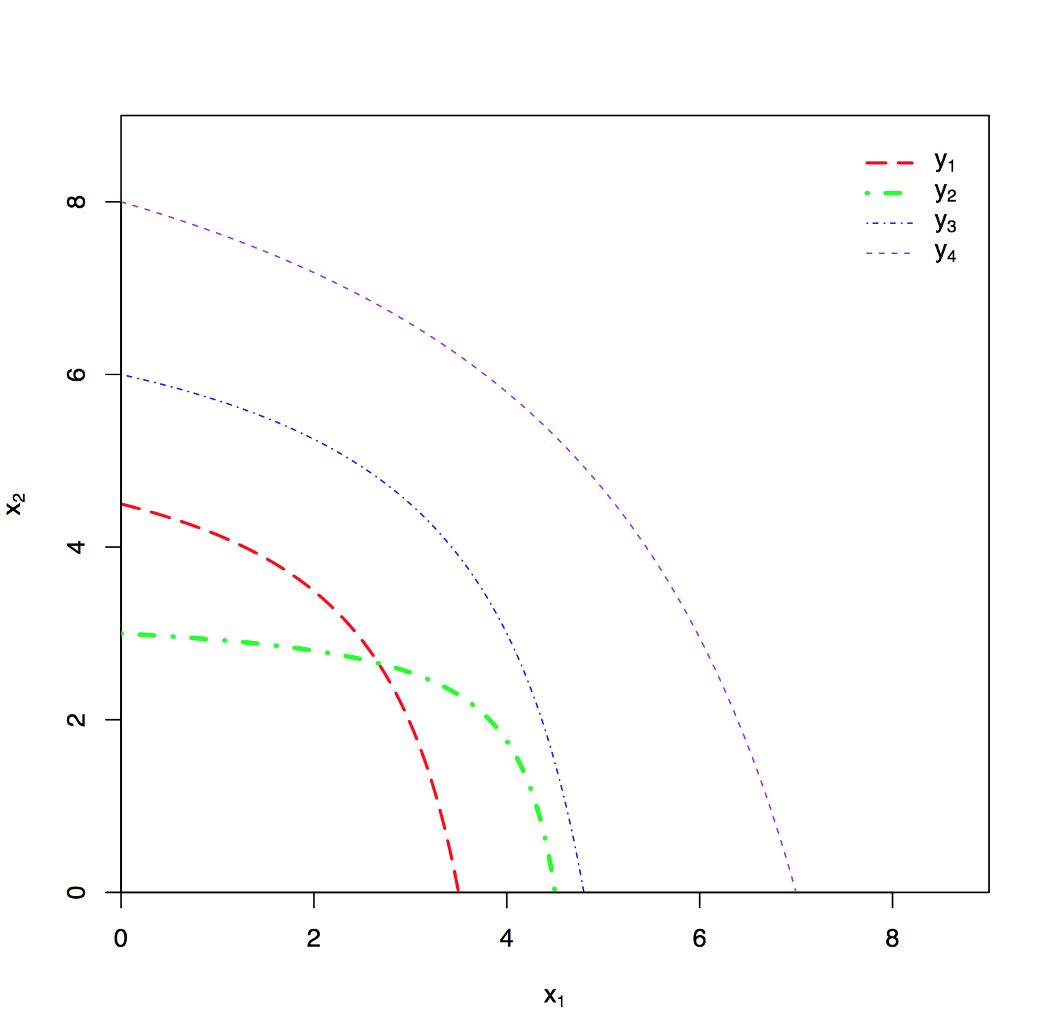

Figure 1. Plot of the true BMDTR*η* where the two endpoints y1 (red) and y2 (green) determine the benchmark dose tolerable region. Simulated Data Example with Antagonistic Effect.

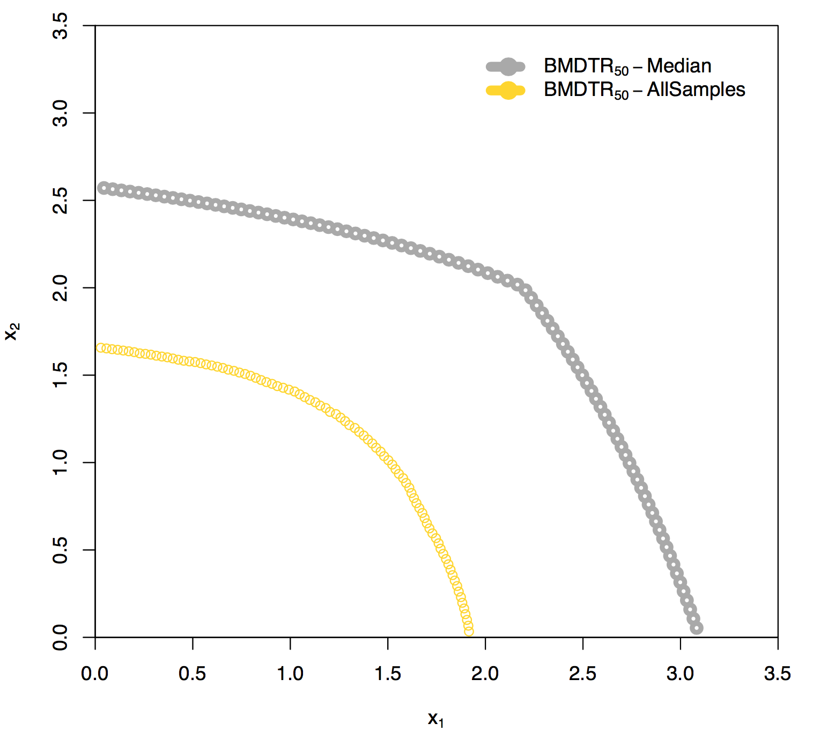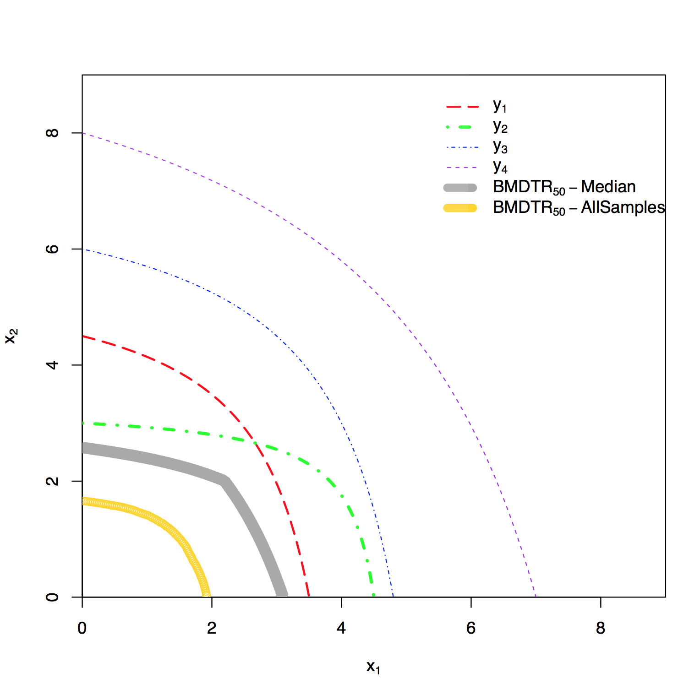Figure. 2 (a) The Overlaid BMDTRη evaluated using the posterior median (grey) and BMDTRη evaluated using all MCMC samples (yellow) and (b) Overlaid BMDTRη with the true BMDTRη-Antagonistic Effect Scenario from simulated data.

** **

Figure 3. (a) The Overlaid BMDTRη based on median sample and BMDTRη determined using all MCMC samples and (b) Overlaid BMDTRη with the true BMDTRη