SUPPORTING DATA

Adsorptive potential of Zea Mays tassel activated carbon towards the removal of metformin hydrochloride from pharmaceutical effluent

Menala Kalumpha^{a,b}, Upenyu Guyo^{a*}, Ngceboyakwethu P. Zinyamaª, Benias C. Nyamunda^{b}, Felistus Muhle Vakirai^{c}

ªDepartment of Chemical Technology, Midlands State University, Private Bag 9055, Senga, Gweru, Zimbabwe.

^{b}Department of Chemical and Processing Engineering, Manicaland State University of Applied Sciences, Private Bag 7001, Off-Vumba Road, Mutare, Zimbabwe.

^{c}Plus Five Pharmaceutical Pvt Ltd, 17181 Nketa Drive, Kelvin West, Bulawayo, Zimbabwe

*Corresponding author: Email upguyo@gmail.com, phone: +263 542 60464, fax: +263 542 60303

Figures:

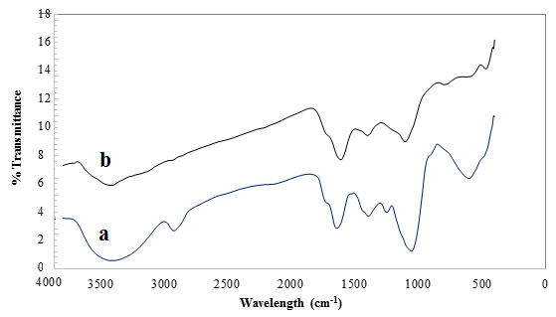
Fig. S1. FTIR spectra of Zea Mays tassel activated carbon before adsorption (a) and Zea Mays tassel activated carbon after adsorption (b).

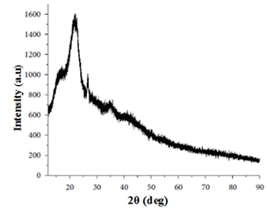
Fig. S2. XRD spectrum of Zea Mays tassel activated

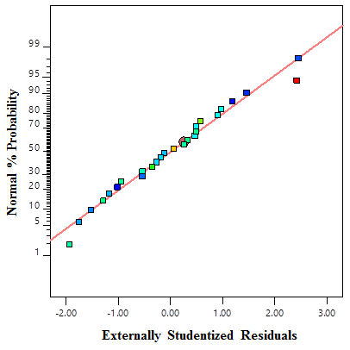
(a)
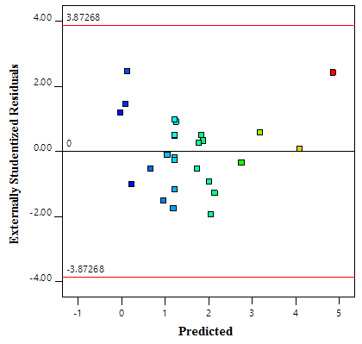
(b)
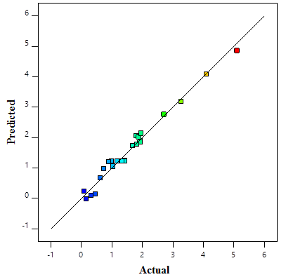
(c)
Fig. S3. Normal probability plot (a) Plot of standard residuals versus the predicted values (b) Plot of predicted versus actual data (c)

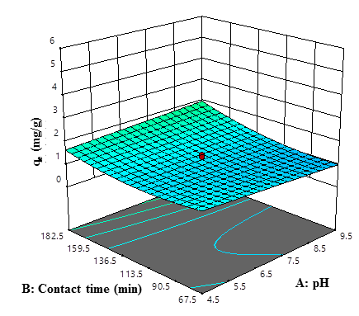
(a)

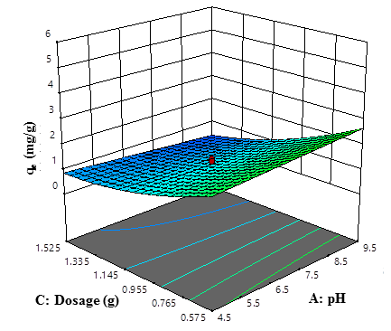
(b)
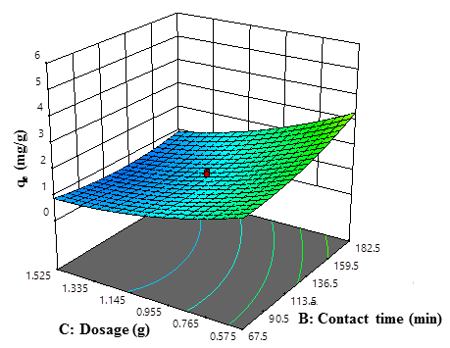

(c)
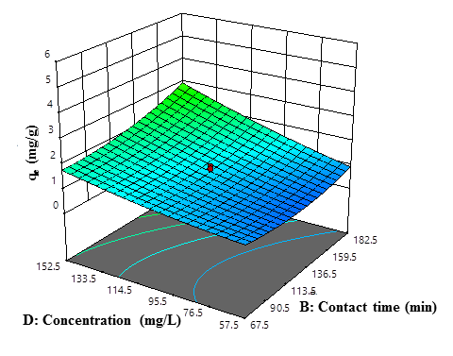
(d)
Fig. S4. 3-D surface plot for the combined effect of pH and contact time (a), pH and dosage (b), contact time and dosage (c), and contact time and concentration on Cd(II) adsorption efficiency.

(a)

(b)

Fig. S5. Pseudo-first-order kinetic (a) and pseudo-second-order kinetic (b) plots for the adsorption of Cd(II) (pH 7, dosage concentration 1.05 g, initial concentration 105 mg/L, temperature 20 ºC, time 10 - 160 min).

(a)

(b)

Fig. S6. Langmuir (a), Freundlich (b) adsorption isotherms for MH onto ZMTAC (pH 7, dosage concentration 1.05 g, contact time 125 min, initial concentration 10 - 200 mg/L, temperature 20 ºC).

Fig. S7 Regenerability of ZMTAC through repeated adsorption-desorption studies

Tables:

Table S1
Central composite design experimental domain

Parameter | pH | Contact time | Dosage | Initial concentration
 |  | (min) | (g) | (mg/L)
Min point | 2 | 10 | 0.1 | 10
Mid point | 7 | 125 | 1.05 | 105
Max point | 12 | 240 | 2.0 | 200

Table S2
Physicochemical properties of ZMTAC
Parameter | Value
pH | 6.7
Loss of mass on ignition (%) | 0.82
Moisture content (%) | 0.42
Bulk density (g/mL) | 0.48
Particle size range (um) | 180
Total ash content (%) | 3.78
Phenolic groups (mmol/g) | 0.837
Carboxylic groups (mmol/g) | 0.562
Phenolic groups (mmol/g) | 0.989
Acidity (mmol/g) | 1.874
Basicity (mmol/g) | 0.911
Total groups (mmol/g) | 2.785
Carbon (%) | 55.24
Hydrogen (%) | 2.46
Nitrogen (%) | 6.87
Oxygen (%) | 28.04

Table S3
Experimental variables and results for MH adsorption using ZMTAC

Run | Factor 1 | Factor 2 | Factor 3 | Factor 4 | Response
 | pH | Contact time | Dosage | Concentration | q_{e}
 |  | (min) | (g) | (mg/L) | (mg/g)
1 | 7 | 125 | 1.05 | 105 | 1.4304
2 | 9.5 | 67.5 | 0.575 | 57.5 | 1.92
3 | 7 | 125 | 1.05 | 10 | 0.0895
4 | 9.5 | 182.5 | 0.575 | 57.5 | 1.8469
5 | 4.5 | 182.5 | 0.575 | 152.5 | 4.1043
6 | 4.5 | 67.5 | 1.525 | 57.5 | 0.7275
7 | 4.5 | 67.5 | 0.575 | 152.5 | 4.8838
8 | 7 | 125 | 1.05 | 105 | 1.1657
9 | 9.5 | 182.5 | 1.525 | 152.5 | 1.8715
10 | 4.5 | 182.5 | 1.525 | 152.5 | 1.9554
11 | 9.5 | 182.5 | 0.575 | 152.5 | 5.1009
12 | 4.5 | 67.5 | 0.575 | 57.5 | 1.8129
13 | 7 | 125 | 1.05 | 105 | 1.1836
14 | 7 | 125 | 0.1 | 105 | 9.984
15 | 7 | 125 | 1.05 | 105 | 0.9809
16 | 4.5 | 182.5 | 0.575 | 57.5 | 1.7997
17 | 12 | 125 | 1.05 | 105 | 0.8891
18 | 4.5 | 67.5 | 1.525 | 152.5 | 1.9321
19 | 9.5 | 67.5 | 1.525 | 57.5 | 0.4553
20 | 2 | 125 | 1.05 | 105 | 1.4242
21 | 9.5 | 67.5 | 0.575 | 152.5 | 2.704
22 | 7 | 10 | 1.05 | 105 | 1.6756
23 | 9.5 | 67.5 | 1.525 | 152.5 | 1.0331
24 | 4.5 | 182.5 | 1.525 | 57.5 | 0.3142
25 | 7 | 125 | 2 | 105 | 0.6118
26 | 7 | 240 | 1.05 | 105 | 0.3659
27 | 7 | 125 | 1.05 | 200 | 3.268
28 | 9.5 | 182.5 | 1.525 | 57.5 | 0.15
29 | 7 | 125 | 1.05 | 105 | 1.3259
30 | 7 | 125 | 1.05 | 105 | 1.3318

Table S4
ANOVA for response surface reduced quadratic model for MH using MTAC
Source | Sum of Squares | Mean Square | F-value | p-value
Model | 33.18 | 3.02 | 59.59 | < 0.0001 | significant
A-pH | 0.0046 | 0.0046 | 0.0907 | 0.7678
B-Contact time | 1.30 | 1.30 | 25.71 | 0.0002
C-Dosage | 11.00 | 11.00 | 217.34 | < 0.0001
D-Concentration | 11.15 | 11.15 | 220.15 | < 0.0001
AB | 0.3996 | 0.3996 | 7.89 | 0.0139
AC | 0.6203 | 0.6203 | 12.25 | 0.0035
BC | 1.02 | 1.02 | 20.11 | 0.0005
BD | 1.02 | 1.02 | 20.06 | 0.0005
B² | 1.15 | 1.15 | 22.78 | 0.0003
C² | 1.39 | 1.39 | 27.50 | 0.0001
D² | 0.3970 | 0.3970 | 7.84 | 0.0142
Residual | 0.7088 | 0.0506
Lack of Fit | 0.5810 | 0.0646 | 2.53 | 0.1601 | not significant
Pure Error | 0.1278 | 0.0256
Cor Total | 33.89

Table S5

Coefficients in Terms of Coded Factors
Factor | Coefficient Estimate | df | Standard Error | 95% CI Low | 95% CI High | VIF
Intercept | 1.22 | 1 | 0.0784 | 1.06 | 1.39
A-pH | -0.0150 | 1 | 0.0499 | -0.1220 | 0.0919 | 1.08
B-Contact time | 0.3095 | 1 | 0.0610 | 0.1786 | 0.4404 | 1.31
C-Dosage | -0.9148 | 1 | 0.0621 | -1.05 | -0.7817 | 1.32
D-Concentration | 0.7399 | 1 | 0.0499 | 0.6330 | 0.8469 | 1.08
AB | 0.1764 | 1 | 0.0628 | 0.0417 | 0.3111 | 1.08
AC | -0.2218 | 1 | 0.0634 | -0.3576 | -0.0859 | 1.11
BC | -0.2841 | 1 | 0.0634 | -0.4200 | -0.1482 | 1.11
BD | 0.2813 | 1 | 0.0628 | 0.1466 | 0.4160 | 1.08
B² | 0.2827 | 1 | 0.0592 | 0.1556 | 0.4097 | 1.22
C² | 0.3194 | 1 | 0.0609 | 0.1887 | 0.4500 | 1.28
D² | 0.1212 | 1 | 0.0433 | 0.0284 | 0.2140 | 1.01

Table S6
Fit Statistics for the model
Parameter | Value
Standard deviation | 0.225
Mean | 1.59
C.V. (%) | 14.18
R² | 0.9791
Adjusted R² | 0.9627
Predicted R² | 0.8998
Adeq Precision | 31.949

Table S7
Kinetic parameters for MH adsorption
Exp value | Pseudo-first-order kinetic model |  |  |  | Pseudo-second-order kinetic model
q_{e} (mg/g) | q_{e} (mg/g) | k₁ (min⁻¹) | SSE | R² | q_{e} (mg/g) | k₂ (g mg⁻¹ min⁻¹) | R² | SSE
1.03 | 3.023 | 0.0062 | 0.896 | 0.9850 | 0.925 | 0.1537 | 0.9960 | 0.0412

Table S8
Isotherm model parameters for MH adsorption onto ZMTAC
Isotherm | Parameter | Value
Langmuir | q_{m} (mg/g) | 44.84
 | b (L/mg) | 0.00026
 | SSE | 0.321
 | R² | 0.9787
Freundlich | K_{F} (mg/g) | 0.156
 | n | 1.041
 | SSE | 2.987
 | R² | 0.943

Table S9
Thermodynamic parameters for MH adsorption onto ZMTAC
Temperature (K) | ΔGº (kJmol⁻¹) | ΔH (kJmol⁻¹) | ΔS  (kJmol⁻¹)
298.15 | -5.78887 | +3.096 | +0.0298
308.15 | -6.08687
328.15 | -6.68287

