Supplementary Information for:

Mātauranga-guided screening of New Zealand native plants reveals compounds from kānuka (Kunzea robusta) with anti-Phytophthora activity.

Authors: Scott A. Lawrence, Elaine J. Burgess, Chris Pairama, Amanda Black⁴ Wayne M. Patrick, Ian Mitchell, Nigel B. Perry and Monica L. Gerth

Corresponding author: Monica Gerth (monica.gerth@vuw.ac.nz)
Supplementary Information: Mātauranga Māori used in the selection of target plants

The mātauranga of these plants as rongoā (medicine) is sacred traditional cultural knowledge. Though rongoā is often thought of in terms of human health, in this context, rongoā is something that can be used to promote ecological balance and health of kauri forests.

This sacred knowledge descends from ‘Te Whare Wānanga o Nukutawhiti’, of Hokianga, according to the proverb: Hokianga Whakapou Karakia (Hokianga where the incantations were exhausted).

Tenei au, Tenei au,
Te hokai nei o taku tapuwae
Ko te hokai nuku, ko te hokai rangi,
ko te hokai a to tupuna, a Tāne nui a Rangi.

This is the beginning of a well-known tauparapara (ancient chant) that describes Tane’s ascent to the heavens to bring back the three baskets of knowledge. Included in the three baskets of knowledge are the whakapapa (genealogical descent) of all things in the natural world, including the whakapapa of plants and the knowledge surrounding the use of those plants as medicines.

In the Māori world, processes always come in threes.

Hence regenerating bush comes in three waves or generations. Kauri does not come in the first generation it comes in the third generation.

The first wave, are plants that commonly grow on our waterways in the north. They grow as ecological companions, they are relatively short lived. Plants such as manuka, kānuka, karamū, tupakihi. By their very nature, they help to secure, cleanse and prepare the soil for the next generations to follow.

The second wave of regeneration, which become the second story in the canopy, are especially the fruiting plants. Plants such as kowhai, kohekohe, taraire. They bring the fertility and the conditions for high biodiversity.

The third wave, includes those plants that are capable of being very long lived such as kauri, rimu, mataī, kahikatea. They bring stability and relative permanency. Kauri stand above them all as the great protector, Te Whakaruruhau. In rainforests of the north, these three classes of species can be seen and take up all spaces in the canopy from the forest floor to the soaring heavens.

This briefly reflects the mātauranga that these plants work as part of a natural process to maintain the health of natural kauri forest ecology. In Māori terms this is te wairua o te Wao Nui o Tāne – the physically and spiritually interconnected whole of the world of Tāne.

This mātauranga is shared by manuscript author Ian Mitchell (Te Uri Taniwha, Ngāpuhi).

Supplementary Methods: Preparation of culture media

All media were prepared using MilliQ (MQ) ultrapure water.

Clarified carrot broth: 50g of defrosted carrots were blended with 200 ml MQ water in a standard kitchen blender for 2 min. The resulting mix was filtered through 4 layers of cheesecloth to remove the bulk of the pulp, then gravity filtered with Whatman No. 1 filter paper. The clarified broth was diluted with MQ water to 500 ml (final concentration of 10% (w/v)) and sterilised by autoclaving.

Clarified V8 broth (cV8-broth) and cV8 agar (cV8-agar): A 20% (v/v) solution was prepared by diluting 200 ml V8 Original Vegetable Juice to 1 l with MQ water. Two grams of calcium carbonate was added to the mixture to adjust the pH to ~7, and the solution was stirred for 30 min at room temperature. The broth was centrifuged for 10 min at 5000 × g, and the supernatant (clarified broth) decanted. The clarified broth was then sterilised by autoclaving.

For the preparation of agar plates (cV8-agar), 15 g of agar was added prior to autoclaving.

Cornmeal agar (BD BBL Dehydrated Culture Media): 17 g of the powder was added per litre of MQ water and sterilised by autoclaving.

Chen-Zentmeyer Salt Solution ^{[1]}: The base Chen-Zentmeyer solution contains 0.01 M calcium nitrate; 0.005 M potassium nitrate; and 0.004 M magnesium sulfate. This base solution was sterilised by autoclaving, and stored protected from light, at room temperature until use. Prior to use, 1 ml of sterile filtered chelated iron was added per litre. This chelated iron was prepared as follows: 13.05 g EDTA (anhydrous), 7.05 g KOH, 24.9 g FeSO₄•7 H₂O were added to 1 l of MQ water. The chelated iron solution was sterilised by filtration and stored in an amber bottle (to protect from light) at 4°C.

1. Chen, D.W. and Zentmyer, G.A. (1970) Production of sporangia by Phytophthora cinnamomi in axenic culture. Mycologia, 62, 397-402.

Sterile Soil Solution: Soil (5% w/v) was stirred in ultrapure water for 4 h, allowed to settle overnight, and then centrifuged at 10,000 × g. The supernatant was filtered through a Whatman No. 1 filter and then sterilized by autoclaving.

Supplementary Figure 1

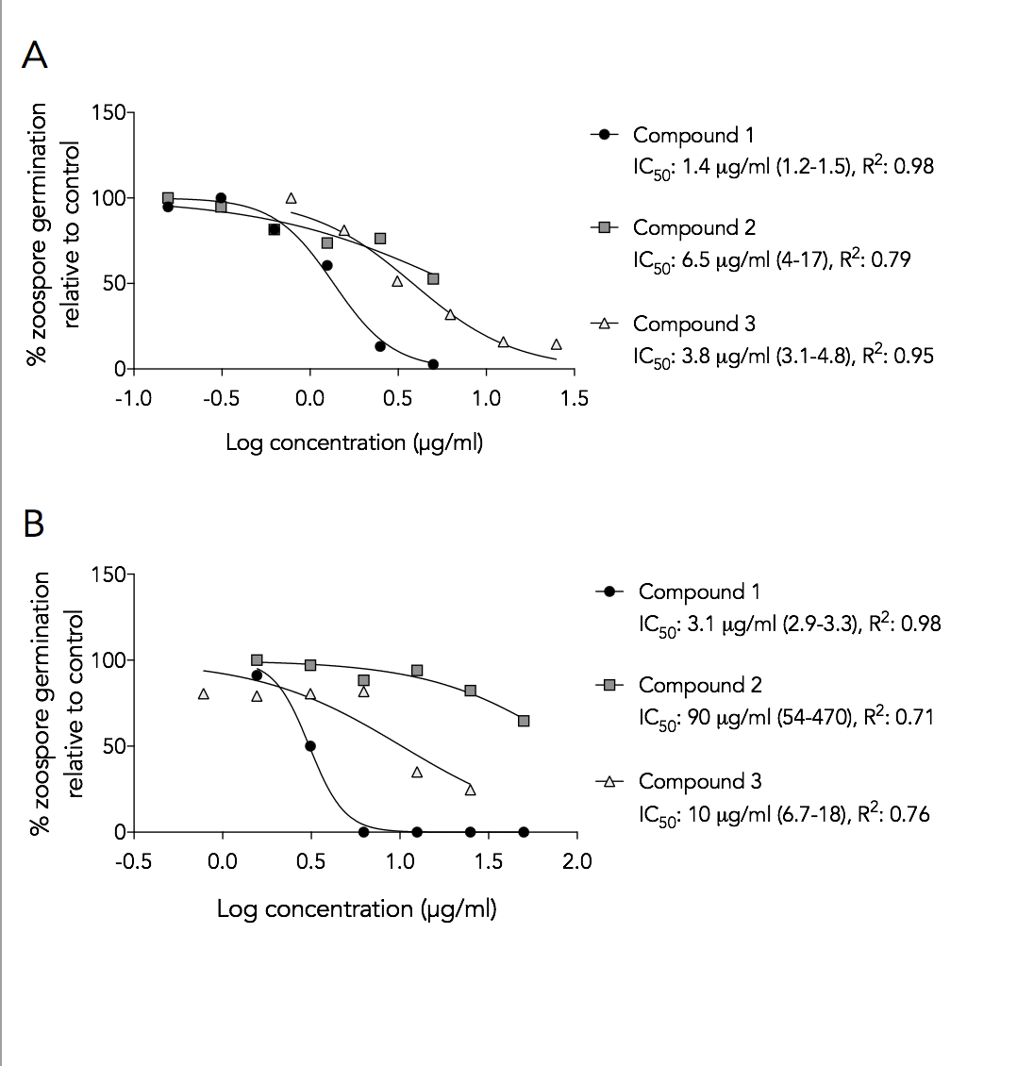
Figure S1. Zoospore germination inhibition by kānuka leaf active compounds. (A) P.agathidicida (B) P. cinnamomi. Symbols are the mean of two independent experiments. IC₅₀ values are the concentrations causing a 50% reduction in germination. Values in parentheses are 95% confidence intervals as calculated from the non-linear fit of the data.

Supplementary Figure 2

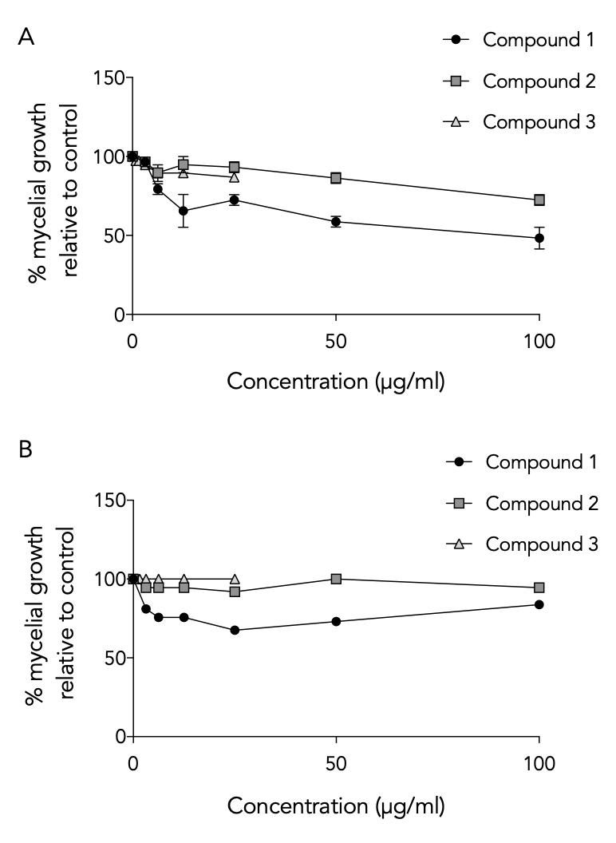

Figure S2. Effect of kānuka active compounds on the mycelial growth of: (A) P. agathidicida and (B) P. cinnamomi. Values are relative to the growth of the negative control (1% ethanol). Error bars are +/- SEM (n = 2).

