**Supporting Information**

**Biocompatible and Na+-sensitive thin film transistor for biological fluid sensing**

Kensuke Ito, Hiroto Satake, Yuto Mori, Alex C. Tseng, and Toshiya Sakata*

Department of Materials Engineering, School of Engineering, The University of Tokyo, 7-3-1 Hongo, Bunkyo-ku, Tokyo, Japan 113-8656

*E-mail T.S.: sakata@biofet.t.u-tokyo.ac.jp

**S1. *V*G-*I*D and *V*D-*I*D electrical characteristics of ISTFT**

The electrical properties of TFT devices such as the *V*G-*I*D and *V*D-*I*D electrical characteristics were analyzed in the PBS buffer (pH 7.4) using a semiconductor parameter analyzer (B1500A, Agilent Technologies), as shown in **Figure S1**. The carrier mobility **sat developed in this study was calculated as approximately 14 cm2/Vs using the following equation,

$$μ_{sat}=\frac{2L{(\sqrt{I_{D1}}-\sqrt{I_{D2}})}^{2}}{C_{OX}W{(V_{G1}-V_{G2})}^{2}}$$

where the width (*W*) and length (*L*) of the gate channel were 360 m and 12 m, respectively, *C*OX was measured as 2.21 × 102 nF (50 Hz) using a impedance analyzer (Agilent Technologies), and *V*G1, *V*G2, *I*D1, and *I*D2 were estimated as 1.25 V, 0.75 V, 40.5 A, and 6.73 M from **Figure S1b**, respectively.

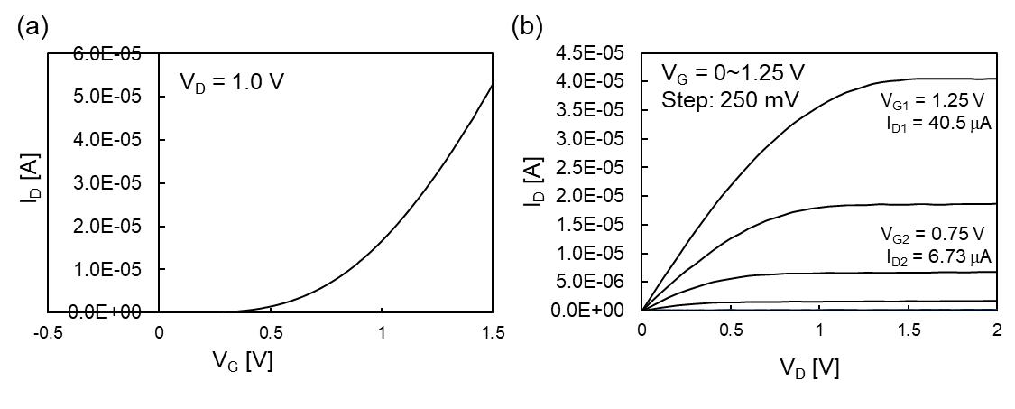

**Figure S1** *V*G-*I*D and *V*D-*I*D electrical characteristics of ISTFT used in this study. No membrane was coated on the Ta2O5 gate insulator.

**S2. Source follower circuit for FET real-time measurement**

The change in surface potential (*V*out) at the gate was measured at a constant ID (700 A) using the source follower circuit shown in **Figure S2**; thus, the detected *V*out was regarded as the change in the source-gate voltage (*V*S), which was equal to –*V*T. Using this system, the surface potential of the FET can be monitored in real time.



**Figure S2** Electrical circuit (source follower circuit) for measuring surface potential of FET sensor.S1

**S3. Reusability of plasticizer-free Na+-sensitive FPS-gate TFT with calix[4]arene**

The pNa sensitivity and the selectivity coefficient $K_{{Na}^{+},K^{+}}$ of the plasticizer-free Na+-sensitive FPS-gate TFT with calix[4]arene were measured for 10 days. As a result, the pNa sensitivity and $K_{{Na}^{+},K^{+}}$ were sufficiently maintained around 60 mV/pNa and less than about 10-2 order, respectively, for 10 days, as shown in **Figure S3**. Therefore, we have demonstrated the sufficient reusability of the devices for 10 days.

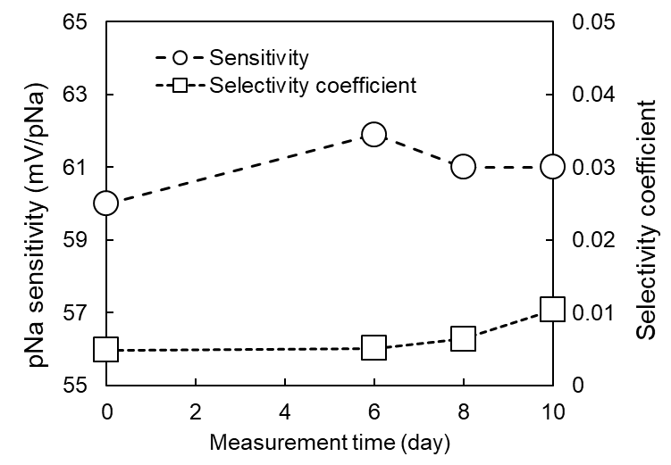

**Figure S3** pNa sensitivity and selectivity coefficients $K_{{Na}^{+},K^{+}}$ of plasticizer-free Na+-sensitive FPS-gate TFT with calix[4]arene.

**References**

1. Sakata, T.; Kamahori, M.; Miyahara, Y. DNA analysis chip based on field-effect transistors. *Jpn. J. Appl. Phys.* **2005**, *44*, 2854.