Supplementary material

- Time effects on ethanol consumption in adolescent males and females
In adolescence, the repeated-measures ANOVA showed a significant effect of time (F_{4,228} = 3.01; p < 0.05) but did not show effect of sex and time interaction (F_{4,228} = 0.37; p = 0.82), MS and time interaction (F_{8,228} = 1.75; p = 0.09) or MS, sex and time interaction (F_{8,228} = 1.30; p = 0.24). The post hoc test showed a decrease in total ethanol consumption on day 7, compared to day 1 (p = 0.03), 5 (p = 0.02) and 9 (p = 0.03) (Supplemental Figure S1A).
The analysis of the consumption of the 4% ethanol solution (Supplemental Figure S1B) showed a significant effect of sex (F_{1,57} = 6.00; p < 0.05). However, repeated-measures ANOVA did not detect significant effect of time (F_{4,228} = 2.33; p = 0.06), sex and time interaction (F_{4,228} = 0.92; p = 0.45), MS and time interaction (F_{8,228} = 0.95; p = 0.48) or MS, sex and time interaction (F_{8,228} = 0.96; p = 0.47). Similar effects were observed concerning the consumption of the 8% ethanol solution (Supplemental Figure S1C). Repeated-measures ANOVA only showed a significant effect of sex (F_{1,57} = 7.57; p < 0.01). There was no effect of time (F_{4,228} = 1.57; p = 0.18), sex and time interaction (F_{4,228} = 1.18; p = 0.32), MS and time interaction (F_{8,228} = 1.53; p = 0.15) or MS, sex and time interaction (F_{8,228} = 1.51; p = 0.16).
The analysis of the water consumption (Supplemental Figure S1D) detected no effect of time (F_{4,228} = 0.68; p = 0.61), sex and time interaction (F_{4,228} = 0.99; p = 0.41), MS and time interaction (F_{8,228} = 1.25; p = 0.27) or MS, sex and time interaction (F_{8,228} = 0.83; p = 0.58).

Supplemental Figure S1. Time analysis of voluntary ethanol consumption in adolescent rats subjected to brief or prolonged maternal separation during the neonatal period (n = 10-12/group). A, total ethanol consumption (g/kg); B, consumption of ethanol solution at 4% (g/kg); C, consumption of ethanol solution at 8% (g/kg); D, water consumption (g/kg). Data represent the mean ± standard error of the mean. Repeated-measures ANOVA followed by the Newman Keuls post hoc test. ^p ≤ 0.05 compared to the day 7; $p ≤ 0.05 compared to the male groups.

- Time effects on ethanol consumption in adult males and females
Total ethanol consumption in adults (Supplemental Figure S2A) was not significant altered by time (F_{4,224} = 2.35; p = 0.06). Also, the repeated-measures ANOVA did not show a significant effect of time and sex interaction (F_{4,224} = 0.64; p = 0.63), MS and time interaction (F_{8,224} = 0.56; p = 0.81) or MS, sex and time interaction (F_{8,224} = 0.51; p = 0.85). ANOVA only indicated effect of sex (F_{1,56} = 7.60; p < 0.01) and MS (F_{2,56} = 6.15; p < 0.01). The post hoc test showed that MS 180 groups showed higher ethanol intake compared to control groups (MS 0) (p < 0.05).
The analysis of the consumption of the 4% ethanol solution (Supplemental Figure S2B) detected a significant effect of time (F_{4,224} = 4.16; p < 0.01), but did not detected a significant effect of sex and time interaction (F_{4,224} = 0.78; p = 0.54), MS and time interaction (F_{8,224} = 1.56; p = 0.14) or MS, sex and time interaction (F_{8,224} = 0.38; p = 0.93). The post hoc test showed a decrease in 4% ethanol consumption on day 3 compared to day 1 (p < 0.001), day 5 (p < 0.05), day 7 (p < 0.05) and day 9 (p < 0.05).
Repeated-measures ANOVA for the ethanol 8% consumption (Supplemental Figure S2C) showed effect of MS (F_{2,56} = 4.16; p < 0.05) and MS and sex interaction (F_{2,56} = 3.85; p < 0.05). There was no significant effect of time (F_{4,224} = 1.08; p = 0.37), sex (F_{1,56} = 3.25; p = 0.08), sex and time interaction (F_{4,224} = 1.28; p = 0.28), MS and time interaction (F_{8,224} = 0.38; p = 0.93) or MS, sex and time interaction (F_{8,224} = 0.66; p = 0.72)]. The post hoc test showed that MS 180 males consumed more ethanol 8% solution than MS 15 and MS 0 male groups (MS 0) (p < 0.05). Moreover, MS 15 females consumed more this ethanol solution than MS 15 male group (p < 0.05).
The analysis of the water consumption (Supplemental Figure S2D) detected a significant effect of time (F_{4,224} = 4.54; p < 0.01) and MS (F_{2,56} = 3.39; p < 0.05), but did not detected a significant effect of sex (F_{1,56} = 1.56; p = 0.22), sex and time interaction (F_{4,224} = 1.30; p = 0.27), MS and time interaction (F_{8,224} = 0.83; p = 0.57) or MS, sex and time interaction (F_{8,224} = 0.94; p = 0.48). The post hoc test showed an increase in water consumption on day 3 compared to day 1 (p < 0.01) and day 9 (p < 0.05), and on day 5 compared to day 1 (p < 0.01).

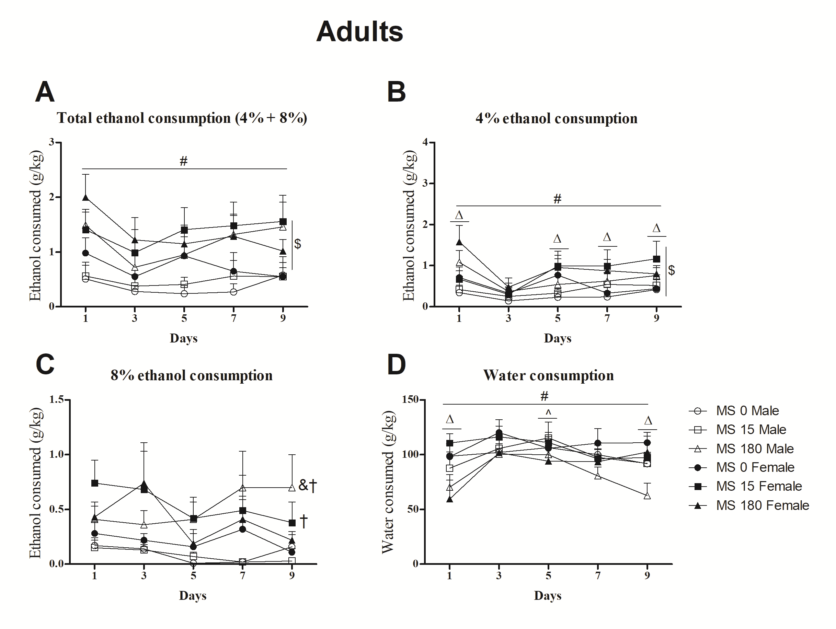
Supplemental Figure S2. Time analysis of voluntary ethanol consumption in adult rats subjected to brief or prolonged maternal separation during the neonatal period (n = 10-11/group). A, total ethanol consumption (g/kg); B, consumption of ethanol solution at 4% (g/kg); C, consumption of ethanol solution at 8% (g/kg); D, water consumption (g/kg). Data represent the mean ± standard error of the mean. Repeated-measures ANOVA followed by the Newman Keuls post hoc test. ^{Δ} p ≤ 0.05 compared to the day 3; ^ p ≤ 0.05 compared to the day 1; $p ≤ 0.05 compared to the male groups; # ≤ 0.05, independent of sex, compared to the MS 0 groups; & p ≤ 0.05 compared to the MS 0 male group; † p ≤ 0.05 compared to the MS 15 male group.

