Supplementary material

Study on the optical and electrochemical performance of V₂O₅ with various morphologies
Zhihui Yu^{1,}*, Jiqi Zheng², Xuyang Jing², Guangfei Hang¹, Qinqi Liu¹, Weijie Cai^{1,} *
¹School of Light Industry and Chemical Engineering, Dalian Polytechnic University, Dalian 116034, PR China
²School of Chemistry, Dalian University of Technology, Dalian 116024, PR China
*Corresponding author. E-mail address: zhi_hui_yu@163.com; caiwj@dlpu.edu.cn

Fig. S1
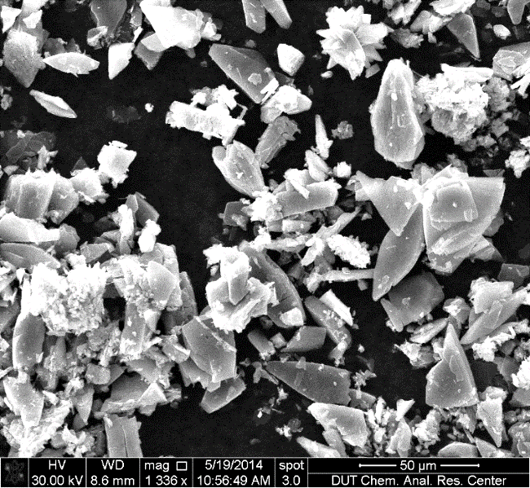
Fig. S1. SEM image of commercial V₂O₅.

Fig. S2. CV curves of V₂O₅ hollow spheres at various scan rates.

Fig. S3. Galvanostatic discharge curves of V₂O₅ hollow spheres at different current densities.

Fig. S4. Cycling performance of V₂O₅ hollow spheres at 20 mV·s⁻¹.

Formation Mechanism:
According previous literatures [Current Applied Physics 15(2015), 493-498; Applied Surface Science 399(2017), 151-159; Inorganic Chemistry 48(2009), 6044-6054], the possible formation mechanism of V₂O₅ was discussed. Nanowires were synthesized from commercial V₂O₅, which converted to [VO(O₂)(OH₂)₃]⁺ by adding H₂O₂ and deionized water. Then the species released oxygen to form [H_{n}V₁₀O₂₈]^{n-6} in hydrothermal reaction. Next, [H_{n}V₁₀O₂₈]^{n-6} was dissociated to vanadium pentoxide gel, which was changed to V₂O₅·nH₂O sheet with increase of reaction time. V₂O₅·nH₂O sheets continued to dehydrated and formed nanowires because they had the tendency to one-dimensionally grow. For layer-by-layer, the addition of carbon spheres was important. Brick-liked particles were firstly formed, then converted to sheet, finally self-assembly constructed layer-by-layer due to the influence of carbon spheres. The function of carbon spheres acted as a structure-oriented agent, such as adhesives, to guide the formation of layer-by-layer structure. Whereas hollow spheres evolved from solid spheres to core/shell structures and then completely became hollow structure. As the reaction proceeded, the solid inner cores shrank and then gradually formed more core-shell space. Finally, the inner cores completely disappeared, leading to hollow spheres. Detailed formation mechanism was further investigated.

