On the second harmonic generation activity in centrosymmetric crystals

Bikshandarkoil R. Srinivasanª, Neha U. Parsekarª, Ruben A. Apreyan^{b}, Aram M. Petrosyan^{b}
ªDepartment of Chemistry, Goa University, Goa 403206, India. Email: srini@unigoa.ac.in
^{b}Institute of Applied Problems of Physics, NAS of Armenia, 25 Nersessyan Str., 0014 Yerevan, Armenia

SUPPLEMENTARY MATERIAL FOR ONLINE VERSION

Description of crystal structure of (I)

The compound tetraaquabis(glycine)zinc(II) dipicrate dihydrate (I) crystallises in the centrosymmetric triclinic space group Pī and is isostructural with the previously reported Cu(II) analogue [8]. The central metal is situated on an inversion centre. In view of the special position of Zn(II), the asymmetric unit consists of a half of the formula unit. The crystal structure consists of a Zn(II) ion, two unique terminal aqua ligands, an independent zwitterionic glycine, a crystallographically unique picrate anion and a lattice water molecule. In (I) the picrate is not coordinated to Zn(II) but functions as a charge balancing counter anion, while the glycine is bonded to the Zn(II) via the carboxylate oxygen O1 in a monodentate fashion. The geometric parameters of the organic moieties viz. free picrate and monodentate glycine are in the normal range (Table S1).
Table S1. Metric parameters [Å and °] of zwitterionic glycine and the picrate anion in I.

Bond lengths
C1-C2 | 1.5202(16) |  | C1-O1 | 1.2588(14)
C2-N1 | 1.4917(15) |  | C1-O2 | 1.2526(15)
C11-O11 | 1.2564(14) |  | N13-C16 | 1.4538(14)
C11-C12 | 1.4529(15) |  | O12-N11 | 1.2246(13)
C11-C16 | 1.4553(16) |  | O13-N11 | 1.2322(13)
C12-C13 | 1.3761(15) |  | O14-N12 | 1.2326(13)
C13-C14 | 1.3883(15) |  | O15-N12 | 1.2340(13)
C14-C15 | 1.3874(15) |  | O16-N13 | 1.2350(13)
C15-C16 | 1.3799(15) |  | O17-N13 | 1.2245(14)
N11-C12 | 1.4591(14) |  | N12-C14 | 1.4462(14)
Bond angles
O1-C1-C2 | 115.49(10) |  | O2-C1-O1 | 127.06(11)
O2-C1-C2 | 117.44(10) |  | N1-C2-C1 | 110.17(9)
O12-N11-O13 | 123.33(10) |  | C13-C12-C11 | 124.94(10)
O12-N11-C12 | 119.65(10) |  | C13-C12-N11 | 115.34(10)
O13-N11-C12 | 117.02(10) |  | C11-C12-N11 | 119.60(10)
O14-N12-O15 | 123.35(10) |  | C12-C13-C14 | 118.89(10)
O14-N12-C14 | 118.36(10) |  | C15-C14-C13 | 121.25(10)
O15-N12-C14 | 118.28(10) |  | C15-C14-N12 | 119.38(10)
O17-N13-O16 | 122.66(10) |  | C13-C14-N12 | 119.18(10)
O17-N13-C16 | 120.14(10) |  | C16-C15-C14 | 118.64(10)
O16-N13-C16 | 117.18(10) |  | C15-C16-N13 | 115.39(10)
O11-C11-C12 | 124.29(10) |  | C15-C16-C11 | 124.97(10)
O11-C11-C16 | 124.80(10) |  | N13-C16-C11 | 119.45(10)
C12-C11-C16 | 110.79(9)

The central metal is hexaccordinated and is bonded to four symmetry related (monodentate) terminal aqua ligands all of which are situated on a square plane. The two symmetry related monodentate glycine ligands disposed trans to each other on either side of the square plane complete the six coordination around the Zin(II) in the tetraaqua(diglycine)zinc(II) cation. The Zn-O bond distances range from 2.0257(8) to 2.1139(9) Å (Table S2). The trans O-Zn-O angles exhibit ideal values of 180° while the cis O-Zn-O angles vary between 87.61(4) to 92.39(4)° indicating a slightly distorted {ZnO₆} octahedron.
Table S2. Selected bond lengths [Å] and angles [°] pertaining to the central metal Zn in (I)

Bond lengths
Zn1-O1 | 2.0257(8) | Zn1-O2W^{i} | 2.1073(10)
Zn1-O1^{i} | 2.0257(8) | Zn1-O1W | 2.1139(9)
Zn1-O2W | 2.1073(10) | Zn1-O1W^{i} | 2.1139(9)
Bond angles
O1^{i} -Zn1-O1 | 180.00 | O2W-Zn1-O1W | 91.70(4)
O1^{i} -Zn1-O2W^{i} | 92.39(4) | O1-Zn1-O1W | 92.07(4)
O1-Zn1-O2W^{i} | 87.61(4) | O1^{i} -Zn1-O1W^{i} | 92.07(4)
O1^{i} -Zn1-O2W | 87.61(4) | O1-Zn1-O1W^{i} | 87.93(4)
O1-Zn1-O2W | 92.39(4) | O2W^{i}-Zn1-O1W | 88.30(4)
O2W^{i} -Zn1-O1W^{i} | 91.70(4) | O2W-Zn1-O1W^{i} | 88.30(4)
O1W^{i} -Zn1-O1W | 180.00 | O2W^{i} -Zn1-O2W | 180.00
O1^{i} -Zn1-O1W | 87.93(4)
Symmetry transformations used to generate equivalent atoms: i) -x+1, -y+1, -z

A scrutiny of the crystal structure reveals that the tetraaqua(diglycine)zinc(II) cation, the picrate anion and the lattice water are interlinked with the aid of three varieties of H-bonding interactions namely O-H···O, N-H···O and C-H···O. Of a total of fourteen H-bonds (Table S3) seven are intramolecular in nature (Fig 1). One H atom (H5) of the lattice water is H-bonded to a [Zn(H₂O)₄(gly)₂]²⁺ cation while the second H makes two bifurcated H-bonds with a picrate anion (Fig S1). The lattice water is further linked to two tetraaqua(diglycine)zinc(II) cations, with the O3 functioning as H-acceptor. An analysis of the H-bonding situation around the picrate anion reveals that each picrate anion is linked to a lattice water, three tetraaqua(diglycine)zinc(II) cations and two symmetry related picrate anions (Fig S2). Of these the C15-H15···O13 interaction which links a picrate with another picrate is notable as this results in an infinite H-bonded chain of picrate anions extending along b axis (Fig S3). Each picrate in the chain is linked via H-bonding to a lattice water (O3W) on one side and to a [Zn(H₂O)₄(gly)₂]²⁺ cation on the other side. The ring centroid to ring centroid distance (Cg∙∙∙Cg) between adjacent picrate anions is found to be 3.3639 Å (Table S4) based on an analysis of the short ring interactions in I using the program Platon [13]. This reveals that I exhibits π∙∙∙π stacking interactions [14].
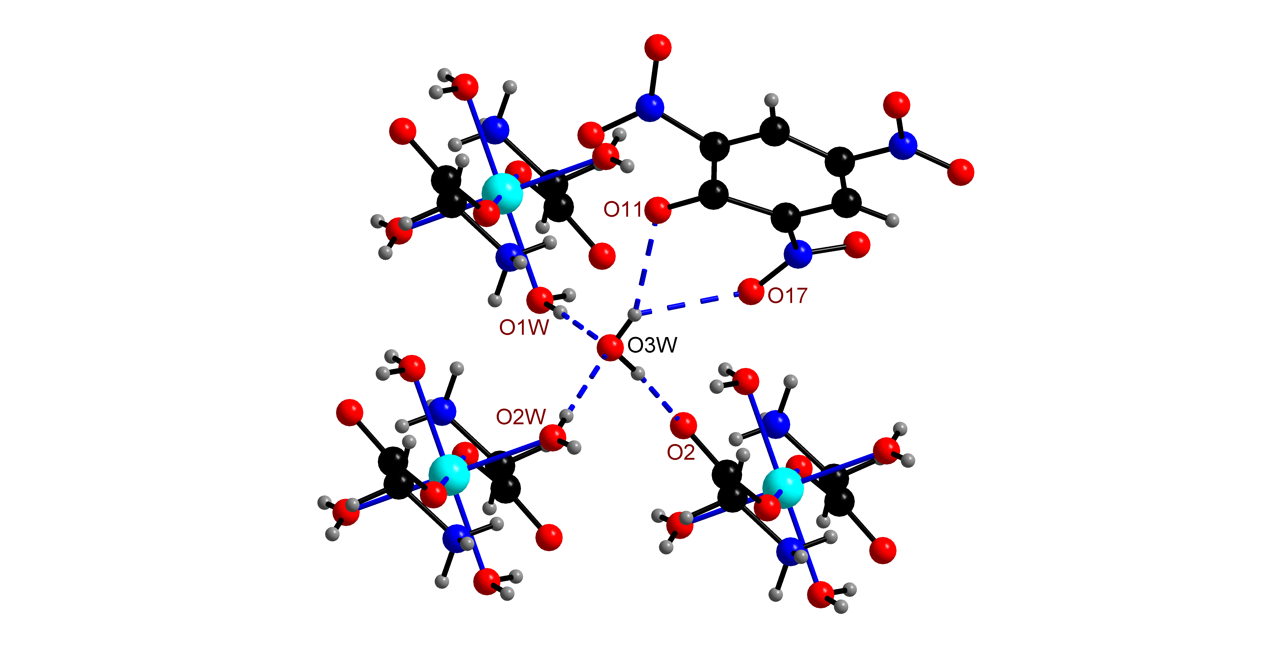
Fig. S1 H-bonding situation around the lattice water (O3W) reveals that each OW3 is linked with the aid of H-bonds to a picrate anion and three symmetry related tetraaqua(bis)glycinezinc(II) cations.

Table S3. Hydrogen bonding geometry [Å and °] for [Zn(gly)₂(H₂O)₄](pic)₂·2H₂O.
D-H···A | d(DH) | d(H···A) | <(DHA) | d(D···A) | Symmetry code
O1W-H1···O3W | 0.823 | 1.887 | 174.4 | 2.708 | x, y, z
O1W-H2···O2 | 0.839 | 1.924 | 154.49 | 2.705 | x, y, z
N1-H1A···O1W | 0.91 | 2.051 | 148.63 | 2.868 | x+1, y, z
N1-H1B···O11 | 0.91 | 2.292 | 173.18 | 3.198 | x, y, z
N1-H1C···O15 | 0.91 | 2.521 | 116.97 | 3.043 | -x+2, -y+1, -z+1
N1-H1C···O16 | 0.91 | 2.059 | 155.42 | 2.912 | x+1, y+1, z
C2-H2B···O12 | 0.99 | 2.456 | 113.65 | 2.994 | x, y, z
C2-H2B···O14 | 0.99 | 2.629 | 148.61 | 3.513 | -x+2, -y+2, -z+1
C15-H15···O13 | 0.95 | 2.459 | 132.92 | 3.183 | x, y-1, z
O2W-H3···O3W | 0.774 | 2.024 | 162.25 | 2.771 | x+1, y, z
O2W-H4···O11 | 0.806 | 2.101 | 164.59 | 2.887 | -x+1, -y+1, -z
O3W-H5···O2 | 0.85 | 1.86 | 167.87 | 2.697 | -x+1, -y+2, -z
O3W-H6···O11 | 0.803 | 2.142 | 157.23 | 2.899 | -x+1, -y+1, -z
O3W-H6···O17 | 0.803 | 2.306 | 126.18 | 2.855 | -x+1, -y+1, -z
D= Donor and A= Acceptor
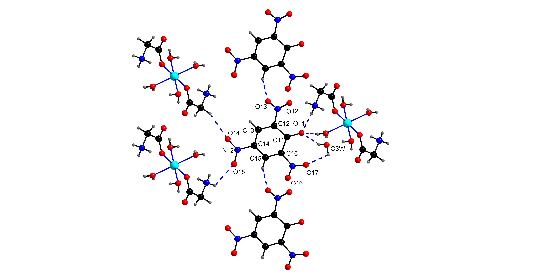
Fig. S2 H-bonding surroundings of the picrate anion showing its linking via H-bonds to a lattice water (OW3), three octahedral zinc(II) cations and two symmetry related picrate anions.

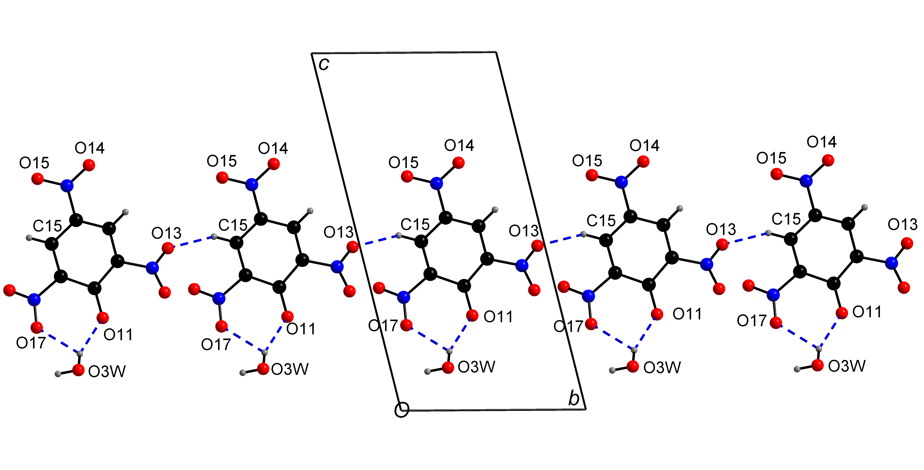
Fig. S3 The C15-H15···O13 interaction links the picrate anions into an infinite chain extending along b axis.

Table S4 - Analysis of Short Ring-Interactions with Cg-Cg Distances < 6.0 Å and β < 60.0⁰

Cg(I) | Res(I) | Cg(J) | [ARU(J)] | Cg-Cg | Α | Β | Γ | CgI_Perp | Cg J_Perp | Slippage
[Zn(H₂O)₄(gly)₂](pic)₂∙2H₂O I
Cg(1) | [ 1] -> | Cg(1) | [2666.01] | 3.5639(7) | 0.02(5) | 28.1 | 28.1 | -3.1440(5) | -3.1440(5) | 1.678
Cg(1) | [ 1] -> | Cg(1) | [2766.01] | 3.6972(7) | 0.02(5) | 26.4 | 26.4 | 3.3108(5) | 3.3108(5) | 1.645
Where, Cg(1)= picrate anion

- Cg(I) = The Cg(I) refer to the Ring Centre-of-Gravity numbers given in the Ring-Analysis above
- Alpha = Dihedral Angle between Planes I and J (Degree)
- Beta = Angle Cg(I)-->Cg(J) or Cg(I)-->Me vector and normal to plane I (Degree)
- Gamma = Angle Cg(I)-->Cg(J) vector and normal to plane J (Degree)
- Cg∙∙∙Cg = Distance between ring Centroids (Angstrom)
- CgI_Perp = Perpendicular distance of Cg(I) on ring J (Angstrom)
- CgJ_Perp = Perpendicular distance of Cg(J) on ring I (Angstrom)
- Slippage = Distance between Cg(I) and Perpendicular Projection of Cg(J) on Ring I (Angstrom)

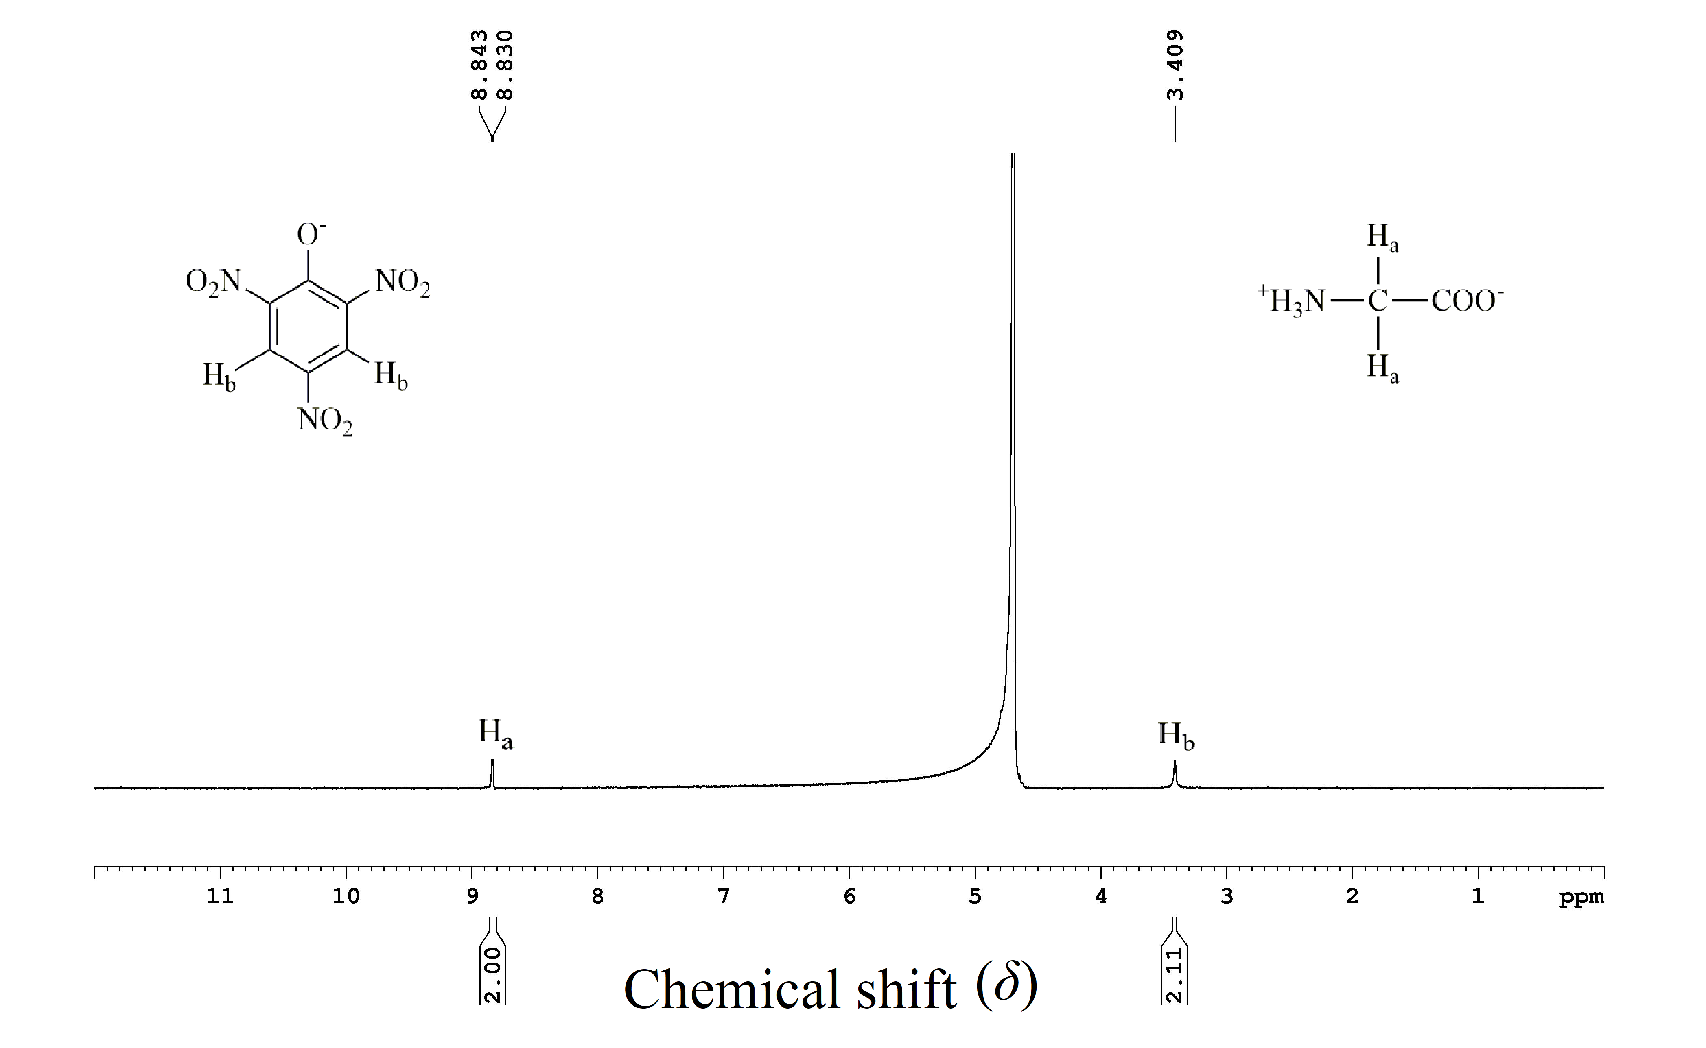
Fig. S4: ¹H NMR spectrum of (I). In D₂O. The strong signal is due to the residual protons of D₂O.
Due to rapid exchange with D of D₂O, no signal is observed for the –NH₃ protons of glycine.
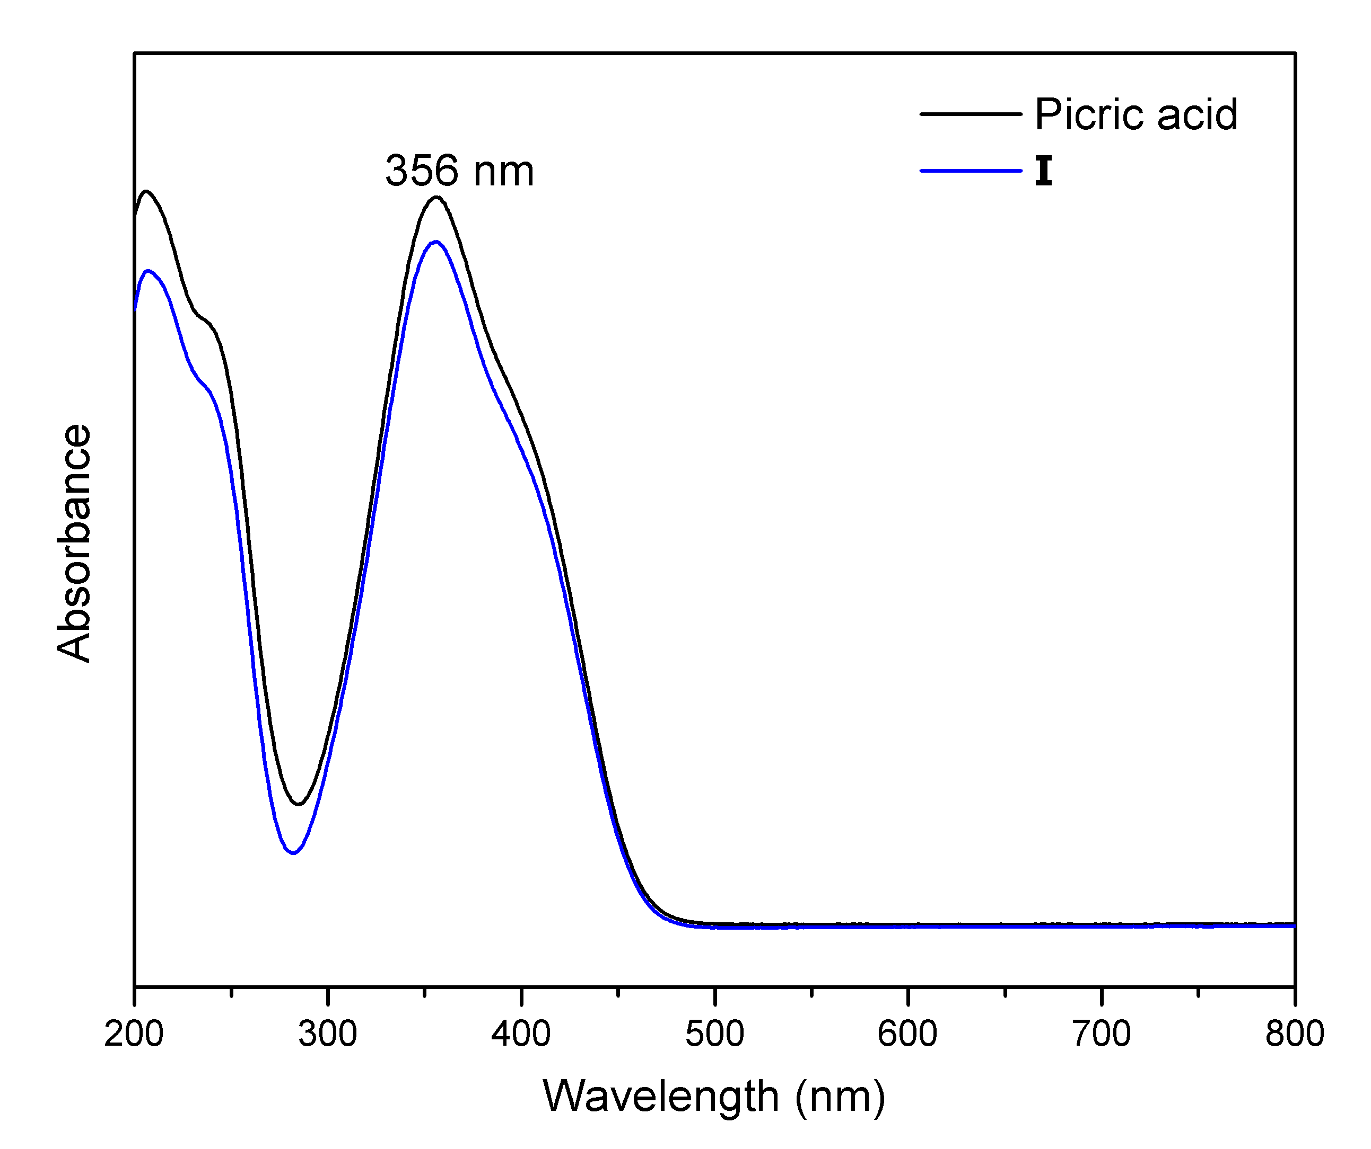Fig S5: UV-Vis spectrum of aqueous solutions of (I) and picric acid
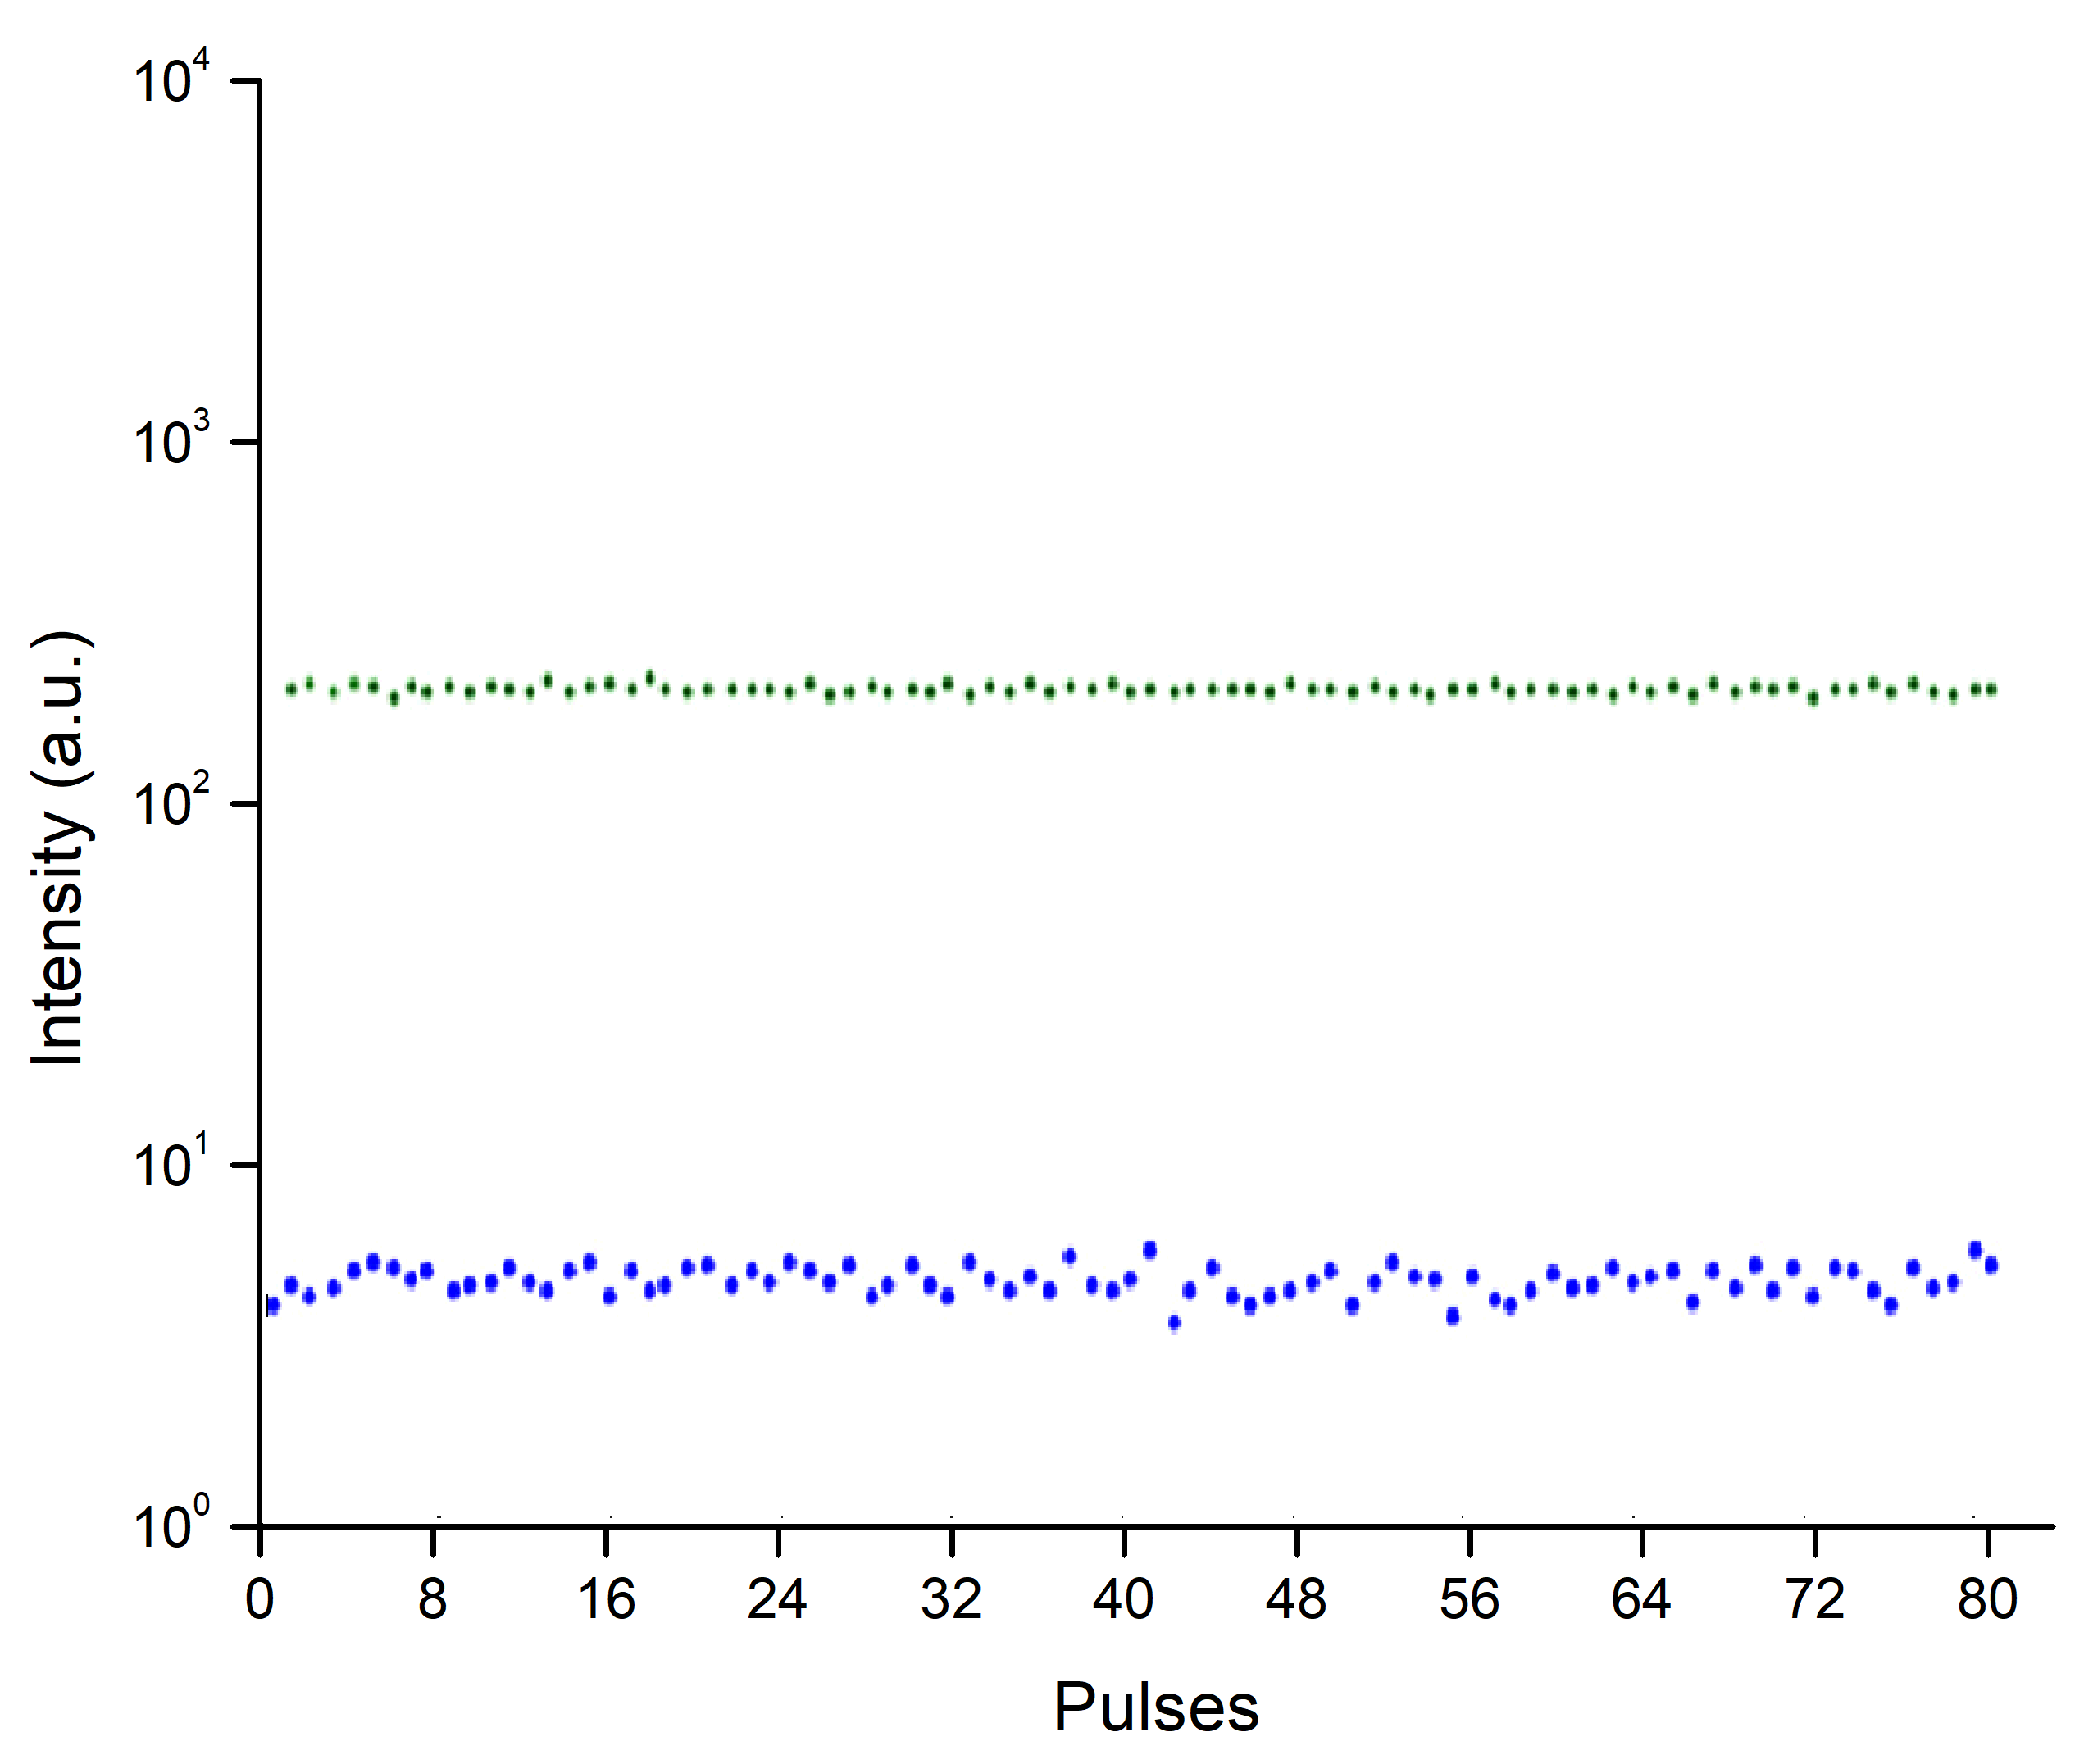

Fig. S6 SHG of KDP in ten-pulse mode. The green points (top) show fluctuation of laser radiation while the blue points (bottom) are the SHG response of KDP. Each point is an average value of ten pulses registered from one point of the powder.
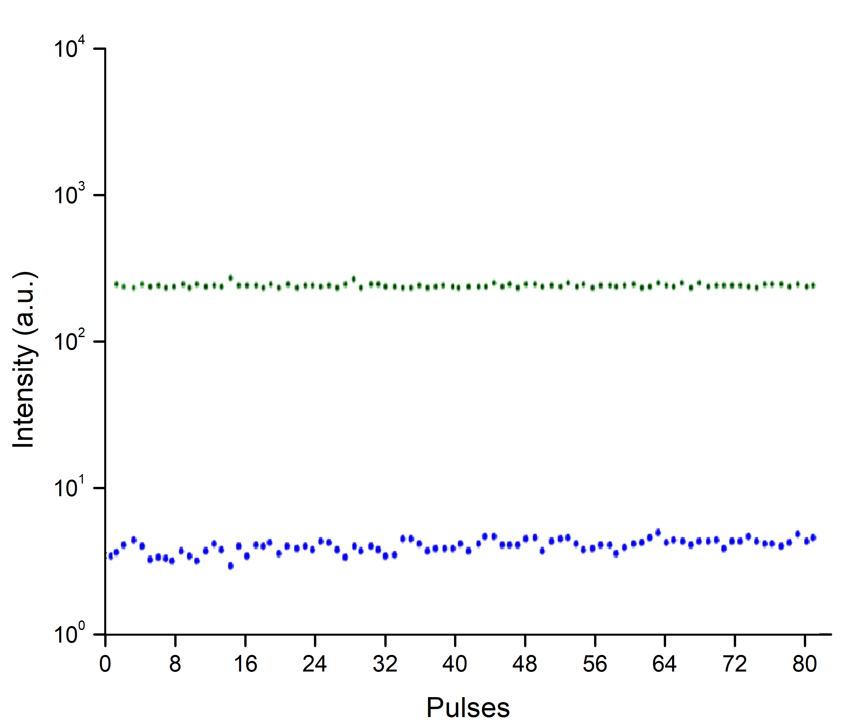

Fig. S7 SHG of (II) in ten-pulse mode. The green points (top) show fluctuation of laser radiation while the blue points (bottom) are the SHG response of (II). Each point is an average value of ten pulses registered from one point of the powder.

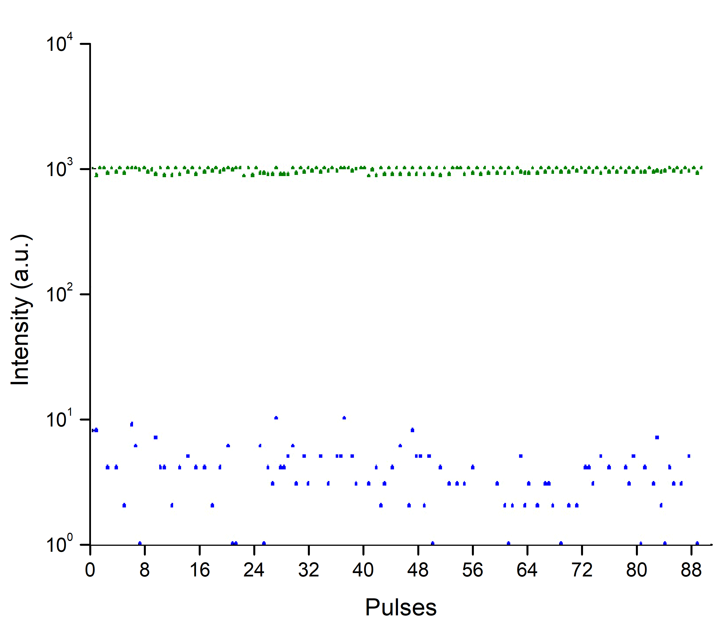

Fig. S8 SHG of (III) in one-pulse mode. The green points (top) show fluctuation of laser radiation while the blue points (bottom) are the SHG response of (III), confirming the crystalline noncentrosymmetry of (III)

