Economic burden of fatigue or morning stiffness among patients with rheumatoid arthritis: a retrospective analysis from real world data
Supplemental online material
The following appendices provide additional information on this study. Appendix A illustrates the selection of study population. Patients meeting the inclusion criteria were divided into cases and controls. Case patients had incident RA with claims for fatigue or morning stiffness after, but not within 12 months before, the RA index date (n = 8,169). Control patients had incident RA with no claims for fatigue or morning stiffness (n = 17,156). Case patients were divided into cohorts with fatigue only (n = 6,465), morning stiffness only (n = 994), or both fatigue and morning stiffness (n = 710). HIV, human immunodeficiency virus; RA = rheumatoid arthritis. Appendix B provides the baseline characteristics for the propensity-score matched cohorts.

Appendix A. Selection of study population
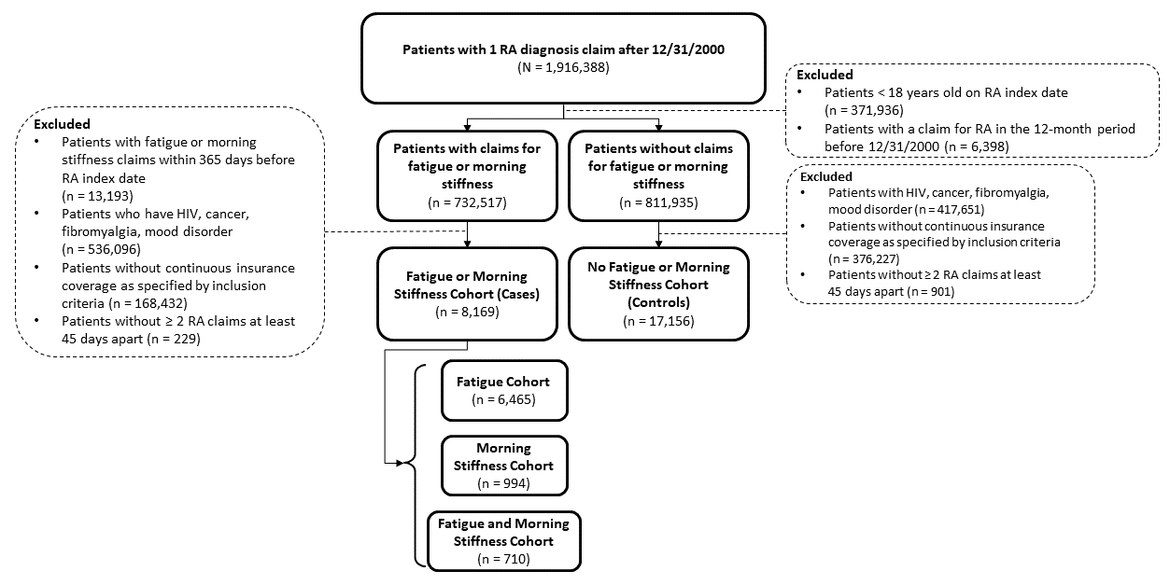

Appendix B. Baseline characteristics for propensity-score matched cohorts
Variable | Fatigue  Cohort  N=6,404 | No Fatigue or Morning Stiffness Cohort  N=12,390 | Standardized Difference | Morning Stiffness  Cohort  N=986 | No Fatigue or Morning Stiffness Cohort  N=3,939 | Standardized Difference | Fatigue and Morning Stiffness Cohort  N=708 | No Fatigue or Morning Stiffness Cohort  N=2,830 | Standardized Difference
Duration of follow-up (months), mean ± SD | 56.2 ± 42.0 | 45.3 ± 36.0 | 0.278 | 54.3 ± 39.8 | 45.0 ± 35.7 | 0.248 | 71.3 ± 46.9 | 48.1 ± 38.6 | 0.54
Demographicsª
Age (yr), mean ± SD | 49.7 ± 15.9 | 49.5 ± 15.1 | 0.011 | 49.1 ± 14.2 | 49.1 ± 15.0 | 0 | 50.1 ± 14.5 | 49.4 ± 14.9 |  | 0.043
Age group (yr), n (%)
18-34 | 1,101 (17.2) | 2,020 (16.3) | 0.024 | 166 (16.9) | 677 (17.2) | 0.009 | 97 (13.7) | 469 (16.6) |  | 0.081
35-44 | 1,408 (22.0) | 2,484 (20.1) | 0.047 | 193 (19.6) | 793 (20.1) | 0.014 | 145 (20.5) | 553 (19.6) |  | 0.023
45-54 | 1,661 (26.0) | 3,336 (27.0) | 0.023 | 286 (29.0) | 1,069 (27.2) | 0.042 | 225 (31.8) | 780 (27.6) |  | 0.092
55-64 | 1,110 (17.4) | 2,656 (21.5) | 0.104 | 189 (19.2) | 840 (21.3) | 0.054 | 114 (16.1) | 587 (20.8) |  | 0.121
65+ | 1,111 (17.4) | 1,862 (15.1) | 0.063 | 151 (15.3) | 557 (14.2) | 0.033 | 126 (17.8) | 434 (15.4) |  | 0.066
Female, n (%) | 3,984 (62.2) | 7,092 (57.2) | 0.101 | 531 (53.9) | 2,145 (54.5) | 0.012 | 420 (59.3) | 1,591 (56.2) |  | 0.063
Region, n (%)
North-central | 1,704 (26.6) | 3,332 (26.9) | 0.006 | 304 (30.8) | 1,062 (27.0) | 0.085 | 246 (34.7) | 829 (29.3) |  | 0.117
Northeast | 1,042 (16.3) | 2,118 (17.1) | 0.022 | 126 (12.8) | 596 (14.4) | 0.049 | 72 (10.2) | 363 (12.8) |  | 0.083
South | 2,566 (40.1) | 4,386 (35.4) | 0.096 | 334 (33.9) | 1,384 (35.1) | 0.027 | 269 (38.0) | 1,077 (38.1) |  | 0.001
West | 1,016 (15.9) | 2,394 (19.3) | 0.091 | 216 (21.9) | 905 (23.0) | 0.026 | 110 (15.5) | 532 (18.8) |  | 0.087
Unknown | 76 (1.2) | 160 (1.3) | 0.009 | 6 (0.6) | 19 (0.5) | 0.017 | 11 (1.6) | 29 (1.0) |  | 0.047
Clinical Characteristics^{b}
CCI, mean ± SD | 0.07 ± 0.34 | 0.06 ± 0.31 | 0.031 | 0.04 ± 0.28 | 0.04 ± 0.25 | 0.004 | 0.07 ± 0.32 | 0.07 ± 0.35 |  | 0.003
Number of psychiatric comorbidities, mean ± SD | 0.02 ±0.13 | 0.02 ± 0.13 | 0 | 0.02 ± 0.14 | 0.02 ± 0.13 | 0.015 | 0.02 ± 0.17 | 0.02 ± 0.13 |  | 0.047
CIRAS score, mean ± SD | 4.66 ± 1.46 | 4.61 ± 1.38 | 0.04 | 4.77 ± 1.39 | 4.63 ± 1.34 | 0.106 | 4.66 ± 1.39 | 4.61 ± 1.35 |  | 0.031
Resource Utilization
ED visits, mean ± SD | 0.35 ± 1.79 | 0.33 ± 1.68 | 0.009 | 0.38 ± 1.63 | 0.35 ± 0.19 | 0.019 | 0.25 ± 1.01 | 0.29 ± 1.3 |  | 0.035
Office visits, mean ± SD | 2.05 ± 5.27 | 1.78 ± 4.73 | 0.053 | 2.31 ± 6.29 | 1.68 ± 4.39 | 0.117 | 2.5 ± 5.9 | 1.8 ± 4.6 |  | 0.127
Hospitalizations, mean ± SD | 0.05 ± 0.24 | 0.04 ± 0.20 | 0.036 | 0.05 ± 0.23 | 0.03 ± 0.21 | 0.069 | 0.05 ± 0.23 | 0.04 ± 0.24 |  | 0.013
Prior drug use, n (%)
DMARDs, n (%) | 279 (4.4) | 670 (5.4) | 0.049 | 47 (4.8) | 205 (5.2) | 0.02 | 31 (4.4) | 150 (5.3) |  | 0.043
Steroids, n (%) | 777 (12.1) | 1,507 (12.2) | 0.001 | 136 (13.8) | 465 (11.8) | 0.06 | 123 (17.4) | 332 (11.7) |  | 0.161
NSAIDs, n (%) | 131 (2.0) | 278 (2.2) | 0.014 | 35 (3.6) | 80 (2.0) | 0.092 | 23 (3.2) | 63 (2.2) |  | 0.063
ªAssessed on RA index date (T₀).
^{b}Assessed during the 12 months before the RA index date (T₀).
Covariates assessed after propensity score matching included age, gender, geographic region, health plan type, year of RA diagnosis, CCI, number of comorbid psychiatric conditions (generalized anxiety disorder, posttraumatic stress disorders, dementia, substance abuse disorder, and personality disorder), medication use (including steroids, analgesics, NSAIDs, and conventional synthetic and biologic DMARDs) the claims-based index for RA severity (CIRAS), and HCRU (hospital admissions and length of hospital stay, and ED, outpatient, and rehabilitation visits).
CCI, Charlson Comorbidity Index; CIRAS, claims-based Index for RA severity; DMARD, disease-modifying antirheumatic drugs; ED, emergency department; NSAIDs, nonsteroidal anti-inflammatory drugs; RA, rheumatoid arthritis; SD, standard deviation.

