S.No. | UPLC Retention Time (min) | m/z  (M-H) | MS/MS  Fragments | Name of Compound | Chemical Structure | Molecular Formula
1 | 0.58 | 211.087 | 193.0791; 101.0290; 119.0396 | Perseitol | 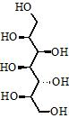 | C7H16O7
2 | 5.25 | 443.190 | 397.1949; 251.1237; 163.0664; 101.0276 | Penstemide | 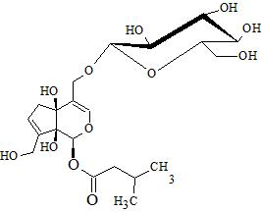 | C21H32C10
3 | 6.31 | 863.212 | 411.0905; 289.0823; 451.1193 | Procyanidin trimer |  | C48H36O18
4 | 7.56 | 441.205 | 395.2015; 263.1583; 330.1476; 113.0288; 139.8753 | Hydroxyabscisic acid β-D-glucoside | 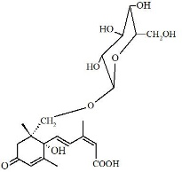 | C21H30O10
5 | 10.1 | 353.214 | 307.1618; 263.1774; 135.0500; 221.1280 | Caffeoylquinic acid | 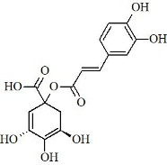 | C16H18O9
6 | 10.37 | 289.211 | 271.2032; 253.1924; 213.1595; 169.1677 | Catechin/ epicatechin | 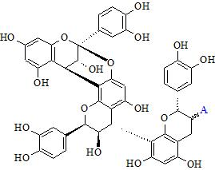 | C15H14O6
7 | 11.18 | 329.242 | 201.1211; 311.2372 | Vanillic acid glucoside | 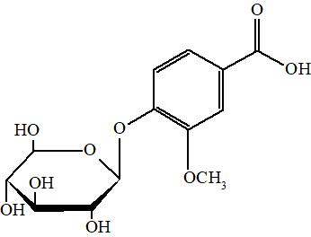 | C14H18O9

Supplementary Table. 1. Retention time, m/z, MS/MS fragments, chemical structure of major phytochemicals characterized by HR-MS.

Fig. S1. Absorption spectra of AgNPs recorded during synthesis at various time period using 10, 20, 30, 40 and 50 % of extract and 3 mM of AgNO₃ (A-E).

A

B

Fig. S2. DLS of AgNPs showing the values of diameter and width of particles (A). EDS spectrum of AgNPs (B). Inset Table: % atomic weight of elements.

