Online Supplementary Material
________________________________________
Passive personal air sampling of dust in a working environment – a pilot study

Mariam Shirdel¹, Ingvar A. Bergdahl¹, Britt M. Andersson², Håkan Wingfors³, Johan N. Sommar¹ and Ingrid E. Liljelind¹

¹Occupational and Environmental Medicine, Department of Public Health and Clinical Medicine, Umeå University, SE-901 87 Umeå, Sweden
²Department of Applied Physics and Electronics, Umeå University, SE-901 87 Umeå, Sweden
³Swedish Defence Research Agency, CBRN Defence & Security Division, Cementvägen 20, SE-901 82 Umeå, Sweden

Supplementary Data
Images from elemental mapping of particles on the collection surface of the UNC sampler with an energy dispersive spectroscopy detector (EDS) in a scanning electron microscope (SEM) are shown in Figures 1 and 2. Two different examples are shown to provide an illustration of how the images from elemental mapping appear. Figure S1 consists of one big particle and Figure S2 consists of an agglomerate of particles.
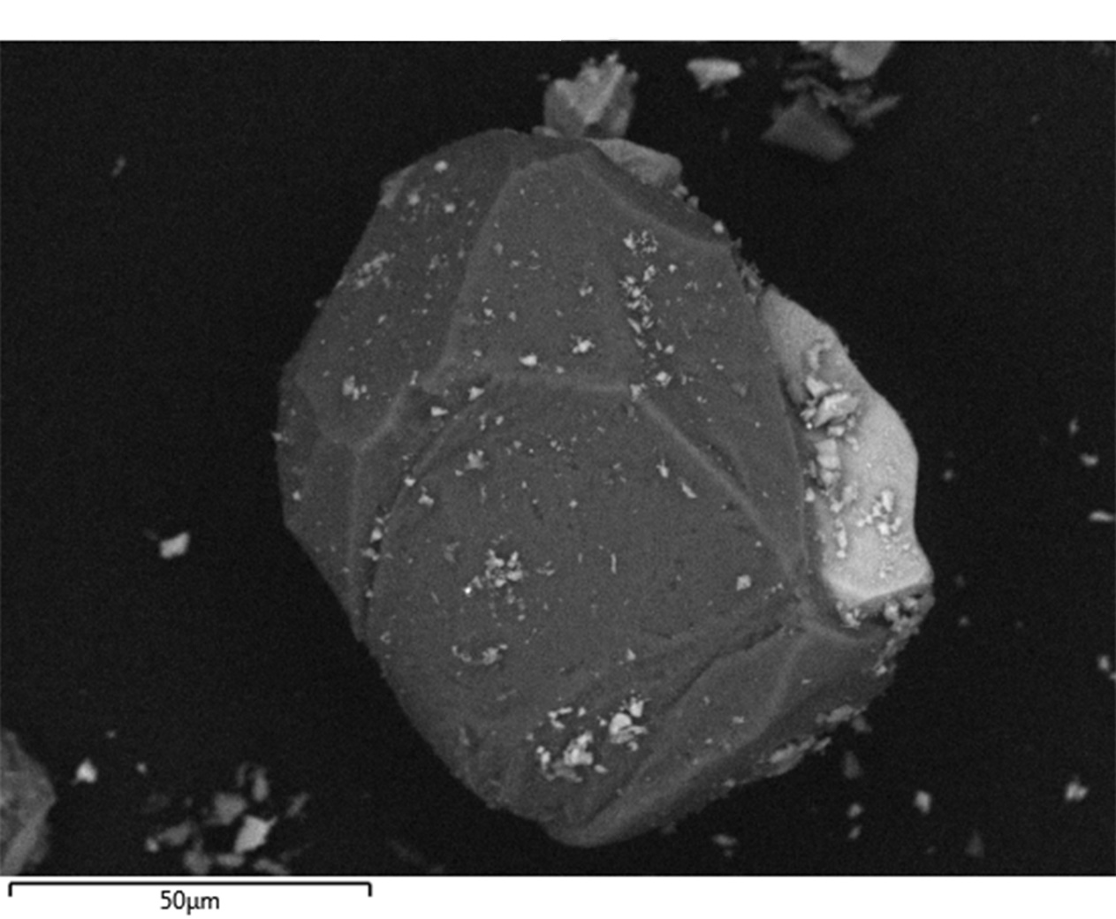
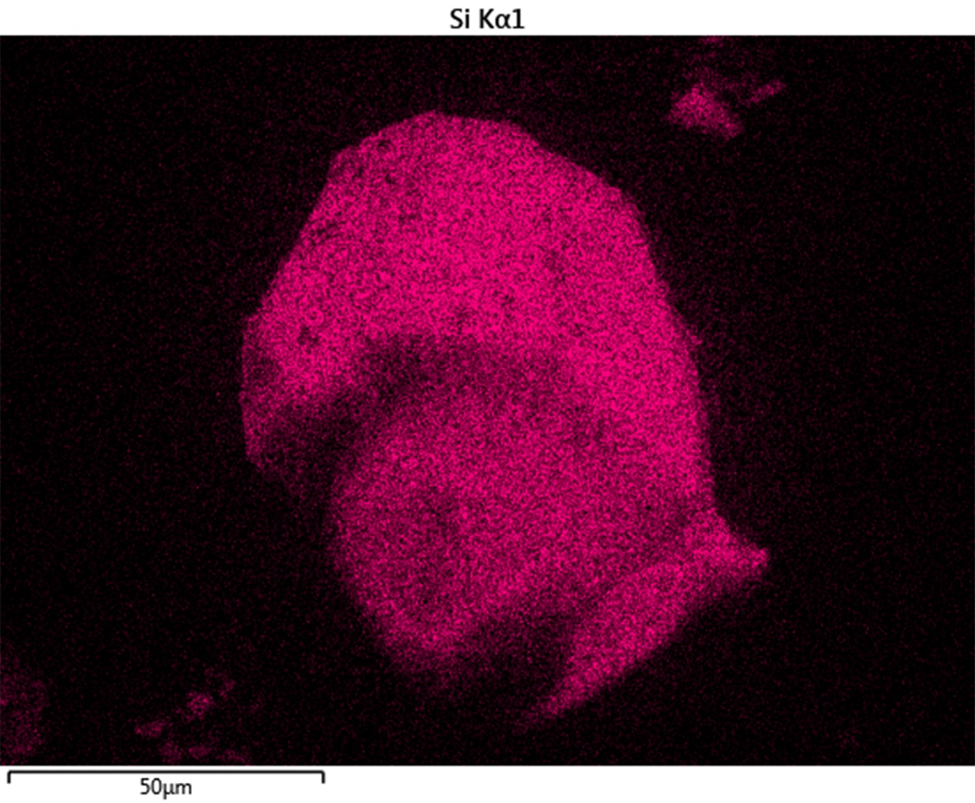
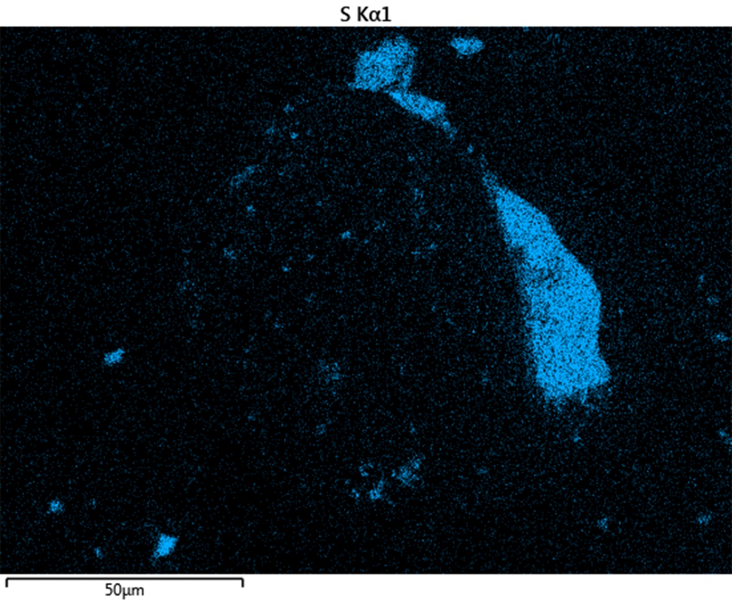
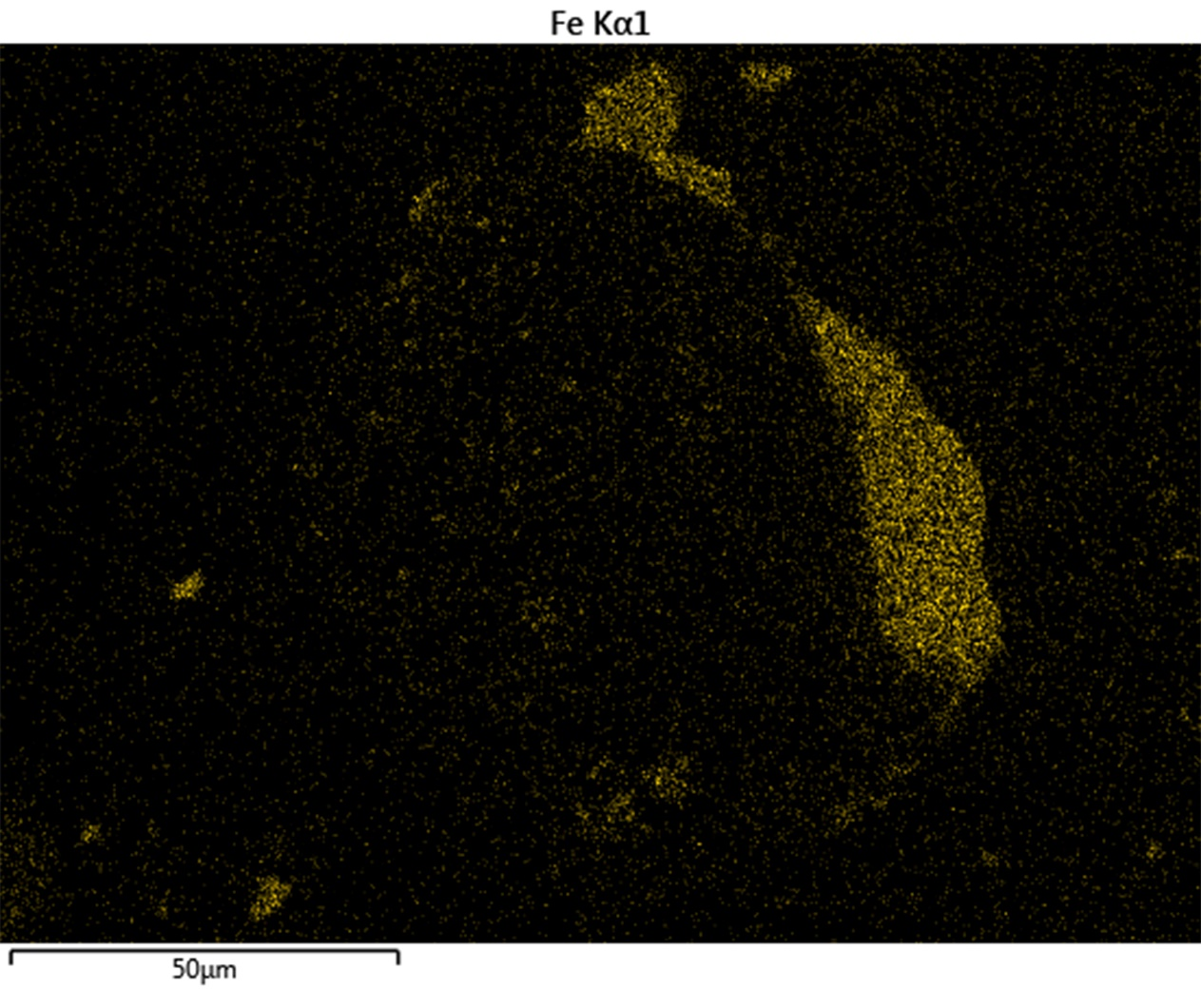
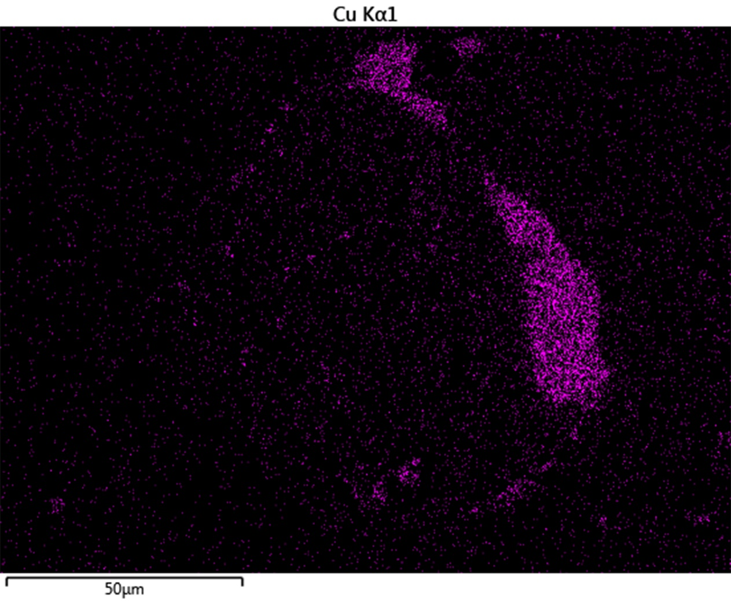
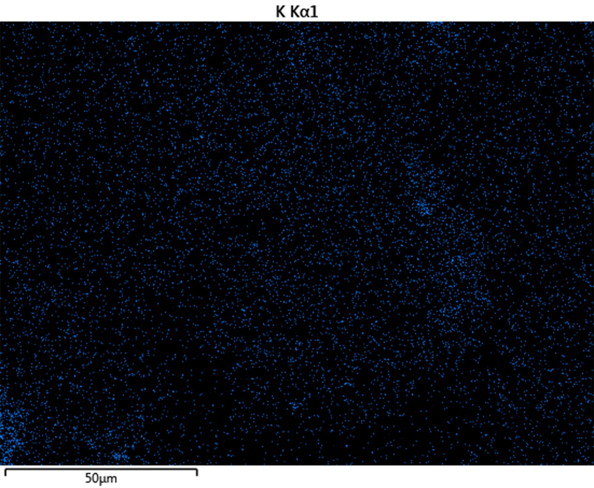
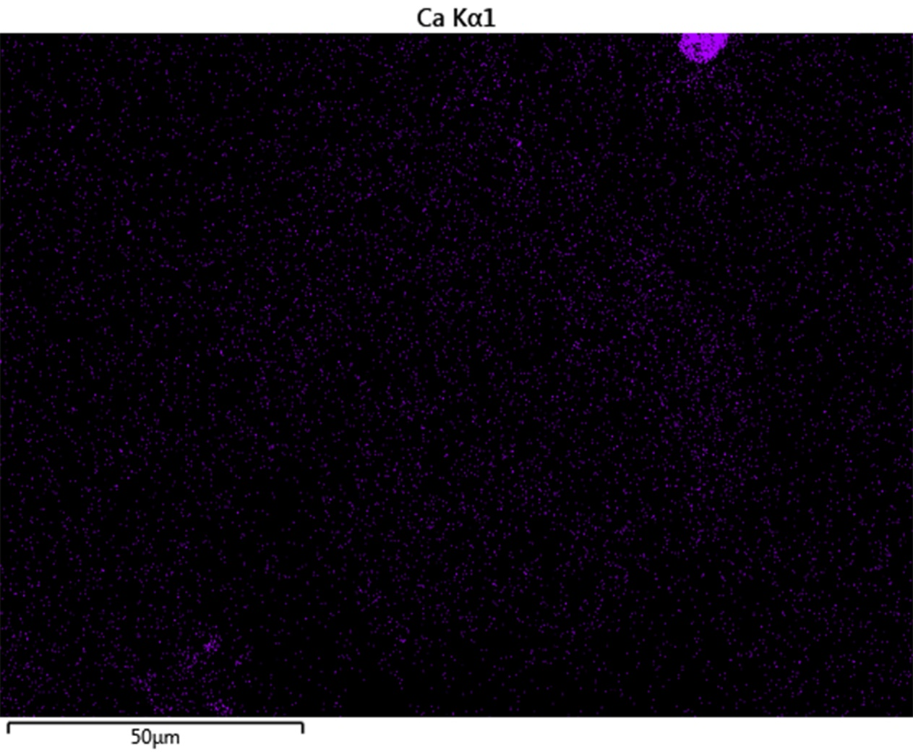
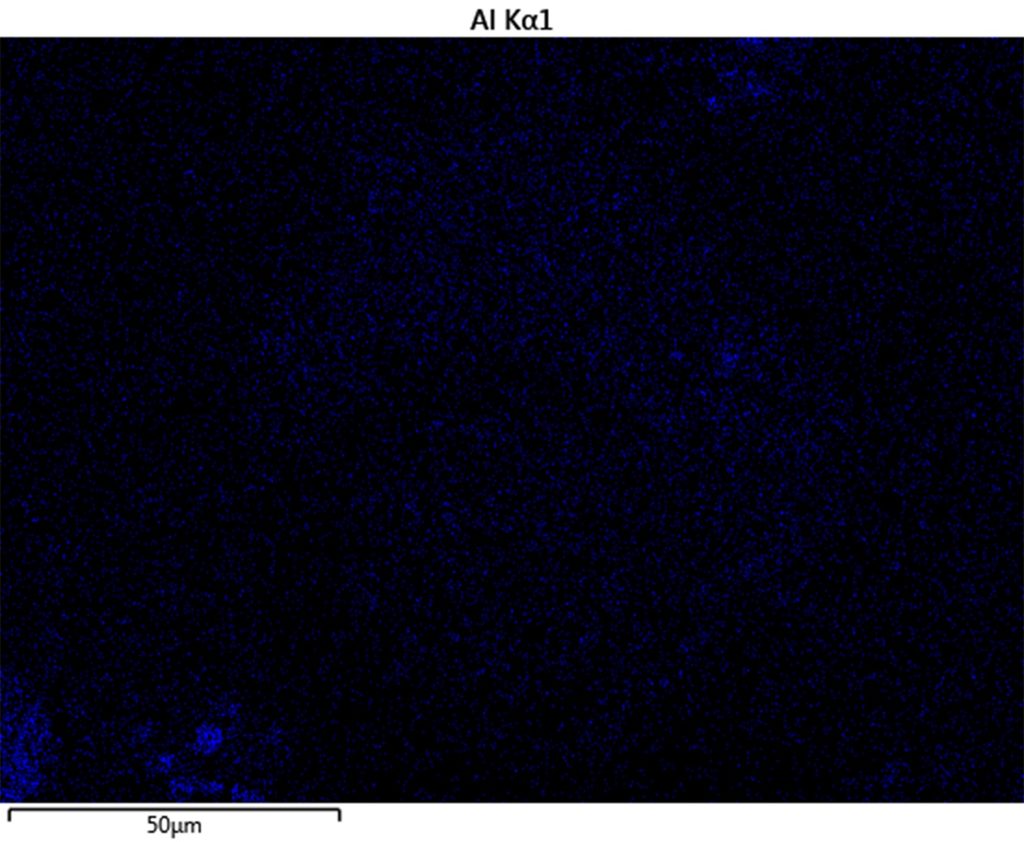
Figure S1. Elemental mapping of one large particle, indicating considerable mineral content. The particle contains traces of silicon, sulphur, iron, copper, potassium, calcium, and aluminium.

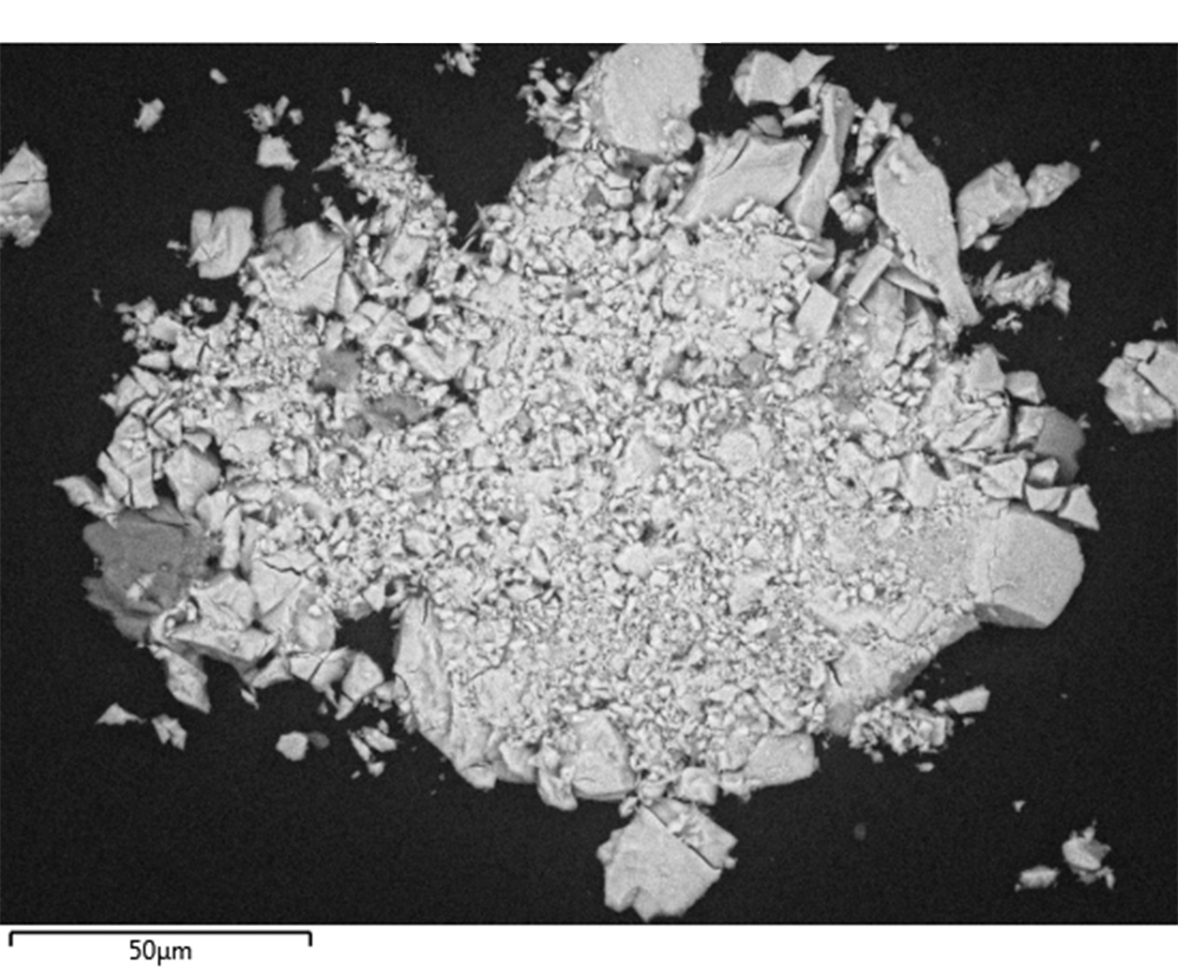
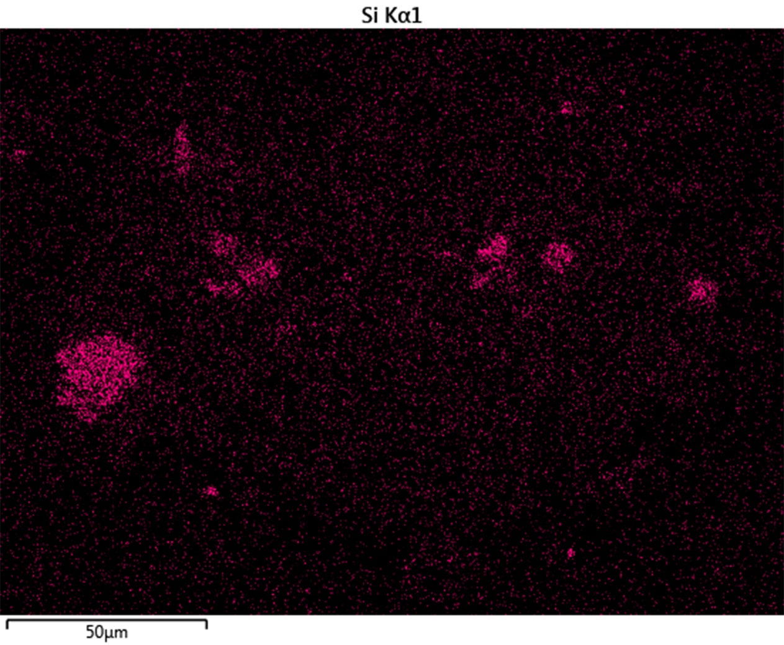
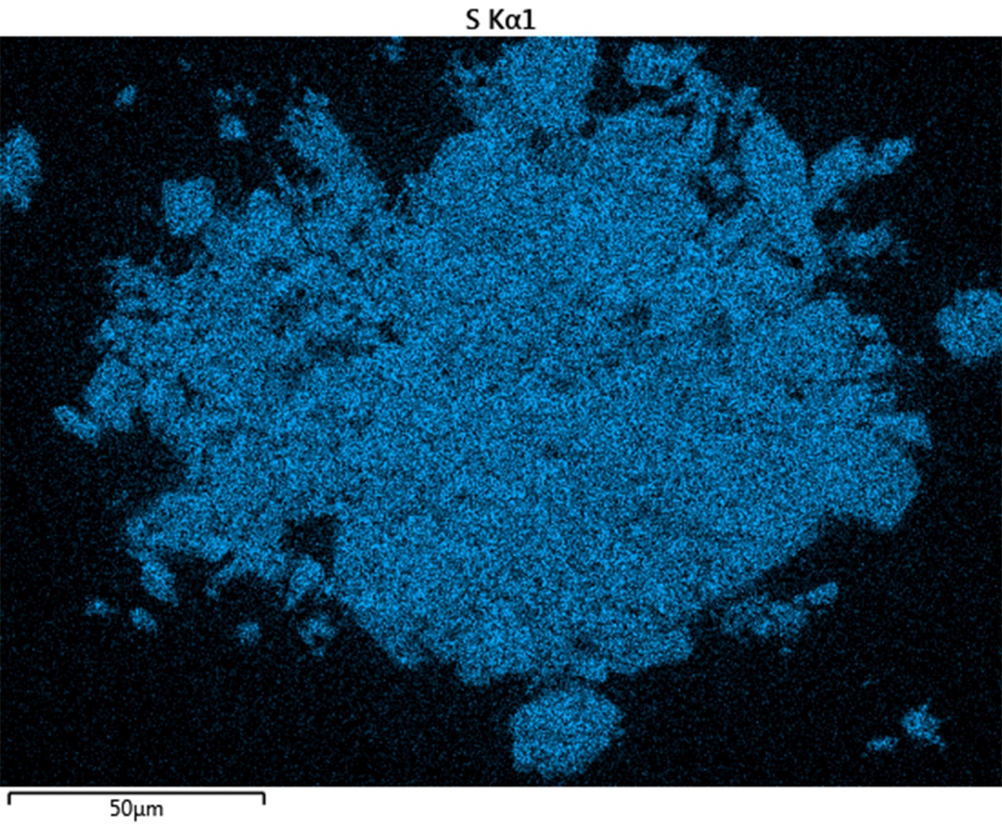
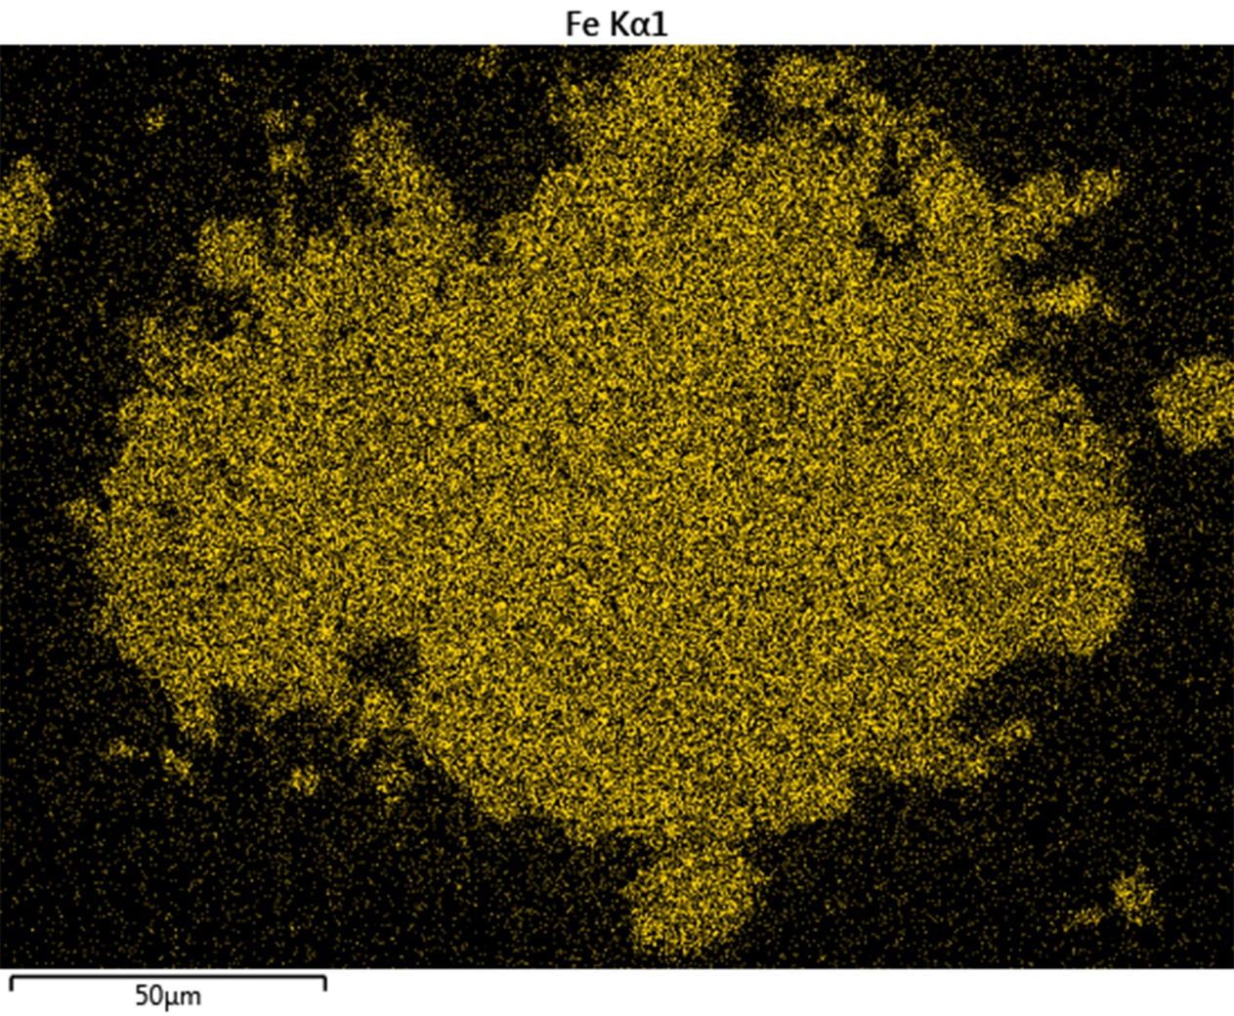
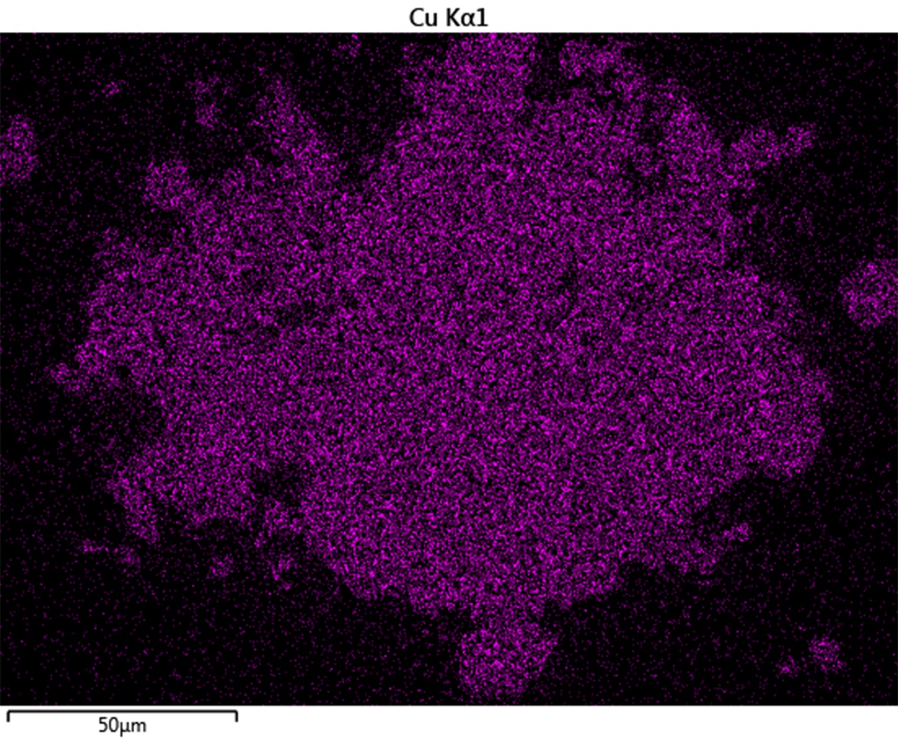
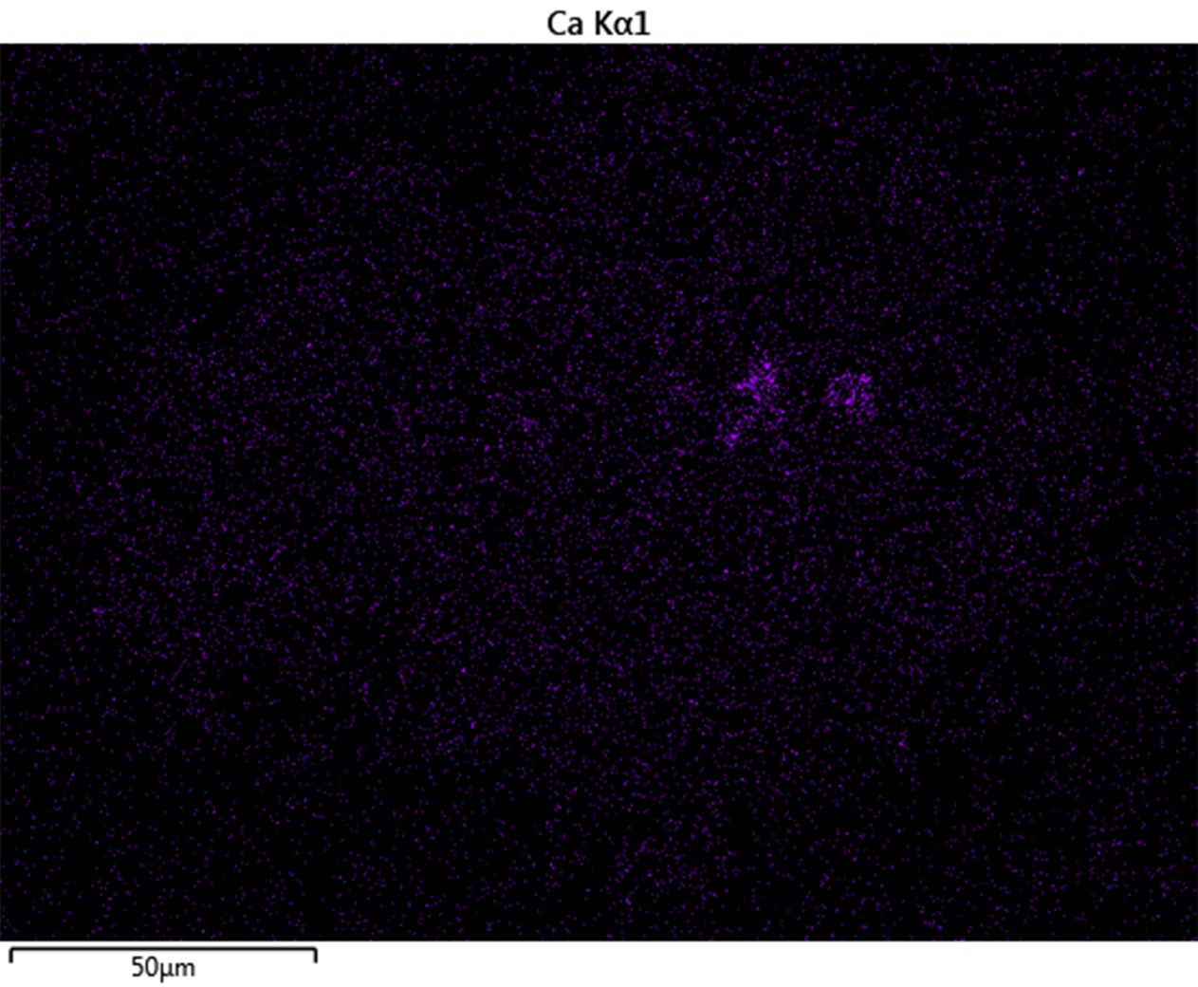
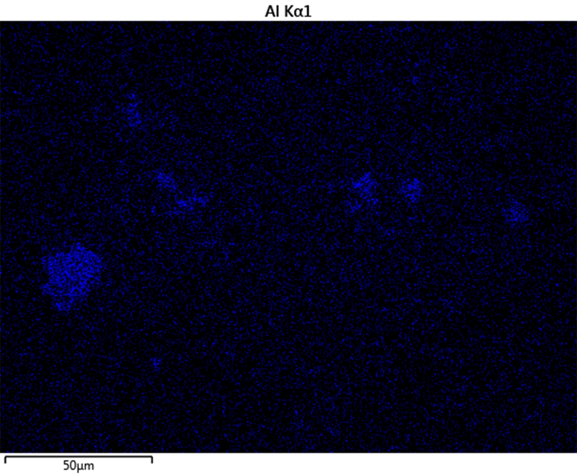
Figure S2. Elemental mapping of an agglomeration of particles indicating considerable mineral content. The particles contain traces of silicon, sulphur, iron, copper, calcium, and aluminium, but the EDS did not record any potassium.

