Cucurbituril derivatives as oxygen carriers
Supporting Information
Gaspard Huber, Patrick Berthault, Anvi Laetitia Nguyen, Alain Pruvost, Elodie Barruet, Julie Rivollier, Marie-Pierre Heck and Benoît Prieur

Table of contents

Binding constant extraction 2
Figure S1 - Inductively coupled plasma mass spectrometry 3
Figure S2 - electrospray ionization mass spectra 4
Figure S3 – ¹H NMR of (OH)₁₀CB[5] 3 in DMSO-d₆ 7
Figure S4 – ¹H relaxation rates of (OH)₁₀CB[5] 3 9
Figure S5 – relaxation rates of 1, 2 and 3 10
Table S1 - Full-width half maximum of the Hax 1H signals of the three cucurbiturils under study, at 293 K 11
Table S2 - Full-width half maximum of OH₁₀CB[5] 3, in a 0.15 M NaCl solution, at 310 K 12

Binding constant extraction
For a model where a cucurbituril can bind one O₂ molecule at most, called 1:1 model, the law of mass action $K=\frac{\left[O_{2}@C\right]}{\left[O_{2}\right]\left[C\right]}$ (1)
and the law of conservation of matter $\left[C_{0}\right]=\left[C\right]+\left[O_{2}@C\right]$ (2)
stand, where [C], [O₂@C] and [C₀] are the free, binding one O₂ guest, and total host concentrations, respectively. In the regime where exchange is far faster than relaxation rate R₁, R₁ is a weighted average of a diamagnetic component R_{1d} where the host C does not bind O₂, and a paramagnetic component R_{1p} where an O₂-C binding occurs. Thus, R₁ verifies the following equation: $R_{1}=\frac{1}{1+K\left[O_{2}\right]}R_{1d}+\frac{K\left[O_{2}\right]}{1+K\left[O_{2}\right]}R_{1p}$ (3)
This equation has been fitted against the O₂ concentration, obtained from the product of O₂ pressure above the solution and the solubility value of 0.18 mM/bar.¹ The reverse of the relative errors on fitted R₁ values have been used as weights for the fitting of K.
In the model where two O₂ molecules, but not only one, called 2:1 model, are encapsulated, equations (1), (2) and (3) become:
$K=\frac{\left[O_{2}@C\right]}{{\left[O_{2}\right]}^{2}\left[C\right]}$ (4)
$\left[C_{0}\right]=\left[C\right]+\left[{\left(O_{2}\right)}_{2}@C\right]$ (5)
$R_{1}=\frac{1}{1+K{\left[O_{2}\right]}^{2}}R_{1d}+\frac{K{\left[O_{2}\right]}^{2}}{1+K{\left[O_{2}\right]}^{2}}R_{1p}$ (6)
R₁ values of H_{ax} of 3 as a function of [O₂] are then used as inputs for a nonlinear least squares fitting procedure (nls function from the R software), adjusting K, R_{1d} and R_{1p} in both 1:1 and 2:1 models.

(1) Garcia, H. E.; Gordon, L. I. Oxygen Solubility in Seawater: Better Fitting Equations. Limnol. Oceanogr. 1992, 37 (6), 1307–1312.

Figure S1 - Inductively coupled plasma mass spectrometry
Titration of potassium in CB[5] 1 and (HO)₁₀CB[5] 3 by ICP-MS, in collision cell mode (KED) mode. The calibration is performed by diluting a certified K standard (diamonds and solid line). (a) The 0.35 mM solution of CB[5] 1, diluted by a factor 1000, indicates a potassium concentration of the non-diluted solution of 0.67 mM (circle and dashed lines). (b) The 1.27 mM solution of (HO)₁₀CB[5], diluted by a factor 10000, indicates a potassium concentration of the non-diluted solution of 5.9 mM.
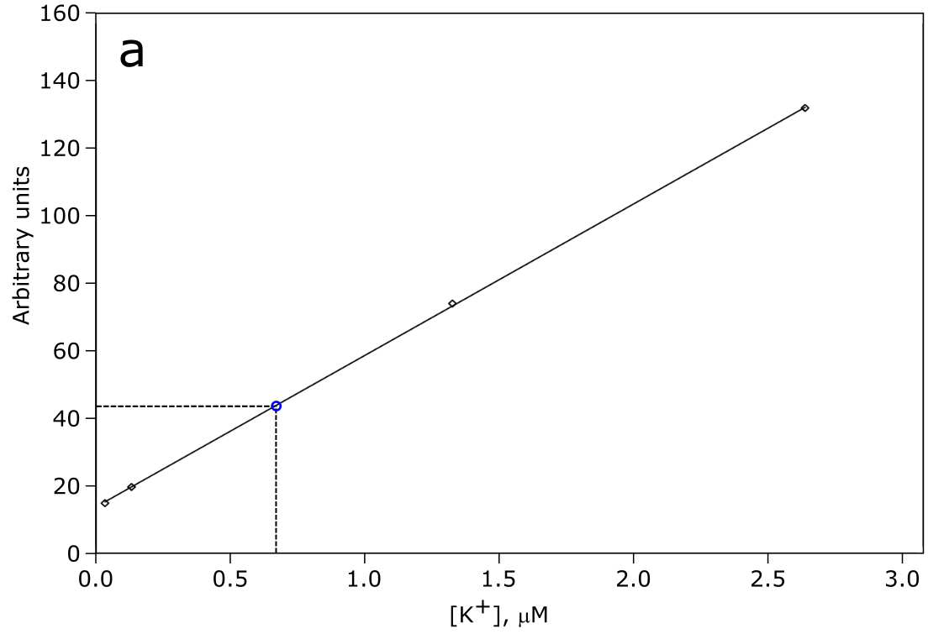
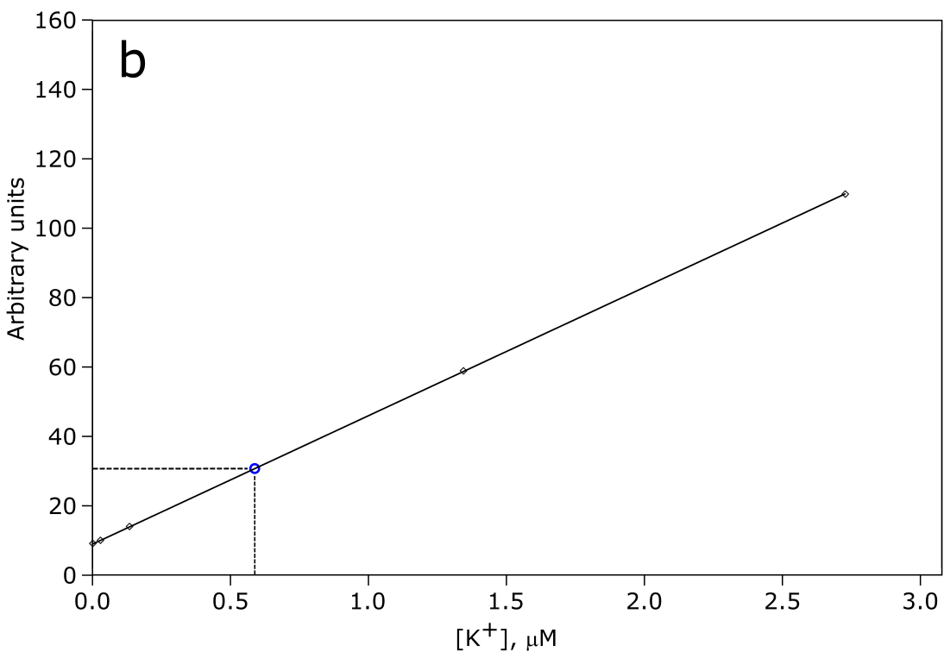

Figure S2 - electrospray ionization mass spectra
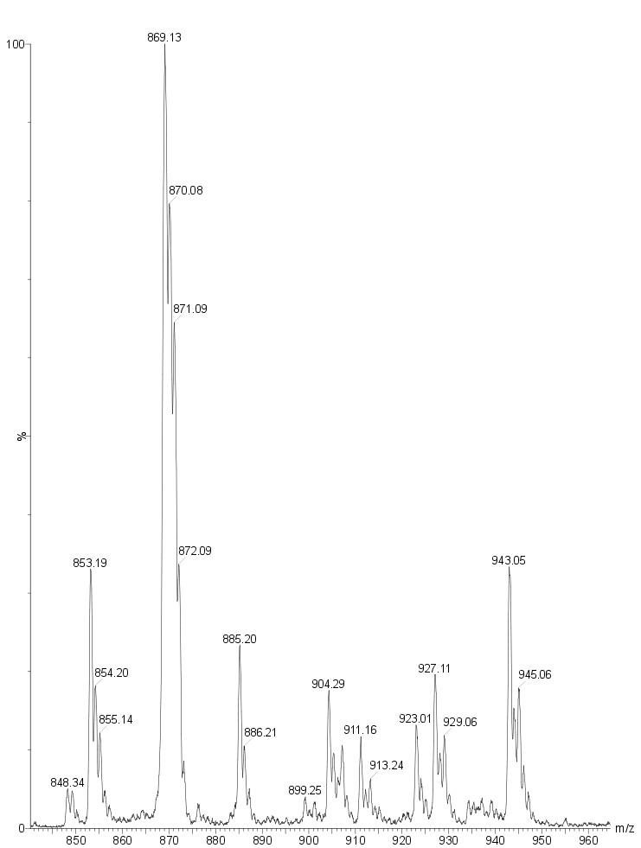
Positive ion electrospray ionization mode mass spectra (ESI-MS) of (a) CB[5] 1, (b) Me₁₀CB[5] 2 and (c) OH₁₀CB[5] 3.
CB[5]
M=830 Da
M+Na⁺
M+K⁺
M+NH₄⁺
a)

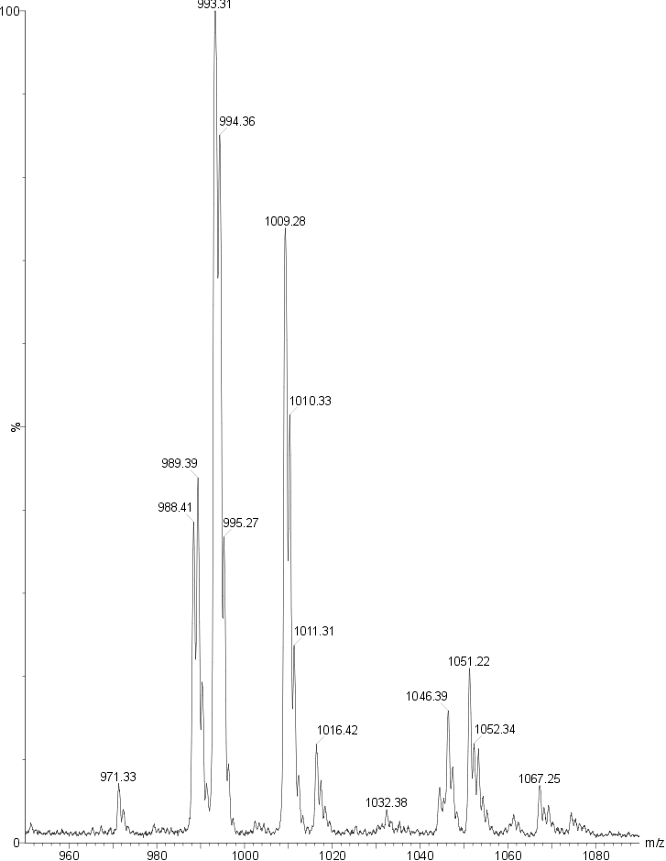
Me₁₀CB[5]
M=970 Da
M+K⁺
M+Na⁺
M+NH₄⁺
b)

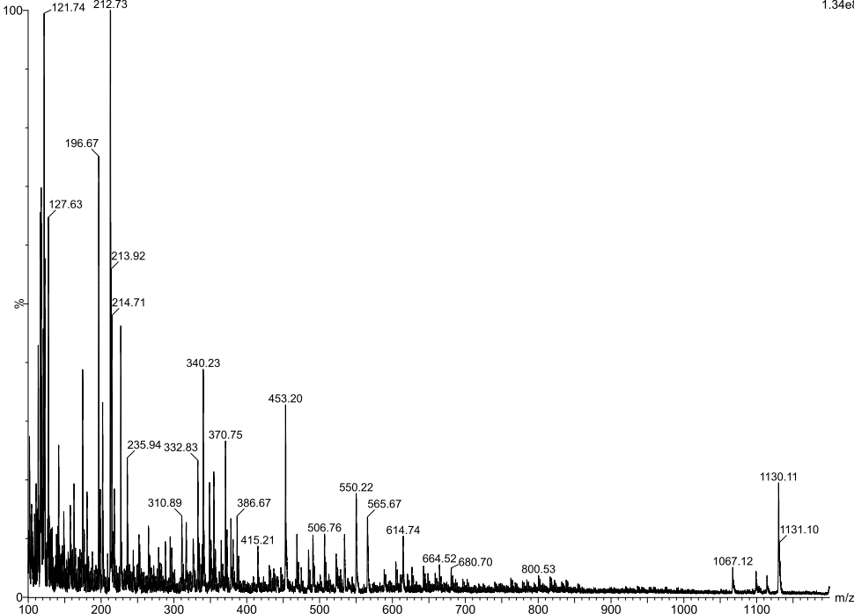
OH₁₀CB[5]
M=990 Da
c)

Figure S3 – ¹H NMR of (OH)₁₀CB[5] 3 in DMSO-d₆
2.7 mM (OH)₁₀CB[5] 3 in DMSO-d₆.

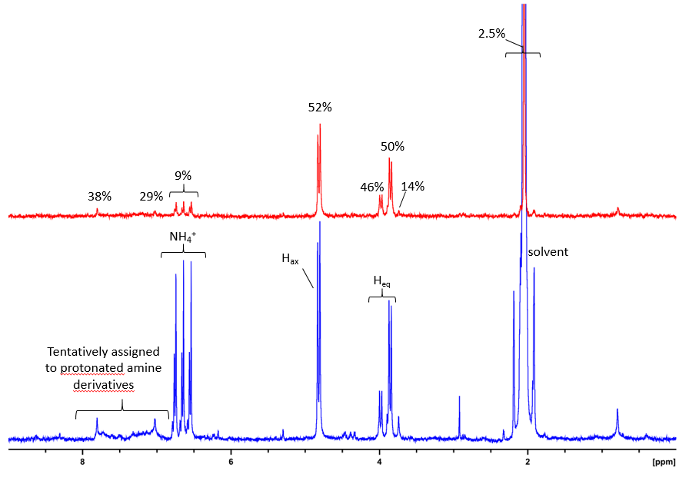

- ¹H NMR spectra with weak (blue) and strong (red) diffusion filters. The red spectrum is scaled to the blue spectrum by taking H_{ax} signals as reference. The DMSO ¹H residual signal (main signal is cut, but 13C satellites are observed) and the signal of NH₄⁺ show a high diffusion coefficient, unlike signals assigned to methylene protons of (OH)₁₀CB[5] and signals tentatively assigned to alkyl amines.

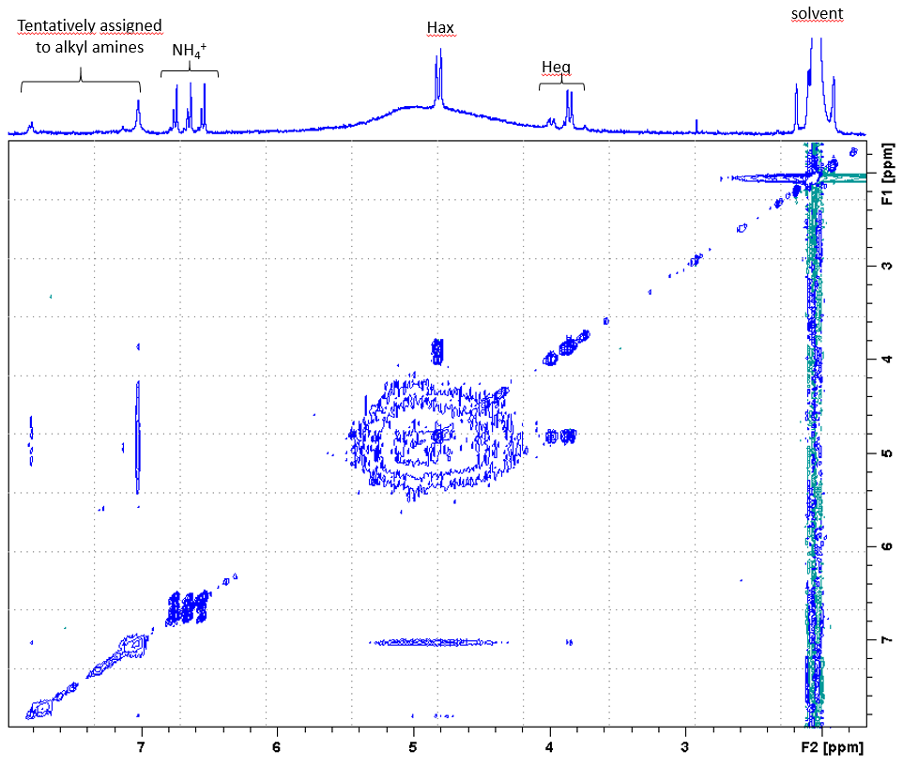
- NOESY spectrum with a mixing time of 0.35 second, a recycling delay of 1 second, at 11.7 T. 1D spectrum with recycling delay is displayed above with assignment.

Figure S4 – ¹H relaxation rates of (OH)₁₀CB[5] 3
Fits of the relaxation rate R₁, in s⁻¹, against the inversion-recovery delay for each proton of OH₁₀CB[5] 3 in D₂O solution and the residual protons of solvent, at 293 K. Error bars stand for one standard deviation. The poor precision on the signals of H_{eq} * comes from a partial overlap with the dominant HDO signal.
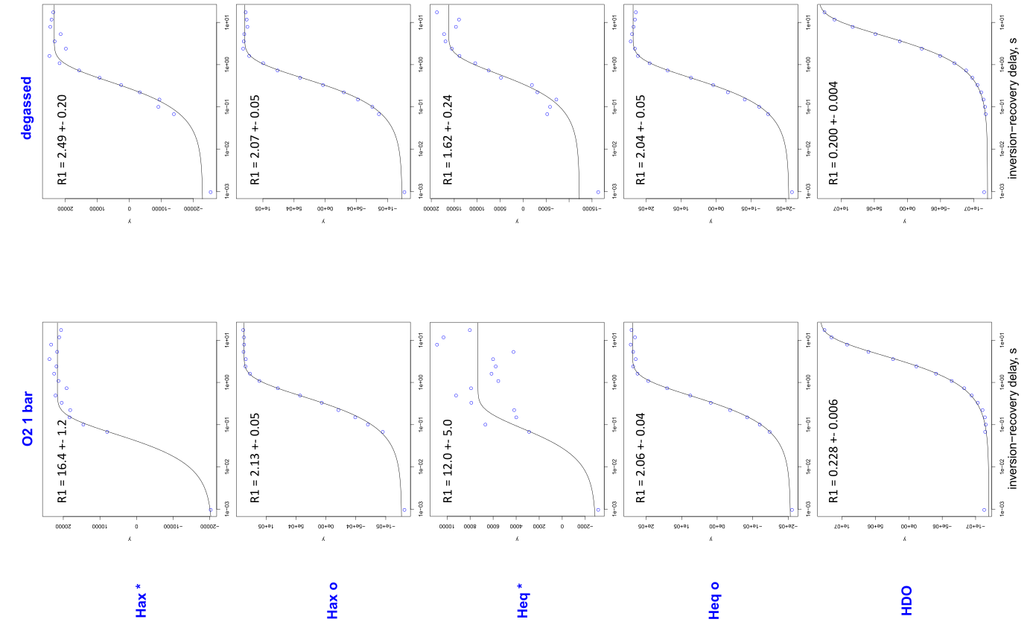

Figure S5 – relaxation rates of 1, 2 and 3
Relaxation rates R₁, in s⁻¹, measured for protons of CB[5] 1, Me₁₀CB[5] 2 and (OH)₁₀CB[5] 3, in D₂O solution, at 293 K. Color codes: blue, under ca. 1 bar of O₂; orange, degassed NMR tubes. Error bars stand for one standard deviation. For a better readability, values are given for HDO signal.
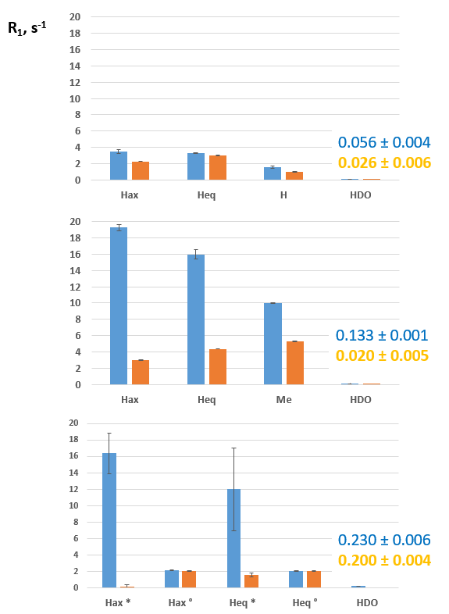

Table S1 - Full-width half maximum of the Hax 1H signals of the three cucurbiturils under study, at 293 K
Full-width half maximum, in s⁻¹, directly measured on the spectra unless otherwise stated, for signals assigned to H_{ax} protons of CB[5] 1 and Me₁₀CB[5] 2 either degassed or under 1 bar of oxygen and, for 2 and 3, also with 155 mM NaCl. O₂ solubility at 293 K is 0.26 mM/bar in pure water and 0.25 mM/bar in a 150 mM NaCl water solution, according to Garcia et Gordon, Limnol Oceanogr 1992;37:1307, already cited in the main text. 3* and 3° stand for signals sensitive and not sensitive to the presence of O2, respectively, as identified in Figure 2.

Molecule | NaCl concentration, mM | O₂ concentration, mM | H_{ax}
CB[5] 1 | 0 | Degassed sample | 2.8
CB[5] 1 | 0 | 0.26 | 3.3
Me₁₀CB[5] 2 | 0 | Degassed sample | 3.4
Me₁₀CB[5] 2 | 0 | 0. 26 | 16
OH₁₀CB[5] 3° | 0 | Degassed sample | 2.3
OH₁₀CB[5] 3° | 0 | 0. 26 | 3.0
OH₁₀CB[5] 3* | 0 | Degassed sample | 2.5
OH₁₀CB[5] 3* | 0 | 0. 26 | 10.4
Me₁₀CB[5] 2 | 155 | Degassed sample | 3.1
Me₁₀CB[5] 2 | 155 | 0. 25 | 5.1
OH₁₀CB[5] 3° | 155 | Degassed sample | 3.0
OH₁₀CB[5] 3° | 155 | 0. 25 | 3.9
OH₁₀CB[5] 3* | 155 | Degassed sample | 4.3
OH₁₀CB[5] 3* | 155 | 0. 25 | 15.7 ª

a: this value results from a fit using PeakFit software.

Table S2 - Full-width half maximum of OH₁₀CB[5] 3, in a 0.15 M NaCl solution, at 310 K
Full-width half maximum, in s⁻¹, directly measured on the spectra unless otherwise stated, for signals assigned to H_{ax} protons marked by a star or a circle in Figure 3, i.e. those of OH₁₀CB[5] 3 sensitive or not to O₂ binding. In these conditions, O₂ solubility is estimated to 0.18 mM Garcia et Gordon, Limnol Oceanogr 1992;37:1307.

O₂ concentration, mM | H_{ax} * | H_{ax} °
Degassed sample | 2.7 | 3.5
0.0012 | 2.7 | 3.6
0.0033 | 3.0 | 3.7
0.0049 | 2.9 | 3.4
0.0112 | 5.0 | 3.2
0.0133 | 8.3 | 4.8
0.0287 | 9.7 | 4.1
0.0731 | 13.5 ª | 3.7
0.1800 | 14.5 ^{b} and 21.0 ^{b,c} | 3.3 and 3.9 ª
0.9326 | 39.0 ^{b} | 3.6

a: this value results from a fit using PeakFit software.
b: values estimated from measurement of the line-width of the doublet, then subtracting the known J coupling of 16 Hz.
c: from 2 distinct samples.

