Supporting information for
Characterization and Demonstration of a Black Carbon Aerosol Mimic for Instrument Evaluation

Christopher D. Zangmeister^{1,} Courtney Grimes², Russell R. Dickerson³, James G. Radney¹
1. Material Measurement Laboratory, National Institute of Standards and Technology,
Gaithersburg, Maryland, 20899, USA
2. Department of Chemistry, University of Maryland, College Park, Maryland, 20742, USA
3. Department of Atmospheric and Oceanic Science, University of Maryland, College Park, Maryland, 20742, USA

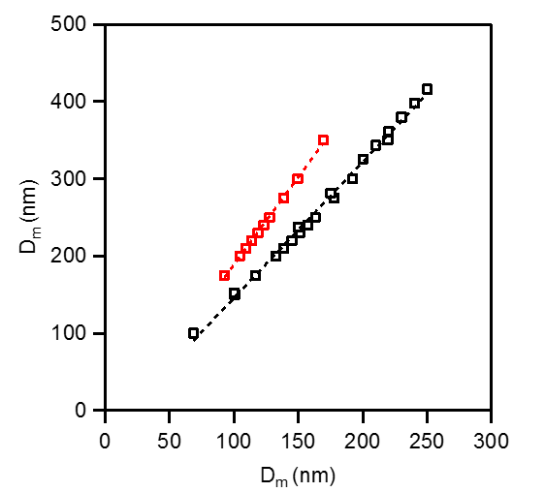
Figure S1. D_{m} of q = +2 (black) and +3 (red) as a function of D_{m} for q = +1 for D_{m} selected CB aerosol. Dashed lines represent linear best fit of each dataset.

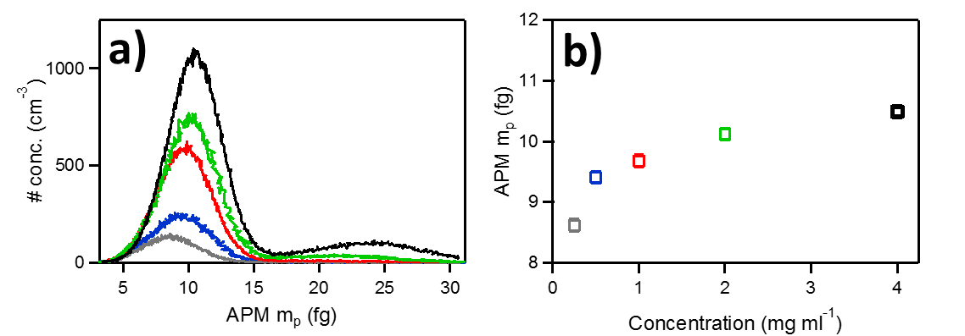
Figure S2. a) Aerosol concentration as a function of aerosol mass (mp) for D_{m} = 300 nm CB 0.25 (grey), 0.50 (blue) 1.0 (red), 2.0 (green), 4.0 (black) mg CB mL⁻¹ aqueous CB suspensions. b) Peak mp for D_{m} = 300 nm CB aerosol as a function of CM suspension concentration.

Table S1.
D_{m}  (nm) | MEC λ = 405 nm  (m² g⁻¹) | MEC λ = 660 nm  (m² g⁻¹)
150 | 13.45 ± 0.86 | 5.79 ± 0.28
200 | 14.02 ± 0.76 | 6.97 ± 0.43
250 | 13.84 ± 0.89 | 7.99 ± 0.95
300 | 13.14 ± 0.91 | 8.33 ± 0.78
350 | 12.27 ± 0.86 | 8.55 ± 0.96
400 | 11.83 ± 0.97 | 8.16 ± 1.02
450 | 11.17 ± 0.81 | 8.64 ± 0.57
500 | 10.65 ± 0.77 | 8.54 ± 0.62

