A Mechanistic Model to Determine the Uptake and Metabolism of Atorvastatin and Inhibition by Cyclosporine in Rat Hepatocytes Using a High Throughput Method
Simon. J. Carter, Alex S. Ferecskó, Lloyd King, Karelle Ménochet, Ted Parton and Michael. J. Chappell

Supplementary Material
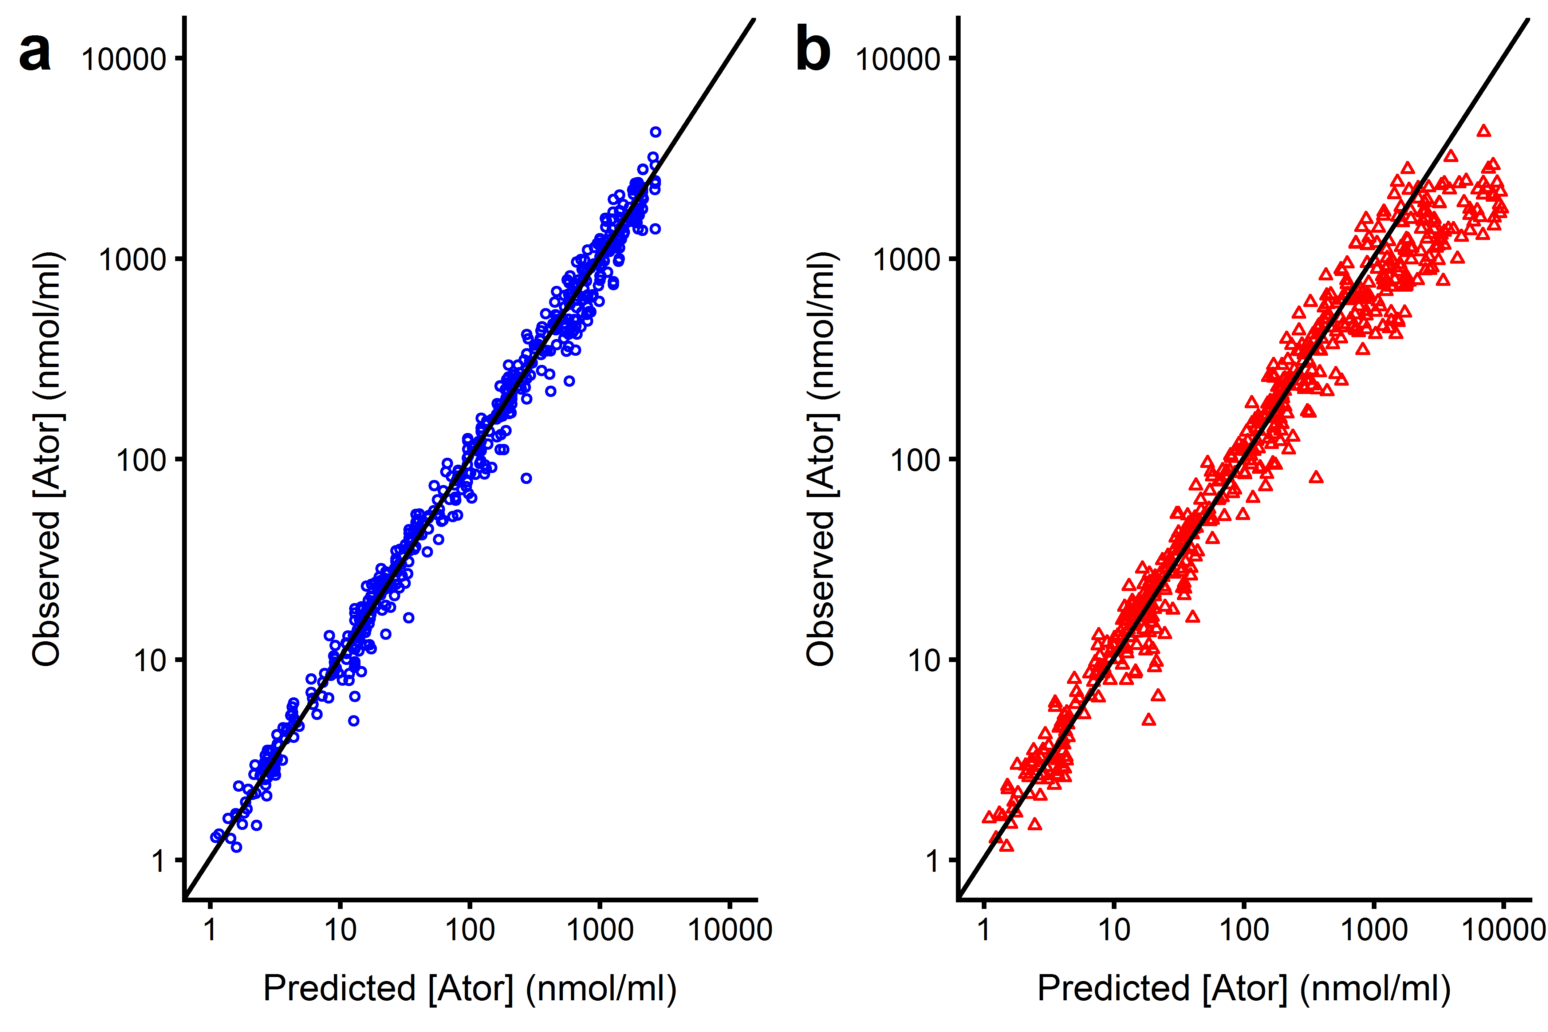
Figure S1: Predicted atorvastatin cellular concentration against observed individual concentration for the best fitting macro-rate constant mechanistic model, Model 3 for all data. Points are data, the black solid line represents the line of unity where observed = predicted. a where two separate passive rate constants were used (blue circles). b where a single passive rate constant and fraction unbound in the cell was used (red triangles)
2-hydroxy atorvastatin and 4-hydroxy atorvastatin were detected within the cell extract at 15 s in the three highest dose groups (25-150 nmol/ml), whilst in the lower dose groups (0.25-5 nmol/ml), detection was variable. The peak area ratio (defined as the ratio of the area of the analyte LCMS peak to that of the internal standard (dextromethorphan) LCMS peak area) of both metabolites was decreased by pre-incubation by CsA, which was similar to the metabolite only at higher atorvastatin incubation concentrations (see Figs. S3 and S4), suggestive of competitive inhibition. The effect of CsA was greatest on 4-hydroxy atorvastatin formation compared to 2-hydroxy atorvastatin formation at lower atorvastatin doses (Figs. S4 and S3 respectively, red dotted lines). Amundsen et al. (2012) also showed the inhibition by CsA on midazolam metabolism to be concentration dependent in human liver microsomes.

Table S1. Compartmental mechanistic model ODEs for competitive and non-competitive inhibition of atorvastatin (A) uptake by CsA (C) in rat hepatocytes.
Micro-rate constant models
Compartment | Competitive Inhibition Model 1 (Fig. 2a) | Non-Competitive Inhibition Model 2 (Fig. 2b)
Medium | $\frac{{dS}_{1}}{dt}=-k_{aA}S_{1}T_{f}-k_{fA}S_{1}+k_{dA}S_{2}+k_{bA}S_{3}$ (1)  $\frac{{dI}_{1}}{dt}=-k_{aC}I_{1}T_{f}+k_{dC}I_{2}$ (2) | $\frac{{dS}_{1}}{dt}= -k_{aA}S_{1}T_{f}-k_{fA}S_{1}+k_{dA}S_{2}+k_{bA}S_{3}-k_{aA}αS_{1}I_{2}+k_{dA}αI_{3}$ (10)  $\frac{{dI}_{1}}{dt}= -k_{aC}I_{1}T_{f}+k_{dC}I_{2}-k_{aC}αS_{2}I_{1}+k_{dC}αI_{3}$ (11)
Transporter | $\frac{{dS}_{2}}{dt}= k_{aA}S_{1}T_{f}-\left(k_{dA}+k_{tA}\right)S_{2}$ (3)  $\frac{{dI}_{2}}{dt}= k_{aC}I_{1}T_{f}-k_{dC}I_{2}$ (4) | $\frac{{dS}_{2}}{dt}= k_{aA}S_{1}T_{f}-\left(k_{dA}+k_{tA}\right)S_{2}-k_{aC}αS_{2}I_{1}+ k_{dC}αI_{3}$ (12)  $\frac{{dI}_{2}}{dt}= k_{aC}I_{1}T_{f}-k_{dC}I_{2}-k_{aA}αS_{1}I_{2}+(k_{dA}+k_{tA}){αI}_{3}$ (13)  $\frac{{dI}_{3}}{dt}= k_{aC}αS_{2}I_{1}+k_{aA}αS_{1}I_{2}-(k_{dA}+k_{tA}+k_{dC})αI_{3}$ (14)
Intracellular | $\frac{{dS}_{3}}{dt}= k_{fA}S_{1}+ k_{tA}S_{2}-k_{bA}S_{3}- \frac{V_{max.met}S_{3}}{K_{m.met}\left(1+\frac{I}{K_{I.met}}\right)+S_{3}}$ (5) | $\frac{{dS}_{3}}{dt}= k_{fA}S_{1}+ k_{tA}S_{2}-k_{bA}S_{3}+ k_{tA}αI_{3}- \frac{V_{max.met}S_{3}}{K_{m.met}\left(1+\frac{I}{K_{I.met}}\right)+S_{3}}$ (15)
Observations (nmol/ml) | $y_{1}=\frac{1}{V_{cell}}\left(S_{2}+S_{3}\right)$ (6) | $y_{1}=\frac{1}{V_{cell}}\left(S_{2}+S_{3}+I_{3}\right)$ (16)
Macro-rate constant models
 | Competitive Inhibition Model 3 (Fig. 2c) | Non-Competitive Inhibition Model 4 (Fig. 2d)
Medium | $\frac{{dS}_{1}}{dt}= -k_{fA}S_{1}-\frac{V_{max.up}S_{1}}{K_{m.up}(1+\frac{I_{1}}{K_{I.up}})+S_{1}}+k_{bA}S_{3}$ (7) | $\frac{{dS}_{1}}{dt}= -k_{fA}S_{1}-\frac{V_{max.up}S_{1}}{(K_{m.up}+S_{1})(1+\frac{I_{1}}{K_{inact}})}+k_{bA}S_{3}$ (17)
Intracellular | $\frac{{dS}_{3}}{dt}= k_{fA}S_{1}+\frac{V_{max}S_{1}}{K_{m}\left(1+\frac{I_{1}}{K_{I}}\right)+S_{1}}-k_{bA}S_{3}- \frac{V_{max.met}S_{3}}{K_{m.met}\left(1+\frac{I}{K_{I.met}}\right)+S_{3}}$ (8) | $\frac{{dS}_{3}}{dt}= k_{fA}S_{1}+\frac{V_{max}S_{1}}{\left(K_{m}+S_{1}\right)\left(1+\frac{I_{1}}{K_{inact.up }}\right)}-k_{bA}S_{3}- \frac{V_{max.met}S_{3}}{K_{m.met}\left(1+\frac{I}{K_{I.met}}\right)+S_{3}}$ (18)
Observations (nmol/ml) | $y_{1}=\frac{1}{V_{cell}}S_{3}$ (9) | $y_{1}=\frac{1}{V_{cell}}S_{3}$ (19)
States – amount (nmol) | S₁ and I₁: atorvastatin and CsA respectively in the medium. S₂ and I₂: atorvastatin and CsA respectively bound to transporter. S₃: intracellular atorvastatin. I₃: atorvastatin-transporter-CsA complex.
Parameters | k_{aA} and k_{aC} are the transporter association rate constants (/nmol/min), k_{dA} and k_{dC} are the dissociation rate constants (/min), k_{tA} is the transporter to intracellular translocation rate constant for atorvastatin (/min), T_{f} is the amount of free transporter (nmol), α is the degree to which bound CsA affects atorvastatin affinity to transporter (dimensionless): α <1 improved atorvastatin affinity, α >1 decreased atorvastatin affinity. V_{cell} is the cell volume per 2x10⁵ cells (0.0011 ml). V_{max} and K_{m} are the maximum transporter uptake velocity (pmol/min) and amount at which 50 % of transporter sites are occupied (nmol). K_{I} and K_{inact} are the competitive and non-competitive inhibition constants respectively (nmol). _{up} = uptake and _{met} = metabolism.

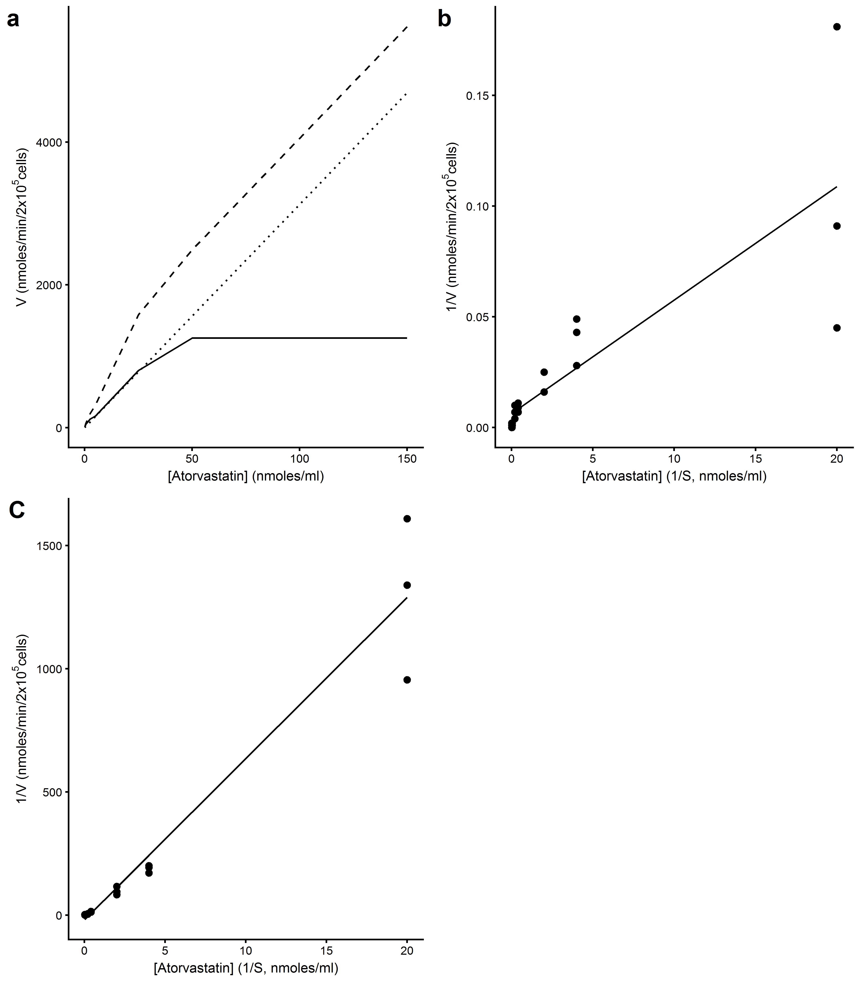
Figure S2: Atorvastatin concentration against velocity or the inverse of the velocity plots. a Yamazaki plot for atorvastatin initial velocity at 15 s against atorvastatin incubation concentration, dashed line = total, dotted line = passive, solid line = saturable uptake, V_{max.up} = 1253 pmol/min/2x10⁵ cells, K_{m.up} = 5-25 nmol/ml. b Lineweaver-Burke plot using ‘Active’ from a, V_{max.up} = 158 (RSE = 80 %) pmol/min/2x10⁵ cells, K_{m.up} = 0.8 (RSE = 14 %) nmol/ml. c Lineweaver-Burke plot for the metabolism of atorvastatin, V_{max.met} = 51.8 (RSE = 143 %) pmol/min/2x10⁵ cells, K_{m.met} = 3.4 (RSE = 5 %) nmol/ml. Data are n=3 from separate experiments
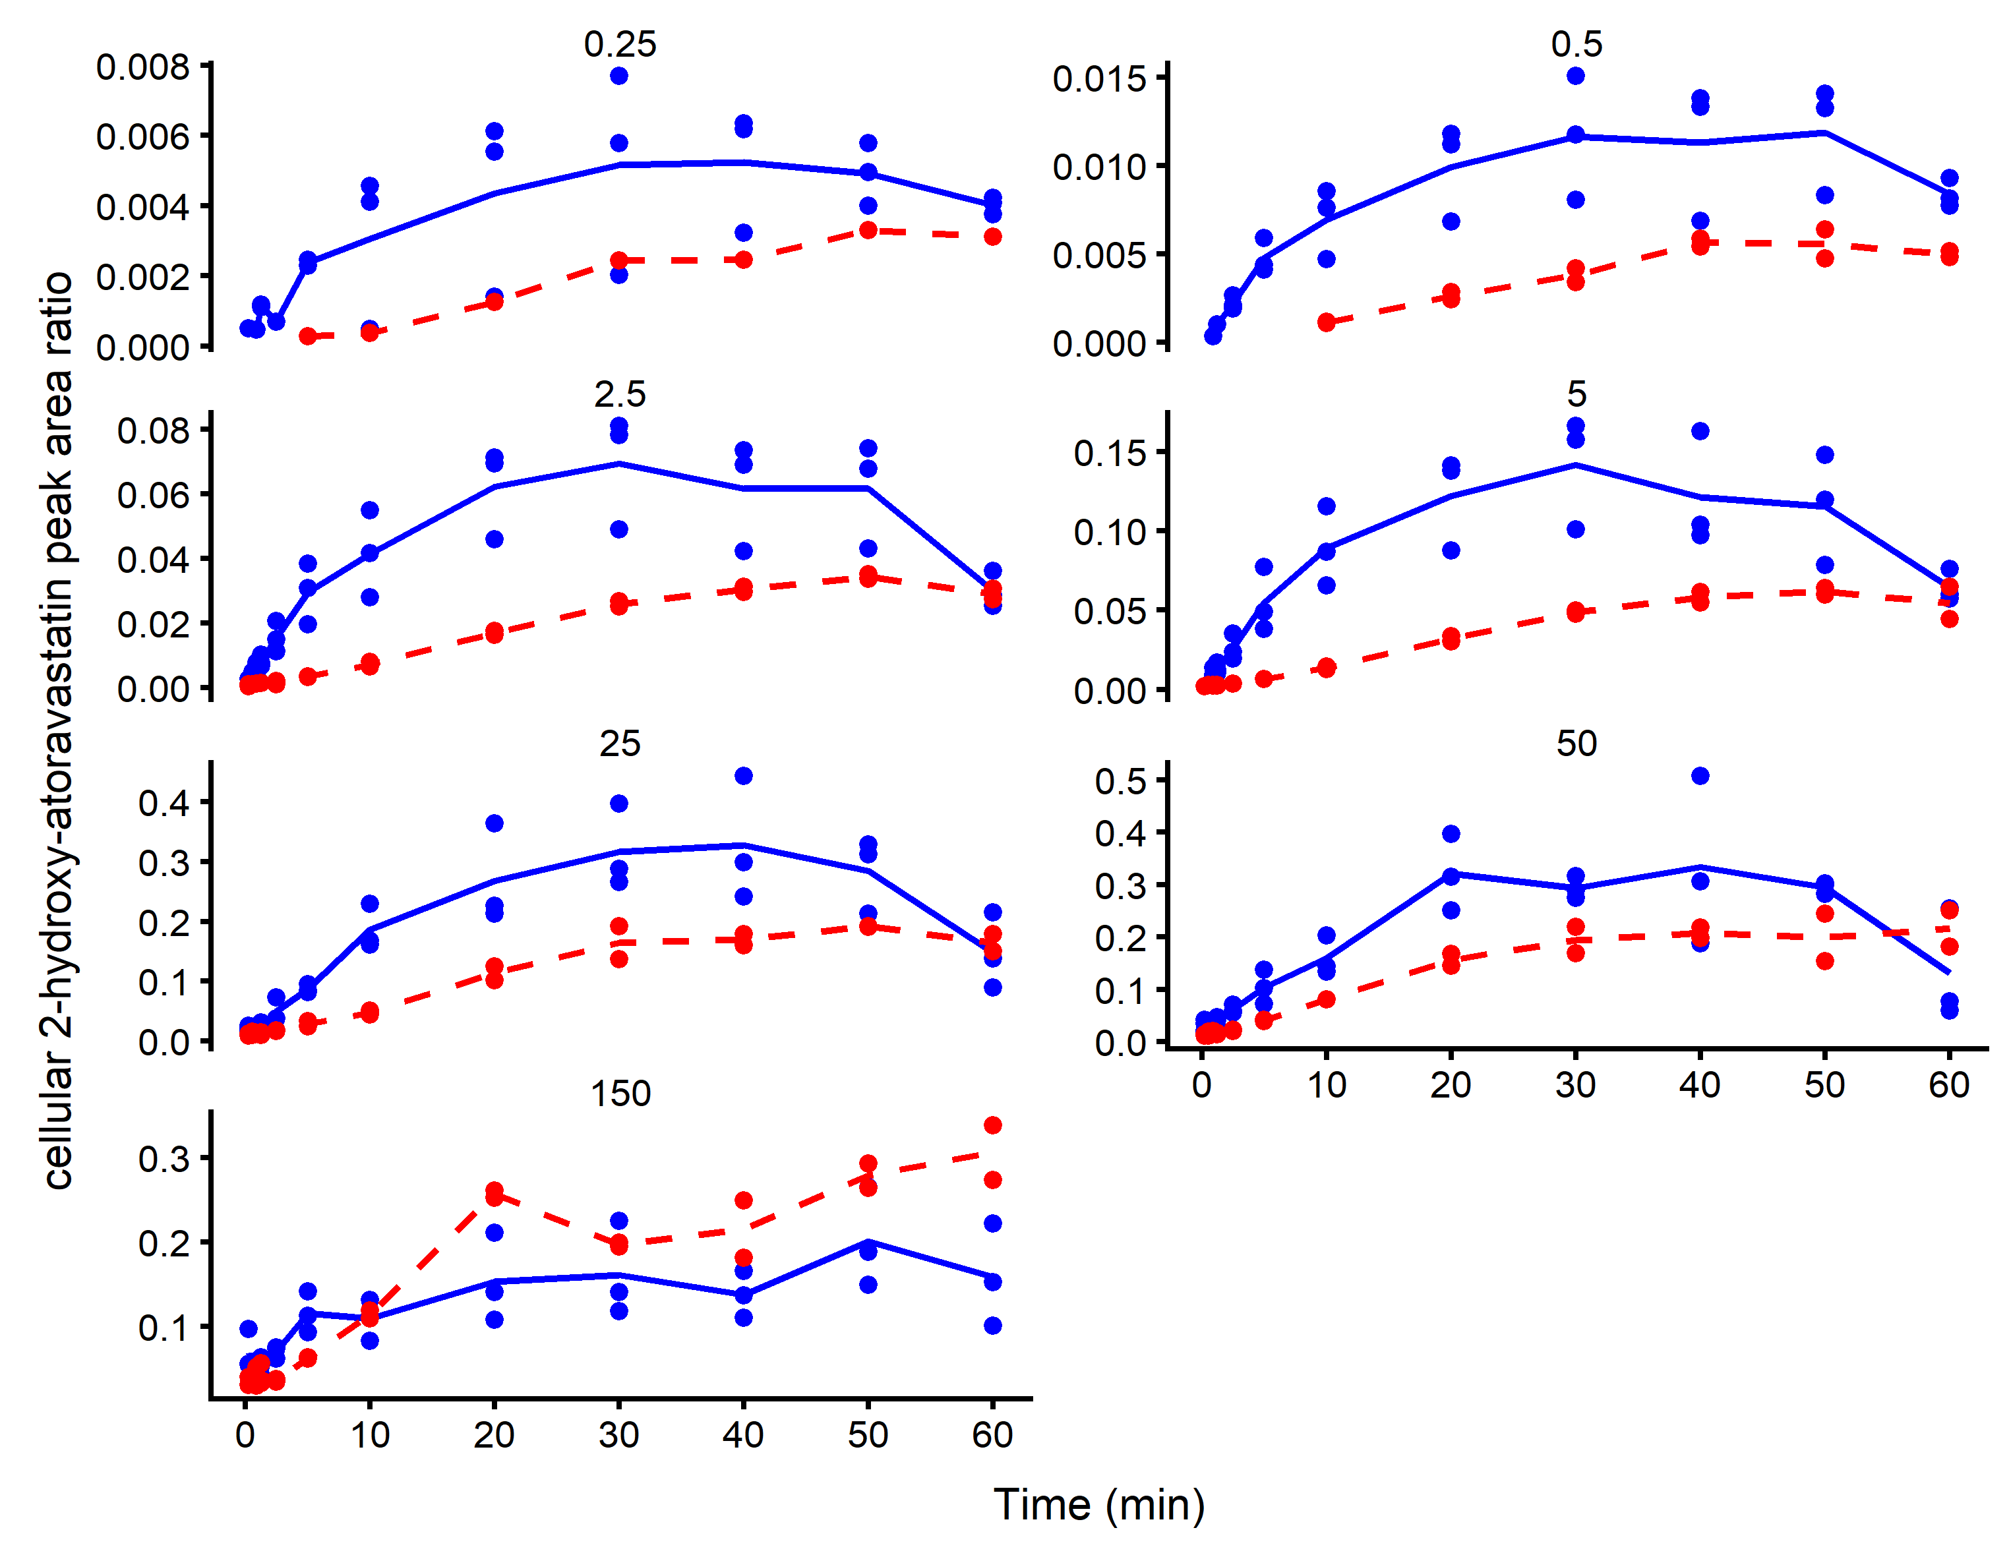
Figure S3: Plots of cellular 2-hydroxy atorvastatin peak area ratio against time following the addition of atorvastatin (0.25, 0.5, 2.5, 5, 25, 50 and 150 nmol/ml) in the absence (blue) and presence (red) of 10 nmol/ml CsA. Each time course represents one experiment from one Teflon block trough. Points are data (n=1-3) and solid lines are the average peak area ratio
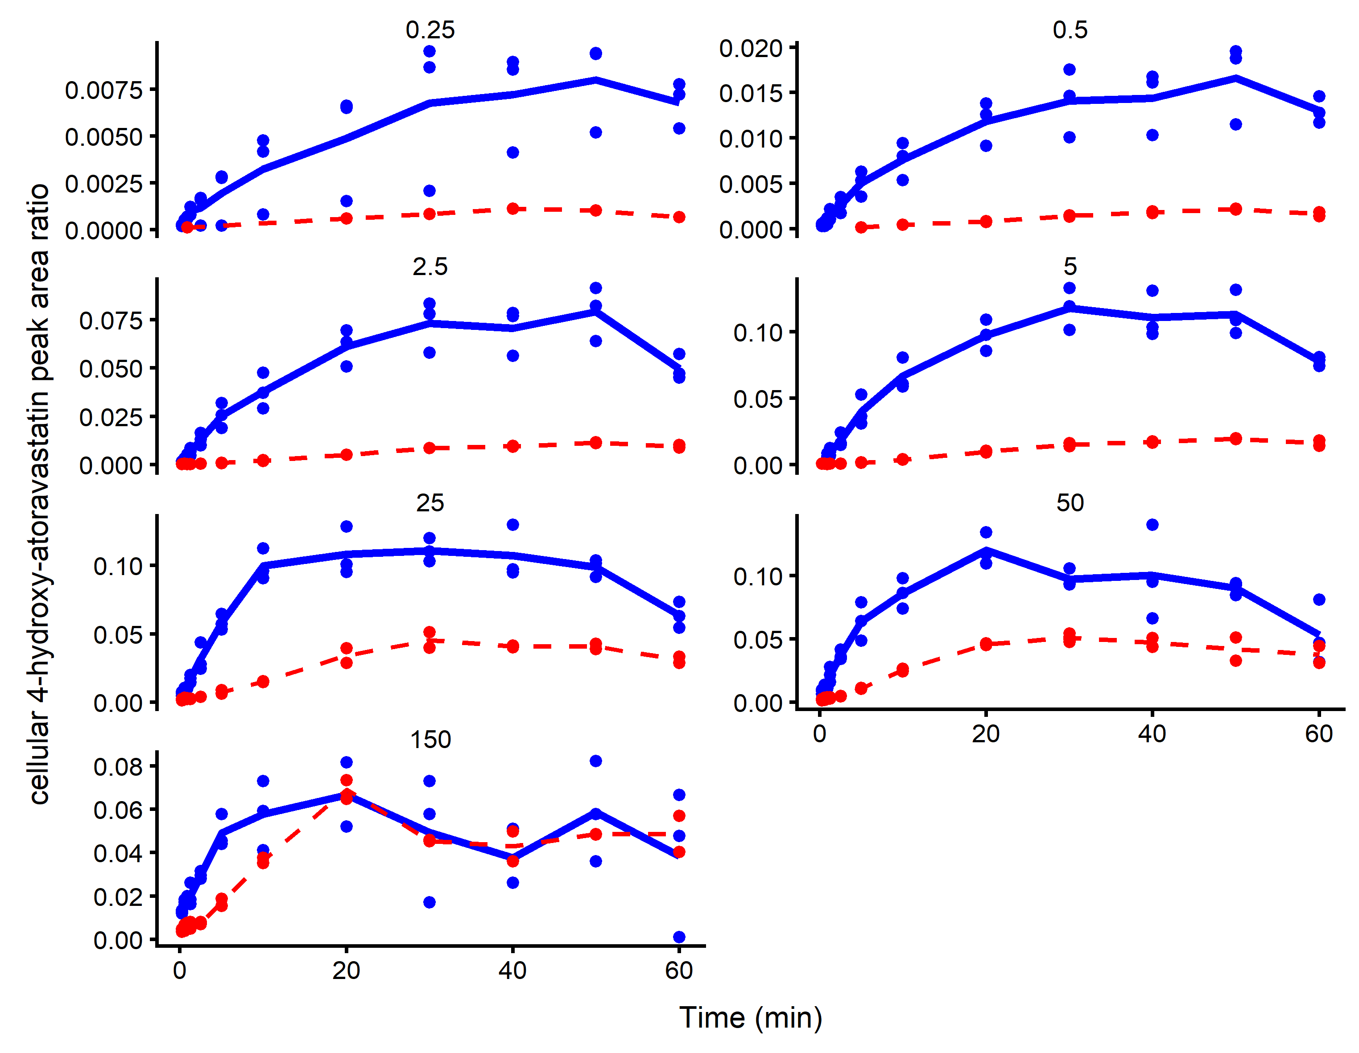
Figure S4: Plots of cellular 4-hydroxy atorvastatin peak area ratio against time following the addition of atorvastatin (0.25, 0.5, 2.5, 5, 25, 50 and 150 nmol/ml) in the absence (blue) and presence (red) of 10 nmol/ml CsA. Each time course represents one experiment from one Teflon block trough. Points are data (n=1-3) and solid lines are the average peak area ratio

Table S3: Macro-rate constant model parameter estimates for the inhibition of atorvastatin by CsA in rat hepatocytes (Model 3 – competitive inhibition and Model 4 – non-competitive inhibition). Data are the individual mode of the conditional distribution obtained from Monolix 2018R2, n=3. All parameter estimates are scaled to per 1x10⁶ cells. V_{max} was scaled to pmol/min and K_{m}, and K_{I} were scaled to nmol/ml
Parameter | Model 3 –  competitive inhibition | Model 4 –  non-competitive inhibition
Passive
k_{fA} (/min) | 1.5 (0.9-2.7) | 1.8 (1-4)
k_{bA} (/min) | 3 (0.3-19) | 3.3 (0.4-19.6)
Transporter
V_{max.up} (pmol/min) | 3220 (1460-13000) | 850 (680-1340)
K_{m.up} (nmol/ml) | 0.74 (0.18-1.08) | 0.09 (0.04-0.17)
K_{I.up} (nmol/ml) | 0.1 (0.07-0.22) | 0.06 (0.04-1.11)
Metabolism
V_{max.met} (pmol/min) | 296 (158-840) | 364 (211-950)
K_{m.met} (nmol/ml) | 340 (251-407) | 436 (296-544)
K_{I.met} (nmol/ml) | 1.1 (1-1.3) | 0.32 (0.27-0.36)

Table S4: Micro-rate constant model parameter estimates for the non-competitive inhibition of atorvastatin by CsA in rat hepatocytes (Model 2). Data are the individual mode of the conditional distribution obtained from Monolix 2018R2, n=3. All parameter estimates are scaled to per 1x10⁶ cells. V_{max} was scaled to pmol/min and K_{m}, K_{I} and K_{inact} were scaled to nmol/ml. Parameters in bold denote those used in main text
Parameter | Assessment 1 | Assessment 2 | Assessment 3 | Assessment 4 | Assessment 5
Passive
k_{fA} (/min) | 1.3 (0.4-20.3) | 1.1 (0.2-23.3) | 0.9 (0.2-25.8) | 1.1 (0.3-27.4) | 1.1 (0.4-26.3)
k_{bA} (/min) | 9.7 (1-31.1) | 9.3 (0.6-36.5) | 7.7 (0.5-39.9) | 9.9 (0.8-42.5) | 8.9 (0.6-41.2)
Transporter
k_{aA} (/nmol/min) | 0.7 (0.2-6.8) | 1.3 (0.6-6.7) | 1.2 (0.6-4.6) | 1.1 (0.4-5.7) | 1.1 (0.5-5.5)
k_{aC} (/nmol/min) | 0.26 (0.25-0.29) | 0.18 (0.16-0.2) | 0.19 (0.17-0.21) | 0.19 (0.18-0.21) | 0.2 (0.2-0.22)
k_{dA} (/min) | 0.013 (0.012-0.014) | 0.017 (0.015-0.021) | 0.013 (0.011-0.014) | 0.011 (0.01-0.012) | 0.012 (0.011-0.013)
k_{dC} (/min) | 0.28 (0.26-0.3) | 0.16 (0.13-0.2) | 0.3 (0.25-0.36) | 0.18 (0.17-0.19) | 0.29 (0.27-0.3)
T_{o} (nmol) | 3.4 (2.8-3.9) | 2.7 (2-3.6) | 2.5 (1.4-5.7) | 3.1 (2.1-4.5) | 2.6 (1.7-4.7)
k_{tA} (/min) | 0.31 (0.3-0.34) | 0.25 (0.23-0.31) | 0.28 (0.24-0.33) | 0.21 (0.18-0.32) | 0.32 (0.28-0.36)
α | 0.012 (0.009-0.021) | 0.013 (0.007-0.023) | 0.016 (0.013-0.018) | 0.012 (0.01-0.016) | 0.015 (0.012-0.018)
Metabolism
V_{max.met} (pmol/min) | 456.5 (324-730) | 393 (284.5-500) | 344.5 (245-645) | 303 (215.5-550) | 505 (385.5-690)
K_{m.met} (nmol/ml) | 27.82 (23.64-30.18) | 17.71 (7.98-30.73) | 28.91 (13.15-45.82) | 9.09 (5.76-12.16) | 55.45 (29.45-83.82)
K_{I.met} (nmol/ml) | 8.1 (4.2-23.8) | 11 (5.5-29.1) | 24.4 (9.2-138.2) | 9.5 (1.7-108.7) | 20.9 (13-46)
-2.LL | 5521 | 5417 | 5491 | 5504 | 5486
BIC | 5618 | 5514 | 5587 | 5601 | 5583

References
Amundsen, R., Asberg, A., Ohm, I.K. & Christensen, H., 2012. Cyclosporine A- and tacrolimus-mediated inhibition of CYP3A4 and CYP3A5 in vitro. Drug Metab Dispos, 40, 655-61.

