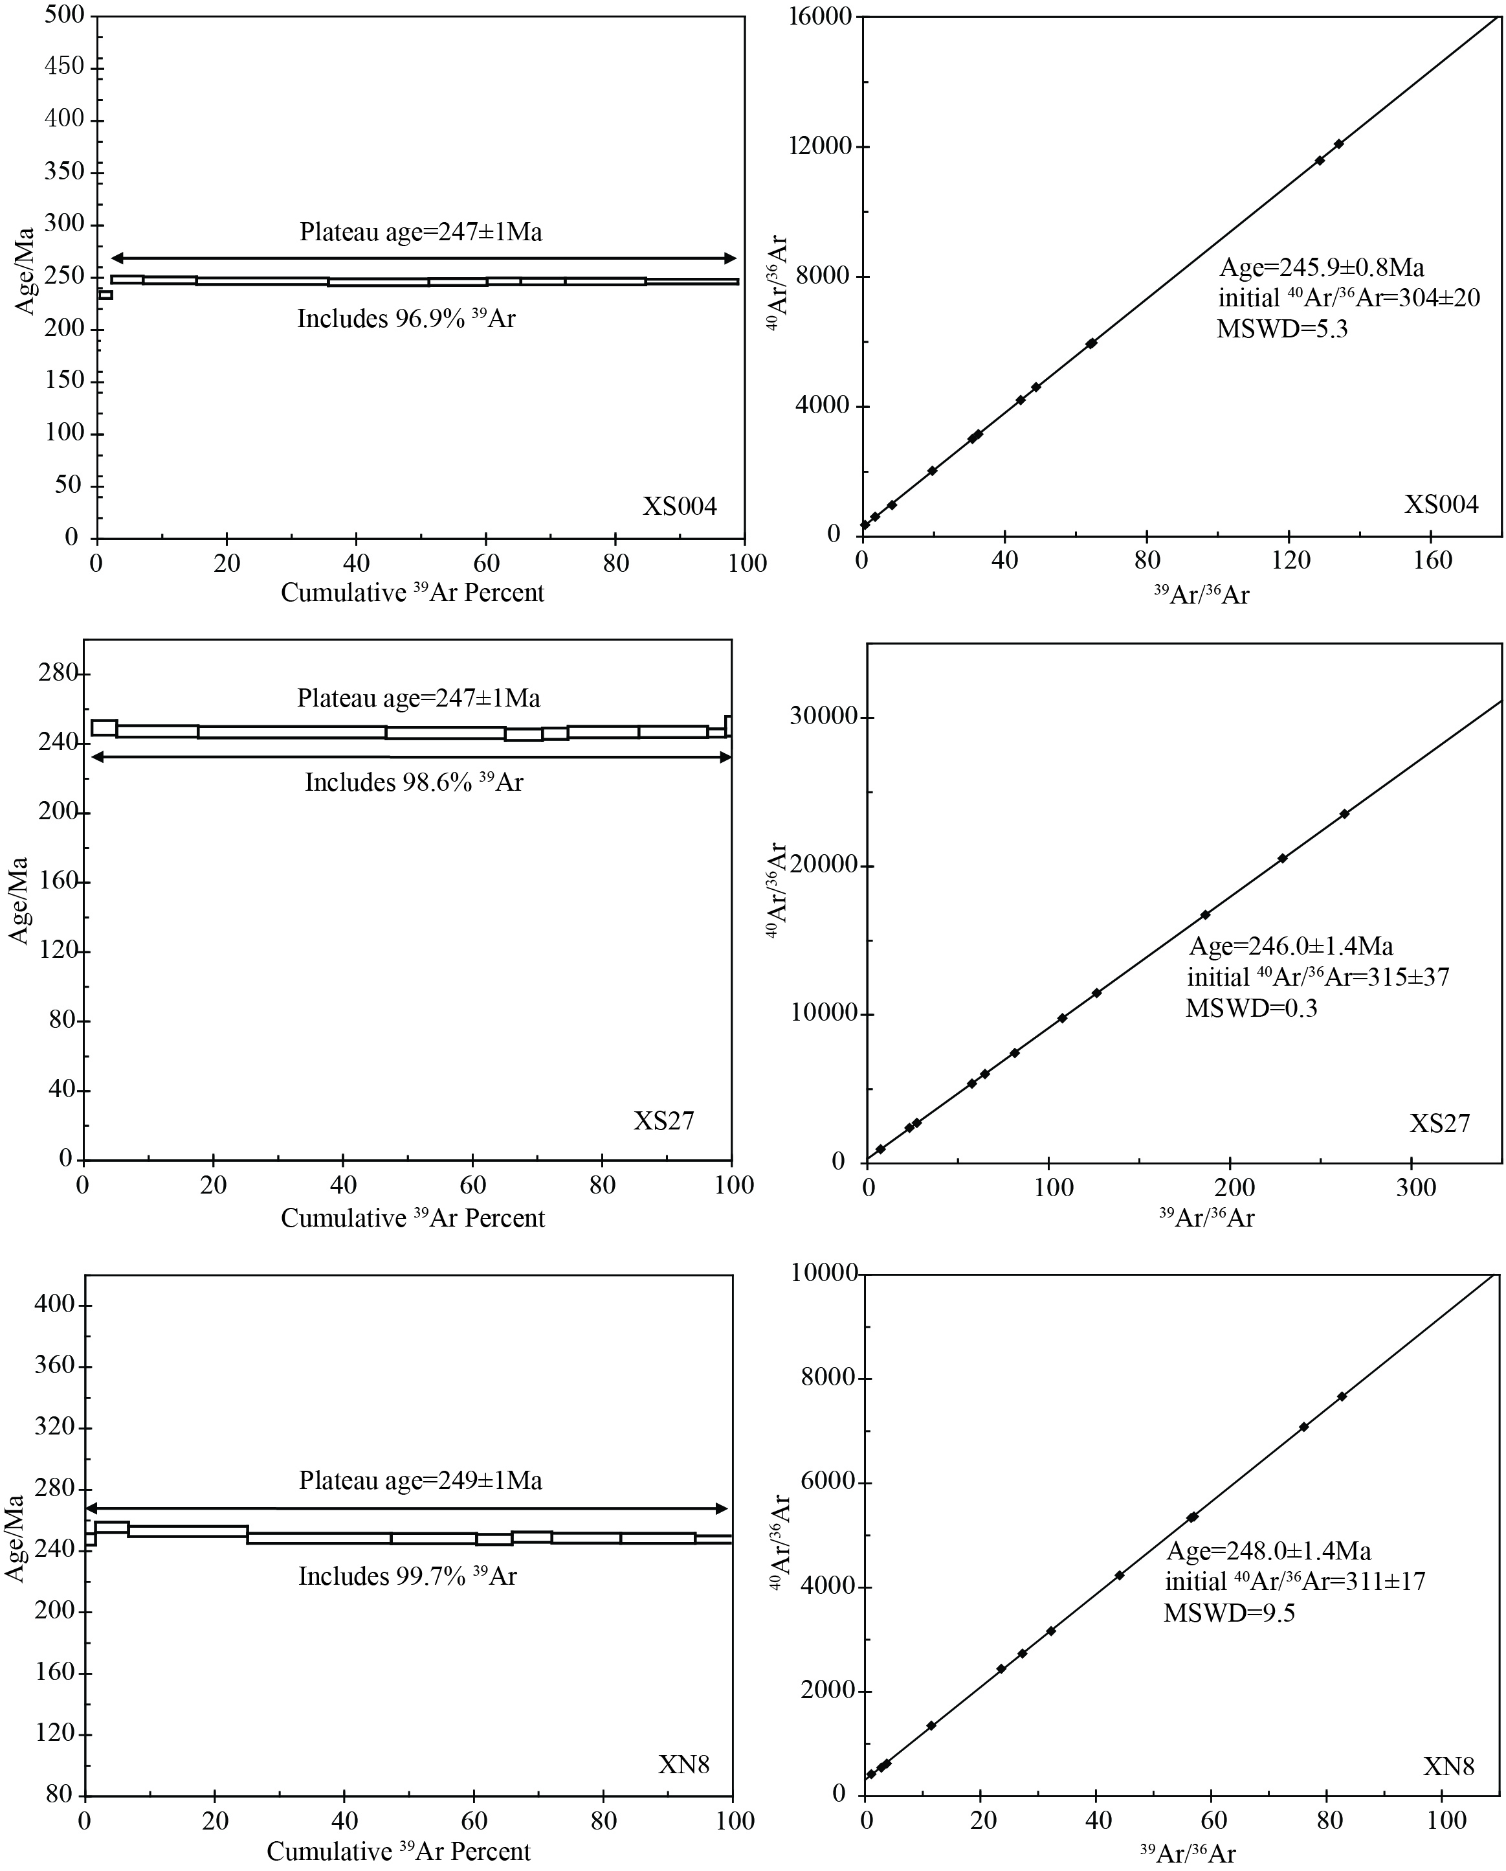
Supplementary figure 1. Muscovite ⁴⁰Ar/³⁹Ar spectra and isochron plots of meta-sedimentary rocks from the Wuguan Complex.

