Supplemental Tables and Figures

Figure S 1. Probability plot for lognormal distribution
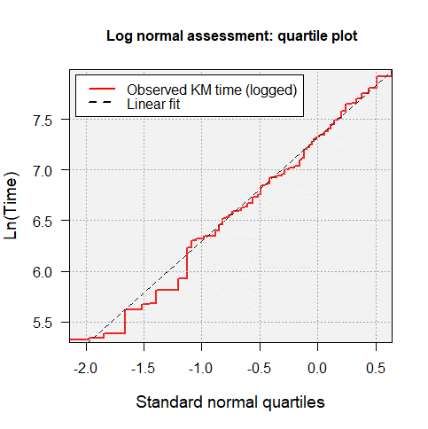
Abbreviation: KM, Kaplan-Meier

Figure S 2. Hazard plot for lognormal distribution
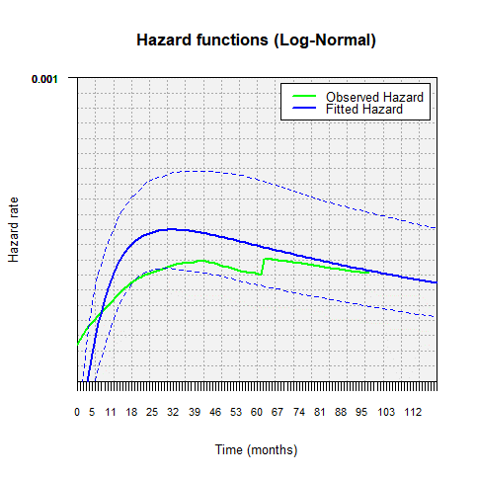

Figure S 3. Observed versus estimated survival
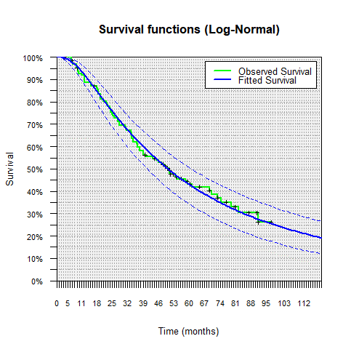

Figure S 4. Time-to-discontinuation
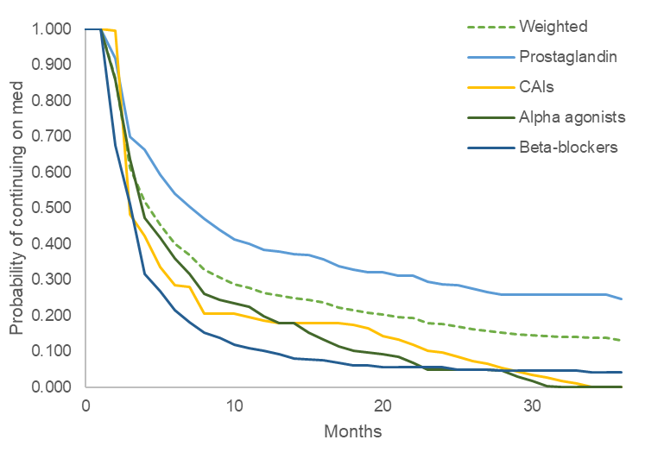
Abbreviation: CAIs, carbonic anhydrase inhibitors.

Table S 1. AIC of distributions
Distribution | AIC
Exponential | 1,313
Weibull | 1,308
Gompertz | 1,313
Log-logistic | 1,303
Lognormala | 1,300
Gamma | 1,306
Generalized gamma | 1,301
Abbreviations: AIC, Akaike information criterion.
ª Parameters to construct the lognormal curve: LogMean = 7.3343; LogStdDeviation = 0.9969.

