**New oxacalix[4]arene carboxylate detects viologen in protic media**

Anna Peterson,a,b Mari-Liis Ludvig,a,b Jevgenija Martõnova,b Sandra Kaabel,b Paul Kerner,a Merle Uudsemaa,a Aleksander Trummal,a Maria Fomitšenko,b Tõnis Pehk,a Riina Aav*b and Jasper Adamson*a

*aNational Institute of Chemical Physics and Biophysics, Akadeemia tee 23, 12618 Tallinn, Estonia; bDepartment of Chemistry, Tallinn University of Technology, Akadeemia tee 15, 12618 Tallinn, Estonia.*

*E-mail of corresponding authors: [jasper.adamson@kbfi.ee](mailto:jasper.adamson@kbfi.ee), riina.aav@taltech.ee

**Electronic Supplementary Information**

Table of Contents

Synthesis and structure characterization S3

General S3

Synthesis of 1a S3

Synthesis of 1b S3

NMR spectra S4

Single Crystal X-ray Structures additional information S7

Crystal Data for oxacalix[4]arene carboxylic acid 1a S7

1H NMR titration experiments S10

General S10

1H NMR titration data of [1b-paraquat] complex in methanol-d4 S11

1H NMR titration data of [1b-paraquat] complex in D2O S13

Dilution measurements S15

Further interpretation of calculations S16

Additional details S16

Cartesian coordinates of the optimized structures in methanol S21

**1a** conformer 1 S21

**1a** conformer 2 S22

**1a** conformer 1 (cluster-continuum approach) S24

**1a** conformer 2 (cluster-continuum approach) S26

References S28

# Synthesis and structure characterization

## General

All purchased reagents were used as received. DMSO was dried over 3Å molecular sieves and MeOH was dried over sodium metal. Column chromatography was performed on a Biotage Isolera™ Prime purification system. TLC analysis was performed on precoated silica gel 60 F254 plates from Merck and silica gel (0.04 –0.063 mm) was obtained from ThoMar. NMR spectra were recorded on Bruker AVANCE III 800 MHz spectrometer. All the NMR spectra measured from methanol-d4 and D2O were referenced based on the solvent residual peaks at 3.31 ppm or 4.79 ppm, respectively. HPLC-HRMS was performed on an Agilent 6540 UHD Accurate-Mass Q-TOF LC/MS spectrometer using an Agilent C18 column (2.1x50 mm, 1.8 μm) and AJ-ESI ionization.

## Synthesis of **1a**



Compound **1** 1,3-Bis(3-hydroxyphenoxy)benzene (CAS nr. 126716-91-4) was prepared based on previously reported Ullman coupling protocol.1,2 A suspension of **1** (203.0 mg, 0.69 mmol), 2,6-diiodobenzoic acid (258.4 mg, 0.69 mmol), Fe(acac)3 (26.3 mg, 0.074 mmol), CuI (13.5 mg, 0.071 mmol) and K2CO3 (278.5 mg, 2.02 mmol) in DMSO (68 mL) was stirred under argon atmosphere at 110 °C for 4 days. The reaction mixture was filtered and washed with DCM (125 mL). The organic phase was washed with 1 M NaOH solution (40 mL), separated and concentrated under reduced pressure. Crude product was purified by column chromatography (1% of 2-propanol in CHCl3), yielding **1a** as a white solid (41 mg, 14%). 1H NMR (800 MHz, methanol-d4) δ (ppm) 7.48 (t, 1H), 7.38 (t, 1H), 7.27 (t, 2H), 7.01 (d, 2H), 6.87-6.86 (m, 2H), 6.77-6.75 (m, 3H), 5.66 (t, 2H). 13C NMR δ (ppm) 166.7, 161.9, 160.7, 157.1, 154.2, 133.6, 132.8, 131.5, 125.7, 121.6, 119.5, 115.9, 112.1, 111.9, 102.6. HRMS: *m*/*z* calculated for C25H16O6 [M-H]- is 411.0874, found 411.0877. The organic phase was washed with 1 M NaOH, 1 M HCl and distilled water in separate reactions. Upon washing with acid, the carboxylic acid group eliminated from the macrocycle, yielding in unsubstituted oxacalix[4]arene, while washing with 1 M NaOH and distilled water yielded in the desired product in 14% yield. The remaining aqueous phases of the washing were lyophilized for 48 hours and the respective 1H NMR spectra measured. The 1H NMR spectra did not show evidence for the product or the formation of oligomers. It is possible that oligomerisation had indeed occurred, however the 1H NMR signals were broad due to the flexible nature of the oligomers and could not be distinguished from the baseline of the spectra.

## Synthesis of **1b**

**1a** (10.0 mg, 0.024 mmol) was added 40% TBAOH solution (15.9 µL, 0.024 mmol) in milliQ water (1 mL) and stirred at room temperature for 1.5 h. The solvent was removed under reduced pressure and product obtained quantitatively as a white solid. 1H NMR (800 MHz, methanol-d4) δ (ppm) 7.34 (t, 1H), 7.20 (t, 1H), 7.18 (t, 2H), 7.09 (t, 1H), 6.81 (d, 2H) 6.73 (d, 2H), 6.66 (d, 2H), 5.71 (t, 2H). 13C NMR δ (ppm) 169.6, 162.5, 160.9, 157.1, 152.7, 133.8, 132.4, 130.8, 129.7, 121.2, 119.7, 118.0, 111.4, 111.0, 102.8, 59.5, 24.8, 20.7, 13.9.

## NMR spectra



Figure S1.1H NMR (methanol-d4, 800 MHz) spectrum of **1a** at 298 K.



Figure S2. 13C NMR (methanol-d4, 800 MHz) spectrum of **1a** at 298 K.

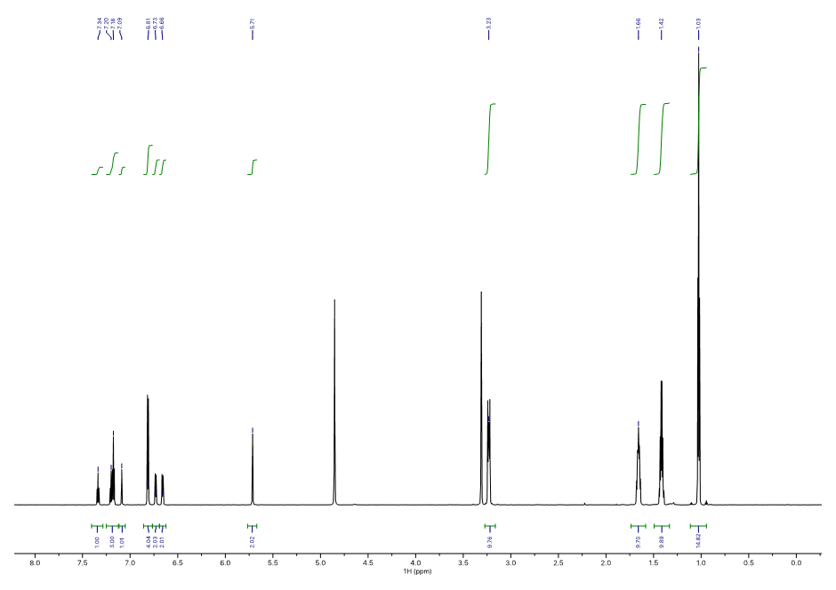

Figure S3. 1H NMR (methanol-d4, 800 MHz) spectrum of **1b** at 298 K.

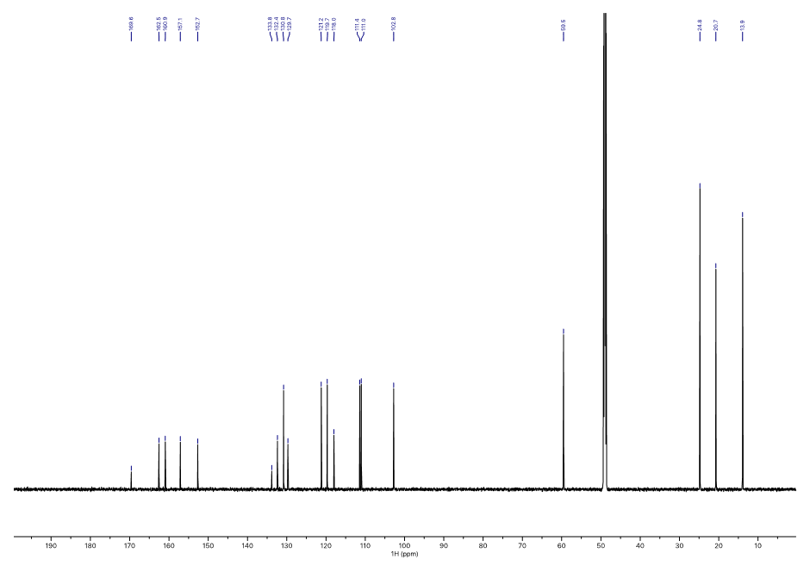

Figure S4. 13C NMR (methanol-d4, 800 MHz) spectrum of **1b** at 298 K.

# Single Crystal X-ray Structures additional information

## **Crystal Data** for oxacalix[4]arene carboxylic acid **1a**

C26H17Cl3O6 (*M*=531.74 g/mol): triclinic, *P*-1 (no. 2), *a* = 9.6243(2) Å, *b* = 11.0341(2) Å, *c* = 12.8627(3) Å, *α* = 110.451(2)°, *β* = 106.547(2)°, *γ* = 91.473(2)°, *V*= 1214.88(5) Å3, *Z* = 2, *T* = 123(2) K, *μ*(Cu-*Kα*) = 3.769 mm−1, *Dcalc* = 1.454 g/cm3, 30113 reflections measured (7.726° ≤ 2*Θ* ≤ 134.72°) of which 4276 unique (4133 with *I* > 2σ(*I*)), *R*int = 0.0282, *R*1 [*F*2 > 2 σ(*F*2)] = 0.0454, *wR*2 (all data) = 0.1151, *S* = 1.085.

Total interaction energies (*E*tot, kJ mol−1) of the **1a** crystal structure were calculated and visualised (Figure S6) through the program *CrystalExplorer*3, as the sum of the four individual energy terms (Table S1) – the electrostatic (*E*ele), polarisation (*E*pol), dispersion (*E*dis) and exchange-repulsion (*E*rep) 4,5.

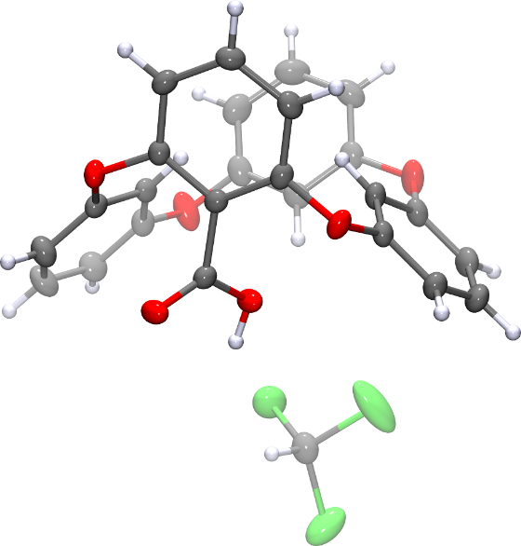

Figure S5. The asymmetric unit in the crystal structure of oxacalix[4]arene carboxylic acid. The anisotropic displacement ellipsoids are drawn a 50% probability level.

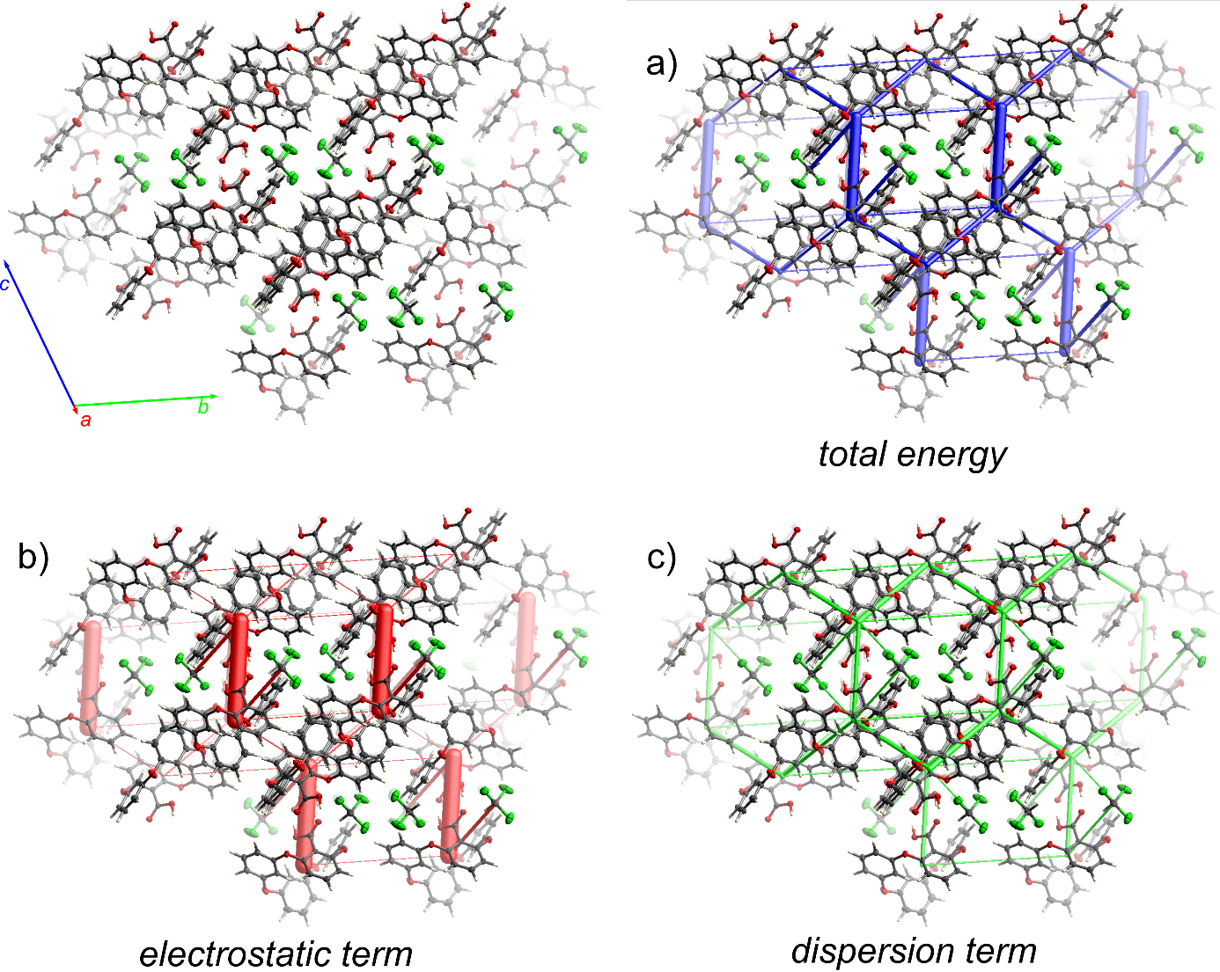

Figure S6. Energy-framework diagrams for the crystal structure of the oxacalix[4]arene carboxylic acid (CCDC 1913616) computed at CE-B3LYP level of theory using the 6-31G(d,p) basis set, through the program CrystalExplorer. b) The total energy Etot (blue) and the relative contributions from the b) electrostatic term Eele (red) and c) dispersion term Edisp (green). The energy frameworks use the same cylindrical scale of 50 and an energy threshold of 10 kJ mol−1.

Table S1. Interaction energies between a selected molecule (in element colours) to its closest neighbours (colour coded, see Figure S3) in the crystal structure. The total energy is reported as the sum of the four energy components- the electrostatic (Eele), polarization (Epol), dispersion (Edis) and exchange-repulsion (Erep) energy, scaled according to the scale factor table (Table S2). R is the distance between molecular centers of mass (Å).

|  |  |  |  |  |  |  |  |  |  |
| --- | --- | --- | --- | --- | --- | --- | --- | --- | --- |
|  | *N* | Sym. op. | *R* | Electron Density | *E*ele | *E*pol | *E*dis | *E*rep | *E*tot |
|  | 1 | −x, −y, 1−z | 9.28 | B3LYP/6-31G(d,p) | 1.5 | −0.8 | −27.1 | 7.6 | −17.8 |
|  | 1 | 1+x, y, z | 7.72 | B3LYP/6-31G(d,p) | −4.8 | −0.4 | −8.8 | 8.8 | −7.6 |
|  | 2 | x, 1+y, z  (x, −1+y, z) | 11.03 | B3LYP/6-31G(d,p) | −5.8 | −0.9 | −14.6 | 11.5 | −12.4 |
|  | 1 | 1−x, 1−y, 2−z | 6.40 | B3LYP/6-31G(d,p) | −26.9 | −6.0 | −21.7 | 33.3 | −31.2 |
|  | 1 | 1−x, 1−y, 2−z | 7.26 | B3LYP/6-31G(d,p) | −122.8 | −27.8 | −38.7 | 158.7 | −86.1 |
|  | 1 | 1−x, −y, 1−z | 7.90 | B3LYP/6-31G(d,p) | −12.1 | −2.3 | −52.7 | 31.9 | −40.7 |
|  | 1 | 1−x, 1−y, 1−z | 7.62 | B3LYP/6-31G(d,p) | −5.9 | −1.2 | −37.9 | 18.4 | −28.8 |
|  | 2 | 1+x, y, z  (−1+x, y, z) | 9.62 | B3LYP/6-31G(d,p) | −2.4 | −1.1 | −19.9 | 12.5 | −13.0 |
|  | 1 | 1−x, −y, 2−z | 8.67 | B3LYP/6-31G(d,p) | −2.1 | −0.2 | −8.5 | 8.5 | −4.5 |
|  | 1 | −x, 1−y, 1−z | 9.34 | B3LYP/6-31G(d,p) | −5.6 | −1.3 | −27.7 | 13.6 | −22.6 |

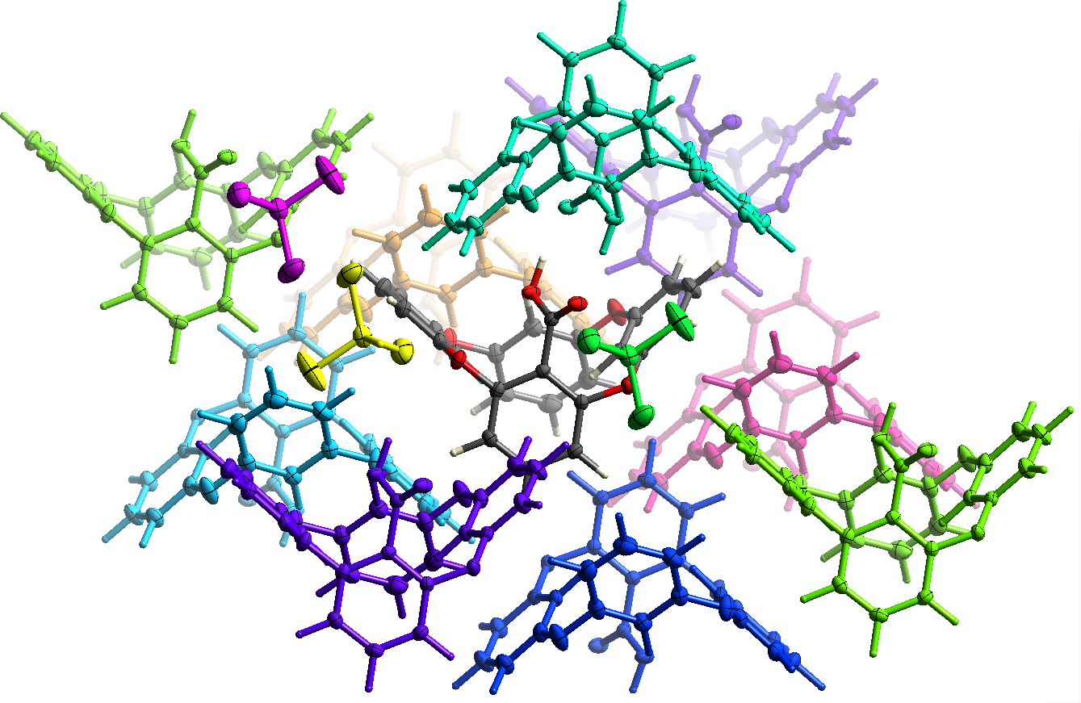

Figure S7. The colour codes for the cluster of nearest neighbour molecules within the crystal structure.

Table S2. Scale factors for benchmarked energy models [11].

|  |  |  |  |  |
| --- | --- | --- | --- | --- |
| Energy Model | k_ele | k_pol | k_disp | k_rep |
| CE-B3LYP ... B3LYP/6-31G(d,p) electron densities | 1.057 | 0.740 | 0.871 | 0.618 |

# 1H NMR titration experiments

## General

The association constant values for [**1b**-paraquat] complexes were determined frommethanol-d4 and D2O. All the spectra were collected on a Bruker AVANCE III 800 MHz spectrometer. The **1b** stock solutions (0.2 mM) were added to a vial containing paraquat to keep the concentration of the macrocycle fixed throughout the titration experiment. All the solutions were prepared using Hamilton® Gastight syringes and samples were weighed on a Sartorius microbalance with an accuracy of 15 µg. Small aliquots from the paraquat stock solution were added increasingly (from 0 to 160-240 µl) to the NMR tube containing 600 µl of the **1b** stock solution. The concentration of the guest stock solution was based on the predicted binding strength. After every addition, the sample was thoroughly shaken using vortex and measured quantitatively, collecting 8 scans with relaxation delay set to 15 s and acquisition time set to 2.4 s. The chemical shifts were referenced based on methanol-d4 and D2O solvents residual peaks. The changes in H4 and H6 proton shifts were monitored and after the addition of paraquat the followed protons shifted upfield with an exception of H6 in methanol. The *K*a values were determined using nonlinear regression analysis. For the fitting of the binding data the 1:1 binding isotherm of BindFit was used (freely available at http://supramolecular.org). Herein, the given standard error in depicts error coming from curve fit calculations.

## 1H NMR titration data of [**1b-**paraquat]complex in methanol-d4



Figure S8. 1H NMR (methanol-d4, 800 MHz) spectra of **1b** (0.2 mM) titration with paraquat at 298 K. On the figure are shown the 16 data points representing all the macrocycles´ peaks with followed H4 and H6 protons additionally marked after the addition of 0.1, 0.4, 0.8, 1.1, 1.5, 2.2, 3.0, 3.9, 6.0, 7.6, 8.4, 10.9, 14.0, 17.0 and 20.2 eq of paraquat. An additional titration point at the end showed H4 peak shifting downfield and H6 peak shifting upfield that refers to a change in complexation stoichiometry towards 1:2 host-guest complex. Enough data points for determining the *K*12 could not be collected since the compounds precipitated at higher concentrations.





Figure S9. Bindfit output of the 1:1 binding isotherms for the [**1b**-paraquat] complex. The global fitting of H4 and H6 protons gave average value of *K*a = (2020 ± 70) M⁻¹.

## 1H NMR titration data of [**1b-**paraquat]complex in D2O



Figure S10. 1H NMR (D2O, 800 MHz) of **1b** (0.2 mM) titration with paraquat at 298 K. On the figure are shown the 17 data points representing all the macrocycles´ peaks with followed H4 and H6 protons additionally marked after the addition of 0.1, 0.3, 0.7, 1.2, 1.5, 2.4, 3.6, 4.0, 6.3, 4.0, 6.3, 8.3, 9.6, 11.9, 15.7, 19.5, 21.7 and 23.7 eq of paraquat. In aqueous media, the last titration point, with 23.7 eq of paraquat used as a guest, resulted in 66% of host-guest complex formation.





Figure S11. Bindfit output of the binding isotherms for the [**1b**-paraquat] complex. The global fitting of H4 and H6 protons gave average value of *K*a = 111 ± 3 M⁻¹.

# Dilution measurements

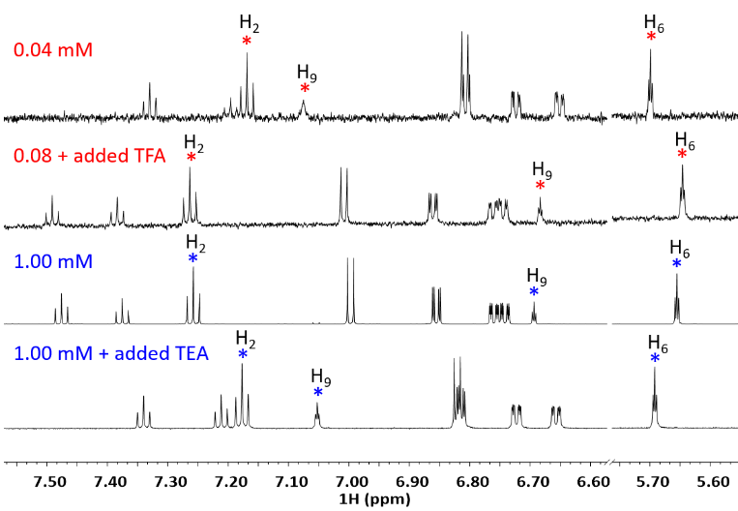

Figure S12. 1H NMR spectra of **1a** in methanol-d4 at 298 K of a) dilute **1a** sample (0.04 mM); b) dilute **1a** sample added TFA (20 eq); c) **1a** sample (1.00 mM); d) **1a** sample added TEA (20 eq). The changes in H2 and H9 proton shifts and inward facing H6 protons were followed.

Upon dilution from 1 mM to 0.04 mM, the NMR chemical shifts in methanol-d4 demonstrated significant changes (Figure S12). Dimerization for the **1a** macrocycle is unlikely to induce these changes in a protic solvent.6,7 We therefore investigated whether this change of chemical shifts is caused by the protonation-deprotonation equilibrium of the carboxylic acid group in **1a** and performed 1H NMR measurements of **1a** in acidic and basic conditions in methanol-d4 by adding trifluoroacetic acid (TFA) or triethylamine (TEA), respectively (Figure S12). The spectrum of **1a** in acidic conditions is indeed similar to the spectrum at high concentrations and that in basic conditions to the low-concentration spectrum.

# Further interpretation of calculations

## Additional details

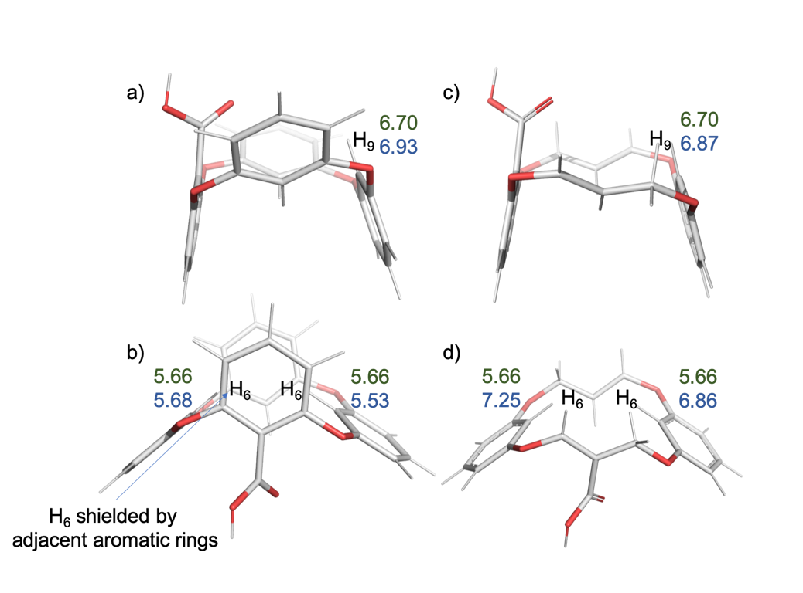Firstly, there is difference between the chemical shifts of H6 and H9 protons in the experimental data with H6 shifted considerably upfield, 6.70 ppm vs 5.66 ppm (Figure 1 in the main text shows proton labelling). The latter is likely to result from the orientation of these protons with regard to the anisotropic shielding cones of adjacent aromatic monomers with H6 experiencing more shielding by the aromatic ring currents [Figure S13(a)(b)]. These differences in the chemical shifts were replicated in the calculated geometry in solution [Figure S13(a)(b)]. We therefore removed two of the aromatic rings in pairs from the optimized model [Figure S13(c)(d)] and calculated chemical shifts in these structures, where H6 and H9 protons do not have adjacent aromatic rings. H9 was almost uninfluenced by this change, whereas H6 shifted considerably downfield. These findings further support our hypothesis that H6 is significantly affected by its position with respect to the neighbouring aromatic groups in the structure. For comparison with experimental data, the calculated 1H and 13C proton resonances (Tables S2 and S5) that are related by symmetry plane were averaged (Tables S4 and S6). The slight differences in calculations for symmetry-related atoms arise from the non-symmetrical orientation of the carboxyl acid group, which is averaged in solution when measuring NMR spectra.

Figure S13**.** a) and b) the positions of H6 and H9 protons with respect to the adjacent aromatic rings, c) and d) models used for chemical shift calculations where two of the aromatic groups have been removed in pairs. Numbers in green and blue denote experimental NMR chemical shifts and calculated chemical shifts (B3LYP/GIAO) in ppm, respectively.

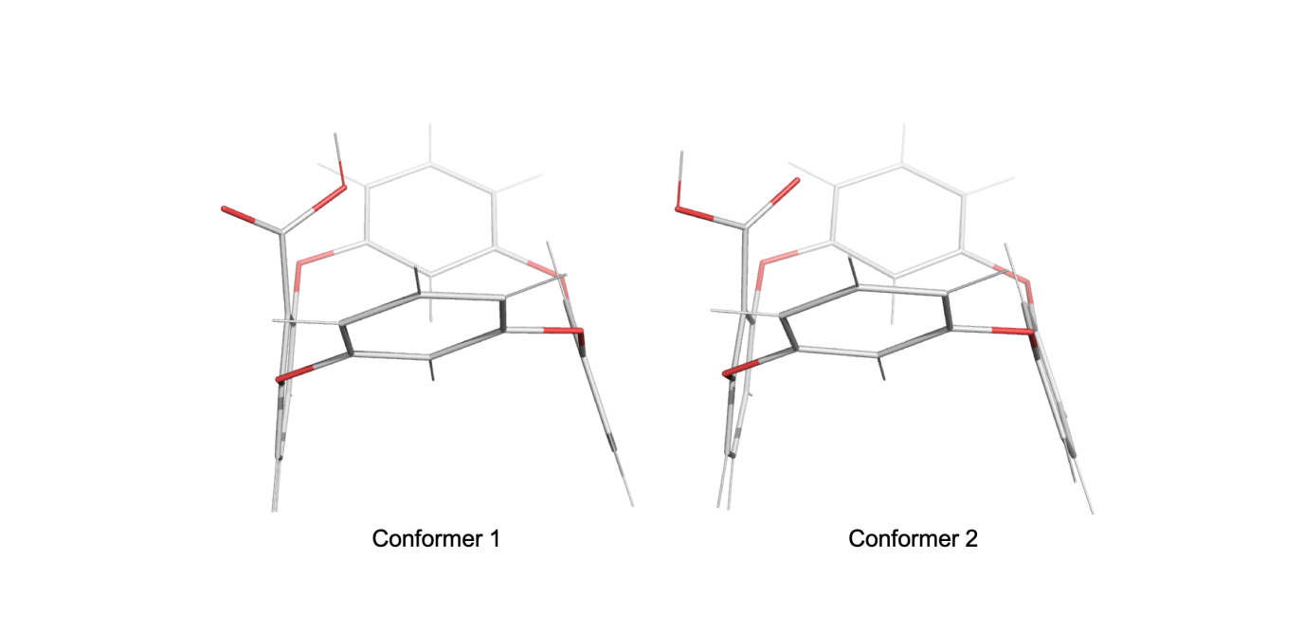

Figure S14. Conformers investigated for **1a** in this work.

The comparison between calculated and experimental 1H and 13C chemical shifts for **1a**, presented in Table S4 and Table S6, respectively, reveals rather reasonable overall correspondence. Particularly, the 1H NMR calculated spectrum is characterized by a mean unsigned error of 0.26 ppm and RMS error of 0.28 ppm at B3LYP GIAO level, while MN12-SX CSGT predictions are somewhat more accurate with respective deviations of 0.22 and 0.24 ppm. For 13C, the mean unsigned and RMS deviations for B3LYP CSGT method are 4.21 and 4.80 ppm, respectively, while lc-TPSS GIAO calculation results in an approximately twofold decrease of the mean absolute and RMS errors, down to 2.07 and 2.89 ppm, respectively. The better overall performance of the MN12-SX method with respect to 1H chemical shifts and the lc-TPSS method with respect to 13C chemical shifts, as compared to the B3LYP method, is quite expected. It should be noted, however, that the latter method provides most accurate predictions for H6 positions that are closely monitored in the present study, as well as for adjacent carbon atoms. A closer look at the corresponding correlations between predictions from the selected theoretical methods and experimental chemical shifts presented in Figures S16 and S17 reveals that the exceptional accuracy of B3LYP method for H6 positions arises from the significant deviation of the linear regression slope value from unity and, therefore, could be regarded as coincidental because computational chemical shifts of H6 atoms are located very close to the point of crossing of linear regression line with y=x line. The situation with carbon atoms connected to H6 hydrogens is somewhat similar, although the slope of regression line is markedly higher for the carbon spectrum. For all other hydrogen and carbon atoms the respective performance of MN12-SX or lc-TPSS functionals is superior to B3LYP. It is worth mentioning that the outmost data points corresponding to H6 protons and adjacent carbons in turn strongly influence the slope of linear regression itself. The above finding could give rise to the hypothesis that the calculations selectively render the chemical shifts further upfield for H6 and possibly for the connected carbons as well because of the deficiency of the continuum solvation approach. Therefore, in order to evaluate possible contributions from specific solvation in the first solvation shell, the discrete-continuum solvation model was constructed where explicit methanol molecule was placed in vicinity of H6 hydrogens and the whole **1a** cluster was immersed in polarized continuum. Indeed, following re-optimization of the structure of the solute, the relative position of methanol molecule changed and localized farther away from H6 atoms. (Figure S15) At the same time, chemical shifts of H6 atoms moved approximately 0.2 ppm downfield while the chemical shifts of remaining hydrogens varied much less (Table S3). Consequently, the slope of regression line increased as well, from 0.80 to 0.88 and from 0.81 to 0.87 for conformers 1 and 2, respectively, being closer to unity than in the polarized continuum approximation (proton shift values are given in parentheses in Table S4). It can be concluded that H6 atoms are more sensitive to the local solvent environment than other macrocycle hydrogen atoms of the **1a**.

Figure S15. (a) Conformers investigated for **1a** in this work as employed in the cluster-continuum solvation model. (b) The designated proton and carbon positions of the macrocycle.

Table S3. Experimental and calculated 1H NMR shifts for **1a.** As noted in the main text, calculations were performed for two conformers, shown in Figure S14 and S15. Values in parentheses represent the cluster-continuum approach.

|  |  |  |  |  |  |  |
| --- | --- | --- | --- | --- | --- | --- |
| Position | Experimental | Conformer 1 | | | | Conformer 2 |
| B3LYP | | MN12-SX | | B3LYP |
| GIAO | CSGT | GIAO | CSGT | GIAO |
| H2 | 7.48 | 7.80 (7.85) | 7.90 | 7.91 | 7.82 | 7.82 (7.88) |
| H8 | 7.38 | 7.73 (7.76) | 7.82 | 7.80 | 7.72 | 7.71 (7.75) |
| H4 | 7.27 | 7.58 (7.56)  7.59 (7.62) | 7.66  7.67 | 7.66  7.65 | 7.51  7.52 | 7.59 (7.57)  7.58 (7.61) |
| H1 | 7.01 | 7.39 (7.41)  7.25 (7.31) | 7.47  7.33 | 7.38  7.23 | 7.31  7.16 | 7.40 (7.41)  7.28 (7.32) |
| H7 | 6.86 | 7.19 (7.14)  7.28 (7.37) | 7.27  7.37 | 7.17  7.25 | 7.09  7.18 | 7.17 (7.12)  7.27 (7.36) |
| H3 | 6.77 | 6.94 (6.96)  6.99 (7.03) | 7.09  7.12 | 6.97  6.97 | 6.88  6.90 | 6.99 (7.03)  6.95 (6.98) |
| H5 | 6.75 | 7.02 (7.00)  6.97 (7.01) | 7.15  7.12 | 7.00  6.97 | 6.91  6.90 | 7.01 (7.00)  6.96 (7.00) |
| H9 | 6.70 | 6.95 (7.04) | 7.11 | 6.89 | 6.80 | 6.93 (7.01) |
| H6 | 5.66 | 5.54 (5.71)  5.70 (5.96) | 5.61  5.76 | 5.32  5.46 | 5.33  5.46 | 5.53 (5.69)  5.68 (5.92) |

Table S4. Experimental and the mean values of calculated 1H NMR shifts for **1a.** As noted in the main text, calculations were performed for two conformers, shown in Figure S14 and S15.

|  |  |  |  |  |  |  |
| --- | --- | --- | --- | --- | --- | --- |
| Position | Experimental | Conformer 1 | | | | Conformer 2 |
| B3LYP | | MN12-SX | | B3LYP |
| GIAO | CSGT | GIAO | CSGT | GIAO |
| H2 | 7.48 | 7.80 (7.85) | 7.90 | 7.91 | 7.82 | 7.82 (7.88) |
| H8 | 7.38 | 7.73 (7.76) | 7.82 | 7.80 | 7.72 | 7.71 (7.75) |
| H4 | 7.27 | 7.59 (7.59) | 7.67 | 7.66 | 7.52 | 7.59 (7.59) |
| H1 | 7.01 | 7.32 (7.36) | 7.40 | 7.31 | 7.24 | 7.34 (7.36) |
| H7 | 6.86 | 7.24 (7.26) | 7.32 | 7.21 | 7.14 | 7.22 (7.22) |
| H3 | 6.77 | 6.97 (7.00) | 7.11 | 6.97 | 6.89 | 6.97 (7.01) |
| H5 | 6.75 | 6.99 (7.01) | 7.14 | 6.99 | 6.91 | 6.99 (7.00) |
| H9 | 6.70 | 6.95 (7.04) | 7.11 | 6.89 | 6.80 | 6.93 (7.01) |
| H6 | 5.66 | 5.62 (5.84) | 5.69 | 5.39 | 5.40 | 5.61 (5.81) |

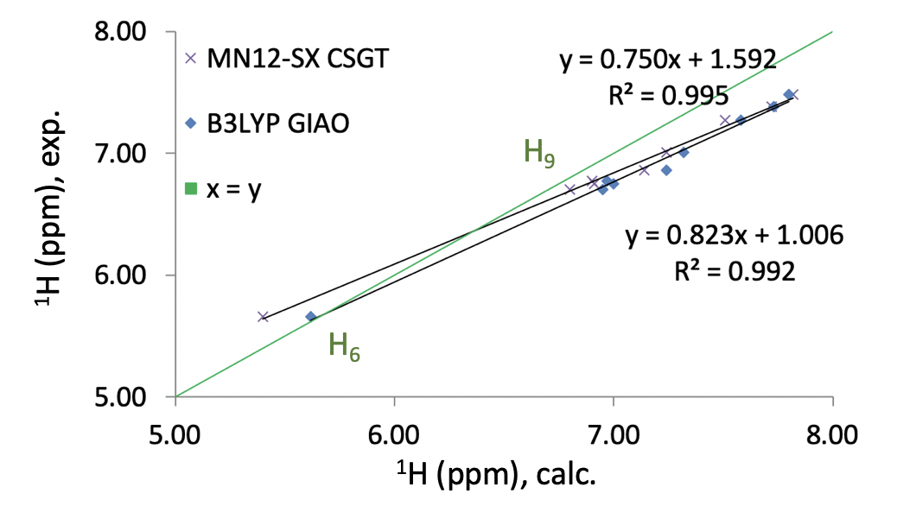

Figure S16. Correlation between experimental and calculated 1H NMR shifts for **1a**, conformer 1.

Table S5. Experimental and calculated 13C NMR shifts for **1a**. As noted in the main text, calculations were performed for two conformers, shown in Figure S14.

|  |  |  |  |  |  |  |
| --- | --- | --- | --- | --- | --- | --- |
| Position | Experimental | Conformer 1 | | | | Conformer 2 |
| B3LYP | | lc-TPSS | | B3LYP |
| GIAO | CSGT | GIAO | CSGT | CSGT |
| COOH | 166.70 | 172.76 | 172.45 | 166.52 | 165.13 | 171.77 |
| C3 | 161.90 | 168.29 169.70 | 168.07 169.48 | 160.80 162.10 | 160.10 161.31 | 167.82 169.99 |
| C4 | 160.70 | 168.80 167.70 | 168.59 167.52 | 161.69 160.73 | 160.75 159.88 | 168.58 167.44 |
| C5 | 157.10 | 161.84 163.21 | 161.62 162.97 | 154.69 156.04 | 154.60 155.88 | 161.60 163.13 |
| C2 | 154.20 | 161.92 160.11 | 161.69 159.91 | 155.07 153.25 | 154.58 152.94 | 161.89 161.03 |
| C-H2 | 133.60 | 139.13 | 138.95 | 136.14 | 136.13 | 139.26 |
| C-H8 | 132.80 | 136.88 | 136.70 | 133.21 | 133.19 | 136.61 |
| C-H4 | 131.50 | 135.48 135.40 | 135.57 135.46 | 133.75 133.57 | 133.60 133.46 | 135.58 135.34 |
| C1 | 125.70 | 128.26 | 127.16 | 120.88 | 119.60 | 125.64 |
| C-H1 | 121.60 | 126.58 126.04 | 126.27 125.83 | 121.14 120.68 | 120.82 120.43 | 126.09 126.04 |
| C-H7 | 119.50 | 124.41 124.51 | 124.22 124.21 | 119.64 119.65 | 119.31 119.28 | 123.98 124.07 |
| C-H9 | 115.90 | 121.65 | 120.79 | 115.71 | 114.24 | 120.55 |
| C-H3 | 112.10 | 113.74 112.63 | 113.74 112.53 | 108.06 106.96 | 107.66 106.68 | 113.80 112.30 |
| C-H5 | 111.90 | 113.81  113.41 | 113.75 113.30 | 108.36 107.80 | 107.94 107.38 | 113.86 113.27 |
| C-H6 | 102.60 | 103.42  103.55 | 102.68 102.74 | 95.95  96.14 | 94.48  94.58 | 102.71 102.62 |

Table S6. Experimental and calculated mean values of 13C NMR shifts for **1a**. As noted in the main text, calculations were performed for two conformers, shown in Figure S14.

|  |  |  |  |  |  |  |  |  |  |  |  |
| --- | --- | --- | --- | --- | --- | --- | --- | --- | --- | --- | --- |
| Position | Experimental | | | Conformer 1 | | | | | | | Conformer 2 |
| B3LYP | | | | lc-TPSS | | | B3LYP |
| GIAO | | CSGT | | GIAO | | CSGT | CSGT |
| COOH | | 166.70 | 172.76 | | 172.45 | | 166.52 | | 165.13 | | 171.77 |
| C3 | | 161.90 | 168.99 | | 169.48 | | 161.45 | | 160.71 | | 168.91 |
| C4 | | 160.70 | 168.25 | | 168.06 | | 161.21 | | 160.32 | | 168.01 |
| C5 | | 157.10 | 162.53 | | 162.30 | | 155.37 | | 155.24 | | 162.37 |
| C2 | | 154.20 | 161.02 | | 160.80 | | 154.16 | | 153.76 | | 161.46 |
| C-H2 | | 133.60 | 139.13 | | 138.95 | | 136.14 | | 136.13 | | 139.26 |
| C-H8 | | 132.80 | 136.88 | | 136.70 | | 133.21 | | 133.19 | | 136.61 |
| C-H4 | | 131.50 | 135.44 | | 135.52 | | 133.66 | | 133.53 | | 135.46 |
| C1 | | 125.70 | 128.26 | | 127.16 | | 120.88 | | 119.60 | | 125.64 |
| C-H1 | | 121.60 | 126.31 | | 126.05 | | 120.91 | | 120.63 | | 126.07 |
| C-H7 | | 119.50 | 124.46 | | 124.22) | | 119.65) | | 119.30) | | 124.03) |
| C-H9 | | 115.90 | 121.65 | | 120.79 | | 115.71 | | 114.24 | | 120.55 |
| C-H3 | | 112.10 | 113.19 | | 133.14 | | 107.51 | | 107.17 | | 113.05 |
| C-H5 | | 111.90 | 113.61 | | 113.53 | | 108.08 | | 107.66 | | 113.57 |
| C-H6 | | 102.60 | 103.49 | | 102.71 | | 96.05 | | 94.53 | | 102.67 |

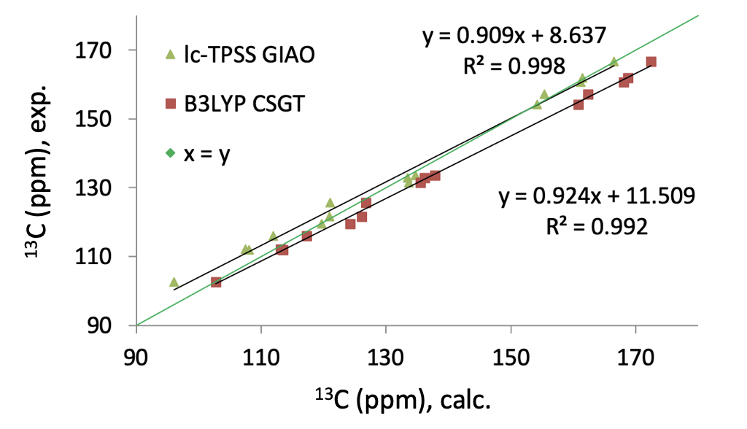

Figure S17. Correlation between experimental and calculated 13C NMR shifts for **1a**, conformer 1.

## Cartesian coordinates of the optimized structures in methanol

### **1a** conformer 1

O 1.96877300 -2.49091700 0.13910500

O -2.75588600 -1.75013800 0.75214900

O 0.04207500 -1.59458100 -1.87150900

H -0.14093500 -1.85741100 -2.78997400

O -1.36247600 -3.29462300 -1.46459200

O 2.86395800 2.26344900 -0.32551500

O -1.90451700 2.79253400 -0.76485900

C 0.87786700 -2.24641700 0.95666600

C -0.39894600 -2.15392300 0.39562900

C -1.47805100 -1.90120500 1.25497900

C -0.63555100 -2.41783100 -1.06050500

C -1.29805500 -1.81629200 2.62642800

H -2.15483400 -1.61828200 3.25679500

C 1.06766600 -2.17786800 2.33096300

H 2.06795500 -2.28177500 2.73038200

C 2.37047800 -0.09662500 -0.02154100

H 1.51534609 0.12808638 0.59595790

C 1.63187400 2.64687200 0.18369800

C -2.26566300 0.52682000 0.05057000

H -1.40535310 0.57912947 0.70011116

C 0.46393300 2.45121400 -0.54851100

H 0.48523300 1.95109900 -1.50784300

C -0.02487300 -1.97578100 3.16324400

H 0.11732400 -1.92200000 4.23497100

C -0.73573900 2.91358000 -0.02140900

C 1.61085700 3.31060900 1.40391500

H 2.53594100 3.45654000 1.94622700

C 0.39953100 3.78062900 1.90182900

H 0.37679800 4.30318900 2.84987000

C -0.78261600 3.57997000 1.19699100

H -1.73135400 3.93756200 1.57548700

C 2.71404500 -1.41337400 -0.30926400

H 3.69774726 -1.57801151 0.07819484

H 2.73737585 -1.46997102 -1.37751137

C -2.61979400 1.61457300 -0.74279200

H -3.61252074 1.89394557 -0.45758227

H -2.62681746 1.25086862 -1.74905727

C 3.13749400 0.93098600 -0.56162100

C -3.04467800 -0.62705800 -0.00820200

H -3.82729472 -0.70519399 -0.58222075

H 3.90801905 0.76687935 -1.13385508

### **1a** conformer 2

O 1.94403100 -2.52401400 0.14766500

O -2.77182300 -1.68908400 0.75855300

O 2.91274100 2.21541000 -0.32322800

O -1.84562500 2.83965300 -0.75439900

C 0.85399000 -2.26589900 0.95987300

C -0.41942000 -2.13548700 0.39441100

C -1.49638000 -1.87513600 1.25492600

C -0.60186400 -2.28603000 -1.08417600

C 2.69188600 -1.45762800 -0.32005700

C -1.31911000 -1.81891000 2.62899400

H -2.17414100 -1.61418800 3.25958900

C 1.03886300 -2.22660200 2.33524600

H 2.03504000 -2.36013300 2.73596800

C 2.37817800 -0.13608700 -0.02107000

H 1.53923000 0.10181300 0.61360500

C -3.03881500 -0.56268600 -0.00407400

C 3.78106000 -1.77639100 -1.12417300

H 4.00457800 -2.81290000 -1.33981500

C 1.68986500 2.62626800 0.18524400

C -2.57702300 1.67196800 -0.73637800

C -2.24222500 0.57887000 0.05801800

H -1.38245800 0.61678600 0.70938800

C 3.15320700 0.87887100 -0.57362900

C 0.51570000 2.44707700 -0.54125000

H 0.52330600 1.93651700 -1.49526500

C -0.05254000 -2.01517900 3.16731300

H 0.08669000 -1.98264000 4.24030600

C -4.16708900 -0.61584100 -0.81315200

H -4.76757700 -1.51530300 -0.83937100

C -0.67202600 2.94092800 -0.01567400

C 4.24605500 0.58833600 -1.38470400

H 4.83588500 1.39532600 -1.79906700

C 1.68644000 3.30330600 1.39851400

H 2.61621200 3.43577900 1.93624200

C 4.55158600 -0.74304600 -1.64501700

H 5.40042600 -0.97963400 -2.27493000

C -4.48880000 0.49820600 -1.58196200

H -5.36374800 0.46861200 -2.21975000

C -3.70073100 1.64173400 -1.55961400

H -3.94042800 2.50458700 -2.16704700

C 0.48697000 3.80392100 1.89499700

H 0.47822600 4.33672900 2.83756100

C -0.70132100 3.62097900 1.19564900

H -1.64117300 4.00277300 1.57263900

O 0.01450600 -1.67929000 -1.92603400

O -1.53076400 -3.21203300 -1.38133000

H -1.61335400 -3.25252200 -2.34940000

### **1a** conformer 1 (cluster-continuum approach)

O 0.83793900 -3.10679500 0.45173900

O -3.07074200 -0.49057800 1.52891200

O 3.00663100 0.67103700 -1.70097500

O -1.37236300 2.70533700 -1.72365500

C 0.13714400 -2.26838500 1.30333000

C -1.14736700 -1.84252400 0.95235200

C -1.81953800 -0.98597700 1.83695800

C -1.84111400 -2.36946800 -0.26691100

C 1.70353700 -2.53968100 -0.46730300

C -1.26161600 -0.63281500 3.05566000

H -1.80995200 0.03147100 3.71036500

C 0.69863300 -1.93402600 2.52854500

H 1.68387600 -2.30689100 2.77575000

C 1.89965800 -1.16631200 -0.56322900

H 1.39795800 -0.48685200 0.10797000

C -3.20822600 0.35292900 0.43678900

C 2.36659100 -3.42300800 -1.31360500

H 2.19787400 -4.48742200 -1.21648000

C 2.10329900 1.62738300 -1.27448900

C -2.35900300 1.93000600 -1.15416700

C -2.14205500 1.10456400 -0.05477300

H -1.16763300 1.04769300 0.40645400

C 2.74365100 -0.67796500 -1.55583600

C 0.76682000 1.60333100 -1.66522600

H 0.37799700 0.79884500 -2.27507300

C -0.01056900 -1.12704000 3.40791900

H 0.42246400 -0.86173500 4.36373000

C -4.47632400 0.44018400 -0.12310900

H -5.28396600 -0.15485900 0.28172500

C -0.06195700 2.64698800 -1.26695800

C 3.41489200 -1.53769000 -2.41818600

H 4.07006300 -1.13223900 -3.17782200

C 2.60948000 2.68348400 -0.52230600

H 3.65813700 2.68794800 -0.25408800

C 3.22344700 -2.90875200 -2.27915800

H 3.74195600 -3.58789400 -2.94478300

C -4.66894000 1.28882900 -1.20855400

H -5.65181600 1.36297100 -1.65753500

C -3.62040100 2.02945100 -1.73803100

H -3.76280200 2.67982500 -2.59108100

C 1.76298800 3.72324000 -0.15027900

H 2.15478600 4.55424700 0.42306000

C 0.41901600 3.70792400 -0.51054000

H -0.24951700 4.51023300 -0.22755400

O -2.89161600 -2.96559800 -0.22234900

C 3.62987800 2.37933200 3.49385000

H 3.68888100 2.26342800 4.57535400

H 4.04157900 3.35592200 3.22232600

H 4.22915800 1.59455700 3.02300200

O 2.24878900 2.27244900 3.13893200

H 2.17084300 2.37507100 2.18237000

O -1.18338100 -2.12760200 -1.40850300

H -1.68347100 -2.53433700 -2.13698100

### **1a** conformer 2 (cluster-continuum approach)

O 0.79219900 -3.13239100 0.41441000

O -3.07757900 -0.44779100 1.49149800

O 3.03977400 0.63692000 -1.67174100

O -1.28541800 2.78378300 -1.67416200

C 0.09315000 -2.29892700 1.26979000

C -1.17558600 -1.83312400 0.90551900

C -1.84468400 -0.98540200 1.80168800

C -1.78568700 -2.26110200 -0.39288400

C 1.65864800 -2.56523500 -0.50256000

C -1.30195100 -0.68045900 3.04094800

H -1.84759000 -0.02184800 3.70360100

C 0.63694000 -2.01263300 2.51418900

H 1.60800000 -2.41602600 2.76917000

C 1.88708900 -1.19526300 -0.57091000

H 1.40459000 -0.51812800 0.11675300

C -3.18590200 0.41753400 0.41373500

C 2.29775900 -3.44650200 -1.36925400

H 2.10405500 -4.50834100 -1.29271300

C 2.15971800 1.60882300 -1.23365800

C -2.29031300 2.01129000 -1.13413700

C -2.10054700 1.15922200 -0.05006000

H -1.13305200 1.07477700 0.42159700

C 2.74013400 -0.70761100 -1.55610900

C 0.82380600 1.62405800 -1.62658500

H 0.41578900 0.83814000 -2.24801900

C -0.07052000 -1.21354300 3.40265500

H 0.35015000 -0.98474600 4.37333500

C -4.44566400 0.53899600 -0.15844600

H -5.26858200 -0.04870900 0.22571900

C 0.02177800 2.68379400 -1.21615000

C 3.38696300 -1.56497800 -2.43911900

H 4.04917300 -1.15950500 -3.19260700

C 2.69149700 2.64177400 -0.46675100

H 3.73942800 2.61556400 -0.19693200

C 3.16281300 -2.93358300 -2.32793300

H 3.66197100 -3.61116000 -3.00976700

C -4.61069600 1.41315200 -1.22807500

H -5.58681600 1.51450000 -1.68636800

C -3.54300500 2.14531900 -1.72989400

H -3.66367600 2.81580200 -2.57062500

C 1.87157100 3.69816100 -0.08253700

H 2.28351300 4.51085500 0.50279400

C 0.52837000 3.72219700 -0.44527800

H -0.12000500 4.53765700 -0.15317600

O -1.25568500 -2.17692500 -1.47410800

C 3.63649400 2.25032700 3.52721800

H 3.68112000 2.10492300 4.60585000

H 4.03303900 3.24199900 3.28986600

H 4.25845200 1.49099600 3.04414100

O 2.26355400 2.12696800 3.14720100

H 2.19843000 2.25907300 2.19318300

O -3.00964800 -2.79076800 -0.21755500

H -3.35861500 -3.03188700 -1.09255300

# References

1 Q. Zhou, L. Su, T. Jiang, B. Zhang, R. Chen, H. Jiang, Y. Ye, M. Zhu, D. Han, J. Shen, G. Dai and Z. Li, *Tetrahedron*, 2014, **70**, 1125–1132.

2 A. Peterson, S. Kaabel, I. Kahn, T. Pehk, R. Aav and J. Adamson, *ChemistrySelect*, 2018, **3**, 9091–9095.

3 S. K. Wolff, D. J. Grimwood, J. J. McKinnon, M. J. Turner, D. Jayatilaka and M. A. Spackman, *Univ. West. Aust.*

4 M. J. Turner, S. Grabowsky, D. Jayatilaka and M. A. Spackman, *J. Phys. Chem. Lett.*, 2014, **5**, 4249–4255.

5 C. F. Mackenzie, P. R. Spackman, D. Jayatilaka and M. A. Spackman, *IUCrJ*.

6 A. Arduini, M. Fabbi, M. Mantovani, L. Mirone, A. Pochini, A. Secchi and R. Ungaro, *J. Org. Chem.*, 1995, **60**, 1454–1457.

7 H. Miyaji, M. Dudic, J. H. R. Tucker, I. Prokes, M. E. Light, T. Gelbrich, M. B. Hursthouse, I. Stibor, P. Lhoták and L. Brammer, *Supramol. Chem.*, 2003, **15**, 385–390.