# Supplementary material



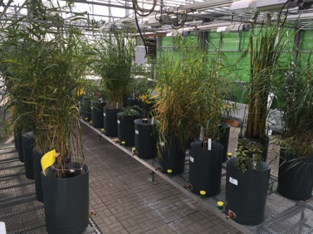 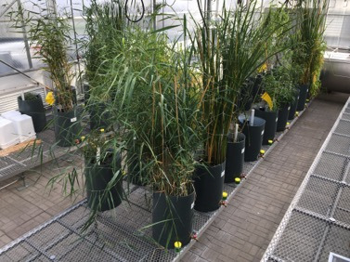

**Figure SM1.** Plan view of the plants’ position and the experimental setup.



**Figure SM2.** *Left Y axes, with related points:* Evapotranspiration rate (L/d) of all mesocosms. Each point represents the mean evapotranspiration of three replicates of the same species. *Right Y axes, with grey histograms:* Greenhouse temperature (°C) during the experiment.