SUPPLMENTAL MATERIAL FOR:
Phase stability and thermoelectric properties of semiconductor-like tetragonal FeAl₂
Kazuki Tobita^{a,}*, Koichi Kitahara^{a,b}, Yukari Katsuraª, Naoki Sato^{c}, Daisuke Nishio-Hamane^{d}, Hirotada Gotou^{d}, and Kaoru Kimura^{a,b}
ªDepartment of Advanced Materials Science, The University of Tokyo, 5-1-5 Kashiwanoha, Kashiwa, Chiba 277-8561, Japan
^{b}OPERANDO–OIL, National Institute of Advanced Industrial Science and Technology (AIST), 148 City Block 4, Kashiwanoha Campus, 178-4 Wakashiba, Kashiwa, Chiba 277-0871, Japan
^{c}International Center for Materials Nanoarchitectonics (MANA), National Institute for Materials Science (NIMS), 1-1 Namiki, Tsukuba, Ibaraki, 305-0044, Japan
^{d}The Institute for Solid State Physics, The University of Tokyo, 5-1-5 Kashiwanoha, Kashiwa, Chiba 277-8581, Japan
*Corresponding Author.
E-mail: t.kazuki52@phys.mm.t.u-tokyo.ac.jp
Phone/Fax: +81-4-7136-3759
Address: Kibantoh 502, 5-1-5 Kashiwanoha, Kashiwa, Chiba 277-8561, Japan

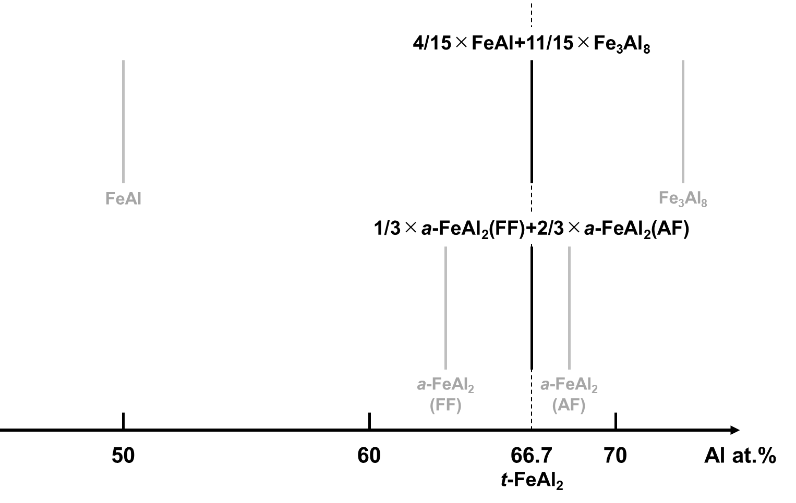
Fig. S1. The normalization of composition to comparing the Gibbs free energies at the same composition (Al 66.7at.%).
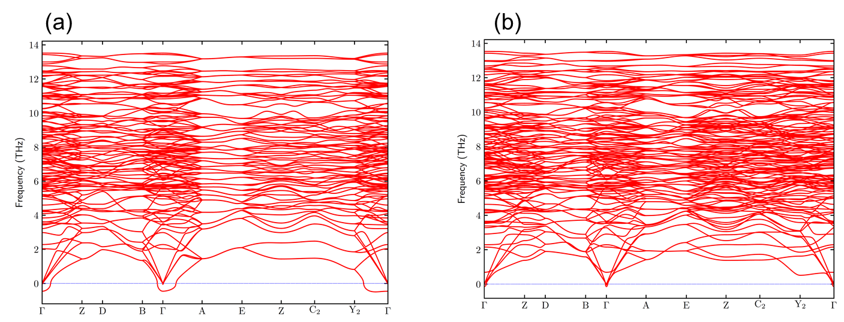
Fig. S2. The phonon band structures of (a) Fe₃Al₈-oP44 and (b) its refined structure Fe₃Al₈-oP44’. The imaginary phonon modes at gamma point were disappeared by shifting the atomic coordinates of Fe₃Al₈-oP44 in the direction of the eigenvector where the imaginary phonon modes appeared. The band-path was determined by using SeeK-path [1].

Table S1. The structural parameters of FeAl primitive cell obtained by the structural relaxation.
Lattice parameters
a(Å) | 2.875
b(Å) | 2.875
c(Å) | 2.875
α | 90.000
β | 90.000
γ | 90.000
Atomic coodinates | x | y | z
Fe1 | 0.500 | 0.500 | 0.500
Al1 | 0.000 | 0.000 | 0.000

Table S2. The structural parameters of t-FeAl₂ primitive cell obtained by the structural relaxation.
Lattice parameters
a(Å) | 3.003
b(Å) | 3.003
c(Å) | 4.750
α | 71.572
β | 71.572
γ | 90.000
Atomic coodinates | x | y | z
Fe1 | 0.000 | 0.000 | 0.000
Al1 | 0.653 | 0.653 | 0.693
Al2 | 0.347 | 0.347 | 0.307

Table S3. The structural parameters of a-FeAl₂(FF) primitive cell obtained by the structural relaxation.
Lattice parameters
a(Å) | 4.803
b(Å) | 6.344
c(Å) | 8.785
α | 87.523
β | 74.498
γ | 83.644
Atomic coodinates | x | y | z
Fe1 | 0.143 | 0.155 | 0.418
Fe2 | 0.857 | 0.845 | 0.582
Fe3 | 0.220 | 0.345 | 0.888
Fe4 | 0.780 | 0.655 | 0.112
Fe5 | 0.000 | 0.000 | 0.000
Fe6 | 0.166 | 0.478 | 0.583
Fe7 | 0.834 | 0.522 | 0.417
Al1 | 0.488 | 0.013 | 0.169
Al2 | 0.512 | 0.987 | 0.831
Al3 | 0.039 | 0.129 | 0.708
Al4 | 0.961 | 0.871 | 0.292
Al5 | 0.601 | 0.186 | 0.514
Al6 | 0.399 | 0.814 | 0.486
Al7 | 0.004 | 0.296 | 0.178
Al8 | 0.996 | 0.704 | 0.822
Al9 | 0.314 | 0.663 | 0.032
Al10 | 0.686 | 0.337 | 0.968
Al11 | 0.412 | 0.464 | 0.301
Al12 | 0.588 | 0.536 | 0.699

Table S4. The structural parameters of a-FeAl₂(AF) primitive cell obtained by the structural relaxation.
Lattice parameters
a(Å) | 4.866
b(Å) | 6.464
c(Å) | 8.636
α | 88.728
β | 74.392
γ | 82.769
Atomic coodinates | x | y | z
Fe1 | 0.137 | 0.165 | 0.416
Fe2 | 0.854 | 0.839 | 0.582
Fe3 | 0.233 | 0.360 | 0.866
Fe4 | 0.772 | 0.637 | 0.137
Fe5 | 0.989 | 0.000 | 0.995
Fe6 | 0.168 | 0.474 | 0.594
Al1 | 0.875 | 0.532 | 0.401
Al2 | 0.493 | 0.994 | 0.162
Al3 | 0.499 | 0.995 | 0.841
Al4 | 0.037 | 0.116 | 0.710
Al5 | 0.937 | 0.911 | 0.287
Al6 | 0.589 | 0.182 | 0.541
Al7 | 0.387 | 0.812 | 0.470
Al8 | 0.045 | 0.286 | 0.152
Al9 | 0.975 | 0.708 | 0.836
Al10 | 0.300 | 0.663 | 0.041
Al11 | 0.691 | 0.337 | 0.966
Al12 | 0.446 | 0.424 | 0.299
Al13 | 0.576 | 0.564 | 0.704

Table S5. The structural parameters of Fe₃Al₈-mC44 primitive cell obtained by the structural relaxation.
lattice parameters
a(Å) | 4.959
b(Å) | 6.513
c(Å) | 9.970
α | 99.620
β | 95.296
γ | 97.322
atomic coodinates | x | y | z
Fe1 | 0.341 | 0.147 | 0.199
Fe2 | 0.678 | 0.881 | 0.814
Fe3 | 0.659 | 0.534 | 0.140
Fe4 | 0.330 | 0.484 | 0.859
Fe5 | 0.670 | 0.198 | 0.480
Fe6 | 0.322 | 0.801 | 0.526
Al1 | 0.976 | 0.978 | 0.035
Al2 | 0.029 | 0.478 | 0.552
Al3 | 0.971 | 0.204 | 0.787
Al4 | 0.024 | 0.704 | 0.303
Al5 | 0.158 | 0.427 | 0.086
Al6 | 0.833 | 0.574 | 0.912
Al7 | 0.167 | 0.108 | 0.428
Al8 | 0.830 | 0.886 | 0.567
Al9 | 0.450 | 0.145 | 0.691
Al10 | 0.550 | 0.873 | 0.304
Al11 | 0.450 | 0.808 | 0.035
Al12 | 0.526 | 0.198 | 0.972
Al13 | 0.474 | 0.484 | 0.367
Al14 | 0.550 | 0.537 | 0.649
Al15 | 0.842 | 0.254 | 0.253
Al16 | 0.170 | 0.796 | 0.772

Table S6. The structural parameters of Fe₃Al₈-oP44 and Fe₃Al₈-oP44’ primitive cells obtained by the structural relaxation. The atomic coordinates of Al21, Al22, Al23, and Al24 were mainly shifted in the Fe₃Al₈-oP44’.
Fe₃Al₈-oP44 |  |  |  | Fe₃Al₈-oP44'
lattice parameters
a(Å) | 12.401 |  |  |  | 12.394
b(Å) | 7.617 |  |  |  | 7.619
c(Å) | 6.392 |  |  |  | 6.393
α | 90.000 |  |  |  | 90.000
β | 90.000 |  |  |  | 90.000
γ | 90.000 |  |  |  | 90.000
atomic coodinates | x | y | z |  | x | y | z
Fe1 | 0.089 | 0.250 | 0.076 |  | 0.078 | 0.249 | 0.085
Fe2 | 0.415 | 0.750 | 0.583 |  | 0.578 | 0.249 | 0.415
Fe3 | 0.915 | 0.750 | 0.917 |  | 0.405 | 0.749 | 0.573
Fe4 | 0.589 | 0.250 | 0.424 |  | 0.905 | 0.749 | 0.927
Fe5 | 0.243 | 0.250 | 0.427 |  | 0.240 | 0.249 | 0.425
Fe6 | 0.256 | 0.750 | 0.926 |  | 0.740 | 0.249 | 0.075
Fe7 | 0.756 | 0.750 | 0.574 |  | 0.252 | 0.749 | 0.926
Fe8 | 0.743 | 0.250 | 0.073 |  | 0.752 | 0.749 | 0.574
Fe9 | 0.418 | 0.250 | 0.078 |  | 0.418 | 0.249 | 0.074
Fe10 | 0.918 | 0.250 | 0.422 |  | 0.918 | 0.249 | 0.426
Fe11 | 0.077 | 0.750 | 0.576 |  | 0.079 | 0.749 | 0.580
Fe12 | 0.577 | 0.750 | 0.924 |  | 0.579 | 0.749 | 0.920
Al1 | 0.062 | 0.250 | 0.712 |  | 0.082 | 0.249 | 0.715
Al2 | 0.562 | 0.250 | 0.788 |  | 0.582 | 0.249 | 0.785
Al3 | 0.419 | 0.750 | 0.214 |  | 0.445 | 0.749 | 0.215
Al4 | 0.919 | 0.750 | 0.286 |  | 0.945 | 0.749 | 0.285
Al5 | 0.078 | 0.054 | 0.377 |  | 0.080 | 0.048 | 0.377
Al6 | 0.578 | 0.054 | 0.123 |  | 0.580 | 0.048 | 0.123
Al7 | 0.418 | 0.549 | 0.876 |  | 0.418 | 0.557 | 0.880
Al8 | 0.918 | 0.549 | 0.624 |  | 0.918 | 0.557 | 0.620
Al9 | 0.418 | 0.951 | 0.876 |  | 0.418 | 0.942 | 0.880
Al10 | 0.918 | 0.951 | 0.624 |  | 0.918 | 0.942 | 0.620
Al11 | 0.578 | 0.446 | 0.123 |  | 0.580 | 0.451 | 0.123
Al12 | 0.078 | 0.446 | 0.377 |  | 0.080 | 0.451 | 0.377
Al13 | 0.255 | 0.059 | 0.118 |  | 0.249 | 0.071 | 0.089
Al14 | 0.755 | 0.059 | 0.382 |  | 0.749 | 0.071 | 0.411
Al15 | 0.245 | 0.569 | 0.597 |  | 0.240 | 0.555 | 0.623
Al16 | 0.745 | 0.569 | 0.903 |  | 0.740 | 0.555 | 0.877
Al17 | 0.245 | 0.931 | 0.597 |  | 0.240 | 0.944 | 0.623
Al18 | 0.745 | 0.931 | 0.903 |  | 0.740 | 0.944 | 0.877
Al19 | 0.755 | 0.441 | 0.382 |  | 0.749 | 0.428 | 0.411
Al20 | 0.255 | 0.441 | 0.118 |  | 0.249 | 0.428 | 0.089
Al21 | 0.290 | 0.250 | 0.780 |  | 0.335 | 0.249 | 0.745
Al22 | 0.790 | 0.250 | 0.720 |  | 0.835 | 0.249 | 0.755
Al23 | 0.174 | 0.750 | 0.256 |  | 0.218 | 0.749 | 0.288
Al24 | 0.674 | 0.750 | 0.244 |  | 0.718 | 0.749 | 0.212
Al25 | 0.416 | 0.076 | 0.427 |  | 0.408 | 0.069 | 0.404
Al26 | 0.916 | 0.076 | 0.073 |  | 0.908 | 0.069 | 0.096
Al27 | 0.086 | 0.572 | 0.912 |  | 0.078 | 0.576 | 0.929
Al28 | 0.586 | 0.572 | 0.588 |  | 0.578 | 0.576 | 0.571
Al29 | 0.086 | 0.928 | 0.912 |  | 0.078 | 0.923 | 0.929
Al30 | 0.586 | 0.928 | 0.588 |  | 0.578 | 0.923 | 0.571
Al31 | 0.916 | 0.424 | 0.073 |  | 0.908 | 0.430 | 0.096
Al32 | 0.416 | 0.424 | 0.427 |  | 0.408 | 0.430 | 0.404

Reference
[1] Hinuma Y, Pizzi G, Kumagai Y, Oba F and Tanaka I Band structure diagram paths based on crystallography Comput. Mater. Sci. 2017 ;128 :140–84

