Supplementary material 1
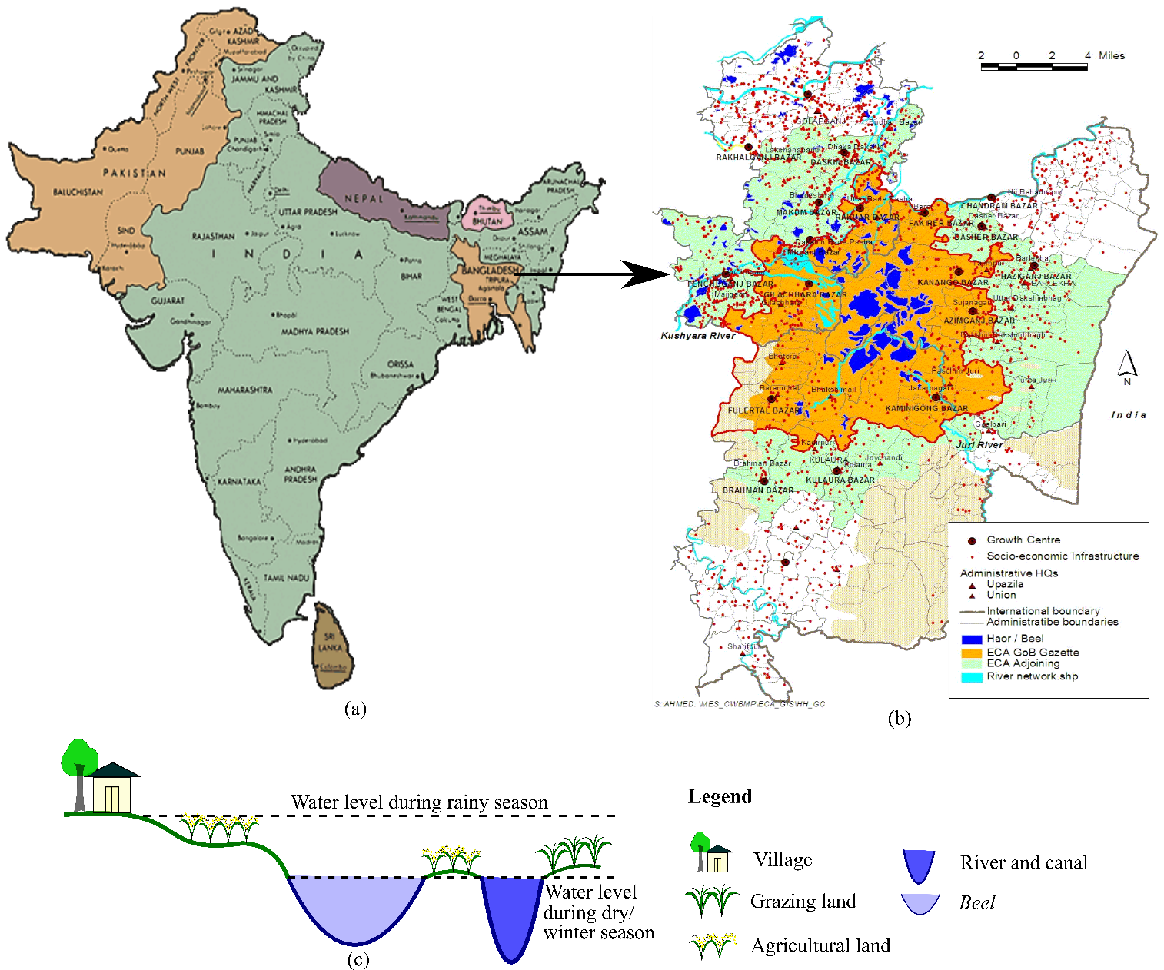
Supplementary material 1. Hakaluki haor: location, land feature and fisheries resource access categories based on seasonality and group identity. ((a) Location of Bangladesh and Hakaluki haor in South Asia; (b) Hakaluki haor; (c) Land features and land use practices of Hakaluki haor based on seasonality. (Map source: Department of Environment, the Government of Bangladesh).

