Supplementary Information
New Strategy for Identifying Potential Natural HIV-1 Non-nucleoside Reverse Transcriptase Inhibitors Against Drug-Resistance: an in silico study
Yanjing Wang^{1,2†}, Xiangeng Wang^{1,2†}, Yi Xiong¹, Aman Chandra Kaushik¹, Junaid Muhammad¹, Abbas Khan¹, Hao Dai³*, Dong-Qing Wei¹*
Affiliation:
¹State Key Laboratory of Microbial Metabolism, School of Life Sciences and Biotechnology, and Joint Laboratory of International Cooperation in Metabolic and Developmental Sciences, Ministry of Education, Shanghai Jiao Tong University, Shanghai 200240, China
²Peng Cheng Laboratory, Vanke Cloud City Phase I Building 8, Xili Street, Nanshan District, Shenzhen, Guangdong, 518055, China
³Shanghai Institute of Biochemistry and Cell Biology, Chinese Academy of Sciences, Shanghai 200031, China

†These authors contributed equally to this work

Yanjing Wang: wangyanjing@sjtu.edu.cn
Xiangeng Wang: wangxiangeng@sjtu.edu.cn
Yi Xiong: xiongyi@sjtu.edu.cn
Aman Chandra Kaushik: amanbioinfo@sjtu.edu.cn
Muhammad Junaid: juni_sjtu@sjtu.edu.cn
Abbas Khan: biotechuos4@gmail.com

*Corresponding author:
Professor: Dong-Qing Wei, dqwei@sjtu.edu.cn
Doctor: Hao Dai, wys8c764@126.com

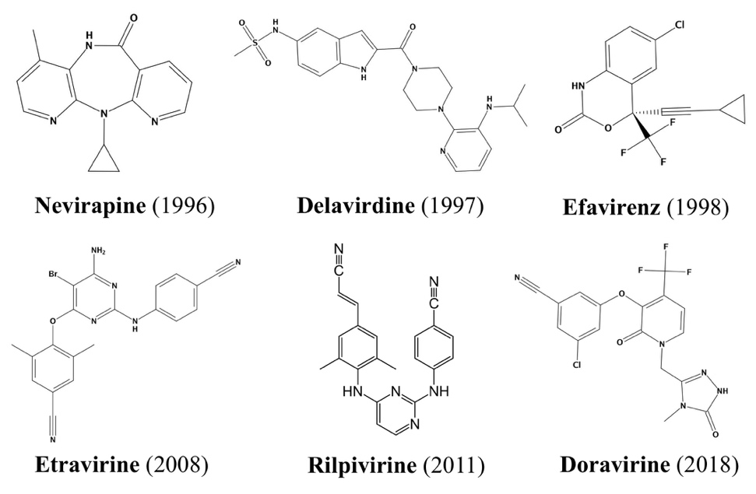
Figure S1. Chemical structure of NNRTIs approved by the FDA for HIV-1 treatment

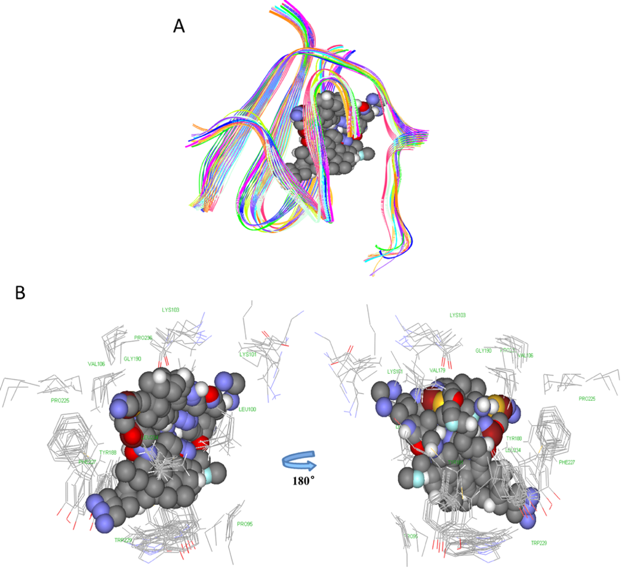
Figure S2. Ligand binding landscape (A) Structure alignment in NNIBP of 10 RT crystallographic structures. Grey balls are the area enveloped by the ligands, which represents the NNRTI binding site. (B) Spatial distribution of 14 amino acids near the ligand-binding site.

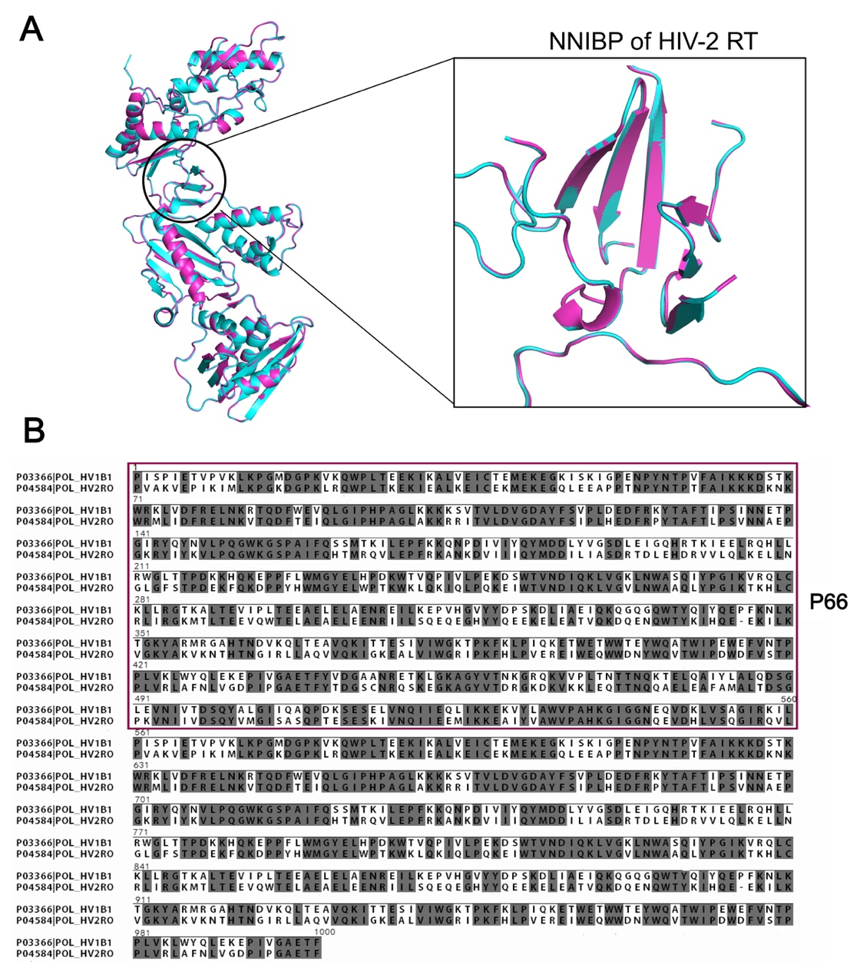
Figure S3. Sequential and Structural comparison between HIV-2 RT and HIV-1 RT. (A) The structure alignment between HIV-2 RT (red) from homology modelling and the template (HIV-1 RT, blue). Only NNRTI was shown. (B) Sequence alignment of template HIV-1 RT sequence with target HIV-2 RT sequence. RT sequences refer to that of HIV-1(PDB:4G1Q, SwissProt: P03366) and HIV-2 (SwissProt: P04584). P66 subunit (1 to 560 residues) has been highlighted in a red box. Sequence identity and similarity were 60.7% and 79.6%, respectively.

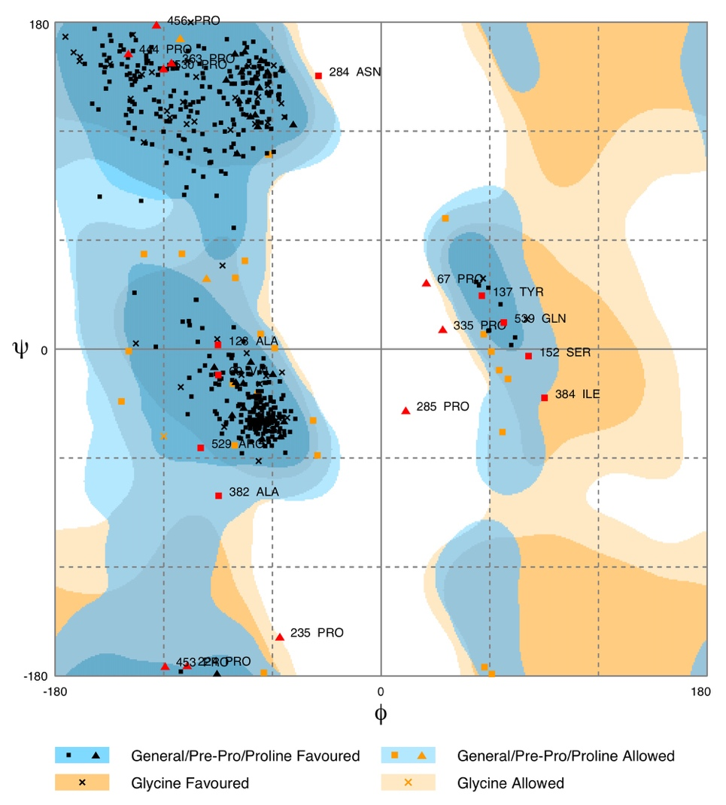
Figure S4. Ramachandran plot for the predicted HIV-2 RT model using RAMPAGE server. The model conformation has high stability and rationality (91.4 % residues in the allowed region).

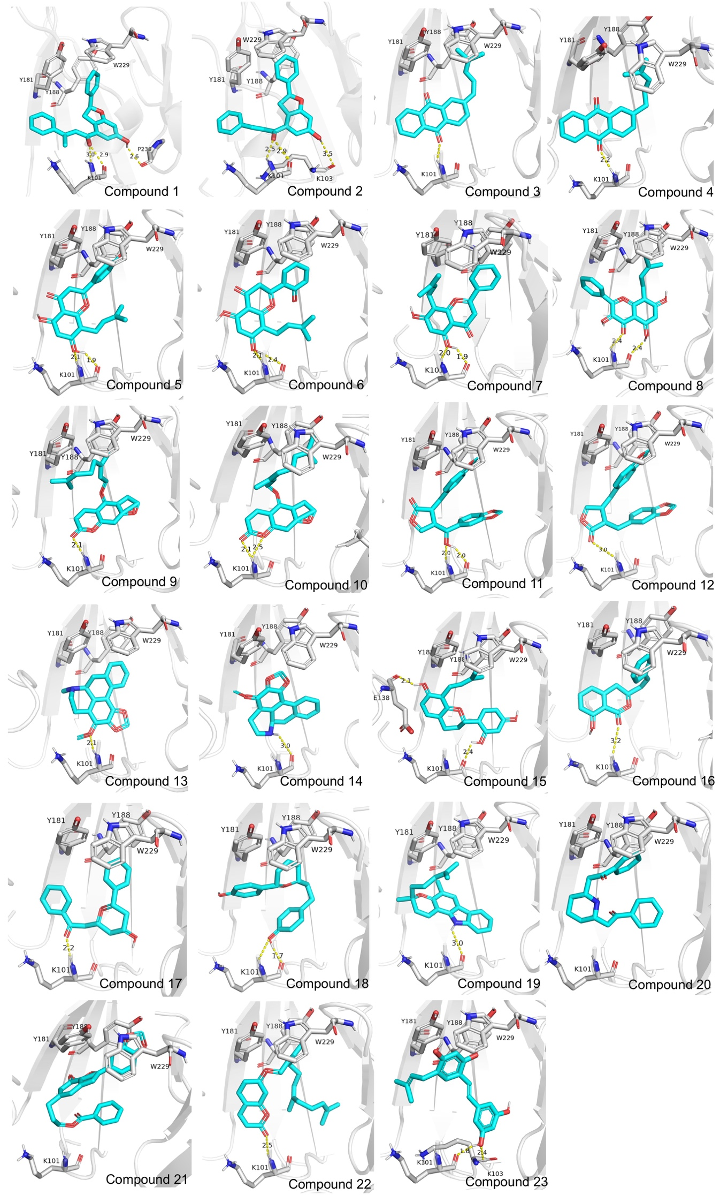

Figure S5. Representative docking poses of 23 hits.

Figure S6. RMSD plot of Backbone atoms RMSD (top), NNIBP (middle) and ligands (bottom) for controls and top 2 candidates in complex with mutant HIV-1 RT protein during 30ns simulations. (A) L100I/K103N variant of HIV-1 RT complexes. (B) K101E variant of HIV-1 RT complexes.

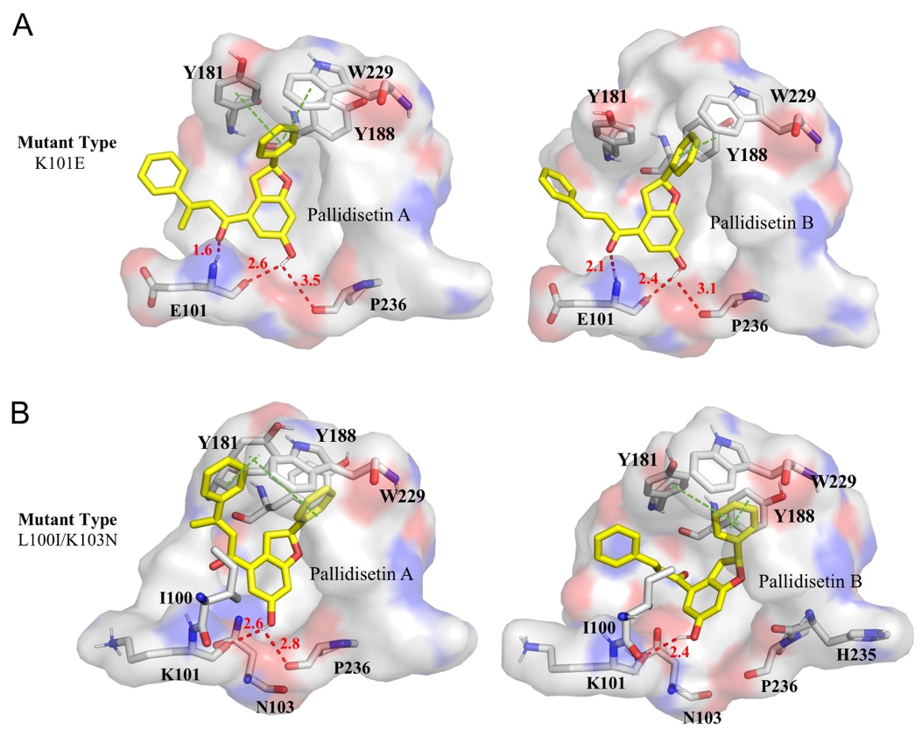

Figure S7. The representative binding mode of top 2 hits in NNIBP of mutated HIV-1 RT.

Table S1. 10 crystal structures for structure alignment

PDB ID | Ligand name | Resolution (Å) | Mutation  (chain A)
4G1Q | RPV | 1.5 | -
4I2Q | 51BT | 2.7 | K103N, Y181C
2YKM | NSC700591 | 2.9 | N57S, F227C
2ZE2 | RPV | 2.9 | L100I, K103N,
1EET | MSC204 | 2.7 | P140S, E478Q
1HNI | R95845 | 2.8 | K172R, C280S
1JKH | EFV | 2.5 | Y181C
3DMJ | GWE | 2.6 | V106A, Y181C
2HND | NVP | 2.5 | K101E
2YNF | WHU | 2.3 | Y188L

Table S2. The RMSD values of Cα in the main chain of 10 structures (The unit is Å)

2HND | 0.97
4I2Q | 1.662 | 1.469
2YKM | 1.224 | 1.042 | 1.729
2ZE2 | 1.484 | 1.371 | 0.874 | 1.515
3DMJ | 1.086 | 1.227 | 1.823 | 1.679 | 1.668
1HNI | 1.413 | 1.401 | 1.846 | 1.03 | 1.603 | 1.826
1JKH | 1.448 | 1.345 | 1.881 | 1.08 | 1.696 | 1.751 | 1.182
1EET | 1.051 | 1.172 | 1.54 | 1.196 | 1.3 | 1.53 | 1.358 | 1.485
4G1Q | 1.553 | 1.271 | 0.742 | 1.569 | 0.698 | 1.702 | 1.658 | 1.735 | 1.313
 | 2YNF | 2HND | 4I2Q | 2YKM | 2ZE2 | 3DMJ | 1HNI | 1JKH | 1EET

Table S3. The 13 drug-resistant mutants located in the NNIBP, and together with the equivalent residues in HIV-2 RT

HIV-1 | Drug-resistance mutation | HIV-2
Leu100 | L100I | Leu
Lys101 | K101P/E | Ala
Lys103 | K103N/S | Lys
Val106 | V106A/M/I | Ile
Val179 | V179F/D/L/T | Ile
Tyr181 | Y181I/C/V | Ile
Tyr188 | Y188L/C/H | Leu
Gly190 | G190A/S | Ala
Pro225 | P225H | Pro
Phe227 | F227L/C | Tyr
Met230 | M230/L/I | Met
Leu234 | L234I | Leu
Lys238 | K238T | Lys

Table S4. Docking score of five approved NNRTIs (kcal/mol).

NNRTI (Year) | HIV-1 | HM | HIV-2
Nevirapine (1996) | -9.5 | -7.3 | -8.9
Delavirdine (1997) | -9.1 | -5.9 | -7.7
Efavirenz (1998) | -10.9 | -8 | -10.2
Etravirine (2008) | -12.7 | -7.2 | -10
Rilpivirine (2011) | -13 | -8 | -9.2

Table S5. Calculated physicochemical properties of NNRTI Drugs

 |  |  |  | Physicochemical Properties
Name | PDB | MW^{b} | VSA^{c} |  | Vol^{d} | cLogP^{e} | HBA^{f} | HBD^{g} | NrotB^{h}
Nevirapineª | 3HVT | 266.30 | 278.92 |  | 569.13 | 2.05 | 3 | 1 | 1
Delavirdineª | 1KLM | 456.56 | 470.77 |  | 594.29 | 1.58 | 4 | 3 | 7
Efavirenzª | 1KF9 | 315.67 | 284.05 |  | 338.22 | 3.68 | 2 | 1 | 2
Etravirineª | 3MEC | 435.28 | 406.50 |  | 510.99 | 6.11 | 5 | 2 | 5
Rilpivirineª | 4G1Q | 366.42 | 409.19 |  | 515.92 | 5.64 | 4 | 2 | 7
MSC204 | 1EET | 422.25 | 384.01 |  | 467.46 | 2.79 | 4 | 3 | 5
R95845 | 1HNI | 440.13 | 354.21 |  | 457.28 | 4.58 | 2 | 2 | 5
NSC700591 | 2YKM | 293.30 | 276.46 |  | 333.86 | 3.63 | 3 | 0 | 3
WHU | 2YNF | 499.13 | 422.26 |  | 504.20 | 4.58 | 4 | 4 | 6
GWE | 3DMJ | 544.91 | 482.28 |  | 592.11 | 5.01 | 5 | 2 | 7
51BT | 4I2Q | 438.52 | 443.79 |  | 404.75 | 3.88 | 6 | 4 | 6
ªThese are approved NNRTIs.
^{b}MW stands for molecular weight
^{c}VSA represents Area of van der Waals surface
^{d}Vol is van der Waals volume
^{e}cLogP means Octanol–water partition coefficient
^{f}HBA stands for Number of H-bond acceptors
^{g}HBD represents Number of H-bond donors
^{h}NrotB means Number of rotatable bonds

Table S6. Calculated Physicochemical Properties of 23 hits

Compound |  | Physicochemical Properties
No. | Formula | MW | VSA | Vol | LogP | HBA | HBD | NrotB
1 | C₂₄H₂₀O₃ | 356.42 | 365.86 | 505.96 | 5.54 | 3 | 1 | 4
2 | C₂₃H₁₈O₃ | 342.39 | 354.81 | 481.53 | 5.04 | 3 | 1 | 4
3 | C₂₀H₁₆O₂ | 288.35 | 307.07 | 415.94 | 5.93 | 2 | 0 | 2
4 | C₂₀H₂₀O₂ | 290.36 | 319.35 | 421.84 | 6.14 | 2 | 0 | 3
5 | C₂₀H₁₈O₅ | 338.36 | 340.84 | 450.98 | 4.41 | 4 | 3 | 3
6 | C₂₀H₂₀O₅ | 340.38 | 347.44 | 456.89 | 3.70 | 5 | 3 | 4
7 | C₂₀H₂₀O₄ | 324.38 | 342.92 | 448.36 | 4.17 | 4 | 2 | 4
8 | C₂₀H₁₈O₆ | 338.36 | 346.36 | 450.98 | 4.51 | 4 | 3 | 3
9 | C₂₁H₂₂O₄ | 336.39 | 371.52 | 471.17 | 5.97 | 2 | 0 | 6
10 | C₂₁H₂₀O₄ | 338.40 | 375.89 | 477.07 | 6.34 | 2 | 0 | 6
11 | C₂₀H₁₈O₇ | 370.36 | 348.52 | 460.60 | 1.77 | 6 | 1 | 4
12 | C₂₀H₁₈O₆ | 354.36 | 351.69 | 452.07 | 2.33 | 5 | 0 | 4
13 | C₁₉H₁₉NO₃ | 309.36 | 303.57 | 423.05 | 2.80 | 4 | 0 | 1
14 | C₁₈H₁₇NO₃ | 295.34 | 292.72 | 397.00 | 2.52 | 4 | 1 | 1
15 | C₂₀H₂₂O₄ | 326.39 | 353.00 | 455.71 | 3.74 | 4 | 3 | 4
16 | C₁₇H₁₄O₃ | 266.30 | 275.75 | 366.55 | 3.59 | 2 | 1 | 2
17 | C₁₉H₂₀O₃ | 296.37 | 327.88 | 421.31 | 3.19 | 3 | 1 | 6
18 | C₁₉H₂₀O₃ | 296.37 | 338.68 | 422.76 | 3.15 | 3 | 2 | 5
19 | C₂₃H₂₅NO | 331.46 | 376.60 | 499.92 | 5.72 | 1 | 1 | 3
20 | C₂₁H₂₃NO₂ | 321.42 | 375.56 | 468.46 | 3.84 | 3 | 1 | 8
21 | C₂₆H₂₂O₆ | 430.46 | 433.11 | 575.04 | 5.35 | 4 | 0 | 7
22 | C₂₄H₃₀O₃ | 336.50 | 440.40 | 553.59 | 7.01 | 2 | 0 | 9
23 | C₁₉H₂₀O₃ | 296.37 | 342.72 | 428.61 | 4.51 | 3 | 3 | 4

Table S7. The predicted HIV-RT IC50 value of 23 hits

No | Name | IC50(μm)
1 | Pallidisetin A | 51.72
2 | Pallidisetin B | 35.28
3 | 2-(4-methylpenta-1,3-dienyl) anthraquinone | 43.51
4 | 2-(4-methylpent-3-enyl) anthraquinone | 66.8
5 | Licoflavone C | 58.35
6 | Kosamol S | 67.67
7 | Glabranin | 44.28
8 | Glepidotin A | 56.92
9 | Anhydronotoptol | 31.81
10 | Bergamottin | 31.81
11 | Parabenzlactone | 46.18
12 | Hinokinin | 23.26
13 | (-)-Stephalagine | 35.69
14 | Norstephalagine | 36.64
15 | Morusyunnansin F | 49.75
16 | Typharin | 48.26
17 | Diospongin B | 31.74
18 | (3S,7S)-5,6-dehydro-4"-de-O- methylcentrolobine | 41.01
19 | Mahanimbine | 16.34
20 | Isolobelanine | 41
21 | 3-[2-(1,3-benzodioxol-5-yl)-7-methoxy-1- benzofuran-5-yl]propylbenzoate | 36.03
22 | Umbelliprenin | 11.77
23 | 5-(γ,γ-dimethylallyl)-oxyresveratrol | 7.58

Table S8. Summary of MD simulation conditions

System | No. | Mutation | Ligand | Ion | N_{Water} | Time(ns)
WT_4G1Q | 1 | Wild type | RPV | 210 Na⁺/213 Cl⁻ | 71691 | 30
 | 2 |  | C1 | 210 Na⁺/213 Cl⁻ | 71640
 | 3 |  | C2 | 210 Na⁺/213 Cl⁻ | 71694
 | 4 |  | C3 | 210 Na⁺/213 Cl⁻ | 71697
MT_2ZE2 | 5 | L100I  K103N | RPV | 213 Na⁺/214 Cl⁻ | 74879 | 30
 | 6 |  | C1 | 213 Na⁺/214 Cl⁻ | 74880
 | 7 |  | C2 | 213 Na⁺/214 Cl⁻ | 74885
MT_2HND | 8 | K101E | NVP | 218 Na⁺/220 Cl⁻ | 76432 | 30
 | 9 |  | C1 | 218Na⁺/220 Cl⁻ | 76410
 | 10 |  | C2 | 218Na⁺/220 Cl⁻ | 76411

Table S9. The structure of top 3 hits and control existing drugs.

Control | Top 3 hits
RPV: Rilpivirine | C1: Pallidisetin A | C2: Pallidisetin B
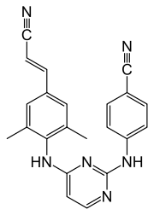 | 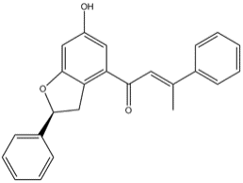 | 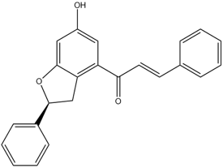
NVP : Nevirapine | C3: ((E)-2-(4-methylpenta-1,3-dienyl)anthraquinone
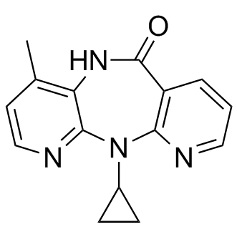 | 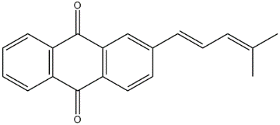

Table S10. Hydrogen bond frequency for Pallidisetin A (PA) and Pallidisetin B (PB)

System | Ligand | H-bondª | Donor | Accepter | H-bond  occupancy
WT | PA | Distance1 | PA:H1 | LYS101:O | 83.43%
 |  | Distance2 | PA:H1 | PRO236:O | 12.00%
 | PB | Distance1 | PB:H1 | LYS101:O | 85.53%
 |  | Distance2 | LYS103:HN | PB:O2 | 86.80%
K101E | PA | Distance1 | PA:H1 | GLU101:O | 38.83%
 |  | Distance2 | PA:H1 | PRO236:O | 58.70%
 | PB | Distance1 | PA:H1 | GLU101:O | 46.90%
 |  | Distance2 | PA:H1 | PRO236:O | 52.13%
L100I/K103N | PA | Distance1 | PA:H1 | LYS101:O | 59.23%
 |  | Distance2 | PA:H1 | PRO236:O | 40.20%
 |  | Distance3 | ASN103:HD2 | PA:O2 | 23.73%
 | PB | Distance1 | PB:H1 | LYS101:O | 14.57%
 |  | Distance2 | PB:H1 | HIS235: | 28.33%
ªH-bond cutoff distance: 3.5 Å

