**Supplemental Information:**

**Multi-walled carbon nanotubes upregulate mitochondrial gene expression and trigger mitochondrial dysfunction in primary human bronchial epithelial cells**

Ryan J. Snydera*, K.C. Verheinb, H.L. Vellersc, A.B. Burkholdera, S. Garantziotisa, S.R. Kleebergera

*aNational Institute of Environmental Health Sciences, NIH, Durham, NC, USA; bQ2 Solutions, Research Triangle Park, NC, USA; cDepartment of Kinesiology and Sport Management, Texas Tech University, Lubbock, TX, USA*

**\* Corresponding Author:**

Ryan J. Snyder

Immunity, Inflammation & Disease Laboratory

National Institute of Environmental Health Sciences, NIH

27709, Durham, NC.

Tel: +1 984 287 4712

Email: snyder3@niehs.nih.gov

**Supplemental Information**

***Gene Expression and Heteroplasmy in Nanographite Shape Control***

To determine the effect of MWCNT shape on mitochondrial gene expression, heteroplasmy, and insertion/deletion mutations, BECs were also exposed to mesoporous graphitized nanocarbon (nanographite, NG), a chemically-similar nanomaterial consisting of graphene sheets rather than tubes. Nanographite was used at 12ug/ml and was found to be non-cytotoxic at this dose in our previous work. NG was purchased from Sigma Aldrich (St. Louis, MO) and its purity was determined to be >99.95%, with only trace metals present, and particle size determined to be <500nm in diameter. Surface area was measured at 70m2/g with a 137Å average pore diameter. Unlike MWCNTs, nanographite did not induce significant changes in expression of mitochondrial genes. It also was not capable of inducing changes in heteroplasmy or insertion/deletion mutations.







***Mitochondrial DNA Agarose Gels***

Following long PCR amplification of the short and long mtDNA fragments using SequalPrep kits, fragments were run on 0.8% agarose gels (SeaKemp) to verify the presence of mtDNA product. A single band corresponding to the size fragment amplified was observed for each sample, verifying the specificity of the SequalPrep amplification. Samples were then further purified by Zymo DNA Clean and Concentrator columns. Only samples 1-8 (BEC1-BEC8, respectively) were used for this study; samples 9-12 in the gel images were outside the age range of the study.

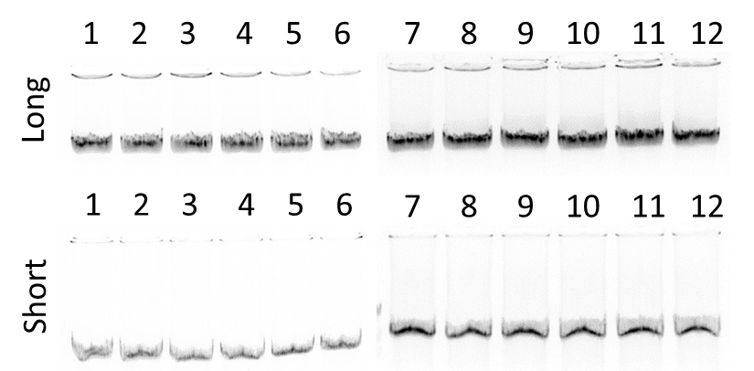

***PrimePCR MIQE Context Sequences***

As the primer sequences used for the mitochondrial gene expression arrays are the proprietary information of BioRad Laboratories, only the amplicon context sequences provided by the manufacturer are shown.

**MT-ATP8:**

CATACTCCTTACACTATTCCTCATCACCCAACTAAAAATATTAAACACAAACTACC

ACCTACCTCCCTCACCAAAGCCCATAAAAATAAAAAATTATAACAAACCCTGAGA

ACCAAAATGAACGAAAATCTGTTCGCTTCATTCATTGCCCCCACAATCCTAG

**MT-ATP6:**

CACCTACTCATGCACCTAATTGGAAGCGCCACCCTAGCAATATCAACCATTAACC

TTCCCTCTACACTTATCATCTTCACAATTCTAATTCTACTGACTATCCTAGAAATC

GCTGTCGCCTTAATCCAAGCCTACGTTTT

**MT-CO1:**

GCAACCTCAACACCACCTTCTTCGACCCCGCCGGAGGAGGAGACCCCATTCTAT

ACCAACACCTATTCTGATTTTTCGGTCACCCTGAAGTTTATATTCTTATCCTACCA

GGCTTCGGAATAATCTCCCATATTGTAAC

**MT-CO2:**

AAACCGTCTGAACTATCCTGCCCGCCATCATCCTAGTCCTCATCGCCCTCCCATC

CCTACGCATCCTTTACATAACAGACGAGGTCAACGATCCCTCCCTTACCATCAAA

TCAATTGGCCACCAATGGTAC

**MT-CO3:**

AGCCTCAGAGTACTTCGAGTCTCCCTTCACCATTTCCGACGGCATCTACGGCTC

AACATTTTTTGTAGCCACAGGCTTCCACGGACTTCACGTCATTATTGGCTCAACT

TTCCTCACTATCTGCTTCATCCGCCAACTAATATTTC

**MT-CYB:**

AACAAAGCATAATATTTCGCCCACTAAGCCAATCACTTTATTGACTCCTAGCCGC

AGACCTCCTCATTCTAACCTGAATCGGAGGACAACCAGTAAGCTACCCTTTTACC

ATCATTGGACAAGTAGCATCCGTACTATA

**MTERF:**

GAGAACGTTCCAAAATATTTACAATTTCAAGGTCTGATGTCACAATCTTTCTCCAC

AGATCCCACCGTTTTGAAAGATTCTCGGGAGTACGTGTTATTGCTCGTGGATATC

TTGATATGATG

**MT-ND1:**

CCTCTAGCCTAGCCGTTTACTCAATCCTCTGATCAGGGTGAGCATCAAACTCAAA

CTACGCCCTGATCGGCGCACTGCGAGCAGTAGCCCAAACAATCTCATATGAAGT

CACCCTAGCCATCATTCTACTATCAACATTACTAATAA

**MT-ND2:**

ATTAAACCAAACCCAGCTACGCAAAATCTTAGCATACTCCTCAATTACCCACATA

GGATGAATAATAGCAGTTCTACCGTACAACCCTAACATAACCATTCTTAATTTAAC

TATTTATATTATCCTAACTACTACCGCATTCCTACTACTCAACTTAAACTCCAGCA

CCACGACCCTACTA

**MT-ND3:**

TACGAGTGCGGCTTCGACCCTATATCCCCCGCCCGCGTCCCTTTCTCCATAAAA

TTCTTCTTAGTAGCTATTACCTTCTTATTATTTGATCTAGAAATTGCCCTCCTTTTA

CCCCTACCATGAGCCCT

**MT-ND4:**

CTCTCACTGCCCAAGAACTATCAAACTCCTGAGCCAACAACTTAATATGACTAGC

TTACACAATAGCTTTTATAGTAAAGATACCTCTTTACGGACTCCACTTATGACTCC

CTAAAGCCCATGTCGAAGCCCCCATCGCTGGGTCAA

**MT-ND4L:**

ATACTAGTATATCGCTCACACCTCATATCCTCCCTACTATGCCTAGAAGGAATAAT

ACTATCGCTGTTCATTATAGCTACTCTCATAACCCTCAACACCCACTCCCTCTTAG

CCAATATTGTGC

**MT-ND5:**

AACCACCCTAACCCTGACTTCCCTAATTCCCCCCATCCTTACCACCCTCGTTAAC

CCTAACAAAAAAAACTCATACCCCCATTATGTAAAATCCATTGTCGCATCCACCTT

TATTATCAGTCTCTTCCCCACAACAATA

**MT-ND6:**

CACCAATAGGATCCTCCCGAATCAACCCTGACCCCTCTCCTTCATAAATTATTCA

GCTTCCTACACTATTAAAGTTTACCACAACCACCACCCCATCATACTCTTTCACCC

ACAGCACCAATCCTACCTCCAT

**UBC:**

AGCTGCTTTCCGGCAAAGATCAACCTCTGCTGGTCAGGAGGAATGCCTTCCTTG

TCCTGGATCTTTGCTTTGACGTTCTCGATGGTGTCACTGGGCTCGACCTCAAGG

GTGATGGTCTTGCCAGTGAGTGTCTTCACGAAGATTTGCAT

***Transmission Electron Microscopy (TEM) of Intracellular MWCNTs***

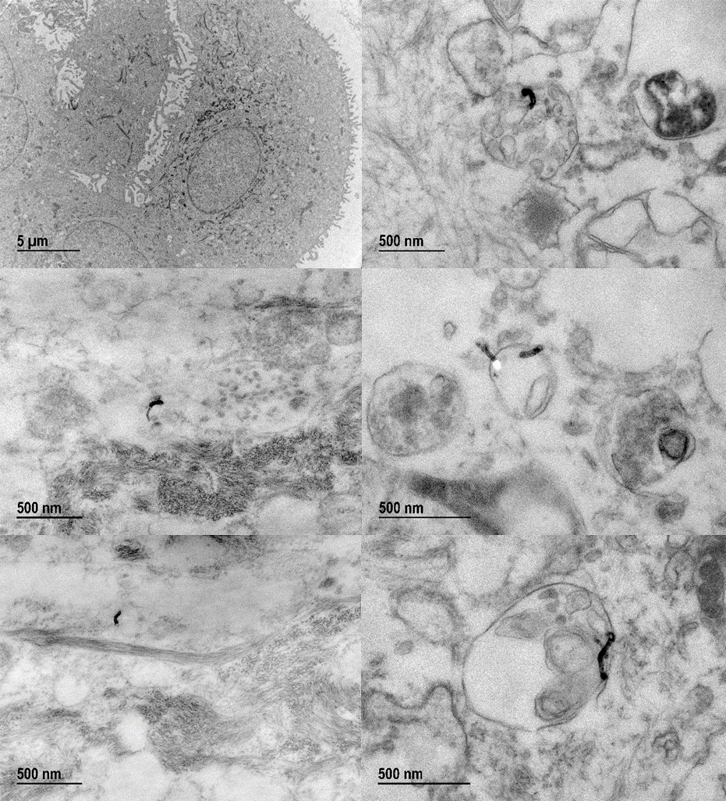 Additional TEM images of MWCNTs within the cells, illustrating morphology. Fibers were found in both intracellular vesicles and the cytoplasm.

***Darkfield Confocal Microscopy of Intracellular MWCNT Distribution***

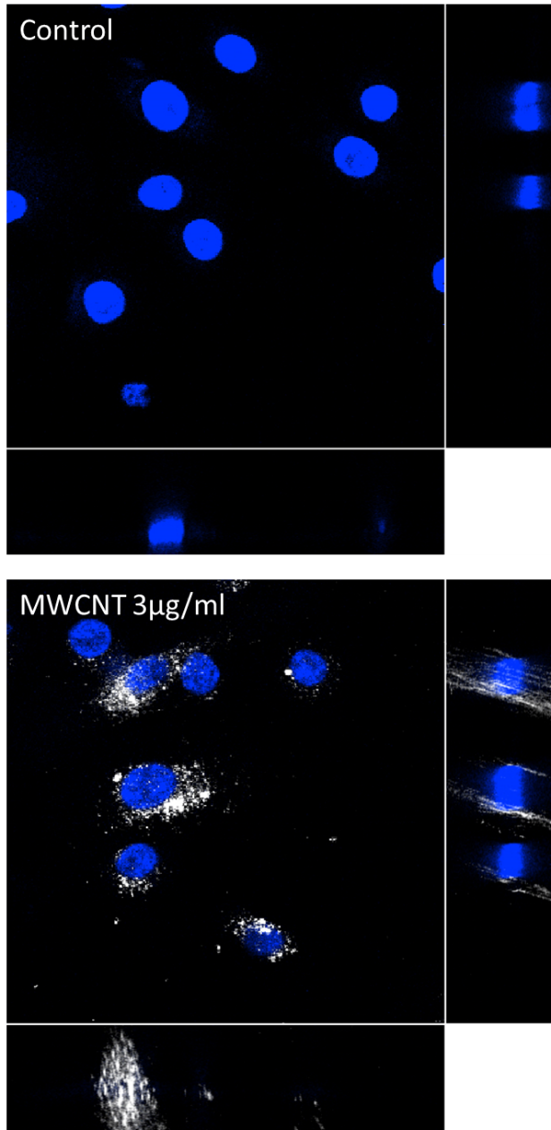The use of a darkfield condenser with a confocal microscope to image light scattered by nano-scale particles within the cell was performed as described by EA Gibbs-Flournoy, et al (Part Fibre Toxicol 2011). This method allowed for a qualitative assessment of the distribution of nanotubes within the BECs. In control dispersion-vehicle BECs only the DAPI nuclear stain can be seen. In MWCNT-treated BECs white scatter cones indicating the presence of light-scattering particles were diffuse throughout the cell, though the nuclei themselves appeared to have relatively few particles.