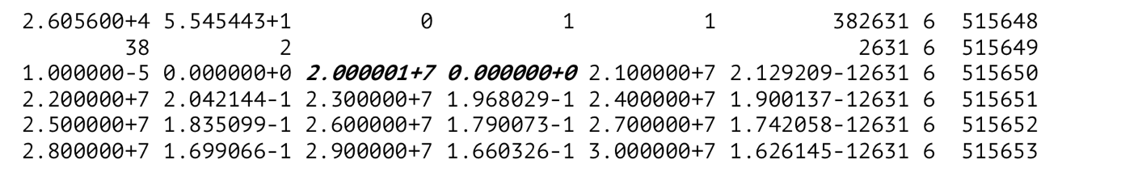

Figure A part of ⁵⁶Fe production yield data in ⁵⁶Fe of FENDL-3.1d (ENDF-6 format).
S. Kwon:
Study on DPA cross sections above 20 MeV in FENDL-3.1d for A-FNS neutronics analysis.

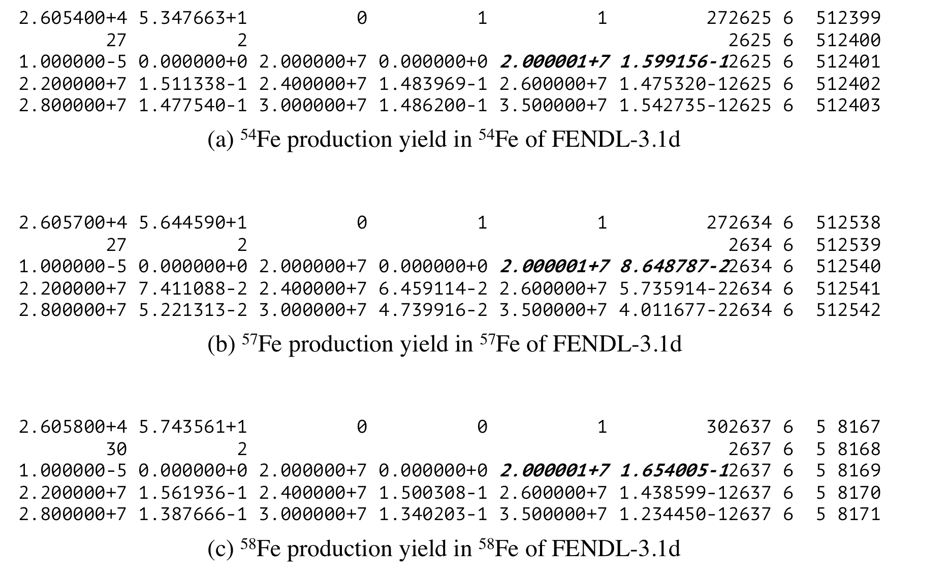

Figure A part of ⁵⁴Fe, ⁵⁷Fe, and ⁵⁸Fe production yield data in ⁵⁴Fe, ⁵⁷Fe, and ⁵⁸Fe of FENDL-3.1d (ENDF format), respectively.
S. Kwon:
Study on DPA cross sections above 20 MeV in FENDL-3.1d for A-FNS neutronics analysis.

