**Supplemental Data**

**ANTIMICROBIAL AND ANTIFOULING POLYMERIC COATING MITIGATES PERSISTENCE OF *PSEUDOMONAS AERUGINOSA* BIOFILM**

Brenda G. Werner, Julia Y. Wu and J. M. Goddard*

Department of Food Science, Cornell University, Ithaca, NY, USA

*corresponding author:

Julie M. Goddard

email: goddard@cornell.edu

Phone: (607) 255-8622

Fax: (607) 254-4868

**(a)**

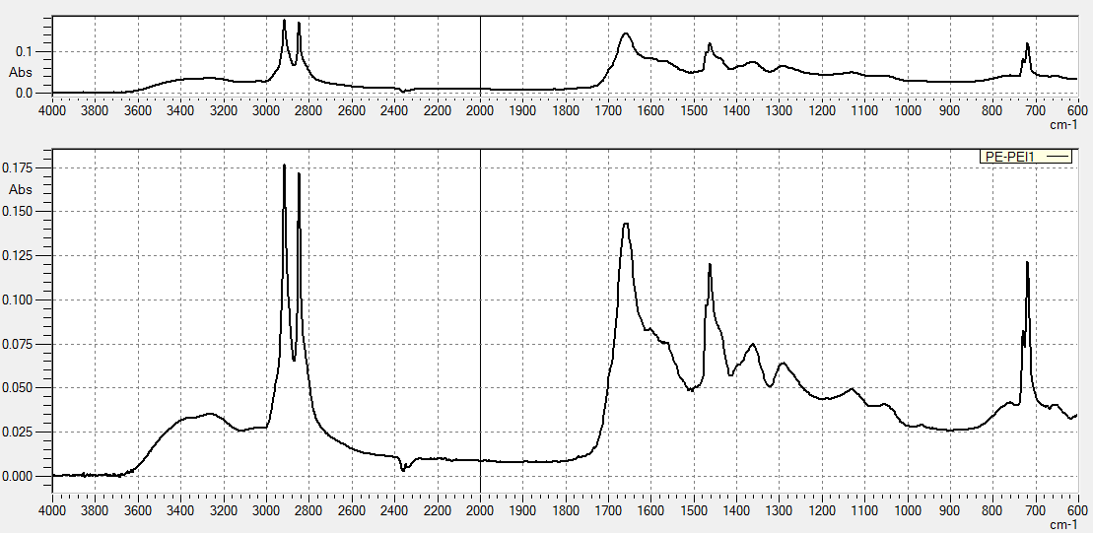

**(b)**

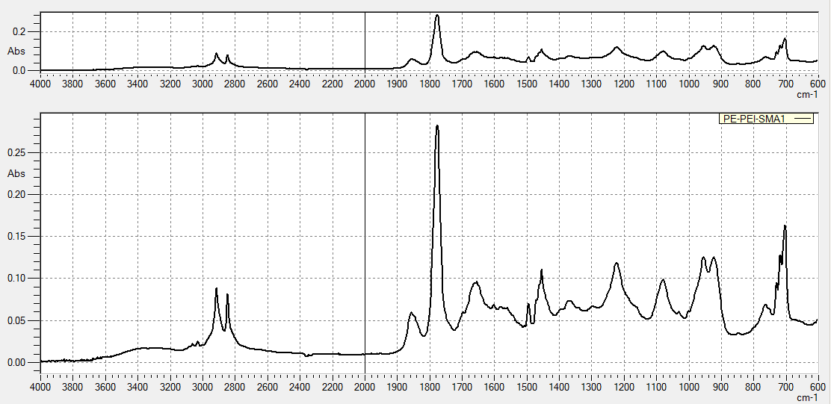

**(c)**

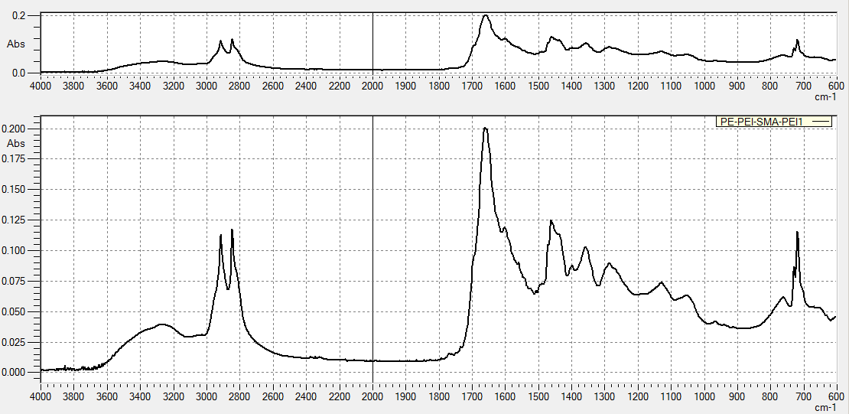

**Figure 1.** ATR-FTIR spectra show characteristic bands during PP coupon coating and heat curing: (a) PP-PEI spin coated; (b) PP-PEI-SMA spin coated; and (d) PP-PEI-SMA-PEI spin coated and heat cured.

Table 1. Growth of *Pseudomonas aeruginosa* on 1.2 cm2 coupons during incubation in a CDC bioreactor for up to 48h at 22 ± 1oC with raw data and calculations of log CFU/cm2 shown. Data for 26 h, the batch phase, was collected semi-hourly while data for 48 h, the continuous phase, was collected as a single endpoint sampling. Data individually shown for (a) native PP incubated up to 26 h ; (b) PP-PEI-SMA-PEI inbubated up to 26 h; (c) native PP incubated for 48 h, replicate 1; (d) native PP incubated for 48 h, replicate 2; (e) PP-PEI-SMA-PEI incubated for 48 h, replicate 1; and (f) PP-PEI-SMA-PEI incubated for 48 h, replicate 2.

(a)



(b)



(c)



(d)



(e)



(f)



Table 2. Quantification of 48 h biofilm of *Pseudomonas aeruginosa*  on three 1.2 cm2 (a) native PP and (b) PP-PEI-SMA-PEI coupons harvested over time (min) after cleaning with 65oC DI water at 0.7 Pa laminar flow.

(a)



(b)

