Supplementary material

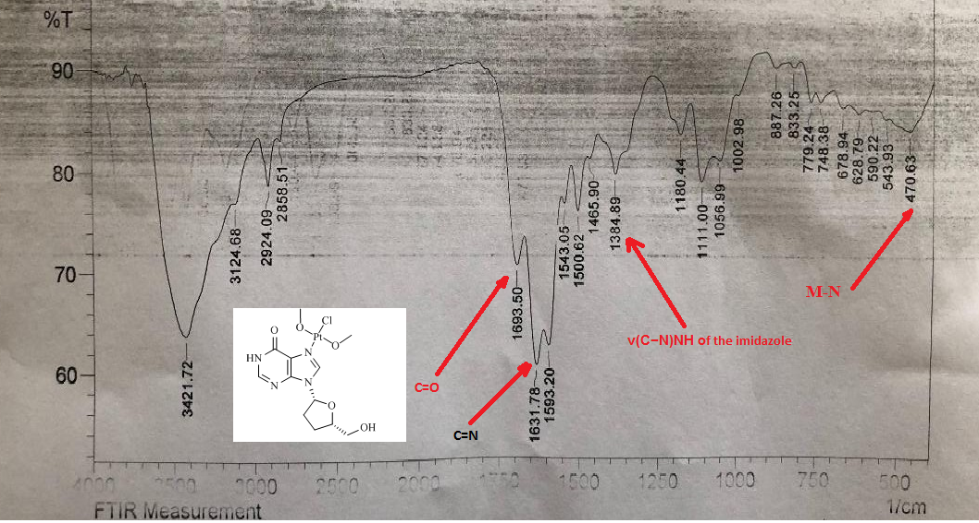

Figure S1. FT-IR spectrum of the K[PtCl(CH₃O)₂(ddI)] complex

