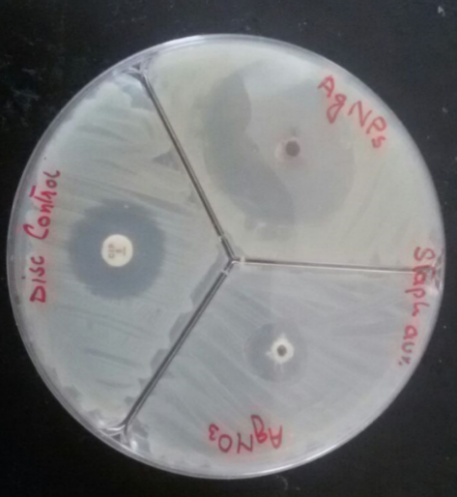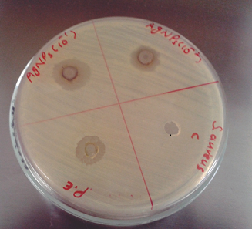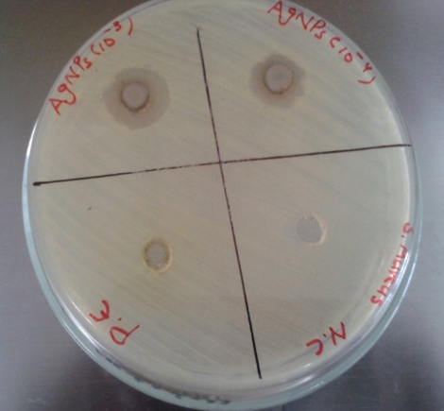
AgNPs 10⁻⁴
Negative control
AgNPs 10⁻³
Plant Extract
Plant Extract
Negative control
AgNPs 10⁻²
AgNPs 10⁻¹
Antibiotic Disc
AgNO₃
AgNPs 1mg/ml
Fig. 1S. Zones of inhibition by 50 µl of silver nanoparticles in different dilutions i.e. 1, 10⁻¹, 10⁻², 10⁻³, 10⁻⁴ mg/mL, plant extract (1 mg\ml), AgNO₃ solution (1mM), and distilled water (negative control) against Staphylococcus aureus. Positive control = 10µg disc of ciprofloxacin.

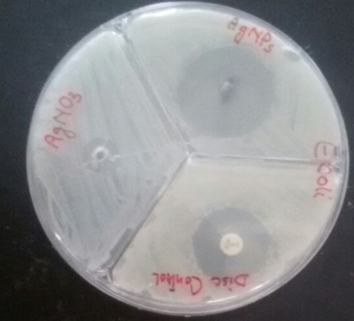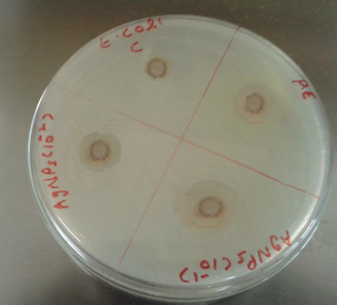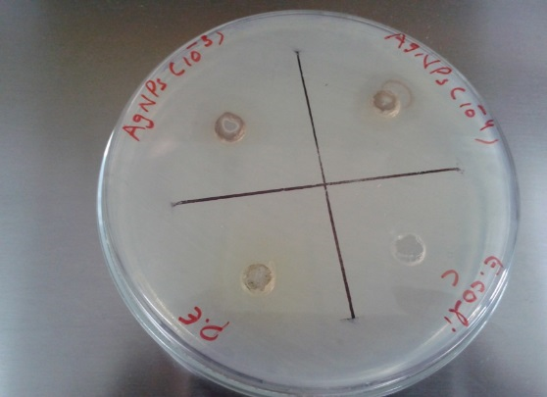
Negative control
AgNPs 10⁻⁴
AgNPs 10⁻³
Plant Extract
Plant Extract
AgNPs 10⁻¹
AgNPs 10⁻²
Negative control
Antibiotic Disc
AgNPs 1mg/ml
AgNO₃

Fig. 2S. Zones of inhibition by 50 µl of silver nanoparticles (AgNPs) in different dilutions i.e. 1, 10⁻¹, 10⁻², 10⁻³, 10⁻⁴ mg/mL, plant extract (1 mg\ml), AgNO₃ solution (1mM), and distilled water (negative control) against Escherichia coli. Positive control = 10µg disc of ciprofloxacin.

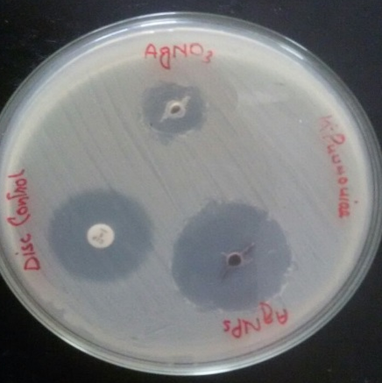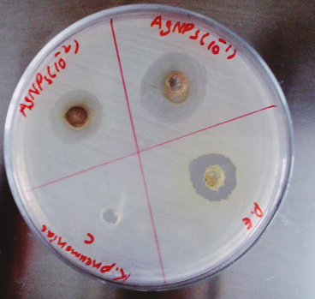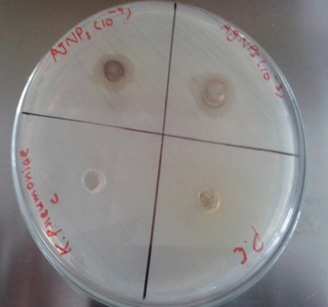
Antibiotic Disc
Plant Extract
Negative control
AgNPs 10⁻³
AgNPs 10⁻⁴
AgNO₃
AgNPs 1mg/ml
Negative control
Plant Extract
AgNPs 10⁻¹
AgNPs 10⁻²
Fig. 3S. Zones of inhibition by 50 µl of silver nanoparticles (AgNPs) in different dilutions i.e. 1, 10⁻¹, 10⁻², 10⁻³, 10⁻⁴ mg/mL, plant extract (1 mg\ml), AgNO₃ solution (1mM), and distilled water (negative control) against Klebsiella pneumoniae. Positive control = 10µg disc of ciprofloxacin.

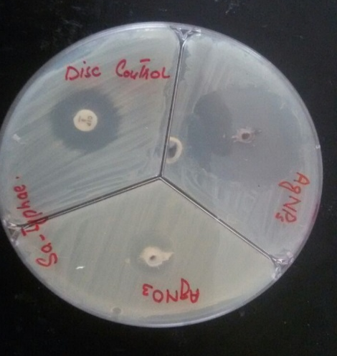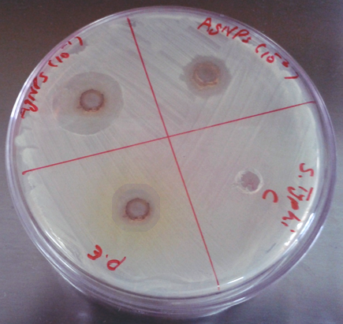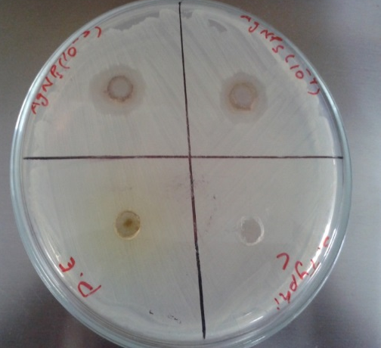
Disc Control
Negative control
Plant Extract
AgNPs 10⁻⁴
AgNPs 10⁻³
Plant Extract
Negative control
AgNPs 10⁻²
AgNPs 10⁻¹
AgNO₃
AgNPs 1mg/ml
Fig. 4S. Zones of inhibition by 50 µl of silver nanoparticles (AgNPs) in different dilutions i.e. 1, 10⁻¹, 10⁻², 10⁻³, 10⁻⁴ mg/mL, plant extract (1 mg\ml), AgNO₃ solution (1mM), and distilled water (negative control) against Salmonella typhi. Positive control = 10µg disc of ciprofloxacin.

