Radiotherapy in combination with hyperthermia suppresses lung cancer progression via increased NR4A3 and KLF11 expression

Beomseok Son^{1,*}, Jaewan Jeon^{1,2,*}, Sungmin Lee¹, Hyunwoo Kim¹, Hyunkoo Kang¹, HyeSook Youn³, Sunmi Jo², and BuHyun Youn^{1,4}
¹Department of Integrated Biological Science, Pusan National University, Busan 46241, Republic of Korea; ²Department of Radiation Oncology, Haeundae Paik Hospital, Inje University School of Medicine, Busan 48108, Republic of Korea; ³Department of Integrative Bioscience and Biotechnology, Sejong University, Seoul 05006, Republic of Korea; ⁴Department of Biological Sciences, Pusan National University, Busan 46241, Republic of Korea.

*These authors contributed equally to this work.

Correspondence: Professor BuHyun Youn, Department of Biological Sciences, Pusan National University, Busandaehak-ro 63beon-gil, Geumjeong-gu, Busan 46241, Republic of Korea. Phone: 82-51-510-2264; Fax: 82-51-581-2962; E-mail: bhyoun72@pusan.ac.kr
Professor Sunmi Jo, Department of Radiation Oncology, Haeundae Paik Hospital, Inje University School of Medicine, Busan 48108, Republic of Korea. Phone: 82-51-797-3820; Fax: 82-51-797-3400; E-mail: smjo@paik.ac.kr
Running title: NR4A3 and KLF11 induction by radiohyperthermia
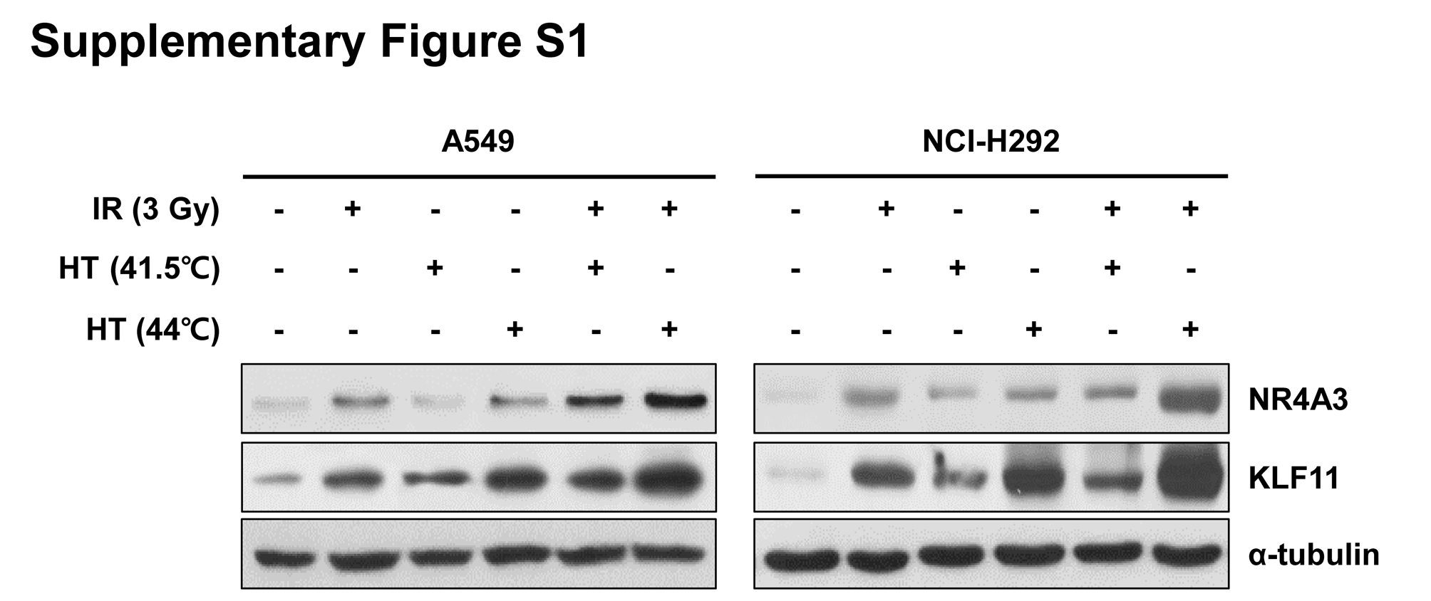
Figure S1. Expression of NR4A3 and KLF11 upon radiation followed by HT. A549 and NCI-H292 cells were treated with radiation treatment followed by HT and the protein expression of NR4A4 and KLF11 was assessed by Western blot analysis.

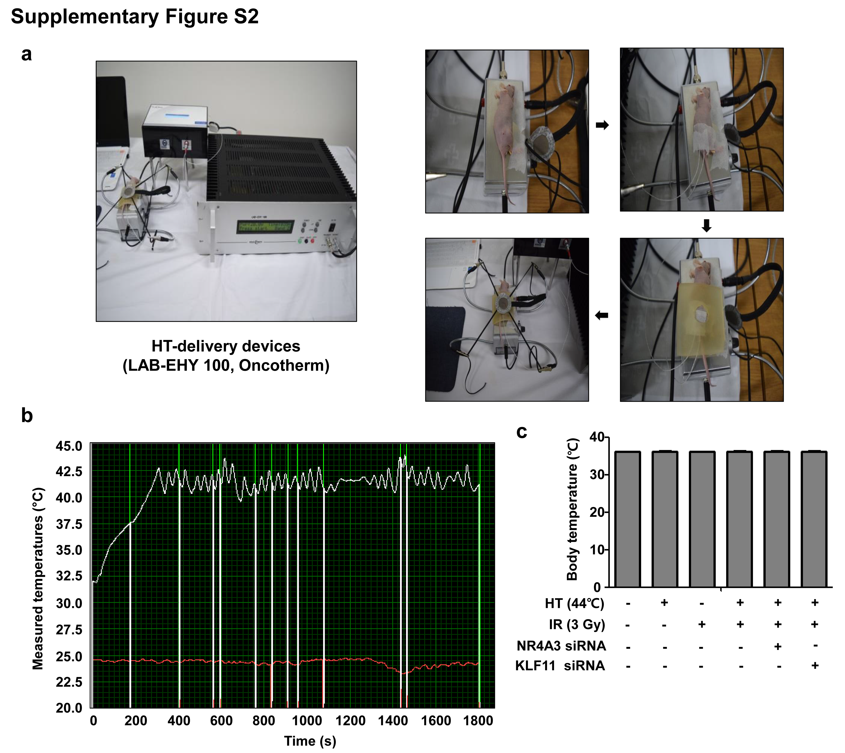
Figure S2. HT-delivering devices specifically designed for animal models were used for the in vivo experiments on HT treatment. a HT-delivering devices and the process of HT treatment are indicated. A bolus was used to protect the areas outside the tumor. A specific sensor was inserted into the center of the tumor to confirm the temperature of the tumor. b HT was administered for 30 min and the temperature of the tumor was measured in real time. c Changes in whole body temperature immediately after HT treatment were measured using an infrared thermometer.

