Supplementary Material
Dominant Volatile Organic Compounds (VOCs) measured at four Cannabis growing facilities: Pilot study results

Vera Samburova,¹ Mark McDaniel,¹ Dave Campbell,¹ Michael Wolf,² William R. Stockwell,³ Andrey Khlystov¹
¹Division of Atmospheric Sciences, Desert Research Institute, Reno, NV
²Air Quality Management Division, Washoe County Health District, Reno, NV
³Department of Physics, University of Texas at El Paso, TX

Keywords: Cannabis, volatile organic compounds, biogenic emissions, terpenes

VOC sampling and analysis
VOC sampling canisters were cleaned prior to sampling by repeated evacuation and pressurization with humidified zero air, as described in the EPA document "Technical Assistance Document for Sampling and Analysis of Ozone Precursors" ^{1, 2}. Six cycles of evacuation to ~0.5 mm Hg absolute pressure were followed by pressurization with ultra-high purity (UHP) humid zero air to ~15 psig was used to clean the canisters. One canister out of the ten per lot was filled with humidified UHP zero air and analyzed by the gas chromatograph coupled with mass spectrometric and flame ionization detectors (GC-MS/FID method), as described below. The canisters were considered clean if the target compound concentrations were less than 0.05 ppbv. The canister sampling systems were cleaned prior to sampling by purging with humidified zero air for 48 hours, followed by purging with dry UHP zero air for one hour.
Canister samples were analyzed for 72 VOC species using GC-MS/FID according to EPA Method TO-15.³ The GC-MS/FID system includes a Lotus Consulting Ultra-Trace Toxics sample preconcentration system built into a Varian 3800 gas chromatograph with flame ionization detector (FID) coupled to a Varian Saturn 2000 ion trap mass spectrometer. The Lotus preconcentration system consists of three traps. Mid- and heavier weight hydrocarbons are trapped on the front trap consisting of 1/8” nickel tubing packed with multiple adsorbents. Trapping is performed at 55 ºC and eluting is performed at 200 ºC. The rear traps consist of two traps: empty 0.040” ID nickel tubing for trapping light hydrocarbons and a cryo-focusing trap for mid and higher weight hydrocarbons isolated in the front trap. The cryo-focusing trap is built from 6’ x 1/8” nickel tubing filled with glass beads. Trapping of both rear traps occurs at -180 ºC and eluting at 200 ºC. Light hydrocarbons are deposited to a Varian CP-Sil5 column (15m × 0.32mm x 1μm) plumbed to a column-switching valve in the GC oven, then to a Chrompack Al₂O₃/KCl column (25m × 0.53mm x 10μm) leading to the flame ionization detector for quantitation of light hydrocarbons. The mid-range and heavier hydrocarbons cryo-focused in the rear trap are deposited to a J&W DB-1 column (60m × 0.32mm × 1μm) connected to the ion trap mass spectrometer. The GC initial temperature is 5 ºC and held for approximately 9.5 minutes, then ramps at 3 ºC min⁻¹ to 200 ºC for a total run time of 80 minutes.
Calibration of the system was conducted with a mixture that contained commonly found hydrocarbons (75 compounds from ethane to n-undecane, purchased from Air Environmental) in the range of 0.2 to 10 ppbv. Three point external calibrations were run prior to analysis, and one calibration check was run every 24 hours. If the response of an individual compound was more than 10% off, the system was recalibrated. Replicate analysis was conducted at least 24 hours after the initial analysis to allow re-equilibration of the compounds within the canister.
VOC molecules were separated on a GC column and identified by their mass-to-charge ratio (m/z) and compared with authentic standards and mass spectra libraries. Our GC-MS method allowed us to identify and quantitatively analyze over 75 individual volatile organic species.

Table S1. List of analyzed non-BVOCs
Ethene | Cyclohexane
1-Butene | Cyclohexene
1-Heptene | Cyclopentane
1-Pentene | Ethane
1,2,3-Trimethylbenzene | Ethylbenzene
1,3-Butadiene | Indane
1,3-Diethylbenzene | iso-Butane
1,3-Dimethylcyclopentane | iso-Butene
1,3-Hexadiene (trans) | iso-Pentane
1,3,5-Trimethylbenzene | iso-Propylbenzene
1,4-Diethylbenzene | m-Ethyltoluene
2-Methyl-1-Butene | m,p-Xylenes
2-Methyl-1-pentene | Methylcyclohexane
2-Methyl-2-butene | Methylcyclopentane
2-Methylheptane | n-Butylbenzene
2-Methylhexane | n-Decane
2-Methylpentane | n-Heptane
2,2-Dimethylbutane | n-Hexane
2,2,4-Trimethylpentane | n-Nonane
2,3-Dimethyl-2-pentene | n-Octane
2,3-Dimethylbutane | n-Pentane
2,3-Dimethylpentane | n-Propylbenzene
2,3,4-Trimethylpentane | n-Undecane
2,4-Dimethylpentane | o-Ethyltoluene
3-Methylheptane | o-Xylene
3-Methylhexane | p-ethyltoluene
3-Methylpentane | Propane
4-Methylheptane | Propene
Benzene | Styrene
Butane | Toluene
cis-2-butene | trans-2-butene
cis-2-Hexene | trans-2-Hexene
cis-2-Pentene | trans-2-Pentene
cis-Pentene

Table S2. Standard mixture of 19 Cannabis VOCs (or BVOCs)
Name | CAS number | Used in the present study
(-)-alpha-Bisabolol | 23089-26-1
Camphene | 79-92-5 | x
delta-3-Carene | 13466-78-9 | x
beta-Caryophyllene | 87-44-5
Geraniol | 106-24-1
(-)-Guaiol | 489-86-1
alpha-Humulene | 6753-98-6
p-Isopropyltoluene (p-cymene) | 99-87-6 | x
(-)-Isopulegol | 89-79-2 | x
d-Limonene | 5989-27-5 | x
Linalool | 78-70-6 | x
beta-Myrcene | 123-35-3 | x
Nerolidol | 7212-44-4
Ocimene | 13877-91-3 | x
alpha-Pinene | 80-56-8) | x
(-)-beta-Pinene | 18172-67-3 | x
alpha-Terpinene | 99-86-5) | x
gamma-Terpinene | 99-85-4 | x
Terpinolene | 586-62-9 | x

Table S3. Additional data on Cannabis grow facilities

Facility name | Volume  of the room,  m³ | Number of plants per room* | Total BVOCs,  µg m⁻³ | Total non-BVOCs,  µg m⁻³
Facility 1.
Outside | - | - | 0.12±0.01 | 15±1
Curing room | 153.9 | - | 863±95 | 3764±226
Grow room | 373.8 | 183 (0.49)* | 1563±172 | 1374±82
Facility 2.
After C-scrubber | - | - | 25±1 | 59±7
Grow room (light/fan: off) | 38.2 | 36 (0.94)* | 5502±55 | 51±6
Grow room (light/fan: on) | 38.2 | 36 | 634±4 | 71±9
Facility 3.
Outside |  |  | N/A | N/A
Grow room | 113.3 | 56 (0.49)* | 196±4 | 6686±152
Purge room | 113.3 | - | 1005±90 | 49431±2482
Facility 4.
Outside | - | - | N/A | N/A
Grow room | 130.5 | 155 (1.19)* | 112±55 | 44±3
Cure room | 130.5 | - | 1055±517 | 42±3

*In brackets is ratio number of plants per room volume

Grow room: where plants are grown under controlled conditions; curing room: where drying and aging of the harvested buds is performed, purging room: where removal of any residual solvents (e.g., liquid butane) is performed from the Cannabis concentrate using a vacuum oven or hot water bath.

Table S4
BVOCs’ emission rates for Facility 2
BVOC | mg day⁻¹ plant⁻¹ | % of the total BVOC | MIR
a-pinene | 142.92 | 19 | 4.51
camphene | 2.54 | 0 | 4.51
b-myrcene | 26.11 | 4 | 4.04
b-pinene | 518.25 | 70 | 3.52
D-limonene | 30.86 | 4 | 4.55
cis-ocimene | 23.77 | 3 | 4.04
terpinolene | 0.00 | 0 | 6.36
isoprene | 1.17 | 0 | 10.61
Total | 744.44

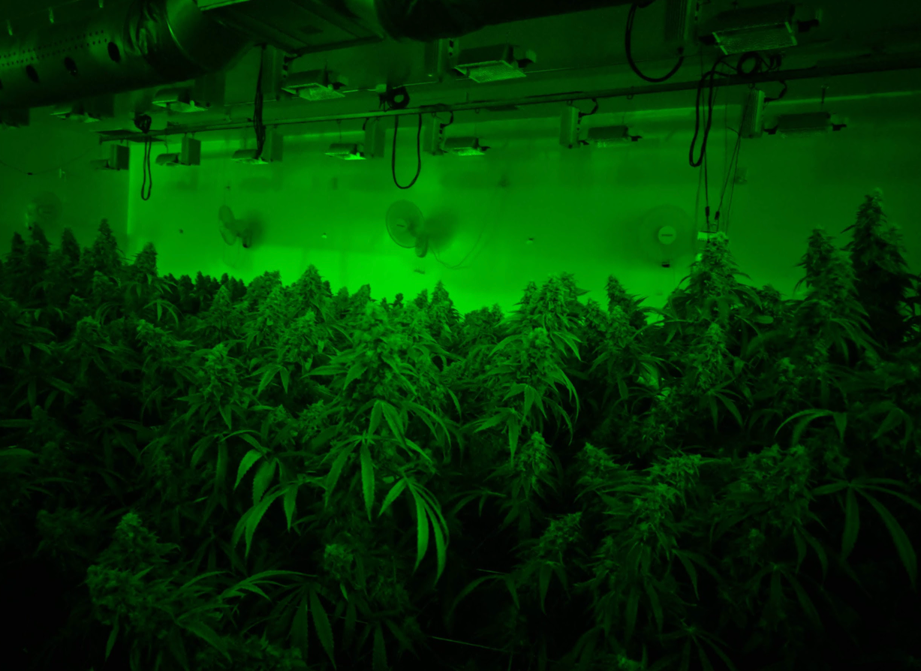
Figure S1. One of the Cannabis grow facilities where VOC samples were collected.

References

1. U.S.EPA, "EPA/600-R-98/161." Technical Assistance Document for Sampling and Analysis of Ozone Precursors. 1998.
2. U.S.EPA, "Technical Assistance Document for the National AirToxics Trends Stations Program." http://www.epa.gov/ttnamti1/files/ambient/airtox/nattsTADRevision2_508Compliant.pdf. 2009.
3. U.S.EPA, Method TO-15. Determination of Volatile Organic Compounds (VOCs) in Air Collected in Specially-Prepared Canisters and Analyzed By Gas Chromatography/Mass Spectrometry (GC/MS)-Second Edition, EPA/625/R-96/010b, January 1999. 1999.

