# Supplementary materials

In the following section, mean frequency occurrence of demersal fish species (n = 250) ordered by broad-scale descriptions and group number are provided (Table A1). An illustration of the hierarchical nature of the classification is provided in Figure A1. Additionally, individual group descriptions for a 30-group demersal fish classification are provided. This includes: location within the New Zealand Continental Shelf Zone to depths of 2000m; information on physical habitat descriptors; and description of species’ assemblages. Although these physical habitat descriptors and species assemblages are summarised in table 2 (physical habitat descriptors) and tables 3, 4, 5, 6 and 7 (species’ assemblages) in the main body of the article. Here there they are provided again for each individual group in order to help stakeholders and managers using these supplementary materials to more easily view the defining biotic and abiotic characteristics.

### Demersal fish species occurrence

Table A1. Mean frequency occurrence of demersal fish species (n = 250) ordered by broad-scale descriptions and group number (columns) and by number of occurrences across groups (rows) . Coloured cells highlight (an arbitrary) threshold of species’ frequency occurrences over 0.3 (light red) to 1.0 (Dark red).

|  |  |  |  |  |  |  |  |  |  |  |  |  |  |  |  |  |  |  |  |  |  |  |  |  |  |  |  |  |  |  |
| --- | --- | --- | --- | --- | --- | --- | --- | --- | --- | --- | --- | --- | --- | --- | --- | --- | --- | --- | --- | --- | --- | --- | --- | --- | --- | --- | --- | --- | --- | --- |
|  | **Deep cold waters** | | | | | | | **Intermediate depths** | | | | | | | **Intermediate – shallow depths, north of STF** | | | | | | | | **Intermediate – shallow depths, south of STF** | | | | | **Very shallow depths** | | |
| **Species** | **1** | **2** | **3** | **4** | **5** | **6** | **7** | **8** | **9** | **10** | **11** | **12** | **13** | **14** | **15** | **16** | **17** | **18** | **19** | **20** | **21** | **22** | **23** | **24** | **25** | **26** | **27** | **28** | **29** | **30** |
| *Macruronus novaezelandiae* | 0.16 | 0.21 | 0.46 | 0.68 | 0.79 | 0.44 | 0.67 | 0.90 | 0.48 | 0.94 | 0.89 | 0.92 | 0.83 | 0.11 |  | 0.13 | 0.01 | 0.02 | 0.32 | 0.09 | 0.40 | 0.22 | 0.45 | 0.09 | 0.06 | 0.10 | 0.34 | 0.03 | 0.14 |  |
| *Squalus acanthias* | 0.01 |  | 0.01 | 0.01 | 0.03 | 0.01 | 0.03 | 0.25 | 0.25 | 0.36 | 0.66 | 0.63 | 0.10 |  |  | 0.03 | 0.07 | 0.12 | 0.68 | 0.65 | 0.74 | 0.51 | 0.80 | 0.80 | 0.63 | 0.90 | 0.36 | 0.77 | 0.58 |  |
| *Genypterus blacodes* | 0.01 | 0.01 | 0.02 | 0.19 | 0.46 | 0.06 | 0.04 | 0.90 | 0.69 | 0.88 | 0.83 | 0.93 | 0.72 | 0.56 |  | 0.03 | 0.04 | 0.02 | 0.16 | 0.14 | 0.47 | 0.27 | 0.38 | 0.31 | 0.34 | 0.52 | 0.12 | 0.08 | 0.21 |  |
| *Thyrsites atun* |  |  |  |  |  |  | 0.01 |  | 0.02 | 0.05 | 0.20 | 0.10 | 0.05 |  |  | 0.30 | 0.33 | 0.33 | 0.84 | 0.76 | 0.91 | 0.71 | 0.80 | 0.85 | 0.70 | 0.81 | 0.13 | 0.63 | 0.62 | 0.17 |
| *Lepidorhynchus denticulatus* | 0.03 | 0.10 | 0.24 | 0.54 | 0.78 | 0.21 | 0.58 | 0.90 | 0.38 | 0.86 | 0.70 | 0.84 | 0.65 | 0.78 |  |  |  |  |  |  | 0.12 | 0.05 |  | 0.01 | 0.02 | 0.03 |  |  | 0.01 |  |
| *Chelidonichthys kumu* | 0.01 |  |  |  |  |  |  |  |  |  | 0.01 |  |  |  |  | 0.67 | 0.83 | 0.83 | 0.50 | 0.58 | 0.29 | 0.34 | 0.50 | 0.45 | 0.05 | 0.20 | 0.05 | 0.49 | 0.74 | 0.68 |
| *Pseudophycis bachus* |  |  |  |  | 0.02 |  | 0.05 | 0.02 | 0.26 | 0.08 | 0.36 | 0.68 | 0.28 |  |  | 0.17 | 0.09 | 0.15 | 0.40 | 0.38 | 0.38 | 0.34 | 0.72 | 0.54 | 0.29 | 0.48 | 0.26 | 0.47 | 0.67 | 0.03 |
| *Galeorhinus galeus* | 0.01 |  |  |  | 0.01 |  |  |  | 0.01 | 0.03 | 0.11 | 0.23 | 0.11 | 0.33 |  | 0.33 | 0.17 | 0.23 | 0.16 | 0.61 | 0.49 | 0.57 | 0.68 | 0.41 | 0.48 | 0.33 | 0.11 | 0.63 | 0.41 | 0.16 |
| *Nemadactylus macropterus* |  |  |  |  |  |  |  |  |  | 0.04 | 0.09 | 0.05 | 0.11 |  |  | 0.77 | 0.23 | 0.09 | 0.42 | 0.56 | 0.83 | 0.77 | 0.77 | 0.67 | 0.21 | 0.45 | 0.09 | 0.18 | 0.25 |  |
| *Merluccius australis* | 0.06 | 0.08 | 0.27 | 0.39 | 0.74 | 0.14 | 0.36 | 0.36 | 0.22 | 0.64 | 0.46 | 0.36 | 0.23 |  |  |  |  | 0.04 | 0.04 | 0.03 | 0.03 | 0.05 | 0.45 | 0.06 | 0.01 | 0.02 |  | 0.16 | 0.34 |  |
| *Mustelus lenticulatus* | 0.01 |  |  |  |  |  |  |  |  | 0.02 | 0.01 | 0.04 | 0.04 | 0.11 |  | 0.27 | 0.29 | 0.41 | 0.48 | 0.53 | 0.17 | 0.33 | 0.59 | 0.28 | 0.17 | 0.22 | 0.05 | 0.50 | 0.44 | 0.34 |
| *Hoplostethus atlanticus* | 0.70 | 0.87 | 0.97 | 0.77 | 0.58 | 0.56 | 0.72 | 0.01 |  | 0.03 |  | 0.02 | 0.01 |  |  |  |  |  |  |  |  |  |  |  |  |  |  |  |  |  |
| *Etmopterus granulosus* | 0.38 | 0.71 | 0.64 | 0.44 | 0.43 | 0.89 | 0.91 | 0.22 | 0.04 | 0.32 | 0.05 | 0.03 |  |  |  |  |  |  |  |  |  |  |  |  |  |  |  |  |  |  |
| *Hydrolagus bemisi* | 0.03 | 0.09 | 0.34 | 0.50 | 0.37 | 0.32 | 0.59 | 0.86 | 0.34 | 0.79 | 0.39 | 0.22 | 0.10 |  |  | 0.03 |  |  |  |  | 0.02 |  |  |  |  | 0.02 |  |  |  |  |
| *Seriolella punctata* |  |  |  | 0.02 |  |  |  | 0.02 | 0.14 | 0.24 | 0.56 | 0.26 | 0.28 |  |  |  | 0.02 | 0.03 | 0.18 | 0.33 | 0.59 | 0.22 | 0.39 | 0.30 | 0.38 | 0.43 | 0.02 | 0.23 | 0.17 | 0.01 |
| *Pseudocyttus maculatus* | 0.42 | 0.69 | 0.56 | 0.43 | 0.42 | 0.91 | 0.97 | 0.02 |  | 0.10 |  | 0.03 |  |  |  |  |  |  |  |  |  |  |  |  |  |  |  |  |  |  |
| *Zeus faber* |  |  |  |  |  |  |  |  |  |  |  |  |  |  |  | 0.53 | 0.79 | 0.72 | 0.26 | 0.55 | 0.01 | 0.39 | 0.10 | 0.02 |  |  | 0.01 | 0.01 | 0.12 | 0.70 |
| *Cyttus traversi* |  |  | 0.01 | 0.18 | 0.17 | 0.01 |  | 0.41 | 0.23 | 0.80 | 0.73 | 0.71 | 0.57 | 0.11 |  | 0.03 |  |  | 0.04 | 0.01 | 0.11 | 0.04 |  |  | 0.01 | 0.03 |  |  |  |  |
| *Halargyreus johnsonii* | 0.49 | 0.59 | 0.76 | 0.51 | 0.45 | 0.64 | 0.50 | 0.01 |  | 0.09 | 0.01 |  | 0.02 | 0.11 |  |  |  |  |  |  |  |  |  |  |  |  |  |  |  |  |
| *Kathetostoma giganteum* |  |  |  | 0.02 | 0.15 |  |  | 0.02 | 0.13 | 0.30 | 0.39 | 0.60 | 0.15 |  |  |  | 0.04 | 0.03 | 0.06 | 0.23 | 0.28 | 0.20 | 0.38 | 0.29 | 0.22 | 0.41 | 0.01 | 0.04 | 0.08 | 0.01 |
| *Chrysophrys auratus* | 0.01 |  |  |  |  |  |  |  |  |  |  |  |  |  |  | 0.37 | 0.86 | 0.85 | 0.10 | 0.24 |  | 0.25 | 0.07 | 0.02 |  |  | 0.02 | 0.01 | 0.25 | 0.96 |
| *Cephaloscyllium isabellum* |  |  |  |  |  |  | 0.01 |  | 0.01 | 0.01 | 0.03 |  | 0.11 |  |  | 0.13 | 0.11 | 0.08 | 0.26 | 0.45 | 0.11 | 0.43 | 0.64 | 0.29 | 0.28 | 0.45 | 0.06 | 0.20 | 0.30 |  |
| *Coryphaenoides subserrulatus* | 0.22 | 0.48 | 0.71 | 0.51 | 0.54 | 0.58 | 0.83 | 0.03 |  | 0.04 | 0.01 | 0.01 |  |  |  |  |  |  |  |  |  |  |  |  |  |  |  |  |  |  |
| *Arnoglossus scapha* |  |  |  |  |  |  |  |  | 0.04 | 0.03 | 0.23 | 0.12 | 0.09 |  |  | 0.17 | 0.17 | 0.11 | 0.18 | 0.18 | 0.26 | 0.22 | 0.45 | 0.42 | 0.16 | 0.48 | 0.02 | 0.17 | 0.32 | 0.02 |
| *Argentina elongata* |  |  |  |  | 0.01 | 0.01 |  | 0.64 | 0.52 | 0.29 | 0.54 | 0.21 | 0.22 |  |  | 0.07 | 0.02 |  |  | 0.04 | 0.25 | 0.25 | 0.34 | 0.07 | 0.12 | 0.20 |  |  | 0.03 |  |
| *Deania calcea* | 0.11 | 0.22 | 0.60 | 0.67 | 0.72 | 0.23 | 0.05 | 0.04 | 0.01 | 0.46 | 0.10 | 0.39 | 0.09 |  |  |  |  |  |  |  | 0.01 |  |  |  |  |  |  |  |  |  |
| *Rexea solandri* |  |  |  | 0.01 | 0.03 |  |  |  |  | 0.05 | 0.08 | 0.55 | 0.52 | 0.56 |  | 0.03 | 0.01 |  | 0.10 | 0.02 | 0.29 | 0.34 | 0.17 | 0.08 | 0.48 | 0.26 |  |  |  |  |
| *Ribaldo moro* | 0.13 | 0.05 | 0.36 | 0.66 | 0.73 | 0.08 | 0.04 | 0.36 | 0.04 | 0.53 | 0.13 | 0.23 | 0.18 |  |  |  |  |  |  |  |  |  |  |  |  |  |  |  |  |  |
| *Polyprion oxygeneios* |  |  |  |  |  |  |  |  |  | 0.02 | 0.13 | 0.17 | 0.03 |  |  | 0.13 | 0.02 |  | 0.46 | 0.07 | 0.66 | 0.15 | 0.05 | 0.41 | 0.53 | 0.52 | 0.10 | 0.06 | 0.01 |  |
| *Etmopterus lucifer* | 0.02 | 0.01 | 0.04 | 0.13 | 0.40 | 0.04 |  | 0.28 | 0.05 | 0.57 | 0.34 | 0.49 | 0.26 | 0.78 |  |  |  |  |  |  | 0.02 |  |  |  |  |  |  |  |  |  |
| *Diastobranchus capensis* | 0.53 | 0.58 | 0.64 | 0.25 | 0.22 | 0.63 | 0.51 | 0.02 |  | 0.01 |  |  |  |  |  |  |  |  |  |  |  |  |  |  |  |  |  |  |  |  |
| *Trachurus novaezelandiae* | 0.01 |  |  |  |  |  |  |  |  |  |  |  |  |  |  | 0.40 | 0.39 | 0.61 | 0.24 | 0.49 |  | 0.31 | 0.04 | 0.05 |  | 0.01 | 0.03 | 0.02 | 0.19 | 0.60 |
| *Centroselachuscrepidater* | 0.17 | 0.30 | 0.60 | 0.51 | 0.77 | 0.36 | 0.41 | 0.01 |  | 0.10 | 0.01 | 0.02 | 0.01 |  |  |  |  |  |  |  |  |  |  |  |  |  |  |  |  |  |
| *Lepidopus caudatus* |  |  |  | 0.01 | 0.01 |  |  |  | 0.01 | 0.01 | 0.05 | 0.04 | 0.24 | 0.56 |  | 0.37 | 0.13 | 0.02 | 0.12 | 0.32 | 0.18 | 0.50 | 0.40 | 0.02 | 0.01 | 0.01 | 0.14 |  | 0.06 |  |
| *Macrourus carinatus* | 0.31 | 0.37 | 0.28 | 0.11 | 0.39 | 0.79 | 0.78 | 0.11 | 0.01 | 0.02 | 0.01 | 0.01 |  |  |  |  |  |  |  |  |  |  |  |  |  |  |  |  |  |  |
| *Coelorinchus fasciatus* | 0.02 | 0.02 | 0.07 | 0.31 | 0.42 | 0.27 | 0.63 | 0.55 | 0.13 | 0.40 | 0.13 | 0.17 | 0.04 |  |  |  |  |  |  |  | 0.02 |  |  |  | 0.01 |  |  |  |  |  |
| *Seriolella brama* |  |  |  |  |  |  |  |  |  | 0.01 | 0.01 | 0.05 | 0.01 |  |  |  | 0.04 | 0.14 | 0.22 | 0.16 | 0.21 | 0.07 | 0.43 | 0.33 | 0.14 | 0.19 | 0.03 | 0.55 | 0.53 | 0.06 |
| *Harriotta raleighana* | 0.02 | 0.10 | 0.36 | 0.38 | 0.15 | 0.25 | 0.41 | 0.48 | 0.13 | 0.54 | 0.16 | 0.06 | 0.01 |  |  |  |  |  |  |  |  |  |  |  |  |  |  |  |  |  |
| *Lepidotrigla brachyoptera* |  |  |  |  |  |  | 0.01 |  |  |  | 0.07 |  |  |  |  | 0.47 | 0.15 | 0.09 | 0.10 | 0.37 | 0.16 | 0.32 | 0.51 | 0.27 | 0.02 | 0.28 |  |  | 0.13 |  |
| *Pelotretis flavilatus* |  |  |  |  |  |  |  |  |  | 0.01 | 0.15 | 0.01 |  |  |  | 0.03 | 0.20 | 0.29 | 0.22 | 0.23 | 0.12 | 0.05 | 0.22 | 0.35 | 0.01 | 0.21 | 0.02 | 0.22 | 0.37 | 0.19 |
| *Hydrolagus novaezealandiae* |  | 0.01 |  | 0.01 | 0.12 | 0.01 |  | 0.05 | 0.29 | 0.13 | 0.55 | 0.51 | 0.28 |  |  | 0.07 |  |  |  | 0.01 | 0.22 | 0.19 | 0.14 | 0.02 | 0.01 | 0.21 | 0.06 |  |  |  |
| *Coryphaenoides serrulatus* | 0.28 | 0.46 | 0.78 | 0.49 | 0.41 | 0.26 | 0.12 | 0.01 |  | 0.05 |  | 0.01 | 0.01 |  |  |  |  |  |  |  |  |  |  |  |  |  |  |  |  |  |
| *Allocyttus niger* | 0.14 | 0.32 | 0.12 | 0.19 | 0.16 | 0.79 | 0.89 | 0.02 |  | 0.20 |  | 0.01 |  |  |  |  |  |  |  |  |  |  |  |  |  |  |  |  |  |  |
| *Alepocephalus australis* | 0.47 | 0.44 | 0.31 | 0.09 | 0.31 | 0.57 | 0.54 |  |  | 0.01 |  |  |  |  |  |  |  |  |  |  |  |  |  |  |  |  |  |  |  |  |
| *Coelorinchus bollonsi* | 0.01 | 0.01 | 0.03 | 0.18 | 0.31 | 0.01 | 0.01 | 0.07 | 0.04 | 0.59 | 0.46 | 0.56 | 0.17 | 0.11 |  |  |  |  |  |  | 0.03 |  |  |  | 0.01 | 0.01 | 0.02 |  |  |  |
| *Trachurus declivis* |  |  |  |  |  |  |  |  |  |  | 0.02 |  | 0.01 |  |  | 0.40 | 0.08 | 0.05 | 0.12 | 0.42 | 0.07 | 0.39 | 0.33 | 0.16 | 0.09 | 0.11 | 0.14 | 0.02 | 0.07 | 0.01 |
| *Coelorinchus oliverianus* | 0.01 | 0.01 | 0.03 | 0.13 | 0.28 | 0.05 | 0.04 | 0.38 | 0.05 | 0.58 | 0.26 | 0.43 | 0.13 |  |  |  |  |  |  |  | 0.01 |  |  |  |  |  | 0.02 |  |  |  |
| *Rhombosolea plebeia* | 0.01 |  |  |  |  |  |  |  |  |  |  |  | 0.01 |  |  |  | 0.14 | 0.48 | 0.08 | 0.14 |  | 0.01 | 0.01 | 0.09 |  |  |  | 0.46 | 0.45 | 0.46 |
| *Coelorinchus innotabilis* | 0.06 | 0.20 | 0.54 | 0.45 | 0.39 | 0.41 | 0.16 | 0.01 |  | 0.06 |  | 0.01 | 0.02 |  |  |  |  |  |  |  |  |  |  |  |  |  |  |  |  |  |
| *Meuschenia scaber* |  |  |  |  |  |  |  |  |  |  |  |  |  |  |  | 0.13 | 0.58 | 0.29 |  | 0.42 | 0.01 | 0.09 |  | 0.11 | 0.01 | 0.02 | 0.04 | 0.25 | 0.17 | 0.15 |
| *Coelorinchus aspercephalus* |  |  |  |  | 0.06 | 0.01 |  | 0.40 | 0.45 | 0.24 | 0.42 | 0.43 |  |  |  |  |  |  |  | 0.01 | 0.10 |  |  | 0.01 | 0.02 | 0.05 | 0.01 |  |  |  |
| *Parapercis colias* | 0.01 |  |  |  |  |  |  |  |  |  | 0.01 |  |  |  |  |  | 0.06 | 0.13 | 0.10 | 0.38 | 0.13 | 0.01 |  | 0.12 | 0.12 | 0.15 | 0.57 | 0.09 | 0.29 |  |
| *Notacanthus sexspinis* | 0.04 | 0.07 | 0.22 | 0.30 | 0.29 | 0.18 | 0.01 | 0.27 | 0.04 | 0.42 | 0.19 |  | 0.02 |  |  |  |  |  |  |  | 0.01 |  |  |  | 0.01 |  | 0.01 |  |  |  |
| *Trachyrincus aphyodes* | 0.18 | 0.27 | 0.55 | 0.43 | 0.27 | 0.12 | 0.11 |  |  | 0.06 |  | 0.02 | 0.01 |  |  |  |  |  |  |  |  |  |  |  |  |  |  |  |  |  |
| *Squalus griffini* |  |  |  |  |  |  |  |  |  | 0.01 | 0.03 | 0.01 | 0.27 | 0.56 |  | 0.40 | 0.02 | 0.01 | 0.02 | 0.11 | 0.10 | 0.33 | 0.09 |  |  |  |  |  |  |  |
| *Hoplostethus mediterraneus* | 0.01 |  | 0.03 | 0.10 | 0.12 |  |  |  |  | 0.16 | 0.15 | 0.26 | 0.47 | 0.56 |  |  |  |  |  |  | 0.03 | 0.02 |  |  |  |  |  |  |  |  |
| *Callorhinchus milii* |  |  |  |  |  |  |  |  |  |  |  |  |  |  |  |  | 0.01 | 0.01 | 0.04 | 0.01 | 0.07 |  | 0.10 | 0.48 | 0.01 | 0.19 | 0.03 | 0.77 | 0.18 |  |
| *Pseudocaranx georgianus* | 0.01 |  |  |  |  |  |  |  |  |  |  |  |  |  |  | 0.10 | 0.40 | 0.33 | 0.22 | 0.14 |  | 0.09 | 0.01 | 0.01 |  |  |  |  | 0.10 | 0.47 |
| *Hoplichthys haswelli* |  |  |  | 0.03 | 0.02 |  |  | 0.01 | 0.01 | 0.28 | 0.32 | 0.23 | 0.42 | 0.44 |  |  |  |  |  |  | 0.04 | 0.03 |  | 0.01 |  | 0.03 |  |  |  |  |
| *Arripis trutta* | 0.01 |  |  |  |  |  |  |  |  |  |  |  |  |  |  | 0.03 | 0.19 | 0.19 | 0.24 | 0.13 |  | 0.04 | 0.04 | 0.08 |  | 0.01 | 0.03 | 0.25 | 0.15 | 0.40 |
| *Bassanago bulbiceps* | 0.02 | 0.01 | 0.12 | 0.20 | 0.09 | 0.04 |  | 0.42 | 0.09 | 0.25 | 0.20 | 0.17 | 0.17 |  |  |  |  |  |  |  | 0.01 |  |  |  |  |  |  |  |  |  |
| *Cyttus novaezealandiae* |  |  |  |  |  |  |  |  | 0.01 | 0.03 | 0.19 | 0.17 | 0.10 |  |  | 0.13 | 0.01 |  | 0.02 | 0.04 | 0.31 | 0.20 | 0.14 | 0.06 | 0.17 | 0.15 | 0.01 |  |  |  |
| *Centroselachusowstoni* | 0.11 | 0.22 | 0.45 | 0.34 | 0.42 | 0.03 | 0.09 | 0.01 |  | 0.04 |  | 0.01 | 0.01 |  |  |  |  |  |  |  |  |  |  |  |  |  |  |  |  |  |
| *Seriolella caerulea* |  |  |  | 0.02 | 0.07 |  | 0.01 | 0.19 | 0.23 | 0.30 | 0.45 | 0.31 | 0.04 |  |  |  |  |  |  |  | 0.04 | 0.01 | 0.01 |  | 0.02 | 0.03 |  |  |  |  |
| *Rhinochimaera pacifica* | 0.12 | 0.26 | 0.45 | 0.23 | 0.11 | 0.25 | 0.26 | 0.02 |  | 0.02 |  |  |  |  |  |  |  |  |  |  |  |  |  |  |  |  |  |  |  |  |
| *Peltorhamphus novaezeelandiae* | 0.01 |  |  |  |  |  |  |  |  |  |  |  |  |  |  |  | 0.08 | 0.17 | 0.10 | 0.02 |  |  | 0.05 | 0.18 |  | 0.01 | 0.01 | 0.61 | 0.34 | 0.10 |
| *Trachurus murphyi* |  |  |  |  |  |  |  |  |  | 0.04 | 0.11 | 0.02 | 0.02 |  |  | 0.20 | 0.01 |  | 0.08 | 0.01 | 0.18 | 0.13 | 0.17 | 0.13 | 0.18 | 0.18 | 0.13 | 0.01 | 0.03 | 0.01 |
| *Paraulopus nigripinnis* |  |  |  |  |  |  |  |  |  |  |  |  | 0.10 | 0.67 |  | 0.43 | 0.02 |  |  | 0.05 | 0.01 | 0.25 | 0.10 |  |  |  |  |  |  |  |
| *Capromimus abbreviatus* |  |  |  | 0.01 |  |  |  |  |  | 0.02 | 0.10 | 0.22 | 0.39 | 0.22 |  | 0.03 |  |  |  | 0.01 | 0.09 | 0.19 | 0.27 |  |  | 0.01 |  |  |  |  |
| *Neocyttus rhomboidalis* | 0.18 | 0.11 | 0.31 | 0.48 | 0.11 | 0.03 | 0.01 | 0.01 |  | 0.22 | 0.03 | 0.01 | 0.01 |  |  |  |  |  |  |  | 0.01 |  |  |  |  |  |  |  |  |  |
| *Centriscops humerosus* | 0.01 |  | 0.01 | 0.07 | 0.03 |  |  | 0.03 | 0.09 | 0.34 | 0.46 | 0.05 | 0.30 |  |  |  |  |  |  |  | 0.06 | 0.01 |  |  |  |  |  |  |  |  |
| *Centrophorus squamosus* | 0.04 | 0.07 | 0.14 | 0.15 | 0.55 | 0.02 | 0.01 | 0.04 | 0.01 | 0.06 | 0.02 | 0.29 | 0.02 |  |  |  |  |  |  |  |  |  |  |  |  |  |  |  |  |  |
| *Coelorinchus kaiyomaru* | 0.06 | 0.10 | 0.03 | 0.04 | 0.27 | 0.51 | 0.39 | 0.01 |  |  |  |  |  |  |  |  |  |  |  |  |  |  |  |  |  |  |  |  |  |  |
| *Mesobius antipodum* | 0.05 | 0.10 | 0.12 | 0.05 |  | 0.51 | 0.57 |  |  |  |  |  |  |  |  |  |  |  |  |  |  |  |  |  |  |  |  |  |  |  |
| *Zearaja nasuta* |  |  |  |  |  |  |  | 0.02 | 0.07 | 0.01 | 0.02 | 0.03 | 0.02 |  |  | 0.03 | 0.05 | 0.03 | 0.10 | 0.07 | 0.04 | 0.06 | 0.06 | 0.17 | 0.05 | 0.10 |  | 0.37 | 0.07 |  |
| *Dalatias licha* | 0.01 | 0.02 | 0.08 | 0.19 | 0.39 | 0.01 |  |  |  | 0.21 | 0.09 | 0.19 | 0.06 |  |  | 0.10 |  |  |  |  | 0.01 |  |  |  |  |  |  |  |  |  |
| *Coelorinchus biclinozonalis* |  |  |  |  | 0.01 |  |  |  |  |  | 0.08 | 0.09 | 0.03 | 0.44 |  |  |  | 0.01 |  | 0.05 | 0.05 | 0.03 | 0.15 | 0.05 |  | 0.07 | 0.18 | 0.04 | 0.04 |  |
| *Bassanago hirsutus* | 0.01 |  | 0.08 | 0.12 | 0.08 | 0.04 |  | 0.29 | 0.04 | 0.20 | 0.16 | 0.18 | 0.10 |  |  |  |  |  |  |  |  |  |  |  |  |  |  |  |  |  |
| *Micromesistius australis* |  |  |  |  |  | 0.01 |  | 0.57 | 0.57 | 0.02 | 0.03 |  |  |  |  |  |  |  |  |  |  |  |  |  |  |  |  | 0.01 |  |  |
| *Lepidion microcephalus* | 0.06 | 0.11 | 0.27 | 0.23 | 0.16 | 0.19 | 0.09 |  |  | 0.01 |  | 0.01 |  |  |  |  |  |  |  |  |  |  |  |  |  |  |  |  |  |  |
| *Myliobatis tenuicaudatus* |  |  |  |  |  |  |  |  |  |  |  |  |  |  |  | 0.10 | 0.24 | 0.23 |  | 0.05 |  | 0.01 |  |  |  |  |  |  | 0.09 | 0.40 |
| *Pterygotrigla picta* |  |  |  |  |  |  |  |  |  |  |  |  | 0.07 | 0.33 |  | 0.50 | 0.08 |  |  |  |  | 0.13 |  |  |  |  |  |  |  |  |
| *Dipturus innominatus* |  |  |  | 0.01 | 0.05 |  |  | 0.01 | 0.02 | 0.08 | 0.13 | 0.12 | 0.11 |  |  | 0.17 | 0.03 | 0.01 | 0.02 | 0.02 | 0.03 | 0.05 | 0.05 | 0.05 | 0.01 | 0.07 |  | 0.03 | 0.01 |  |
| *Coelorinchus matamua* | 0.02 | 0.06 | 0.23 | 0.38 | 0.23 | 0.04 | 0.04 | 0.02 |  | 0.04 |  |  | 0.01 |  |  |  |  |  |  |  |  |  |  |  |  |  |  |  |  |  |
| *Ambophthalmos angustus* | 0.01 |  | 0.02 | 0.03 | 0.03 | 0.01 | 0.07 | 0.26 | 0.16 | 0.16 | 0.16 | 0.04 | 0.08 |  |  |  |  |  |  |  |  |  |  |  |  | 0.01 |  |  |  |  |
| *Allomycterus jaculiferus* |  |  |  |  |  |  |  |  |  |  |  |  |  |  |  | 0.17 | 0.25 | 0.05 | 0.22 | 0.16 | 0.01 | 0.09 |  |  |  |  |  |  | 0.02 | 0.03 |
| *Emmelichthys nitidus* |  |  |  |  | 0.01 |  |  |  | 0.01 | 0.01 | 0.10 | 0.08 | 0.04 |  |  | 0.03 | 0.01 | 0.01 |  | 0.02 | 0.24 | 0.11 | 0.06 | 0.01 | 0.13 | 0.06 | 0.02 |  |  |  |
| *Scomber australasicus* | 0.01 |  |  |  |  |  |  |  |  |  |  |  |  |  |  | 0.10 | 0.13 | 0.15 | 0.06 | 0.10 | 0.01 | 0.10 | 0.05 | 0.03 |  |  | 0.02 |  | 0.04 | 0.11 |
| *Genyagnus monopterygius* |  |  |  |  |  |  |  |  |  |  |  |  |  |  |  |  | 0.14 | 0.26 |  | 0.01 |  | 0.01 |  | 0.01 |  |  |  | 0.17 | 0.08 | 0.23 |
| *Notolabrus celidotus* |  |  |  |  |  |  |  |  |  |  |  |  |  |  |  |  | 0.02 | 0.23 |  | 0.04 |  |  |  | 0.06 |  |  |  | 0.08 | 0.27 | 0.18 |
| *Hyperoglyphe antarctica* | 0.01 |  | 0.01 | 0.02 | 0.03 |  |  |  |  | 0.04 | 0.09 | 0.16 | 0.20 | 0.22 |  |  |  |  |  |  | 0.06 | 0.01 |  |  |  | 0.02 |  |  |  |  |
| *Gollum attenuatus* |  |  |  |  |  |  |  |  |  |  |  | 0.02 | 0.21 | 0.56 |  |  |  |  |  |  | 0.01 | 0.02 |  |  | 0.01 |  |  |  |  |  |
| *Beryx splendens* | 0.03 | 0.01 | 0.03 | 0.04 | 0.02 |  |  |  |  | 0.07 | 0.28 | 0.04 | 0.16 | 0.11 |  |  |  |  |  |  | 0.04 |  |  |  |  |  |  |  |  |  |
| *Lucigadus nigromaculatus* |  | 0.01 | 0.01 | 0.08 | 0.28 | 0.05 |  | 0.06 | 0.01 | 0.15 | 0.06 | 0.10 | 0.02 |  |  |  |  |  |  |  |  |  |  |  |  |  |  |  |  |  |
| *Rhombosolea leporina* |  |  |  |  |  |  |  |  |  |  |  |  |  |  |  |  | 0.01 | 0.14 |  |  |  |  |  |  |  |  |  | 0.20 | 0.16 | 0.31 |
| *Latridopsis ciliaris* |  |  |  |  |  |  |  |  |  |  |  |  |  |  |  | 0.03 | 0.02 | 0.01 | 0.42 | 0.01 | 0.04 | 0.01 |  | 0.07 | 0.03 | 0.03 | 0.04 | 0.03 | 0.01 |  |
| *Zenopsis nebulosa* |  |  |  |  |  |  | 0.01 |  |  | 0.01 | 0.02 |  | 0.18 | 0.22 |  | 0.10 | 0.02 |  |  |  | 0.04 | 0.11 |  | 0.01 |  | 0.01 |  |  |  |  |
| *Proscymnodon plunketi* | 0.02 | 0.08 | 0.07 | 0.08 | 0.20 | 0.05 | 0.04 | 0.02 | 0.01 | 0.11 | 0.01 | 0.03 | 0.01 |  |  |  |  |  |  |  |  |  |  |  |  |  |  |  |  |  |
| *Epigonus telescopus* | 0.09 | 0.05 | 0.09 | 0.12 | 0.20 | 0.01 |  |  |  | 0.06 | 0.03 | 0.03 | 0.03 |  |  |  |  |  |  |  |  |  |  |  |  |  |  |  |  |  |
| *Coryphaenoides dossenus* | 0.07 | 0.08 | 0.12 | 0.10 | 0.06 | 0.08 | 0.11 | 0.02 |  | 0.04 |  |  |  |  |  |  |  |  |  |  |  |  |  |  |  |  |  |  |  |  |
| *AntmoraiRibaldo rostrata* | 0.18 | 0.10 | 0.02 | 0.01 | 0.06 | 0.20 | 0.08 |  |  |  |  | 0.01 | 0.01 |  |  |  |  |  |  |  |  |  |  |  |  |  |  |  |  |  |
| *Paratrachichthys trailli* |  |  |  | 0.01 | 0.02 |  |  |  |  | 0.03 | 0.08 | 0.10 | 0.10 | 0.11 |  | 0.03 | 0.01 |  |  |  | 0.08 | 0.04 | 0.02 | 0.01 | 0.01 |  | 0.02 |  |  |  |
| *Centrolophus niger* | 0.01 | 0.01 | 0.02 | 0.03 | 0.08 | 0.01 |  | 0.03 | 0.01 | 0.19 | 0.15 | 0.08 | 0.03 |  |  |  |  |  |  |  | 0.01 |  |  |  |  |  |  |  |  |  |
| *Xenodermichthys copei* | 0.04 | 0.05 | 0.15 | 0.33 | 0.02 | 0.03 |  |  |  | 0.01 |  |  | 0.02 |  |  |  |  |  |  |  |  |  |  |  |  |  |  |  |  |  |
| *Allocyttus verrucosus* | 0.18 | 0.26 | 0.15 | 0.03 |  |  |  |  |  |  |  |  |  |  |  |  |  |  |  |  |  |  |  |  |  |  |  |  |  |  |
| *Auchenoceros punctatus* | 0.01 |  |  |  |  |  |  |  |  |  |  |  |  |  |  |  | 0.02 | 0.06 |  | 0.01 |  |  | 0.07 | 0.01 |  |  |  | 0.16 | 0.18 | 0.09 |
| *Seriola lalandi* |  |  |  |  |  |  |  |  |  |  |  |  |  |  |  | 0.10 | 0.10 | 0.03 | 0.20 | 0.03 |  | 0.05 |  |  |  |  |  |  |  | 0.07 |
| *Engraulis australis* |  |  |  |  |  |  |  |  |  |  |  |  |  |  |  |  | 0.05 | 0.11 | 0.02 | 0.02 |  | 0.01 | 0.03 |  |  |  | 0.02 | 0.01 | 0.22 | 0.05 |
| *Phosichthys argenteus* | 0.05 | 0.04 | 0.05 | 0.05 | 0.09 | 0.09 | 0.01 | 0.03 | 0.01 | 0.07 | 0.02 | 0.02 |  |  |  |  |  |  |  |  |  |  |  |  |  |  |  |  |  |  |
| *Sardinops sagax* |  |  |  |  |  |  |  |  |  |  |  |  |  |  |  |  | 0.05 | 0.12 | 0.02 | 0.02 |  | 0.01 |  |  |  |  | 0.01 |  | 0.13 | 0.14 |
| *Lepidoperca aurantia* |  |  |  |  |  |  |  |  |  | 0.01 | 0.15 | 0.01 | 0.06 |  |  |  |  |  | 0.02 |  | 0.18 | 0.04 |  |  | 0.01 |  |  |  |  |  |
| *Bathytoshia lata* | 0.01 |  |  |  |  |  |  |  |  |  |  |  |  |  |  | 0.10 | 0.08 | 0.08 |  |  |  | 0.01 |  |  |  |  |  |  |  | 0.19 |
| *Colistium guntheri* |  |  |  |  |  |  |  |  |  |  |  |  |  |  |  |  | 0.01 | 0.02 |  | 0.01 |  |  | 0.03 | 0.02 |  |  |  | 0.20 | 0.12 | 0.02 |
| *Chauliodus sloanei* | 0.02 | 0.05 | 0.06 | 0.06 | 0.06 | 0.05 |  |  |  | 0.01 |  |  |  | 0.11 |  |  |  |  |  |  |  |  |  |  |  |  |  |  |  |  |
| *Euclichthys polynemus* |  |  |  |  |  |  |  |  |  | 0.01 |  |  | 0.07 | 0.33 |  |  |  |  |  |  |  |  |  |  |  |  |  |  |  |  |
| *Aldrichetta forsteri* |  |  |  |  |  |  |  |  |  |  |  |  |  |  |  |  | 0.02 | 0.05 |  | 0.01 |  |  |  |  |  |  |  | 0.04 | 0.08 | 0.20 |
| *Coelorinchus maurofasciatus* |  |  |  | 0.01 |  |  |  |  |  | 0.02 | 0.01 |  | 0.02 | 0.33 |  |  |  |  |  |  |  |  |  |  |  |  |  |  |  |  |
| *Coelorinchus cookianus* | 0.01 |  | 0.01 | 0.01 |  |  |  |  |  |  |  |  | 0.01 | 0.33 |  |  |  |  |  |  |  |  |  |  |  |  |  |  |  |  |
| *Zenion leptolepis* |  |  |  |  |  |  |  |  |  |  |  |  | 0.03 | 0.33 |  |  |  |  |  |  |  |  |  |  |  |  |  |  |  |  |
| *Xenocephalus armatus* |  |  |  |  |  |  |  |  |  |  |  |  | 0.05 |  |  | 0.20 | 0.02 |  |  | 0.01 |  | 0.07 |  |  |  |  |  |  |  |  |
| *Coelorinchus parvifasciatus* |  |  |  |  |  |  |  |  |  | 0.02 | 0.08 | 0.17 | 0.06 |  |  |  |  |  |  |  | 0.01 | 0.01 |  |  |  |  |  |  |  |  |
| *Contusus richei* |  |  |  |  |  |  |  |  |  |  |  |  |  |  |  |  |  |  |  |  |  |  |  | 0.01 |  |  |  | 0.29 | 0.03 |  |
| *Notopogon lilliei* |  |  |  |  |  |  |  |  | 0.01 | 0.01 | 0.02 |  |  |  |  |  |  |  |  |  | 0.03 |  |  | 0.05 | 0.01 | 0.19 |  |  |  |  |
| *Neophrynichthys latus* |  |  |  |  |  |  |  | 0.01 | 0.06 | 0.02 | 0.02 |  | 0.02 |  |  |  |  |  |  |  |  |  | 0.02 | 0.06 | 0.01 | 0.02 |  | 0.07 |  |  |
| *Rhombosolea tapirina* |  |  |  |  |  |  |  |  | 0.03 |  |  |  |  |  |  |  |  |  |  |  |  |  |  | 0.03 | 0.17 | 0.01 |  | 0.03 | 0.03 |  |
| *Macroramphosus scolopax* |  |  |  |  |  |  |  |  |  | 0.01 |  |  |  |  |  | 0.20 | 0.03 |  |  |  |  | 0.04 |  | 0.01 |  | 0.01 |  |  |  |  |
| *Notophycis marginata* |  |  |  | 0.01 | 0.05 | 0.01 | 0.01 | 0.08 | 0.08 | 0.03 | 0.02 |  | 0.01 |  |  |  |  |  |  |  |  |  |  |  |  |  |  |  |  |  |
| *Peltorhamphus latus* |  |  |  |  |  |  |  |  |  |  |  |  |  |  |  |  |  | 0.05 |  |  |  |  |  | 0.01 |  |  |  | 0.06 | 0.10 | 0.08 |
| *Psychrolutes microporos* | 0.04 | 0.05 | 0.05 | 0.01 | 0.01 | 0.09 | 0.05 |  |  |  |  |  |  |  |  |  |  |  |  |  |  |  |  |  |  |  |  |  |  |  |
| *Bathyraja shuntovi* | 0.02 | 0.05 | 0.05 | 0.02 | 0.01 | 0.07 | 0.05 | 0.01 | 0.01 |  |  |  |  |  |  |  |  |  |  |  |  |  |  |  |  |  |  |  |  |  |
| *Bathytoshia brevicaudata* |  |  |  |  |  |  |  |  |  |  |  |  |  |  |  |  | 0.05 | 0.04 |  | 0.01 |  | 0.01 |  |  |  |  |  |  |  | 0.17 |
| *Nezumia namatahi* | 0.04 | 0.07 | 0.06 | 0.01 | 0.04 | 0.05 |  |  |  |  |  | 0.01 |  |  |  |  |  |  |  |  |  |  |  |  |  |  |  |  |  |  |
| *Pentaceros decacanthus* |  |  |  |  |  |  |  |  |  |  | 0.01 |  | 0.24 |  |  |  |  |  |  |  |  | 0.01 |  |  |  |  |  |  |  |  |
| *Alertichthys blacki* |  |  |  |  |  |  |  | 0.08 | 0.14 | 0.02 | 0.02 |  |  |  |  |  |  |  |  |  |  |  |  |  |  |  |  |  |  |  |
| *Gadomus aoteanus* | 0.09 | 0.08 | 0.08 | 0.01 |  |  |  |  |  |  |  |  |  |  |  |  |  |  |  |  |  |  |  |  |  |  |  |  |  |  |
| *Upeneichthys lineatus* |  |  |  |  |  |  |  |  |  |  |  |  |  |  |  |  | 0.07 | 0.13 |  | 0.01 |  |  |  |  |  |  |  |  | 0.03 | 0.02 |
| *Bythaelurus dawsoni* |  |  |  |  | 0.01 |  |  | 0.08 | 0.11 | 0.02 | 0.03 |  |  |  |  |  |  |  |  |  |  |  |  |  | 0.01 |  |  |  |  |  |
| *Trachyscorpia eschmeyeri* | 0.01 | 0.02 | 0.09 | 0.10 | 0.03 |  |  |  |  |  |  | 0.01 |  |  |  |  |  |  |  |  |  |  |  |  |  |  |  |  |  |  |
| *Tubbia tasmanica* | 0.02 | 0.03 | 0.02 | 0.03 | 0.03 | 0.03 | 0.09 |  |  |  | 0.01 |  |  |  |  |  |  |  |  |  |  |  |  |  |  |  |  |  |  |  |
| *Oxynotus bruniensis* |  |  | 0.01 | 0.01 |  |  |  | 0.01 | 0.02 | 0.07 | 0.08 | 0.03 | 0.01 |  |  |  |  |  |  |  | 0.01 |  |  |  |  |  |  |  |  |  |
| *Colistium nudipinnis* | 0.01 |  |  |  |  |  |  |  |  |  |  |  |  |  |  | 0.03 | 0.04 | 0.03 | 0.02 |  |  |  |  | 0.01 |  |  |  | 0.01 | 0.07 | 0.02 |
| *Oncorhynchus tshawytscha* |  |  |  |  |  |  |  |  |  |  |  |  |  |  |  |  |  |  |  |  |  |  |  | 0.01 |  |  |  | 0.19 | 0.01 |  |
| *Latris lineata* |  |  |  |  |  |  |  |  |  |  | 0.01 |  |  |  |  |  |  |  | 0.04 |  | 0.09 | 0.02 |  | 0.02 | 0.02 | 0.01 |  |  |  |  |
| *Epigonus lenimen* |  | 0.01 | 0.01 | 0.01 | 0.09 |  |  |  |  | 0.03 | 0.03 | 0.01 | 0.02 |  |  |  |  |  |  |  |  |  |  |  |  |  |  |  |  |  |
| *Parapercis gilliesii* |  |  |  |  |  |  |  |  |  |  | 0.01 | 0.02 |  |  |  | 0.03 |  |  |  |  | 0.04 | 0.01 |  | 0.01 | 0.07 | 0.01 |  |  |  |  |
| *Epigonus robustus* |  | 0.04 | 0.04 | 0.02 | 0.04 | 0.01 |  |  |  | 0.02 | 0.01 |  |  |  |  |  |  |  |  |  |  |  |  |  |  |  |  |  |  |  |
| *Zanclistius elevatus* |  |  |  |  |  |  |  |  |  |  |  |  |  |  |  | 0.13 | 0.03 |  |  |  |  | 0.01 |  |  |  |  |  |  |  |  |
| *Bathysaurus ferox* | 0.11 | 0.05 | 0.01 |  |  |  |  |  |  |  |  |  |  |  |  |  |  |  |  |  |  |  |  |  |  |  |  |  |  |  |
| *Chimaera lignaria* | 0.03 | 0.03 | 0.01 | 0.01 |  | 0.06 |  | 0.01 | 0.01 | 0.01 |  |  |  |  |  |  |  |  |  |  |  |  |  |  |  |  |  |  |  |  |
| *Sprattus muelleri* |  |  |  |  |  |  |  |  |  |  |  |  |  |  |  |  |  | 0.02 |  | 0.02 |  |  | 0.01 | 0.01 |  |  |  | 0.04 | 0.05 | 0.01 |
| *Idiolophorhynchus andriashevi* | 0.14 | 0.02 |  |  |  |  |  |  |  |  |  |  |  |  |  |  |  |  |  |  |  |  |  |  |  |  |  |  |  |  |
| *Sphyrna zygaena* |  |  |  |  |  |  |  |  |  |  |  |  |  |  |  |  | 0.03 | 0.04 |  |  |  |  |  |  |  |  |  |  |  | 0.09 |
| *Arhynchobatis asperrimus* |  |  |  |  |  |  |  |  |  |  |  | 0.02 | 0.02 | 0.11 |  |  |  |  |  |  |  | 0.01 |  |  |  |  |  |  |  |  |
| *Hydrolagus trolli* | 0.10 | 0.04 |  |  |  | 0.01 |  |  |  |  |  |  |  |  |  |  |  |  |  |  |  |  |  |  |  |  |  |  |  |  |
| *Congiopodus coriaceus* |  |  |  |  |  |  |  | 0.01 | 0.11 |  | 0.01 |  |  |  |  |  |  |  |  |  |  |  |  |  |  | 0.02 |  |  |  |  |
| *Crapatalus novaezelandiae* |  |  |  |  |  |  |  |  |  |  |  |  |  |  |  |  |  |  |  |  |  |  |  | 0.01 |  |  |  | 0.13 |  |  |
| *Notothenia microlepidota* |  |  |  |  |  |  |  | 0.01 | 0.13 |  |  |  |  |  |  |  |  |  |  |  |  |  |  |  |  |  |  |  |  |  |
| *Tripterophycis gilchristi* |  |  | 0.01 | 0.01 | 0.03 |  | 0.01 |  | 0.02 | 0.02 | 0.01 |  | 0.02 |  |  |  |  |  |  |  | 0.01 |  |  |  |  |  |  |  |  |  |
| *Peltorhamphus tenuis* |  |  |  |  |  |  |  |  |  |  |  |  |  |  |  |  |  |  |  |  |  |  |  | 0.01 |  |  |  | 0.10 | 0.02 |  |
| *Plagiogeneion rubiginosum* |  |  |  |  |  |  |  |  |  |  | 0.02 |  | 0.06 |  |  |  |  |  |  |  | 0.03 | 0.02 |  |  |  |  |  |  |  |  |
| *Pseudolabrus miles* |  |  |  |  |  |  |  |  |  |  |  |  |  |  |  |  |  |  |  | 0.01 | 0.05 |  |  | 0.01 | 0.01 | 0.03 | 0.01 | 0.01 |  |  |
| *Lophonectes gallus* |  |  |  |  |  |  |  |  |  |  |  |  |  |  |  |  | 0.07 | 0.04 |  |  |  |  |  |  |  |  |  |  |  | 0.01 |
| *Azygopus pinnifasciatus* |  |  |  |  |  |  |  | 0.01 | 0.01 | 0.01 | 0.01 |  | 0.07 |  |  |  |  |  |  |  |  |  |  |  | 0.01 |  |  |  |  |  |
| *Echiodon cryomargarites* | 0.01 | 0.04 | 0.02 | 0.01 |  | 0.03 |  |  |  |  |  |  |  |  |  |  |  |  |  |  |  |  |  |  |  |  |  |  |  |  |
| *Simenchelys parasitica* | 0.01 | 0.02 | 0.04 | 0.01 |  | 0.02 |  |  |  |  |  |  |  |  |  |  |  |  |  |  |  |  |  |  |  |  |  |  |  |  |
| *Diretmus argenteus* |  | 0.01 | 0.01 | 0.01 | 0.04 | 0.02 |  |  |  |  |  | 0.01 |  |  |  |  |  |  |  |  |  |  |  |  |  |  |  |  |  |  |
| *Maurolicus australis* |  |  | 0.01 | 0.01 |  | 0.01 |  |  | 0.01 | 0.01 | 0.01 |  | 0.01 |  |  |  |  |  |  |  |  |  |  |  |  |  | 0.02 |  |  |  |
| *Cottunculus nudus* |  |  |  | 0.01 |  | 0.04 | 0.04 |  |  |  |  |  |  |  |  |  |  |  |  |  |  |  |  |  |  |  |  |  |  |  |
| *Halosaurus pectoralis* |  |  | 0.02 | 0.06 |  |  |  |  |  |  |  |  | 0.01 |  |  |  |  |  |  |  |  |  |  |  |  |  |  |  |  |  |
| *Amblyraja hyperborea* |  | 0.01 |  |  |  | 0.04 | 0.03 |  | 0.01 |  |  |  |  |  |  |  |  |  |  |  |  |  |  |  |  |  |  |  |  |  |
| *Solegnathus spinosissimus* |  |  |  |  |  |  |  |  |  |  |  |  |  |  |  |  |  |  |  | 0.01 |  | 0.04 | 0.01 | 0.02 |  | 0.01 |  |  |  |  |
| *Centroselachuscoelolepis* | 0.01 | 0.03 | 0.02 | 0.01 | 0.01 |  |  |  |  |  |  | 0.01 |  |  |  |  |  |  |  |  |  |  |  |  |  |  |  |  |  |  |
| *Girella tricuspidata* |  |  |  |  |  |  |  |  |  |  |  |  |  |  |  |  | 0.01 | 0.03 |  |  |  |  |  |  |  |  |  |  |  | 0.04 |
| *Nemadactylus douglasii* |  |  |  |  |  |  |  |  |  |  |  |  |  |  |  |  | 0.04 | 0.01 | 0.02 |  |  |  |  |  |  |  |  |  |  | 0.01 |
| *Caesioperca lepidoptera* |  |  |  |  |  |  |  |  |  |  |  | 0.01 |  |  |  |  | 0.01 |  |  |  | 0.04 | 0.01 |  |  | 0.01 |  |  |  |  |  |
| *Rosenblattia robusta* | 0.02 | 0.02 | 0.02 | 0.01 |  | 0.01 |  |  |  |  |  |  |  |  |  |  |  |  |  |  |  |  |  |  |  |  |  |  |  |  |
| *Coelorinchus kermadecus* |  | 0.04 | 0.03 |  |  |  |  |  |  |  |  |  |  |  |  |  |  |  |  |  |  |  |  |  |  |  |  |  |  |  |
| *Heptranchias perlo* |  |  |  |  |  |  |  |  |  |  |  |  | 0.04 |  |  |  |  |  |  |  | 0.01 | 0.02 |  |  |  |  |  |  |  |  |
| *Chaunax pictus* | 0.01 | 0.01 | 0.02 | 0.03 |  |  |  |  |  |  |  |  |  |  |  |  |  |  |  |  |  |  |  |  |  |  |  |  |  |  |
| *Persparsia kopua* |  | 0.01 | 0.02 | 0.01 | 0.01 | 0.02 |  |  |  |  |  |  |  |  |  |  |  |  |  |  |  |  |  |  |  |  |  |  |  |  |
| *Lampanyctodes hectoris* | 0.01 |  |  | 0.01 | 0.01 | 0.01 |  |  |  | 0.01 | 0.01 |  | 0.01 |  |  |  |  |  |  |  |  |  |  |  |  |  |  |  |  |  |
| *Pseudoicichthys australis* | 0.01 |  |  | 0.01 |  | 0.01 |  | 0.01 |  | 0.02 | 0.01 |  |  |  |  |  |  |  |  |  |  |  |  |  |  |  |  |  |  |  |
| *Melanonus gracilis* |  | 0.02 | 0.02 | 0.01 |  | 0.01 |  |  |  |  |  |  |  |  |  |  |  |  |  |  |  |  |  |  |  |  |  |  |  |  |
| *Cryptopsaras couesii* | 0.01 | 0.01 | 0.01 | 0.01 |  | 0.01 | 0.01 |  |  |  |  |  |  |  |  |  |  |  |  |  |  |  |  |  |  |  |  |  |  |  |
| *Coryphaenoides mcmillani* | 0.03 | 0.03 |  |  |  |  |  |  |  |  |  |  |  |  |  |  |  |  |  |  |  |  |  |  |  |  |  |  |  |  |
| *Coryphaenoides striaturus* | 0.03 | 0.03 |  |  |  |  |  |  |  |  |  |  |  |  |  |  |  |  |  |  |  |  |  |  |  |  |  |  |  |  |
| *Anoplogaster cornuta* | 0.02 | 0.02 | 0.01 |  |  |  |  |  |  |  |  |  |  |  |  |  |  |  |  |  |  |  |  |  |  |  |  |  |  |  |
| *Diretmichthys parini* | 0.01 |  | 0.02 | 0.02 |  |  |  |  |  |  |  |  |  |  |  |  |  |  |  |  |  |  |  |  |  |  |  |  |  |  |
| *Alepisaurus brevirostris* | 0.01 | 0.03 | 0.01 |  |  |  |  |  |  |  |  |  |  |  |  |  |  |  |  |  |  |  |  |  |  |  |  |  |  |  |
| *Polyprion americanus* |  |  |  |  |  |  |  |  |  |  |  |  | 0.03 |  |  |  |  |  |  |  | 0.01 | 0.01 |  |  |  |  |  |  |  |  |
| *Talismania longifilis* | 0.01 | 0.02 | 0.02 |  |  |  |  |  |  |  |  |  |  |  |  |  |  |  |  |  |  |  |  |  |  |  |  |  |  |  |
| *Kuronezumia bubonis* |  | 0.01 | 0.02 | 0.01 | 0.01 |  |  |  |  |  |  |  |  |  |  |  |  |  |  |  |  |  |  |  |  |  |  |  |  |  |
| *Magnisudis prionosa* |  |  | 0.01 | 0.01 |  |  |  | 0.02 |  | 0.01 |  |  |  |  |  |  |  |  |  |  |  |  |  |  |  |  |  |  |  |  |
| *Kuronezumia leonis* |  | 0.01 | 0.01 |  |  | 0.01 | 0.01 |  |  |  |  |  |  |  |  |  |  |  |  |  |  |  |  |  |  |  |  |  |  |  |
| *Melanostigma gelatinosum* |  |  | 0.01 | 0.01 | 0.01 |  |  |  |  |  | 0.01 |  |  |  |  |  |  |  |  |  |  |  |  |  |  |  |  |  |  |  |
| *Coelorinchus celaenostomus* |  |  | 0.01 | 0.01 | 0.01 |  |  |  |  |  |  |  | 0.01 |  |  |  |  |  |  |  |  |  |  |  |  |  |  |  |  |  |
| *Beryx decadactylus* |  |  |  |  |  |  |  |  |  |  |  |  | 0.03 |  |  |  |  |  |  |  |  |  |  |  |  |  |  |  |  |  |
| *Lepidion schmidti* |  | 0.01 |  |  |  | 0.02 |  |  |  |  |  |  |  |  |  |  |  |  |  |  |  |  |  |  |  |  |  |  |  |  |
| *Brotulotaenia crassa* |  | 0.01 | 0.01 |  |  |  | 0.01 |  |  |  |  |  |  |  |  |  |  |  |  |  |  |  |  |  |  |  |  |  |  |  |
| *Gonostoma elongatum* | 0.01 |  | 0.01 | 0.01 |  |  |  |  |  |  |  |  |  |  |  |  |  |  |  |  |  |  |  |  |  |  |  |  |  |  |
| *Coelorinchus mycterismus* | 0.01 | 0.01 | 0.01 |  |  |  |  |  |  |  |  |  |  |  |  |  |  |  |  |  |  |  |  |  |  |  |  |  |  |  |

**Illustration of the hierarchical nature of Gradient Forest classifications**

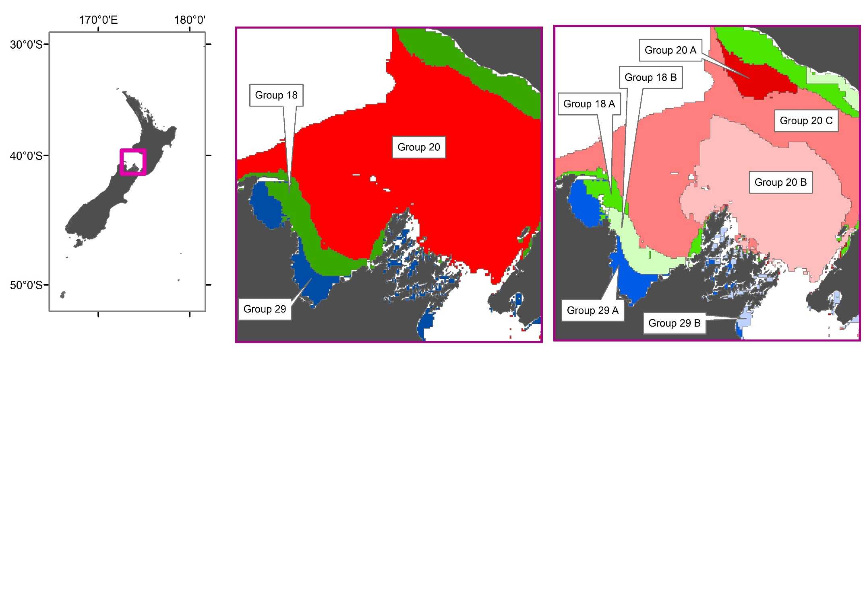

Figure A1. Comparison of a 30-group (left) and 100-group (right) demersal fish Gradient forest classification for the South Taranaki Bight, Tasman and Golden Bays and Marlborough Sounds. The hierarchical nature of the classification results in the finer-scale 100-group classification (right) being nested within the broader-scale 30-group classification (left).

### Group 1

#### Geographic location

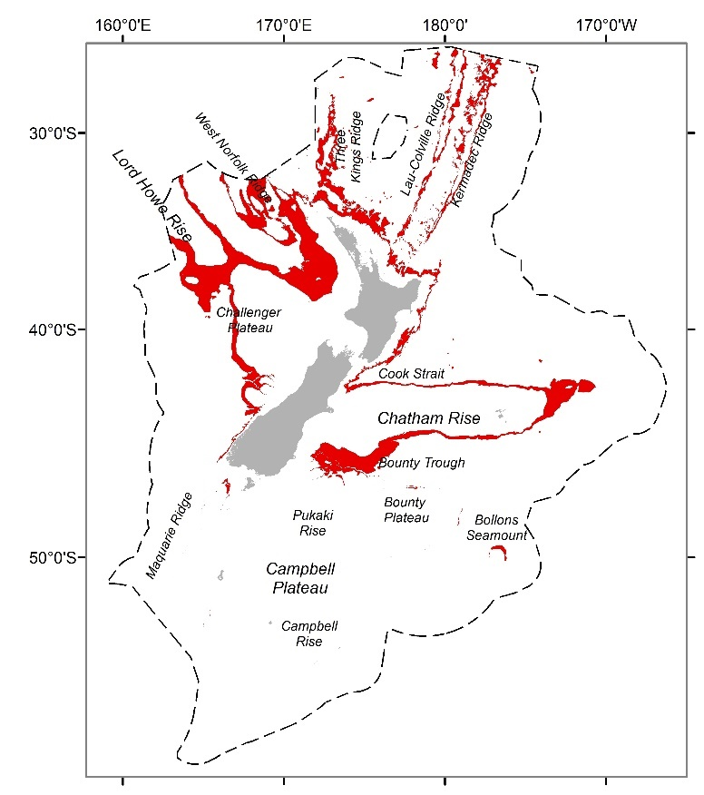

Figure 1. Geographic distributions of group 1 (red) from a 30-group demersal fish classification for the seas within the New Zealand Extended Continental Shelf (dashed line) to a depth of 2000 m.

#### Group description

This widespread group (Figure 1) occurs in very deep, cold, low oxygen waters with high roughness (i.e. high variability in depths in a surrounding 3 x 3 km neighbourhood) and high concentrations of bottom silicate (Table 1). Other environmental variables show little variation reflecting the homogenous environmental conditions generally prevailing at these depths. Species assemblages are primarily characterised (e.g. > 10% intra-group similarity) by moderate occurrence of orange roughy, basketwork eel and smooth oreo (Table 2).

#### Similar groups

Closely related to group 2.

#### Characterising environmental conditions

Table 1. Group 1 characterising environmental conditions

|  |  |  |
| --- | --- | --- |
| **Environmental variable** | **Mean value** | **Qualitative description** |
| Bathymetry | 1422.49 m | Very deep water |
| Roughness | 91.12 | Very high variability in seabed depths |
| Bottom silicate | 69.82 umol l-1 | High concentrations of silicate at depth. |
| Dissolved oxygen at depth | 3.89 ml l-1 | Low concentrations of oxygen at depth |
| Bottom temperature | 3.46 °C km-1 | Low bottom water temperature |
| VGPM | 620.48 mgC m-2 d-1 | Moderate – low productivity |

#### Characterising Species

Table 2. Species name, mean frequency occurrence and % contribution to group 1 similarity for those species contributing to a total of 70% of the group similarity or > 4 % to the group 1 similarity. If English common names were not available, these were recorded as *na*.

|  |  |  |  |
| --- | --- | --- | --- |
| **Common name** | **Scientific name** | **Mean frequency occurrence** | **% contribution to similarity** |
| Orange roughy | *Hoplostethus atlanticus* | 0.69 | 25.43 |
| Basketwork eel | *Diastobranchus capensis* | 0.52 | 12.83 |
| Smooth oreo | *Pseudocyttus maculatus* | 0.45 | 11.53 |
| Big scaled and small scaled brown slickhead | *Alepocephalus australis*  *Alepocephalus antipodianus* | 0.38 | 7.44 |
| Johnson’s cod | *Halargyreus johnsonii* | 0.38 | 7.38 |
| Baxter’s dogfish | *Etmopterus granulosus* | 0.38 | 5.39 |

### Group 2

#### Geographic location

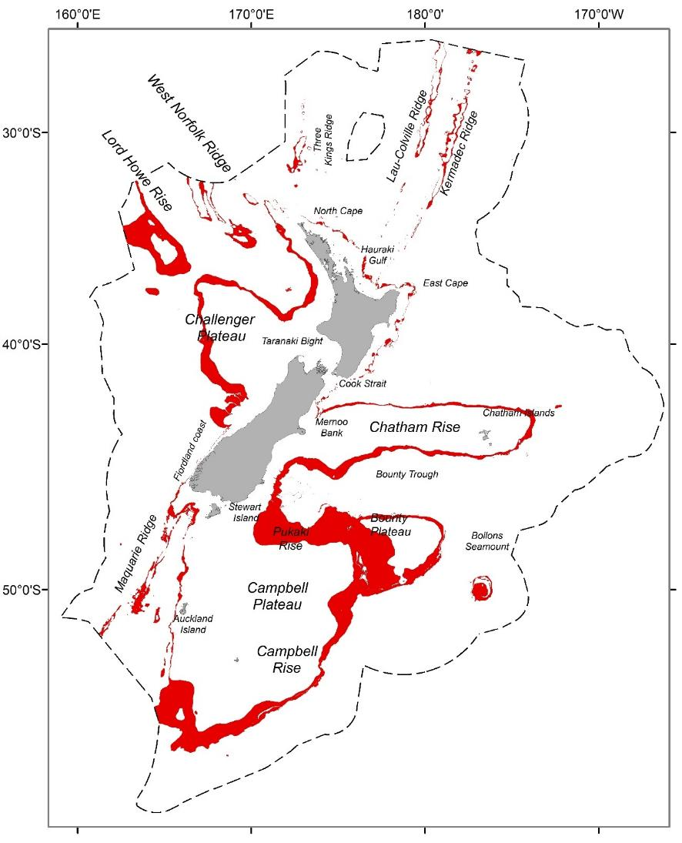

Figure 2. Geographic distributions of group 2 (red) from a 30-group demersal fish classification for the seas within the New Zealand Extended Continental Shelf (dashed line) to a depth of 2000 m.

#### Group description

Similarly to group 1, this widespread group (Figure 2) occurs in very deep, cold, low oxygen waters, with moderate – high seabed roughness (Table 3). Other environmental variables show little variation reflecting the homogenous environmental conditions generally prevailing at these depths. Species assemblages are primarily characterised (e.g. > 10% intra-group similarity) by high frequency occurrence of orange roughy, Baxter’s dogfish and smooth oreo (Table 3).

#### Similar groups

Closely related to group 1.

#### Characterising environmental conditions

Table 3. Group 2 characterising environmental conditions

|  |  |  |
| --- | --- | --- |
| **Environmental variable** | **Mean value** | **Qualitative description** |
| Bathymetry | 1221 m | Very deep water |
| Roughness | 43.87 | High variability in seabed depths |
| Bottom silicate | 51.25 umol l-1 | High concentrations of silicate at depth. |
| Dissolved oxygen at depth | 4.16 ml l-1 | Low concentrations of oxygen at depth |
| Bottom temperature | 4.14 °C km-1 | Low bottom water temperature |
| VGPM | 582.5 mgC m-2 d-1 | Moderate – low productivity |

#### Characterising Species

Table 4. Species name, mean frequency occurrence and % contribution to group 2 similarity for those species contributing to a total of 70% of the group similarity or > 4 % to the group 2 similarity. If English common names were not available, these were recorded as *na*.

|  |  |  |  |
| --- | --- | --- | --- |
| **Common name** | **Scientific name** | **Mean frequency occurrence** | **% contribution to similarity** |
| Orange roughy | *Hoplostethus atlanticus* | 0.87 | 21.99 |
| Baxter’s dogfish | *Etmopterus granulosus* | 0.73 | 14.28 |
| Smooth oreo | *Pseudocyttus maculatus* | 0.69 | 14.17 |
| Basketwork eel | *Diastobranchus capensis* | 0.58 | 7.85 |
| Johnson’s cod | *Halargyreus johnsonii* | 0.57 | 7.6 |
| Four-rayed rattail | *Coryphaenoides subserrulatus* | 0.49 | 5.17 |

### Group 3

#### Geographic location

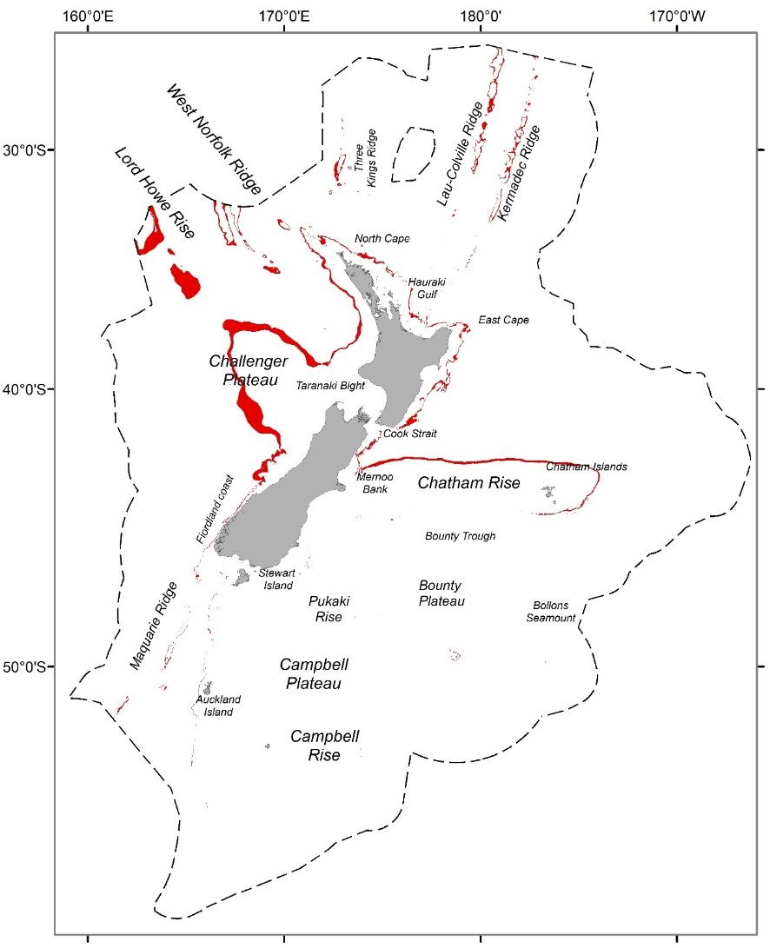

Figure 3. Geographic distributions of group 3 (red) from a 30-group demersal fish classification for the seas within the New Zealand Extended Continental Shelf (dashed line) to a depth of 2000 m.

#### Group description

Group 3 is a large, widespread group occurring in deep cold waters predominately north of the STF with low oxygen, bottom salinity and primary productivity (Table 5). Particularly prevalent in the north-east of the study area on the Challenger plateau (Figure 3). Species assemblages are primarily characterised by very high frequency occurrence of orange roughy, and intermediate frequency occurrences of Serrulate rattail and Johnson’s codling (Table 6).

#### Similar groups

Closely related to group 4; more loosely related to group 5.

#### Characterising environmental conditions

Table 5. Group 3 characterising environmental conditions

|  |  |  |
| --- | --- | --- |
| **Environmental variable** | **Mean value** | **Qualitative description** |
| Bathymetry | 1011 m | Deep water |
| Roughness | 29.56 | Moderate – high variability in seabed depths |
| Bottom silicate | 35.4 umol l-1 | High concentrations of silicate at depth. |
| Dissolved oxygen at depth | 4.31 ml l-1 | Low concentrations of oxygen at depth |
| Bottom temperature | 5.37 °C km-1 | Low bottom water temperature |
| VGPM | 646.8 mgC m-2 d-1 | Moderate – low productivity |

#### Characterising Species

Table 6. Species name, mean frequency occurrence and % contribution to group 3 similarity for those species contributing to a total of 70% of the group similarity or > 4 % to the group 3 similarity. If English common names were not available, these were recorded as *na*.

|  |  |  |  |
| --- | --- | --- | --- |
| **Common name** | **Scientific name** | **Mean frequency occurrence** | **% contribution to similarity** |
| Orange roughy | *Hoplostethus atlanticus* | 0.97 | 16.01 |
| Serrulate rattail | *Coryphaenoides serrulatus* | 0.83 | 10.05 |
| Johnson’s codling | *Halargyreus johnsonii* | 0.77 | 8.53 |
| Four-rayed rattail | *Coryphaenoides subserrulatus* | 0.72 | 7.12 |
| Baxter’s dogfish | *Etmopterus granulosus* | 0.65 | 6.1 |
| Basketwork eel | *Diastobranchus capensis* | 0.65 | 5.79 |
| Longnose velvet dogfish | *Centroselachus crepidater* | 0.61 | 5.05 |
| Shovelnose spiny dogfish | *Deania calcea* | 0.61 | 5.04 |
| Notable rattail | *Coelorinchus innotabilis* | 0.56 | 4.1 |
| White rattail | *Trachyrincus aphyodes* | 0.55 | 4.06 |

### Group 4

#### Geographic location

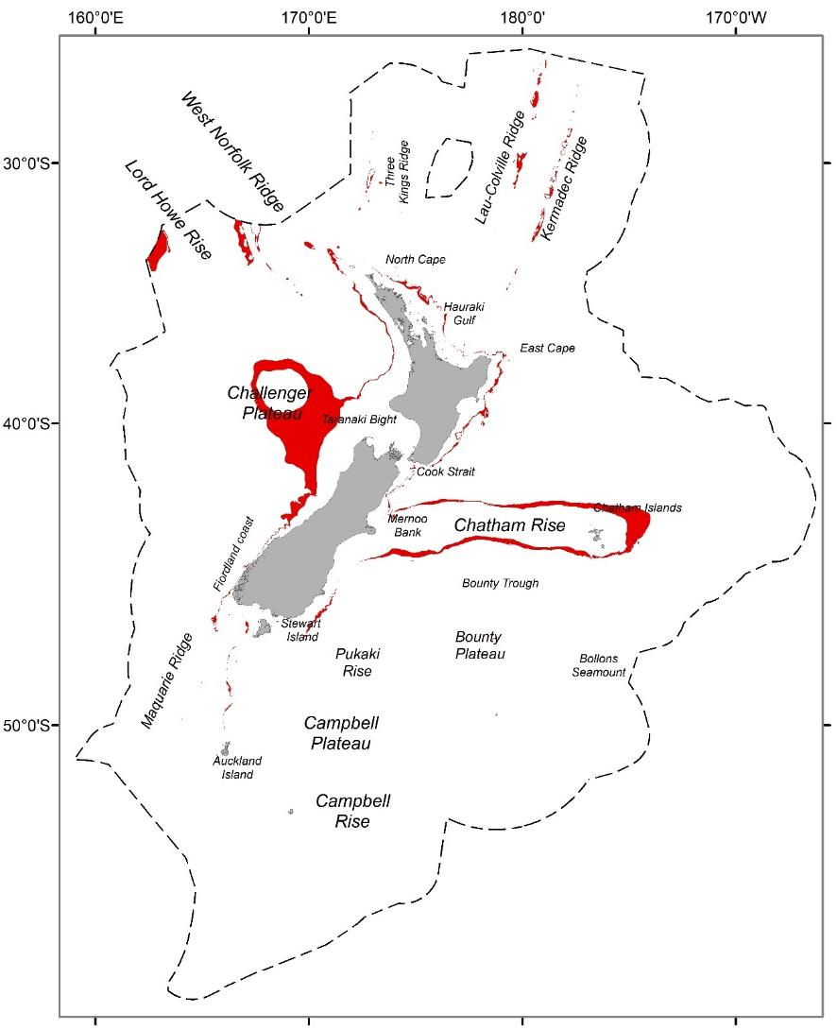

Figure 4. Geographic distributions of group 4 (red) from a 30-group demersal fish classification for the seas within the New Zealand Extended Continental Shelf (dashed line) to a depth of 2000 m.

#### Group description

Group 4 is a large, widespread group (Figure 4) occurring in deep cold waters with low oxygen, bottom salinity and primary productivity (Table 7). Although closely related to group 3, this group occurs in slightly shallower water with lower variability in seabed depths. Species assemblages are primarily characterised by intermediate frequency occurrence of orange roughy and to a lesser extent, other intermediate frequency occurrences of deep water fish species (e.g. Hoki, Ribaldo, Shovelnose spiny dogfish, Javelinfish) (Table 8).

#### Similar groups

Closely related to group 3; more loosely related to group 5.

#### Characterising environmental conditions

Table 7. Group 4 characterising environmental conditions

|  |  |  |
| --- | --- | --- |
| **Environmental variable** | **Mean value** | **Qualitative description** |
| Bathymetry | 836 m | Deep water |
| Roughness | 16.3 | Moderate variability in seabed depths |
| Bottom silicate | 24.7 umol l-1 | High concentrations of silicate at depth. |
| Dissolved oxygen at depth | 4.6 ml l-1 | Low concentrations of oxygen at depth |
| Bottom temperature | 6.4 °C km-1 | Low bottom water temperature |
| VGPM | 600.0 mgC m-2 d-1 | Low productivity |

#### Characterising Species

Table 8. Species name, mean frequency occurrence and % contribution to group 4 similarity for those species contributing to a total of 70% of the group similarity or > 4 % to the group 4 similarity. If English common names were not available, these were recorded as *na*.

|  |  |  |  |
| --- | --- | --- | --- |
| **Common name** | **Scientific name** | **Mean frequency occurrence** | **% contribution to similarity** |
| Orange roughy | *Hoplostethus atlanticus* | 0.77 | 14.94 |
| Hoki | *Macruronus novaezelandiae* | 0.68 | 8.04 |
| Ribaldo | *Ribaldo moro* | 0.66 | 7.8 |
| Shovelnose spiny dogfish | *Deania calcea* | 0.67 | 7.36 |
| Javelinfish | *Lepidorhynchus denticulatus* | 0.54 | 4.68 |
| Johnson’s codling | *Halargyreus johnsonii* | 0.51 | 4.15 |
| Longnose velvet dogfish | *Centroselachus crepidater* | 0.51 | 4.09 |
| Four-rayed rattail | *Coryphaenoides subserrulatus* | 0.51 | 4.06 |

### Group 5

#### Geographic location

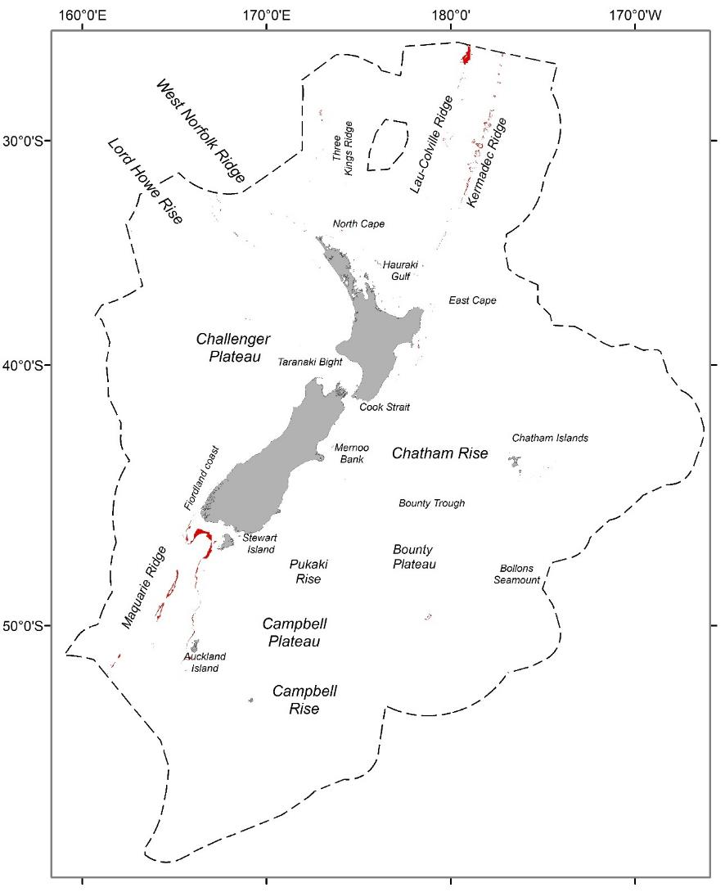

Figure 5. Geographic distributions of group 5 (red) from a 30-group demersal fish classification for the seas within the New Zealand Extended Continental Shelf (dashed line) to a depth of 2000 m.

#### Group description

Group 5 is of limited extent but occurring in both the north and south of study area primarily along deep sea ridges (Macquarie, Lau-Colville and Kermadec ridges) (Figure 5). This group is characterised by deep cold waters with low oxygen, bottom salinity and primary productivity with moderate variability in seabed depths (Table 9). Species assemblages are weakly characterised (e.g. < 10% contribution to intra-group similarity) by several high frequency occurrence species: longnose velvet dogfish, Hoki, Javelinfish, Hake, Ribaldo (Table 10).

#### Similar groups

Loosely related to groups 3 and 4.

#### Characterising environmental conditions

Table 9. Group 5 characterising environmental conditions

|  |  |  |
| --- | --- | --- |
| **Environmental variable** | **Mean value** | **Qualitative description** |
| Bathymetry | 879 m | Deep water |
| Roughness | 38.8 | High variability in seabed depths |
| Bottom silicate | 25.5 umol l-1 | High concentrations of silicate at depth. |
| Dissolved oxygen at depth | 4.67 ml l-1 | Low concentrations of oxygen at depth |
| Bottom temperature | 6.1 °C km-1 | Low bottom water temperature |
| VGPM | 508.5 mgC m-2 d-1 | Low productivity |

#### Characterising Species

Table 10. Species name, mean frequency occurrence and % contribution to group 5 similarity for those species contributing to a total of 70% of the group similarity or > 4 % to the group 5 similarity. If English common names were not available, these were recorded as *na*.

|  |  |  |  |
| --- | --- | --- | --- |
| **Common name** | **Scientific name** | **Mean frequency occurrence** | **% contribution to similarity** |
| Longnose velvet dogfish | *Centroselachuscrepidater* | 0.82 | 9.57 |
| Hoki | *Macruronus novaezelandiae* | 0.78 | 8.33 |
| Javelinfish | *Lepidorhynchus denticulatus* | 0.78 | 8.32 |
| Hake | *Merluccius australis* | 0.76 | 8.24 |
| Ribaldo | *Ribaldo moro* | 0.78 | 8.18 |
| Orange roughy | *Hoplostethus atlanticus* | 0.58 | 5.1 |
| Leafscale gulper shark | *Centrophorus squamosus* | 0.58 | 4.41 |
| Four-rayed rattail | *Coryphaenoides subserrulatus* | 0.56 | 4.2 |
| Shovelnose spiny dogfish | *Deania calcea* | 0.58 | 4.05 |

### Group 6

#### Geographic location

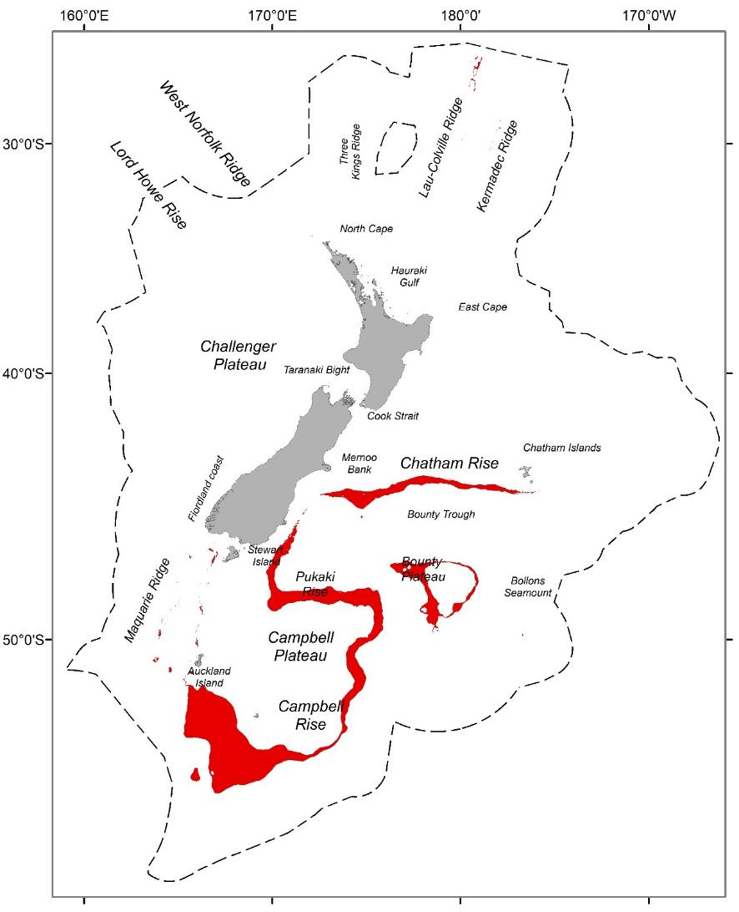

Figure 6. Geographic distributions of group 6 (red) from a 30-group demersal fish classification for the seas within the New Zealand Extended Continental Shelf (dashed line) to a depth of 2000 m.

#### Group description

A large, widespread group in deeper waters along the Campbell Rise, Campbell Plateau, Bounty Plateau and Chatham Rise (Figure 6). Group 6 occurs in the deep, low productivity, low oxygen waters south of the STF, with high concentrations of bottom silicate and nitrogen (Table 11). Species assemblages are primarily characterised by high frequency occurrence of smooth oreo, Baxter’s dogfish, back oreo and ridge scaled rattail (Table 12).

#### Similar groups

Closely related to groups 7.

#### Characterising environmental conditions

Table 11. Group 6 characterising environmental conditions

|  |  |  |
| --- | --- | --- |
| **Environmental variable** | **Mean value** | **Qualitative description** |
| Bathymetry | 976 m | Deep water |
| Bottom nitrate | 30.3 umol l-1 | High concentrations of nitrate at depth. |
| Bottom silicate | 41.9 umol l-1 | High concentrations of silicate at depth. |
| Dissolved oxygen at depth | 4.65 ml l-1 | Low concentrations of oxygen at depth |
| Bottom temperature | 4.2 °C km-1 | Very low bottom water temperature |
| VGPM | 446.1 mgC m-2 d-1 | Low productivity |

#### Characterising Species

Table 12. Species name, mean frequency occurrence and % contribution to group 6 similarity for those species contributing to a total of 70% of the group similarity or > 4 % to the group 6 similarity. If English common names were not available, these were recorded as *na*.

|  |  |  |  |
| --- | --- | --- | --- |
| **Common name** | **Scientific name** | **Mean frequency occurrence** | **% contribution to similarity** |
| Smooth oreo | *Pseudocyttus maculatus* | 0.91 | 14.68 |
| Baxter’s dogfish | *Etmopterus granulosus* | 0.89 | 13.2 |
| Black oreo | *Allocyttus niger* | 0.79 | 10.67 |
| Ridge scaled rattail | *Macrourus carinatus* | 0.79 | 9.78 |
| Johnson’s codling | *Halargyreus johnsonii* | 0.64 | 6.47 |
| Basketwork eel | *Diastobranchus capensis* | 0.63 | 6.01 |
| Orange roughy | *Hoplostethus atlanticus* | 0.56 | 5.2 |
| Big scaled and small scaled brown slickhead | *Alepocephalus australis*  *Alepocephalus antipodianus* | 0.57 | 5.03 |

### Group 7

#### Geographic location

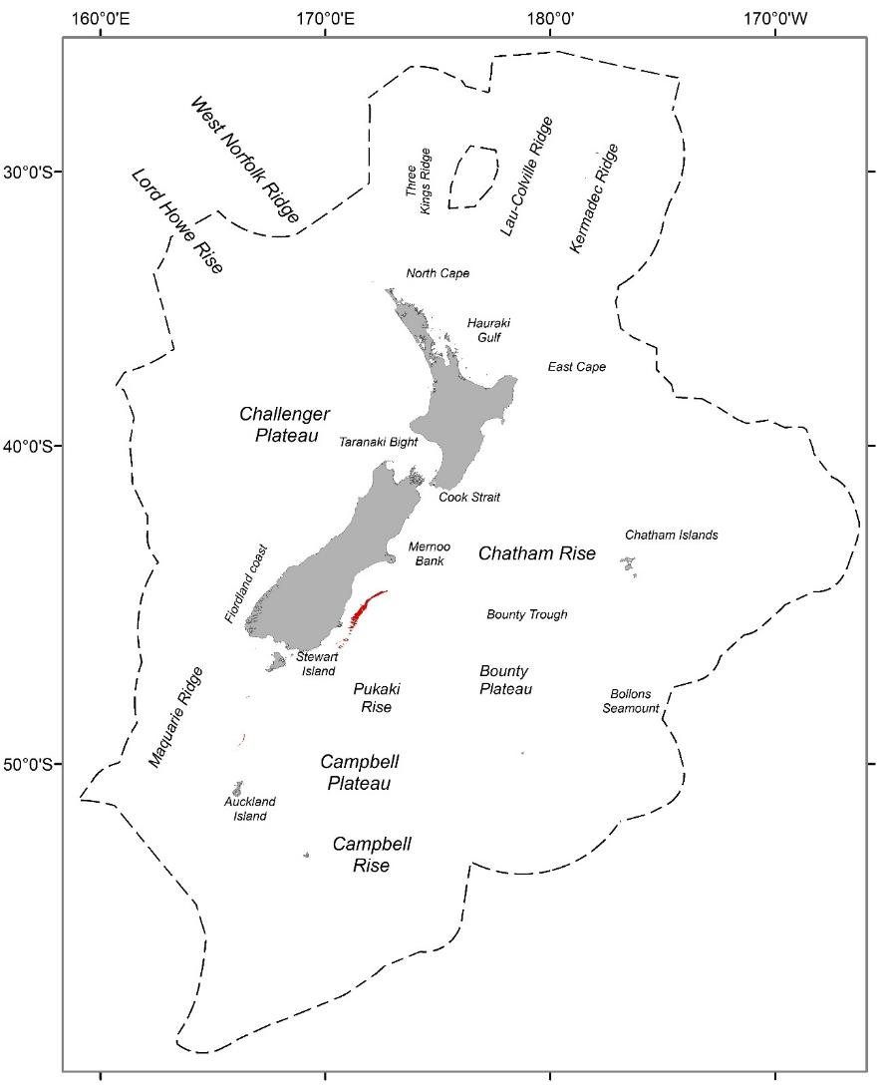

Figure 7. Geographic distributions of group 7 (red) from a 30-group demersal fish classification for the seas within the New Zealand Extended Continental Shelf (dashed line) to a depth of 2000 m.

#### Group description

Group 7 occurs across a limited area along steep bathymetric drop along the continental shelf into the Bounty Trough (Figure 7). Group 7 occurs in the deep, low productivity, low oxygen waters south of the STF, with high concentrations of bottom silicate and nitrogen (Table 13). Species assemblages are primarily characterised by high frequency occurrence of smooth oreo, Baxter’s dogfish and back oreo (Table 14).

#### Similar groups

Closely related to groups 6.

Table 13. Group 7 characterising environmental conditions

|  |  |  |
| --- | --- | --- |
| **Environmental variable** | **Mean value** | **Qualitative description** |
| Bathymetry | 1012 m | Deep water |
| Bottom nitrate | 31.8 umol l-1 | High concentrations of nitrate at depth. |
| Bottom silicate | 44.5 umol l-1 | High concentrations of silicate at depth. |
| Dissolved oxygen at depth | 4.66 ml l-1 | Low concentrations of oxygen at depth |
| Bottom temperature | 4.16 °C km-1 | Very low bottom water temperature |
| VGPM | 371.7 mgC m-2 d-1 | Low productivity |

#### Characterising Species

Table 14. Species name, mean frequency occurrence and % contribution to group 7similarity for those species contributing to a total of 70% of the group similarity or > 4 % to the group similarity. If no English common name was available, these were recorded as *na*.

|  |  |  |  |
| --- | --- | --- | --- |
| **Common name** | **Scientific name** | **Mean frequency occurrence** | **% contribution to similarity** |
| Smooth oreo | *Pseudocyttus maculatus* | 0.97 | 13.42 |
| Baxter’s dogfish | *Etmopterus granulosus* | 0.91 | 11.35 |
| Black oreo | *Allocyttus niger* | 0.89 | 10.99 |
| Four-rayed rattail | *Coryphaenoides subserrulatus* | 0.83 | 8.94 |
| Ridge scaled rattail | *Macrourus carinatus* | 0.78 | 7.62 |
| Orange roughy | *Hoplostethus atlanticus* | 0.72 | 7.03 |
| Hoki | *Macruronus novaezelandiae* | 0.67 | 5.66 |
| Banded rattail | *Coelorinchus fasciatus* | 0.63 | 4.99 |

### Group 8

#### Geographic location

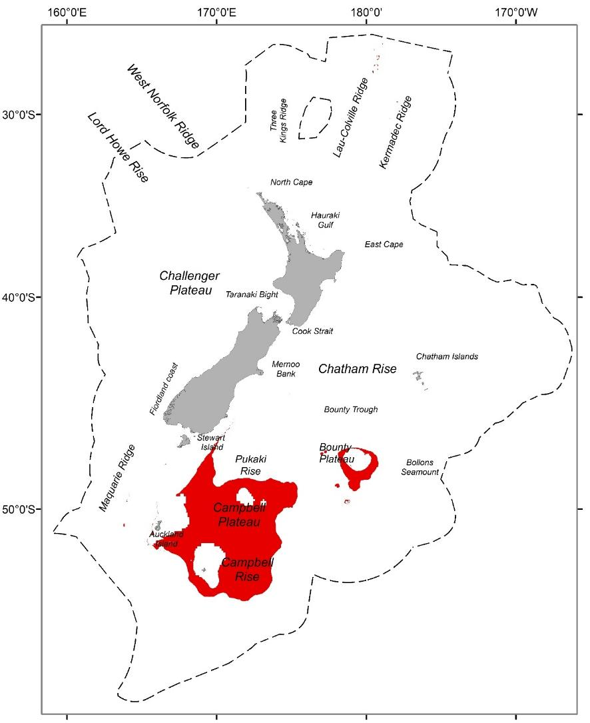

Figure 8. Geographic distributions of group 8 (red) from a 30-group demersal fish classification for the seas within the New Zealand Extended Continental Shelf (dashed line) to a depth of 2000 m.

#### Group description

The widespread group 8 occurs across large areas of the Campbell Plateau and Campbell Rise at intermediate depths, in the less saline, more oxygenated, very low productivity waters south of the STF (Figure 8). It is characterised by moderate – high concentrations of dissolved oxygen and nitrate at depth, but low values for other environmental variables (e.g. low productivity, roughness, bottom salinity) (Table 15). Species assemblages are primarily characterised by high frequency occurrence of Ling, Hoki, Javelinfish, pale ghost shark (Table 16).

#### Similar groups

Closely related to group 9; more loosely related to groups 10 – 12.

#### Characterising environmental conditions

Table 15. Group 8 characterising environmental conditions

|  |  |  |
| --- | --- | --- |
| **Environmental variable** | **Mean value** | **Qualitative description** |
| Bathymetry | 580 m | Intermediate depth waters |
| Roughness | 2.3 | Very low variability in seabed depths |
| Bottom salinity | 34.4 ppt | Low water salinity at depth. |
| Dissolved oxygen at depth | 5.77 ml l-1 | High concentrations of oxygen at depth |
| Bottom nitrate | 21.7 umol l-1 | Moderate – high water nitrate concentration at the seafloor |
| VGPM | 233 mgC m-2 d-1 | Very low productivity |

#### Characterising Species

Table 16. Species name, mean frequency occurrence and % contribution to group 8 similarity for those species contributing to a total of 70% of the group similarity or > 4 % to the group 8 similarity. If English common names were not available, these were recorded as *na*.

|  |  |  |  |
| --- | --- | --- | --- |
| **Common name** | **Scientific name** | **Mean frequency occurrence** | **% contribution to similarity** |
| Ling | *Genypterus blacodes* | 0.9 | 14.56 |
| Hoki | *Macruronus novaezelandiae* | 0.9 | 14.34 |
| Javelinfish | *Lepidorhynchus denticulatus* | 0.9 | 13.93 |
| Pale ghost shark | *Hydrolagus bemisi* | 0.86 | 12.75 |
| Silverside | *Argentina elongata* | 0.64 | 7.31 |
| Southern blue whiting | *Micromesistius australis* | 0.57 | 6.92 |
| Banded rattail | *Coelorinchus fasciatus* | 0.55 | 4.64 |

### Group 9

#### Geographic location

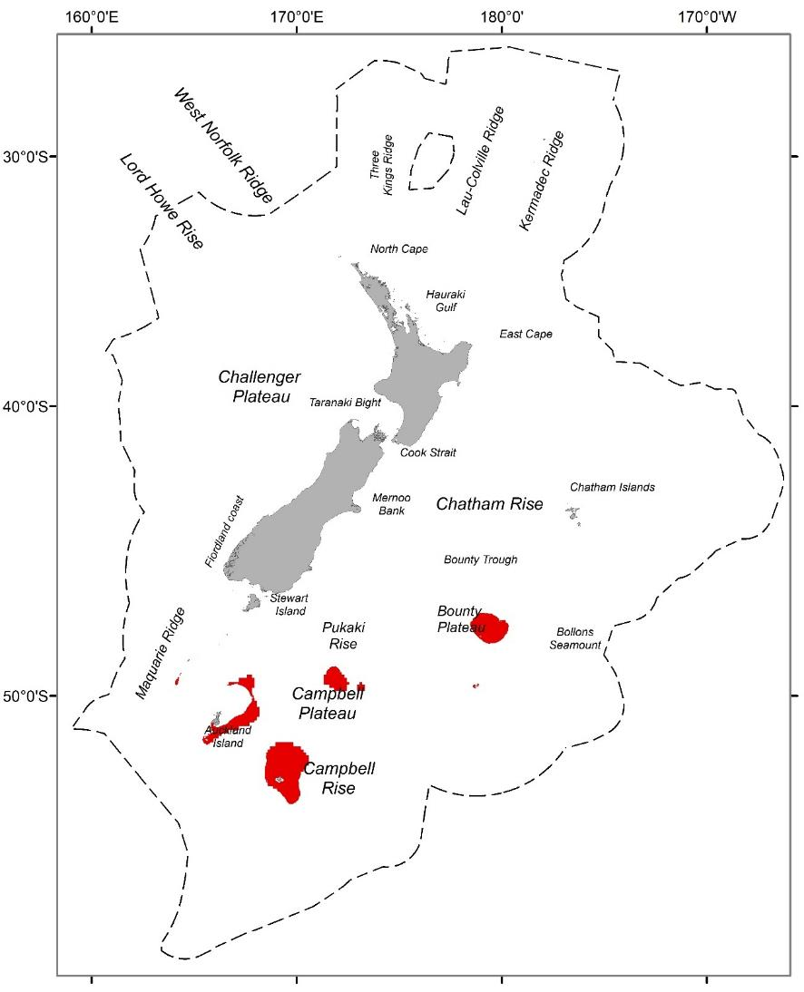

Figure 9. Geographic distributions of group 9 (red) from a 30-group demersal fish classification for the seas within the New Zealand Extended Continental Shelf (dashed line) to a depth of 2000 m.

#### Group description

Group 9 occurs across large areas of the Campbell plateau and Rise at intermediate depths, in the less saline, more oxygenated, very low productivity waters south of the STF (Figure 9). It is characterised by very high concentrations of dissolved oxygen and moderate concentrations of nitrate at depth, but low values for other environmental variables (e.g. very low productivity and low roughness and bottom salinity) (Table 17). Species assemblages are strongly characterised (> 20% contribution to intra-group similarity) by intermediate frequency occurrence of Ling, and to a lesser extent southern blue whiting, silverside (Table 18).

#### Similar groups

Closely related to group 8; more loosely related to groups 10 – 12.

#### Characterising environmental conditions

Table 17. Group 9 characterising environmental conditions

|  |  |  |
| --- | --- | --- |
| **Environmental variable** | **Mean value** | **Qualitative description** |
| Bathymetry | 342.9 m | Intermediate depth waters |
| Roughness | 7.9 | Low variability in seabed depths |
| Bottom salinity | 34.4 ppt | Low water salinity at depth. |
| Dissolved oxygen at depth | 6.19 ml l-1 | Very high concentrations of oxygen at depth |
| Bottom nitrate | 15.9 umol l-1 | Moderate water nitrate concentration at the seafloor |
| VGPM | 277 mgC m-2 d-1 | Very low productivity |

#### Characterising Species

Table 18. Species name, mean frequency occurrence and % contribution to group 9 similarity for those species contributing to a total of 70% of the group similarity or > 4 % to the group 9 similarity. If English common names were not available, these were recorded as *na*.

|  |  |  |  |
| --- | --- | --- | --- |
| **Common name** | **Scientific name** | **Mean frequency occurrence** | **% contribution to similarity** |
| Ling | *Genypterus blacodes* | 0.69 | 23.92 |
| Southern blue whiting | *Micromesistius australis* | 0.57 | 15.25 |
| Silverside | *Argentina elongata* | 0.52 | 11.25 |
| Hoki | *Macruronus novaezelandiae* | 0.48 | 9.73 |
| Oblique banded rattail | *Coelorinchus aspercephalus* | 0.45 | 7.75 |
| Javelinfish | *Lepidorhynchus denticulatus* | 0.38 | 4.88 |

### Group 10

#### Geographic location

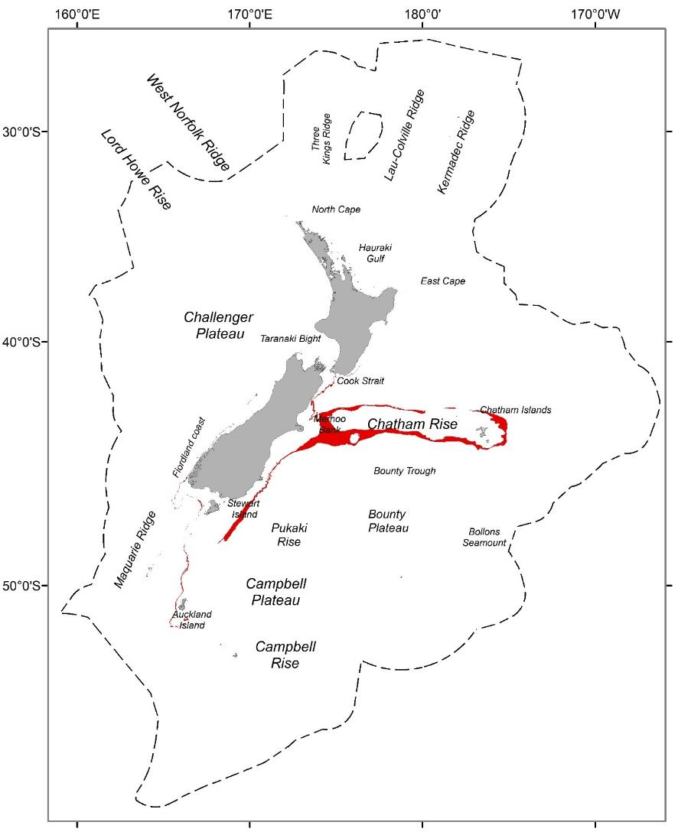

Figure 10. Geographic distributions of group 10 (red) from a 30-group demersal fish classification for the seas within the New Zealand Extended Continental Shelf (dashed line) to a depth of 2000 m.

#### Group description

Group 10 occurs at intermediate depths along the north and the south of the Chatham Rise and extending in a narrow band along much of the South Island along the western edge of the Campbell Plateau (Figure 10). Group 10 is characterised by more productive waters associated with the STF (high sea surface gradients and moderate concentrations of bottom oxygen), but low – moderate values for other environmental variables (e.g. moderate productivity, roughness and low bottom salinity and bottom temperature). Species assemblages are primarily characterised by high frequency occurrence of Hoki, Ling, and Javelinfish (Table 20).

#### Similar groups

Closely related to 11; more loosely related to groups 8,9 and 12.

#### Characterising environmental conditions

Table 19. Group 10 characterising environmental conditions

|  |  |  |
| --- | --- | --- |
| **Environmental variable** | **Mean value** | **Qualitative description** |
| Bathymetry | 541.0 m | Intermediate depth waters |
| Roughness | 12.3 | Moderate variability in seabed depths |
| Bottom salinity | 34.5 ppt | Low water salinity at depth. |
| Dissolved oxygen at depth | 5.5 ml l-1 | Moderate concentrations of oxygen at depth |
| Bottom temperature | 7.3 °C km-1 | Low – moderate water temperature at depth |
| VGPM | 645 mgC m-2 d-1 | Moderate productivity |

#### Characterising Species

Table 20. Species name, mean frequency occurrence and % contribution to group 10 similarity for those species contributing to a total of 70% of the group similarity or > 4 % to the group 10 similarity. If English common names were not available, these were recorded as *na*.

|  |  |  |  |
| --- | --- | --- | --- |
| **Common name** | **Scientific name** | **Mean frequency occurrence** | **% contribution to similarity** |
| Hoki | *Macruronus novaezelandiae* | 0.94 | 13.26 |
| Ling | *Genypterus blacodes* | 0.88 | 11.07 |
| Javelinfish | *Lepidorhynchus denticulatus* | 0.86 | 10.01 |
| Lookdown dory | *Cyttus traversi* | 0.8 | 8.84 |
| Pale ghost shark | *Hydrolagus bemisi* | 0.79 | 8.25 |
| Hake | *Merluccius australis* | 0.64 | 5.47 |
| Bollons' rattail | *Coelorinchus bollonsi* | 0.59 | 4.33 |
| Lucifer dogfish | *Etmopterus lucifer* | 0.57 | 4.11 |
| Oliver’s rattail | *Coelorinchus oliverianus* | 0.58 | 4.09 |

### Group 11

#### Geographic location

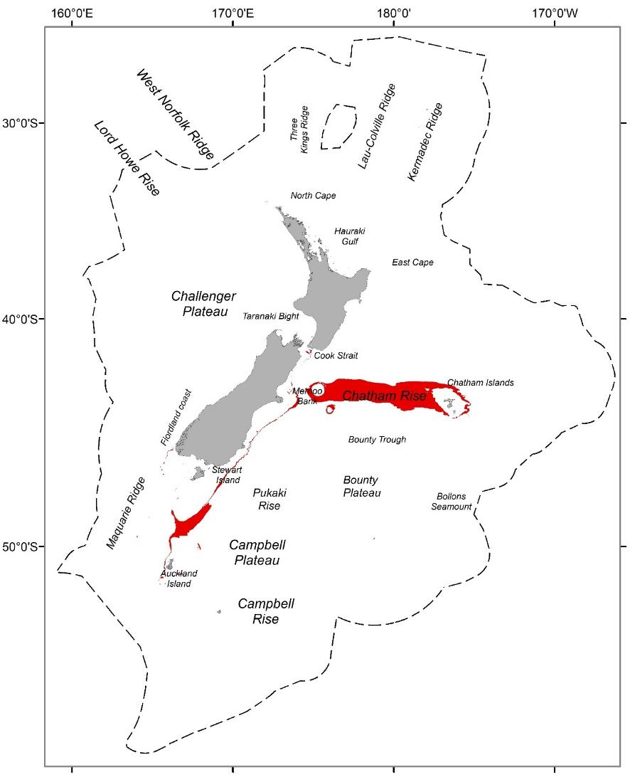

Figure 11. Geographic distributions of group 11 (red) from a 30-group demersal fish classification for the seas within the New Zealand Extended Continental Shelf (dashed line) to a depth of 2000 m.

#### Group description

Group 11 occurs at intermediate depths along the Chatham Rise and extending in a narrow band along the western edge of the Campbell Plateau (Figure 11). Group 11 is characterised by more productive waters associated with the STF (high sea surface gradients and moderate current speeds and concentrations of bottom oxygen), but low – moderate values for other environmental variables (e.g. moderate productivity, roughness and low bottom salinity and bottom temperature) (Table 21). Species assemblages are primarily characterised by high frequency occurrence of Hoki and Ling (Table 22).

#### Similar groups

Closely related to 10; more loosely related to groups 8,9 and 12.

#### Characterising environmental conditions

Table 21. Group 11 characterising environmental conditions

|  |  |  |
| --- | --- | --- |
| **Environmental variable** | **Mean value** | **Qualitative description** |
| Bathymetry | 389.7 m | Intermediate depth waters |
| Roughness | 13.6 | Moderate variability in seabed depths |
| Bottom salinity | 34.6 ppt | Low – moderate water salinity at depth. |
| Dissolved oxygen at depth | 5.6 ml l-1 | Moderate concentrations of oxygen at depth |
| Bottom temperature | 8.6 °C km-1 | Low – moderate water temperature at depth |
| VGPM | 624 mgC m-2 d-1 | Moderate productivity |

#### Characterising Species

Table 22. Species name, mean frequency occurrence and % contribution to group 11 similarity for those species contributing to a total of 70% of the group similarity or > 4 % to group 11 similarity. If English common names were not available, these were recorded as *na*.

|  |  |  |  |
| --- | --- | --- | --- |
| **Common name** | **Scientific name** | **Mean frequency occurrence** | **% contribution to similarity** |
| Hoki | *Macruronus novaezelandiae* | 0.89 | 14.66 |
| Ling | *Genypterus blacodes* | 0.83 | 12.05 |
| Lookdown dory | *Cyttus traversi* | 0.73 | 8.16 |
| Javelinfish | *Lepidorhynchus denticulatus* | 0.7 | 7.8 |
| Spiny dogfish | *Squalus acanthias* | 0.66 | 7.51 |
| Silver warehou | *Seriolella punctata* | 0.56 | 5.23 |
| Dark ghostshark | *Hydrolagus novaezealandiae* | 0.55 | 4.65 |
| Silverside | *Argentina elongata* | 0.54 | 4.47 |

### Group 12

#### Geographic location

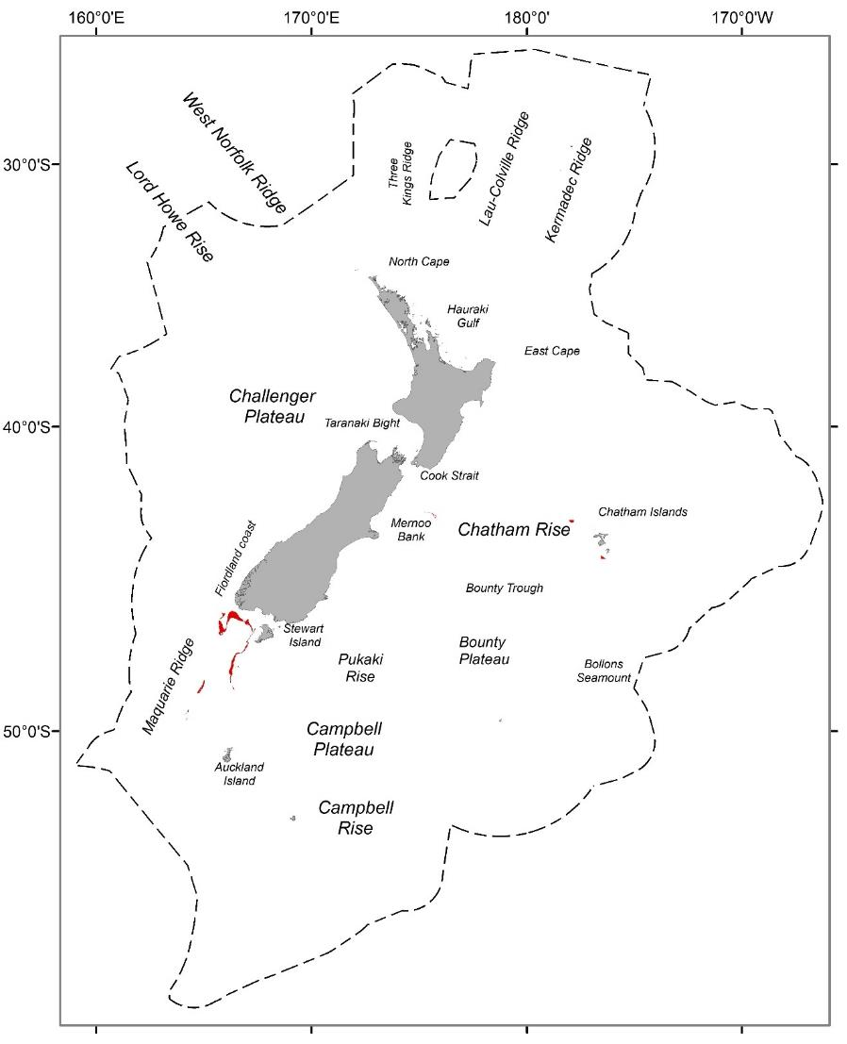

Figure 12. Geographic distributions of group 12 (red) from a 30-group demersal fish classification for the seas within the New Zealand Extended Continental Shelf (dashed line) to a depth of 2000 m.

#### Group description

Group 12 is of limited extent and occurs at intermediate depths sites east of the Macquarie Ridge (Figure 12). Group 12 is characterised by moderate concentrations of oxygen, tidal currents, depth gradients bottom temperature and salinity (Table 23). Species assemblages are primarily characterised by high frequency occurrence of Ling, Hoki and Javelinfish (Table 24).

#### Similar groups

Loosely related to groups 8 – 11

#### Characterising environmental conditions

Table 23. Group 12 characterising environmental conditions

|  |  |  |
| --- | --- | --- |
| **Environmental variable** | **Mean value** | **Qualitative description** |
| Bathymetry | 389.7 m | Intermediate depth waters |
| Roughness | 16.7 | Moderate variability in seabed depths |
| Bottom salinity | 34.7 ppt | Moderate water salinity at depth. |
| Dissolved oxygen at depth | 5.5 ml l-1 | Moderate concentrations of oxygen at depth |
| Bottom temperature | 8.9 °C km-1 | Moderate water temperature at depth |
| Tidal current speed | 0.24 m s-1 | Moderate – high tidal current speeds |

#### Characterising Species

Table 24. Species name, mean frequency occurrence and % contribution to group 26 similarity for those species contributing to a total of 70% of the group similarity or > 4 % to group 26 similarity. If English common names were not available, these were recorded as *na*.

|  |  |  |  |
| --- | --- | --- | --- |
| **Common name** | **Scientific name** | **Mean frequency occurrence** | **% contribution to similarity** |
| Ling | *Genypterus blacodes* | 0.93 | 13.31 |
| Hoki | *Macruronus novaezelandiae* | 0.92 | 13.03 |
| Javelinfish | *Lepidorhynchus denticulatus* | 0.84 | 10.35 |
| Lookdown dory | *Cyttus traversi* | 0.71 | 7.32 |
| Red cod | *Pseudophycis bachus* | 0.68 | 6.99 |
| Spiny dogfish | *Squalus acanthias* | 0.63 | 6.09 |
| Giant stargazer | *Kathetostoma giganteum* | 0.6 | 4.92 |
| Gemfish | *Rexea solandri* | 0.55 | 4.75 |
| Bollons' rattail | *Coelorinchus bollonsi* | 0.56 | 4.23 |

### Group 13

#### Geographic location

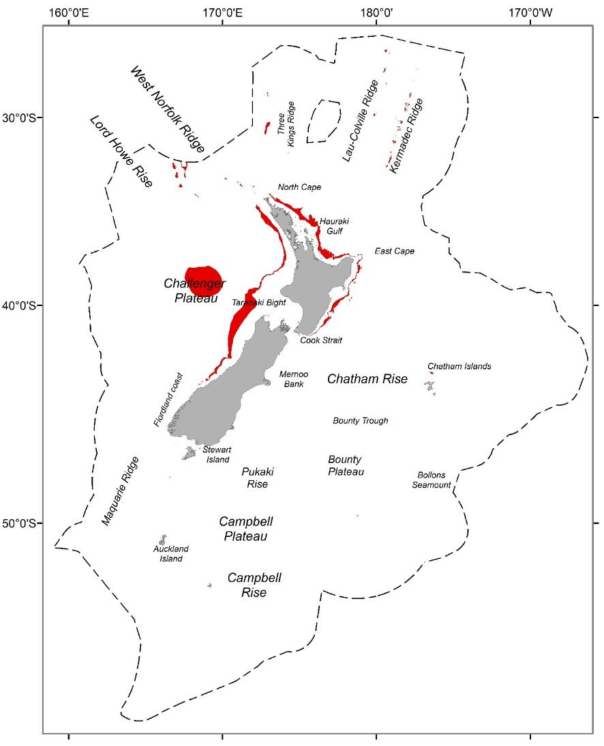

Figure 13. Geographic distributions of group 13 (red) from a 30-group demersal fish classification for the seas within the New Zealand Extended Continental Shelf (dashed line) to a depth of 2000 m.

#### Group description

A widespread group covering a moderate extent of the study area on the Challenger Plateau (Figure 13), occurs at intermediate depths, in moderate – high saline, low oxygenated waters north of the STF. Many other environmental variables have moderate values (e.g. roughness, bottom temperature, bottom silicate, productivity) (Table 25). Species assemblages are strongly characterised (> 20% contribution to intra-group similarity) by high frequency occurrence of Hoki and to a lesser extent Ling (Table 26).

#### Similar groups

Closely related to group 14.

#### Characterising environmental conditions

Table 25. Group 13 characterising environmental conditions

|  |  |  |
| --- | --- | --- |
| **Environmental variable** | **Mean value** | **Qualitative description** |
| Bathymetry | 439 m | Intermediate water depths |
| Bottom nitrate | 18.5 umol l-1 | Moderate – high concentrations of nitrate at depth. |
| Bottom salinity | 34.8 psu | Moderate – high salinity at depth. |
| Dissolved oxygen at depth | 4.79 ml l-1 | Low concentrations of oxygen at depth |
| Bottom temperature | 10.9 °C km-1 | Moderate bottom water temperature |
| VGPM | 710 mgC m-2 d-1 | Moderate productivity |

#### Characterising Species

Table 26. Species name, mean frequency occurrence and % contribution to group 13 similarity for those species contributing to a total of 70% of the group similarity or > 4 % to the group 13 similarity. If English common names were not available, these were recorded as *na*.

|  |  |  |  |
| --- | --- | --- | --- |
| **Common name** | **Scientific name** | **Mean frequency occurrence** | **% contribution to similarity** |
| Hoki | *Macruronus novaezelandiae* | 0.83 | 21.66 |
| Ling | *Genypterus blacodes* | 0.72 | 13.75 |
| Javelinfish | *Lepidorhynchus denticulatus* | 0.65 | 9.81 |
| Lookdown dory | *Cyttus traversi* | 0.57 | 8.6 |
| Gemfish | *Rexea solandri* | 0.52 | 7.69 |
| Silver roughy | *Hoplostethus mediterraneus* | 0.47 | 4.73 |
| Deepsea flathead | *Hoplichthys haswelli* | 0.42 | 3.78 |

### Group 14

#### Geographic location

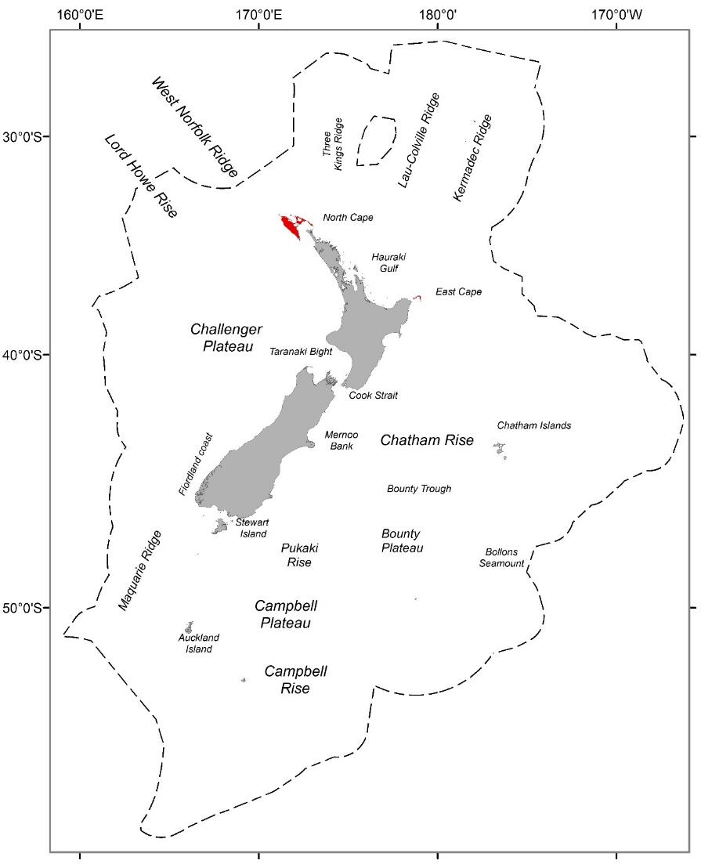

Figure 14. Geographic distributions of group 14 (red) from a 30-group demersal fish classification for the seas within the New Zealand Extended Continental Shelf (dashed line) to a depth of 2000 m.

#### Group description

A localised group covering a small extent of the study area, occurs at intermediate depths, in moderate – high saline, low oxygenated waters north of the STF. Many other environmental variables have moderate values (e.g. roughness, bottom temperature, bottom silicate, productivity) (Table 27). Group 14, is restricted to areas with high tidal currents and SST gradients west of the Three Kings Islands (Figure 14). Species assemblages are primarily characterised by intermediate frequency occurrence of Lucifer dogfish, Javelinfish and cucumber fish (Table 28).

#### Similar groups

Closely related to group 13.

#### Characterising environmental conditions

Table 27. Group 14 characterising environmental conditions

|  |  |  |
| --- | --- | --- |
| **Environmental variable** | **Mean value** | **Qualitative description** |
| Bathymetry | 527 m | Intermediate water depths |
| Tidal current | 0.57 m s-1 | Moderate – high tidal current speeds |
| Bottom salinity | 34.8 psu | Moderate – high salinity at depth. |
| Dissolved oxygen at depth | 4.79 ml l-1 | Low concentrations of oxygen at depth |
| Bottom temperature | 9.4 °C km-1 | Moderate bottom water temperature |
| Sea surface temperature gradients | 0.03 °C km-1 | Moderate SST gradients |

#### Characterising Species

Table 28. Species name, mean frequency occurrence and % contribution to group 14 similarity for those species contributing to a total of 70% of the group similarity or > 4 % to the group 14 similarity. If English common names were not available, these were recorded as *na*.

|  |  |  |  |
| --- | --- | --- | --- |
| **Common name** | **Scientific name** | **Mean frequency occurrence** | **% contribution to similarity** |
| Lucifer dogfish | *Etmopterus lucifer* | 0.78 | 15.81 |
| Javelinfish | *Lepidorhynchus denticulatus* | 0.78 | 14.13 |
| Cucumber fish | *Paraulopus nigripinnis* | 0.67 | 10.63 |
| Northern spiny dogfish | *Squalus griffini* | 0.56 | 7.7 |
| Silver roughy | *Hoplostethus mediterraneus* | 0.56 | 6.9 |
| Johnson’s smooth-hound | *Gollum attenuatus* | 0.56 | 6.8 |
| Gemfish | *Rexea solandri* | 0.56 | 6.47 |
| Frostfish | *Lepidopus caudatus* | 0.56 | 5.73 |

### Group 15

#### Geographic location

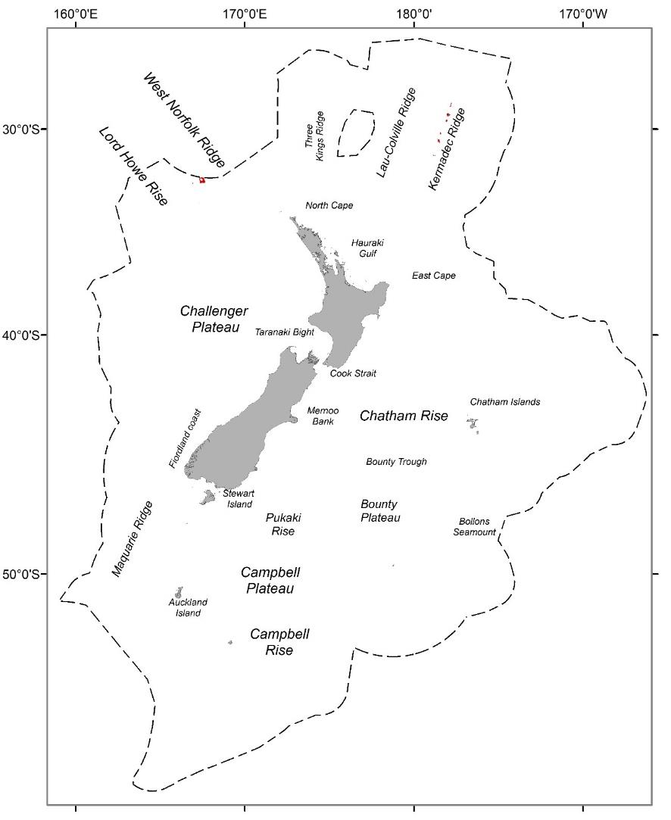

Figure 15. Geographic distributions of group 15 (red) from a 30-group demersal fish classification for the seas within the New Zealand Extended Continental Shelf (dashed line) to a depth of 2000 m.

#### Group description

A highly localised group occurring at intermediate depths on the West Norfolk Ridge (Figure 15), typified by strong seasonal temperature variation, high productivity and bottom water temperature, moderate dissolved organic matter and moderate oxygen concentrations.

#### Similar groups

Closely related to group 16.

#### Characterising Species

Due to the lack of demersal fish samples within this group, species assemblages were not able to be identified.

### Group 16

#### Geographic location

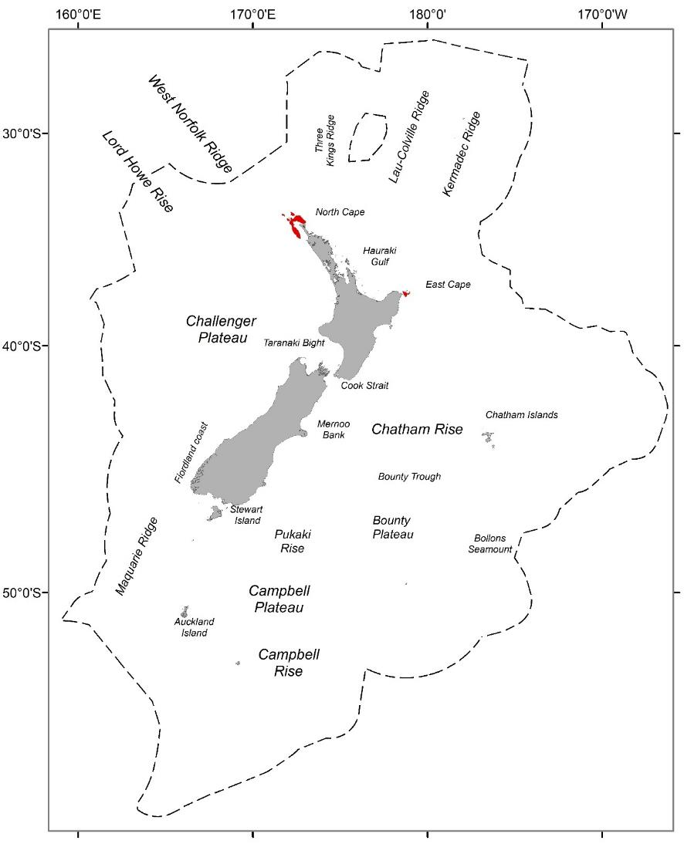

Figure 16. Geographic distributions of group 16 (red) from a 30-group demersal fish classification for the seas within the New Zealand Extended Continental Shelf (dashed line) to a depth of 2000 m.

#### Group description

A highly localised group occurring in shallow waters off the East Cape and the North Cape of the North Island (Figure 16). Despite group 16 occurring at intermediate depths, this group is typified by strong tidal currents and high benthic sediment disturbance with high productivity, bottom water temperature and bottom salinity (Table 29). Species assemblages are primarily characterised by low – intermediate frequency occurrence of Tarakihi, Red gurnard and John Dory (Table 30).

#### Similar groups

Closely related to group 15.

#### Characterising environmental conditions

Table 29. Group 16 characterising environmental conditions

|  |  |  |
| --- | --- | --- |
| **Environmental variable** | **Mean value** | **Qualitative description** |
| Bathymetry | 51.0 m | Shallow water depths |
| Tidal currents | 0.5 m s-1 | High tidal current speed |
| Bottom salinity | 35.3 psu | High salinity at depth. |
| Benthic sediment disturbance | -3.47 | High relative benthic sediment disturbance |
| Bottom temperature | 14.6 °C km-1 | High bottom water temperature |
| VGPM | 900 mgC m-2 d-1 | Moderate – high productivity |

#### Characterising Species

Table 30. Species name, mean frequency occurrence and % contribution to group 16 similarity for those species contributing to a total of 70% of the group similarity or > 4 % to the group 16 similarity. If English common names were not available, these were recorded as *na*.

|  |  |  |  |
| --- | --- | --- | --- |
| **Common name** | **Scientific name** | **Mean frequency occurrence** | **% contribution to similarity** |
| Tarakihi | *Nemadactylus macropterus* | 0.77 | 19.8 |
| Red gurnard | *Chelidonichthys kumu* | 0.67 | 14.79 |
| John Dory | *Zeus faber* | 0.53 | 9.96 |
| Spotted gurnard | *Pterygotrigla picta* | 0.5 | 7.47 |
| Scaly gurnard | *Lepidotrigla brachyoptera* | 0.47 | 5.6 |
| Cucumber fish | *Paraulopus nigripinnis* | 0.43 | 5.36 |
| Northern spiny dogfish | *Squalus griffini* | 0.4 | 4.43 |
| Jack mackerel | *Trachurus declivis* | 0.4 | 4.12 |

### Group 17

#### Geographic location

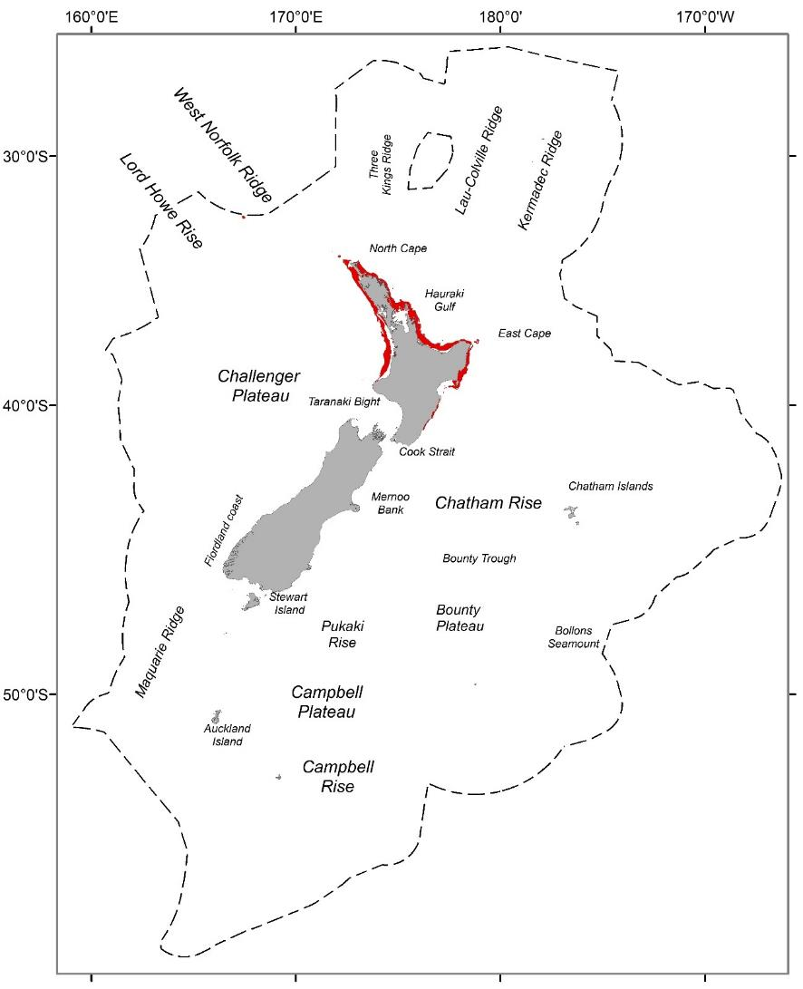

Figure 17. Geographic distributions of group 17 (red) from a 30-group demersal fish classification for the seas within the New Zealand Extended Continental Shelf (dashed line) to a depth of 2000 m.

#### Group description

A moderate sized group occurring in shallow waters of the north North Island (Figure 17). Group 17 is typified by strong seasonal temperature variation, high productivity and bottom water temperature, moderate and high bottom salinity (Table 31). Species assemblages are strongly characterised by high frequency occurrence of Snapper and Red gurnard and intermediate frequency occurrence of John Dory and Leatherjacket (Table 32).

#### Similar groups

Closely related to group 18.

#### Characterising environmental conditions

Table 31. Group 17 characterising environmental conditions

|  |  |  |
| --- | --- | --- |
| **Environmental variable** | **Mean value** | **Qualitative description** |
| Bathymetry | 51.0 m | Shallow water depths |
| Annual amplitude of sea floor temperature | 3.1 °C km-1 | high difference in seafloor temperature throughout the year |
| Bottom salinity | 35.3 psu | High salinity at depth. |
| Suspended particulate matter | 0.5 g m-3 | Moderate suspended particulate matter concentration |
| Bottom temperature | 16.1 °C km-1 | High bottom water temperature |
| VGPM | 1195 mgC m-2 d-1 | High productivity |

#### Characterising Species

Table 32. Species name, mean frequency occurrence and % contribution to group 17 similarity for those species contributing to a total of 70% of the group similarity or > 4 % to the group 17 similarity. If English common names were not available, these were recorded as *na*.

|  |  |  |  |
| --- | --- | --- | --- |
| **Common name** | **Scientific name** | **Mean frequency occurrence** | **% contribution to similarity** |
| Snapper | *Chrysophrys auratus* | 0.86 | 23.17 |
| Red gurnard | *Chelidonichthys kumu* | 0.83 | 20.93 |
| John Dory | *Zeus faber* | 0.79 | 18.94 |
| Leatherjacket | *Meuschenia scaber* | 0.58 | 10.46 |

### Group 18

#### Geographic location

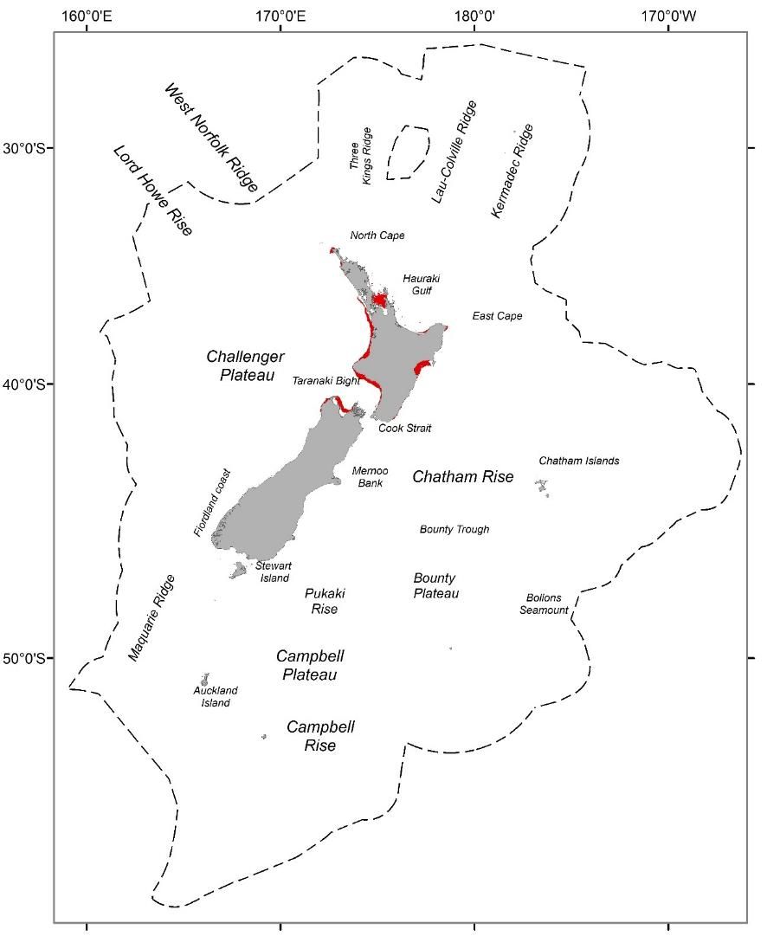

Figure 18. Geographic distributions of group 18 (red) from a 30-group demersal fish classification for the seas within the New Zealand Extended Continental Shelf (dashed line) to a depth of 2000 m.

#### Group description

A relatively widespread group occurring over a relatively small extent of the study area in very shallow waters of the North Island and the north of the South Island (Figure 18). Group 18 is typified by strong seasonal temperature variation, very high productivity and bottom water temperature, bottom salinity, tidal current speeds and benthic seabed disturbance (Table 33). Species assemblages are strongly characterised by high frequency occurrence of Snapper, and Red gurnard, and less strongly characterised by intermediate frequency occurrence of John Dory and Yellowtail jack mackerel (Table 34).

#### Similar groups

Closely related to group 17.

#### Characterising environmental conditions

Table 33. Group 18 characterising environmental conditions

|  |  |  |
| --- | --- | --- |
| **Environmental variable** | **Mean value** | **Qualitative description** |
| Bathymetry | 32.0 m | Very shallow water depths |
| Tidal currents | 0.28 m s-1 | Moderate – high tidal current speed |
| Bottom salinity | 35.2 psu | High salinity at depth. |
| Benthic sediment disturbance | -2.44 | High relative benthic sediment disturbance |
| Bottom temperature | 16.49 °C km-1 | Very high bottom water temperature |
| VGPM | 1605 mgC m-2 d-1 | High productivity |

#### Characterising Species

Table 34. Species name, mean frequency occurrence and % contribution to group 18 similarity for those species contributing to a total of 70% of the group similarity or > 4 % to the group 18 similarity. If English common names were not available, these were recorded as *na*.

|  |  |  |  |
| --- | --- | --- | --- |
| **Common name** | **Scientific name** | **Mean frequency occurrence** | **% contribution to similarity** |
| Snapper | *Chrysophrys auratus* | 0.85 | 23.23 |
| Red gurnard | *Chelidonichthys kumu* | 0.83 | 19.26 |
| John Dory | *Zeus faber* | 0.72 | 15.74 |
| Yellowtail jack mackerel | *Trachurus novaezelandiae* | 0.61 | 11.57 |
| Sand flounder | *Rhombosolea plebeia* | 0.48 | 5.69 |

### Group 19

#### Geographic location

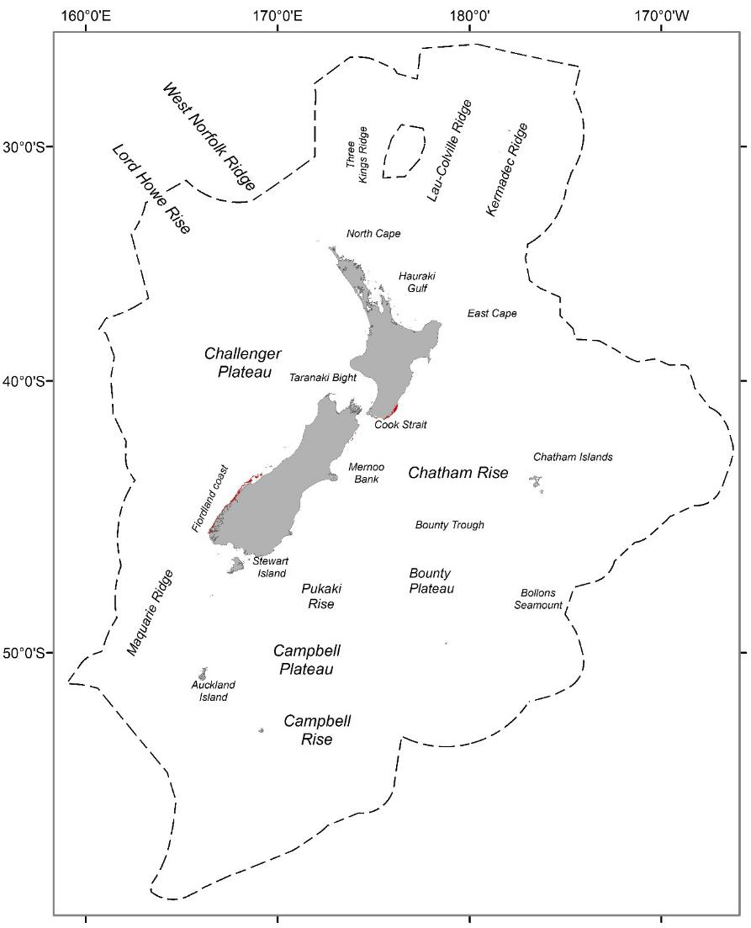

Figure 19. Geographic distributions of group 19 (red) from a 30-group demersal fish classification for the seas within the New Zealand Extended Continental Shelf (dashed line) to a depth of 2000 m.

#### Group description

Group 19, occupies very small areas of intermediate water depths occurring around the cook strait and on the south Fiordland coast (Figure 19). Group 19 is characterised by moderate values for many of the environmental variables (e.g. seabed roughness, bottom temperature, bottom concentration of oxygen, bottom salinity, productivity and benthic seabed disturbance) (Table 35). Species assemblages are primarily characterised by high and intermediate frequency occurrence of Barracouta and spiny dogfish respectively (Table 36).

#### Similar groups

Loosely related to groups 20 – 23.

#### Characterising environmental conditions

Table 35. Group 19 characterising environmental conditions

|  |  |  |
| --- | --- | --- |
| **Environmental variable** | **Mean value** | **Qualitative description** |
| Bathymetry | 82.4 m | Intermediate – shallow water depths |
| VGPM | 967.2 mgC m-2 d-1 | Moderate productivity |
| Bottom salinity | 34.9 psu | Moderate salinity at depth. |
| Benthic seabed disturbance | -3.6 | Moderate relative benthic seabed disturbance |
| Bottom temperature | 12.8 °C km-1 | Moderate bottom water temperature |
| Roughness | 18.9 | Moderate variability in seabed depths |

#### Characterising Species

Table 36. Species name, mean frequency occurrence and % contribution to group 19 similarity for those species contributing to a total of 70% of the group similarity or > 4 % to the group 19 similarity. If English common names were not available, these were recorded as *na*.

|  |  |  |  |
| --- | --- | --- | --- |
| **Common name** | **Scientific name** | **Mean frequency occurrence** | **% contribution to similarity** |
| Barracouta | *Thyrsites atun* | 0.84 | 26.86 |
| Spiny dogfish | *Squalus acanthias* | 0.68 | 15.64 |
| Red gurnard | *Chelidonichthys kumu* | 0.5 | 6.49 |
| Rig | *Mustelus lenticulatus* | 0.48 | 6.41 |
| Hāpuku | *Polyprion oxygeneios* | 0.46 | 6.05 |
| Tarakihi | *Nemadactylus macropterus* | 0.42 | 5.72 |
| Red cod | *Pseudophycis bachus* | 0.4 | 4.95 |

### Group 20

#### Geographic location

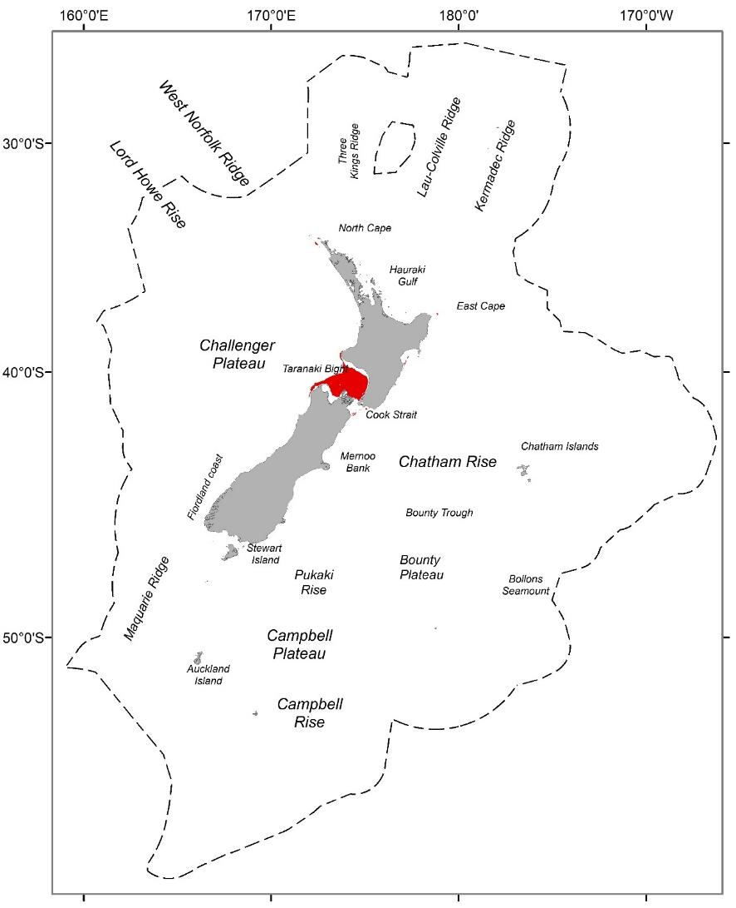

Figure 20. Geographic distributions of group 20 (red) from a 30-group demersal fish classification for the seas within the New Zealand Extended Continental Shelf (dashed line) to a depth of 2000 m.

#### Group description

Group 20, occupies relatively small areas of shallow – intermediate water depths in the South Taranaki Bight and Tasman and Golden Bays at the top of the South Island (Figure 20). Environmentally, group 20 is characterised by moderate – high bottom water temperatures, bottom salinity and productivity, tidal current speeds and benthic seabed disturbance (Table 37). Species assemblages are primarily characterised by intermediate frequency occurrence of Barracouta and to a lesser extent spiny dogfish (Table 2).

(Table 38).

#### Similar groups

Closely related to groups 21. More loosely related to groups 19, 22 and 23.

#### Characterising environmental conditions

Table 37. Group 20 characterising environmental conditions

|  |  |  |
| --- | --- | --- |
| **Environmental variable** | **Mean value** | **Qualitative description** |
| Bathymetry | 74.4 m | Shallow – Intermediate water depths |
| VGPM | 1087 mgC m-2 d-1 | Moderate productivity |
| Bottom salinity | 35.1 psu | Moderate – high salinity at depth. |
| Benthic seabed disturbance | -3.0 | Moderate relative benthic seabed disturbance |
| Bottom temperature | 13.6 °C km-1 | Moderate – high bottom water temperature |
| Tidal current speed | 0.44 m s-1 | Moderate tidal current speeds |

#### Characterising Species

Table 38. Species name, mean frequency occurrence and % contribution to group 20 similarity for those species contributing to a total of 70% of the group similarity or > 4 % to the group 20 similarity. If English common names were not available, these were recorded as *na*.

|  |  |  |  |
| --- | --- | --- | --- |
| **Common name** | **Scientific name** | **Mean frequency occurrence** | **% contribution to similarity** |
| Barracouta | *Thyrsites atun* | 0.76 | 13.51 |
| Spiny dogfish | *Squalus acanthias* | 0.65 | 9.86 |
| School shark | *Galeorhinus galeus* | 0.61 | 8.09 |
| Red gurnard | *Chelidonichthys kumu* | 0.58 | 7.22 |
| Tarakihi | *Nemadactylus macropterus* | 0.56 | 7.08 |
| John Dory | *Zeus faber* | 0.55 | 6.78 |
| Blue cod | *Parapercis colias* | 0.38 | 6.38 |
| Rig | *Mustelus lenticulatus* | 0.53 | 6.11 |
| Yellowtail jack mackerel | *Trachurus novaezelandiae* | 0.49 | 4.84 |
| Carpet shark | *Cephaloscyllium isabellum* | 0.45 | 4.11 |

### Group 21

#### Geographic location

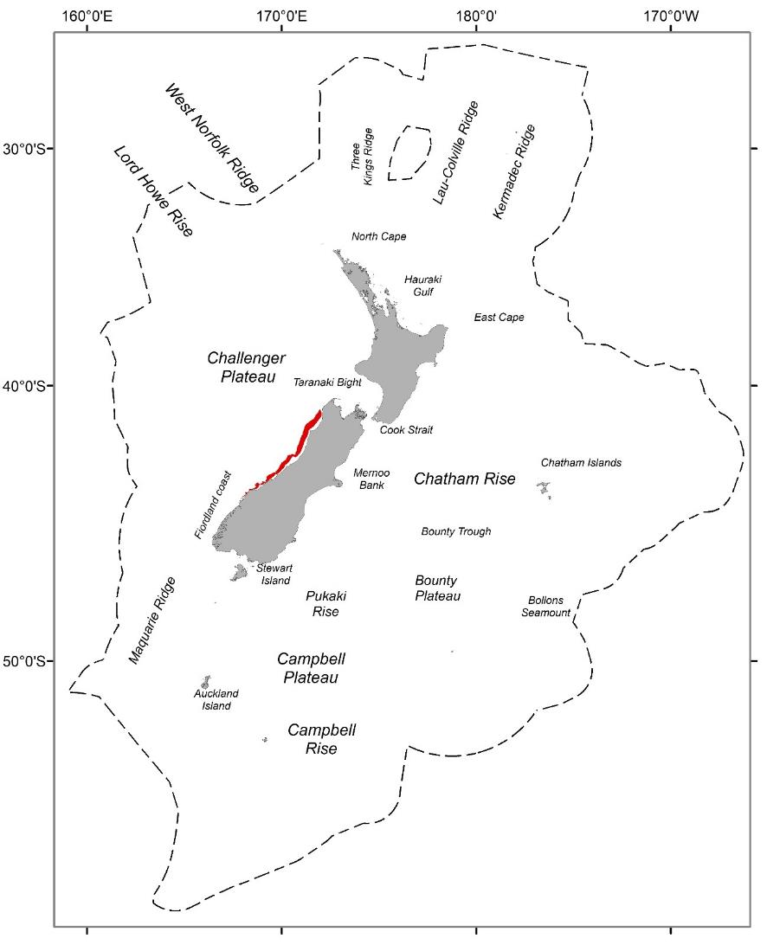

Figure 21. Geographic distributions of group 21 (red) from a 30-group demersal fish classification for the seas within the New Zealand Extended Continental Shelf (dashed line) to a depth of 2000 m.

#### Group description

#### Similar groups

Group 21, occupies relatively small areas of shallow - intermediate water depths, in inshore sites on the west coast of the South Island (Figure 21). Group 21 is characterised by moderate – high bottom water temperatures and high bottom salinity and productivity (Table 39). Species assemblages are primarily characterised by high frequency occurrence of spiny dogfish, Barracouta and Tarakihi (Table 40).

#### Similar groups

Closely related to groups 20. More loosely related to groups 19, 22 and 23.

#### Characterising environmental conditions

Table 39. Group 21 characterising environmental conditions

|  |  |  |
| --- | --- | --- |
| **Environmental variable** | **Mean value** | **Qualitative description** |
| Bathymetry | 112 m | Shallow – Intermediate water depths |
| VGPM | 1556 mgC m-2 d-1 | High productivity |
| Bottom salinity | 35.2 psu | Moderate – high salinity at depth. |
| Benthic seabed disturbance | -2.74 | High benthic seabed disturbance |
| Bottom temperature | 13.4 °C km-1 | Moderate – high bottom water temperature |
| Sea surface temperature gradients | 0.03 °C km-1 | Moderate SST gradients |

#### Characterising Species

Table 40. Species name, mean frequency occurrence and % contribution to group 21 similarity for those species contributing to a total of 70% of the group similarity or > 4 % to the group 21 similarity. If English common names were not available, these were recorded as *na*.

|  |  |  |  |
| --- | --- | --- | --- |
| **Common name** | **Scientific name** | **Mean frequency occurrence** | **% contribution to similarity** |
| Spiny dogfish | *Squalus acanthias* | 0.92 | 11.31 |
| Barracouta | *Thyrsites atun* | 0.91 | 11.16 |
| Tarakihi | *Nemadactylus macropterus* | 0.89 | 10.49 |
| Red cod | *Pseudophycis bachus* | 0.82 | 8.69 |
| School shark | *Galeorhinus galeus* | 0.77 | 7.78 |
| Carpet shark | *Cephaloscyllium isabellum* | 0.74 | 6.8 |
| Rig | *Mustelus lenticulatus* | 0.68 | 6.02 |
| Red gurnard | *Chelidonichthys kumu* | 0.57 | 4.27 |
| Scaly gurnard | *Lepidotrigla brachyoptera* | 0.59 | 4.01 |

### Group 22

#### Geographic location

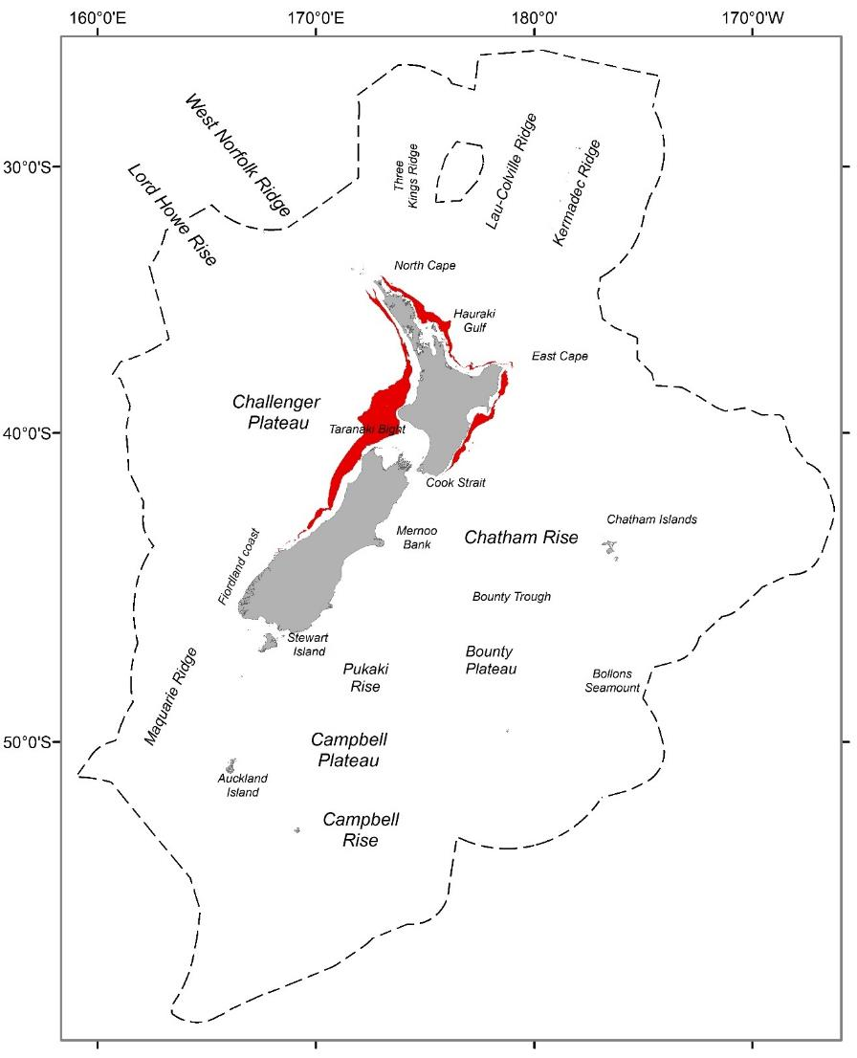

Figure 22. Geographic distributions of group 22 (red) from a 30-group demersal fish classification for the seas within the New Zealand Extended Continental Shelf (dashed line) to a depth of 2000 m.

#### Group description

Group 22, is an extensive group, occurring at intermediate water depths on the outer continental shelf from the west coast of the South Island around much of the North Island to just northeast of Cook Strait (Figure 22). Group 22 is characterised by moderate – high bottom water temperatures, bottom salinity and productivity, but with low concentrations of bottom oxygen (Table 41). Species assemblages are primarily characterised by intermediate frequency occurrence of Tarakihi and Barracouta (Table 42).

#### Similar groups

Closely related to groups 23. More loosely related to groups 19 – 21.

#### Characterising environmental conditions

Table 41. Group 22 characterising environmental conditions

|  |  |  |
| --- | --- | --- |
| **Environmental variable** | **Mean value** | **Qualitative description** |
| Bathymetry | 172 m | Intermediate water depths |
| VGPM | 893 mgC m-2 d-1 | Moderate – high productivity |
| Bottom salinity | 35.2 psu | Moderate – high salinity at depth. |
| Dissolved oxygen at depth | 5.23 ml l-1 | Low concentrations of oxygen at depth |
| Bottom temperature | 13.4 °C km-1 | Moderate – high bottom water temperature |
| Sea surface temperature gradients | 0.03 °C km-1 | Moderate SST gradients |

#### Characterising Species

Table 42. Species name, mean frequency occurrence and % contribution to group 22 similarity for those species contributing to a total of 70% of the group similarity or > 4 % to the group 22 similarity. If English common names were not available, these were recorded as *na*.

|  |  |  |  |
| --- | --- | --- | --- |
| **Common name** | **Scientific name** | **Mean frequency occurrence** | **% contribution to similarity** |
| Tarakihi | *Nemadactylus macropterus* | 0.77 | 15.87 |
| Barracouta | *Thyrsites atun* | 0.71 | 13.63 |
| School shark | *Galeorhinus galeus* | 0.57 | 8.67 |
| Spiny dogfish | *Squalus acanthias* | 0.51 | 6.84 |
| Frostfish | *Lepidopus caudatus* | 0.5 | 6.28 |
| Carpet shark | *Cephaloscyllium isabellum* | 0.43 | 4.6 |
| John Dory | *Zeus faber* | 0.39 | 4.07 |

### Group 23

#### Geographic location

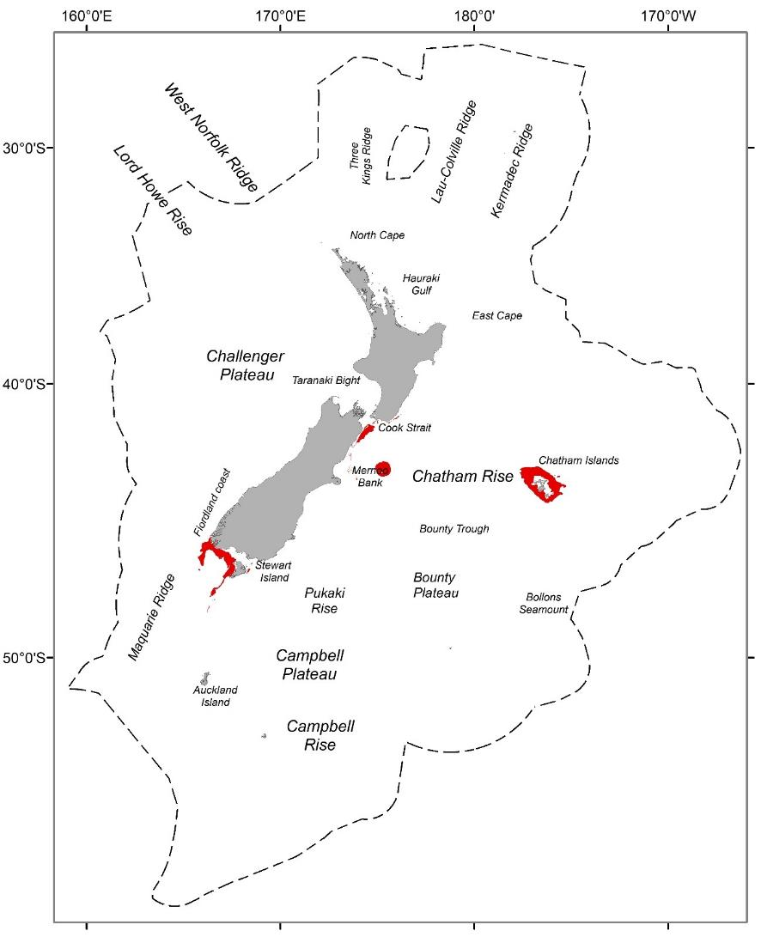

Figure 23. Geographic distributions of group 23 (red) from a 30-group demersal fish classification for the seas within the New Zealand Extended Continental Shelf (dashed line) to a depth of 2000 m.

#### Group description

Group 23, occupies relatively small areas of intermediate water depths, occurring around the cook strait, on the south Fiordland coast, the Mernoo Bank and the waters surrounding the Chatham Islands (Figure 23). Group 23 is characterised by moderate values for many of the environmental variables (e.g. tidal current speeds, bottom temperature, bottom concentration of oxygen, bottom salinity, productivity and benthic seabed disturbance (Table 43). Species assemblages are primarily characterised by high frequency occurrence of Barracouta, Tarakihi and spiny dogfish (Table 44).

#### Similar groups

Closely related to groups 22. More loosely related to groups 19 – 21.

#### Characterising environmental conditions

Table 43. Group 23 characterising environmental conditions

|  |  |  |
| --- | --- | --- |
| **Environmental variable** | **Mean value** | **Qualitative description** |
| Bathymetry | 163.6 m | Intermediate water depths |
| VGPM | 681 mgC m-2 d-1 | Moderate – low productivity |
| Bottom salinity | 34.8 psu | Moderate salinity at depth. |
| Benthic seabed disturbance | -4.3 | Moderate relative benthic seabed disturbance |
| Bottom temperature | 11.1 °C km-1 | Moderate bottom water temperature |
| Tidal current speed | 0.36 m s-1 | Moderate tidal current speeds |

#### Characterising Species

Table 44. Species name, mean frequency occurrence and % contribution to group 23 similarity for those species contributing to a total of 70% of the group similarity or > 4 % to the group 23 similarity. If English common names were not available, these were recorded as *na*.

|  |  |  |  |
| --- | --- | --- | --- |
| **Common name** | **Scientific name** | **Mean frequency occurrence** | **% contribution to similarity** |
| Barracouta | *Thyrsites atun* | 0.79 | 21.15 |
| Tarakihi | *Nemadactylus macropterus* | 0.72 | 16.11 |
| Spiny dogfish | *Squalus acanthias* | 0.65 | 12.53 |
| Hāpuku | *Polyprion oxygeneios* | 0.58 | 9.97 |
| Silver warehou | *Seriolella punctata* | 0.51 | 6.98 |
| School shark | *Galeorhinus galeus* | 0.43 | 5.54 |

### Group 24

#### Geographic location

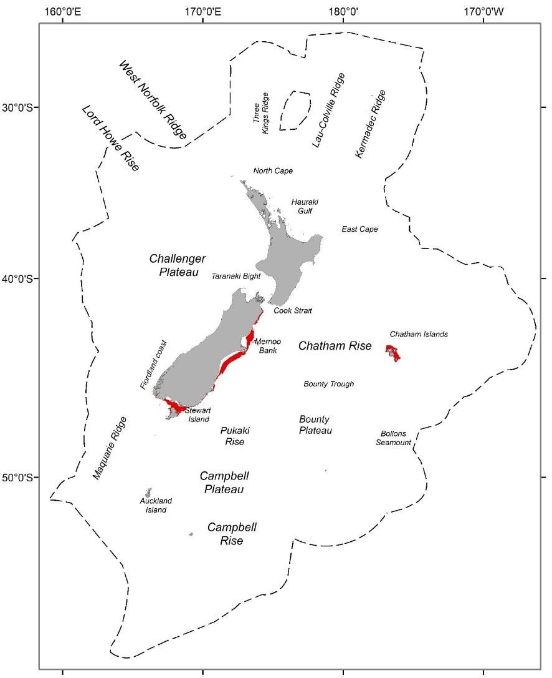

Figure 24. Geographic distributions of group 24 (red) from a 30-group demersal fish classification for the seas within the New Zealand Extended Continental Shelf (dashed line) to a depth of 2000 m.

#### Group description

Group 24 occurs on sites at intermediate water depths off the southern Fiordland coast, south of Cook Strait, on the Mernoo Bank and around the north of the Chatham Islands (Figure 24). Group 24 is characterised by high oxygen and seasonal variation in bottom water temperature, but with moderate productivity and bottom water temperatures and low bottom water salinity (Table 45). Species assemblages are strongly characterised by high frequency occurrence of Barracouta and spiny dogfish and to a lesser extent Tarakihi (Table 46).

#### Similar groups

Loosely related to 25 – 27.

#### Characterising environmental conditions

Table 45. Group 24 characterising environmental conditions

|  |  |  |
| --- | --- | --- |
| **Environmental variable** | **Mean value** | **Qualitative description** |
| Bathymetry | 62.7 m | Moderate – shallow water depths |
| Annual amplitude of sea floor temperature | 2.5 °C km-1 | Moderate – high difference in seafloor temperature throughout the year |
| Bottom salinity | 34.6 psu | Low – moderate salinity at depth. |
| Dissolved oxygen at depth | 6.0 ml l-1 | High concentrations of oxygen at depth |
| Bottom temperature | 11.3 °C km-1 | Moderate bottom water temperature |
| VGPM | 858 mgC m-2 d-1 | Moderate productivity |

#### Characterising Species

Table 46. Species name, mean frequency occurrence and % contribution to group 24 similarity for those species contributing to a total of 70% of the group similarity or > 4 % to the group 24 similarity. If English common names were not available, these were recorded as *na*.

|  |  |  |  |
| --- | --- | --- | --- |
| **Common name** | **Scientific name** | **Mean frequency occurrence** | **% contribution to similarity** |
| Barracouta | *Thyrsites atun* | 0.85 | 20.17 |
| Spiny dogfish | *Squalus acanthias* | 0.8 | 17.38 |
| Tarakihi | *Nemadactylus macropterus* | 0.67 | 11.81 |
| Red cod | *Pseudophycis bachus* | 0.54 | 6.89 |
| Elephantfish | *Callorhinchus milii* | 0.48 | 5.99 |
| Red gurnard | *Chelidonichthys kumu* | 0.45 | 5.07 |
| Hāpuku | *Polyprion oxygeneios* | 0.41 | 4.4 |

### Group 25

#### Geographic location

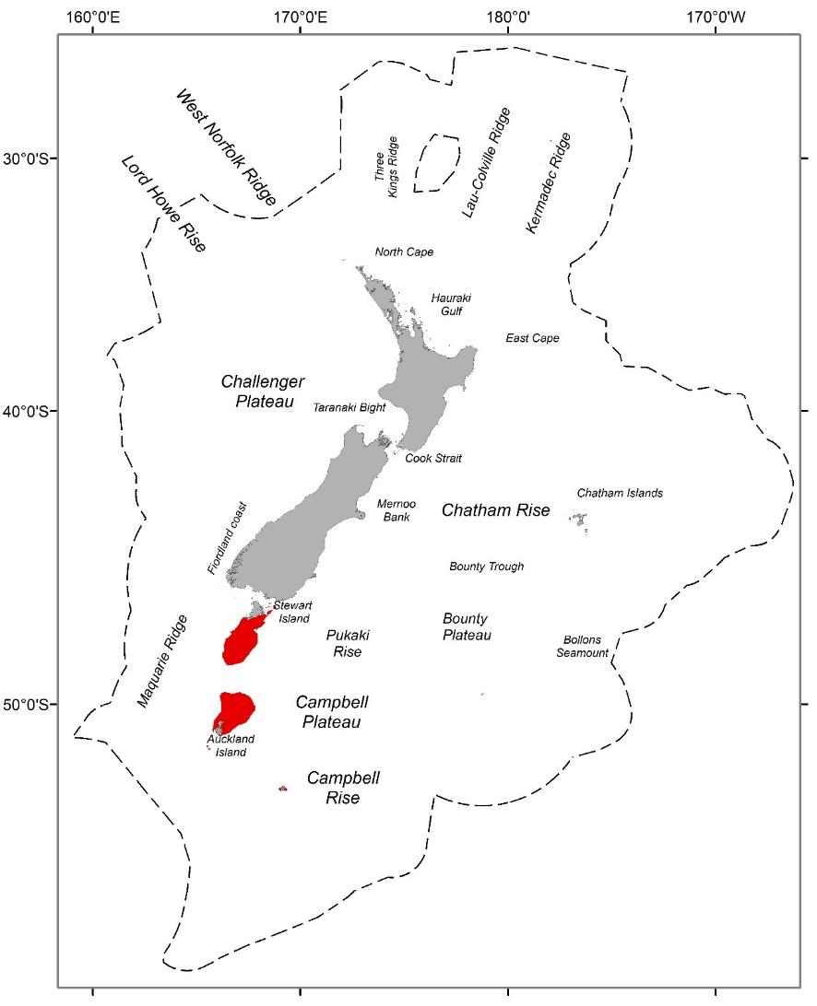

Figure 25. Geographic distributions of group 25 (red) from a 30-group demersal fish classification for the seas within the New Zealand Extended Continental Shelf (dashed line) to a depth of 2000 m.

#### Group description

Group 25 occurs at intermediate depths south from Stewart Island to the Auckland Islands (Figure 25). It is characterised by its very strong tidal currents and high oxygen concentration at depth, but reduced variation in depth and very low productivity and low bottom temperature (Table 47). Species assemblages are strongly characterised by intermediate frequency occurrence of Barracouta and to a lesser extent spiny dogfish and Hāpuku (Table 48).

#### Similar groups

Closely related to group 26. More loosely related to groups 24 and 27.

#### Characterising environmental conditions

Table 47. Group 25 characterising environmental conditions

|  |  |  |
| --- | --- | --- |
| **Environmental variable** | **Mean value** | **Qualitative description** |
| Bathymetry | 155.9 m | Intermediate water depths |
| Roughness | 2.7 | Very low variability in seabed depths |
| Tidal current speed | 0.68 m s-1 | High tidal current speeds |
| Dissolved oxygen at depth | 6.1 ml l-1 | High concentrations of oxygen at depth |
| Bottom temperature | 10.6 °C km-1 | Moderate – low bottom water temperature |
| VGPM | 389 mgC m-2 d-1 | Low productivity |

#### Characterising Species

Table 48. Species name, mean frequency occurrence and % contribution to group 25 similarity for those species contributing to a total of 70% of the group similarity or > 4 % to the group 25 similarity. If English common names were not available, these were recorded as *na*.

|  |  |  |  |
| --- | --- | --- | --- |
| **Common name** | **Scientific name** | **Mean frequency occurrence** | **% contribution to similarity** |
| Barracouta | *Thyrsites atun* | 0.7 | 23.01 |
| Spiny dogfish | *Squalus acanthias* | 0.63 | 16.25 |
| Hāpuku | *Polyprion oxygeneios* | 0.53 | 10.74 |
| Gemfish | *Rexea solandri* | 0.48 | 8.62 |
| School shark | *Galeorhinus galeus* | 0.48 | 8.32 |
| Silver warehou | *Seriolella punctata* | 0.38 | 7.9 |

### Group 26

#### Geographic location

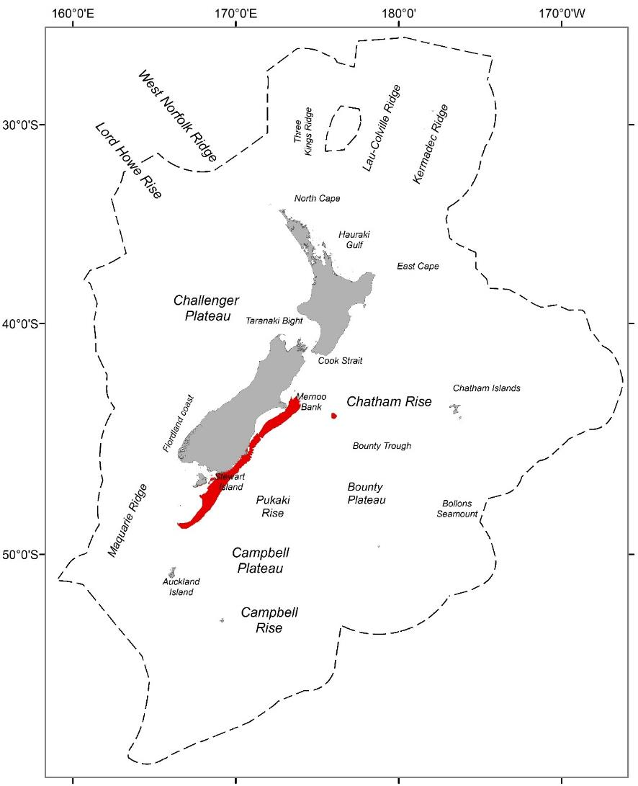

Figure 26. Geographic distributions of group 26 (red) from a 30-group demersal fish classification for the seas within the New Zealand Extended Continental Shelf (dashed line) to a depth of 2000 m.

#### Group description

Group 26 occurs at intermediate depths along the east coast of the South Island (Figure 26). It is characterised by strong sea surface temperature gradients, high oxygen concentration at depth, but low variation in seabed depth, bottom salinity and productivity (Table 49). Species assemblages are primarily characterised by high frequency occurrence of spiny dogfish and Barracouta (Table 50).

#### Similar groups

Closely related to group 25. More loosely related to groups 24 and 27.

#### Characterising environmental conditions

Table 49. Group 26 characterising environmental conditions

|  |  |  |
| --- | --- | --- |
| **Environmental variable** | **Mean value** | **Qualitative description** |
| Bathymetry | 119.0 m | Intermediate water depths |
| Roughness | 4.9 | Very low variability in seabed depths |
| Sea surface temperature gradients | 0.04 °C km-1 | High SST gradients |
| Dissolved oxygen at depth | 6.1 ml l-1 | High concentrations of oxygen at depth |
| Bottom salinity | 34.6 | Low salinity at depth |
| VGPM | 567 mgC m-2 d-1 | Low productivity |

#### Characterising Species

Table 50. Species name, mean frequency occurrence and % contribution to group 26 similarity for those species contributing to a total of 70% of the group similarity or > 4 % to the group 26 similarity. If English common names were not available, these were recorded as *na*.

|  |  |  |  |
| --- | --- | --- | --- |
| **Common name** | **Scientific name** | **Mean frequency occurrence** | **% contribution to similarity** |
| Spiny dogfish | *Squalus acanthias* | 0.9 | 23.02 |
| Barracouta | *Thyrsites atun* | 0.81 | 18.47 |
| Hāpuku | *Polyprion oxygeneios* | 0.52 | 7.64 |
| Ling | *Genypterus blacodes* | 0.52 | 6.56 |
| Witch | *Arnoglossus scapha* | 0.48 | 5.33 |
| Red cod | *Pseudophycis bachus* | 0.48 | 5.3 |
| Tarakihi | *Nemadactylus macropterus* | 0.45 | 4.6 |

### Group 27

#### Geographic location

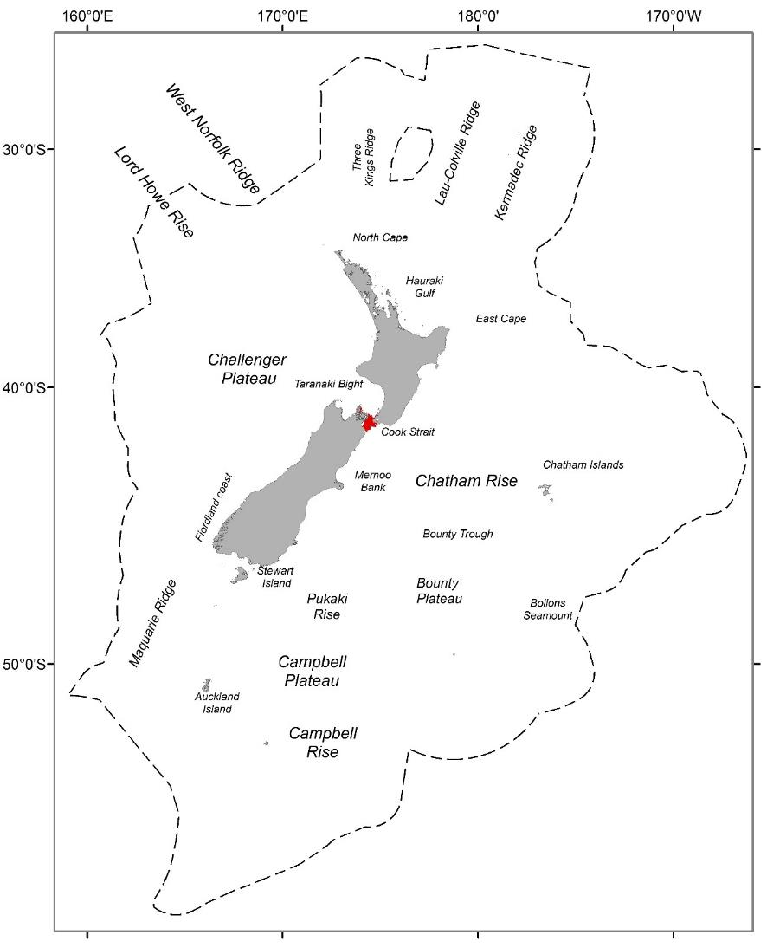

Figure 27. Geographic distributions of group 27 (red) from a 30-group demersal fish classification for the seas within the New Zealand Extended Continental Shelf (dashed line) to a depth of 2000 m.

#### Group description

Group 27 occurs across a very small are of the study extent on sites at intermediate water depths in the Cook Strait and the Marlborough Sounds (Figure 27). Group 27 is characterised by very high tidal currents, and moderate – high values for other environmental variables (e.g. benthic seabed disturbance, seasonal variation in bottom water temperature, productivity, bottom water temperatures and bottom water salinity) (Table 51). Species assemblages are characterised by low – intermediate frequency occurrence of Blue cod (Table 52).

#### Similar groups

Loosely related to groups 24 – 26

#### Characterising environmental conditions

Table 51. Group 27 characterising environmental conditions

|  |  |  |
| --- | --- | --- |
| **Environmental variable** | **Mean value** | **Qualitative description** |
| Bathymetry | 120.7 m | Intermediate water depths |
| Annual amplitude of sea floor temperature | 2.3 °C km-1 | Moderate difference in seafloor temperature throughout the year |
| Bottom salinity | 34.9 psu | Moderate salinity at depth. |
| Dissolved oxygen at depth | 5.48 ml l-1 | Moderate concentrations of oxygen at depth |
| Tidal current speed | 0.92 m s-1 | Very high tidal current speeds |
| VGPM | 1191 mgC m-2 d-1 | Moderate – high productivity |

#### Characterising Species

Table 52. Species name, mean frequency occurrence and % contribution to group 27 similarity for those species contributing to a total of 70% of the group similarity or > 4 % to the group 27 similarity. If English common names were not available, these were recorded as *na*.

|  |  |  |  |
| --- | --- | --- | --- |
| **Common name** | **Scientific name** | **Mean frequency occurrence** | **% contribution to similarity** |
| Blue cod | *Parapercis colias* | 0.57 | 78.53 |

### Group 28

#### Geographic location

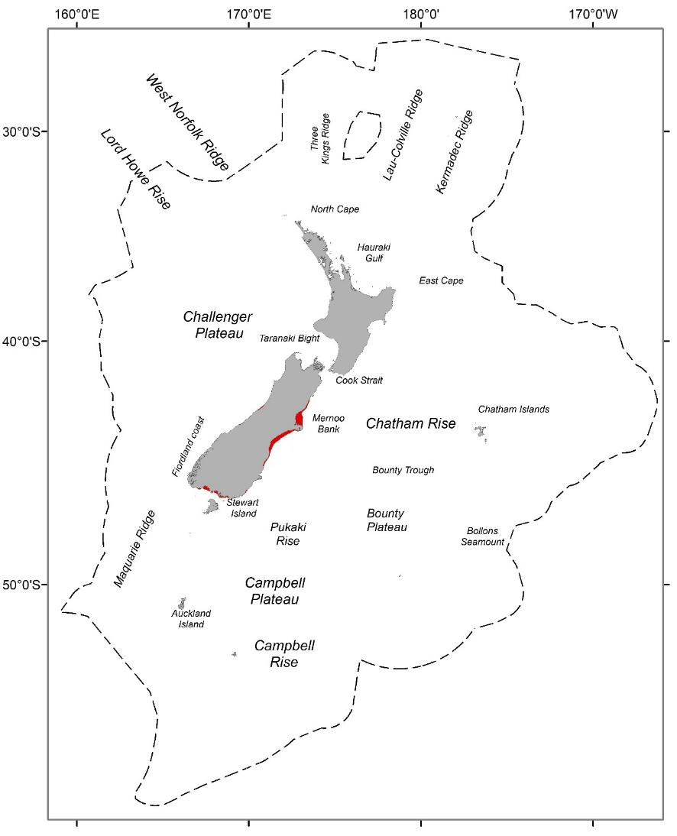

Figure 28. Geographic distributions of group 28 (red) from a 30-group demersal fish classification for the seas within the New Zealand Extended Continental Shelf (dashed line) to a depth of 2000 m.

#### Group description

Group 28 occurs on sites at very shallow water depths off the southern Fiordland coast, south and on the Mernoo Bank (Figure 28). Group 28 is characterised by high oxygen and seasonal variation in bottom water temperature and productivity, but with moderate bottom water temperatures and low bottom water salinity (Table 53). Species assemblages are primarily characterised by intermediate frequency occurrence of spiny dogfish and Elephantfish (Table 54).

#### Similar groups

Closely related to group 29; more loosely related to groups 30.

#### Characterising environmental conditions

Table 53. Group 28 characterising environmental conditions

|  |  |  |
| --- | --- | --- |
| **Environmental variable** | **Mean value** | **Qualitative description** |
| Bathymetry | 20.5 m | Shallow water depths |
| Annual amplitude of sea floor temperature | 4.6 °C km-1 | High difference in seafloor temperature throughout the year |
| Bottom salinity | 34.3 psu | Low salinity at depth. |
| Dissolved oxygen at depth | 6.2 ml l-1 | Very high concentrations of oxygen at depth |
| Bottom temperature | 12.3 °C km-1 | Moderate bottom water temperature |
| VGPM | 1171 mgC m-2 d-1 | Moderate – high productivity |

#### Characterising Species

Table 54. Species name, mean frequency occurrence and % contribution to group 28 similarity for those species contributing to a total of 70% of the group similarity or > 4 % to the group 28 similarity. If English common names were not available, these were recorded as *na*.

|  |  |  |  |
| --- | --- | --- | --- |
| **Common name** | **Scientific name** | **Mean frequency occurrence** | **% contribution to similarity** |
| Spiny dogfish | *Squalus acanthias* | 0.77 | 14.62 |
| Elephantfish | *Callorhinchus milii* | 0.77 | 14.44 |
| Barracouta | *Thyrsites atun* | 0.63 | 9.58 |
| New Zealand sole | *Peltorhamphus novaezeelandiae* | 0.61 | 8.83 |
| School shark | *Galeorhinus galeus* | 0.63 | 8.59 |
| Blue warehou | *Seriolella brama* | 0.55 | 6.64 |
| Red gurnard | *Chelidonichthys kumu* | 0.49 | 6.17 |
| Rig | *Mustelus lenticulatus* | 0.5 | 5.55 |

### Group 29

#### Geographic location

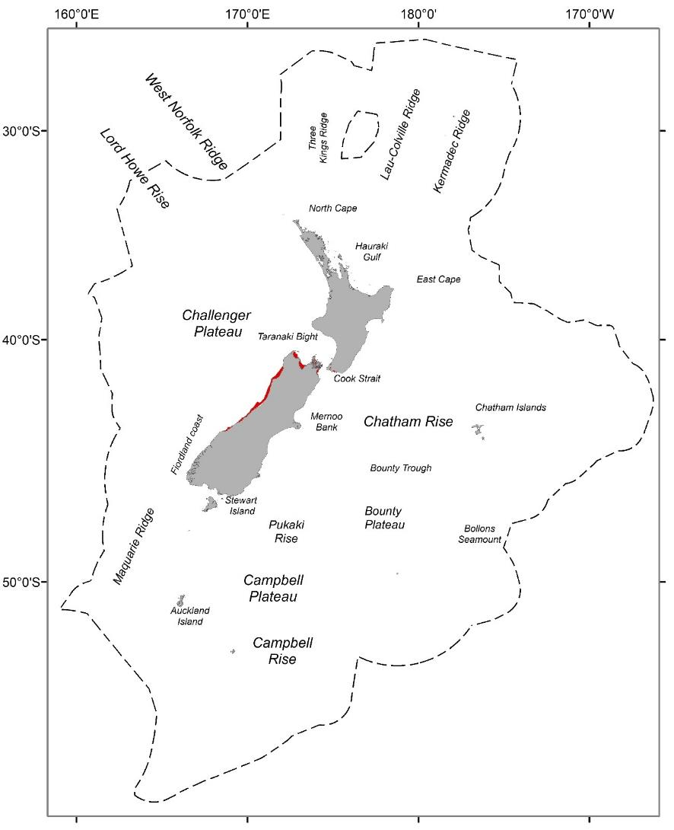

Figure 29. Geographic distributions of group 29 (red) from a 30-group demersal fish classification for the seas within the New Zealand Extended Continental Shelf (dashed line) to a depth of 2000 m.

#### Group description

Group 29 has a more central distribution occurring predominantly on inshore, very shallow water sites around the upper west coast and top of South Island over a relatively small extent of the study area (Figure 29). Group 29 is typified by high variation in temperature seasonality, productivity, bottom water temperature, bottom salinity and benthic seabed disturbance. In addition, this group also has moderate – high values for sea surface temperature gradient and bottom oxygen (Table 55). Species assemblages are primarily characterised by low frequency occurrence of Blue cod and intermediate frequency occurrence of Red gurnard and Red cod (Table 56).

#### Similar groups

Closely related to group 28; more loosely related to groups 30.

#### Characterising environmental conditions

Table 55. Group 29 characterising environmental conditions

|  |  |  |
| --- | --- | --- |
| **Environmental variable** | **Mean value** | **Qualitative description** |
| Bathymetry | 29.3 m | Very shallow water depths |
| Annual amplitude of sea floor temperature | 3.8 °C km-1 | High difference in seafloor temperature throughout the year |
| Bottom salinity | 34.8 psu | High salinity at depth. |
| Benthic sediment disturbance | -3.25 | High relative benthic sediment disturbance |
| Bottom temperature | 14.35 °C km-1 | High bottom water temperature |
| VGPM | 1605 mgC m-2 d-1 | Very high productivity |

#### Characterising Species

Table 56. Species name, mean frequency occurrence and % contribution to group 29 similarity for those species contributing to a total of 70% of the group similarity or > 4 % to the group 29 similarity. If English common names were not available, these were recorded as *na*.

|  |  |  |  |
| --- | --- | --- | --- |
| **Common name** | **Scientific name** | **Mean frequency occurrence** | **% contribution to similarity** |
| Blue cod | *Parapercis colias* | 0.29 | 13.61 |
| Red gurnard | *Chelidonichthys kumu* | 0.74 | 13.55 |
| Red cod | *Pseudophycis bachus* | 0.67 | 10.6 |
| Barracouta | *Thyrsites atun* | 0.62 | 8.76 |
| Spiny dogfish | *Squalus acanthias* | 0.58 | 7.85 |
| Blue warehou | *Seriolella brama* | 0.53 | 6.25 |
| Sand flounder | *Rhombosolea plebeia* | 0.45 | 4.72 |
| Rig | *Mustelus lenticulatus* | 0.44 | 4.42 |

### Group 30

#### Geographic location

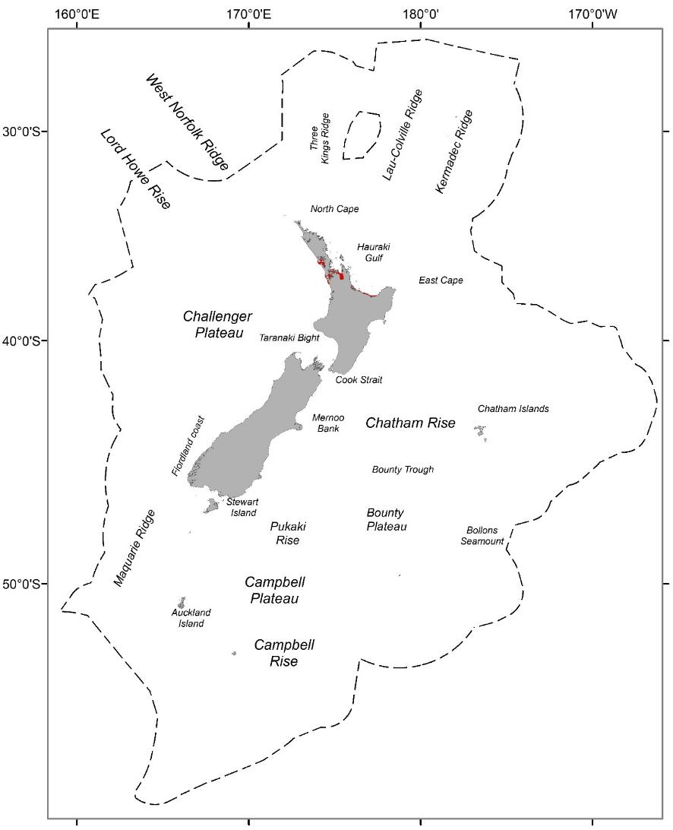

Figure 30. Geographic distributions of group 30 (red) from a 30-group demersal fish classification for the seas within the New Zealand Extended Continental Shelf (dashed line) to a depth of 2000 m.

#### Group description

Group 30, is a highly localised group occurring over a very small extent of the study area in very shallow waters of the North Island; occurring in and around the mouths of the estuaries in the inner Hauraki Gulf (Kaipara, Manukau, Waitemata and Tauranga harbours) (Figure 30). It has the highest variation in temperature seasonality and productivity of the groups presented here and is also typified by very high bottom water temperature, bottom salinity and benthic seabed disturbance (Table 57). Species assemblages are strongly characterised by very high frequency occurrence of Snapper and to a lesser extent by intermediate frequency occurrence of John Dory, Red gurnard and Yellowtail jack mackerel (Table 58).

#### Similar groups

Loosely related to groups 28 and 29.

#### Characterising environmental conditions

Table 57. Group 30 characterising environmental conditions

|  |  |  |
| --- | --- | --- |
| **Environmental variable** | **Mean value** | **Qualitative description** |
| Bathymetry | 16.1 m | Very shallow water depths |
| Annual amplitude of sea floor temperature | 5.5 °C km-1 | Very high difference in seafloor temperature throughout the year |
| Bottom salinity | 35.3 psu | Very high salinity at depth. |
| Benthic sediment disturbance | -2.56 | High relative benthic sediment disturbance |
| Bottom temperature | 17.6 °C km-1 | Very high bottom water temperature |
| VGPM | 2058 mgC m-2 d-1 | Very high productivity |

#### Characterising Species

Table 58. Species name, mean frequency occurrence and % contribution to group 30 similarity for those species contributing to a total of 70% of the group similarity or > 4 % to the group 30 similarity. If English common names were not available, these were recorded as *na*.

|  |  |  |  |
| --- | --- | --- | --- |
| **Common name** | **Scientific name** | **Mean frequency occurrence** | **% contribution to similarity** |
| Snapper | *Chrysophrys auratus* | 0.96 | 28.71 |
| John Dory | *Zeus faber* | 0.7 | 14.08 |
| Red gurnard | *Chelidonichthys kumu* | 0.68 | 13.01 |
| Yellowtail jack mackerel | *Trachurus novaezelandiae* | 0.6 | 10.4 |
| Trevally | *Pseudocaranx georgianus* | 0.47 | 6.16 |